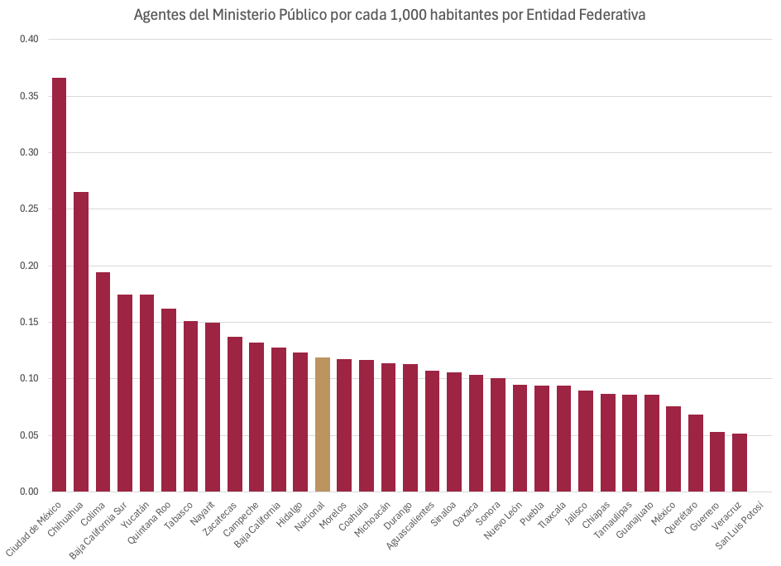
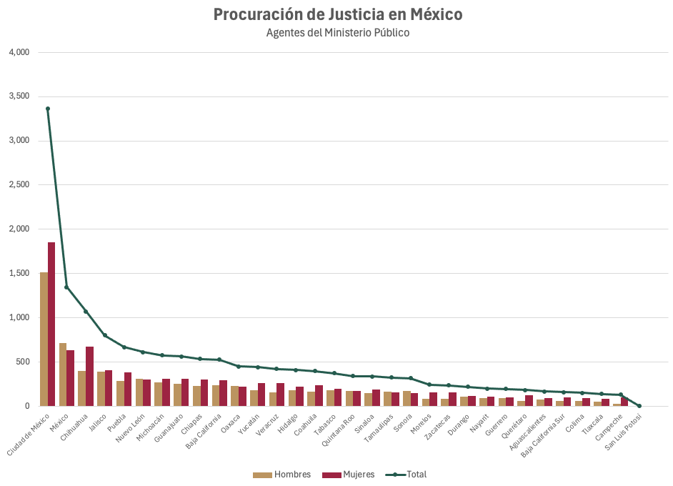
Entidad federativa | Hombres | Mujeres | Total | Poblacion | Tasa por 1000 hab
Ciudad de México | 1,511 | 1,850 | 3,361 | 9,183,658 | 0.3660
Chihuahua | 398 | 674 | 1,072 | 4,043,130 | 0.2651
Colima | 60 | 89 | 149 | 767,105 | 0.1942
Baja California Sur | 61 | 97 | 158 | 904,052 | 0.1748
Yucatán | 181 | 258 | 439 | 2,513,461 | 0.1747
Quintana Roo | 171 | 169 | 340 | 2,101,638 | 0.1618
Tabasco | 179 | 194 | 373 | 2,467,519 | 0.1512
Nayarit | 88 | 110 | 198 | 1,324,282 | 0.1495
Zacatecas | 82 | 153 | 235 | 1,712,936 | 0.1372
Campeche | 25 | 102 | 127 | 958,567 | 0.1325
Baja California | 238 | 289 | 527 | 4,131,619 | 0.1276
Hidalgo | 183 | 224 | 407 | 3,299,857 | 0.1233
Nacional | 7,119 | 8,727 | 15,846 | 133,367,428 | 0.1188
Morelos | 85 | 157 | 242 | 2,056,103 | 0.1177
Coahuila | 160 | 236 | 396 | 3,400,257 | 0.1165
Michoacán | 268 | 307 | 575 | 5,045,030 | 0.1140
Durango | 104 | 114 | 218 | 1,927,128 | 0.1131
Aguascalientes | 76 | 90 | 166 | 1,549,118 | 0.1072
Sinaloa | 150 | 187 | 337 | 3,187,466 | 0.1057
Oaxaca | 225 | 223 | 448 | 4,339,377 | 0.1032
Sonora | 170 | 146 | 316 | 3,140,762 | 0.1006
Nuevo León | 307 | 301 | 608 | 6,413,123 | 0.0948
Puebla | 286 | 380 | 666 | 7,070,124 | 0.0942
Tlaxcala | 51 | 85 | 136 | 1,447,721 | 0.0939
Jalisco | 390 | 408 | 798 | 8,903,326 | 0.0896
Chiapas | 228 | 304 | 532 | 6,107,903 | 0.0871
Tamaulipas | 164 | 158 | 322 | 3,748,419 | 0.0859
Guanajuato | 253 | 308 | 561 | 6,537,669 | 0.0858
México | 714 | 631 | 1,345 | 17,723,173 | 0.0759
Querétaro | 60 | 121 | 181 | 2,654,421 | 0.0682
Guerrero | 93 | 99 | 192 | 3,607,434 | 0.0532
Veracruz | 158 | 263 | 421 | 8,121,275 | 0.0518
San Luis Potosí | 0 | 0 | 0 | 2,979,775 | 0.0000

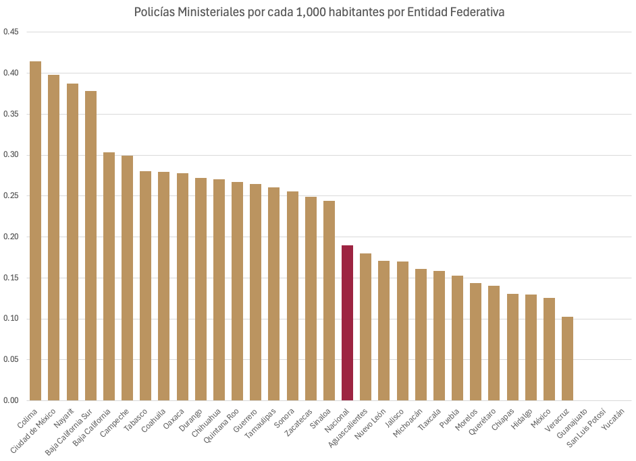
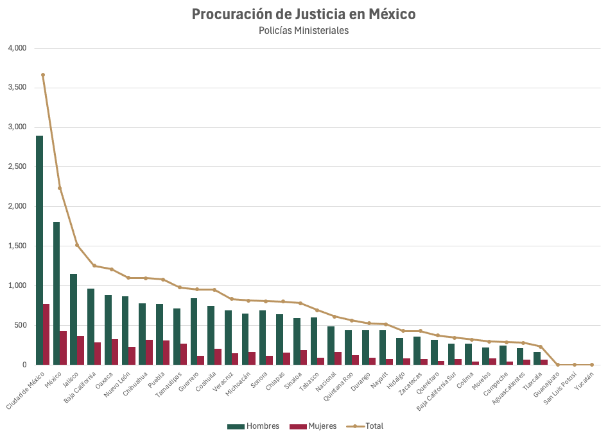
Entidad federativa | Hombres | Mujeres | Total | Poblacion | Tasa por 1000 hab
Colima | 272 | 46 | 318 | 767105 | 0.4145
Ciudad de México | 2891 | 768 | 3659 | 9183658 | 0.3984
Nayarit | 435 | 78 | 513 | 1324282 | 0.3874
Baja California Sur | 271 | 71 | 342 | 904052 | 0.3783
Baja California | 966 | 286 | 1252 | 4131619 | 0.3030
Campeche | 246 | 41 | 287 | 958567 | 0.2994
Tabasco | 603 | 88 | 691 | 2467519 | 0.2800
Coahuila | 745 | 206 | 951 | 3400257 | 0.2797
Oaxaca | 883 | 324 | 1207 | 4339377 | 0.2782
Durango | 438 | 87 | 525 | 1927128 | 0.2724
Chihuahua | 779 | 315 | 1094 | 4043130 | 0.2706
Quintana Roo | 435 | 126 | 561 | 2101638 | 0.2669
Guerrero | 843 | 111 | 954 | 3607434 | 0.2645
Tamaulipas | 712 | 265 | 977 | 3748419 | 0.2606
Sonora | 687 | 115 | 802 | 3140762 | 0.2554
Zacatecas | 355 | 71 | 426 | 1712936 | 0.2487
Sinaloa | 590 | 188 | 778 | 3187466 | 0.2441
Nacional | 19976.00 | 5330.00 | 25306.00 | 133367428 | 0.1897
Aguascalientes | 215 | 64 | 279 | 1549118 | 0.1801
Nuevo León | 869 | 229 | 1098 | 6413123 | 0.1712
Jalisco | 1146 | 365 | 1511 | 8903326 | 0.1697
Michoacán | 650 | 161 | 811 | 5045030 | 0.1608
Tlaxcala | 166 | 64 | 230 | 1447721 | 0.1589
Puebla | 769 | 311 | 1080 | 7070124 | 0.1528
Morelos | 216 | 79 | 295 | 2056103 | 0.1435
Querétaro | 320 | 53 | 373 | 2654421 | 0.1405
Chiapas | 642 | 157 | 799 | 6107903 | 0.1308
Hidalgo | 343 | 85 | 428 | 3299857 | 0.1297
México | 1803 | 430 | 2233 | 17723173 | 0.1260
Veracruz | 686 | 146 | 832 | 8121275 | 0.1024
Guanajuato | 0 | 0 | 0 | 6537669 | 0.0000
San Luis Potosí | 0 | 0 | 0 | 2979775 | 0.0000
Yucatán | 0 | 0 | 0 | 2513461 | 0.0000

