CN HW2

資工三 b04902103 蔡昀達

**Execute:**

Python3 agent.py [loss rate]

Python3 sender.py [source path]

Python3 reciever.py [destination path]

# ip & port info is in config

**Program structure:**

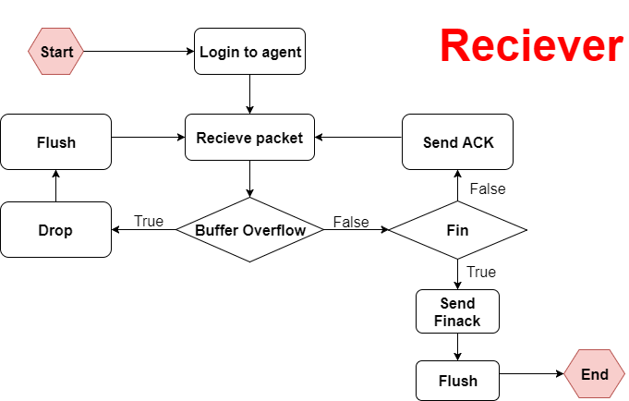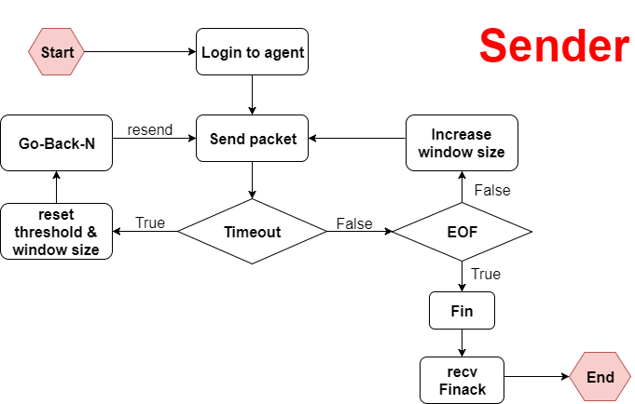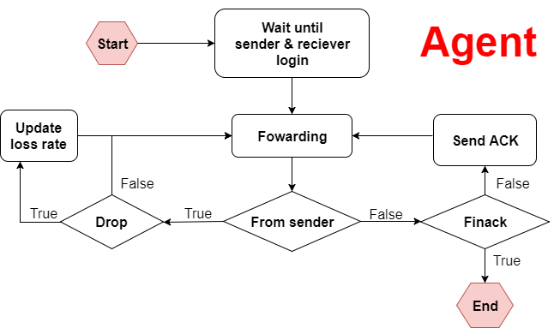

**Difficulty and Solutions:**

The uncertainty of the udp protocal is the most annoying part. You’ll have to check the correctness of the order and the completeness of the packet by yourself.

Sufficient info is required in the header.