**蔡昀達 R08946007**

Homework 1A

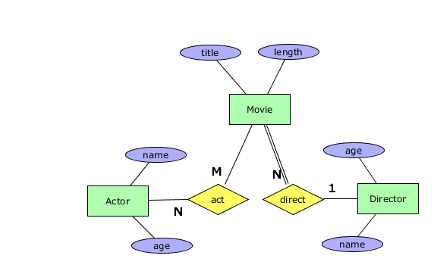

Homework 1B

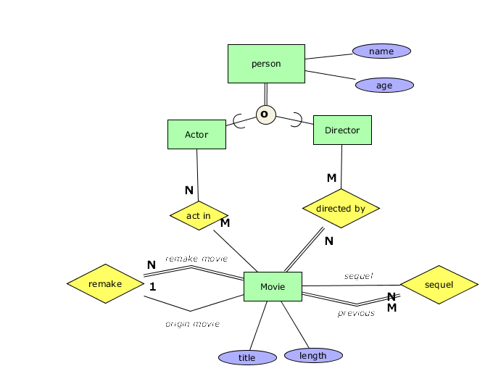

Homework 1C

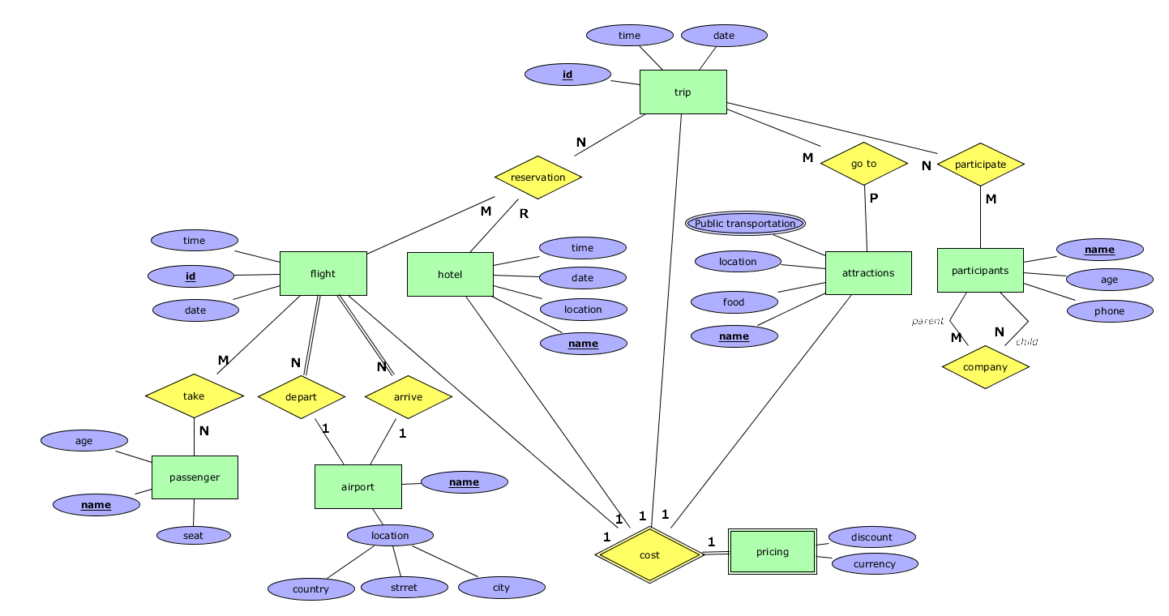

1. A trip can have several reservations for flight and hotel.
2. Each flight and hotel can be reserved by many trips.
3. A flight must have depart and arrival time with an airport.
4. An airport can have depart and arrival time with many flights.
5. A passenger can take many flights.
6. A flight can have many passengers.
7. A trip, a flight and a hotel reservation must have a pricing.
8. A trip can go to several attractions.
9. An attraction can be in many trips.
10. A trip can have many participants.
11. A participant can attend several trips.
12. Participants can be parents or child of other participants.