108-1 SQL HW4 Report

Name:蔡昀達

UID: r08946007

**Part 2 Graph Database (20 %)**

1. **Write a Cypher query to return you and your peer student in a graph. (20%)**

MATCH (a:Person)

WHERE a.department = '資料科學學程碩士班'

RETURN a

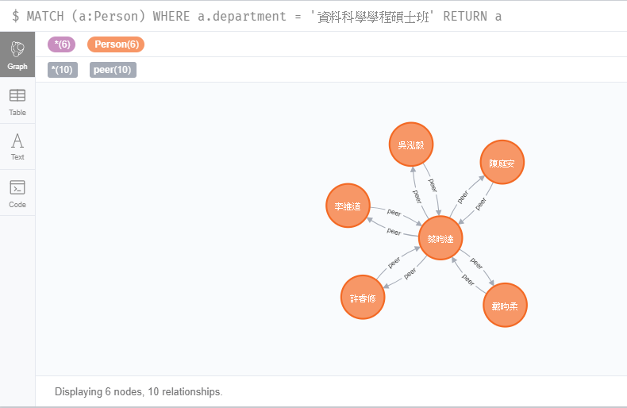

**Part 3 Part III Graph Database**

1. **Write a cypher query to print out your “foaf” and their associate new hobbies. (15%)**

**我嘗試了兩種方法，一種使用label來幫每個人標記複數個hobby，另一個使用array property**

**但query的語意相同，只差在一個呼叫n.hooby一個是labels(n)**

**Query的思路是先match有跟我一樣hobby的人然後match這些跟hobby friend相同hobby的人，也就是foaf，然後返回foaf的node和個別的hobby**

match (n{studentID:'r08946007'}), (m)

where any(x in labels(n) where x in labels(m))

with m, n

match (m), (o)

where any(x in labels(m) where x in labels(o)) and (o.studentID <> r08946007')

return DISTINCT o.name, filter(y in labels(o) where not y in labels(n))

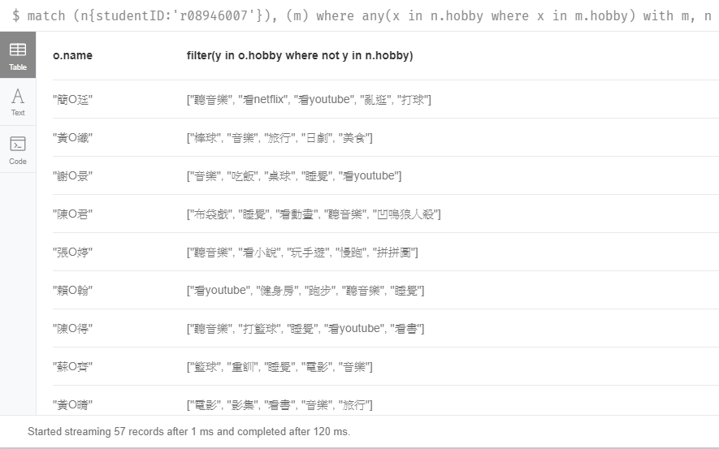

1. **Write a cypher query to print our all the new hobbies of your foaf.**

**和上題思路一模一樣但是把返回foaf node改成將foaf hobby展開並且返回distinct**

match (n{studentID:'r08946007'}), (m)

where any(x in labels(n) where x in labels(m))

with m, n

match (m), (o)

where any(x in labels(m) where x in labels(o)) and (o.studentID <> 'r08946007')

unwind filter(y in labels(o) where not y in labels(n)) as new_hobby

return distinct new_hobby

