**系統與網路安全實驗 lab1**

B04902103 資工四 蔡昀達

1. Please write your rules, and write down why should you set up those rules.

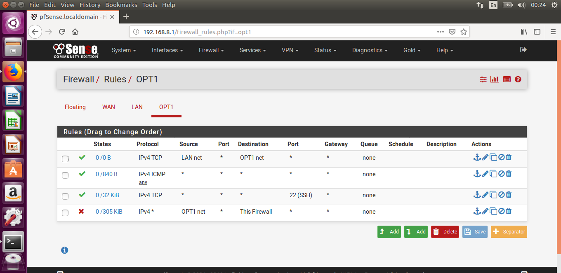

1 Allow admin to nmap scan A, B

2 Allow everyone to ping each other

3 Allow A, B to ssh admin

4 Block to access firewall unless in whitelist

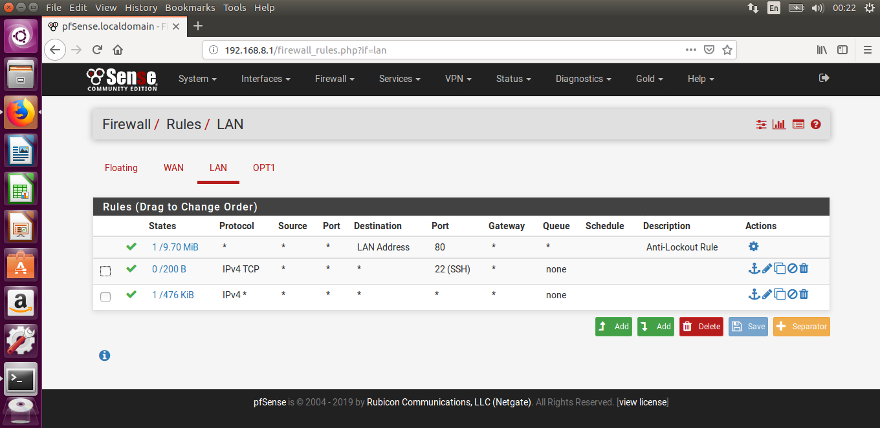

Allow admin to access firewall, ping and ssh.

1. Please write down 3 cpe( OS, Application, hardware)

* cpe:/a:google:chrome:2.0.172
* cpe:/o:linux:kernel:2.6.11.4
* cpe:/h:mcafee:web_gateway:7.0

1. Please write down corresponding CVE for your cpe.

* cpe:/a:google:chrome:2.0.172

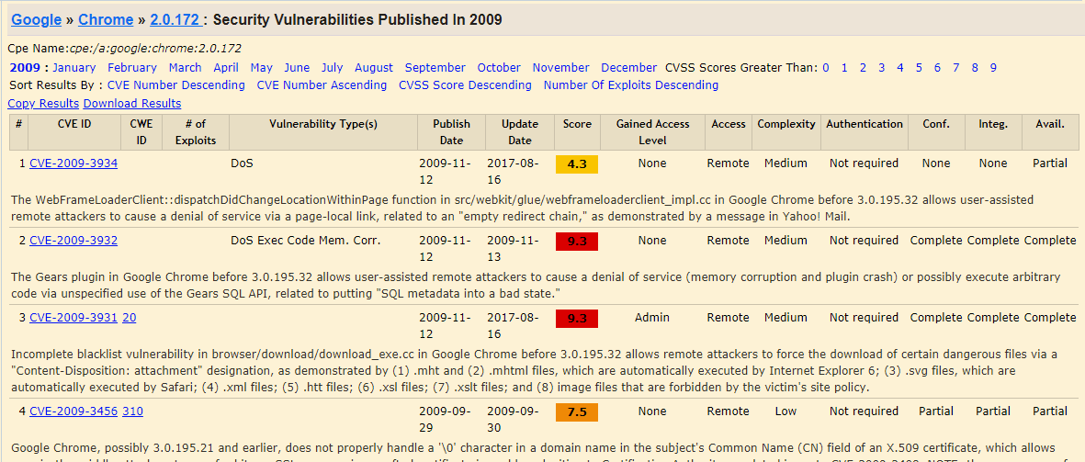

* cpe:/o:linux:kernel:2.6.11.4

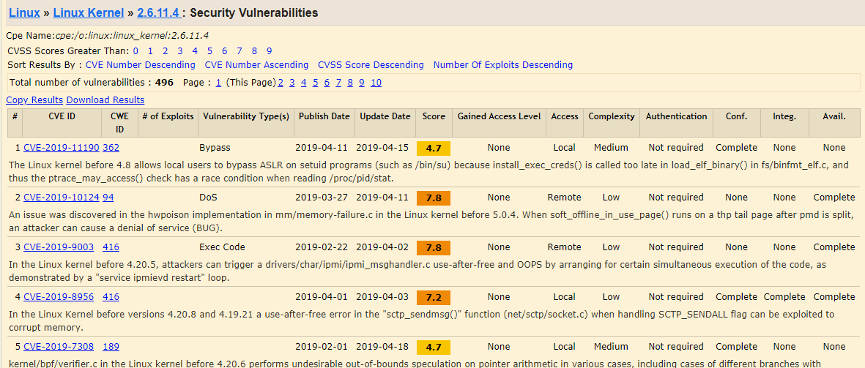

* cpe:/h:mcafee:web_gateway:7.0

