**系統與網路安全實驗 lab5-1**

B04902103 資工四 蔡昀達

1. What does the applet do? Provide the link to the applet.

Say thank you to new twitter follower.

<https://ifttt.com/applets/277508p-thank-new-twitter-follower?term=twitter>

1. Who plays the role of resource owner, resource server, authorization server, and client?

resource owner : me

resource server : twitter

authorization server : twitter

client : IFTTT

1. List the authorization and token endpoints (URLs) of the authorization server.

<https://api.twitter.com/oauth/authorize>

[https://api.twitter.com/oauth/access_token](https://api.twitter.com/oauth/acess_token)

1. Which grant type does the authorization flow follow?

Authorization Code Grant

1. What scope name does the applet request for? You may provide a screenshot.

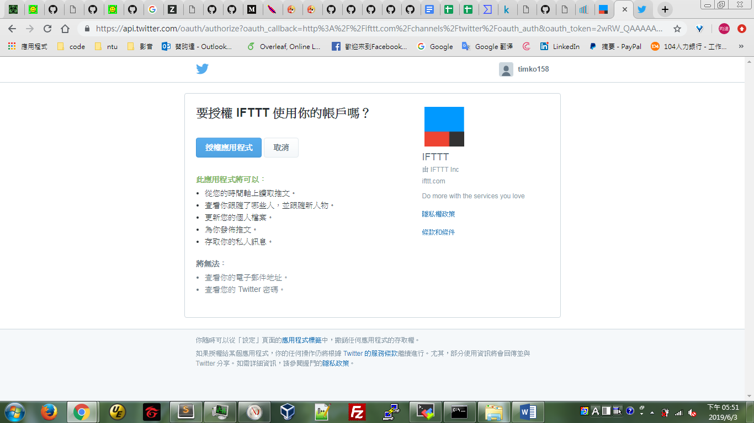

1. What can the applet do after being authorized by user?

從您的時間軸上讀取推文。

查看你跟隨了哪些人，並跟隨新人物。

更新您的個人檔案。

為你發佈推文。

存取你的私人訊息。

1. Is the applet over-privileged? Why or why not?

Yes, 他不需要更新個人檔案的權限, 也會存取到開起這個功能之前的個人資料和紀錄。