To whom it may concern:

I’m Kexin Sun, a journalism student in University of Missouri. It’s my honor to test the usability of your site.

I asked three classmates to test the usability of Columbia Convention and Visitors Bureau website. There are three tasks, find a great restaurant near Faurot Field at Memorial Stadium, find a latest art exhibition, and request a tour proposal. According to the result of those tests, the major problem is about the maps and directions.

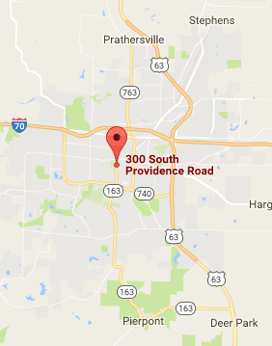

It can be seen that the map is just google map. When those three students tried to do the first task, finding a great restaurant near Faurot Field at Memorial Stadium, they found it’s hard to find detailed information about restaurants. I suggest to design your own map, and mark all the good restaurants and hotels near great places of interest or places where big events happen.

In addition, the home page contains too many colors, and the structure is a little complicated.

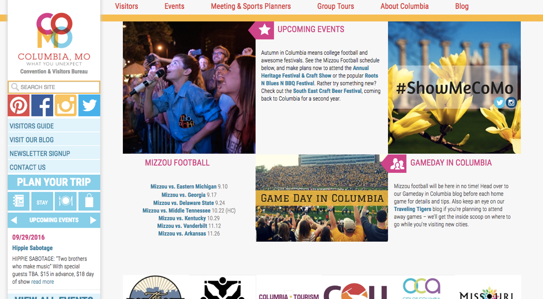

It follows that the home page contains a large amount of information, but it’s hard for visitors to find what they want. I suggest to reorganize the structure of the home page, cut the color types into two or three, from light to dark.

I will choose this site, because it provides useful information about the events and locations which attracts visitors. It’s really helpful for visitors who travel to Columbia to find good places to eat, live and have fun.

But I won’t choose this site if I cannot find what I need easily and fast, or the disordered structure and colors distract me too much.

Best wishes!