HW1 - 614

Jared ‘Jay’ Klein

8/31/2021

1. Use and show R code to evaluate the following expression:[ln(120)]^3 - π

desired_value <- (abs(log(120))^3) - pi  
print(desired_value)

## [1] 106.5881

1. Use and show R code to round your answer from number 1 to the nearest hundredth.

print(round(desired_value, digits = 2))

## [1] 106.59

1. Use and show R code to produce all even integers greater than 7 but less than 101.

c <- vector()  
for (variable in 8:100) {  
 if (variable %% 2 == 0) {  
 c <- append(c, variable)  
 }  
}  
  
print(c)

## [1] 8 10 12 14 16 18 20 22 24 26 28 30 32 34 36 38 40 42 44  
## [20] 46 48 50 52 54 56 58 60 62 64 66 68 70 72 74 76 78 80 82  
## [39] 84 86 88 90 92 94 96 98 100

1. Use and show R code to find the mean of all positive integers less than 100.

another_c <- vector()  
for (i in 0:99) {  
 another_c <- append(another_c, i)  
}  
  
print(mean(another_c))

## [1] 49.5

help("seq")

1. For the given data set below, Use and show R code to create a vector and assign the vector to variable,{10, 22, 24, 34, 35, 39, 41, 43, 44, 45.5, 47, 51, 53, 54.5, 55, 56.75, 58, 58.3, 59, 59}

mommys_favorite_vector <- c(10, 22, 24, 34, 35, 39, 41, 43, 44, 45.5, 47, 51, 53, 54.5, 55, 56.75, 58, 58.3, 59, 59)

5a) Use and show R code to find the median for the data set.

median(mommys_favorite_vector)

## [1] 46.25

5b) Use and show R code to produce a boxplot for the data set.

boxplot(mommys_favorite_vector)

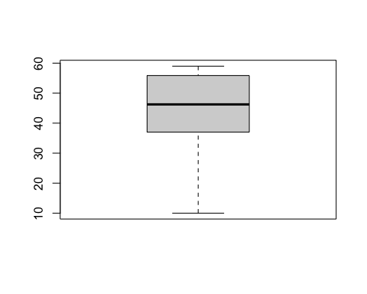 5c) Use and show R code to find the mean, median, maximum, minimum, 1stquartile and the 3rd quartile for the data set.

summary(mommys_favorite_vector)

## Min. 1st Qu. Median Mean 3rd Qu. Max.   
## 10.00 38.00 46.25 44.45 55.44 59.00

5d) Use and show R code to produce a histogram.

hist(mommys_favorite_vector)

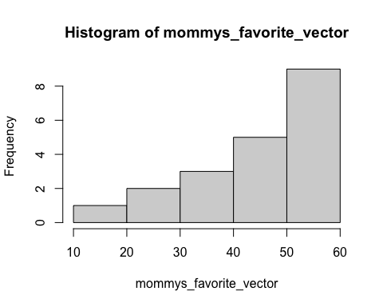 Data is skewed to the left.

1. This is a long question so I won’t copy paste here.

my_credit_score_is_better_than_these_not_bragging <- c(545, 595, 640, 675, 705, 750)  
  
interest_rates_i_never_understand <- c(18.982, 17.976, 12.218, 8.612, 6.680, 5.150)  
  
plot(my_credit_score_is_better_than_these_not_bragging, interest_rates_i_never_understand)

