HMTL with Calibration - Experimental Report
Generated: 2025-12-10T16:09:34.655610

Executive Summary
This report summarizes the results of comprehensive experiments on Hierarchical Multi-Task Learning (HMTL) with uncertainty estimation and conformal calibration for tabular regression.

1. Main HMTL Experiment

Метрики (валидация / тест)
Metric | Validation | Test
RMSE | 0.296722 | 0.294180
MAE | 0.190745 | 0.185180
R-AUC MSE | 0.024995 | 0.024434
Mean Uncertainty | 0.392680 | 0.389794
Mean Epistemic | 0.154717 | —
Mean Aleatoric | 0.356158 | —

Покрытие после конформной калибровки
Level | Val Coverage | Val Width | Test Coverage | Test Width
80% | 79.96% | 0.587196 | 81.10% | 0.587196
90% | 89.98% | 0.905961 | 89.99% | 0.905961
95% | 95.01% | 1.319216 | 95.16% | 1.319216

Разложение неопределенности
- Вал. неопределенность: 0.392680 (эпистемическая: 0.154717, алеаторная: 0.356158)
- Тестовая неопределенность: 0.389794
- Средний R-AUC MSE по ансамблю: 0.055765
- Размер ансамбля: 20

Ключевые графики
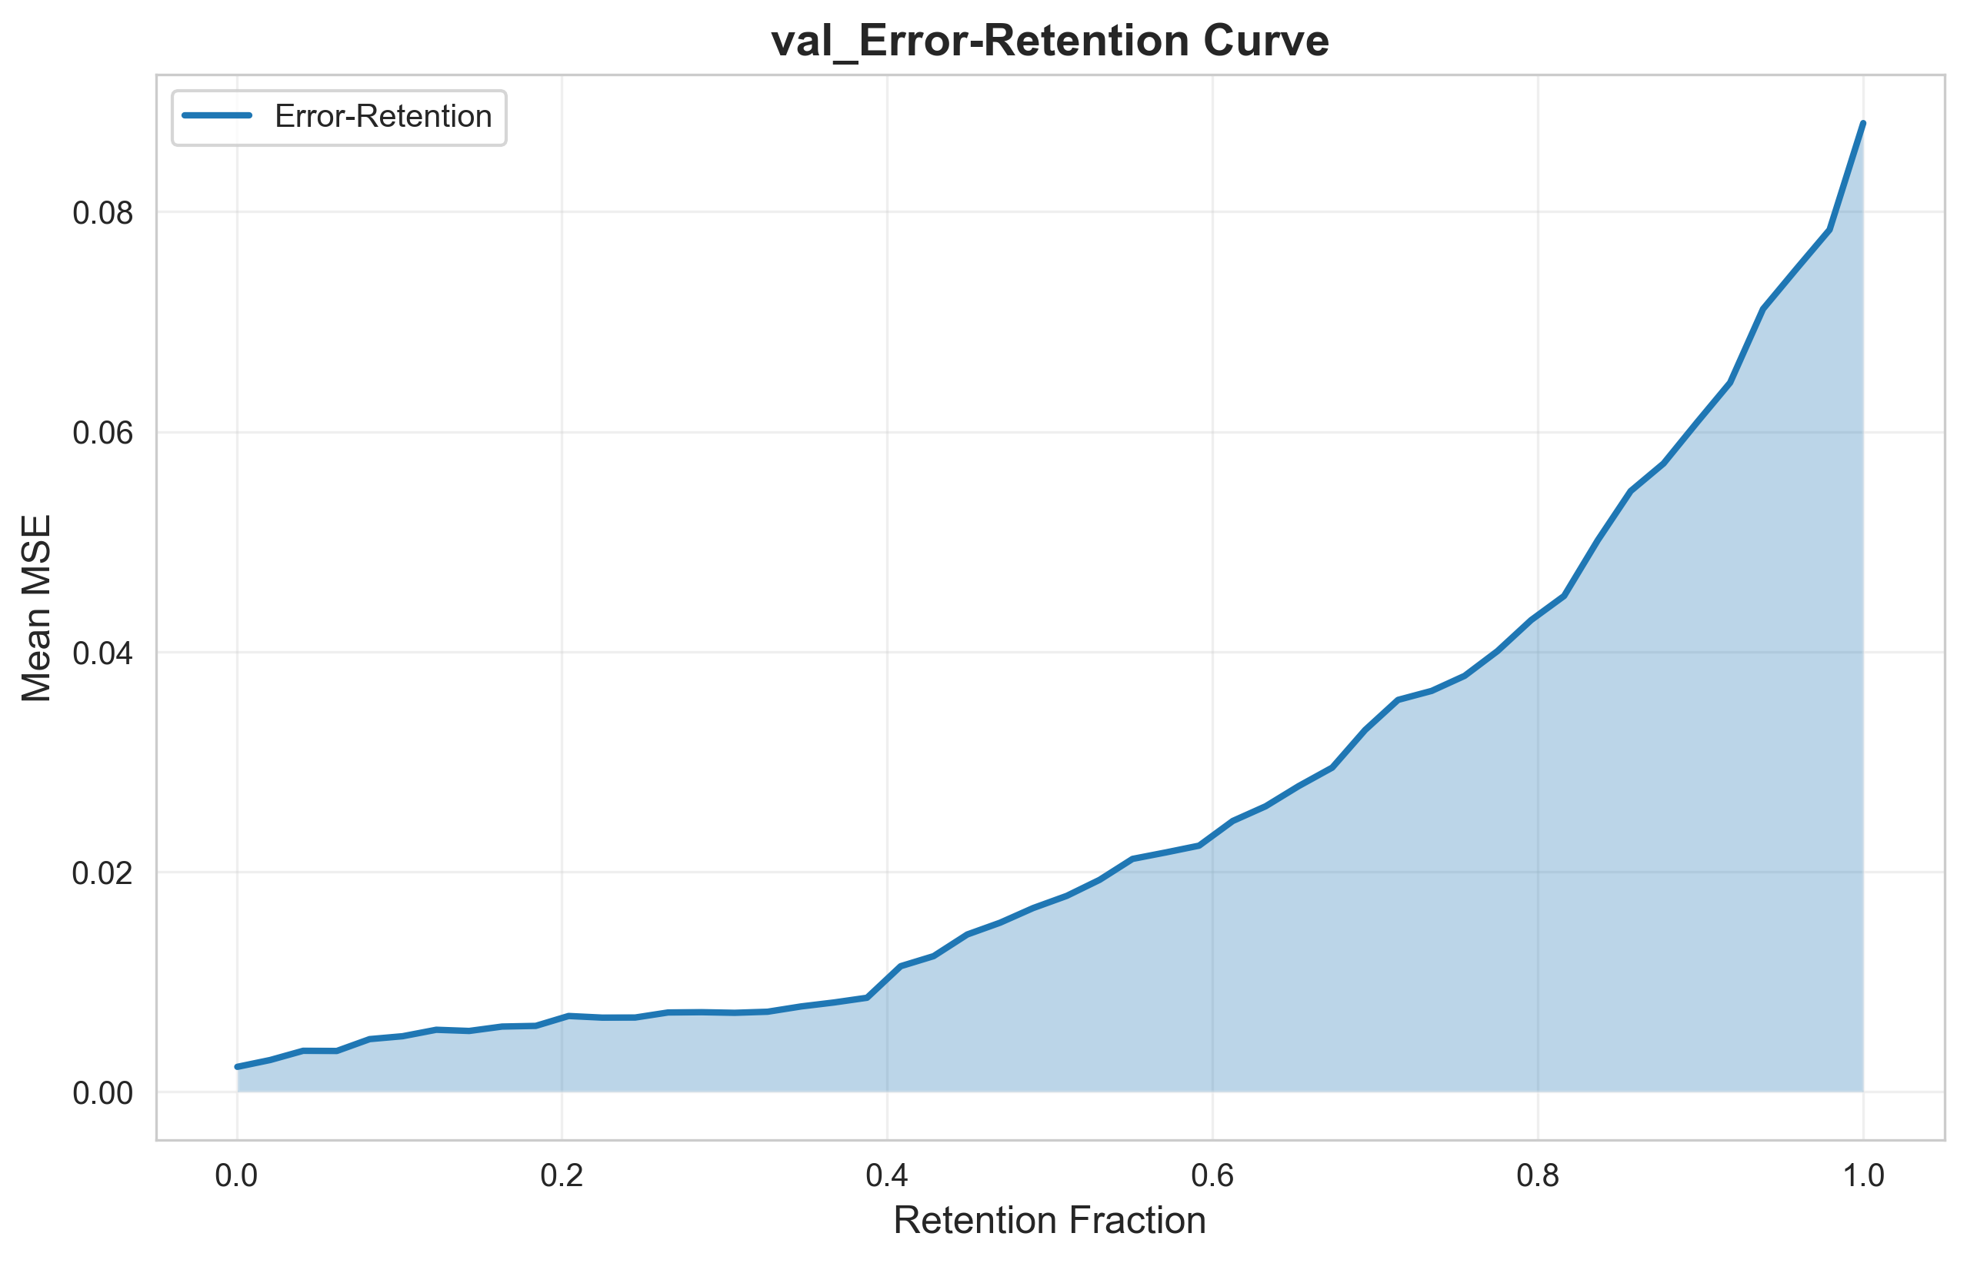
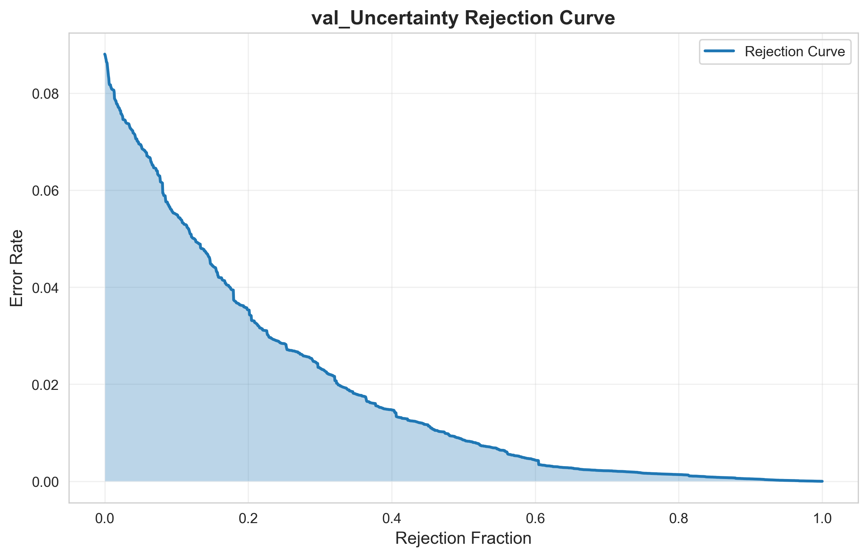
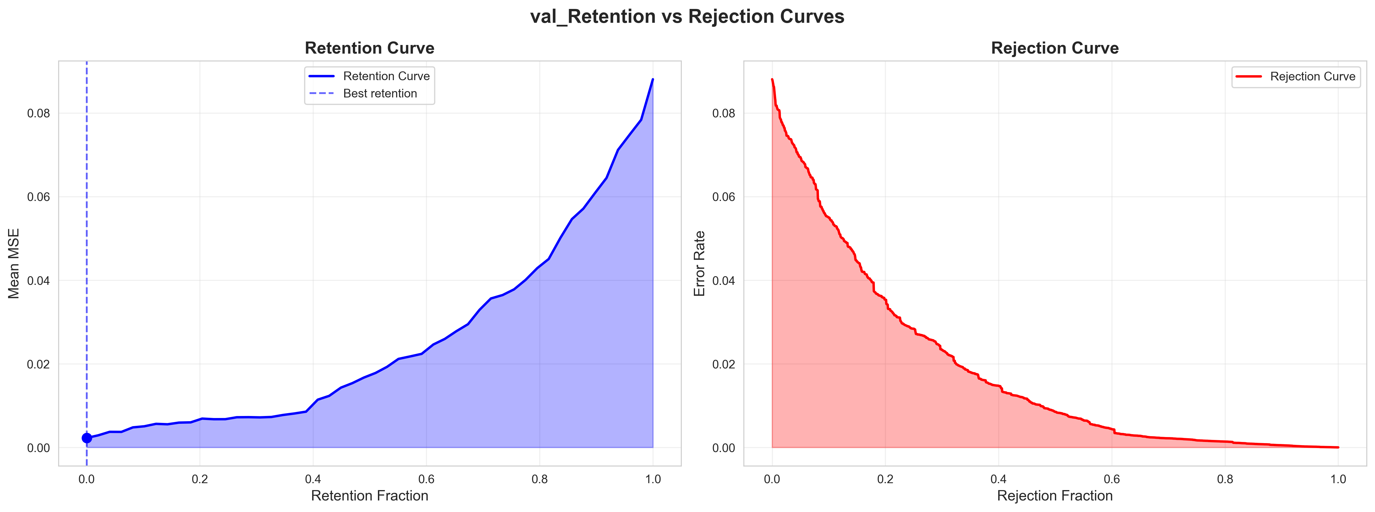
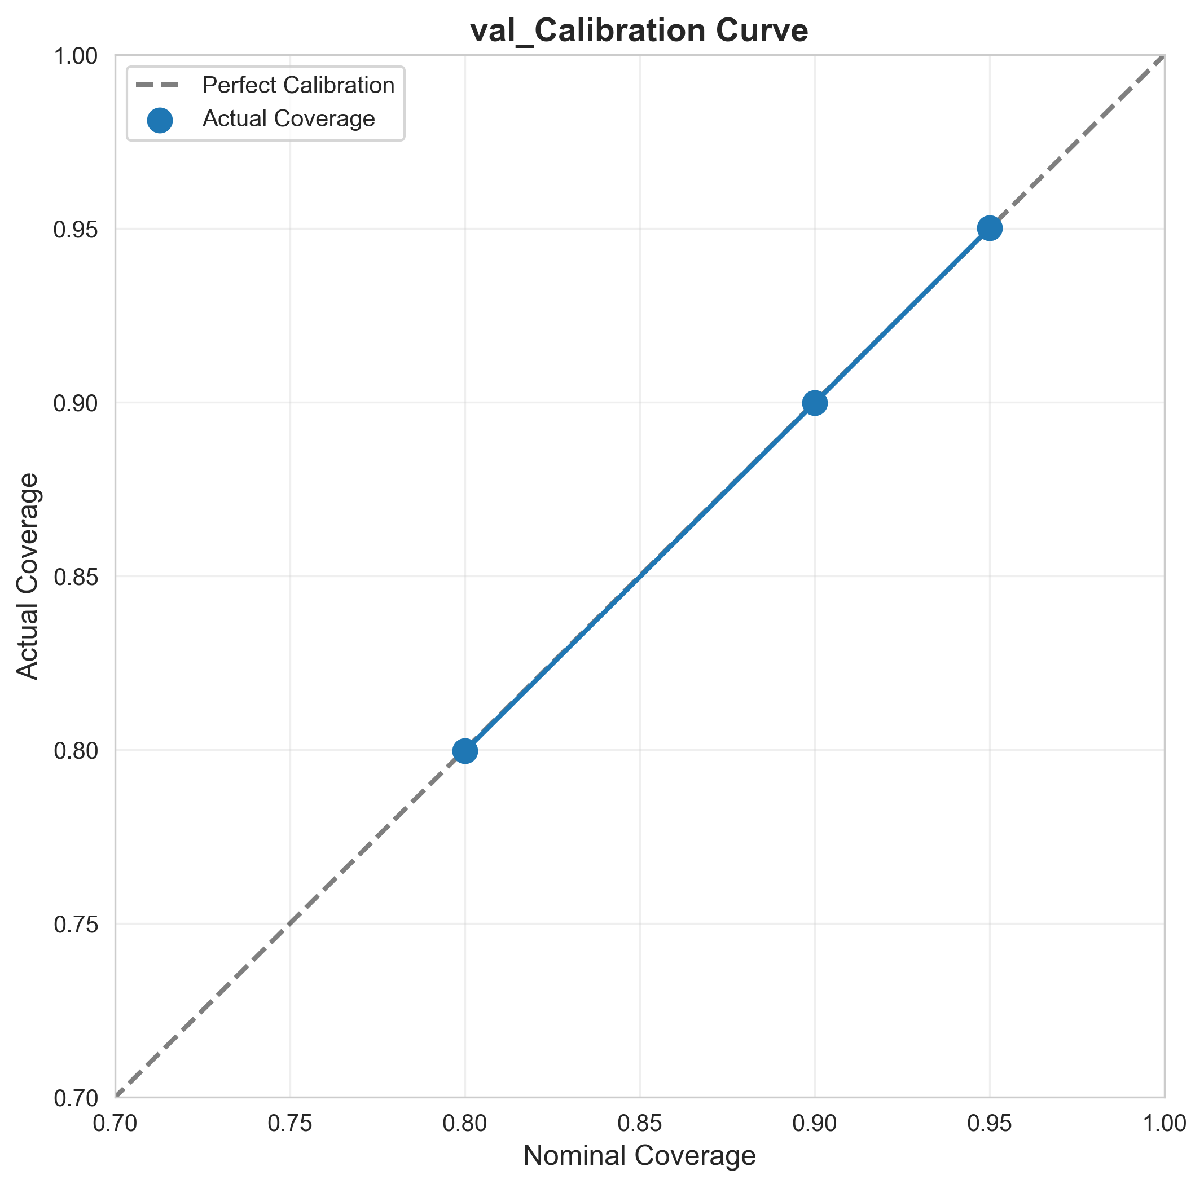
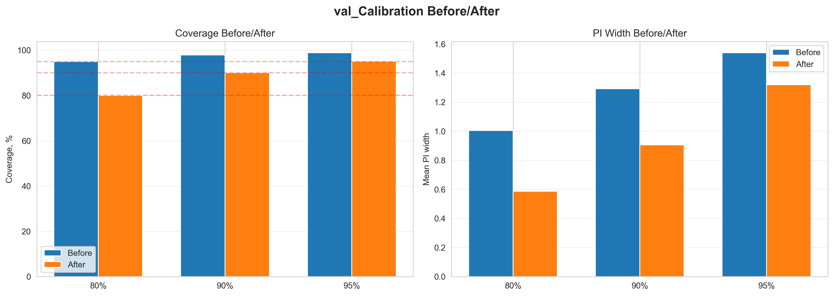
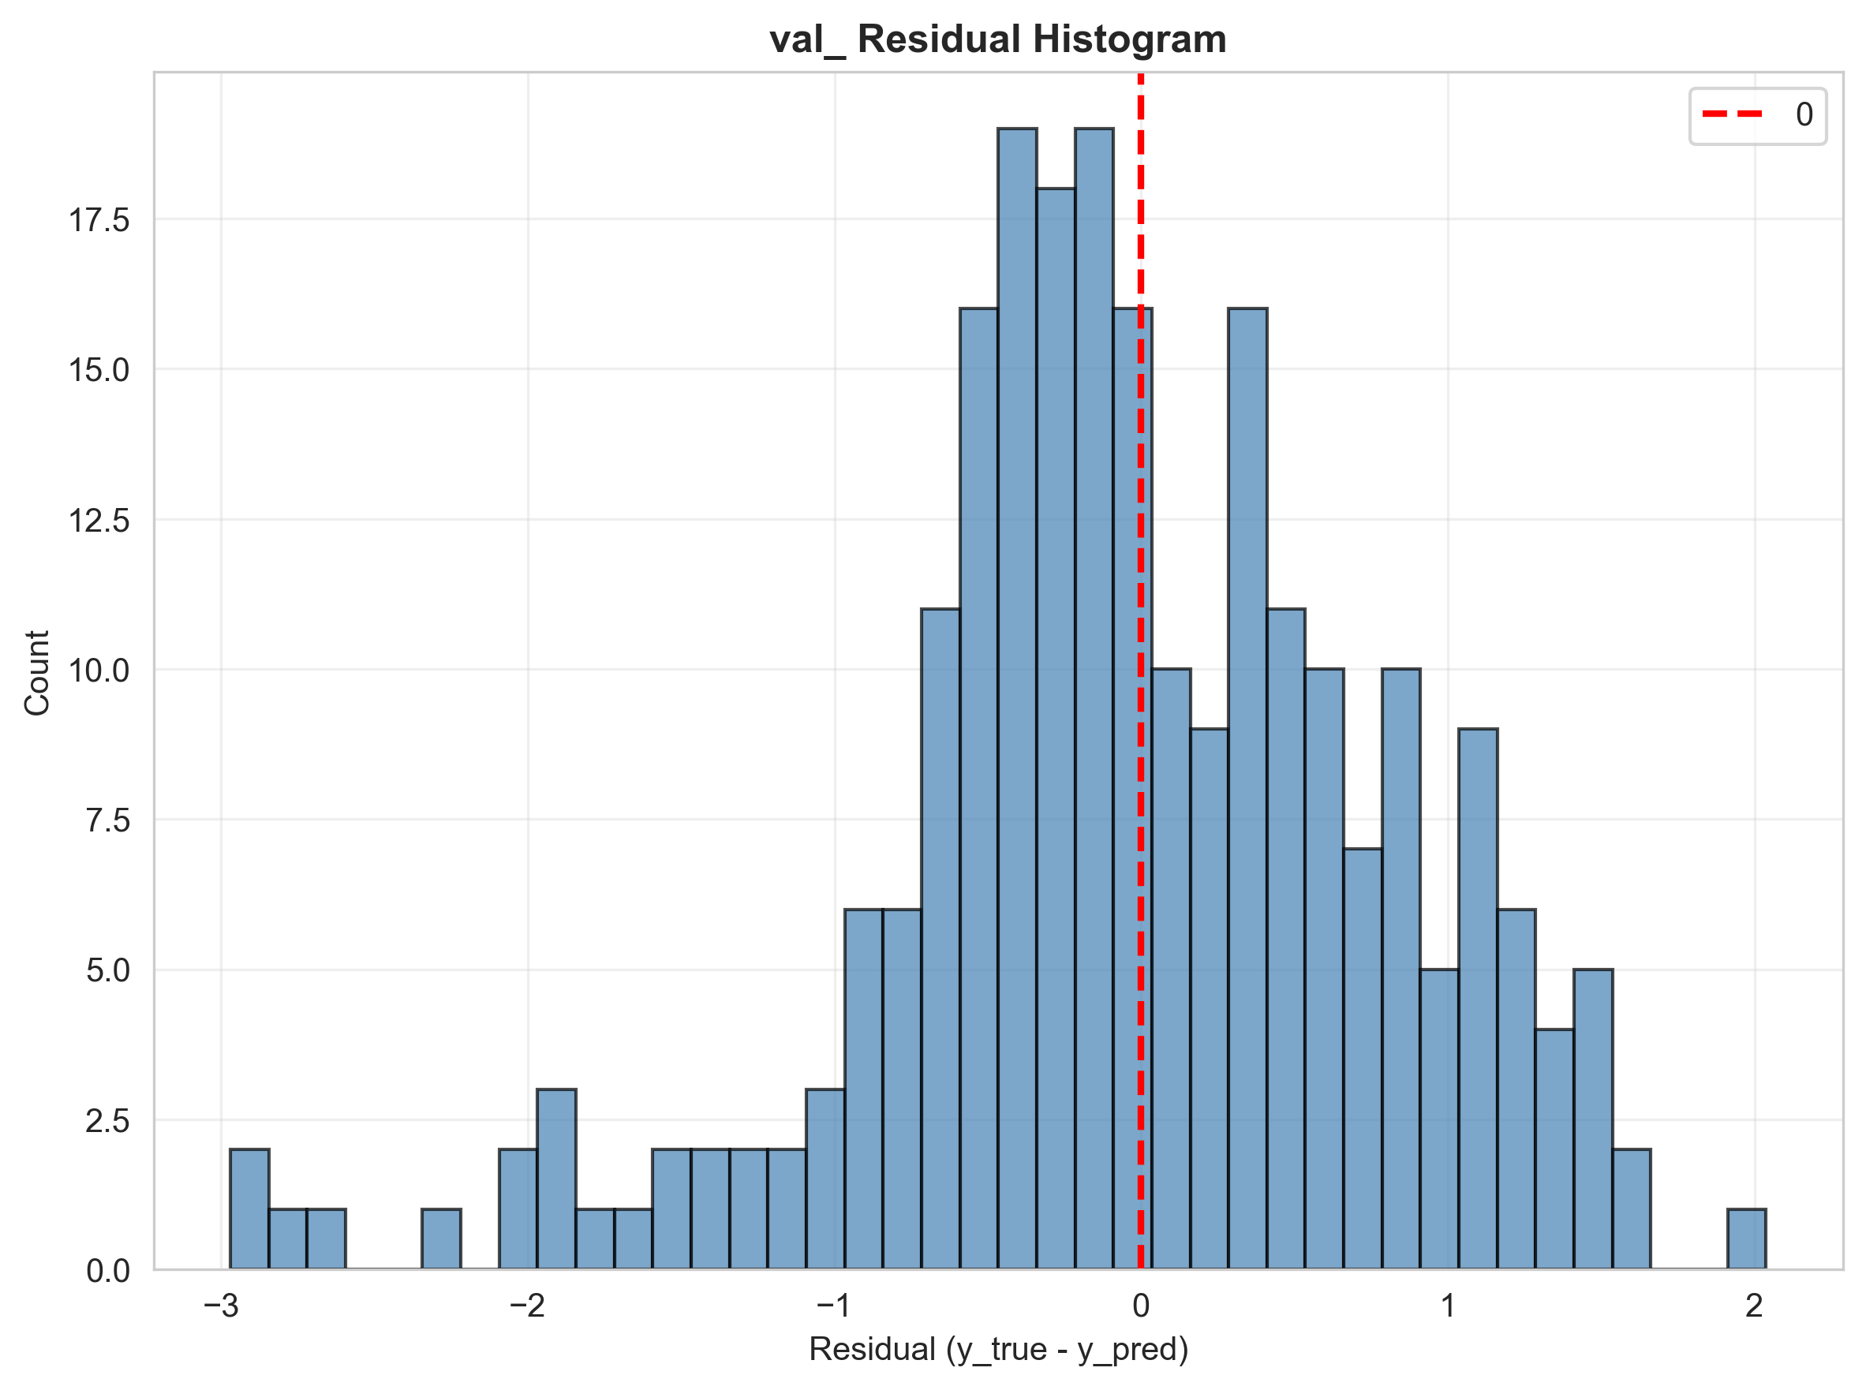
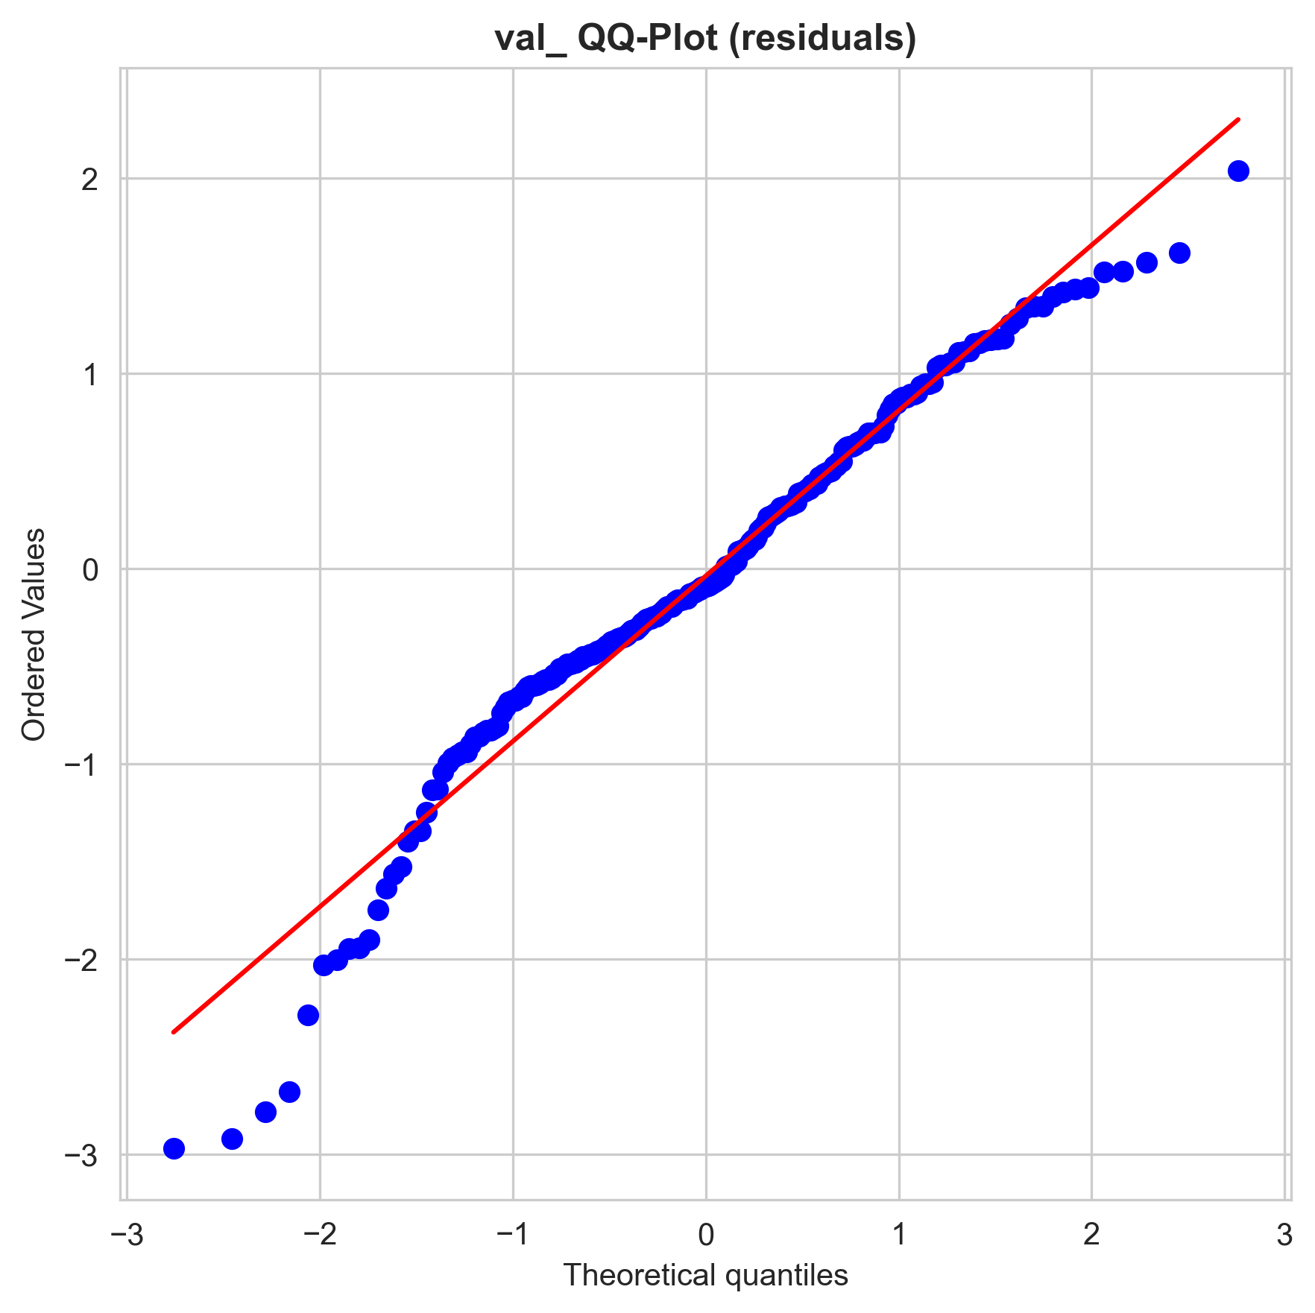
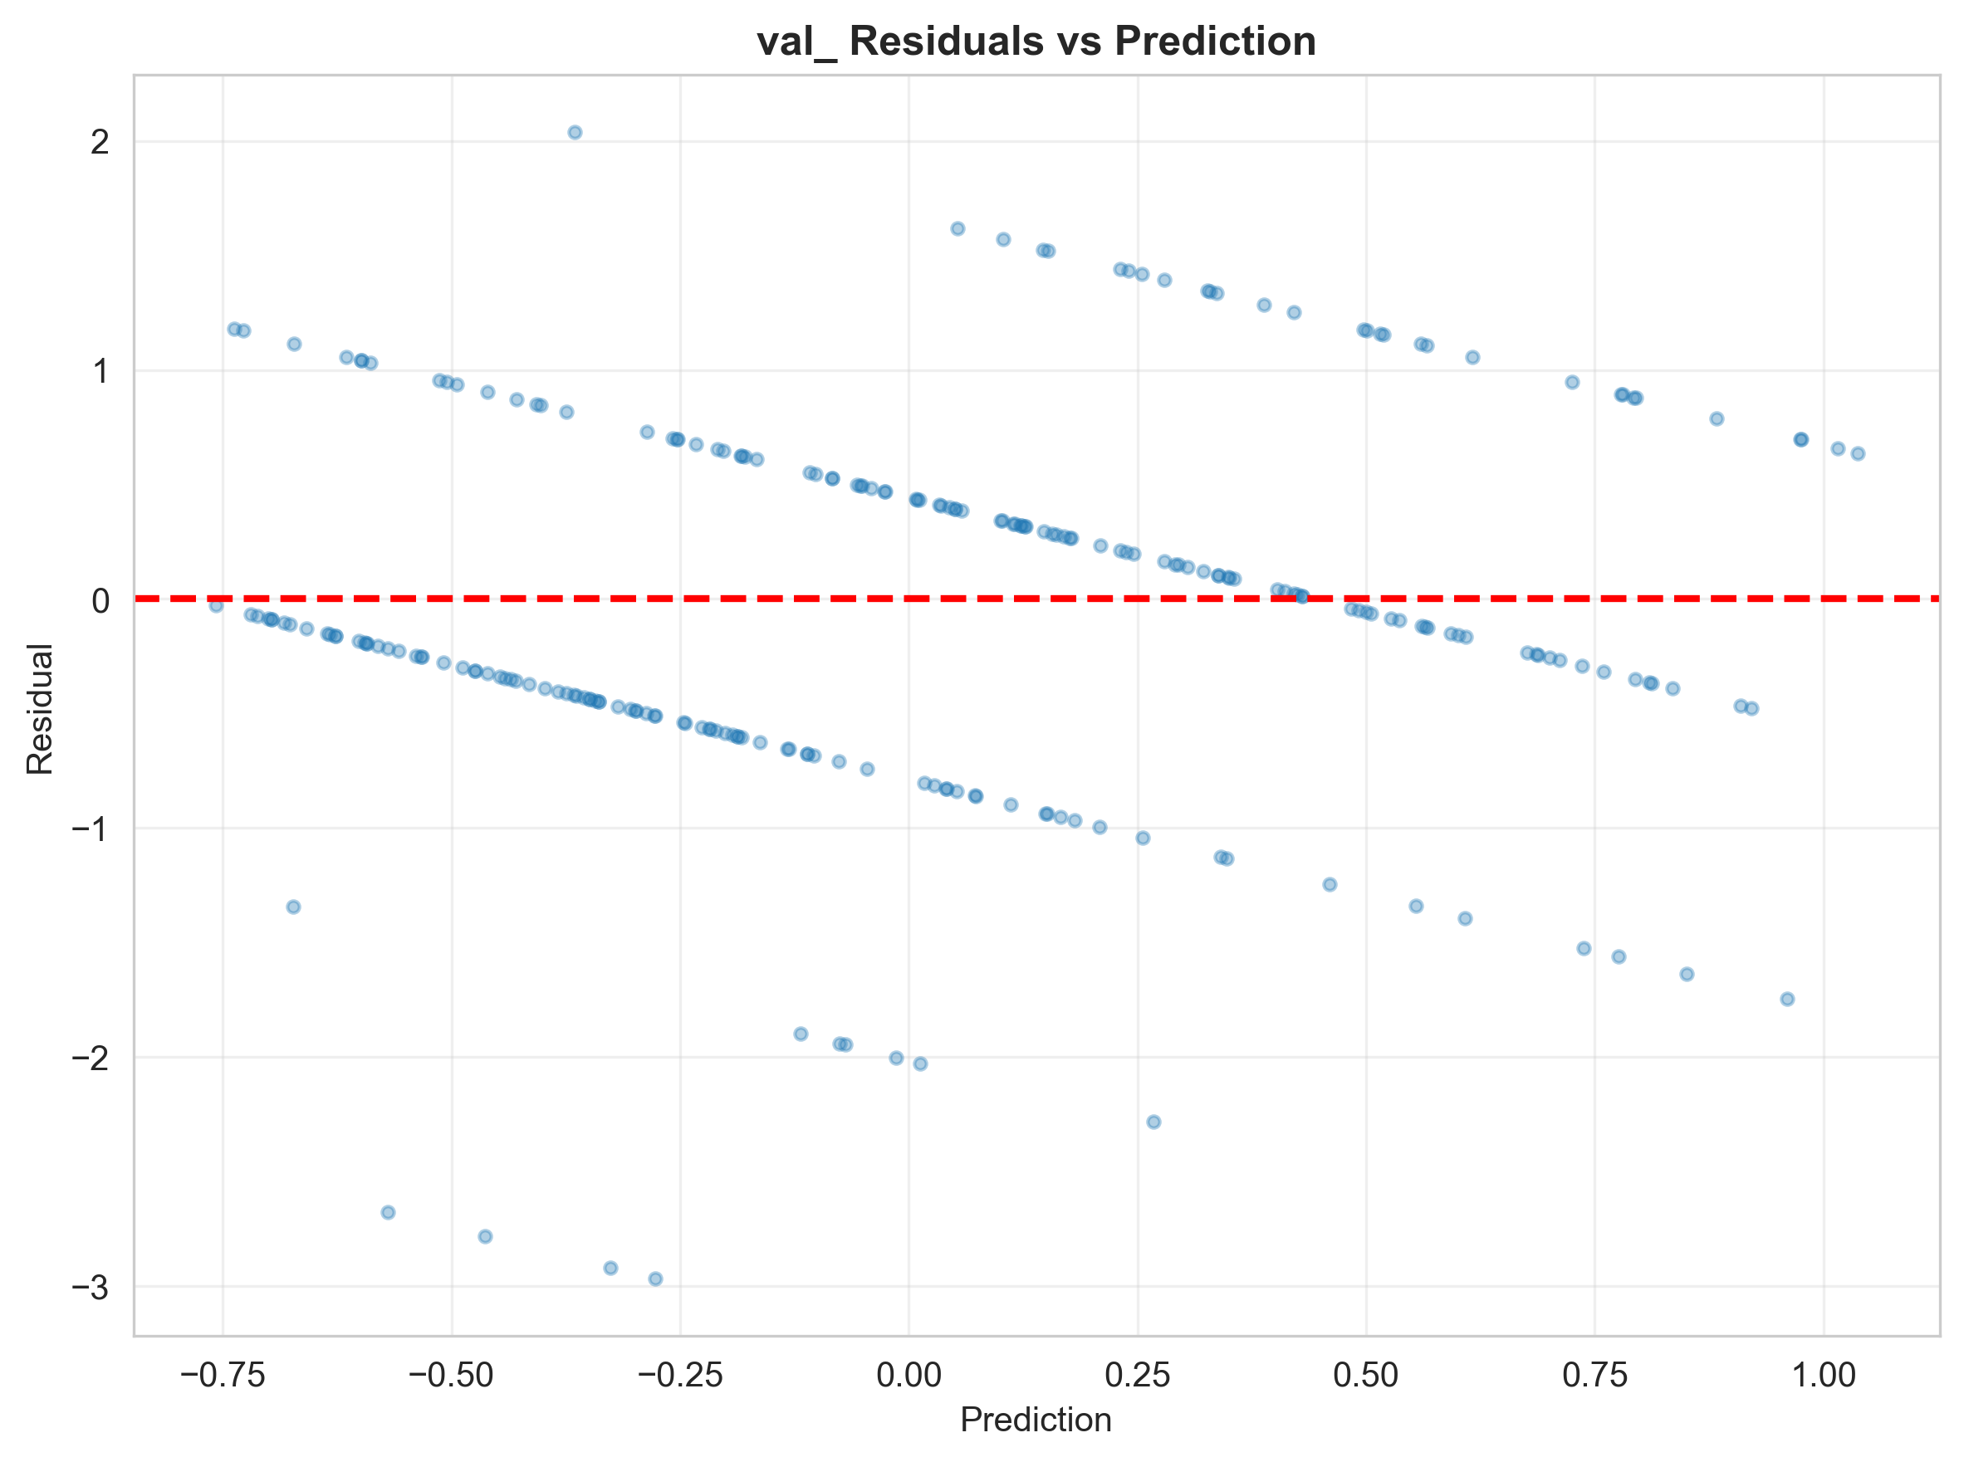
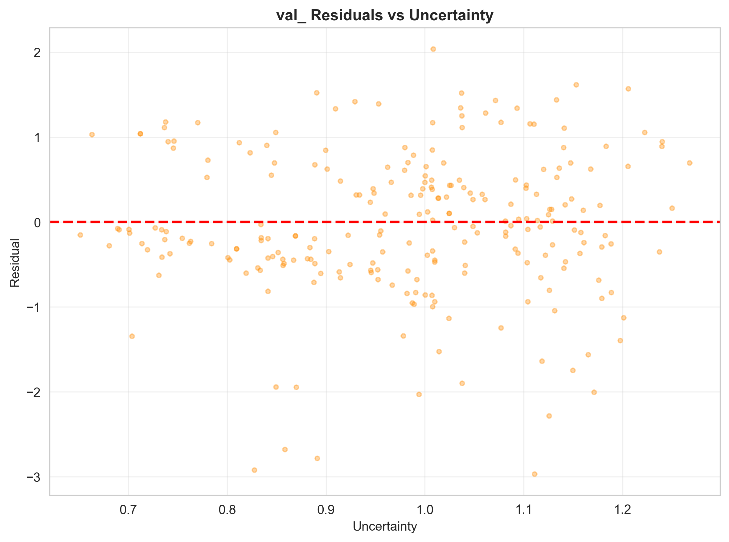
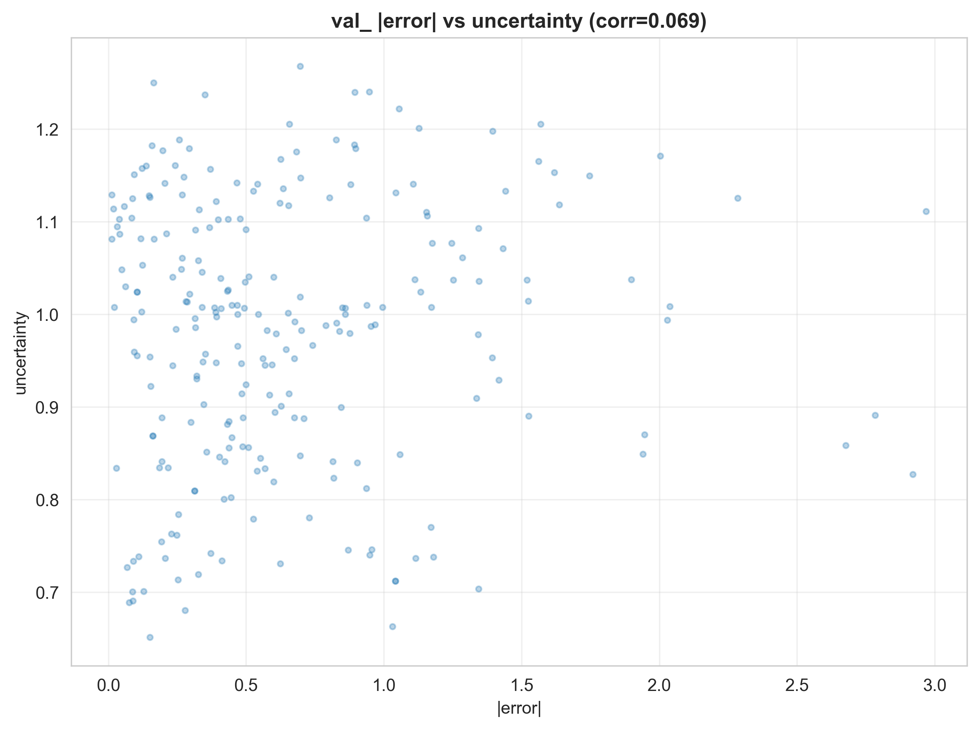
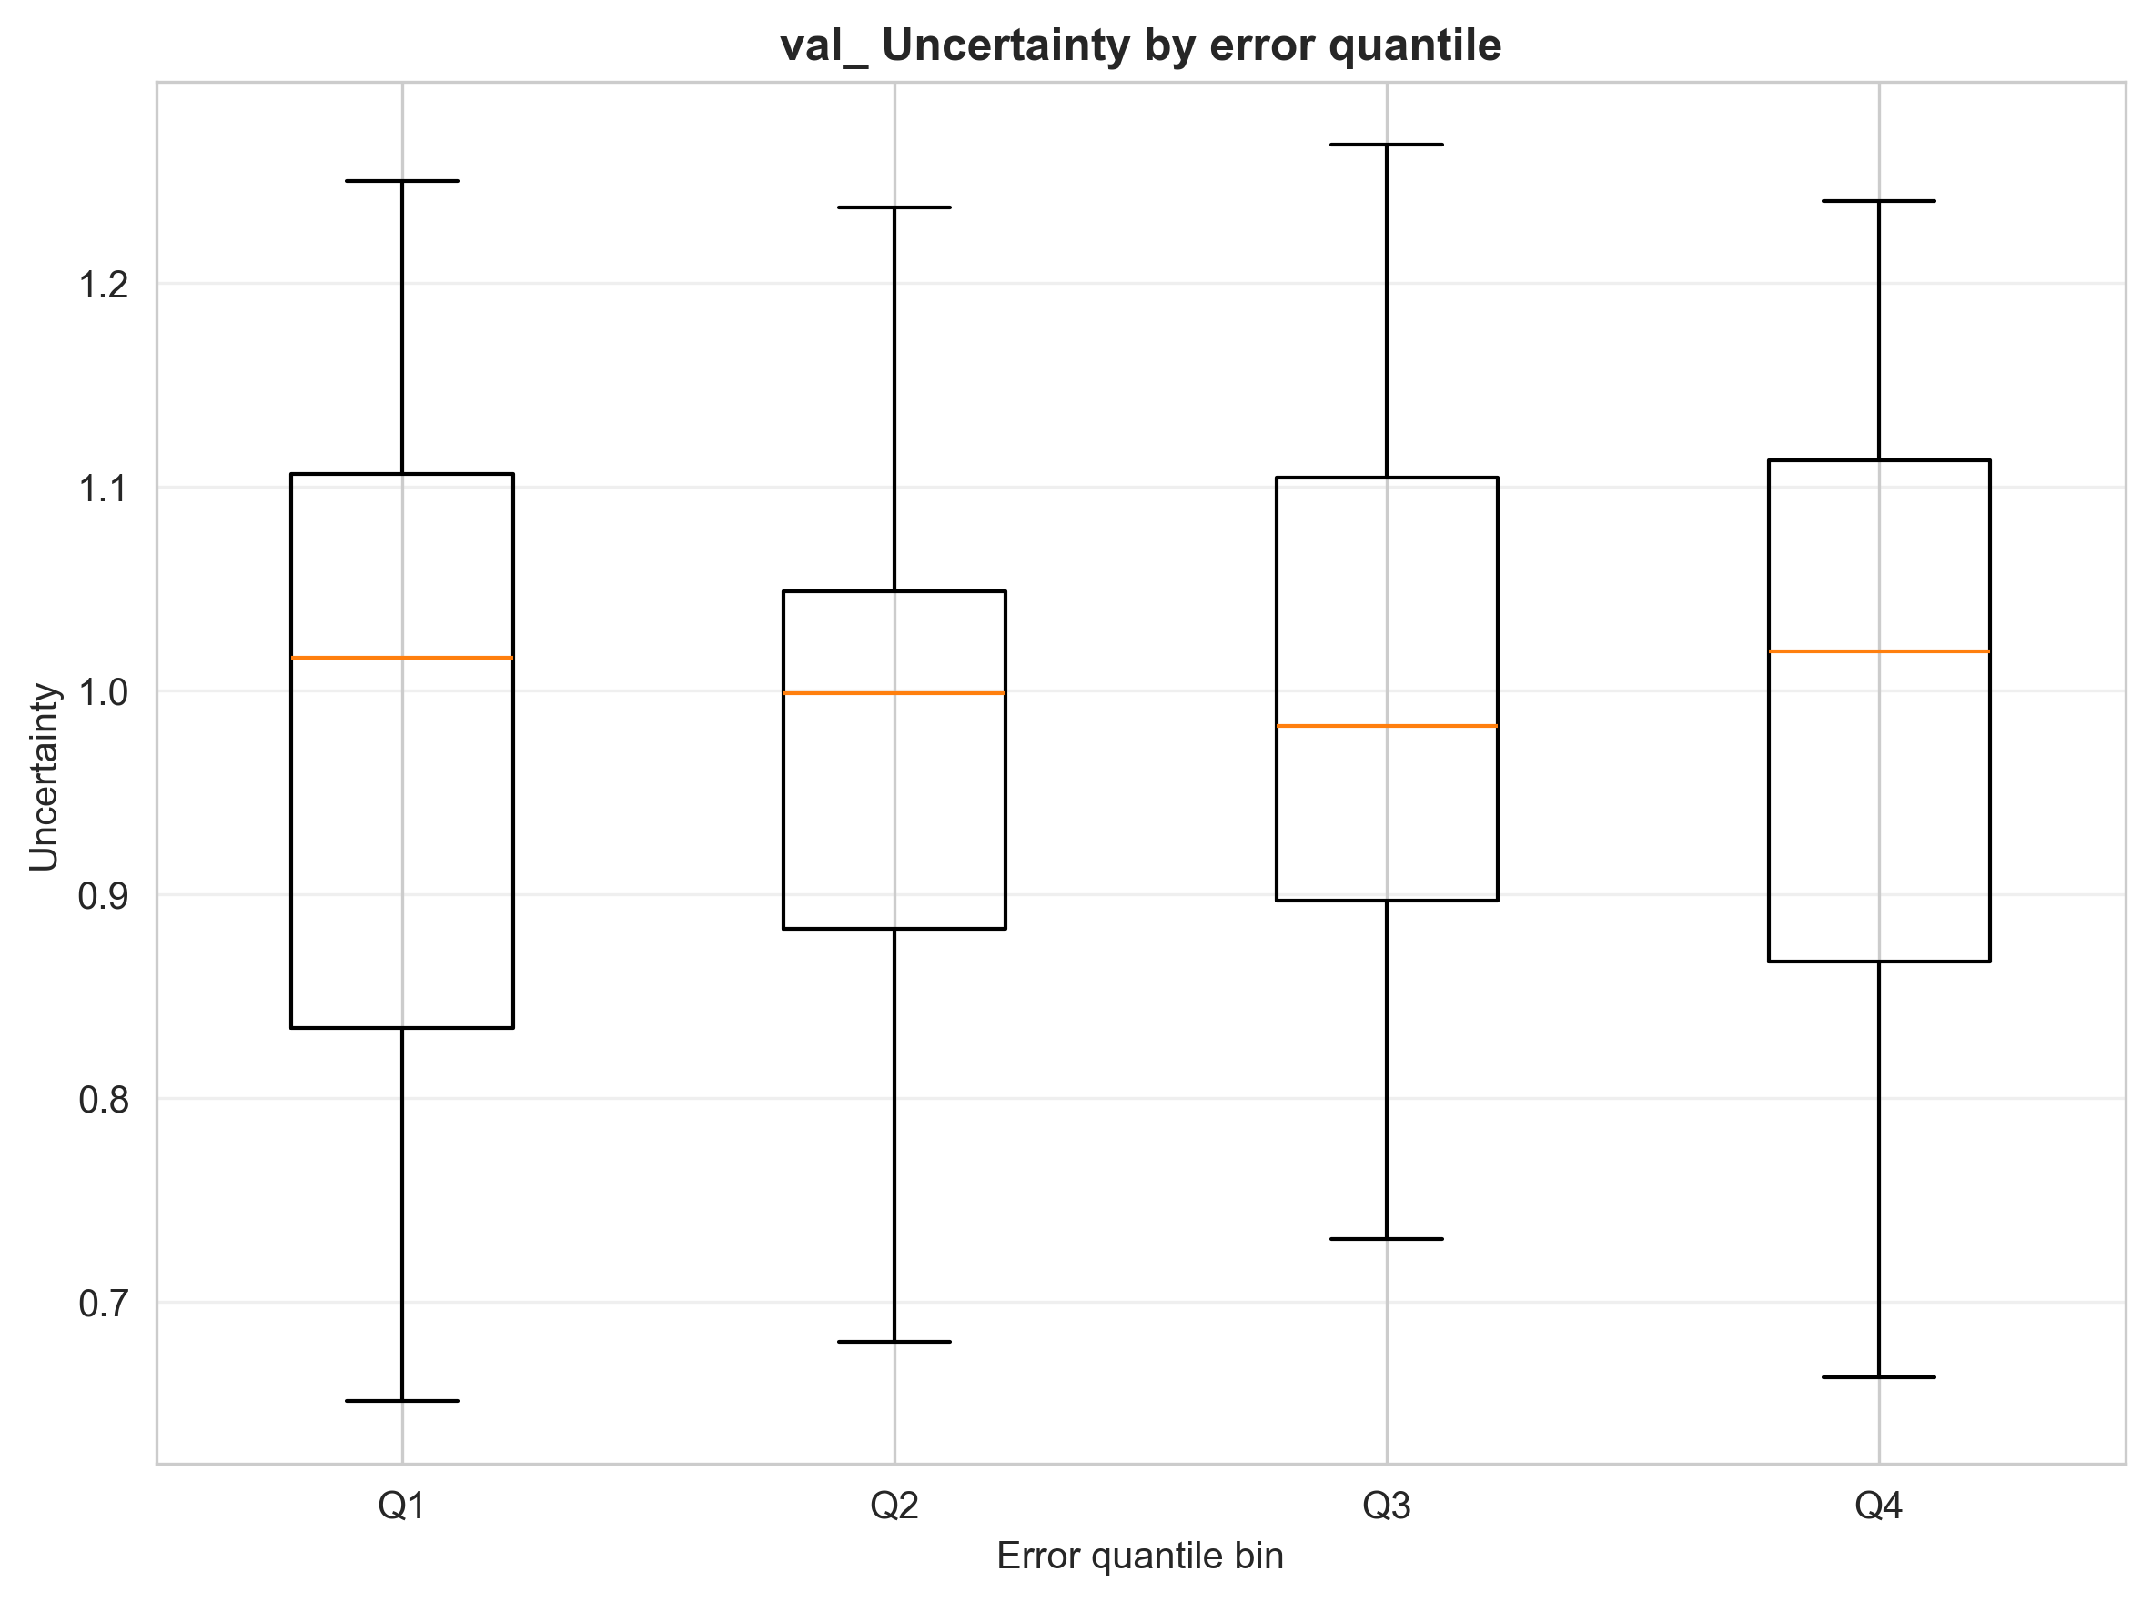
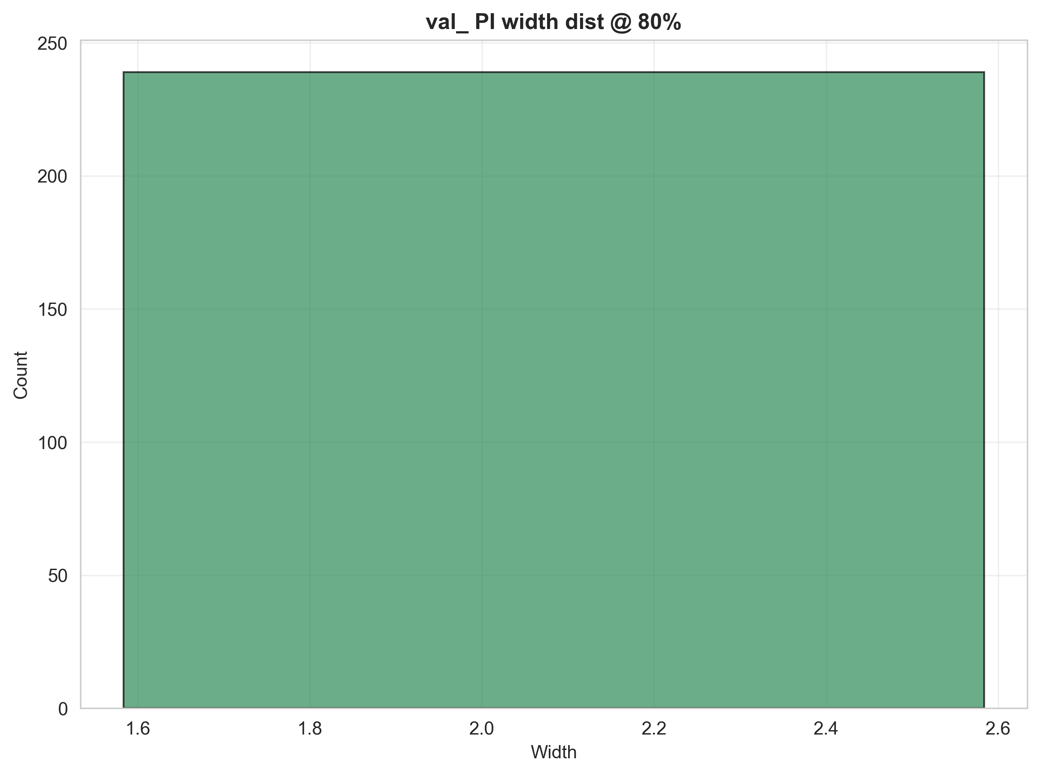
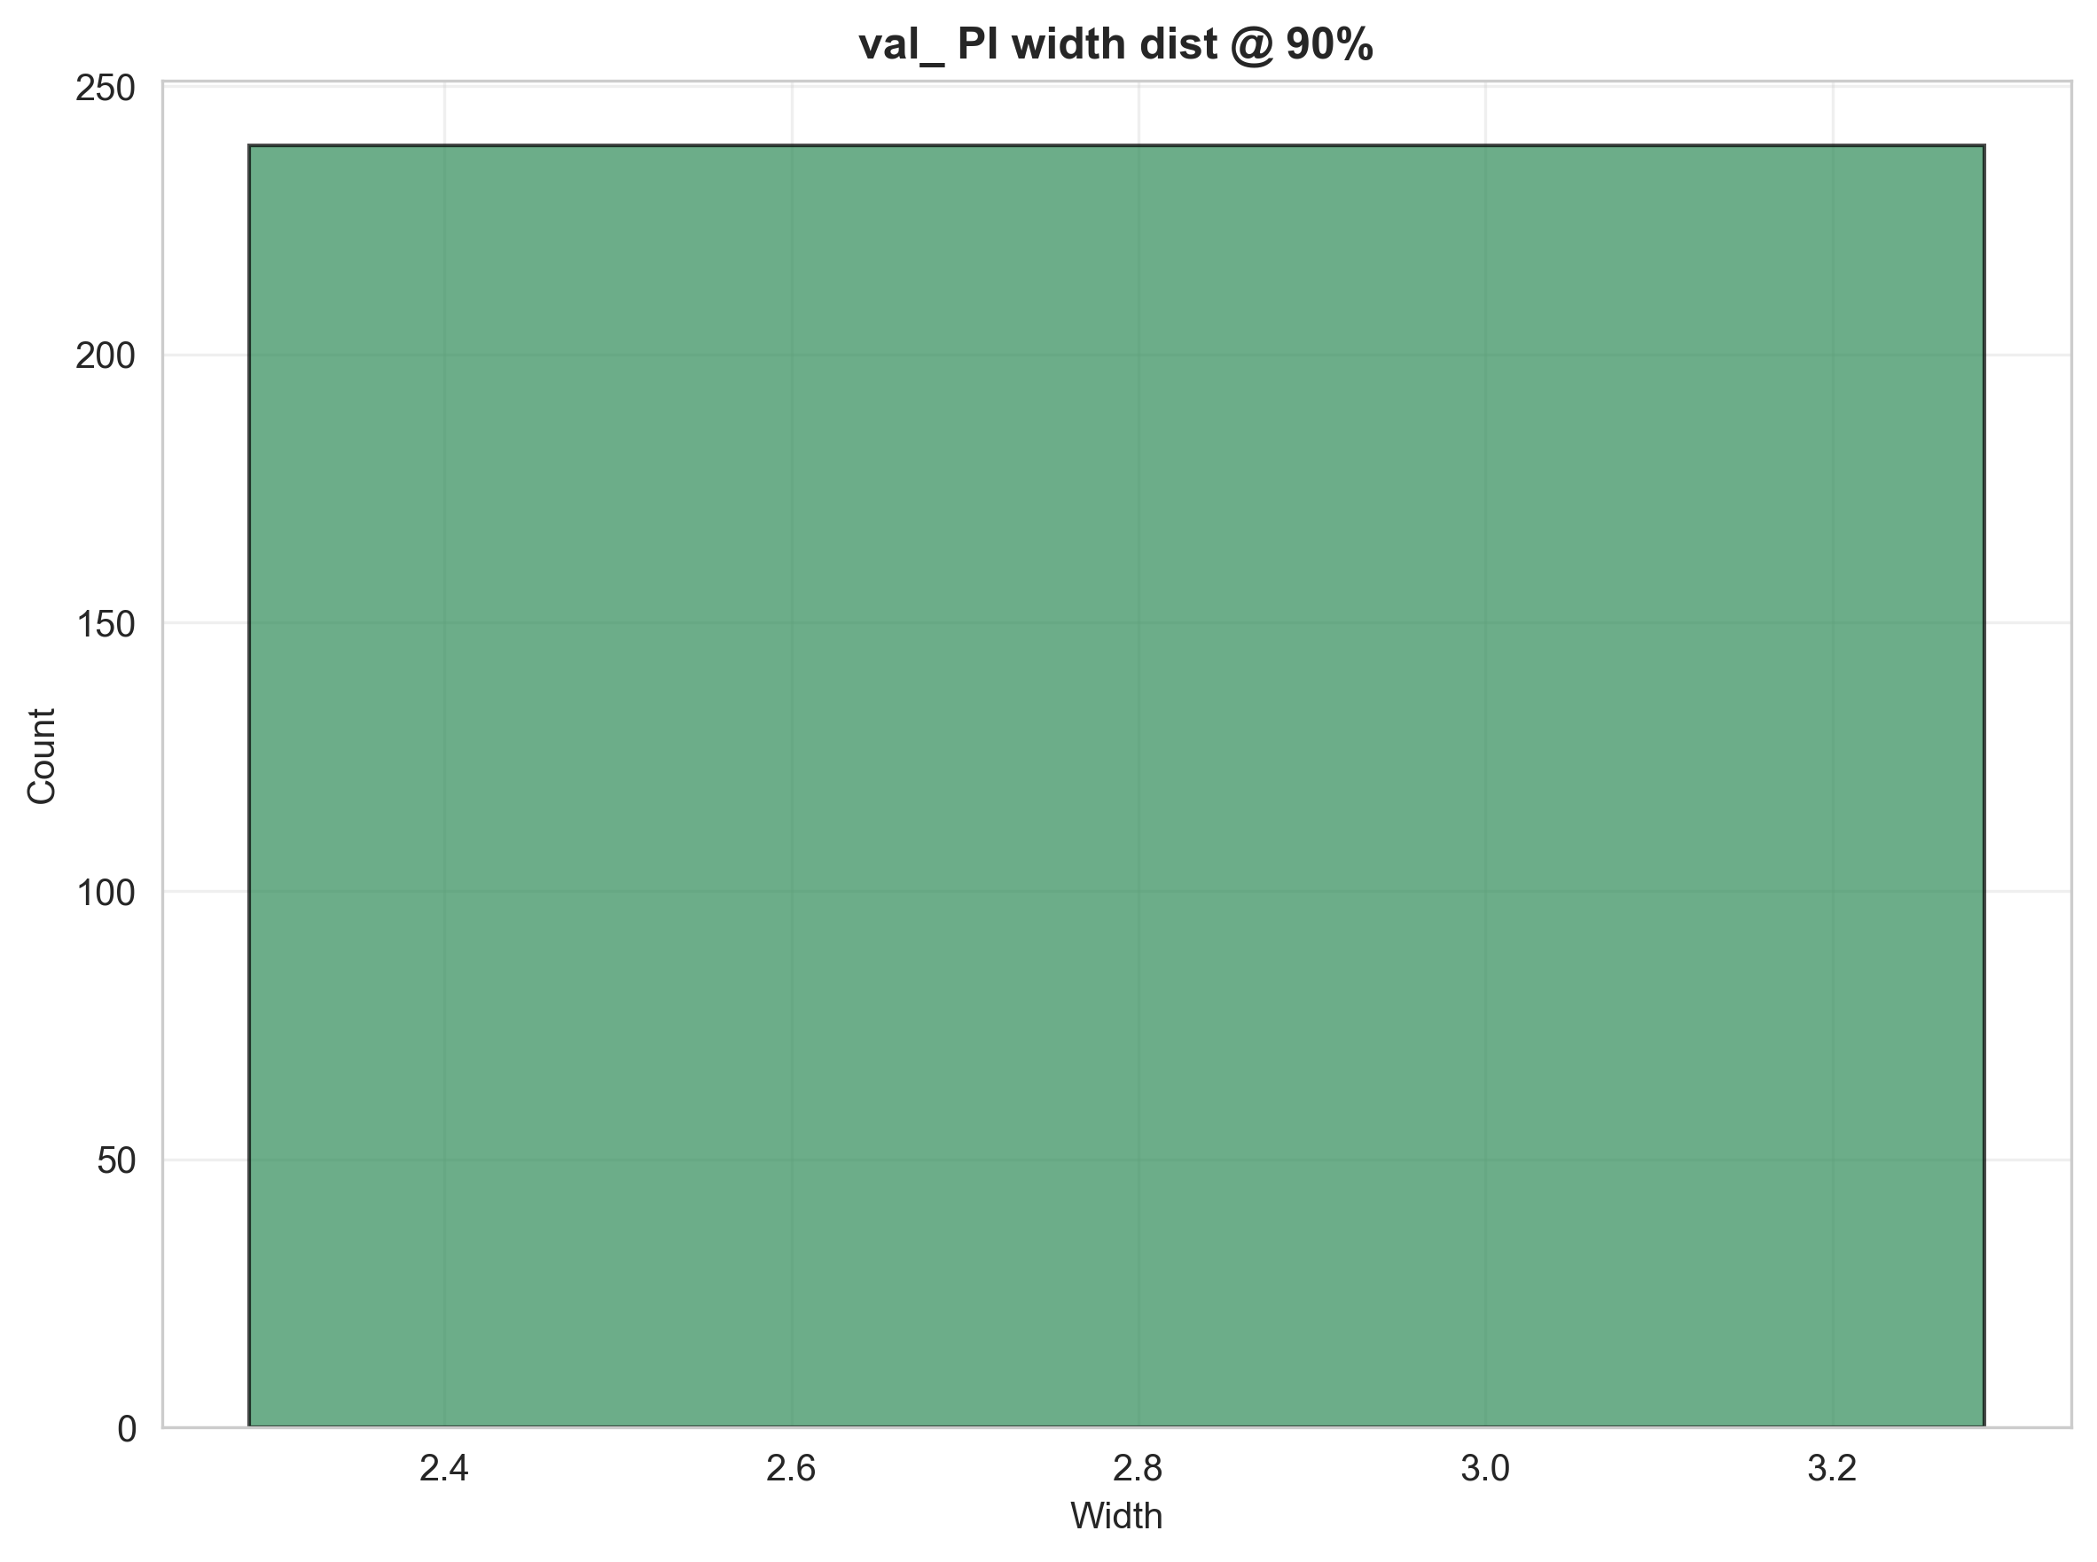
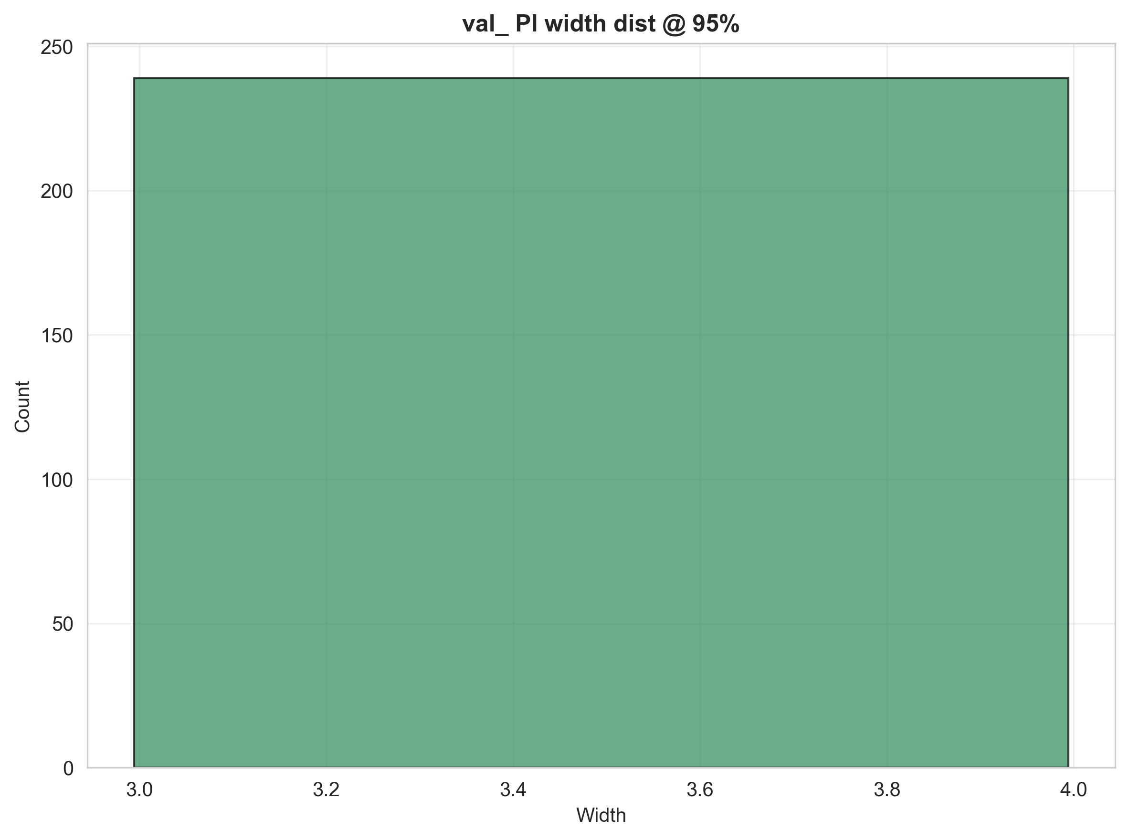
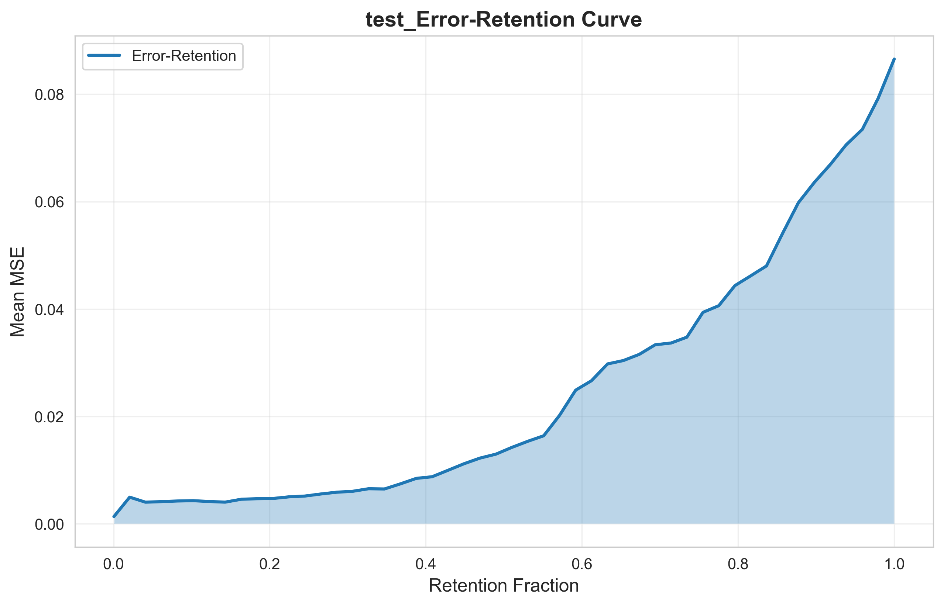
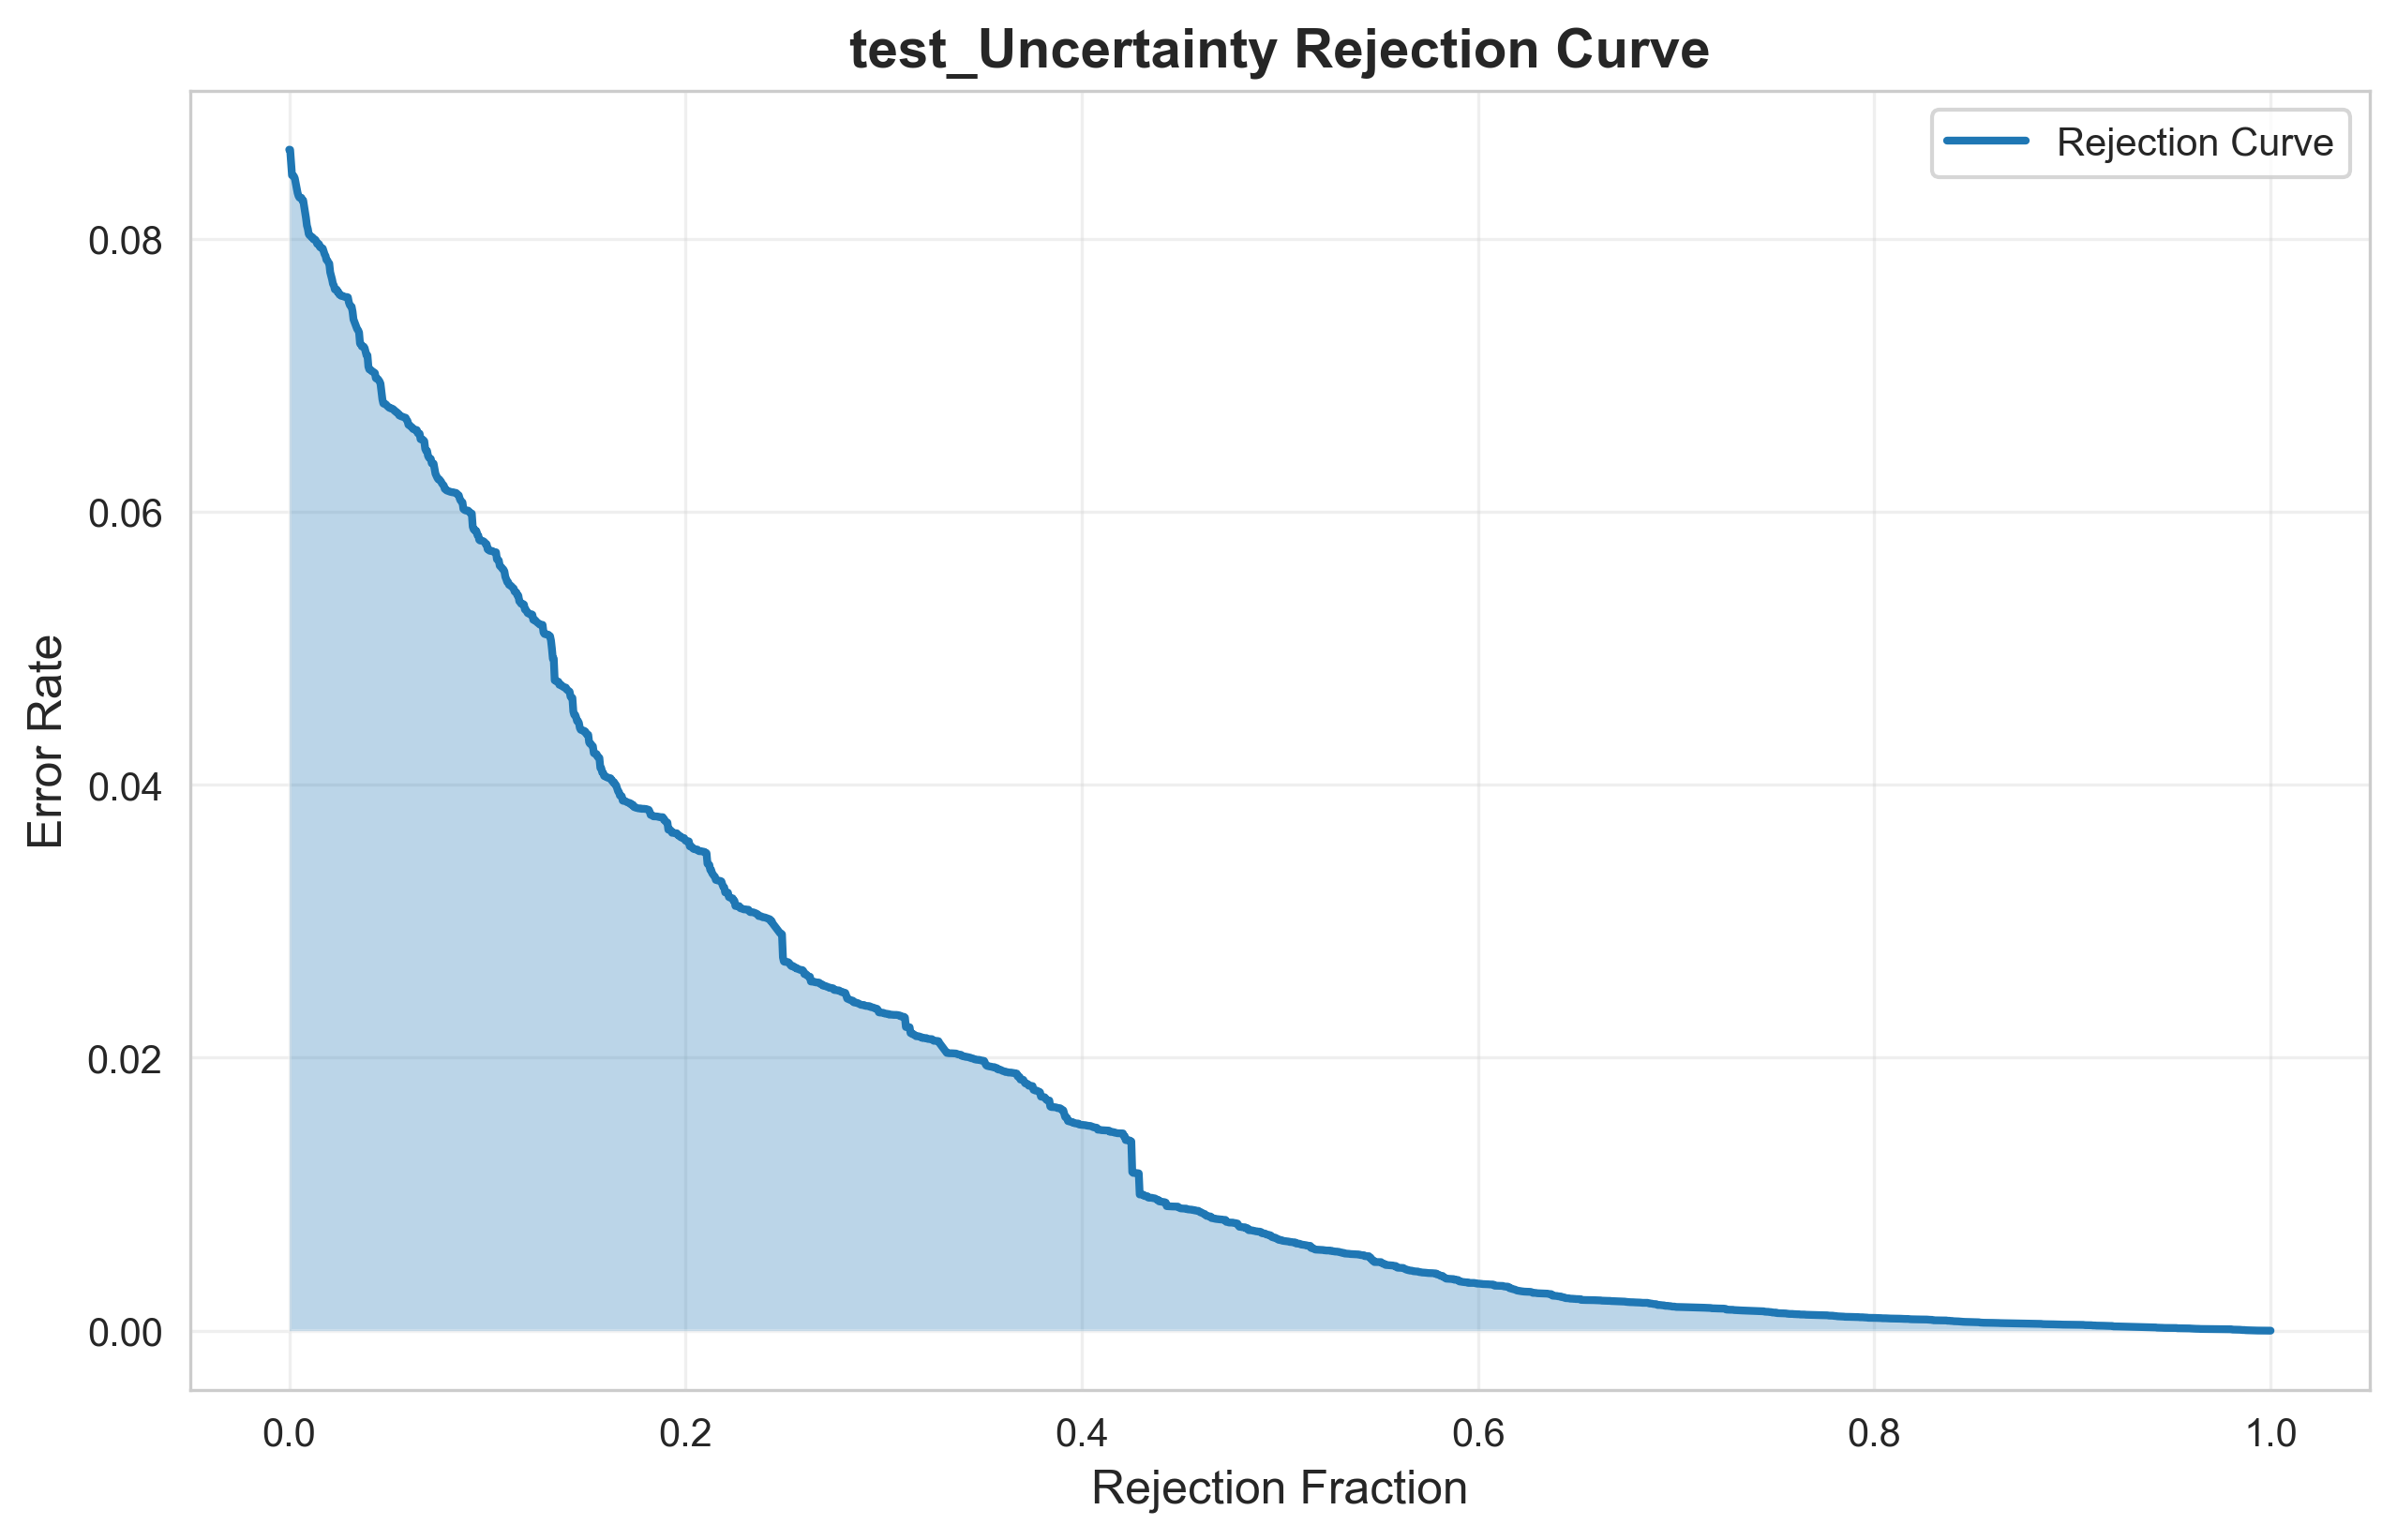
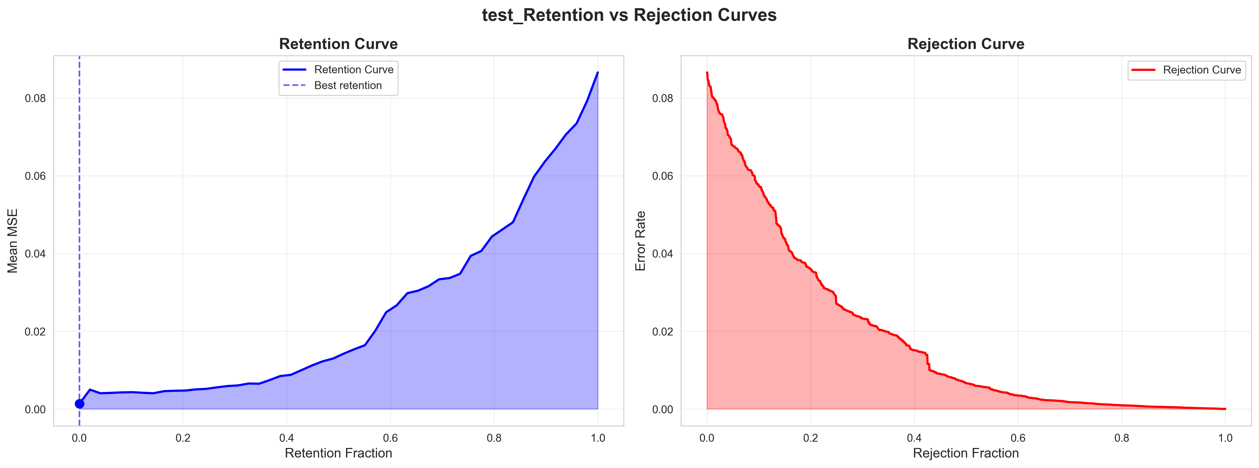
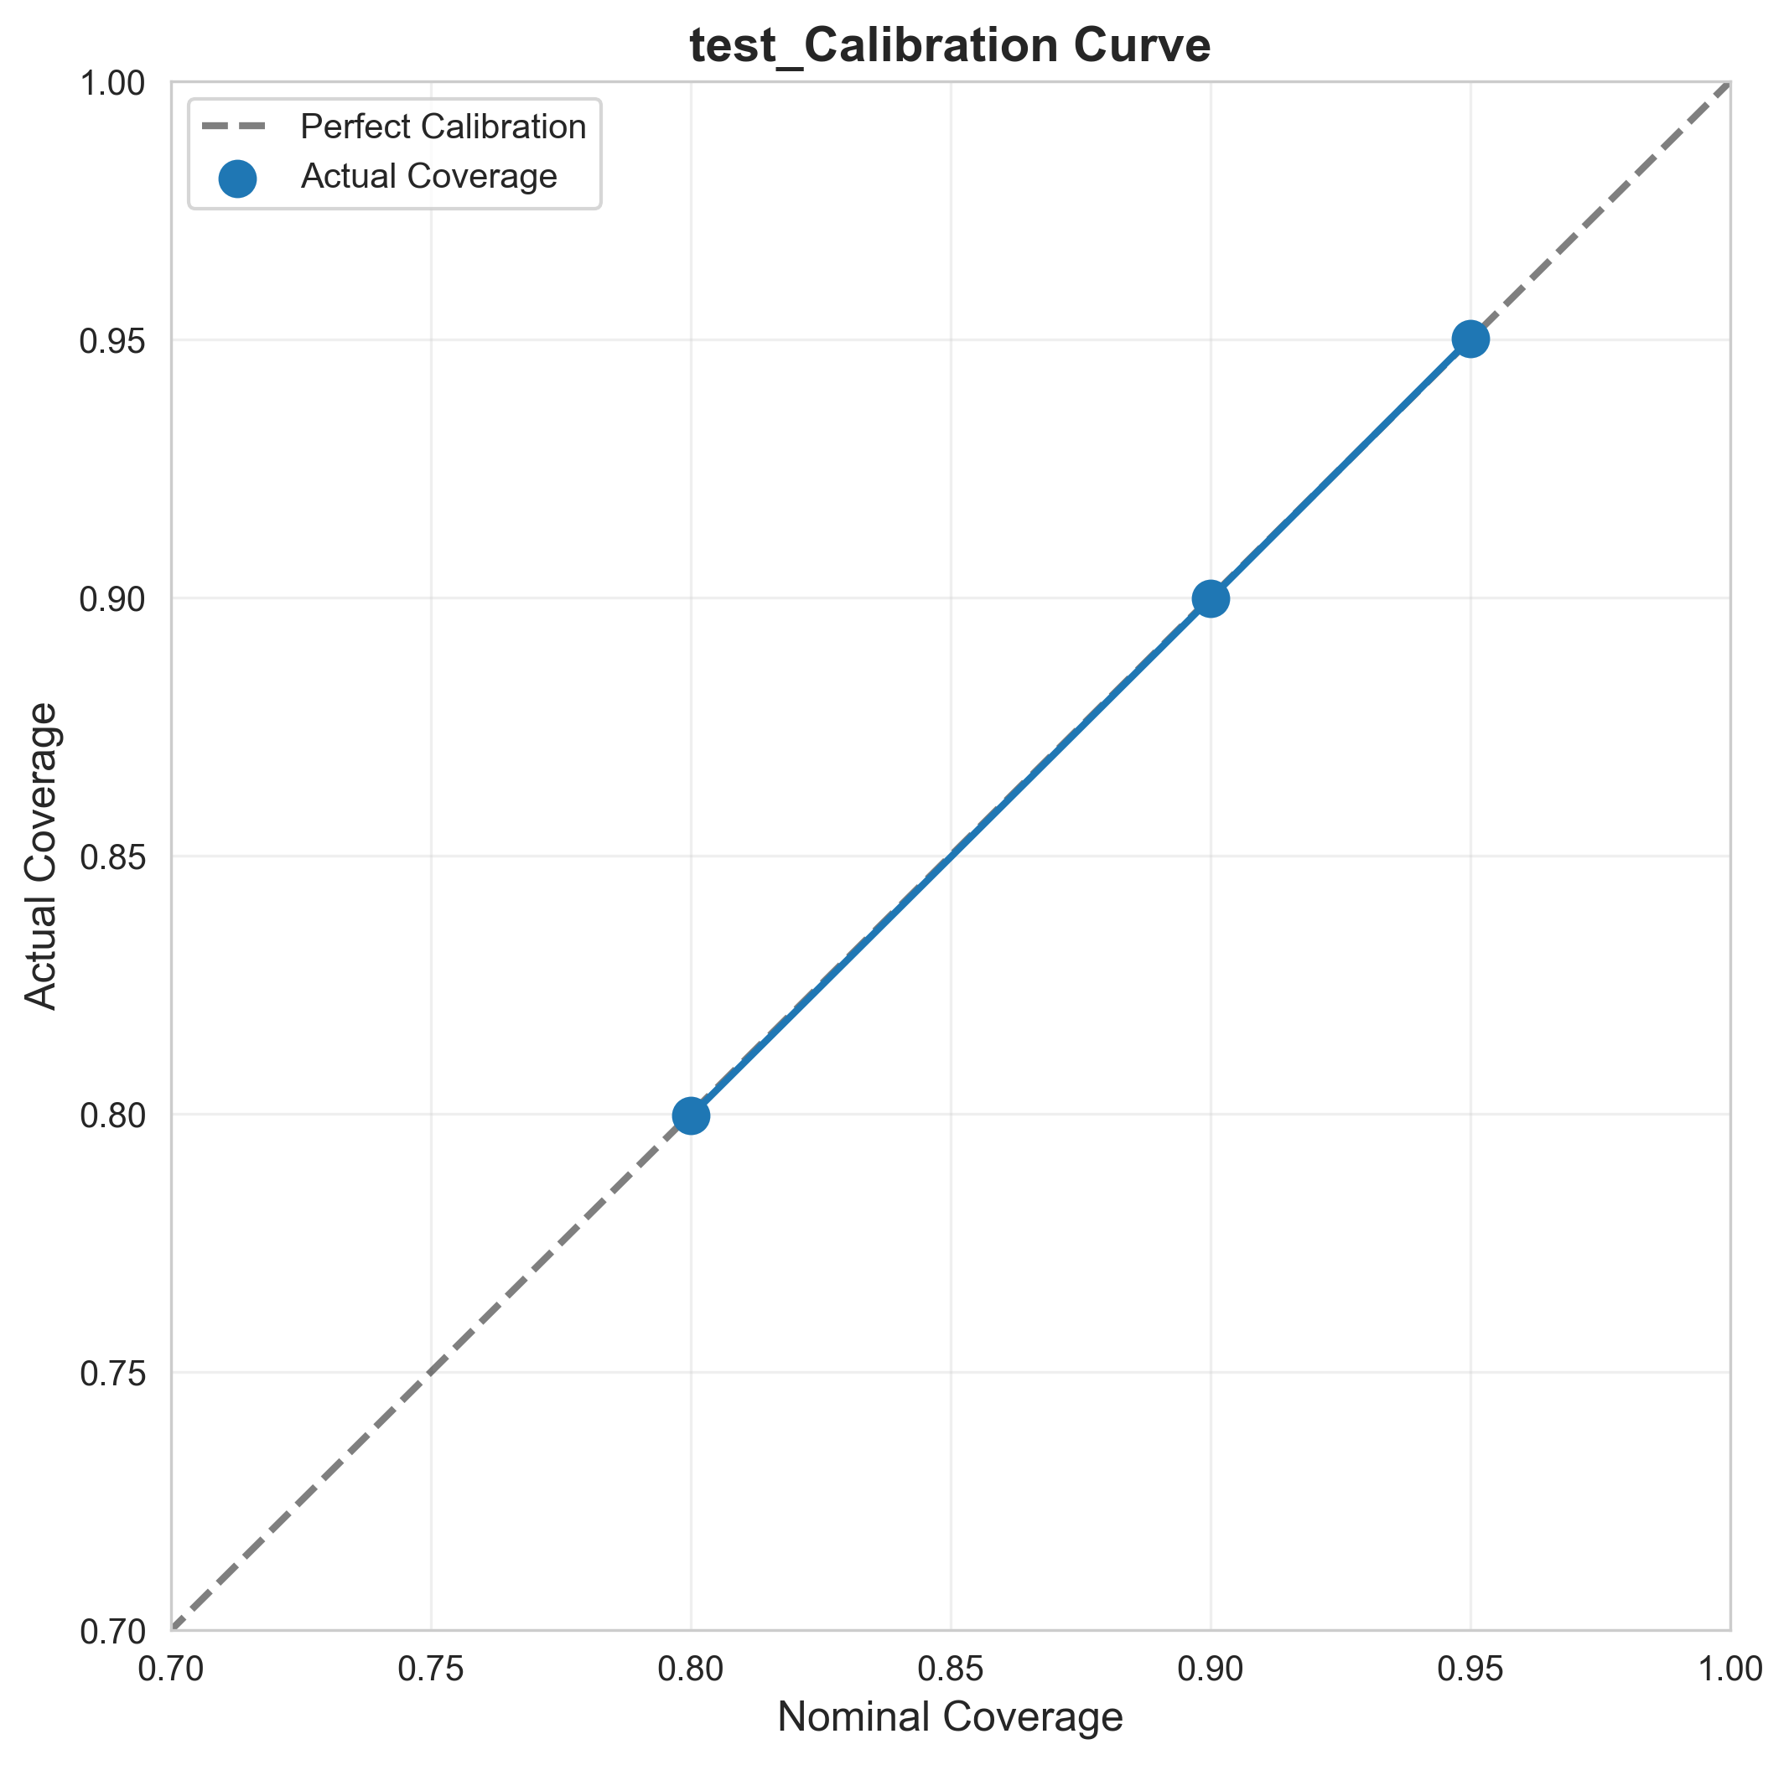
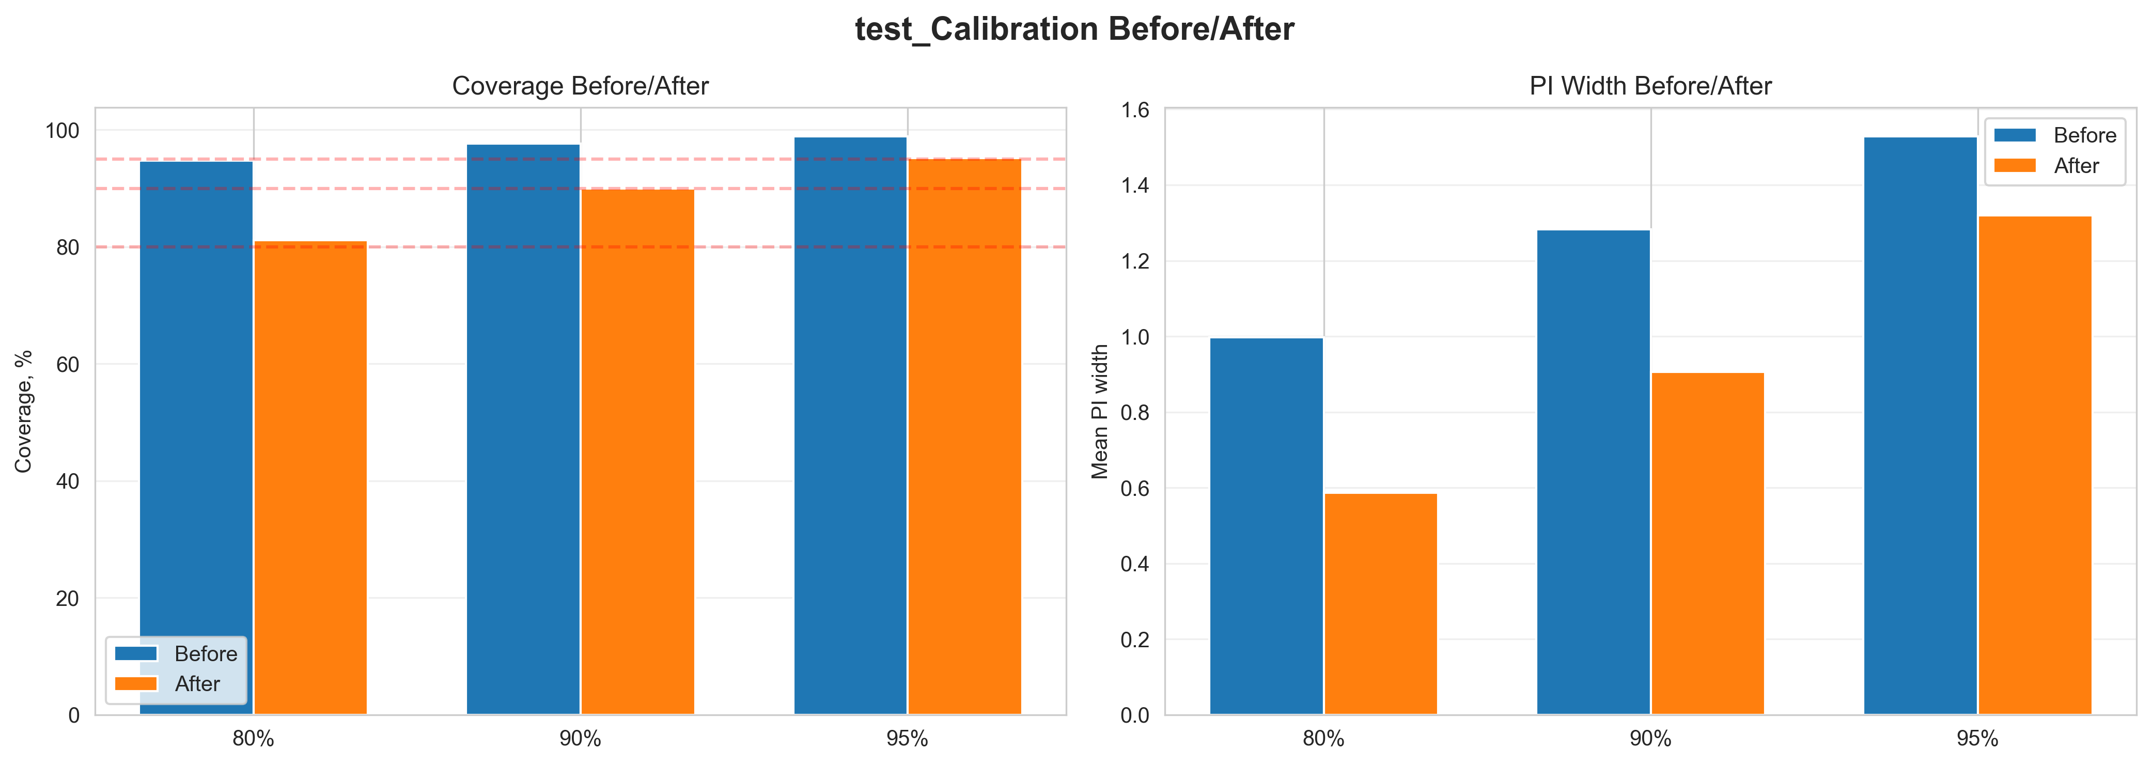
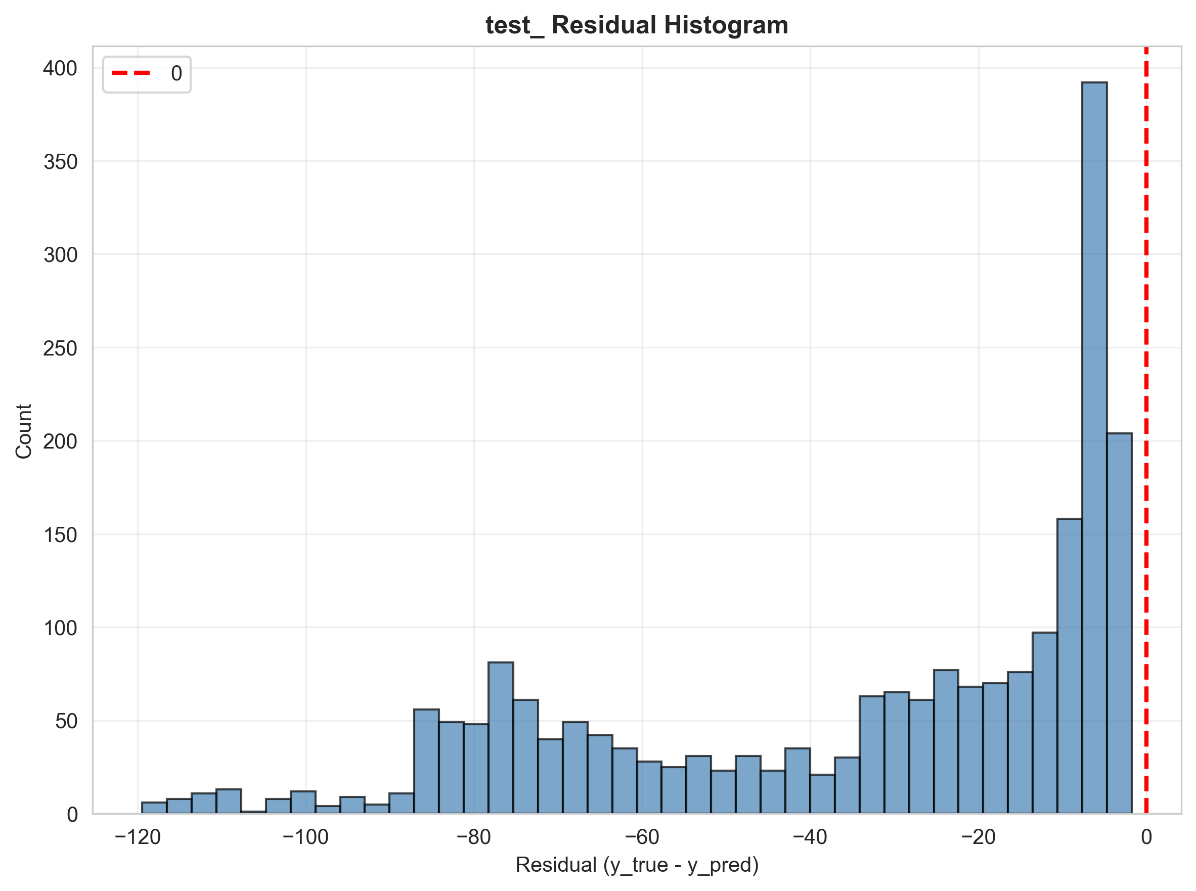
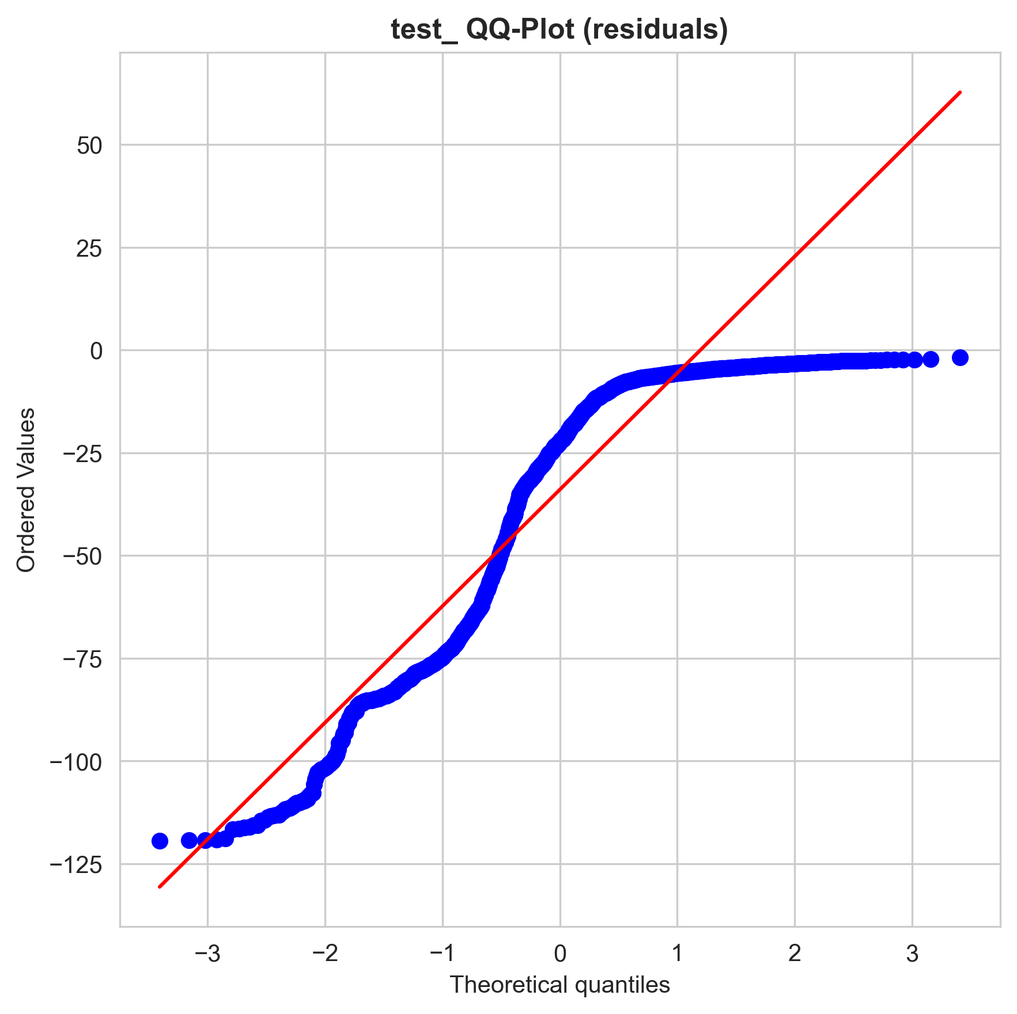
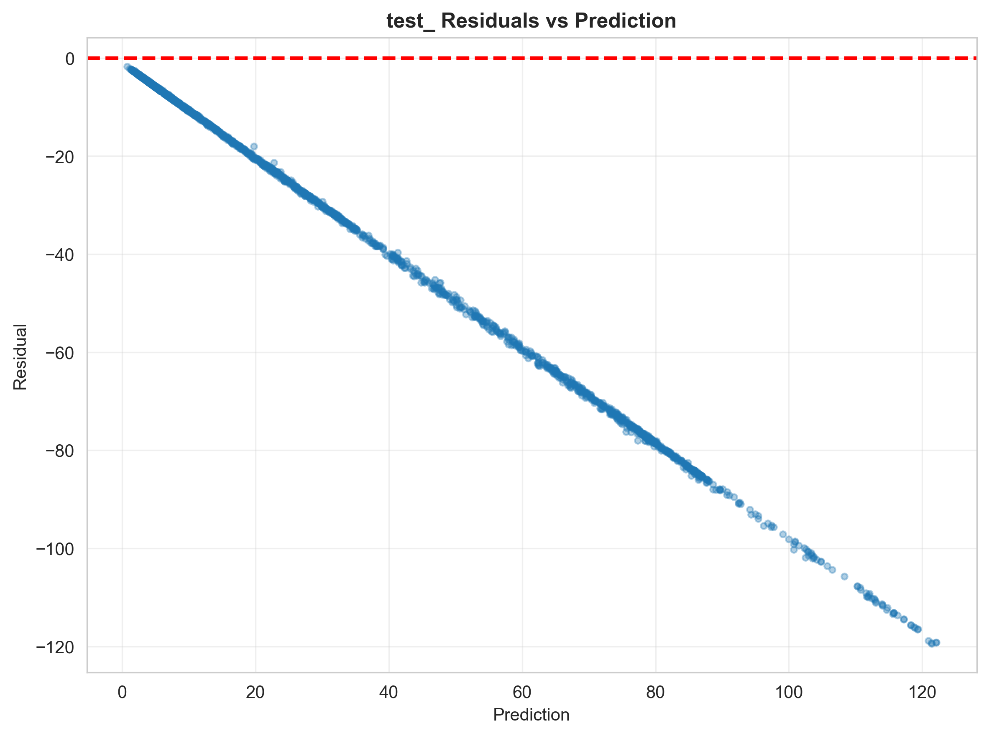
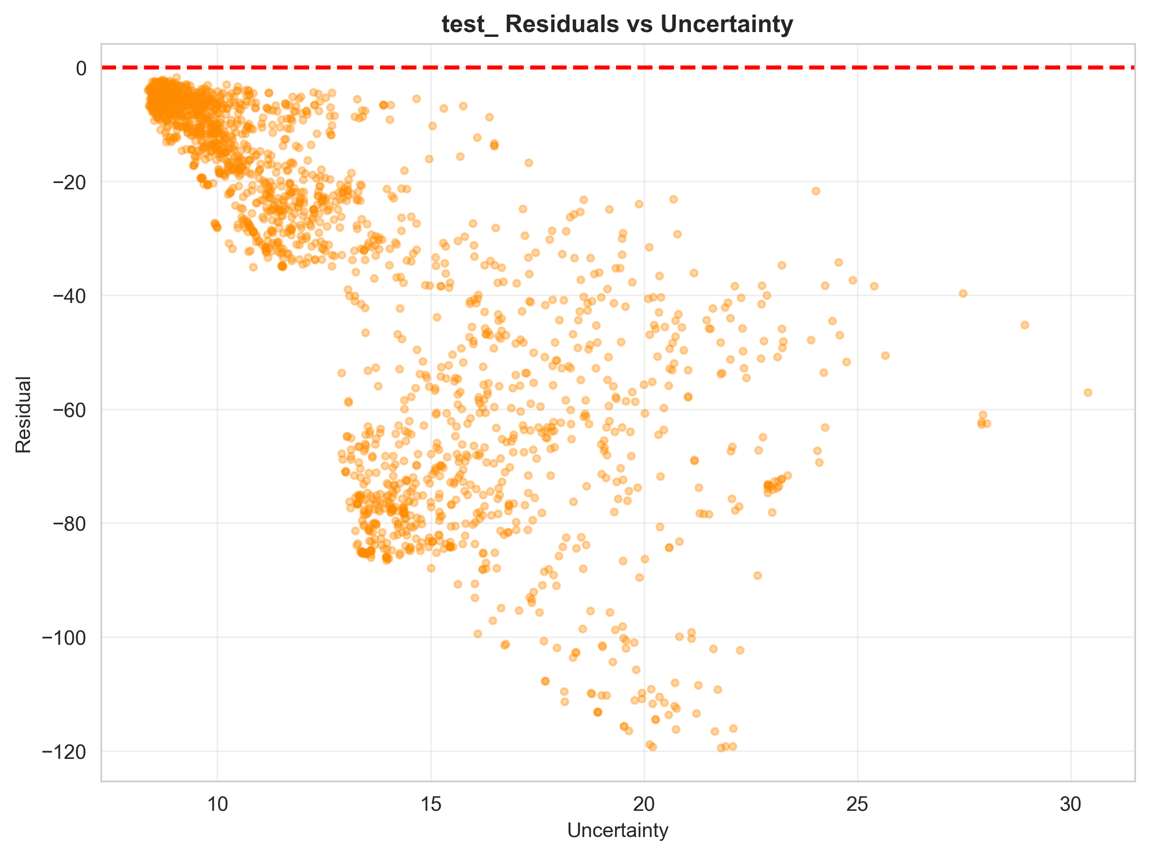
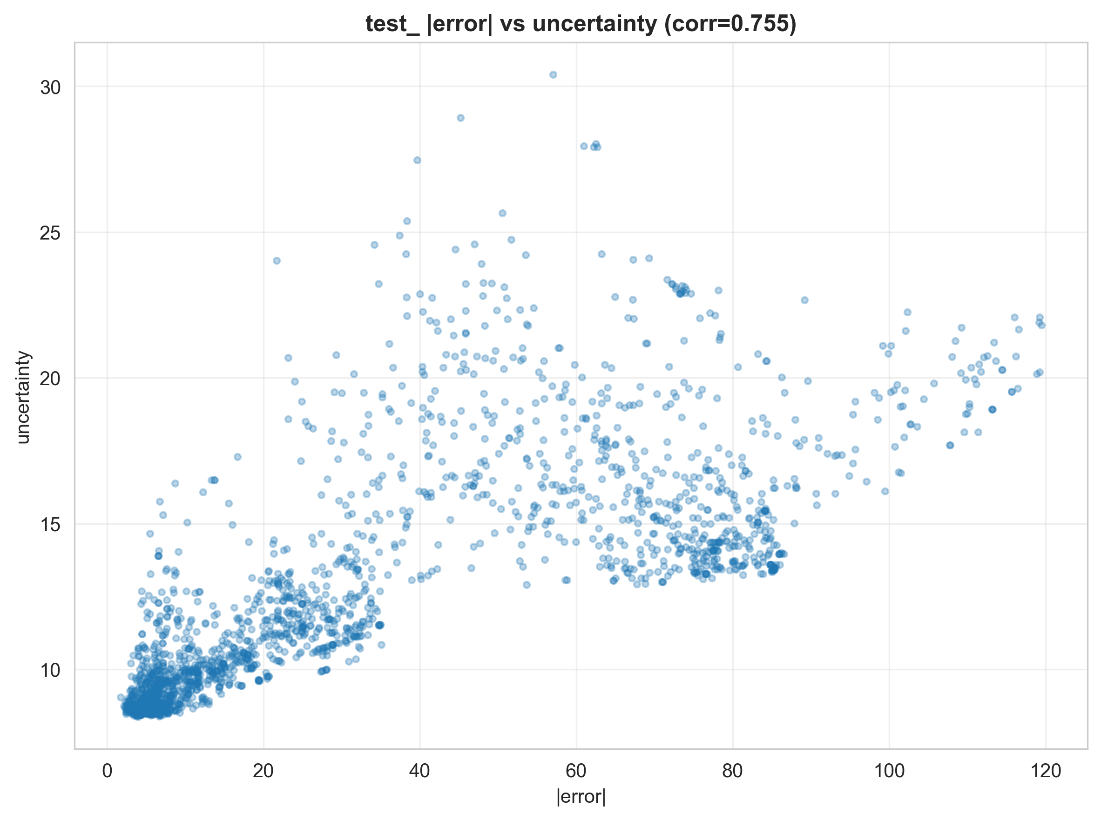
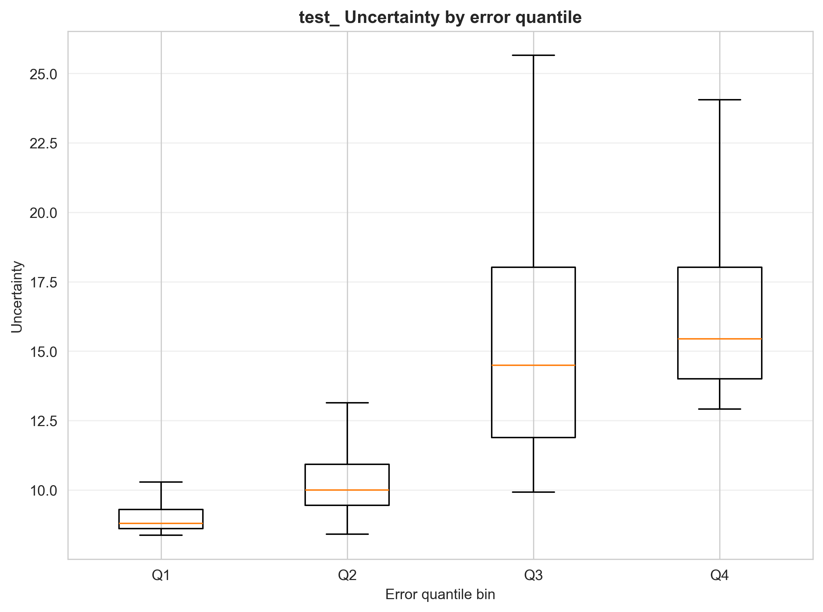
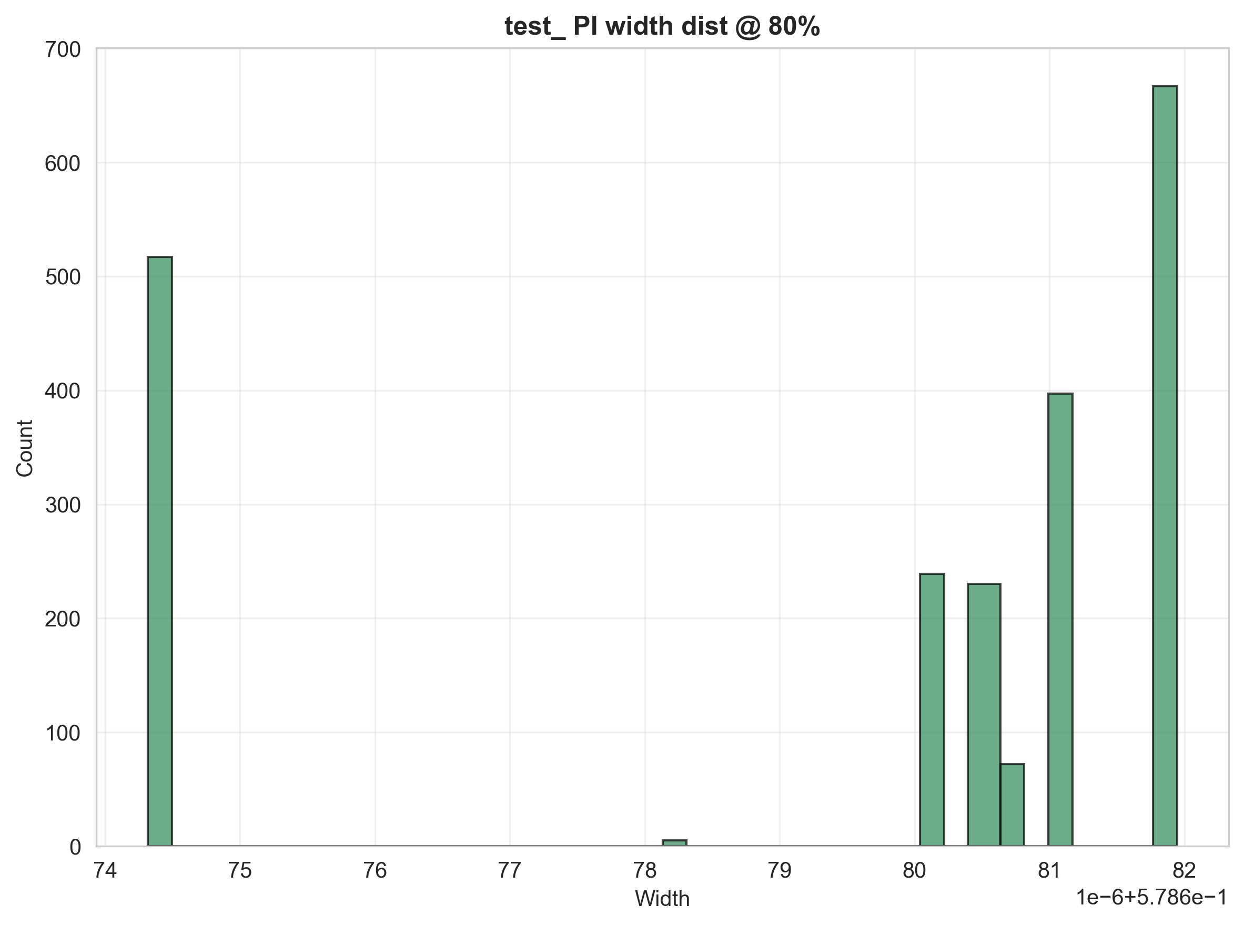
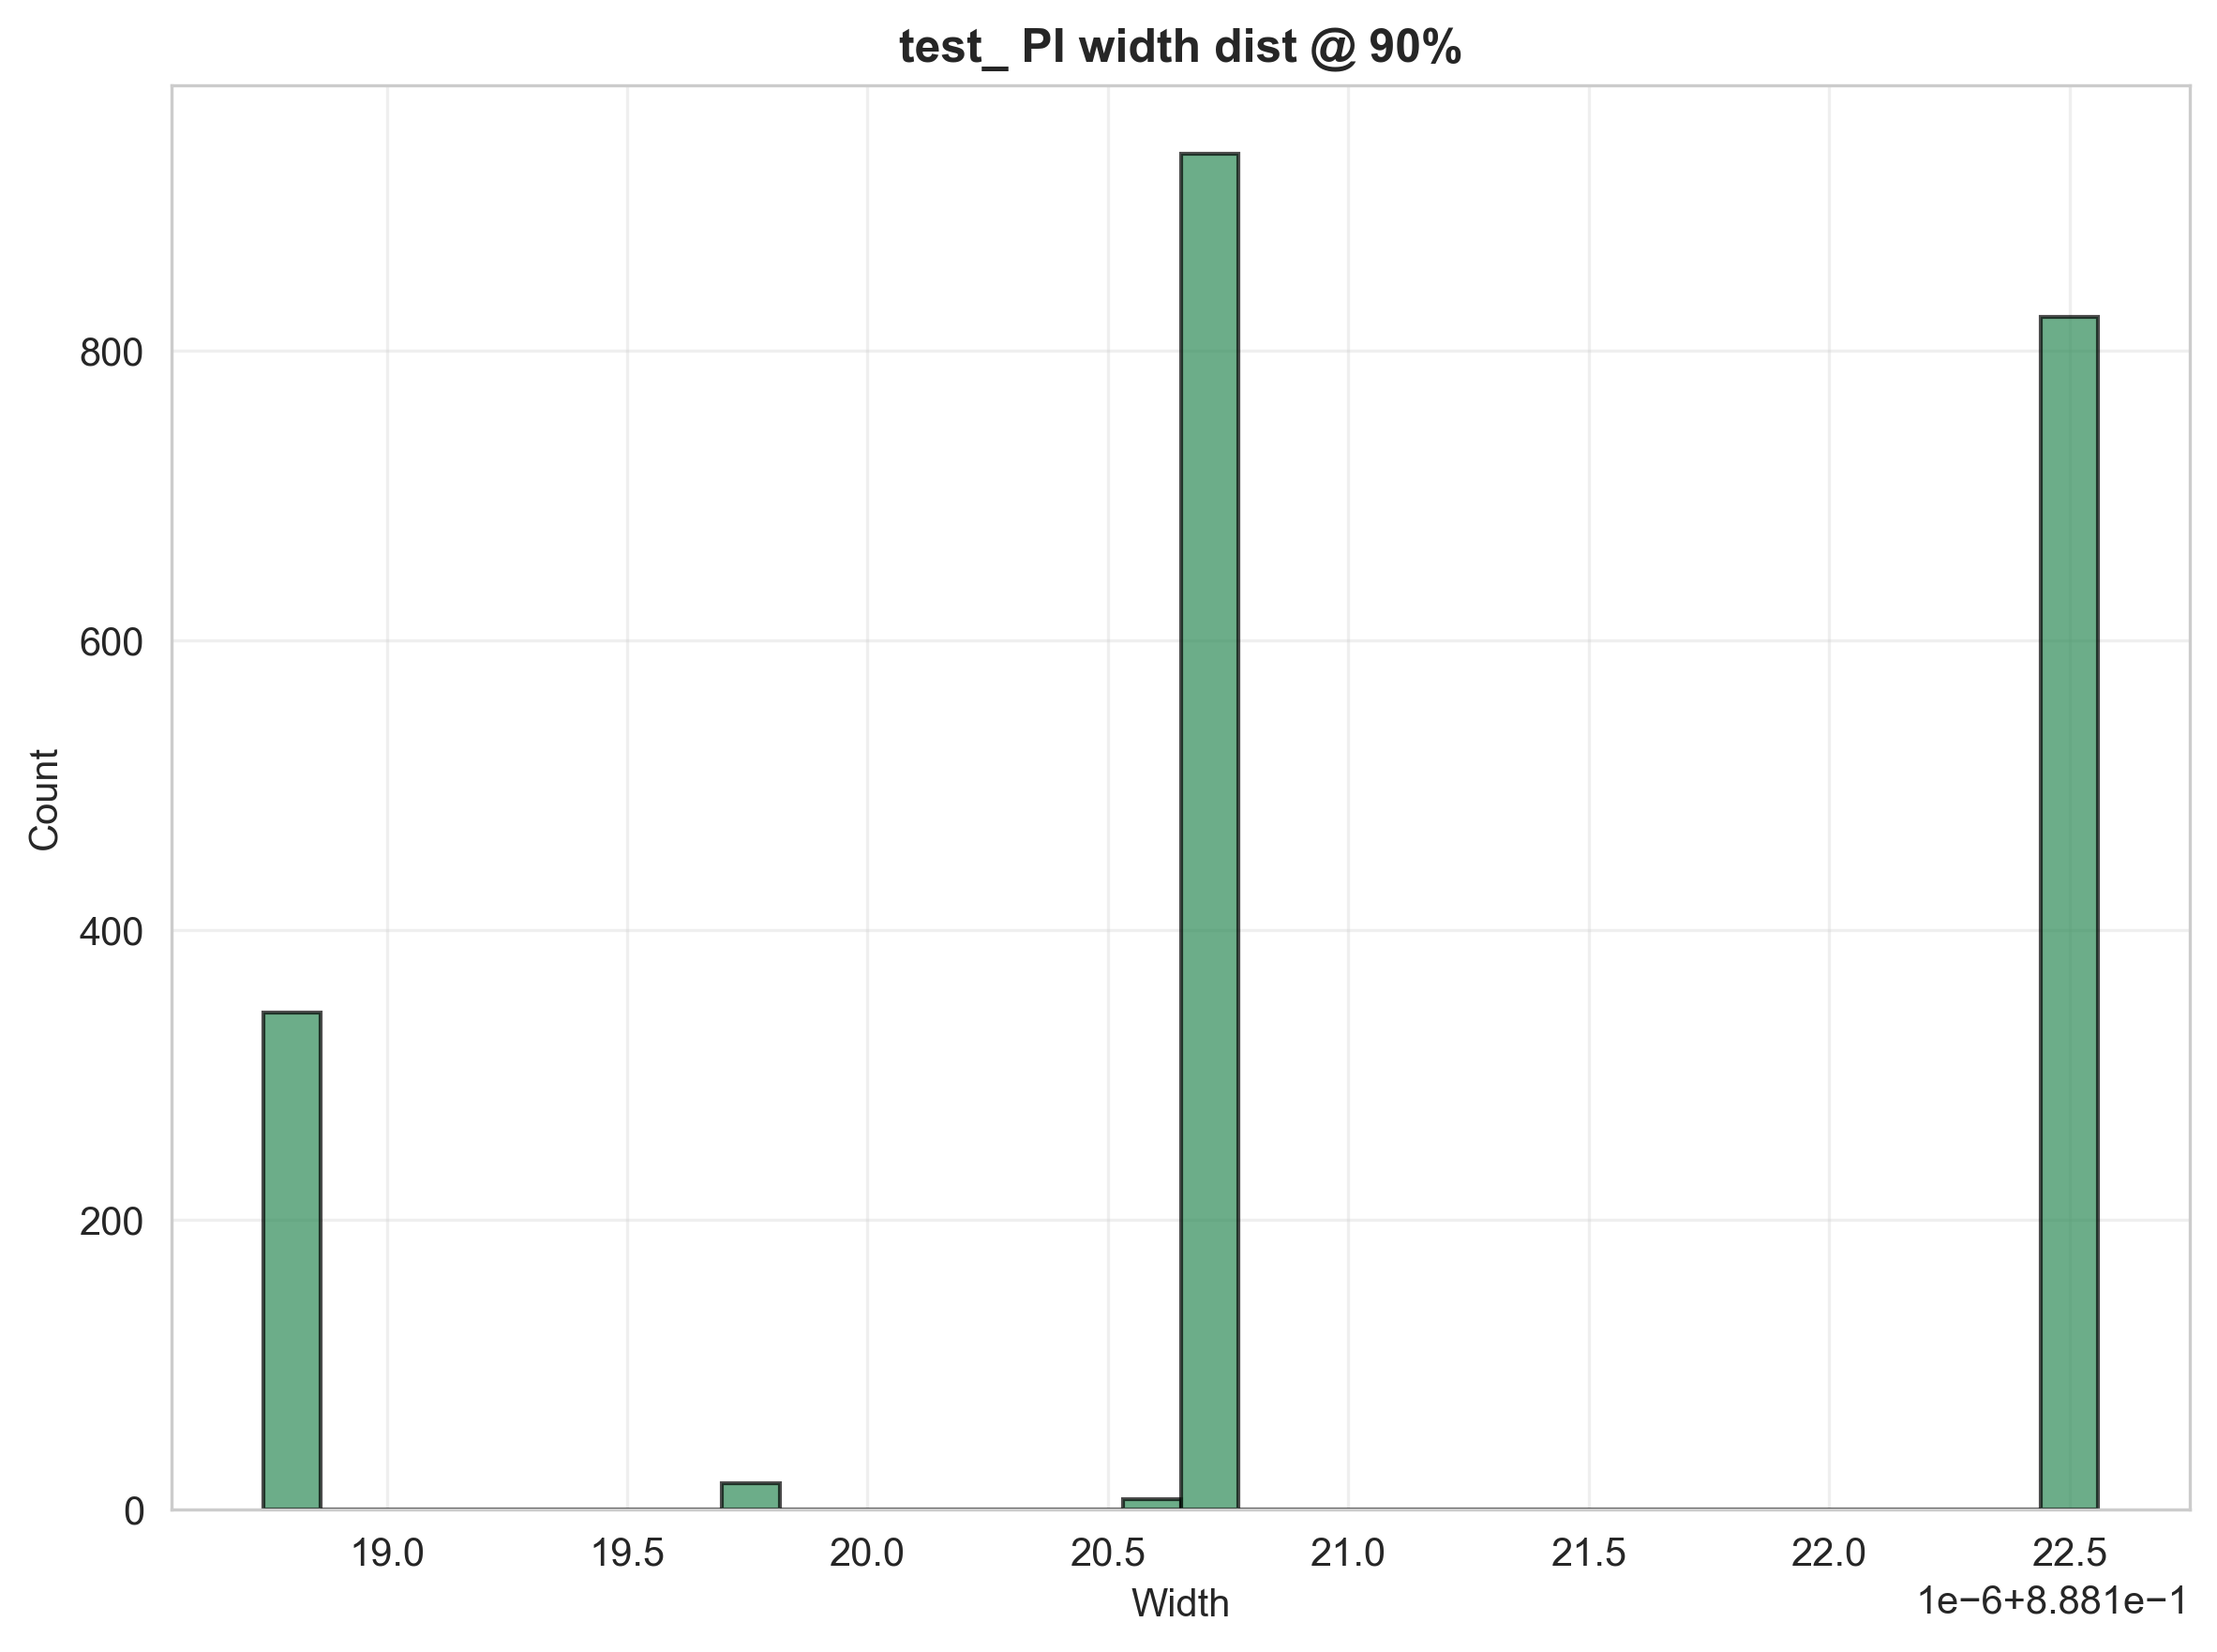
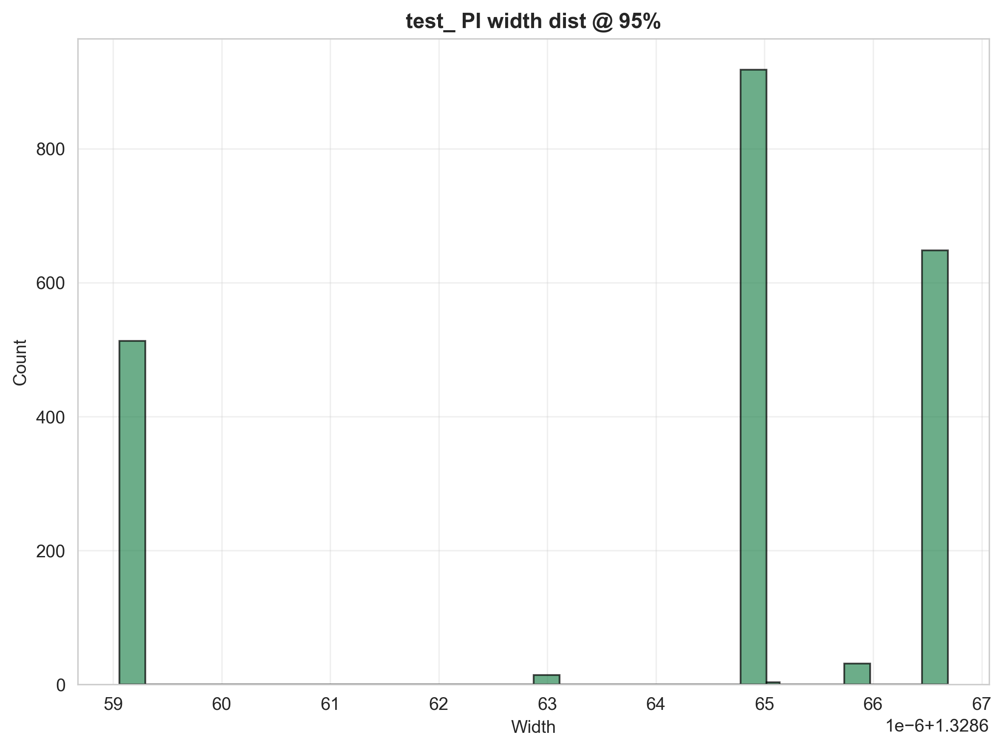

Кривые обучения ансамбля HMTL
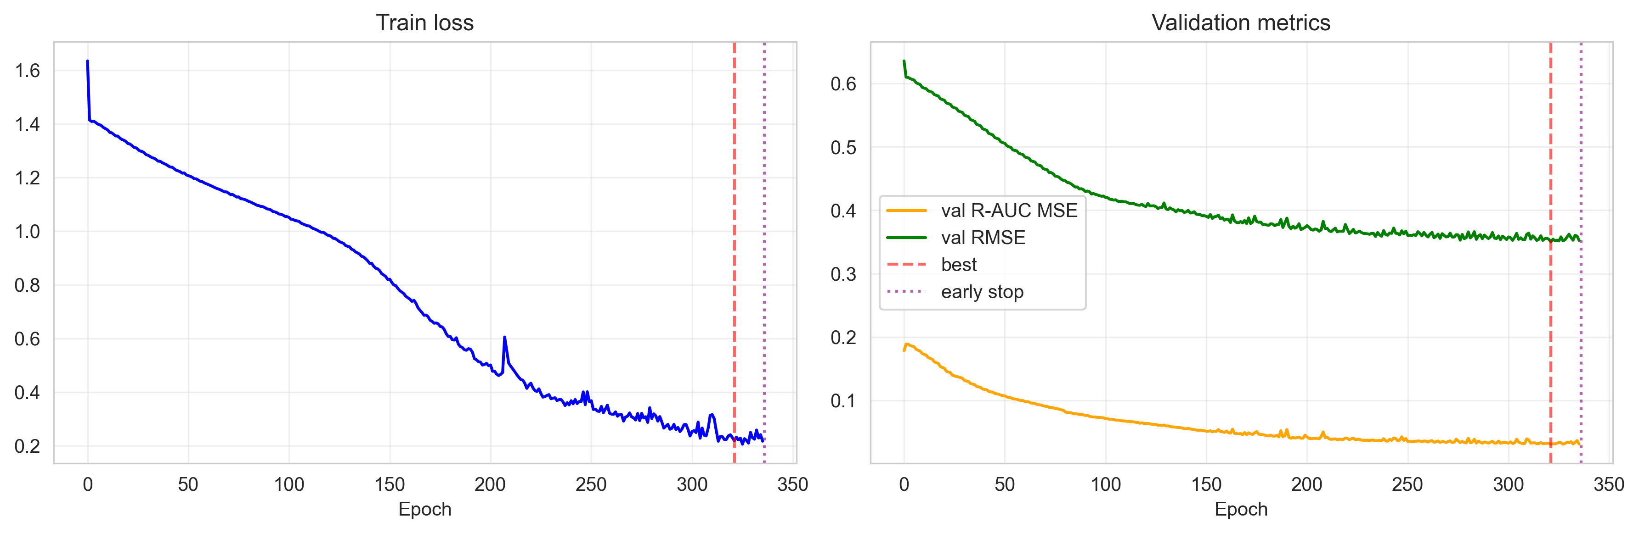
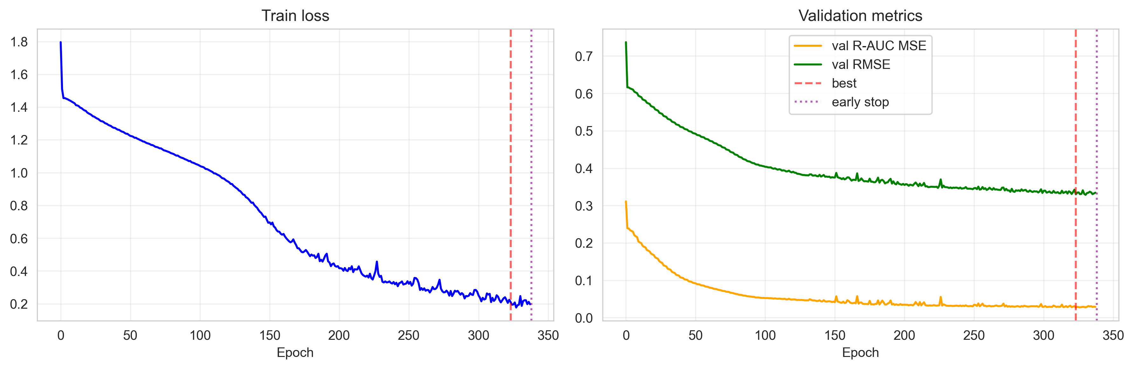
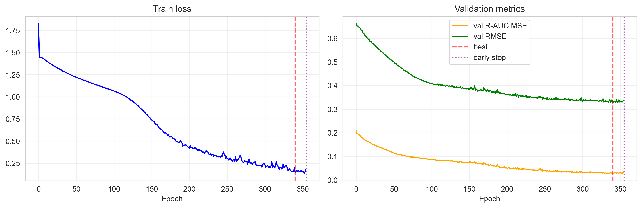
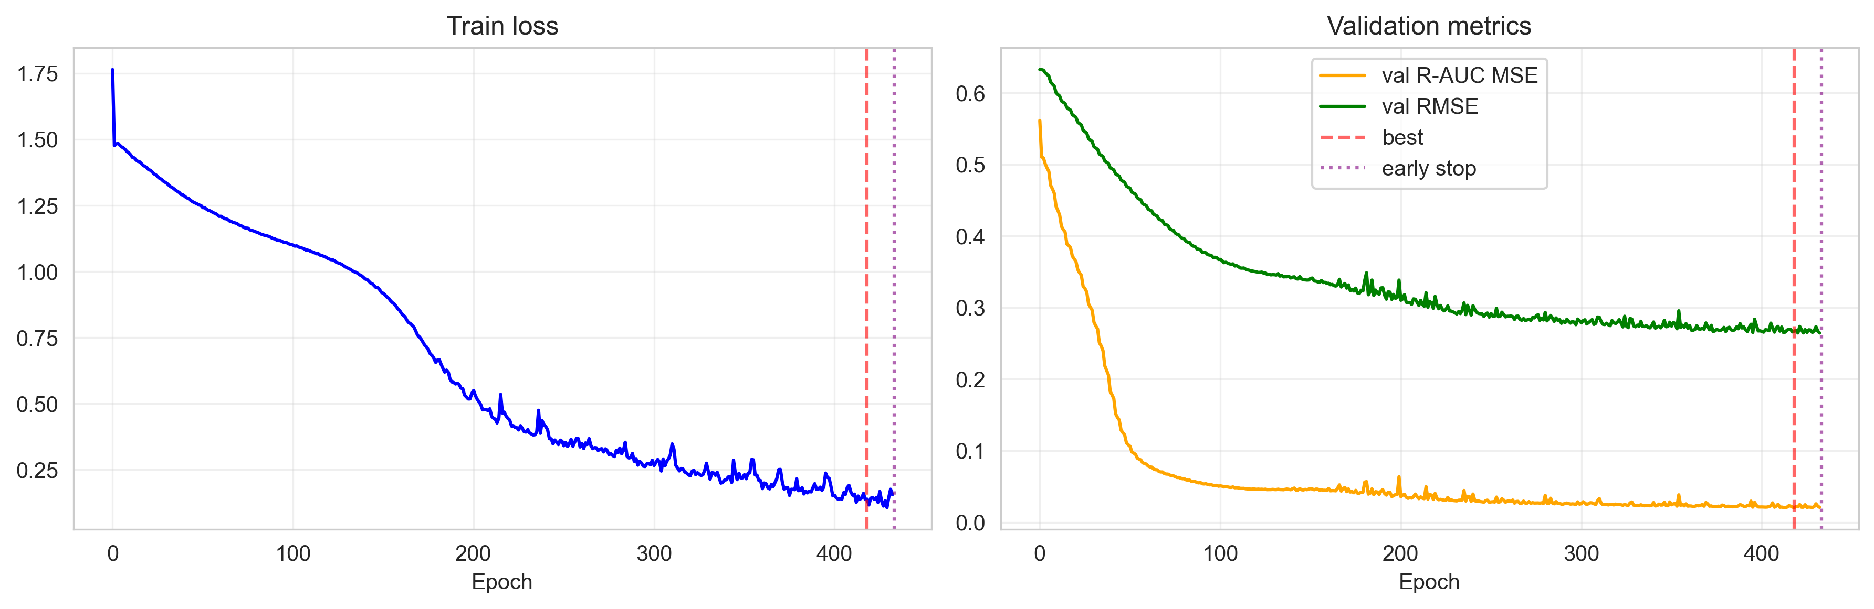
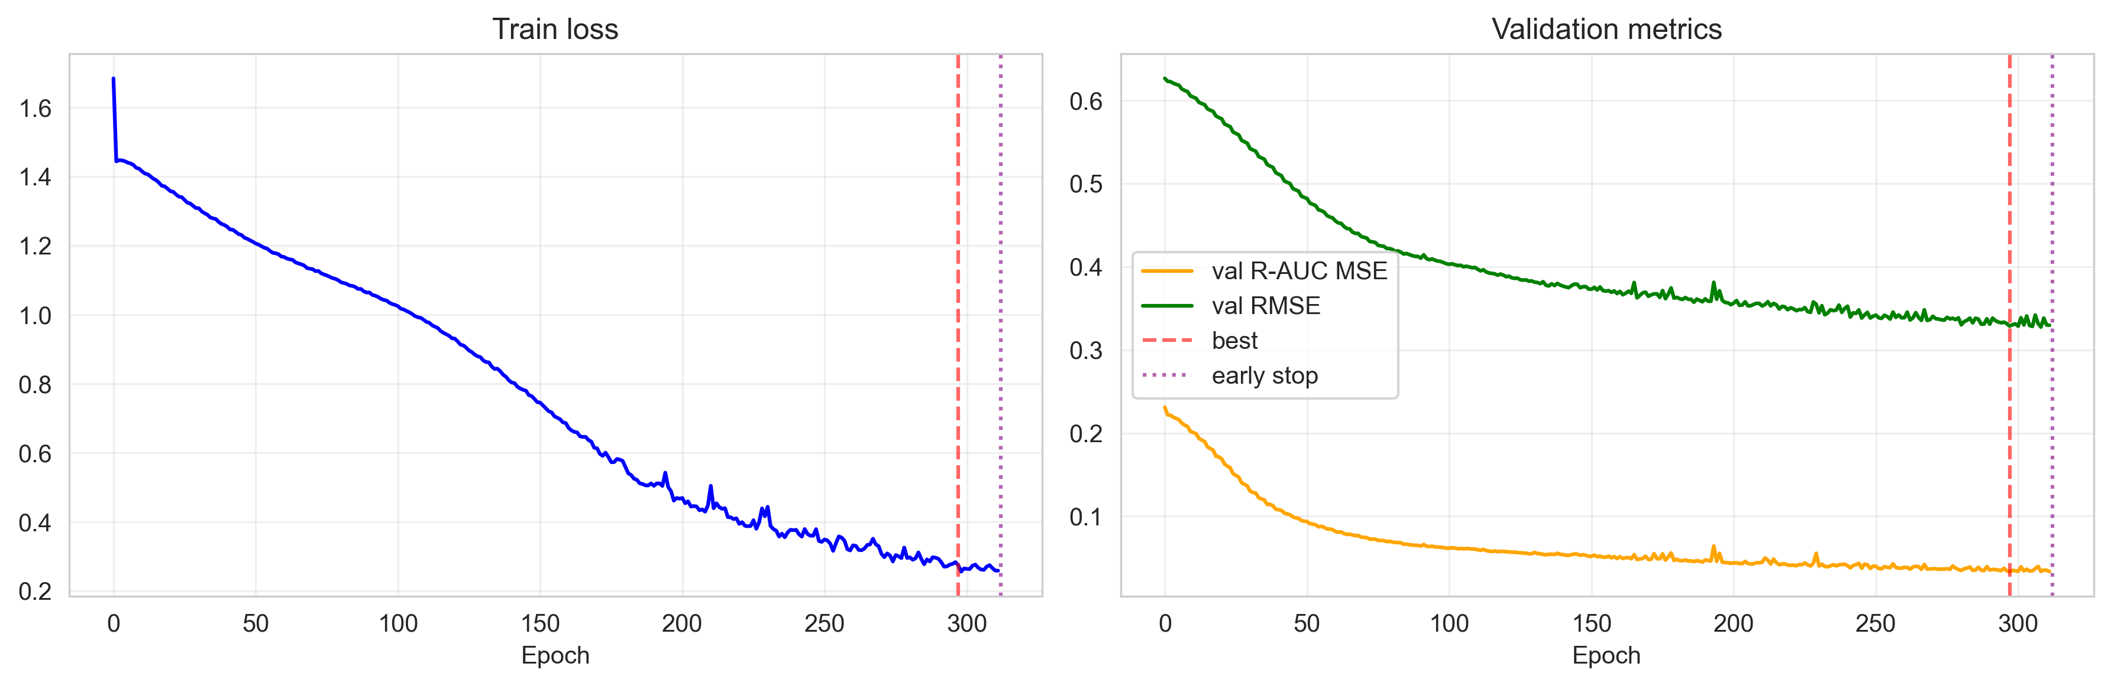
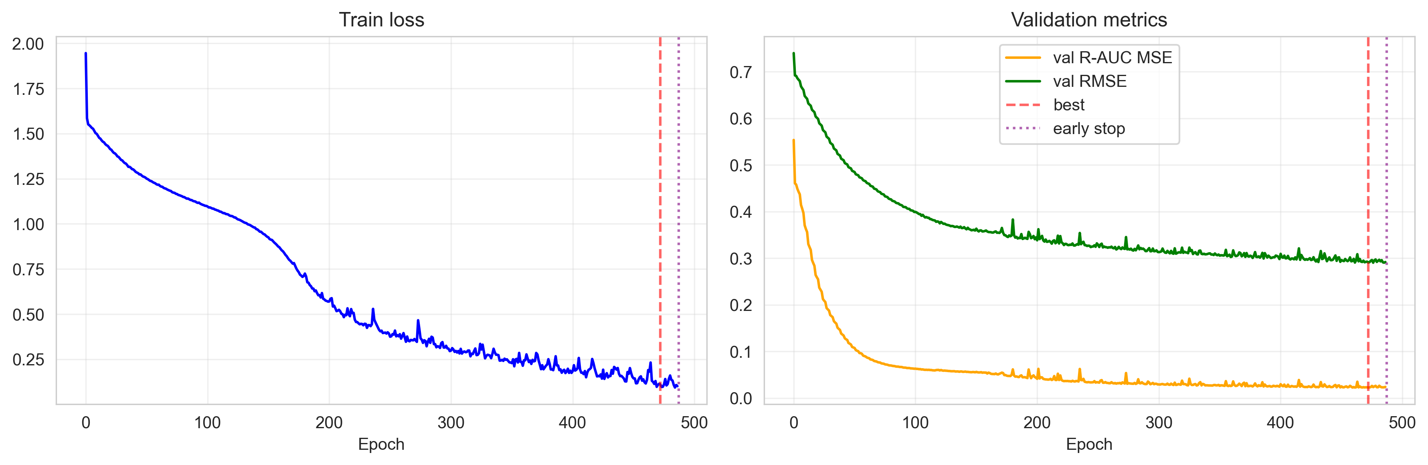
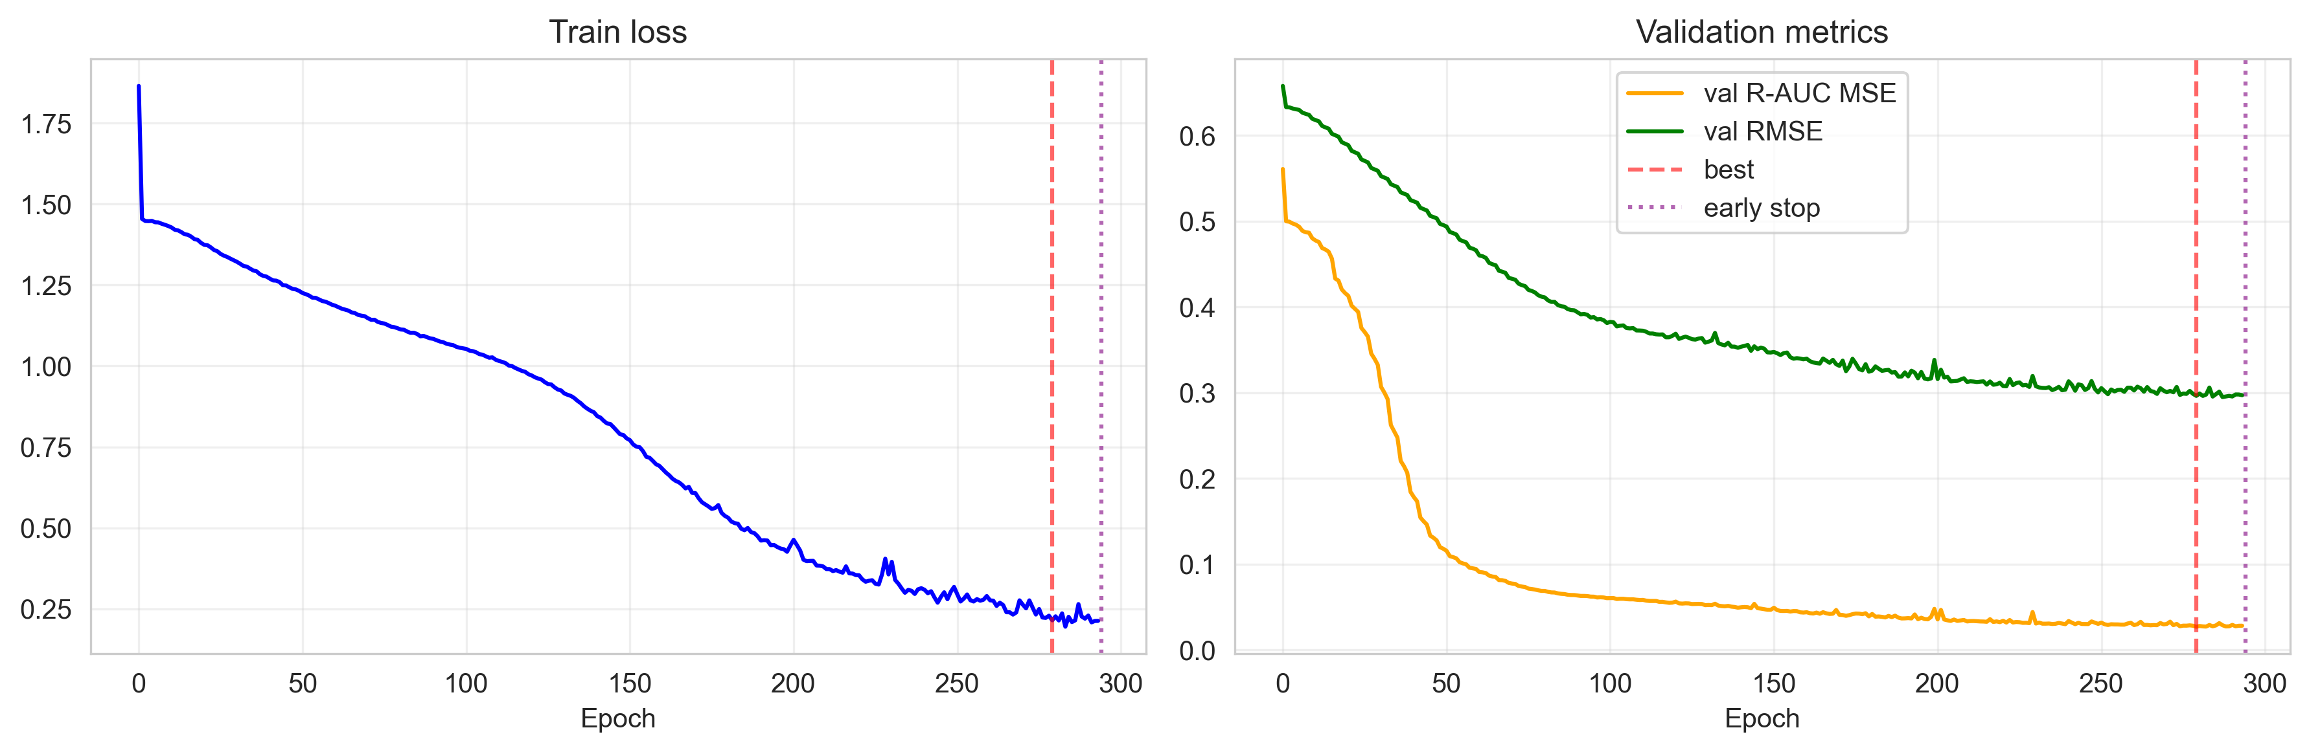
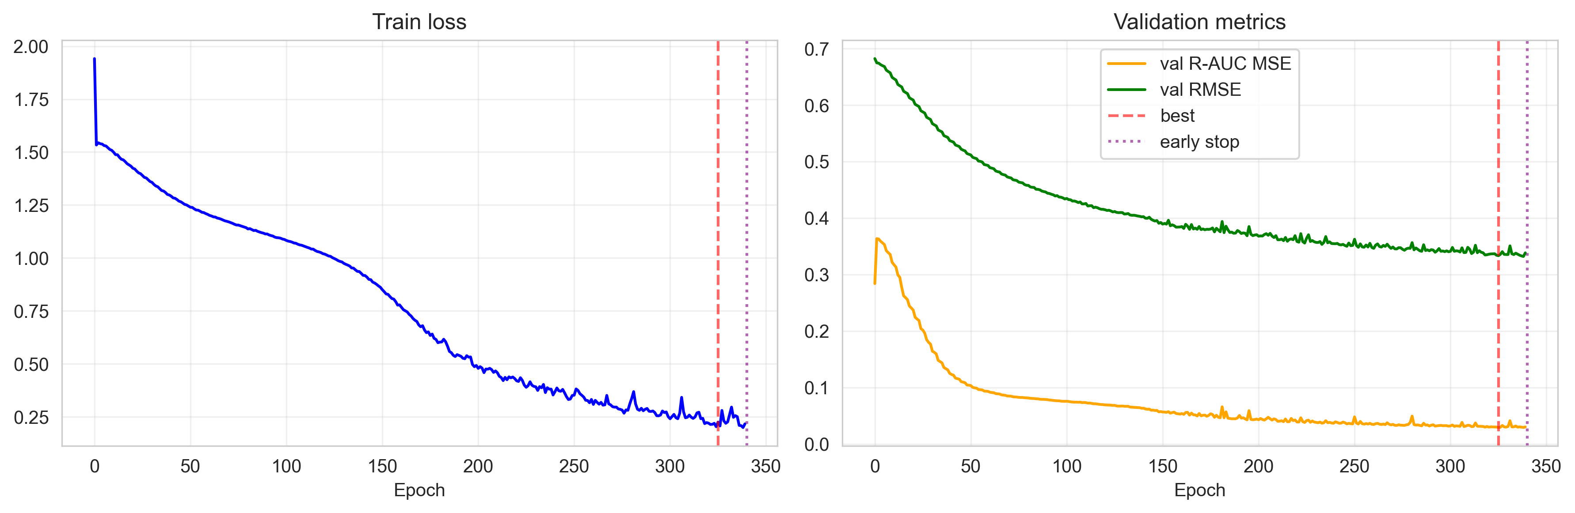
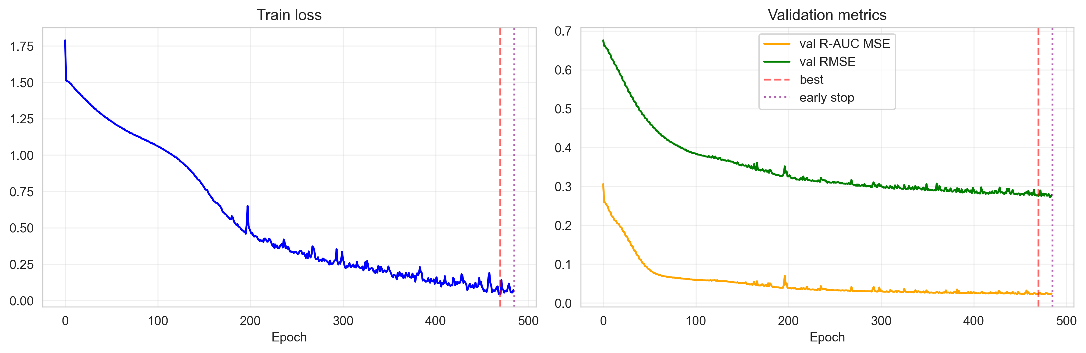
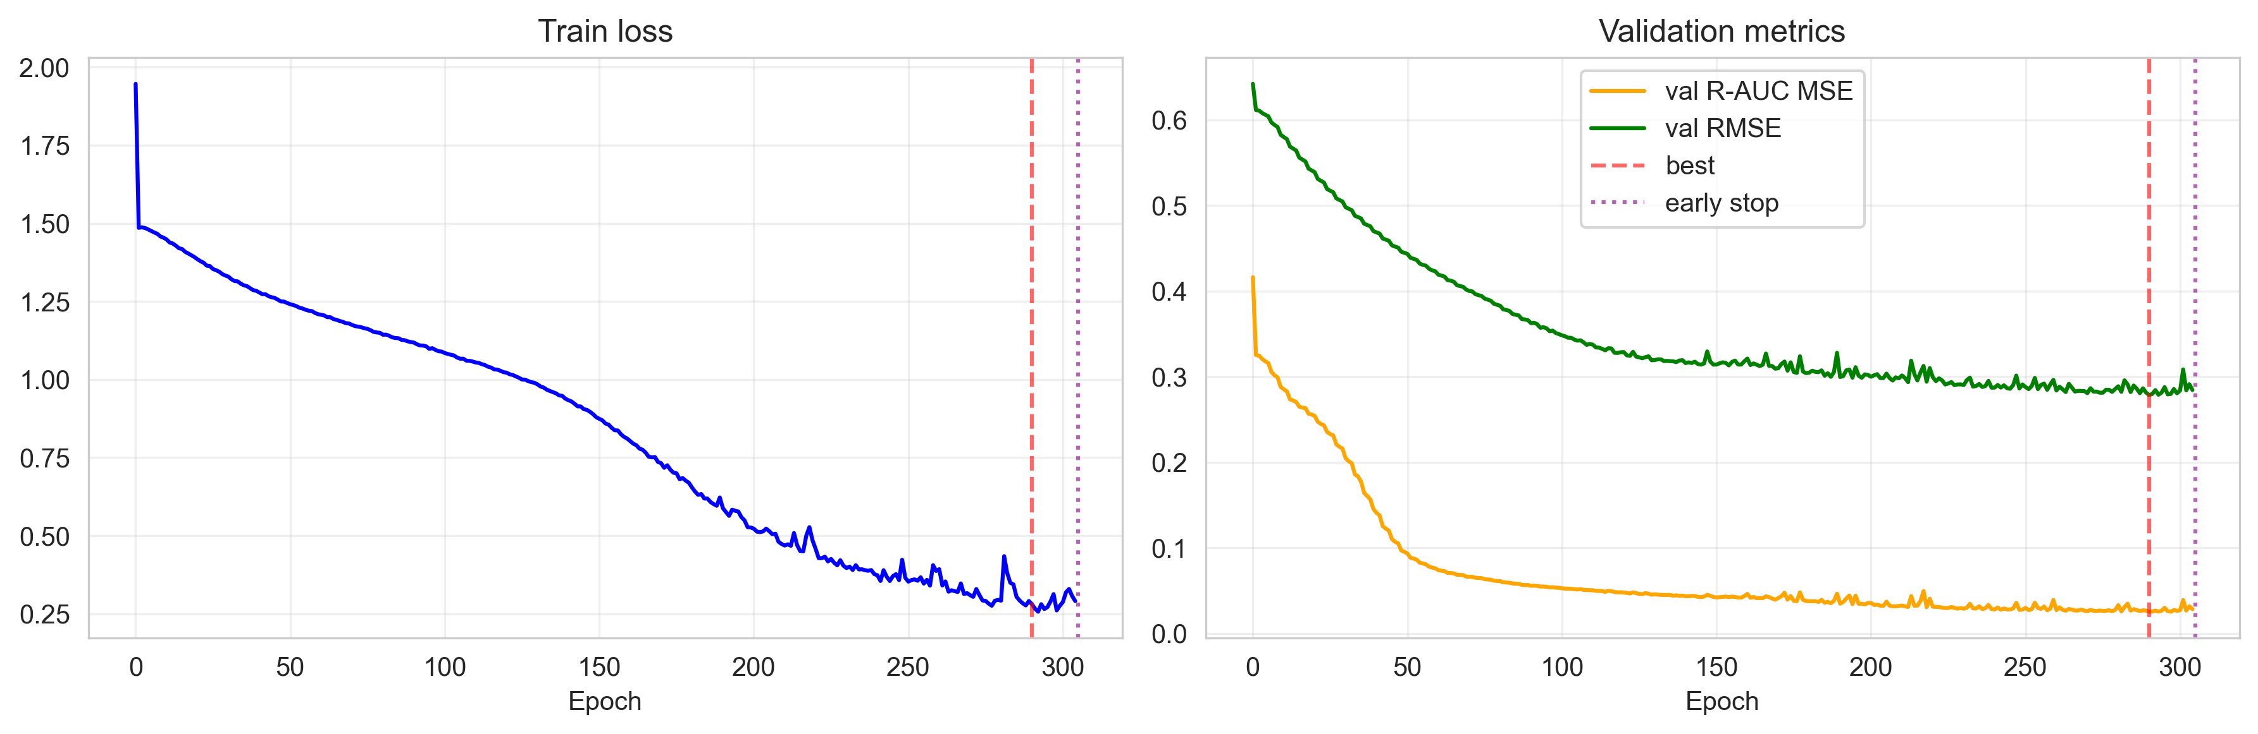
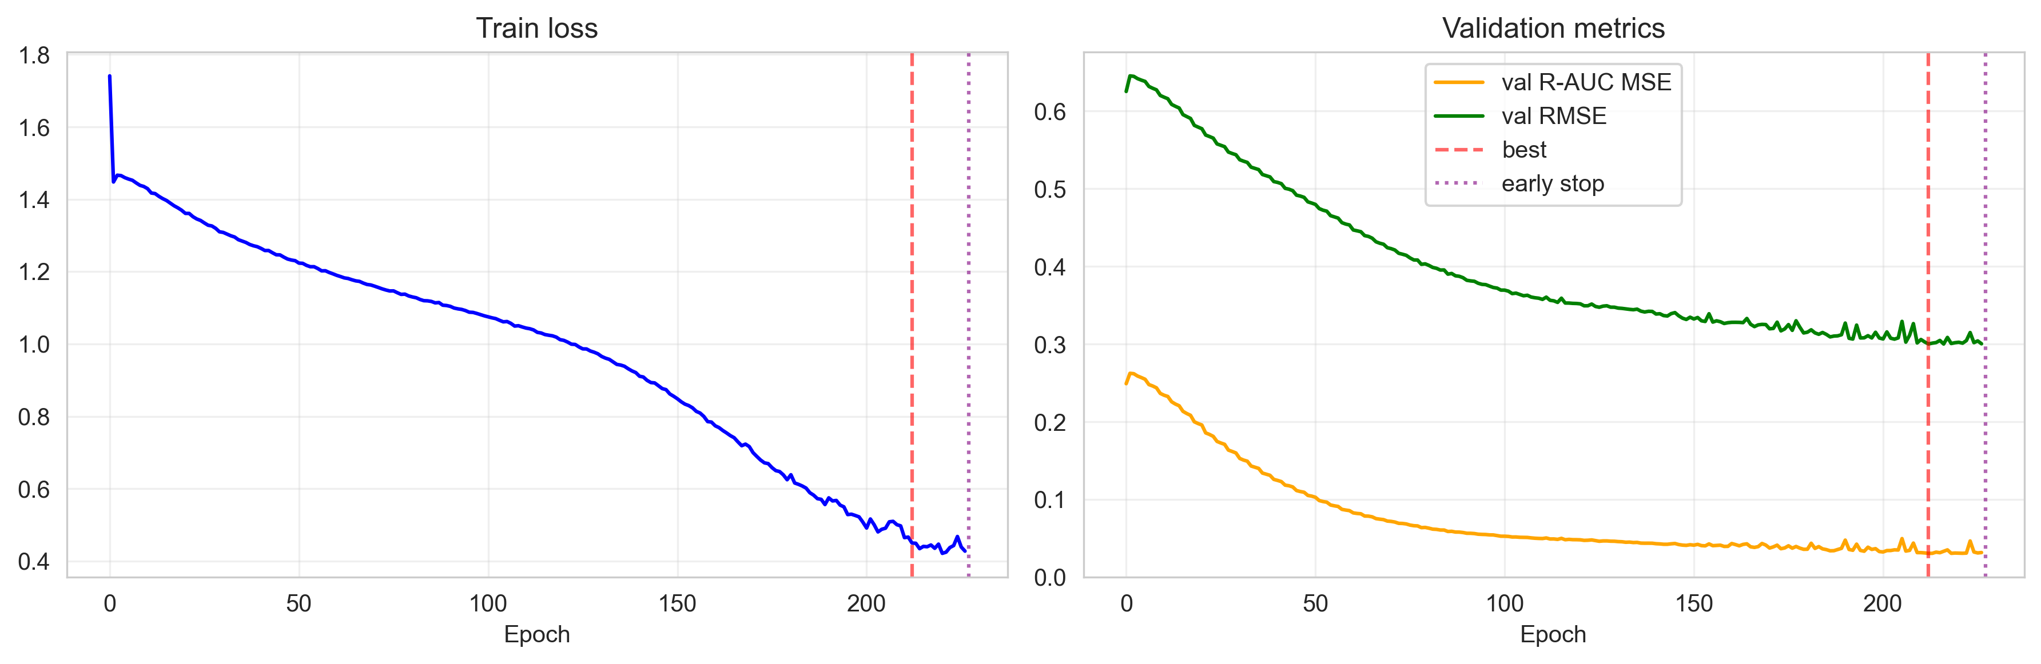
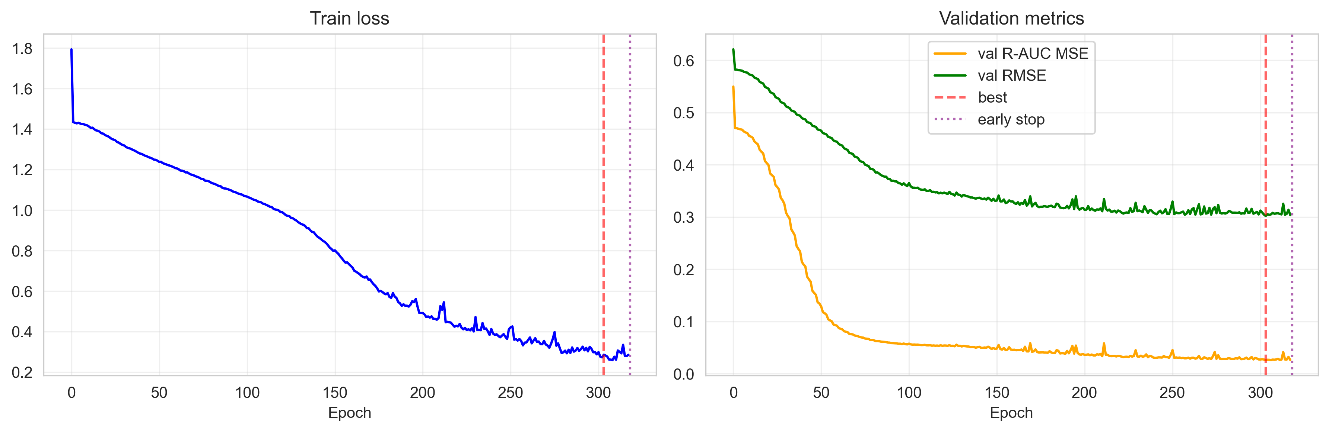
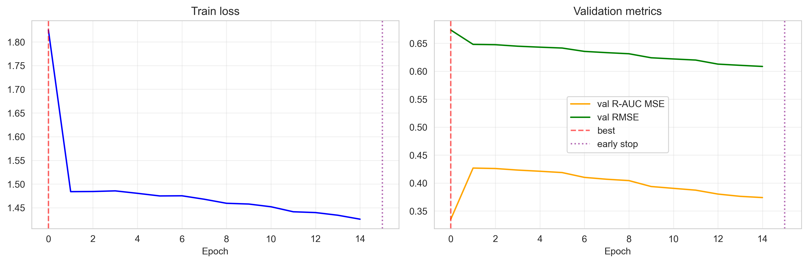
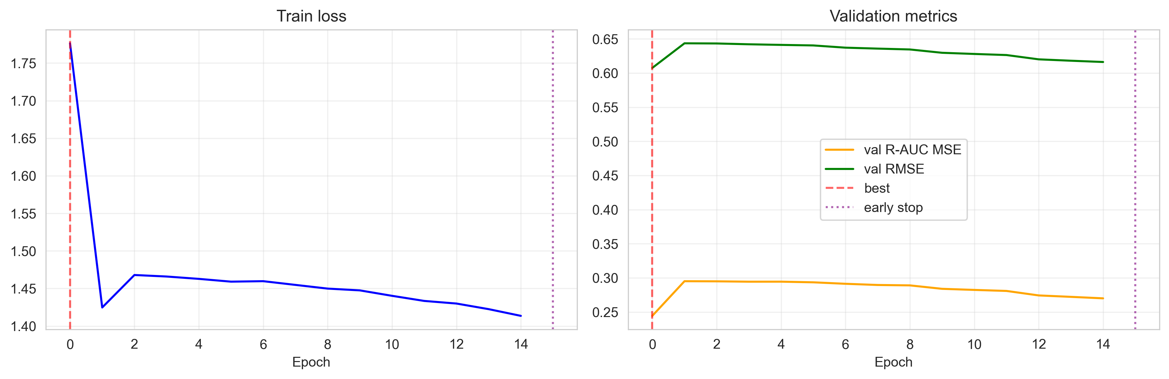
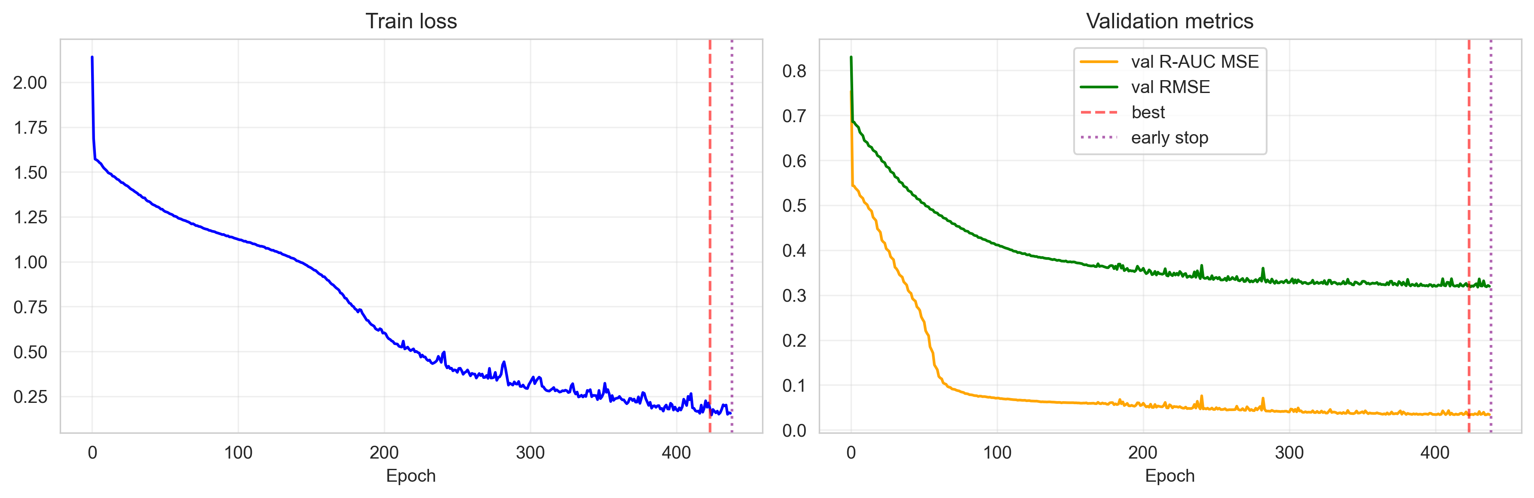
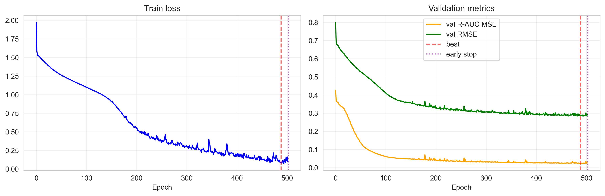
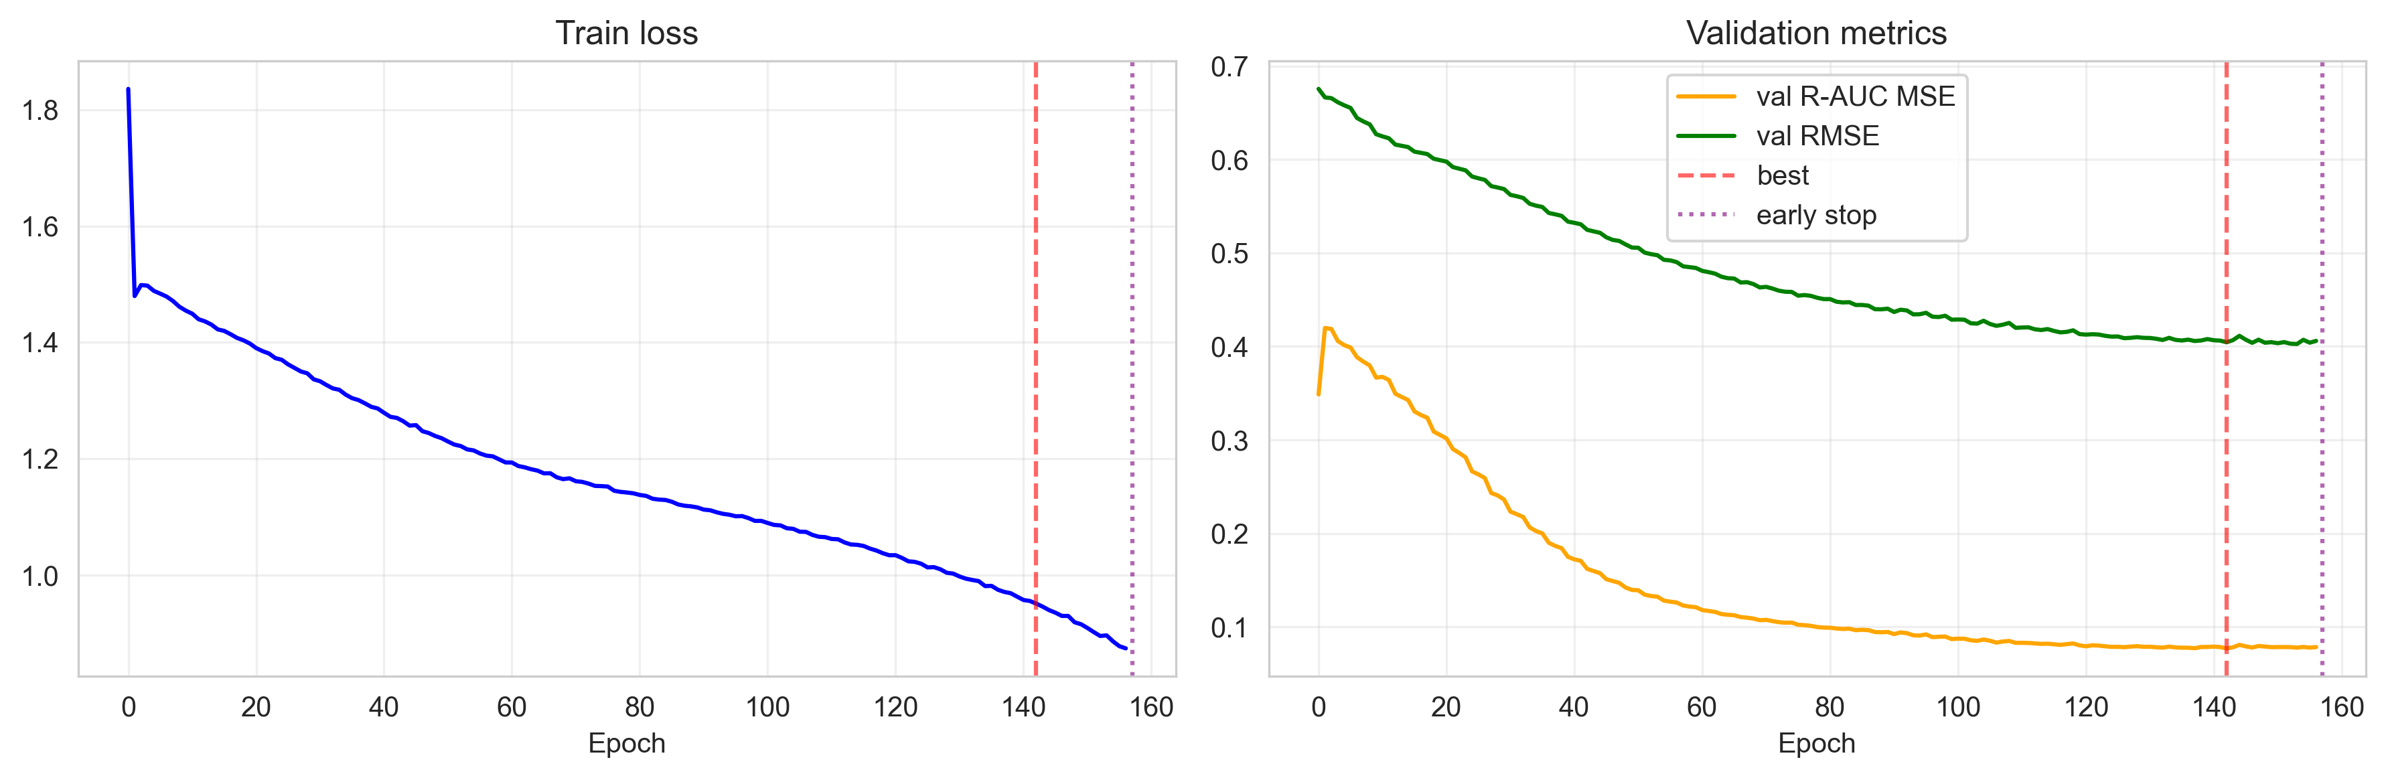
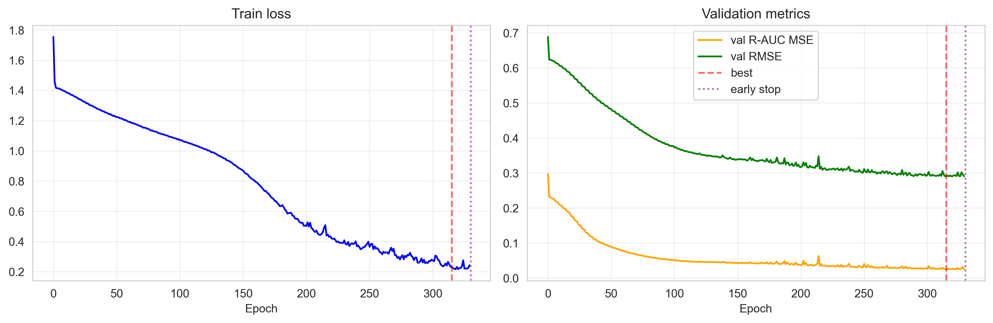
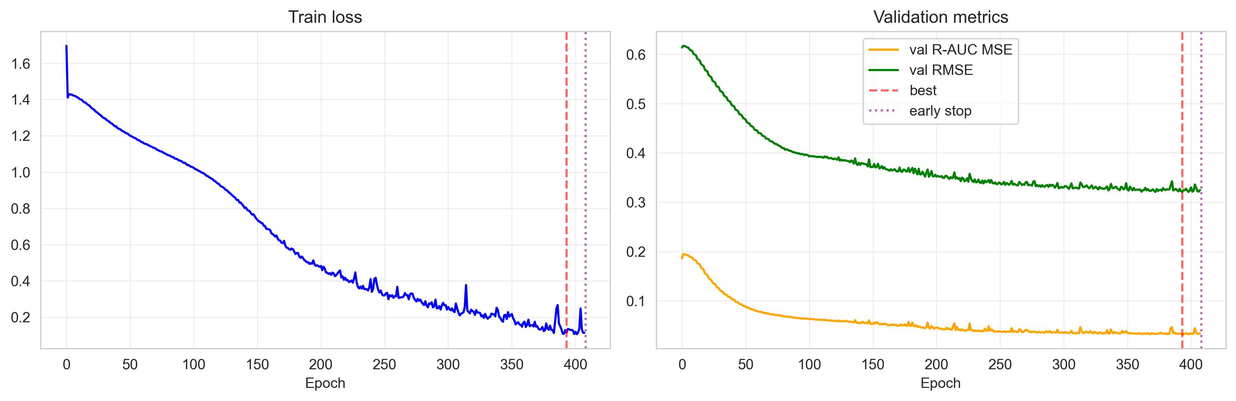
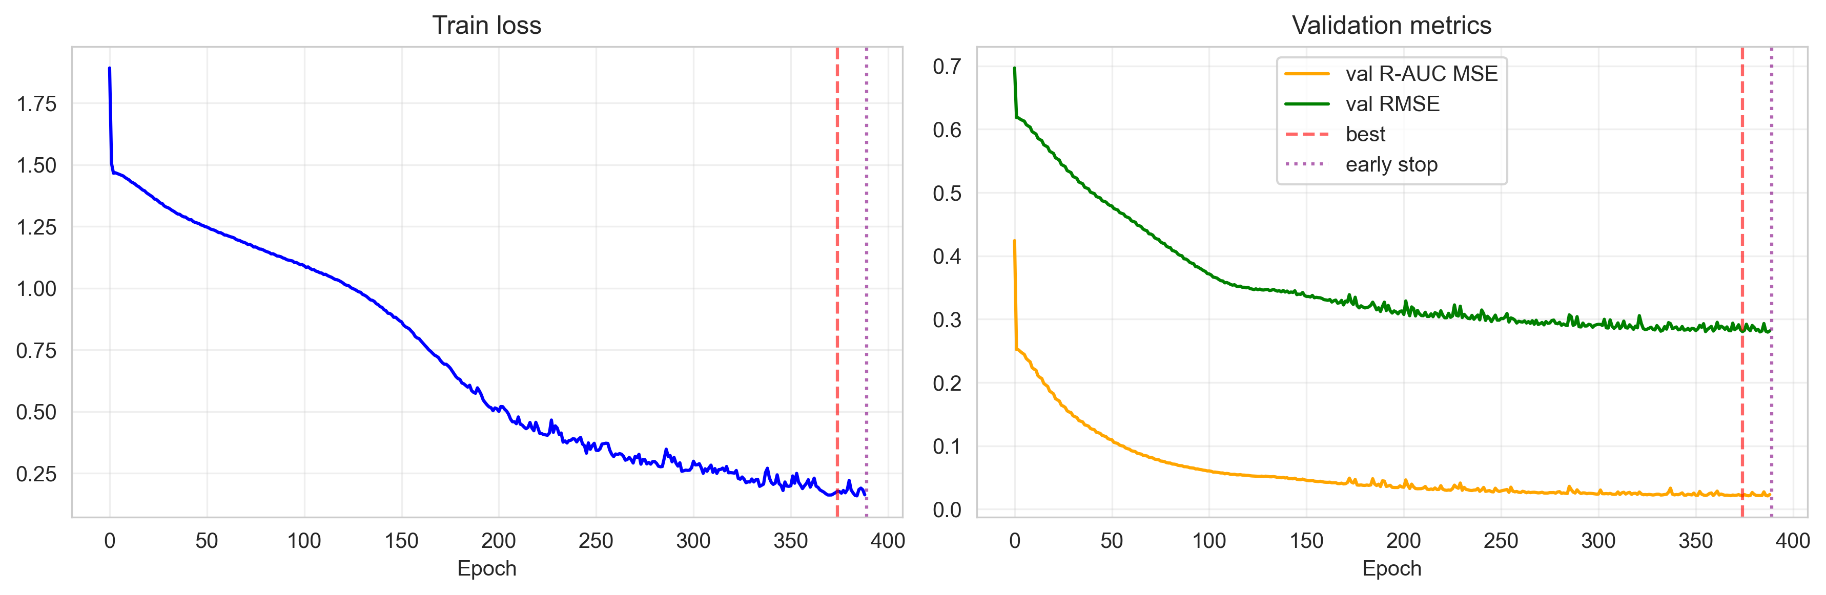

2. Multi-Seed Experiments
Number of seeds: 3 Seeds used: 42, 43, 44

Aggregated Metrics (Mean ± Std)
Metric | Mean | Std
rmse | 46.524107 | 0.000000
mse | 2164.492538 | 0.000000
mae | 34.794618 | 0.000000
r_auc_mse | 617.815537 | 0.000000
mean_uncertainty | 12.860828 | 0.000000
mean_epistemic | 5.109567 | 0.000000
mean_aleatoric | 11.614145 | 0.000000
rejection_ratio | 80.336850 | 0.000000
rejection_auc | 496.694539 | 0.000000
f_beta_auc | 0.696427 | 0.000000
f_beta_95 | 0.689588 | 0.000000

Покрытие (Mean ± Std)
Level | Mean | Std
80% | 0.00% | 0.00%
90% | 0.00% | 0.00%
95% | 0.00% | 0.00%

Individual Seed Results
Seed 43:
- RMSE: 46.524107
- R-AUC MSE: 617.815537

Визуализация по сиду
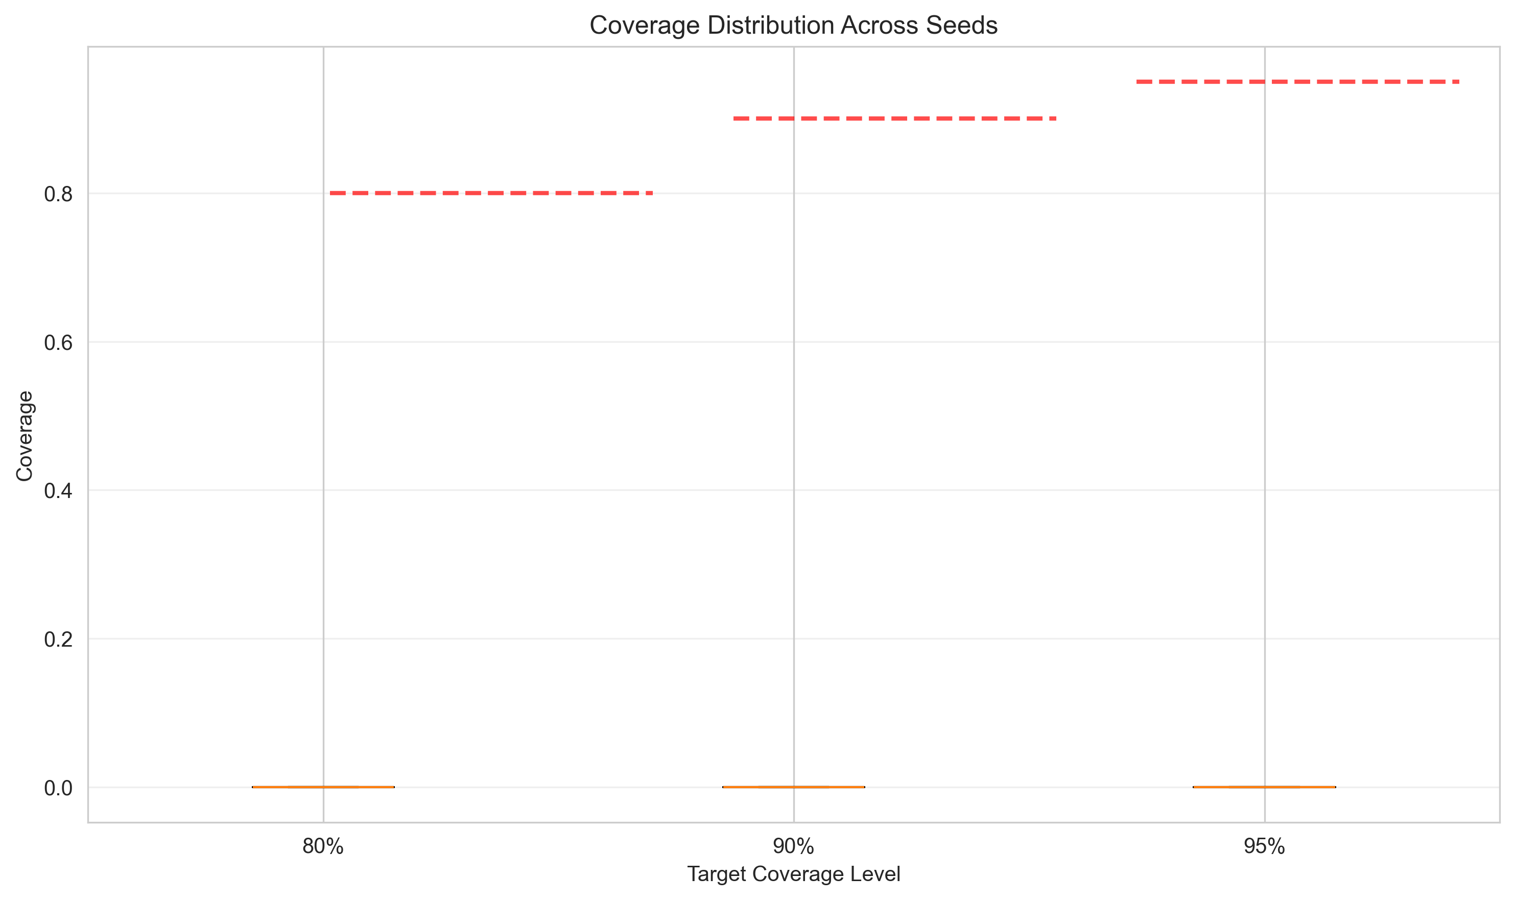
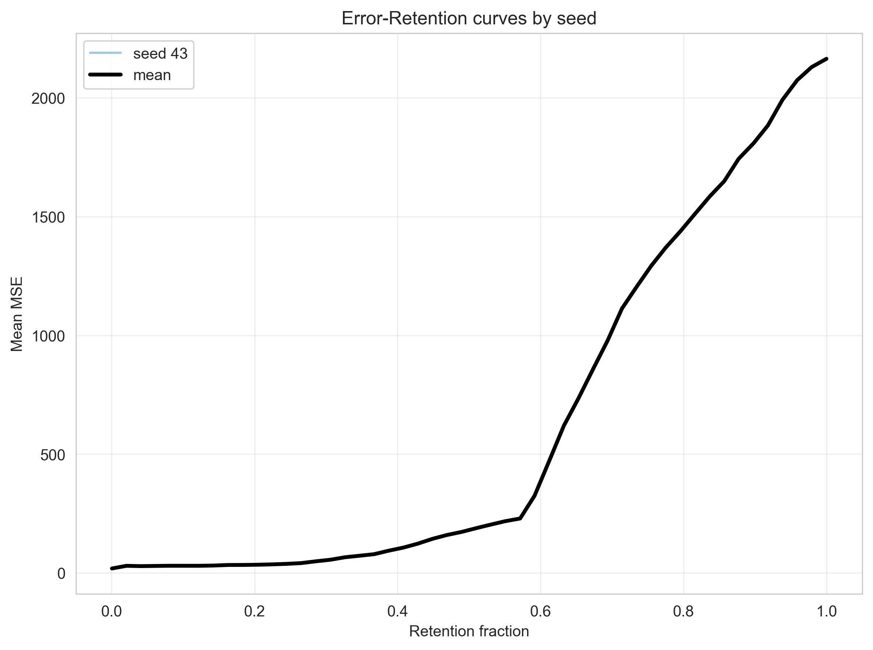
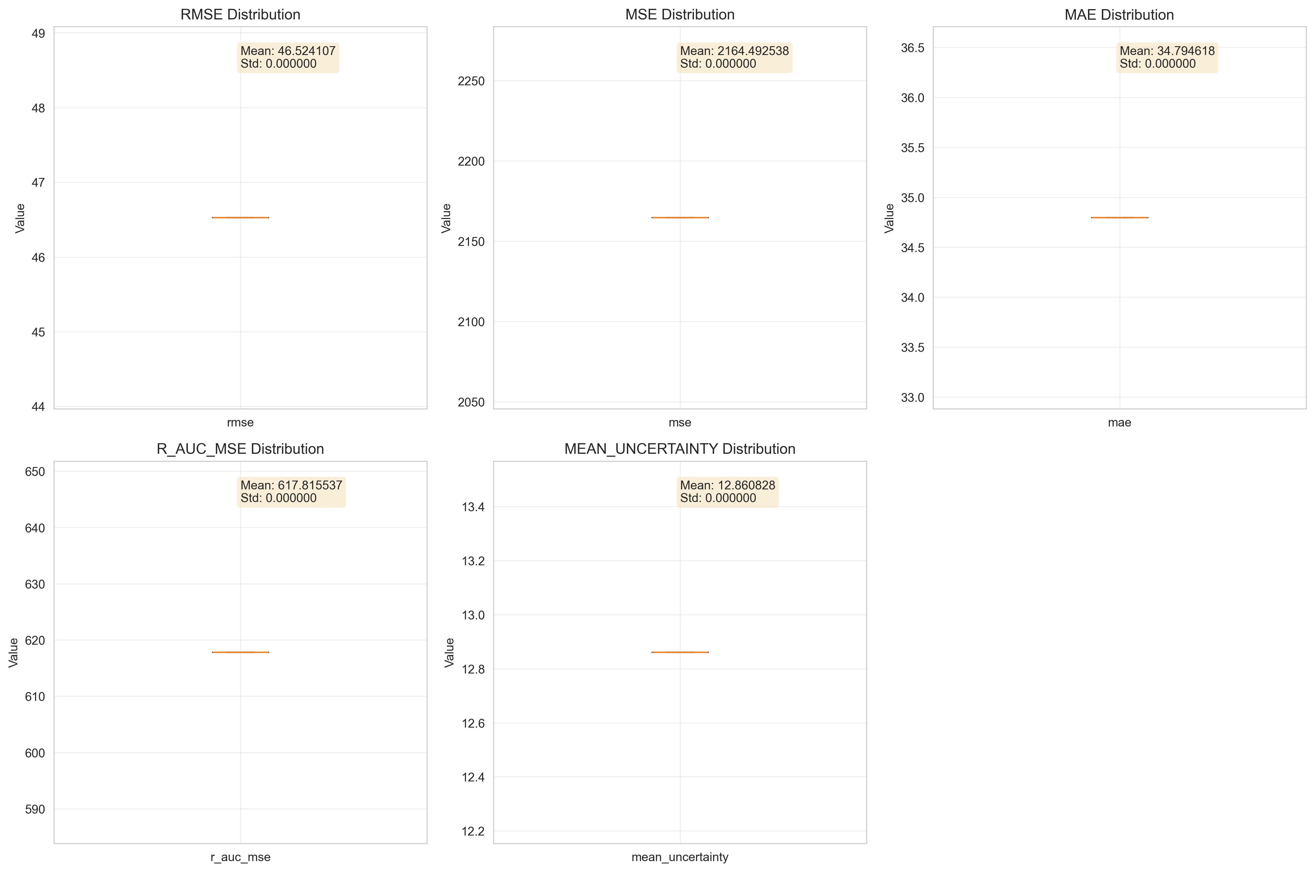

3. Baseline Comparison

Comparison Table
Model | RMSE | MSE | MAE | R-AUC MSE | Mean Uncertainty | Coverage@80 | Coverage@90 | Coverage@95 | Rejection Ratio (%) | Rejection AUC | F-Beta AUC | F-Beta@95 | ΔRMSE_vs_HMTL | ΔR-AUC_vs_HMTL
single_mlp | 0.354199 | 0.125457 | 0.228164 | 0.0346055 | 0.383213 | 0 | 0 | 0 | 73.2344 | 0.0258702 | 0.637956 | 0.685047 | 0.0574768 | 0.00961055
flat_mtl | 0.34636 | 0.119965 | 0.219221 | 0.029481 | 0.306764 | 0 | 0 | 0 | 75.8167 | 0.0230137 | 0.643888 | 0.682452 | 0.049638 | 0.0044861
catboost | 0.391341 | 0.153148 | 0.268451 | 0.0420738 | 0.160143 | 0.800094 | 0.900282 | 0.950141 | 77.4471 | 0.0308446 | 0.635318 | 0.684398 | 0.094619 | 0.0170788
hmtl | 0.296722 | 0.0880438 | 0.190745 | 0.0249949 | 0.39268 | 0.799624 | 0.899812 | 0.950141 | nan | nan | nan | nan | 0 | 0

Метрики неопределенности
- Rejection Ratio: Нормализованная метрика качества неопределенности (0-100%). Чем выше значение, тем лучше модель ранжирует ошибки по неопределенности.
- Rejection AUC: Площадь под кривой отбрасывания (rejection curve).
- F-Beta AUC: Площадь под кривой F-beta для оценки качества неопределенности.
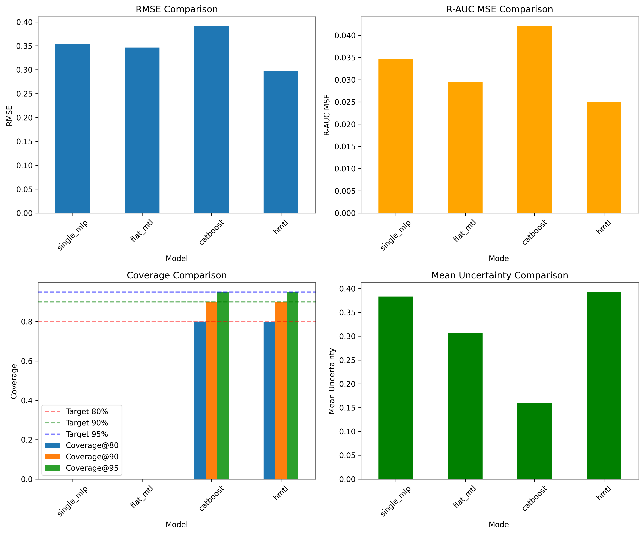

Best Models
- RMSE: hmtl (0.296722)
- R-AUC MSE: hmtl (0.024995)
- MAE: hmtl (0.190745)
HMTL включен в сравнение базлайнов по умолчанию.

4. Summary and Conclusions

Key Findings
- Best R-AUC MSE: hmtl (0.024995)
- Best RMSE: hmtl (0.296722)
- HMTL (val) RMSE 0.296722, R-AUC MSE 0.024995
- HMTL (test) RMSE 0.294180, R-AUC MSE 0.024434
- Conformal coverage@90 (val): 89.98%
- HMTL R-AUC MSE (multi-seed): 617.815537 ± 0.000000
- HMTL RMSE (multi-seed): 46.524107 ± 0.000000

Model Comparison
Based on the baseline comparison:
- HMTL model performance compared to baselines:
Top 3 models by R-AUC MSE:
Model | R-AUC MSE | RMSE | Rejection Ratio (%)
hmtl | 0.0249949 | 0.296722 | nan
flat_mtl | 0.029481 | 0.34636 | 75.8167
single_mlp | 0.0346055 | 0.354199 | 73.2344

Recommendations
- Review plots in experiments/plots/ for detailed visualizations
- Check experiments/baselines/comparison_table.csv for full baseline comparison
- Examine experiments/multi_seed/results.json for detailed multi-seed statistics
- Analyze error-retention curves to understand uncertainty calibration quality
- Compare coverage metrics before and after conformal calibration

Output Files
All experiment outputs are saved in the following locations:
- experiments/plots/ - Visualization plots (error-retention, calibration, reliability)
- experiments/baselines/ - Baseline comparison results
- experiments/multi_seed/ - Multi-seed experiment results
- experiments/runs/ - Individual training runs (if MLflow disabled)

