**ERD:**

<https://app.diagrams.net/#G1Tyns9A4zUNR1YbsY3Lh07ZCk_jhZ6Jjs>

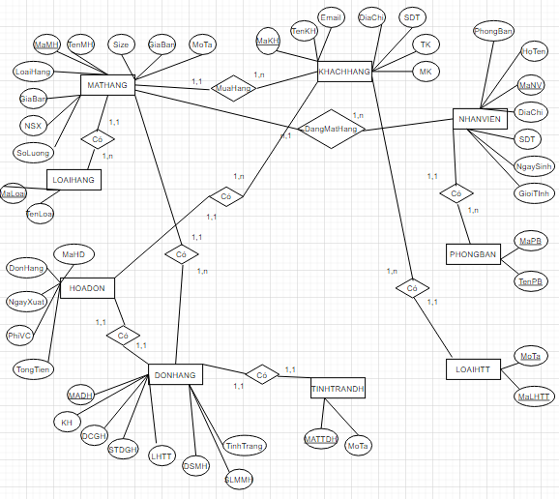

**Mô HÌnh Logic Trên Mẫu Tin:**

* MATHANG(MaMH, TenMH, SIZE, LoaiHang, GiaMua, GiaBan, MoTa, SoLuong, NSX)
* KHACHHANG (MaKH, TenKH, Email, DiaChi, SoDienThoai, TaiKhoan, MatKhau)
* DONHANG (MaDH, KhachHang, DiaChiGiaoHang, SoDTGiaoHang, LoaiHinhThanhToan, DanhSachMatHang, SoLuongMoiMatHang, NgayDatHang, TinhTrang)
* HOADON (MaHD, DonHang, NgayXuat, PhiVanChuyen, TongTien)
* TINHTRANGDONHANG (MaTTDH, MoTa)
* LOAIHINHTHANHTOAN (MaLHTT, MoTa)
* NHANVIEN (MaNV, HoTen, DiaChi, SoDienThoai, NgaySinh, GioiTinh, PhongBan)
* PHONGBAN (MaPB, TenPB)
* LOAIHANG (MaLoai, TenLoai)