HomEwork 5

julien Blanchet

November 2, 2019 ● COSC 181 ● Prof. Li

# 

# Question 1

*In the following picture, a robot is deployed in the a rectangular room at the asterisk, where the walls are depicted with green lines. The robot is pointing upwards and the black lines indicate four measurements from the sonar sensor that returns the distances to the walls. The red points indicate the particles of a particle filter at the initialization -- the robot doesn't know where it is in the environment.*

*Please draw the areas where after the update of the particle filter, particles will have the weight increased*.

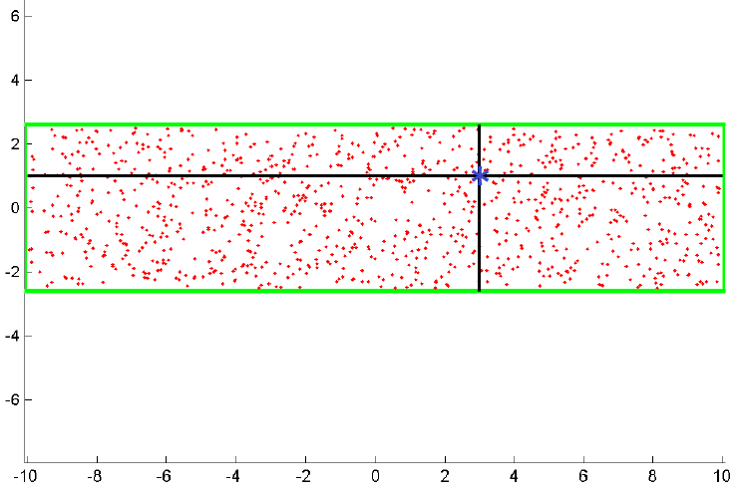

Weights will increase within the zones circled in blue



*Can the robot globally localize in that room? Please motivate the answer showing the motions that it has to do to localize (if possible).*

I don’t think it’s possible for the robot to truly localize in this room, because the room is rotationally symmetric around the center with a ½ turn (180 deg). Thus, for any possible path the robot takes, it would receive the same readings if it had started 180 deg from its initial position relative to the center of the rectangle. Another way of saying this: for any given estimated pose, an equally believable pose exists at the location and orientation of a half turn around the center of the rectangle.

Note that the robot *can* narrow down the localization to two options, even with a single measurement as illustrated above. However, without another sensor that can break the symmetry (such as a compass) there’s no way for the robot to know which of these two options is the real one.

# Question 2

*In the following, a particle filter is used to track the position of the robot in a two dimensional environment, with noise in translation (x axis) and in lateral drift (y axis). The two pictures identify two different instances of using such a particle filter for a robot that goes forward of 100 cm along the x axis. Why is there a difference between the two instances?*

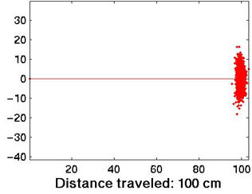 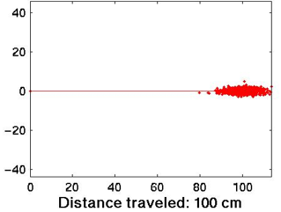



The difference likely has to do with the difference in modeled odometry accuracy.

* In the chart on the left…
  + The particle filter models outcomes assuming that the odometry system has low error with drift– thus if odom reports a heading of directly forwards (0 deg), the filter places high belief in particles whose locations are very close to that heading (which is why the particles show minimal vertical deviation from the x-axis).
  + The particle filter models outcomes assuming that the odomety system delivers a less accurate measurement of translational distance. Therefore, the filter places high belief in particles over a wider range of values surrounding the 100cm reported distance (shown in the chart as a larger horizontal spread).
* In the chart on the right
  + The particle filter models an odom system with higher translational accuracy but higher drift error. Therefore, particles with high-belief are concentrated more tightly around areas 100cm from the starting location, but with less tightly around a 0 deg heading.

# Question 3

*The following picture shows an occupancy grid map created by a robot equipped with a laser sensor. Explain the main reasons why there are errors in the map.*

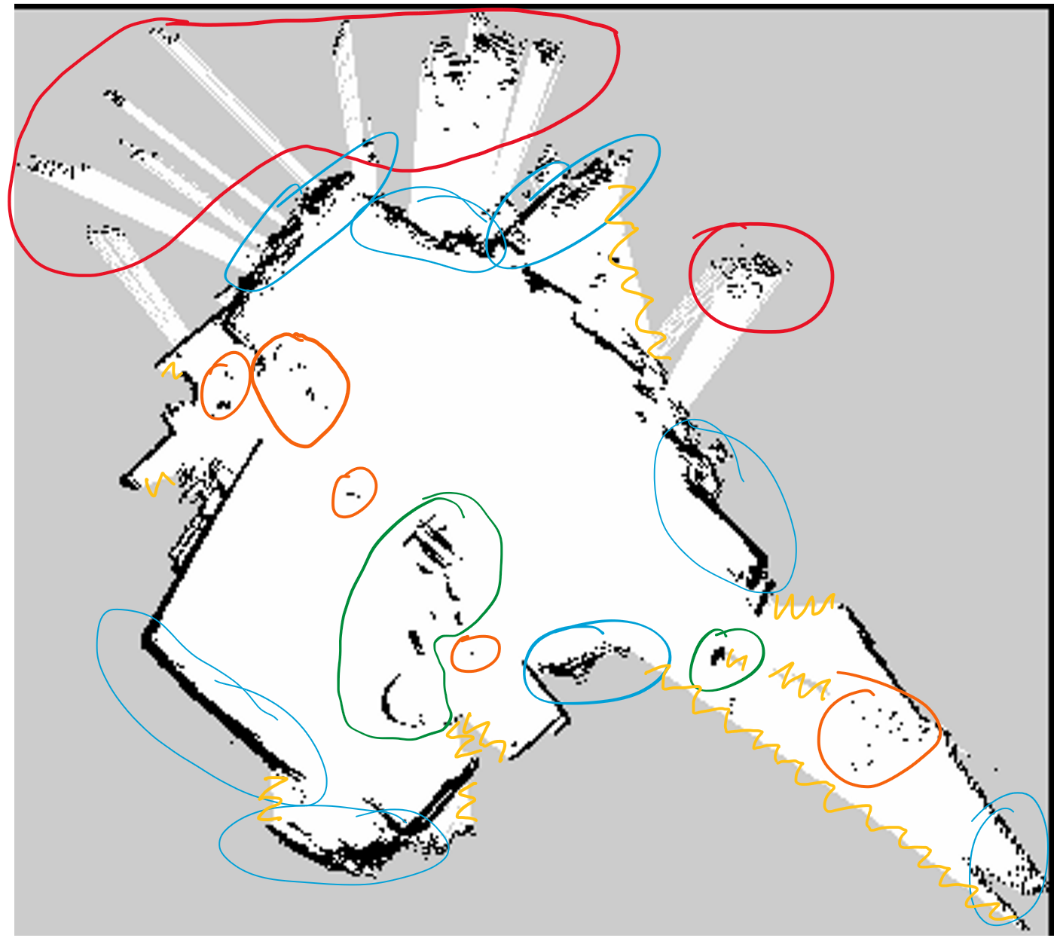

See the illustration for the anomolies that I identified on the map. Some of these anomolies are clearly flaws in the map, while others could be considered expected behavior. The table on the next page breaks down observed anomolies into several categories.

|  |  |
| --- | --- |
| Observed Anomoly | Potential Explanation(s) |
| Scattered exterior readings (RED) | Reflective materials or windows could have interefered with the laser sensor’s readings, causing the laser beam to reflect somewhere and the time-of-flight measurement to be erroneous. |
| Isolated interior readings (ORANGE) | Transient obstacles (such as a human moving through the environment during mapping phase) could have caused the robot to register occupancy in one cell, and the obstacle could have moved before the robot took a reading across the adjacent cell. |
| Interior reading clusters (GREEN) | These readings could represent static interior obstacles (like walls) or semi-static interior obstacles (like fruniture). Depending on the use-case, these could be seen as valid representations of occupied space (if the robot doesn’t intend to move fruniture) or as errors (such as a humanoid robot that could step over certain obstacles or move things that are in the way). |
| “Thick Walls” (BLUE) | Expected behavior is that the walls of a room would be captured as 1-cell wide lines of occupied cells, rather than thicker walls. While this behavior could be explained by walls made of translucent material that reflects light at varying depths, a more likely explanation is that the laser sensor is not perfectly precise with its measurements, and thus two readings bouncing off the same point on a wall could be recoreded as different depths.   * Also note that the detected location of an occupied cell also depends on accurate localization of the robot. Error in localization will propogate to error in the occupancy grid. |
| Unexplored Regions (YELLOW) | A fully explored map would have no boundries where unexplored cells (gray) are adjacent to unoccupied cells (white). Patterns in these boundries (illustated by yellow zig-zags) indicated that the robot likely traveled around the center of the area during the mapping phase, rather then exhaustively searching and following all walls. The bottom-right portion of the map in particular has large unexplored boundries. |