Team CUNYPrime

Capstone Project - iOS App

Software Design Document

Michael Rueda

Date: (12/17/2015)

Software Design Document

TABLE OF CONTENTS

1. **Introduction**

1.1 Purpose

1.2 Scope

1.3 Overview

1.4 Reference Material

1.5 Definitions and Acronyms

2. **System Overview**

3. **System Architecture**

3.1 Architectural Design

3.2 Decomposition Description

3.3 Design Rationale

Software Design Document



1. INTRODUCTION

1.1 **Purpose**

This software design document describes the architecture and system design of CUNYPrime for iOS. The intended audience is for anyone looking to construct a schedule and to make a resume for themselves.

1.2 **Scope**

CUNYPrime was written in Swift 2.0 for iOS 9.0 in Xcode 7.0. The goal of the CUNYPrime mobile app is to provide an alternative way for users to schedule their courses and to make a Resumé.

1.3 **Overview**

An overview of this Software Design document is to interpret the view controller tree as displayed on an iOS device. The organization of this document is detailed information on each view from the Home to the Profile.

1.4 **Reference Material**

“Learn iOS 9 App Development with Xcode 7 and Swift 2” by Susan Starkman

“The Complete IOS 9 Swift 2.0 Guide” by Udemy

1.5 **Definitions and Acronyms**

1

Software Design Document



ViewController – A controller that manages a view in Swift.

WebView – Displays embedded web content and enables content navigation.

TabBarController – A Controller that manages a set of view controllers that represent tab bar items.

2. **SYSTEM OVERVIEW**

A general description of the goals of the functionality, context and design of my project are to provide three sections, Schedule, Resume and Profile where a user can perform these actions.

3. **SYSTEM ARCHITECTURE**

3.1 **Architectural Design**

A modular program structure is seen in the Xcode main.storyboard view. The Home ViewController, Schedule WebView, Resumé TabBarController and Profile WebView can all be seen here. This is a high level overview of how responsibilities of the system were partitioned and then assigned to subsystems. Segues are shown connecting each view to Home, the high level subsystem. Its role and responsibility is to provide a starting point when loading the application and have 3 image buttons linking to the Schedule, Resumé and Profile views. This is shown in the

2

Software Design Document



following diagram.

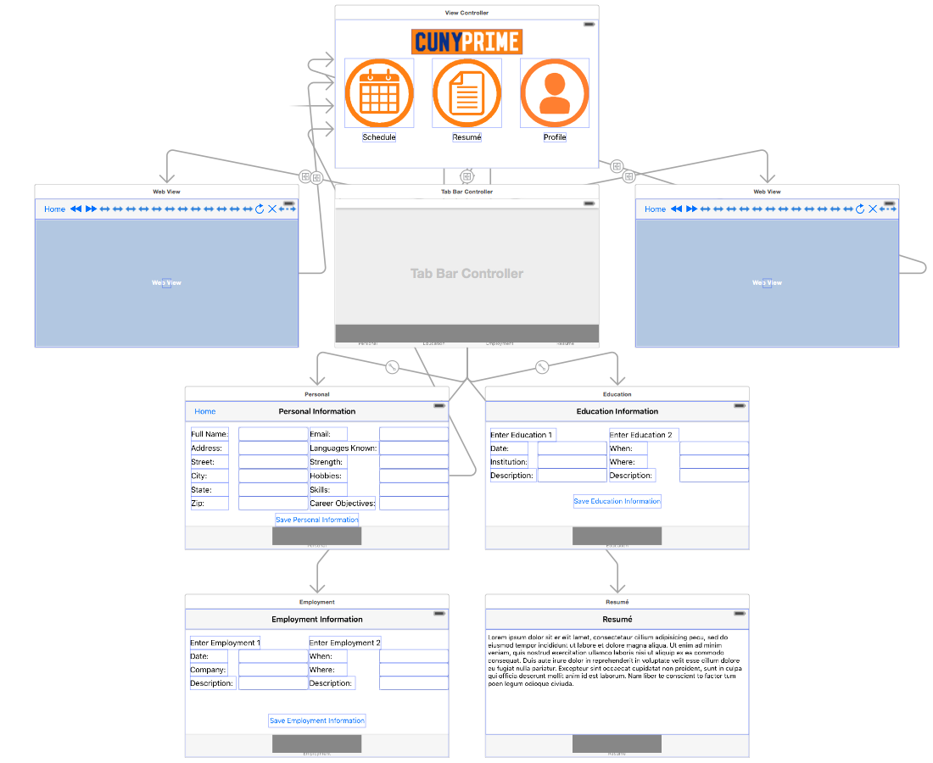

3.2 **Design Rationale**

I will now discuss the rationale for selecting the architecture described in 3.1. This was the most logical architecture to choose from as there are three sections that needed to be managed by one starting point.

3