Panda Run

Thank you for purchasing this Game.

Panda Run game is 2d platform jumping game, can be build to android, ios & windows phone 8.
It is strongly recommend importing this package in an empty Project to avoid tag and iTween conflicts.

BUILD SETTINGS

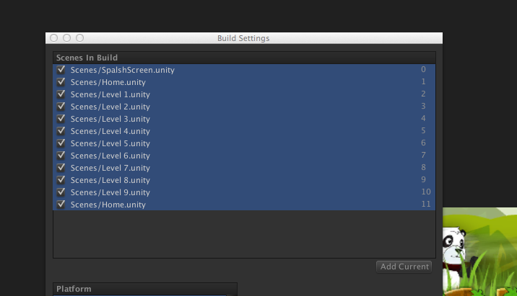
Make sure you added these scenes as per order.

Support
For Quick questions & support, contact me at kiran.killstreak@gmail.com
Skype ID kirankillstreak

Thanks
Kiran

