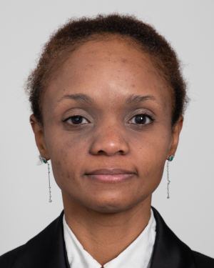
JAMILAH FOUCHER (M’2016) became a Member (M) of IEEE in 2016. Jamilah received a B.S. degree in electrical engineering from the State University of Binghamton, New York in 2003 and PhD. degree in mechanical engineering from University of California, Santa Barbara with emphasis in control theory, dynamical systems, and numerical analysis in 2012; with application to neuroscience and psychophysical experimentation. She is currently a Data Scientist, a member of Sigma Xi, and a member of the Frontiers Neuroergonomics Editorial Board.

ANNE-CLAIRE COLLET received an engineer degree in 2010, a Master degree in biology and neurosciences in 2012 and a PhD in Cognitive neurosciences in 2016, with an emphasis on perception and object recognition. She currently works in Human Design Group as a neuroscientist and is involved as a subcontractor in Airbus projects that require expertise in neuroscience and/or in human physiology.
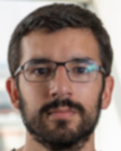
KEVIN LE GOFF received a PhD degree in neuroscience from Aix-Marseille University in 2016. He is currently a Human Factors specialist working on cockpit design and physiological topics at Airbus Operations SAS, Toulouse.
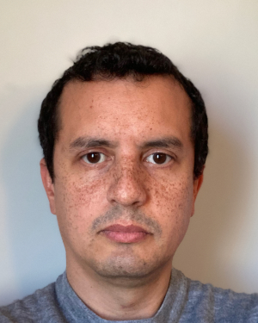
THOMAS RAKOTOMAMONJY received an Engineering diploma in aerospace from l'Ecole Nationale Supérieure de l'Aéronautique et de l'Espace, Toulouse, in 2002, and a PhD. degree in automatics and systems control from Aix-Marseille University in 2006. He is currently Senior Research Scientist at ONERA - The French Aerospace Lab, working on model identification for piloting assistance and interfaces.

VALÉRIE JUPPET is an Airbus expert, at Airbus Helicopters Design Office, in the domain of human factor applied to the cockpit design and certification verification engineer for cockpit arrangement and human factor topics.
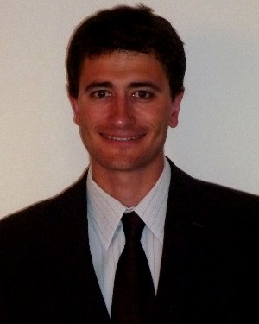
THOMAS DESCATOIRE received a master degree in mechanical engineering. Currently, he is working as an cockpit operations specialist in the cockpit design and Human Factor department, at Airbus Helicopters Design Office.

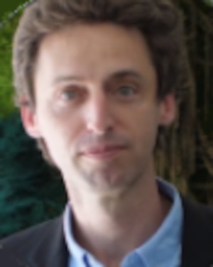
JERÉMIE LANDRIEU received a M.S. in mechanical engineering and PhD in Computer Graphics with emphasis in Virtual Reality technologies. He is currently a R&D Manager at Gambi-M company. --------------------------------------------------------------------------------------

MARIELLE PLAT-ROBAIN received a PhD degree in cognitive psychology from University of Paris VIII with emphasis on ergonomy in 2001. PhD was about aviation atypical incidental situations (linked with automations surprises) and crew diagnosis of those situations. She is currently working on cockpit design at Airbus Operations SAS,Toulouse, for 21 years.
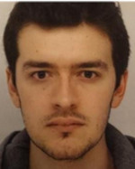
FRANÇOIS DENQUIN received an engineer diploma in electronics and informatics from the ENSEA engineering school in 2015, and a M.S. in artificial intelligence and robotics from the University of Cergy-Pontoise (France) the same year. Then, he received a PhD in human movement sciences in 2021 from the University of Montpellier (France), with emphasis in neurosciences and human perception of the environment. He is currently a IA engineer in the R&D team of AnotherBrain company.
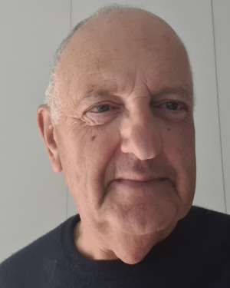
ARTHUR J. GRUNWALD is a retired Associate Professor at the Faculty of Aerospace Engineering, Technion, Haifa, Israel. His main fields of interest are flight simulation, Human-Machine systems, advanced electronic display formats in Aerospace applications, visual perception models, and Human Interface design.
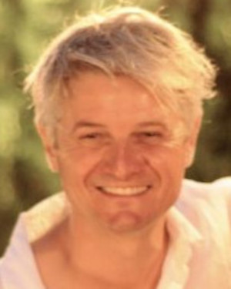
JEAN-CHRISTOPHE SARRAZIN, PhD is a cognitive psychologist. After two postdocs in computational neuroscience (postdoc INRIA, one year) and cognitive neuroscience (postdoc Marie Curie, two years) respectively, Jean-Christophe Sarrazin obtained a permanent position at the Office National d’Etudes et de Recherches Aérospatiales (ONERA, the French aerospace lab). At ONERA, in the Systems and Information Processing Department, he leads the research unit ‘Cognitive Engineering and Applied Neurosciences’ and works on the scientific and technical development of human system integration studies.
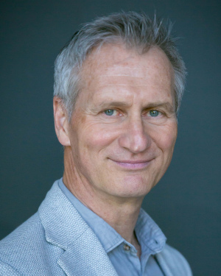
BENOÎT G. BARDY received the PhD and Habilitation degrees in movement sciences from Aix-Marseille University, France, in 1991 and 1998, respectively. In 1994, he was awarded a NATO Research Fellowship to develop his research on locomotion in virtual reality at Brown University, RI, USA. After being selected as a new Professor at the University of Paris (Paris-Sud) in 1999, he entered the prestigious Institut Universitaire de France as a Junior Member from 2001 to 2006. In 2005, he returned to the South of France and created EuroMov, a European center for research, technology, and innovation at the crossover between movement, health, and digital sciences (now EuroMov Digital Health in Motion (DHM), www.euromov.eu). In 2012, he was re-inducted into the Institut Universitaire de France as a Senior Member. His research focuses on perception and action, in real and virtual environments, deploying technology-oriented, rehabilitation, industrial, or artistic solutions. He has coordinated several European, national, and regional initiatives, in both research and research and development projects, and he is a Regular Expert for the European Commission and the private sector.

