Rotation

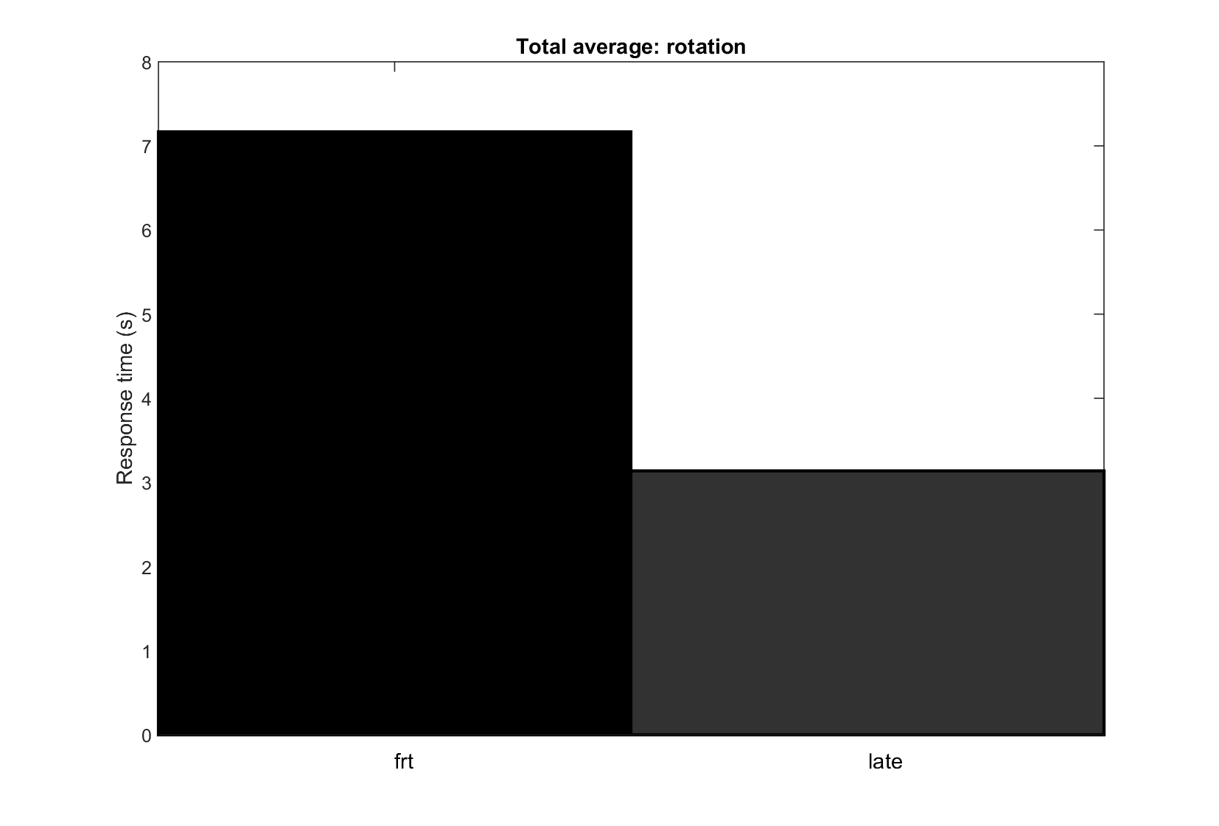

Figure 1 : New figure, just to see a general trend. Total response time average across participants, trials, axis conditions, directional conditions, stimulus conditions. I did not intend to put this in the paper.

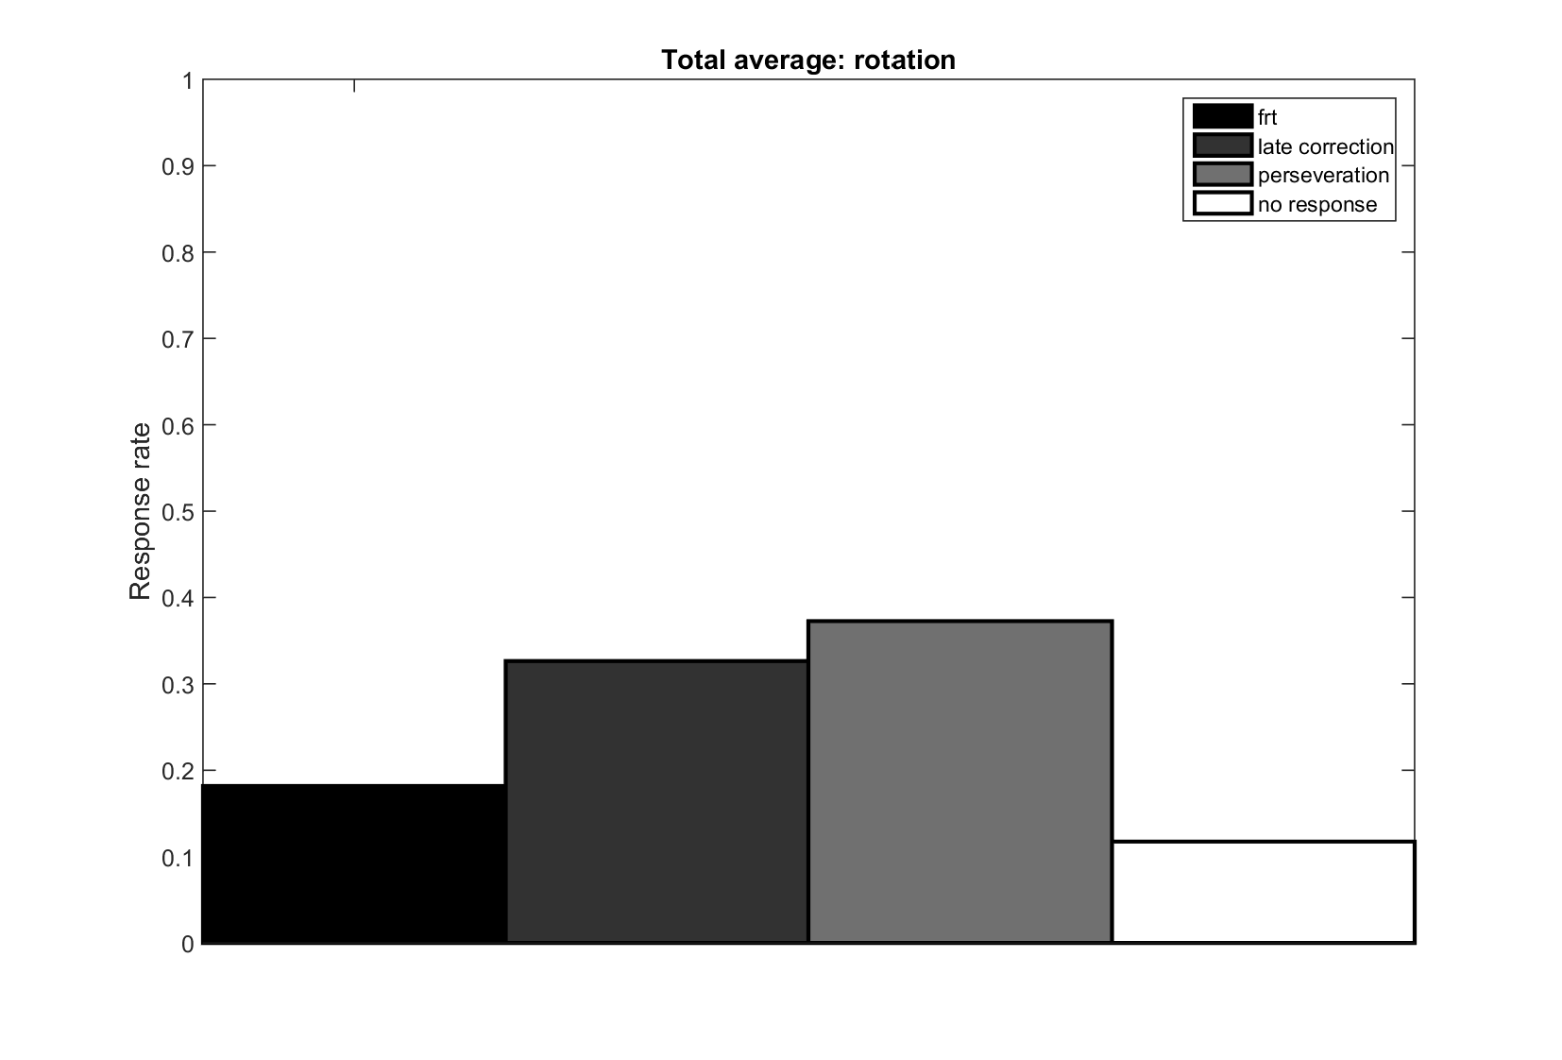

Figure 2 : New figure, just to see a general trend. Total response rate average across participants, trials, axis conditions, directional conditions, stimulus conditions. I did not intend to put this in the paper.

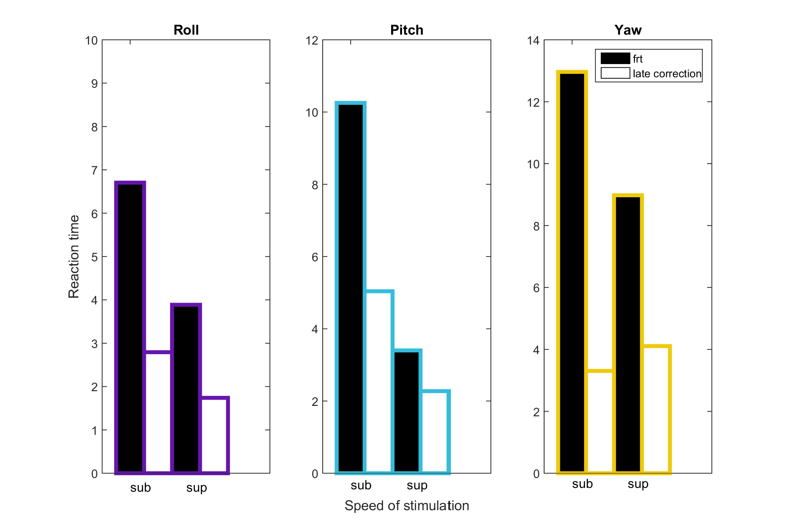

Figure 3 : New figure that I wanted to create to compare reaction times for frt and late correction. Anne-Claire did not make this figure, I intended to put this in the paper.

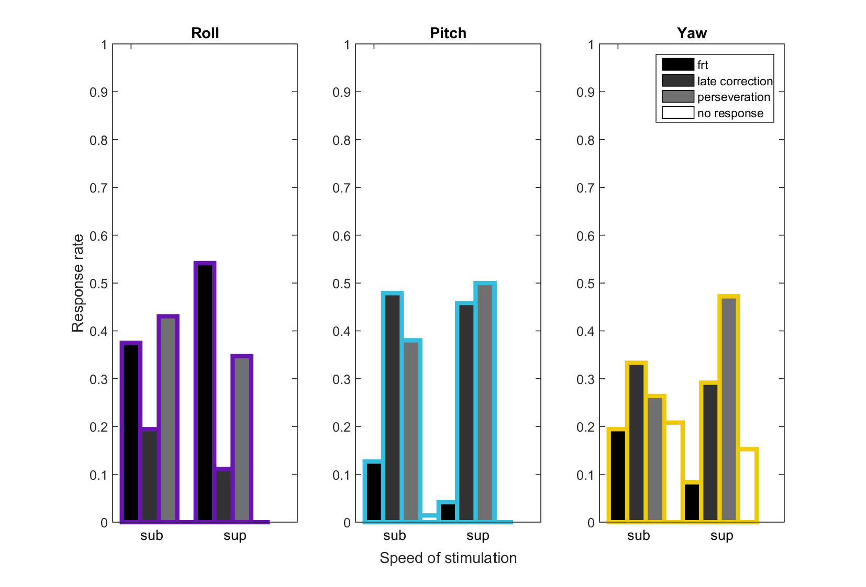

Figure 4 : Closer to Anne-Claire’s result (frt roll, frt yaw, and no response yaw are exact). Pitch is different than her result, which indicates a difference in data used, perhaps she used all the data instead of just the last 30 trials.

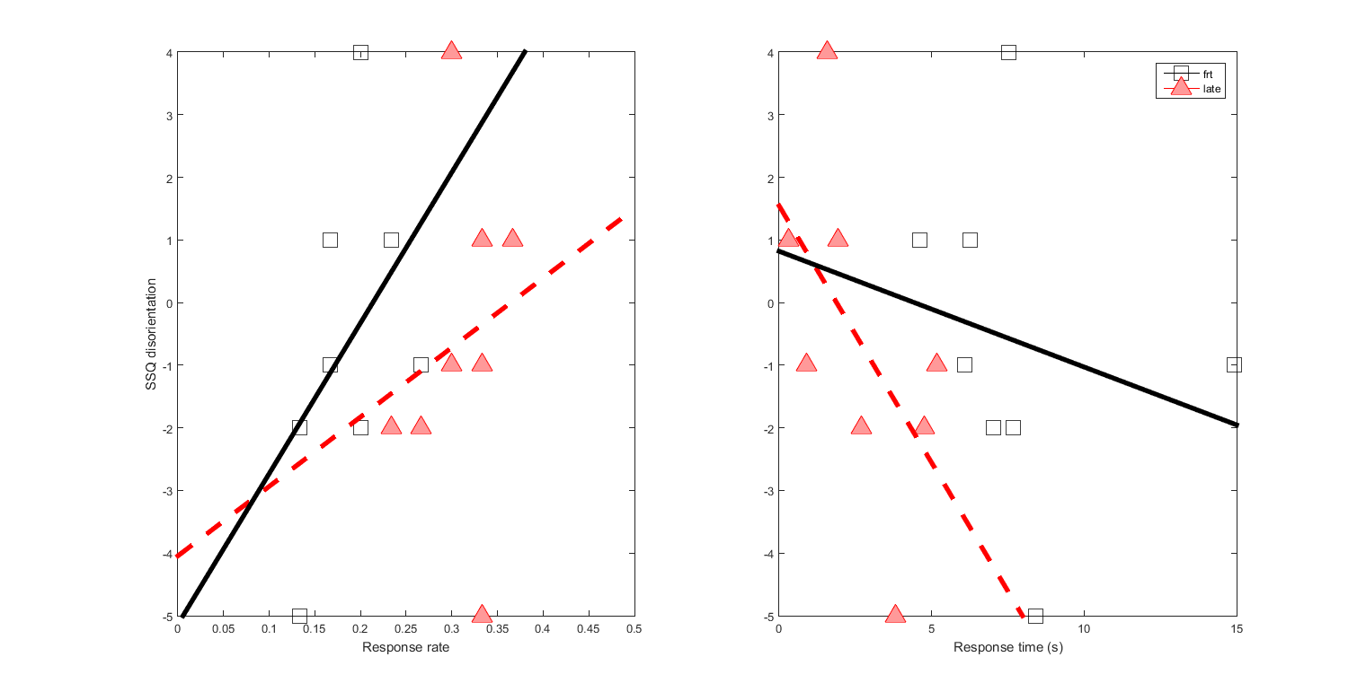

Figure 5 : SSQ disorientation subscale : I intended to put this in the paper. This figure connects response rate (frt, late correction) and time to disorientation, we were lacking the connection between our response characteristics and disorientation in the first draft.

Observations:

(1) SSQ dis and response rate:

a) for those who responded with less late or frt (meaning they never succeed to detect,

small response rate value), they are more disoriented (large

negative SSQ value). And, vice versa, as participants feel

better after the task (positive SSQ dis) they tend to respond

with more late behavior followed by frt.

b) shows that for this task, if participants were not disoriented,

they should respond with frt 20.59% of the time and late 36.67%; there is a

16% difference between the two(0.3667 - 0.2059=0.1608)

(2) SSQ dis and response time:

a) For those who respond late tend to respond quickly, the

quicker they respond the less disoriented they are, but the

longer they wait and respond late they are more disoriented.

b) For those who respond frt tend to respond slower, and

do not become as disoriented as late responders (half as likely

to become disoriented as late responders)

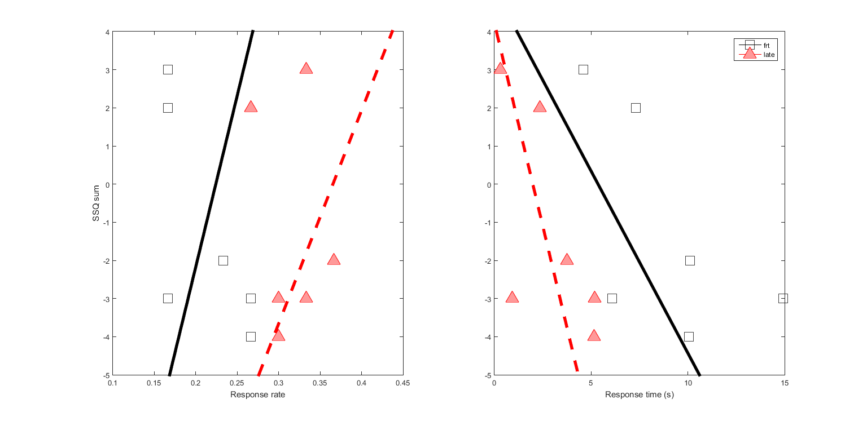

Figure 6 : SSQ sum (nausee, oculo-motor, disorientation, sickness)

Translation

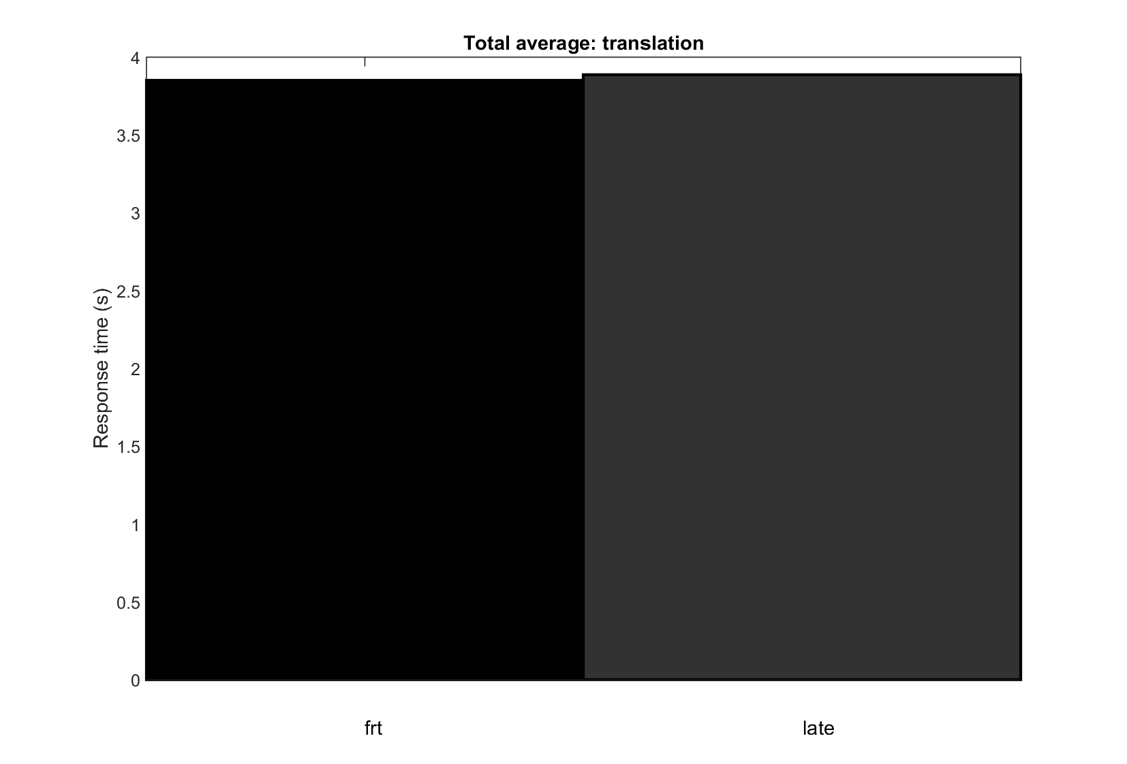

Figure 7 : New figure, just to see a general trend. Total response time average across participants, trials, axis conditions, directional conditions, stimulus conditions. I did not intend to put this in the paper.

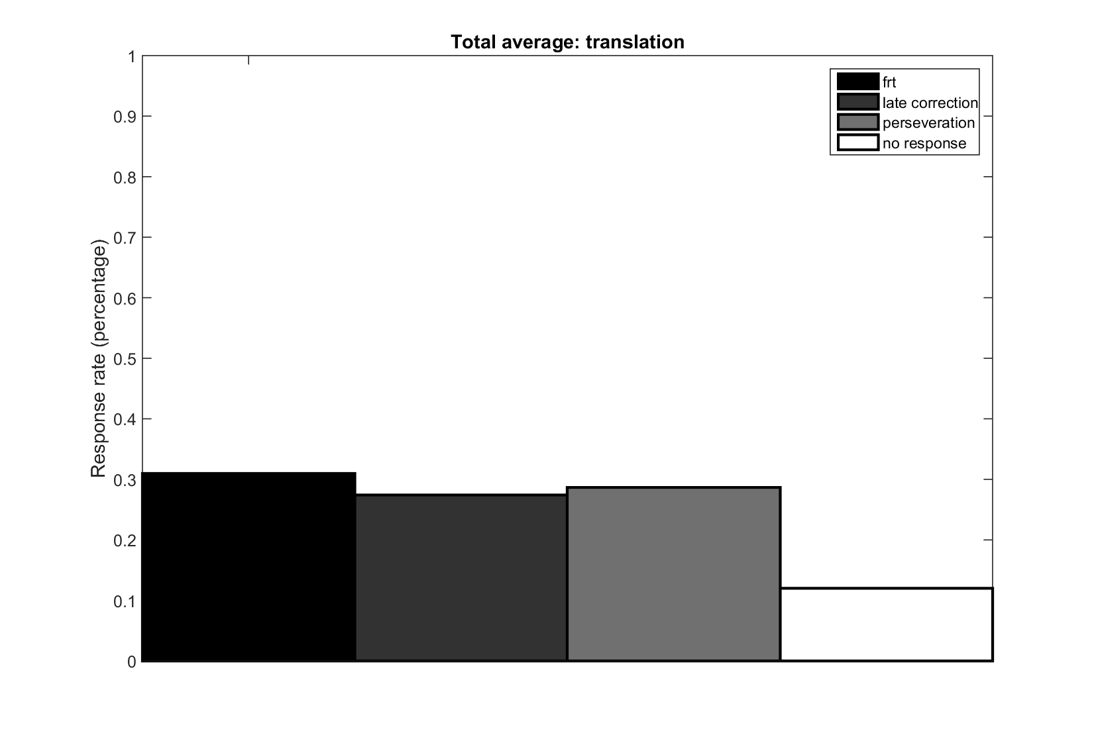

Figure 8 : New figure, just to see a general trend. Total response rate average across participants, trials, axis conditions, directional conditions, stimulus conditions. I did not intend to put this in the paper.

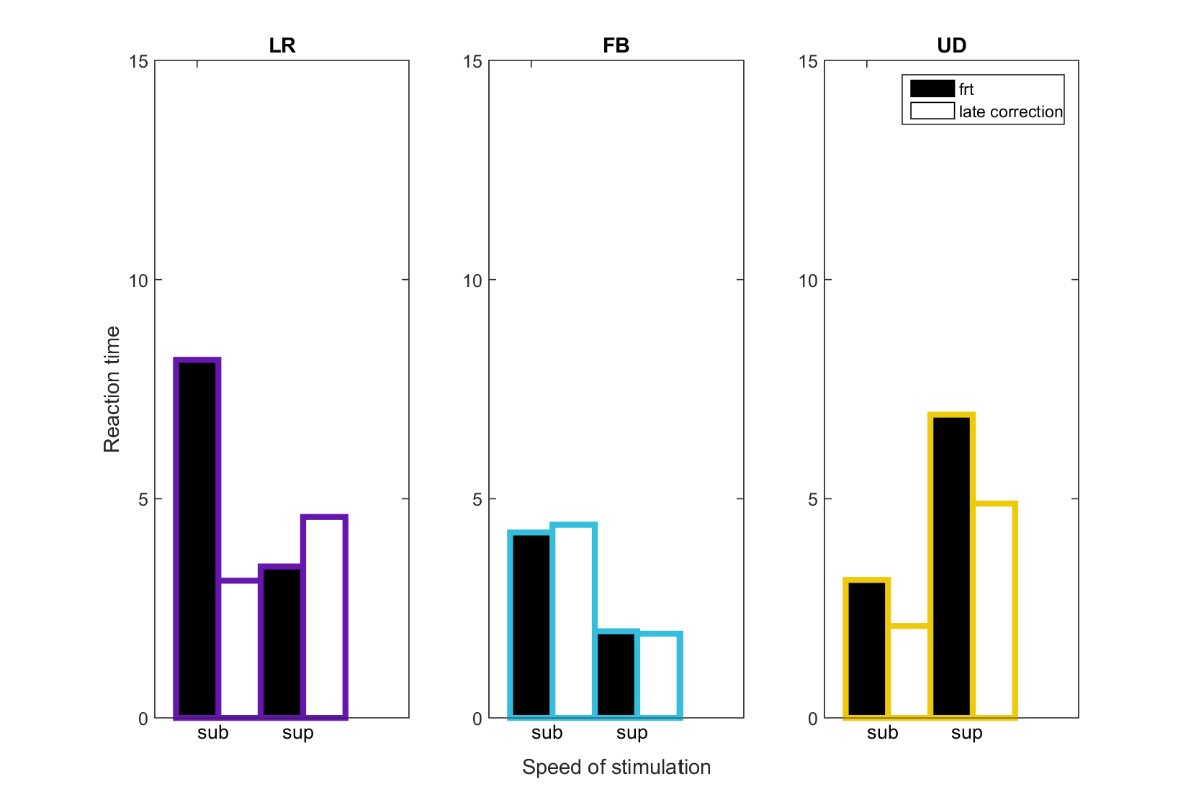

Figure 9 : New figure that I wanted to create to compare reaction times for frt and late correction. Anne-Claire did not make this figure, I intended to put this in the paper.

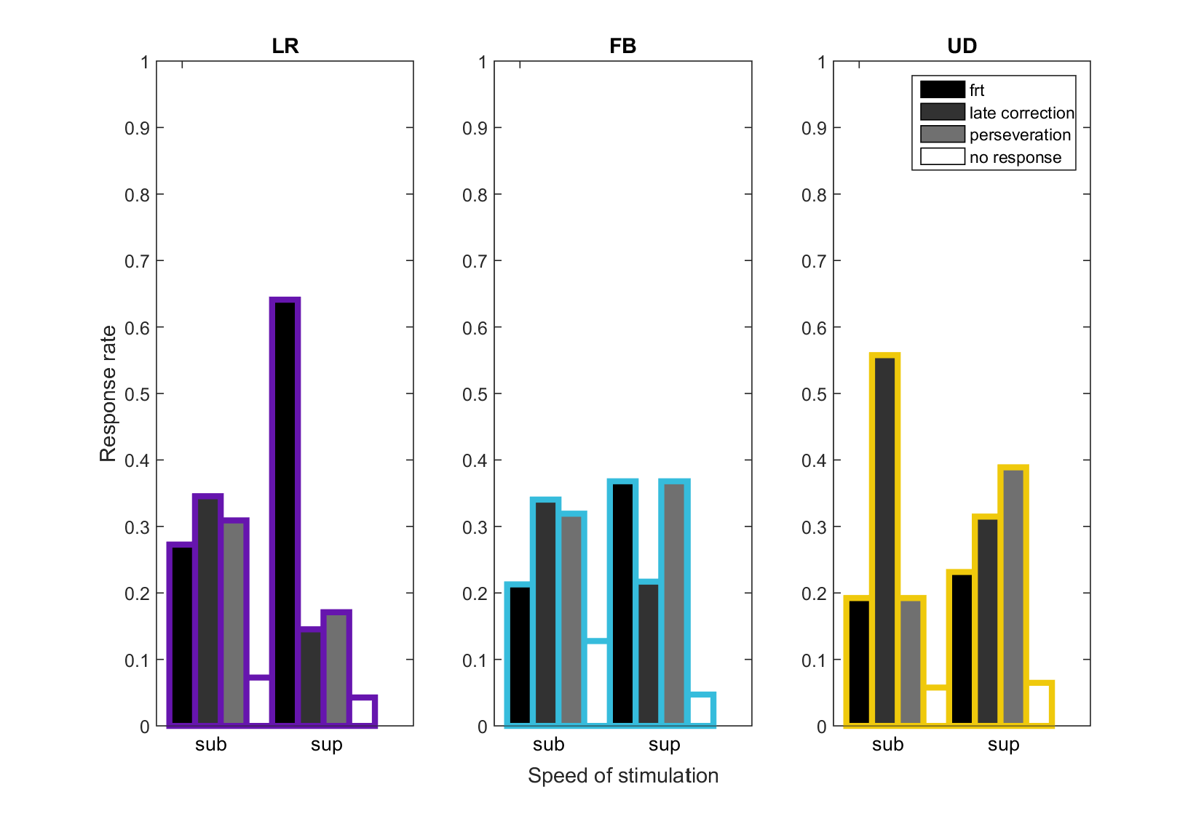

Figure 10 : Closer to Anne-Claire’s result (frt roll / pitch / yaw and no response roll / pitch / yaw are similar). Differences in late correction and perseveration.

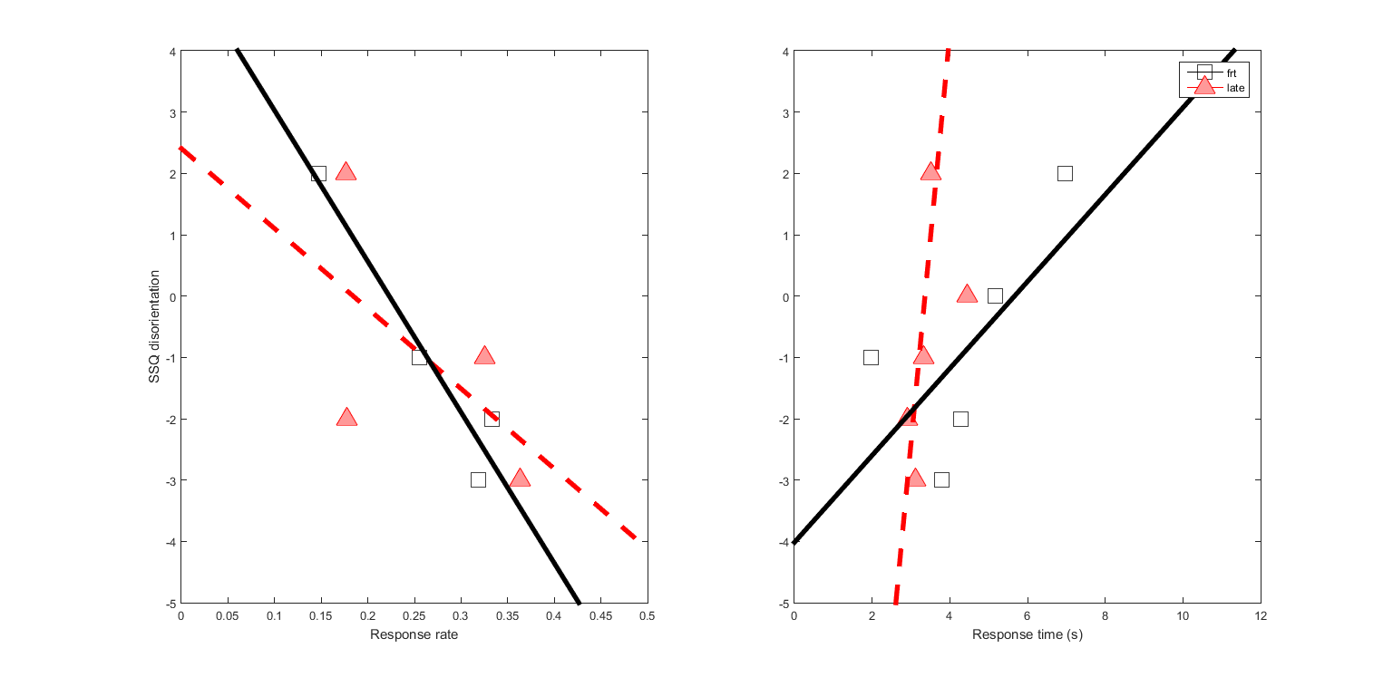

Figure 11 : SSQ disorientation subscale : I intended to put this in the paper. This figure connects response rate (frt, late correction) and time to disorientation, we were lacking the connection between our response characteristics and disorientation in the first draft.

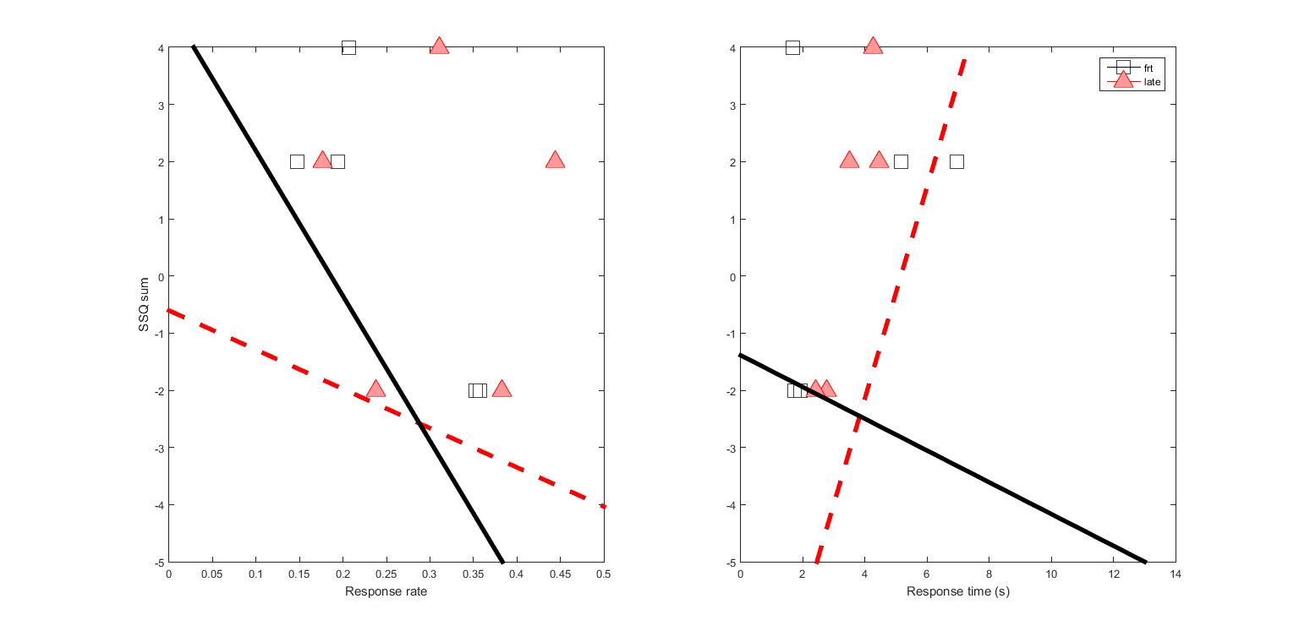

Figure 12 : SSQ sum (nausee, oculo-motor, disorientation, sickness)