Rotation

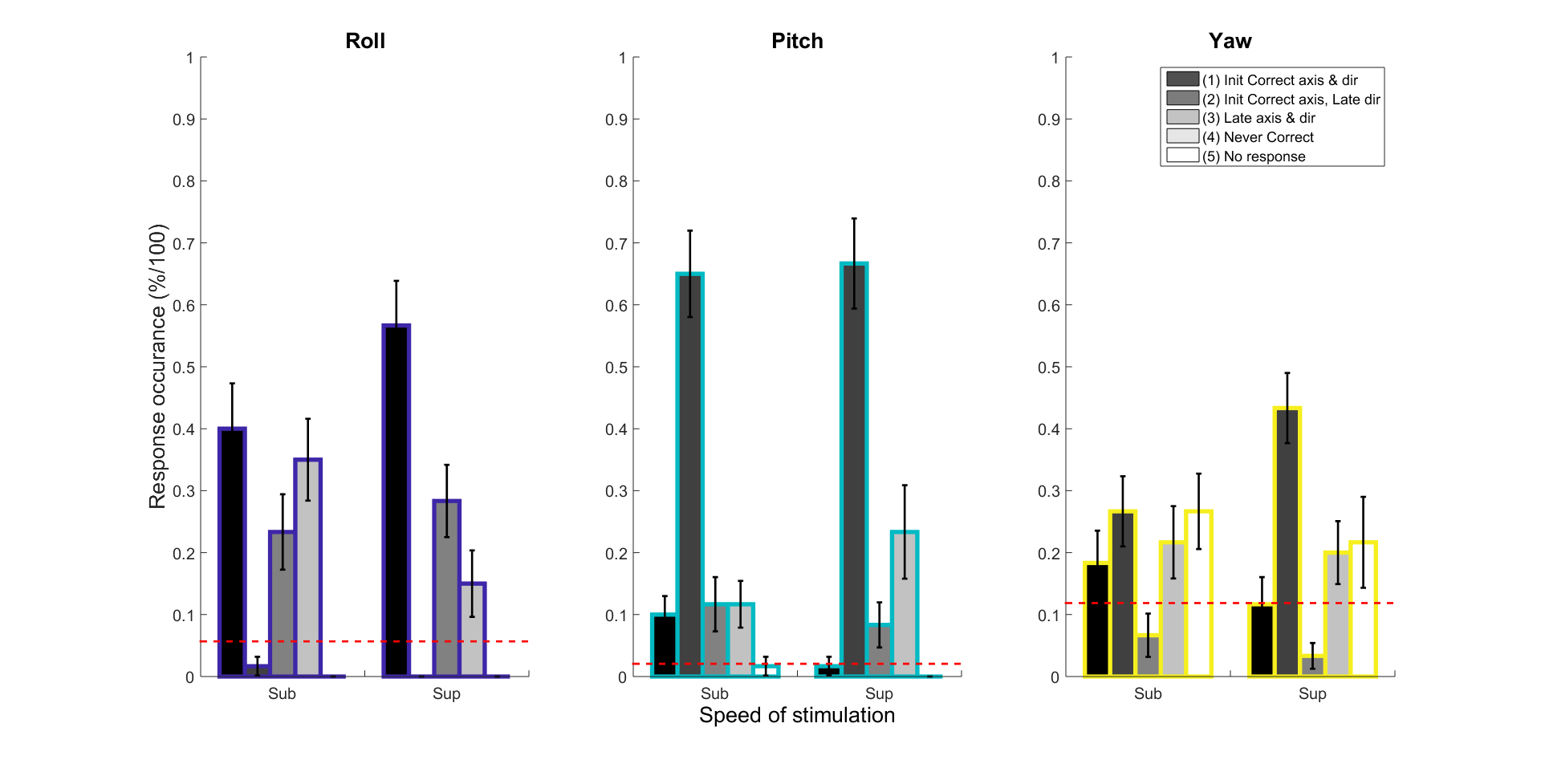

**Figure: (Table calculation) Response occurrence**: Roll can compare (1), (3), (4). Pitch can compare (2), (3),(4). Yaw can compare (2), (4), (5)

Ok, wonderful ! With the lower confidence interval we obtain the pattern that we expect. For example, Roll (1) sub is less than (1) sup. Also, Pitch (2) sub is less than (2) sup. Also, Yaw (2) sub is less than (2) sup. This also shows that for Roll response participants could immediately detect axis and direction, whereas for Pitch and Yaw they could detect the correct axis but they had difficulty in detecting the direction initially. Also, in comparing Pitch and Yaw we can see that participants even had more trouble detecting Yaw. The fact that participants could best detect Roll, followed by Pitch and then Yaw is in alignment with movement thresholds found in literature. In general, Roll has the lowest movement threshold, followed by Pitch and then Yaw\cite{Benson, Hartmann}.

In running the Wilcoxon sign rank test :

* (p < 0.05) Roll (1) sub is significantly smaller than Roll (1) sup – makes sense because for sub they could not detect the movement as well as in sup, so they got more ‘Initial Correct axis & direction’ responses for sup than sub
* (p > 0.0061) Roll (4) sub is significantly bigger than Roll (4) sup – makes sense because for sub they could not detect the movement as well as in sup, so they got more ‘Never correct’ responses for sub than for sup.
* (p < 0.0220) Yaw (2) sub is significantly smaller than Yaw (2) sup – makes sense because for sub they could not detect the movement as well as in sup, so they got more ‘Initial Correct axis, Late direction’ responses for sup than sub

**Figure: (Stacking calculation) Response occurrence**

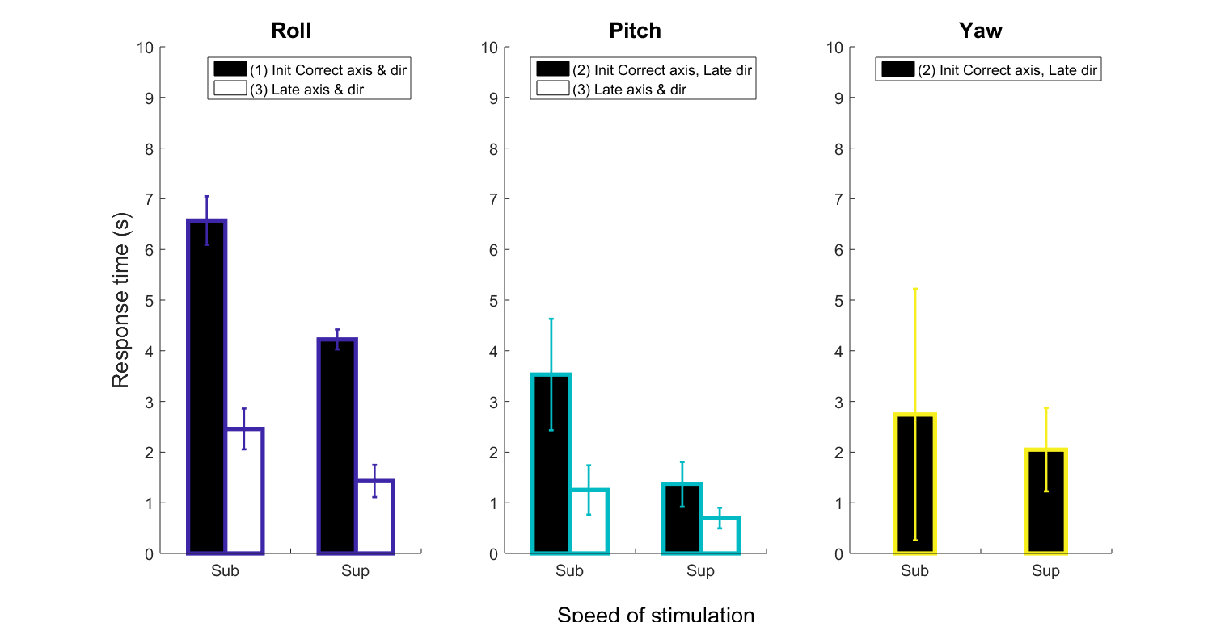

**Figure : (Table calculation) Response time** for Initial and Late response above the 95% lower confidence interval

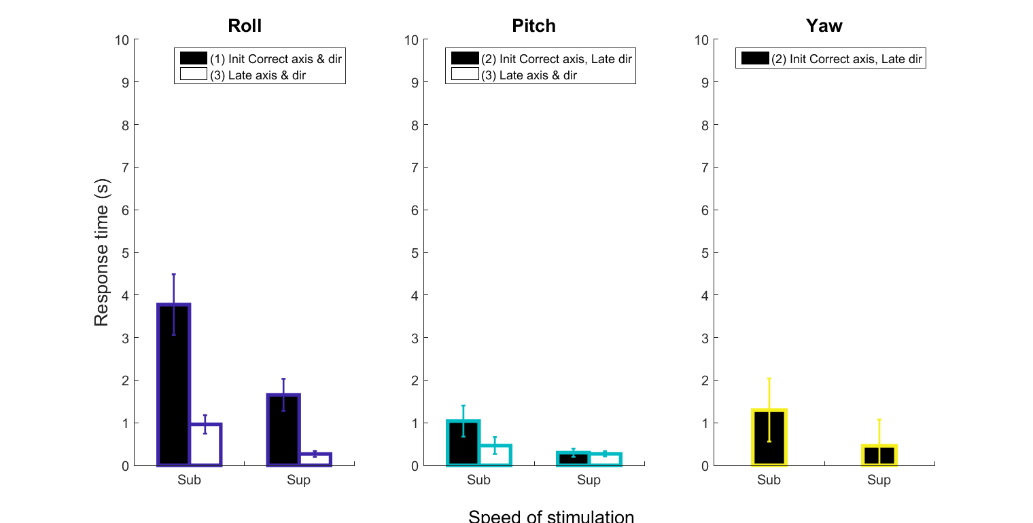

**Figure : (Stacking calculation) Response time** for Initial and Late response above the 95% lower confidence interval

We want to report the mean difference between Initial and Late ; knowing the difference between Initial and Late tells us how much time the pilot needs before they succeed in detecting the correct stimulation. In terms of automated assistance during disorientation, knowing how much time on average the pilot needs to detect is useful because automated systems can wait, this amount of time, instead of starting automatically and even confusing the pilot more.

The Wilcoxon sign rank test reports that sub(3) and sub (1) & sup (3) and sup(1) are significantly different (p < 0.0313) & (p<0.00048). This means that participants whom immediately acted on the stick, searching for information, eventually found the correct axis and direction faster than when participants waited to perceive the movement and report it correctly. Therefore, initial erroneous detection does not necessarily mean a loss of time, self-movement generated by mistakes during roll can help detection faster as long as it is done in approximately 3-4 seconds. Other Initial and Late relationships were not significant, however it is interesting to note a similar trend, of finding the correct axis and direction rapidly despite detecting initially wrong in comparison to inital correct detection, for sub roll (1.14 second difference) and pitch (2.17 second difference).

In running the Wilcoxon sign rank test :

* (p < 0.00024) Roll (1) sub and Roll (1) sup are significantly different

Table matlab gives different answer than organizing by switch for rotational. Translational obtains the same answer . which to beieve… Organizing by switch does not give correct signed rank sum statistic (roll (1) is obviously significant but it says it is not). Stats are correct for table matlab.

* I believe the switch more, because translational and rotational response times in literature are similar (not 2 times more for rotational than translational). The problem seems to be the way matlab does the table calculation…

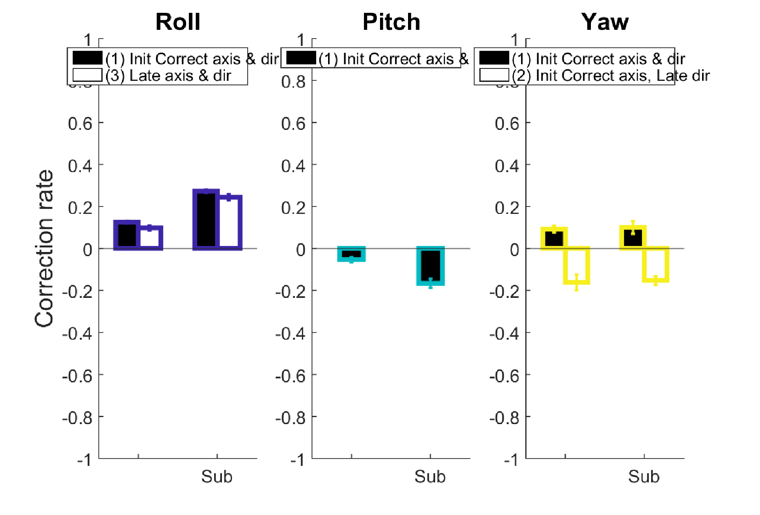

**Figure : (Table calculation) Correction rate**

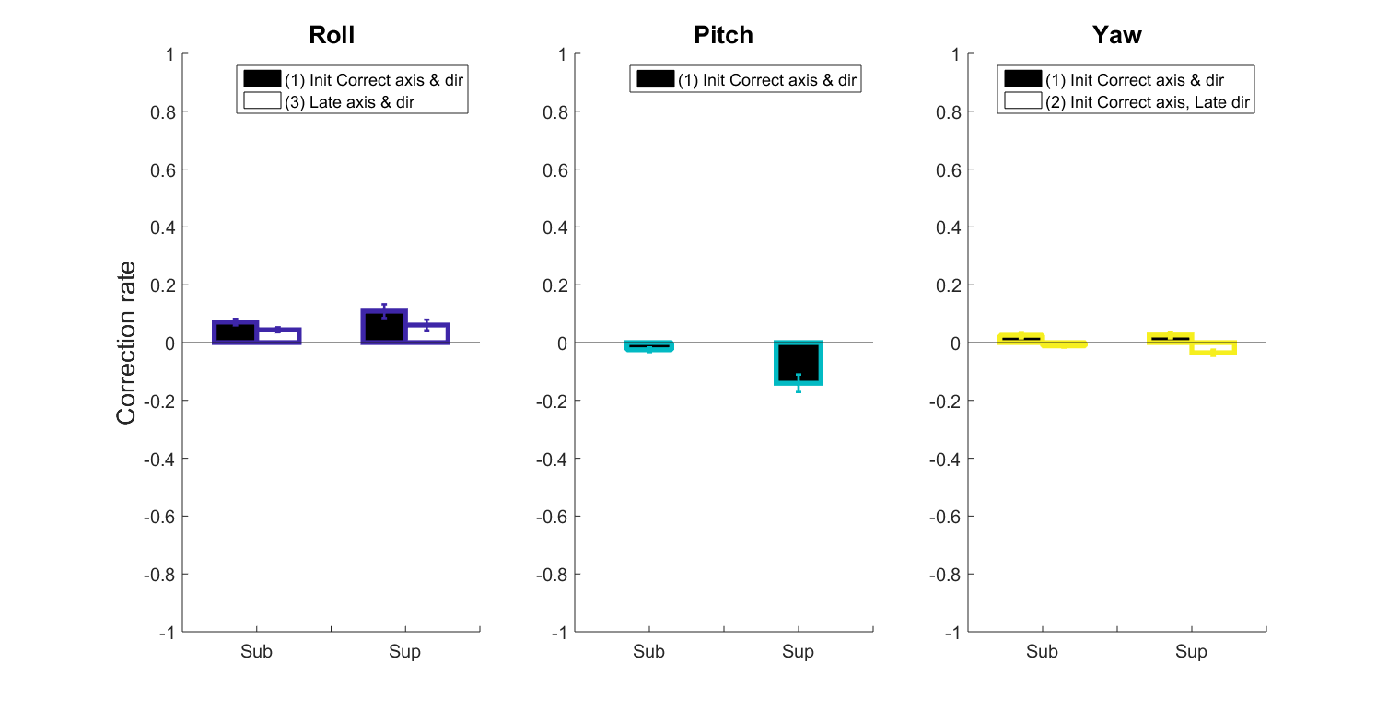

**Figure : (Stacking calculation) Correction rate**

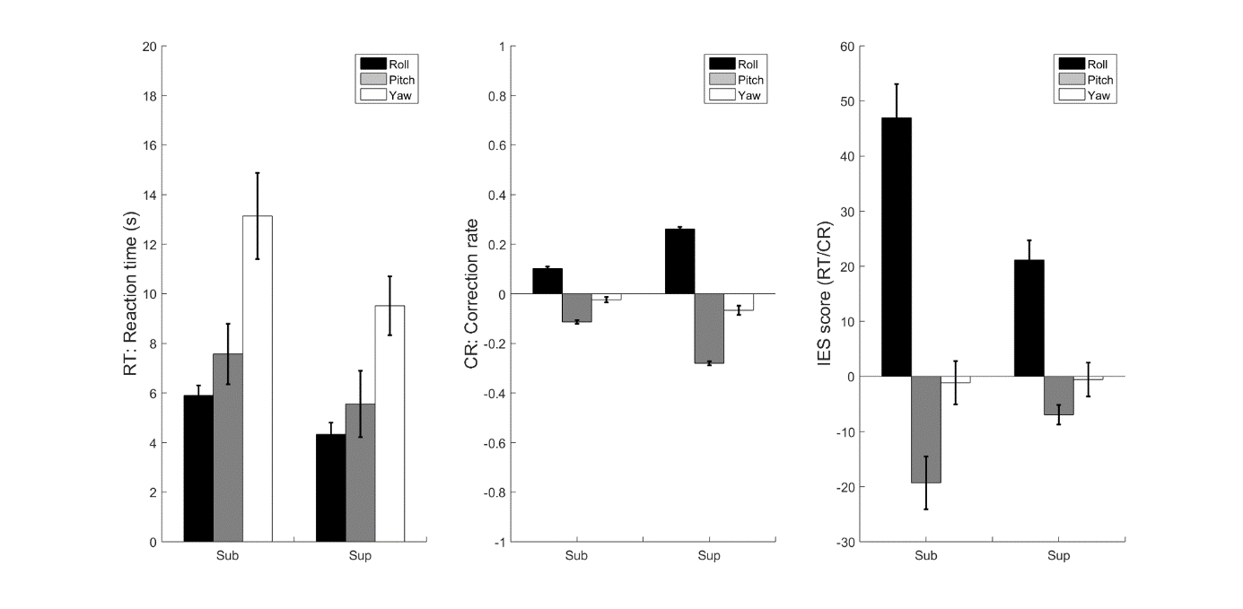

**Figure : (Table calculation) Summary of Detection and Correction** \*\***ALL\*\*** participants 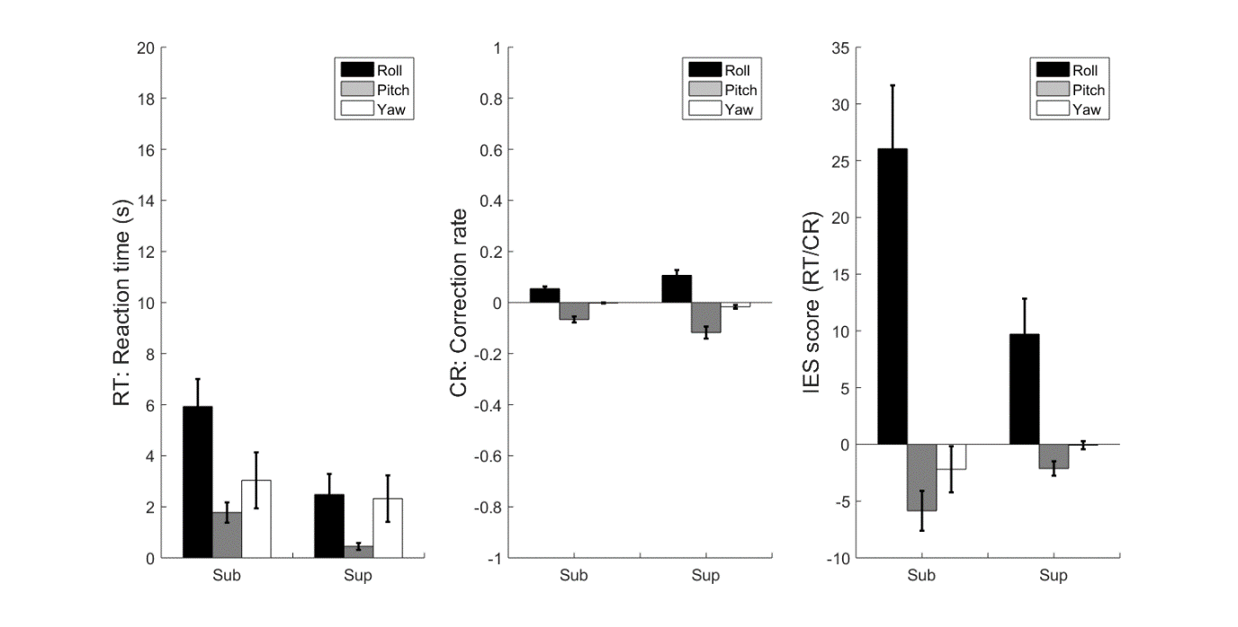

**Figure : (Stacking calculation) Summary of Detection and Correction** \*\***ALL\*\*** participants

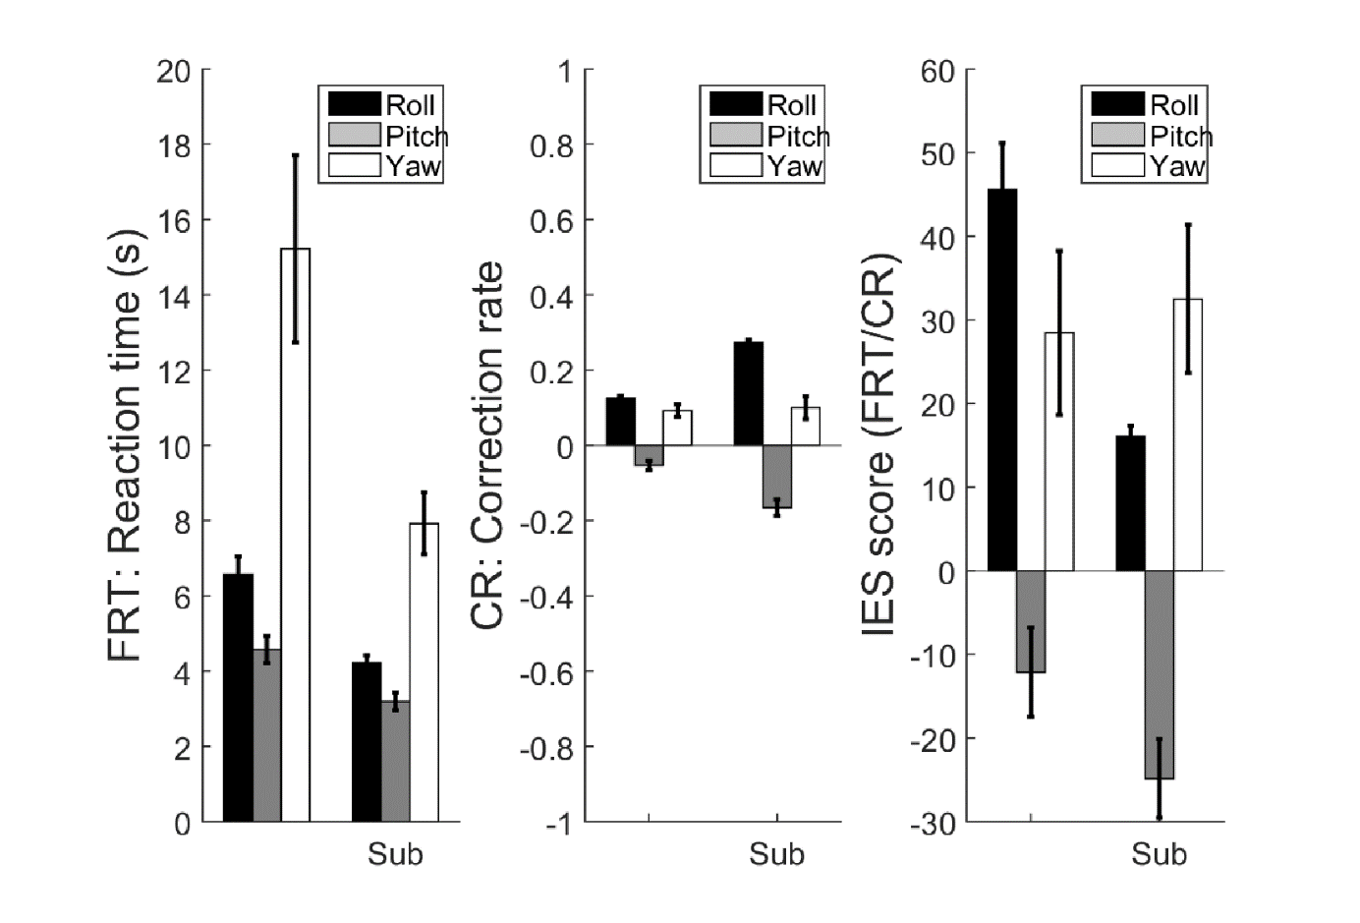

**Figure : (Table calculation) Summary of Detection and Correction** \*\***FRT\*\*** participants 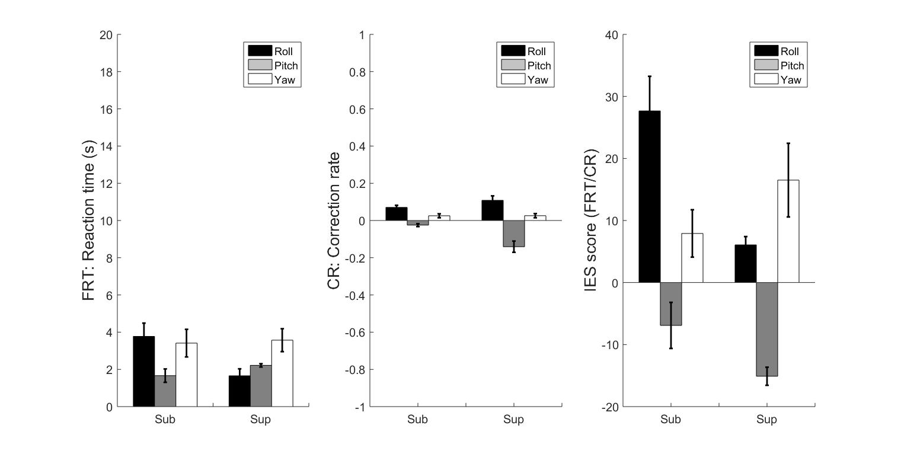

**Figure : (Stacking calculation) Summary of Detection and Correction** \*\***FRT\*\*** participants

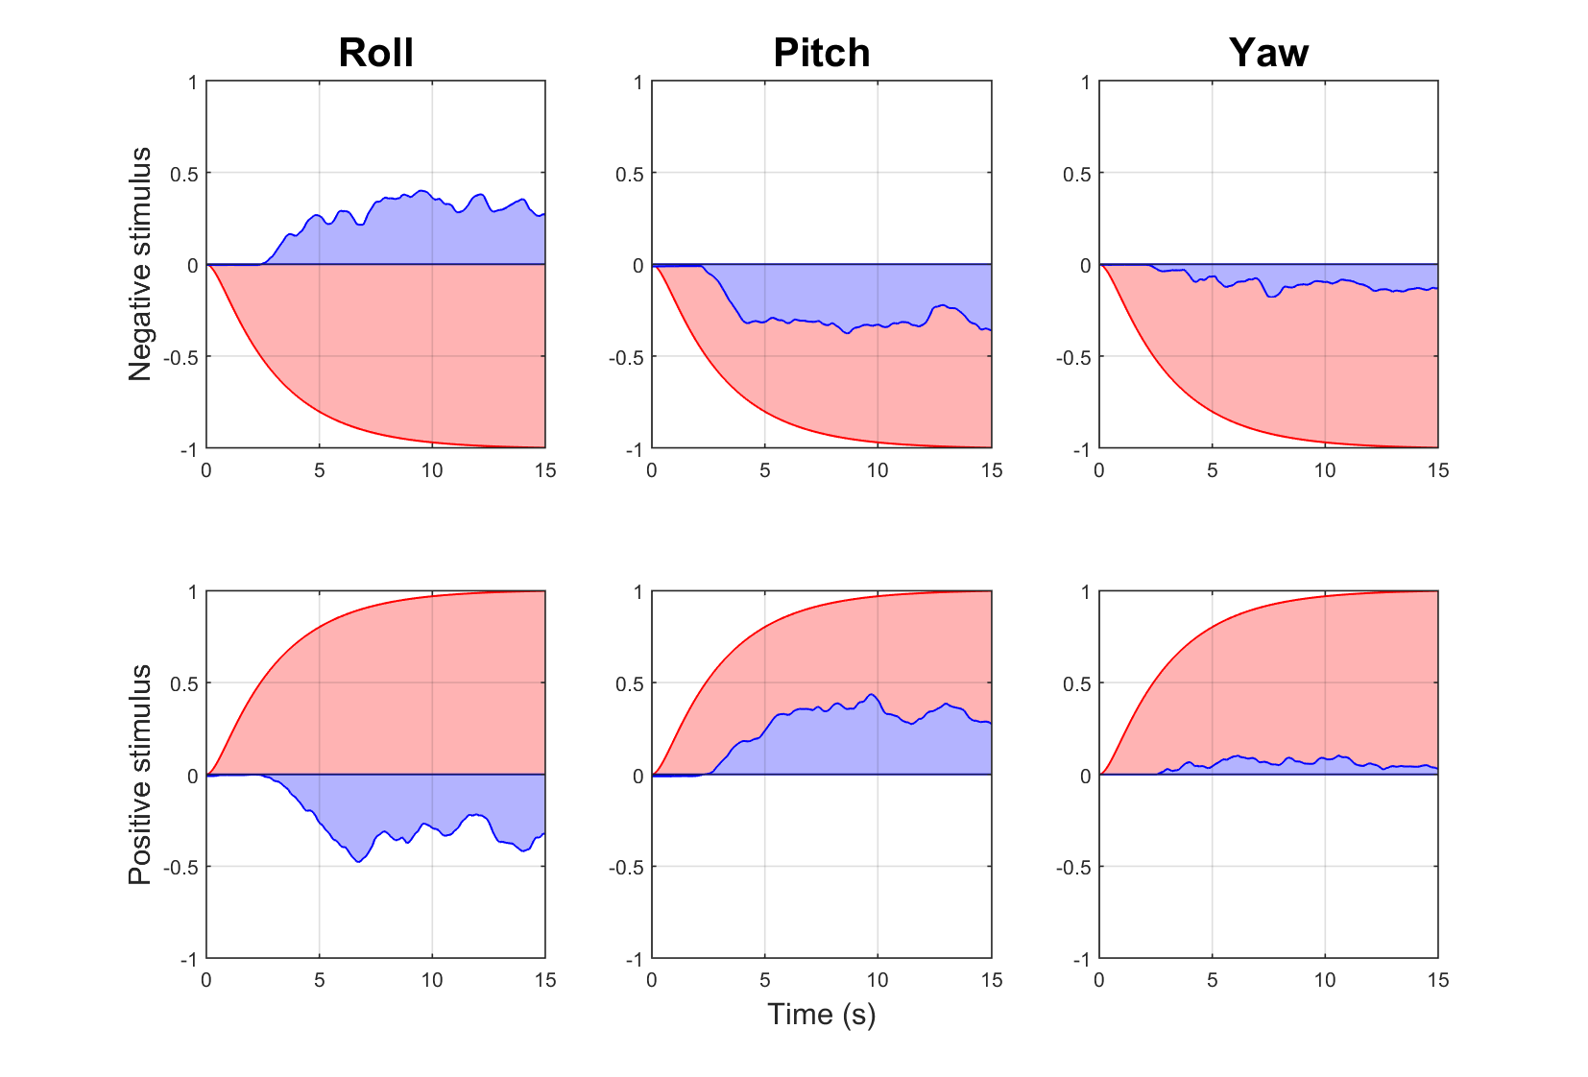

**Figure : Joystick and stimulus trajectories for sup-threshold stimulation**

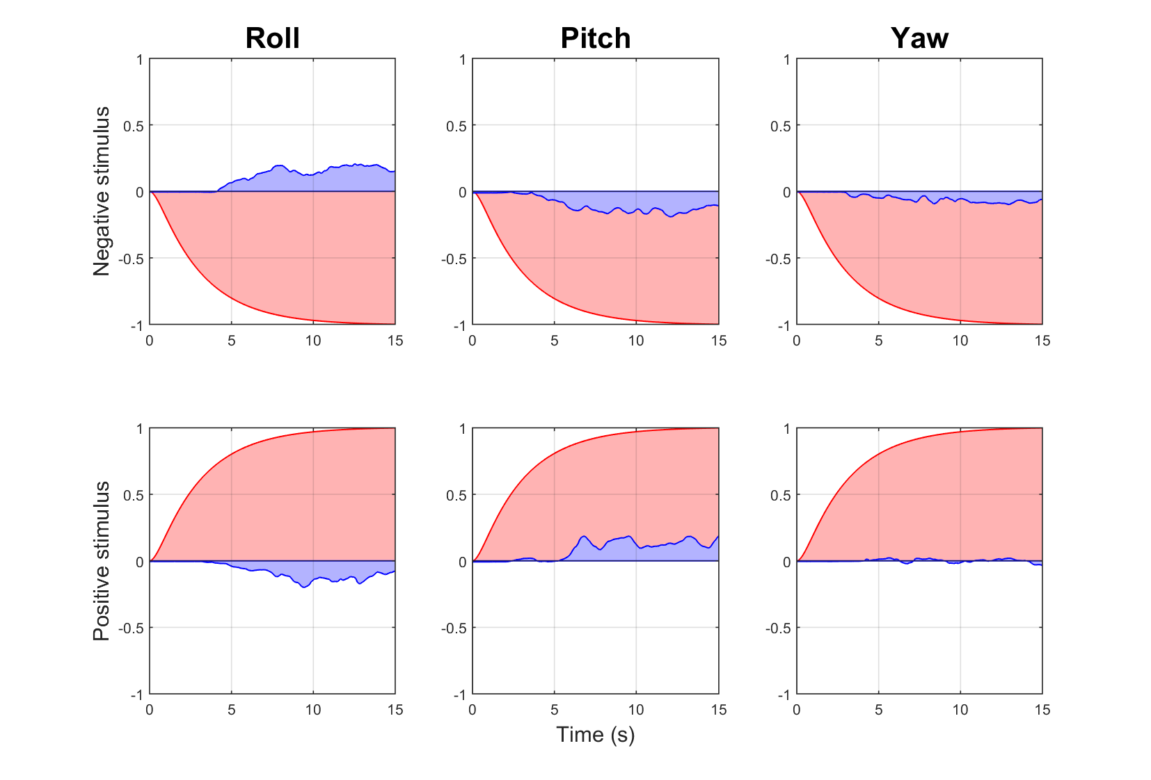

**Figure : Joystick and stimulus trajectories for sub-threshold stimulation**

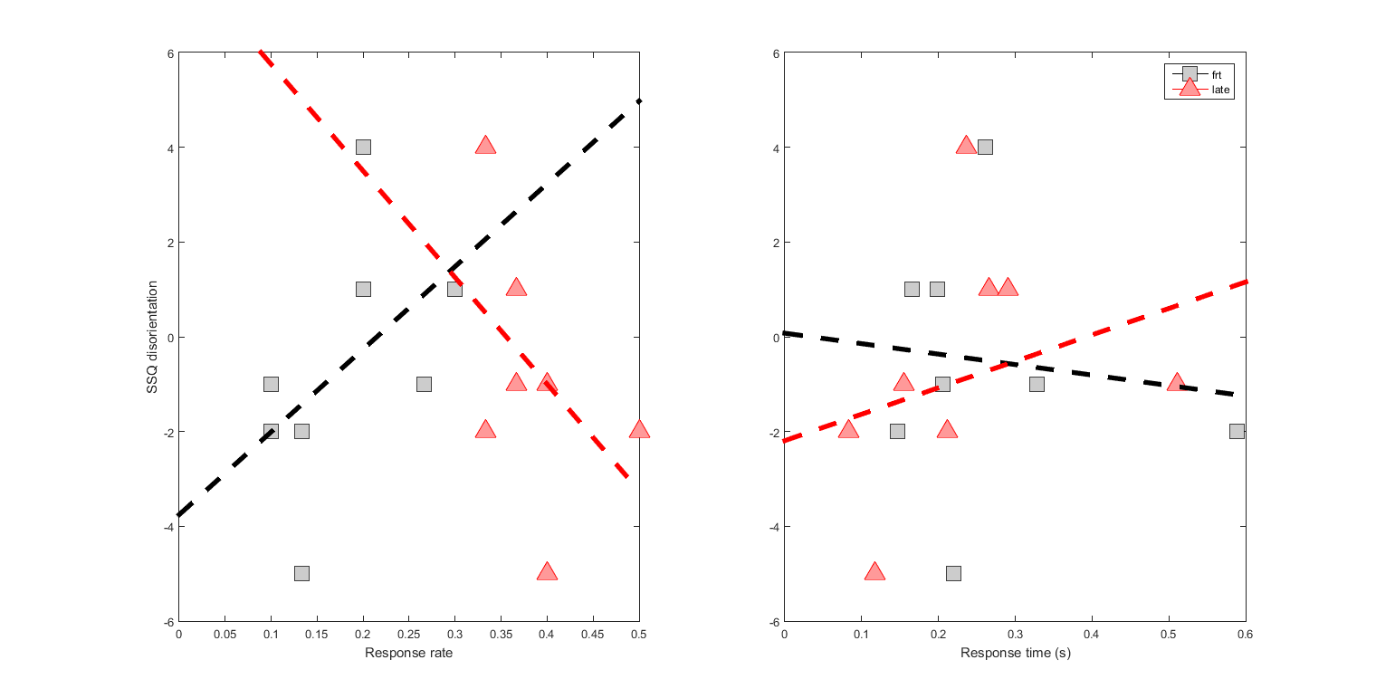

**Figure : (Table calculation) SSQ disorientation subscale :** I intended to put this in the paper. This figure connects response rate (frt, late correction) and time to disorientation, we were lacking the connection between our response characteristics and disorientation in the first draft.

**Figure : (Stacking calculation) SSQ disorientation subscale**

Translation

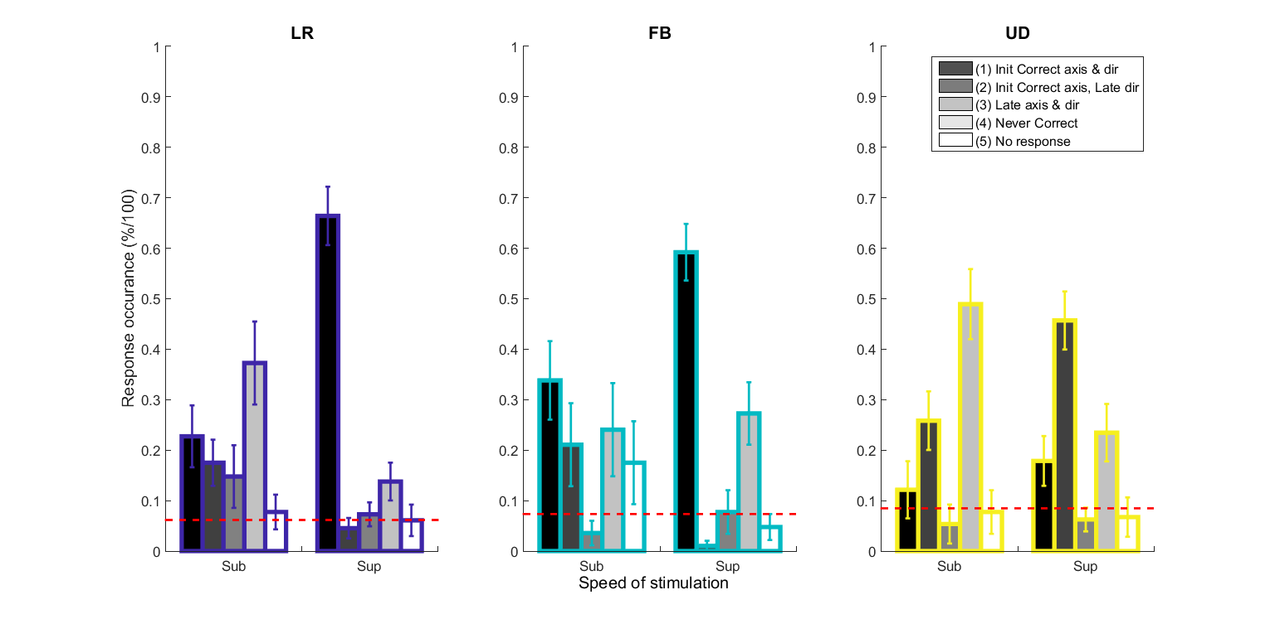

**Figure: (Table calculation) Response occurrence**

**Figure: (Stacking calculation) Response occurrence**

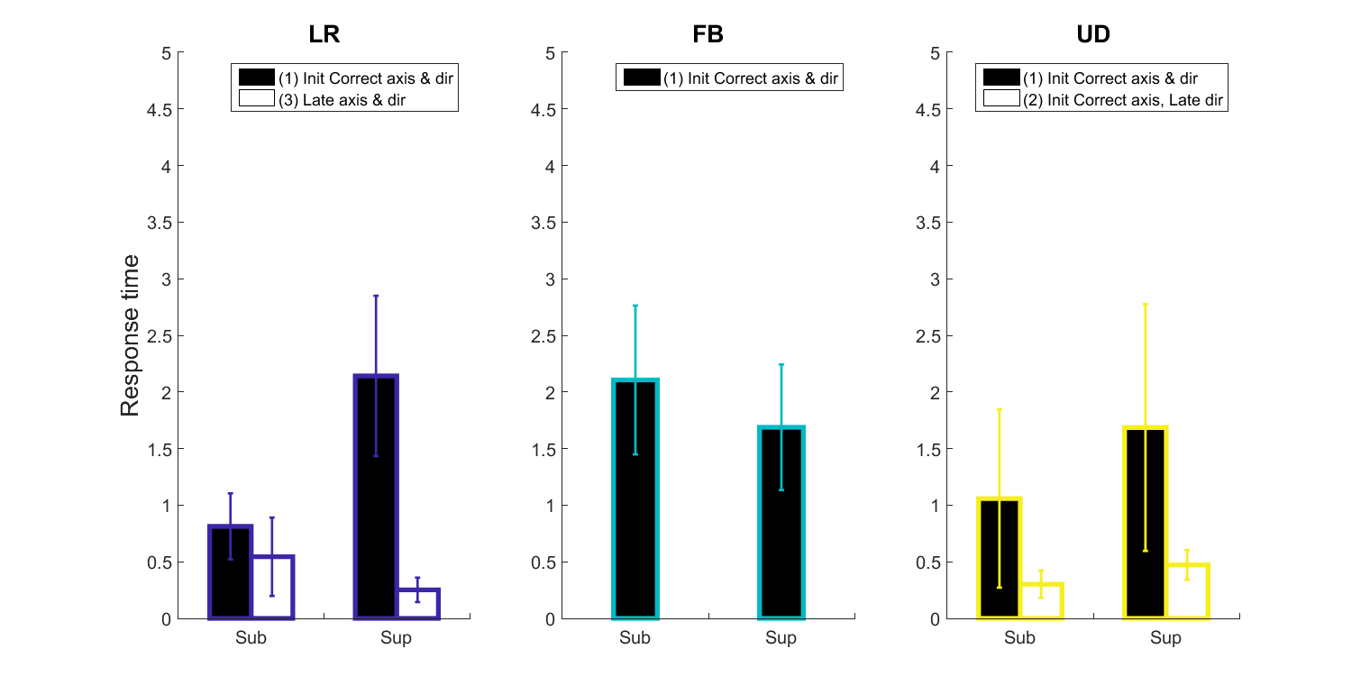

**Figure : (Table calculation) Response time** for Initial and Late response above the 95% lower confidence interval

**Figure : (Stacking calculation) Response time** for Initial and Late response above the 95% lower confidence interval

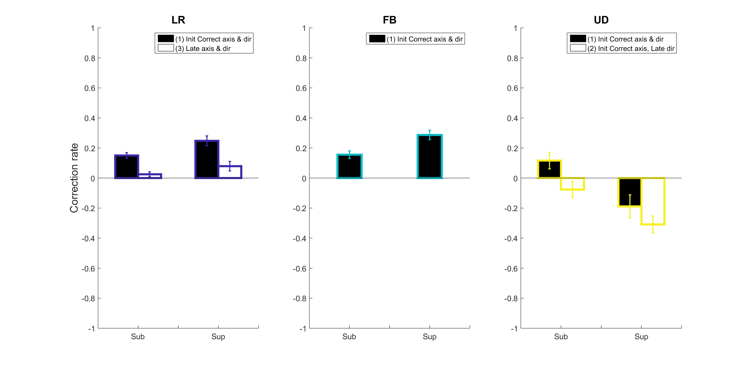

**Figure : (Table calculation) Correction rate**

**Figure : (Stacking calculation) Correction rate**

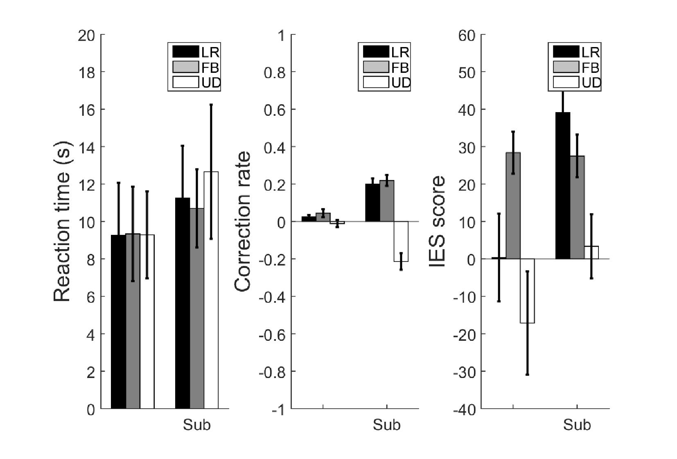

**Figure : (Table calculation) Summary of Detection and Correction **ALL** participants**

**Figure : (Stacking calculation) Summary of Detection and Correction **ALL** participants**

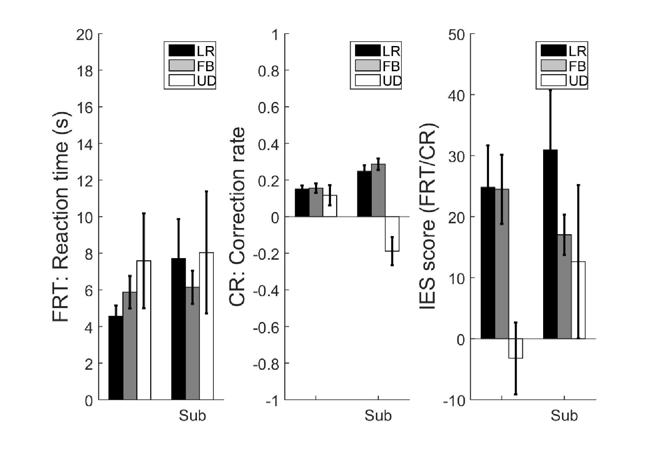

**Figure : (Table calculation) Summary of Detection and Correction **FRT** participants**

**Figure : (Stacking calculation) Summary of Detection and Correction **FRT** participants**

**Figure : Joystick and stimulus trajectories for sup-threshold stimulation**

**Figure : Joystick and stimulus trajectories for sub-threshold stimulation**

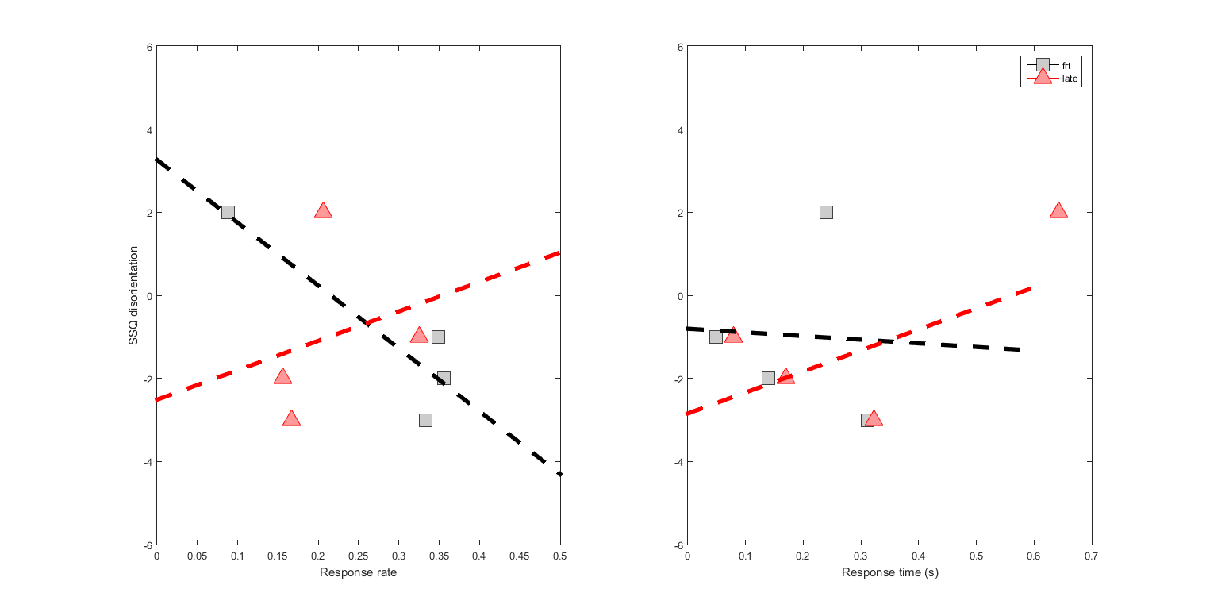

**Figure : (Table calculation) SSQ disorientation subscale**: I intended to put this in the paper. This figure connects response rate (frt, late correction) and time to disorientation, we were lacking the connection between our response characteristics and disorientation in the first draft.

1. SSQ dis and response rate: If one responds quickly , within 0.3 seconds, using an frt response strategy it is likely that they are not disoriented ; this is likely to arrise 25% of the time. However, frt response time always results in some disorientation.

**Figure : (Stacking calculation) SSQ disorientation subscale**