Rotation

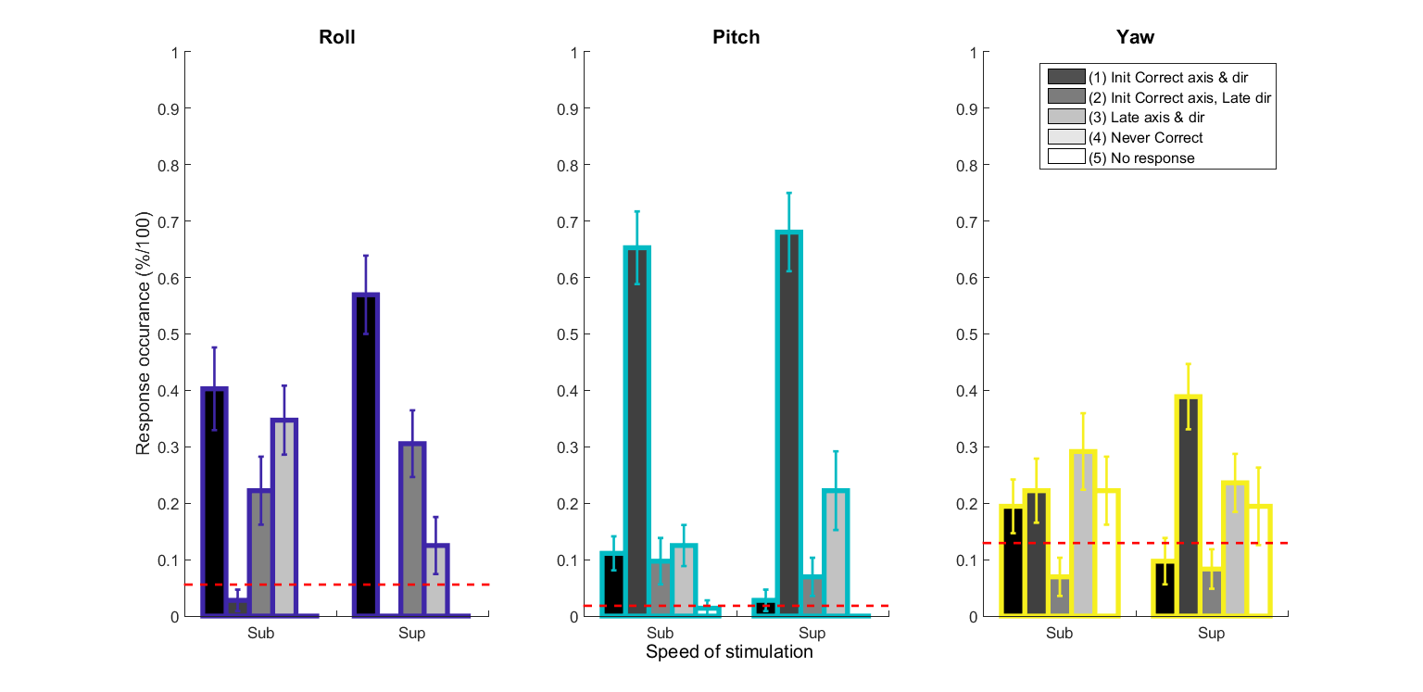

**Figure: (Table calculation) Response occurrence**

In running the Wilcoxon sign rank test :

* (p < 0.05) Roll (1) sub is significantly smaller than Roll (1) sup – makes sense because for sub they could not detect the movement as well as in sup, so they got more ‘Initial Correct axis & direction’ responses for sup than sub
* (p < 0.0061) Roll (4) sub is significantly bigger than Roll (4) sup – makes sense because for sub they could not detect the movement as well as in sup, so they got more ‘Never correct’ responses for sub than for sup.
* (p < 0.0313) Pitch (1) sub is significantly bigger than Pitch (1) sup
* (p < 0.0220) Yaw (2) sub is significantly smaller than Yaw (2) sup – makes sense because for sub they could not detect the movement as well as in sup, so they got more ‘Initial Correct axis, Late direction’ responses for sup than sub

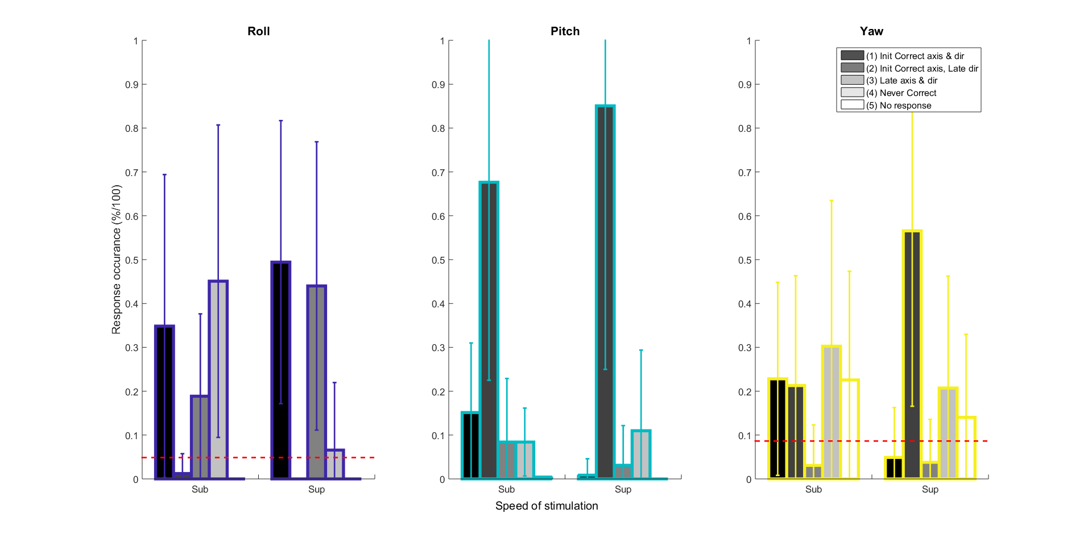

**Figure: (Stacking calculation) Response occurrence**

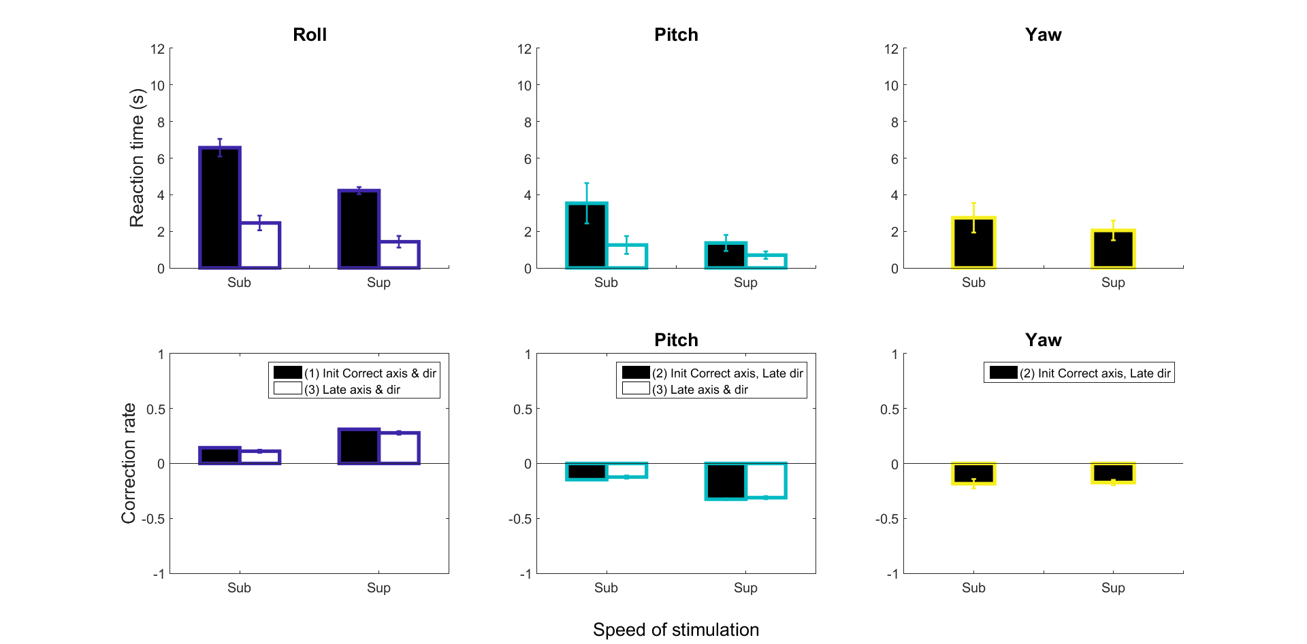

**Figure : (Table calculation) Reaction time and Correction rate** for Initial and Late response above the 95% lower confidence interval.

* (p < 0.00024) Roll RT (1) sup is different than Roll (1) sub
* (p < 0.0313) Roll RT (1) sub is different than Roll (3) sub
* (p < 0.0004) Roll RT (1) sup is different than Roll (3) sup

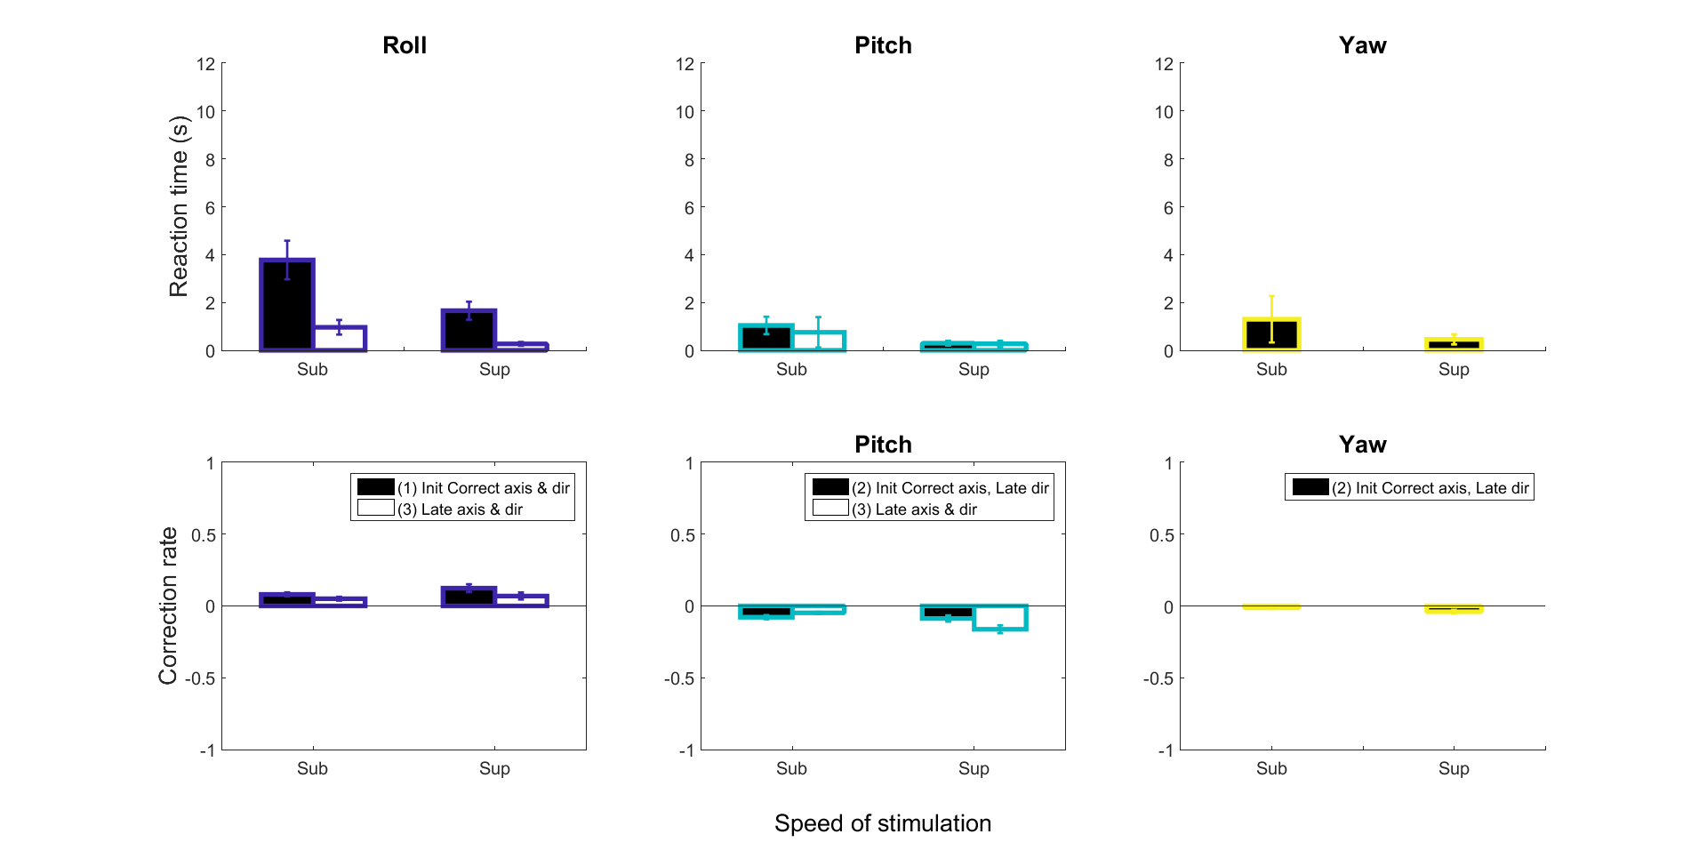

**Figure : (Stacking calculation) Reaction time and Correction rate** for Initial and Late response above the 95% lower confidence interval.

In running the Wilcoxon sign rank test :

* (p < 0.0312) Pitch RT (1) sub and Pitch (1) sup are significantly different
* (p < 0.0078) Roll RT (1) sub is different than Roll (3) sub
* (p < 0.0061) Roll RT (1) sup is different than Roll (3) sup

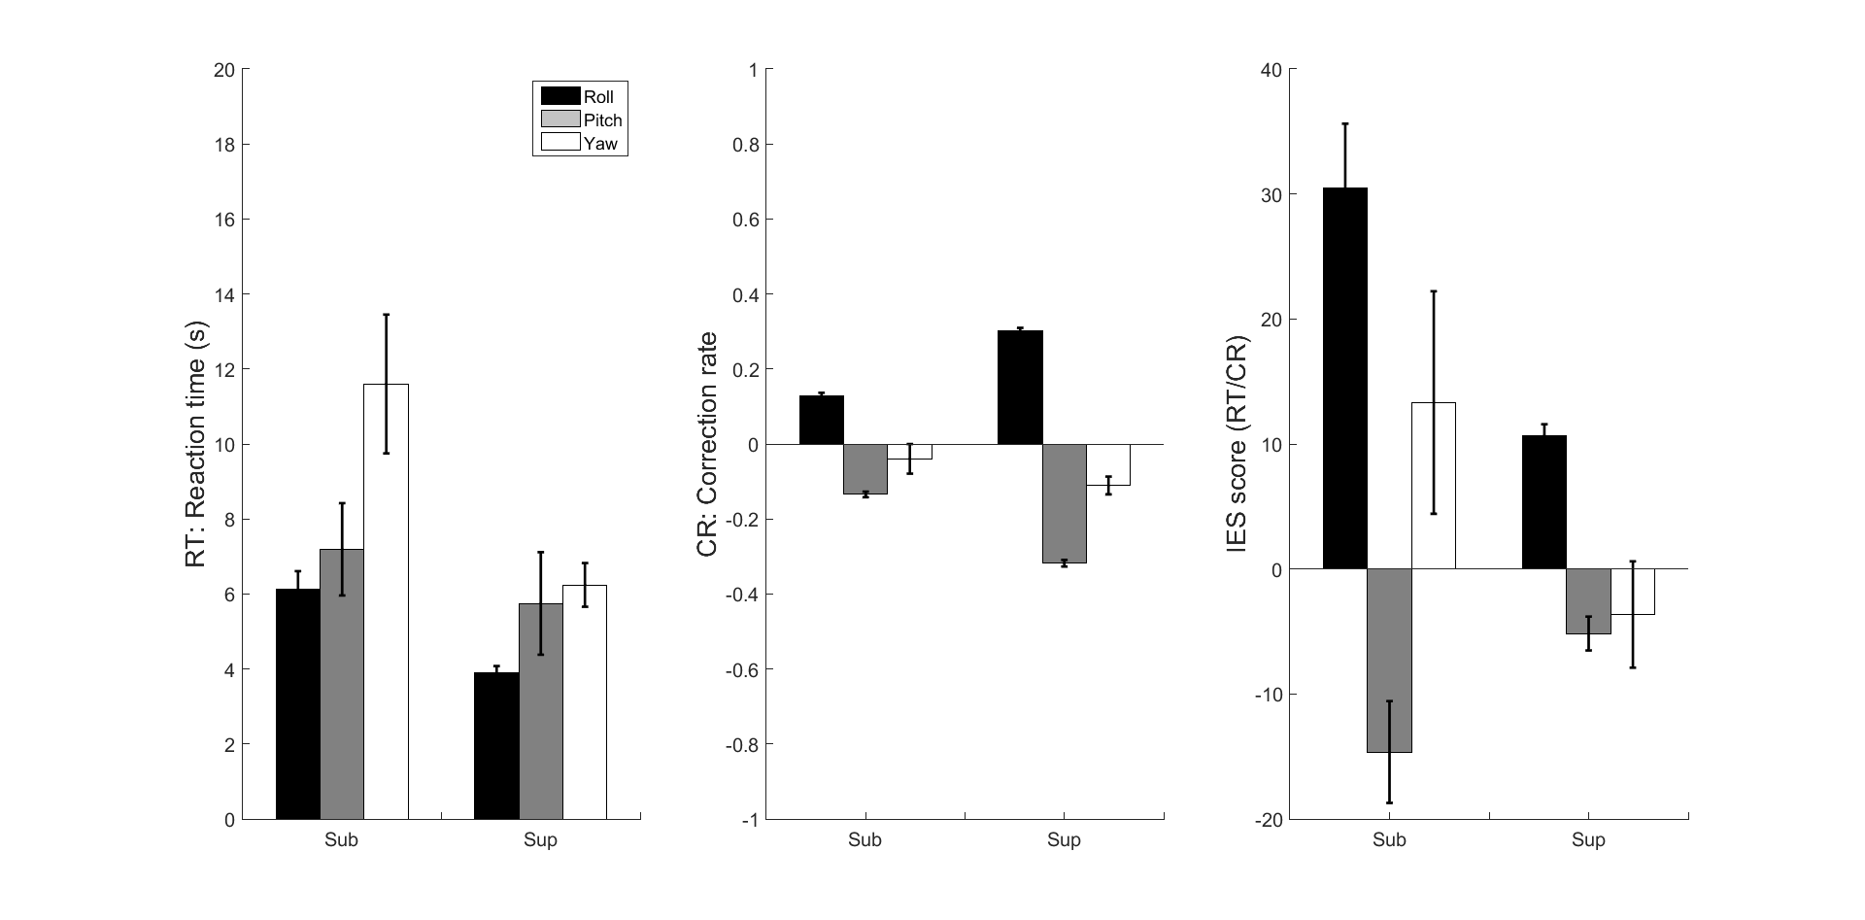

**Figure : (Table calculation) Summary of Detection and Correction **3 categories** participants**

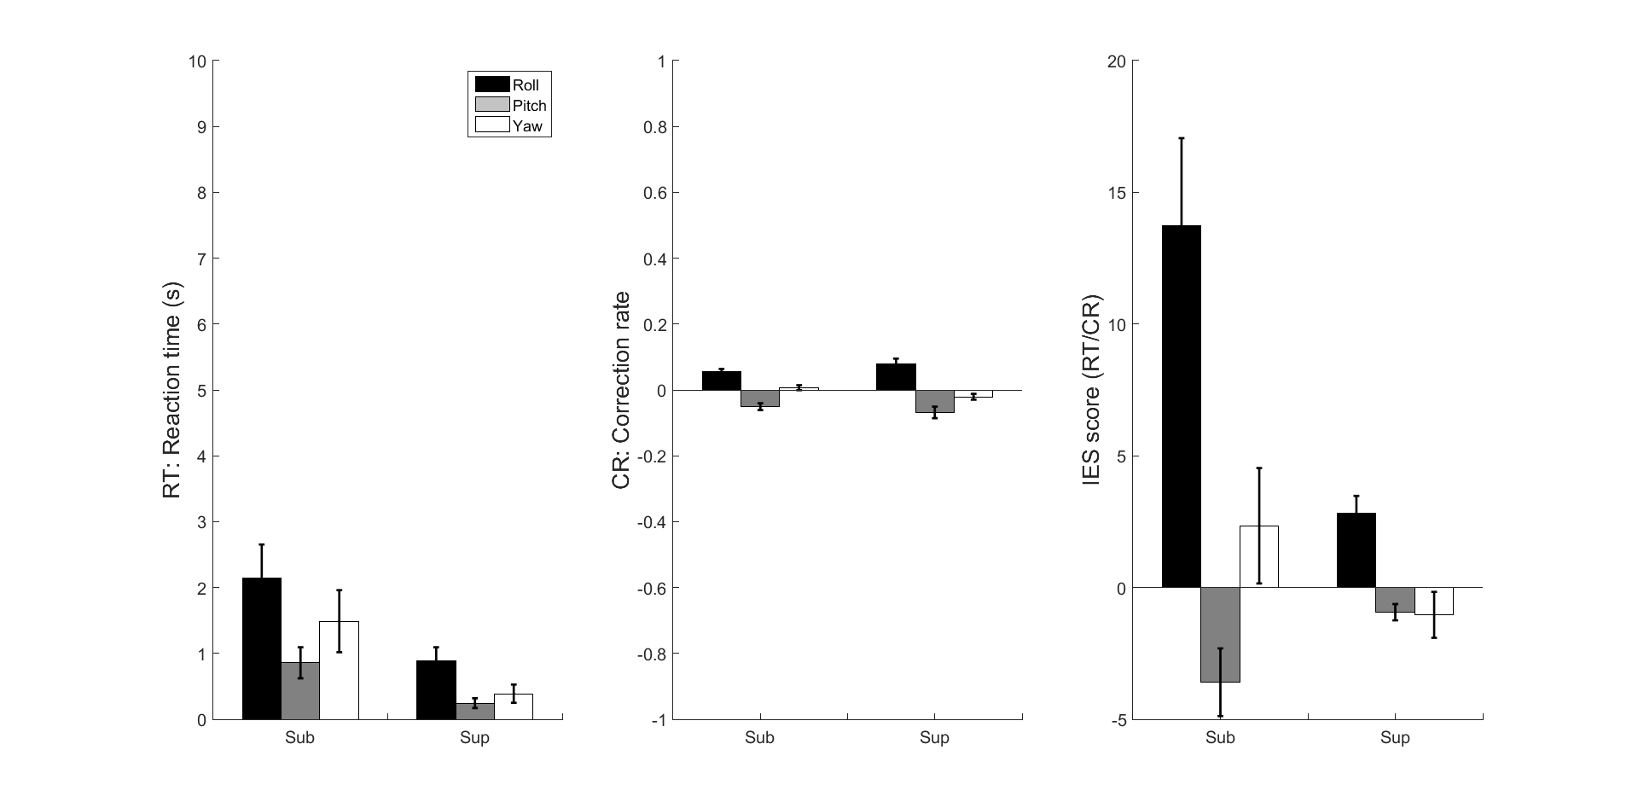

**Figure : (Stacking calculation) Summary of Detection and Correction **3 categories** participants**

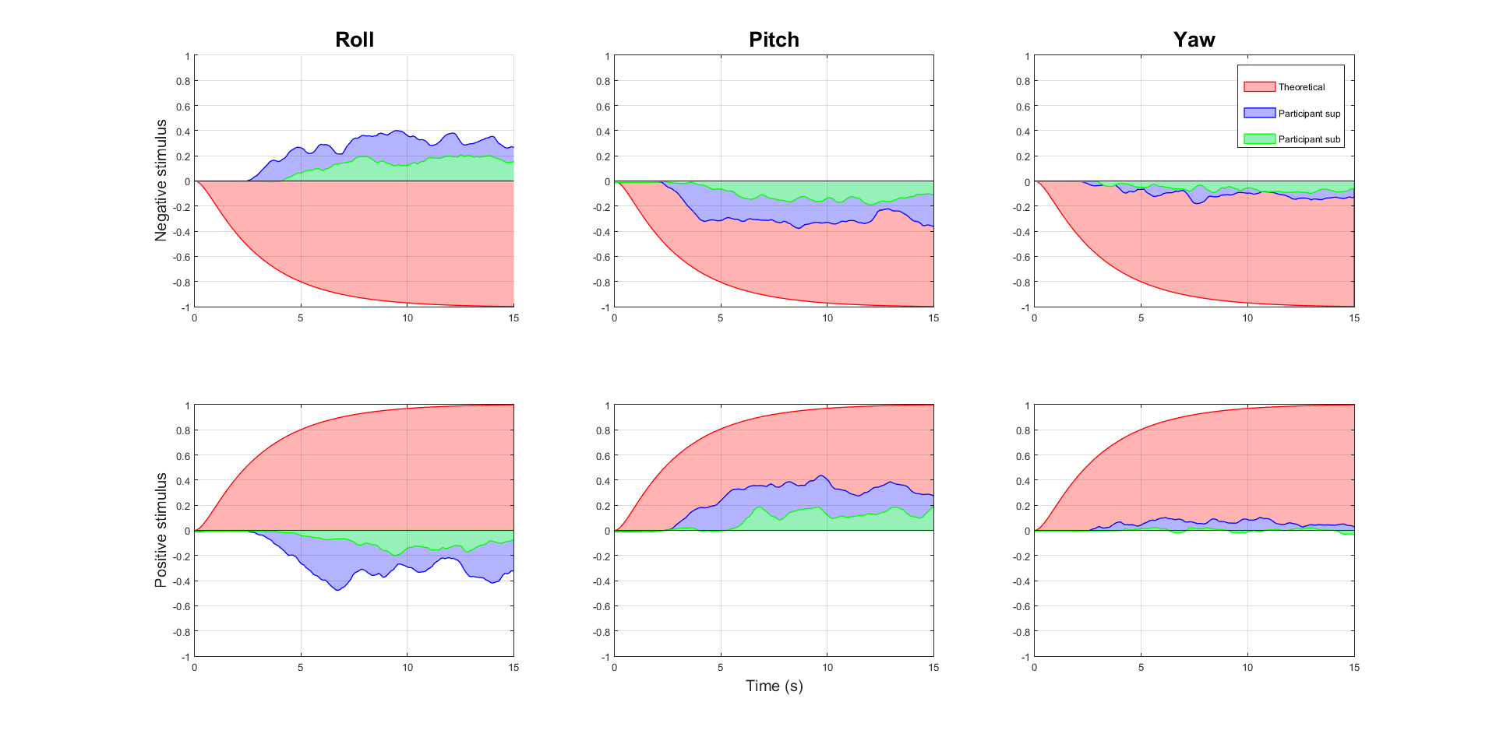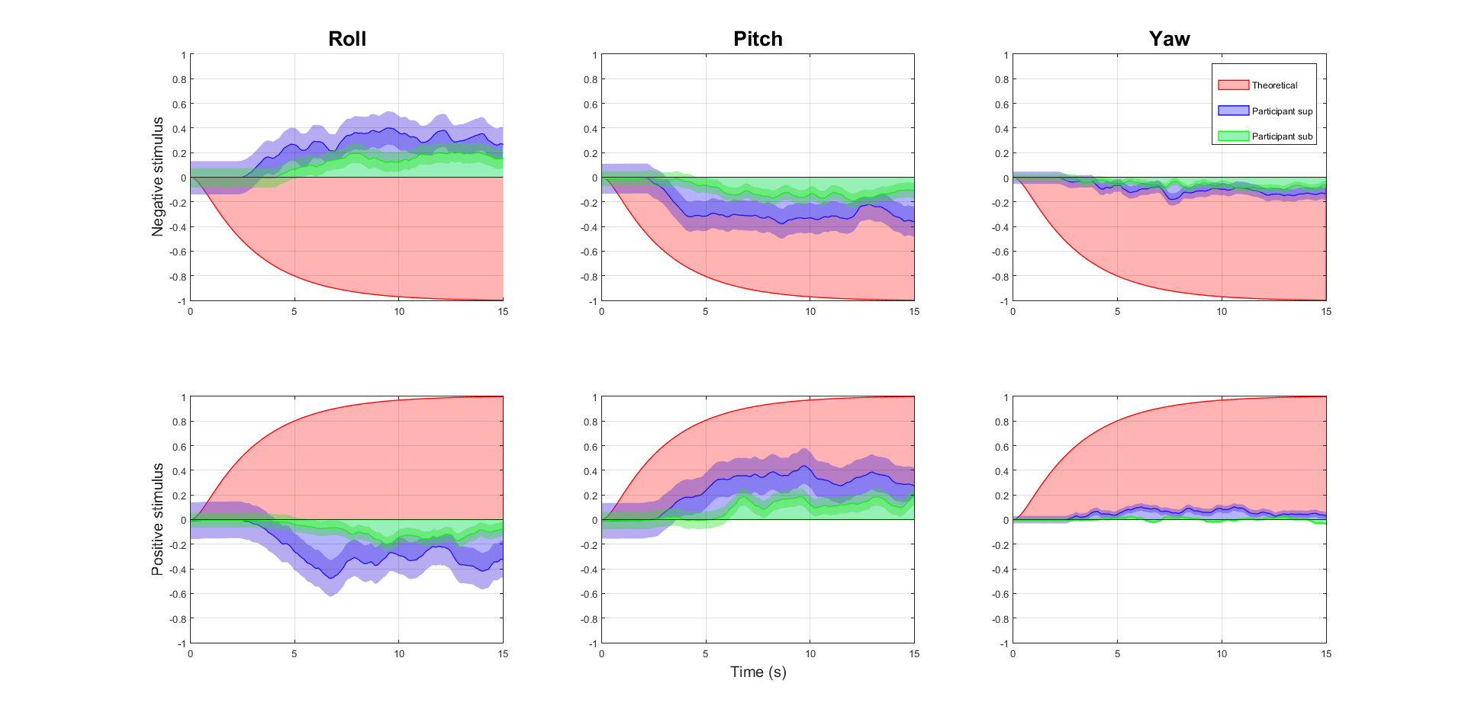

**Figure : Joystick and stimulus trajectories for sub-threshold and sup-threshold stimulation**

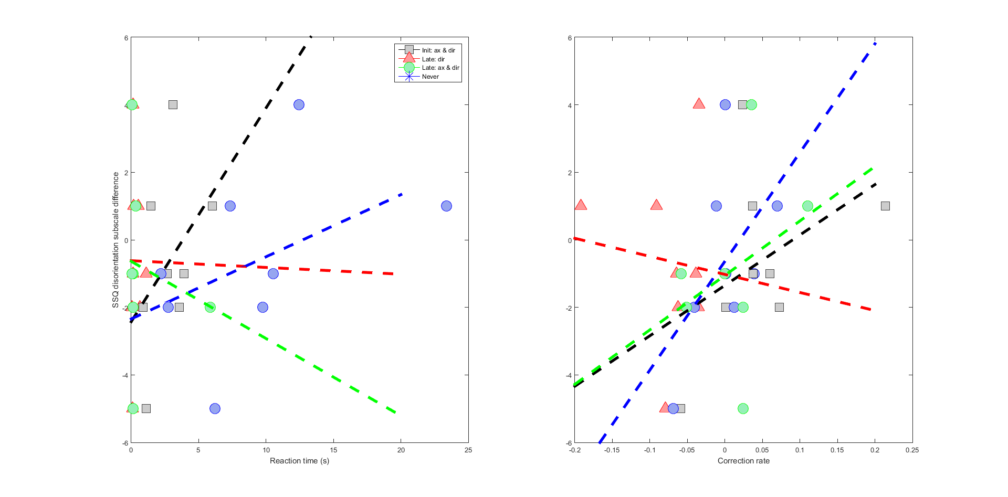

**Figure : (Stacking calculation) SSQ disorientation subscale**

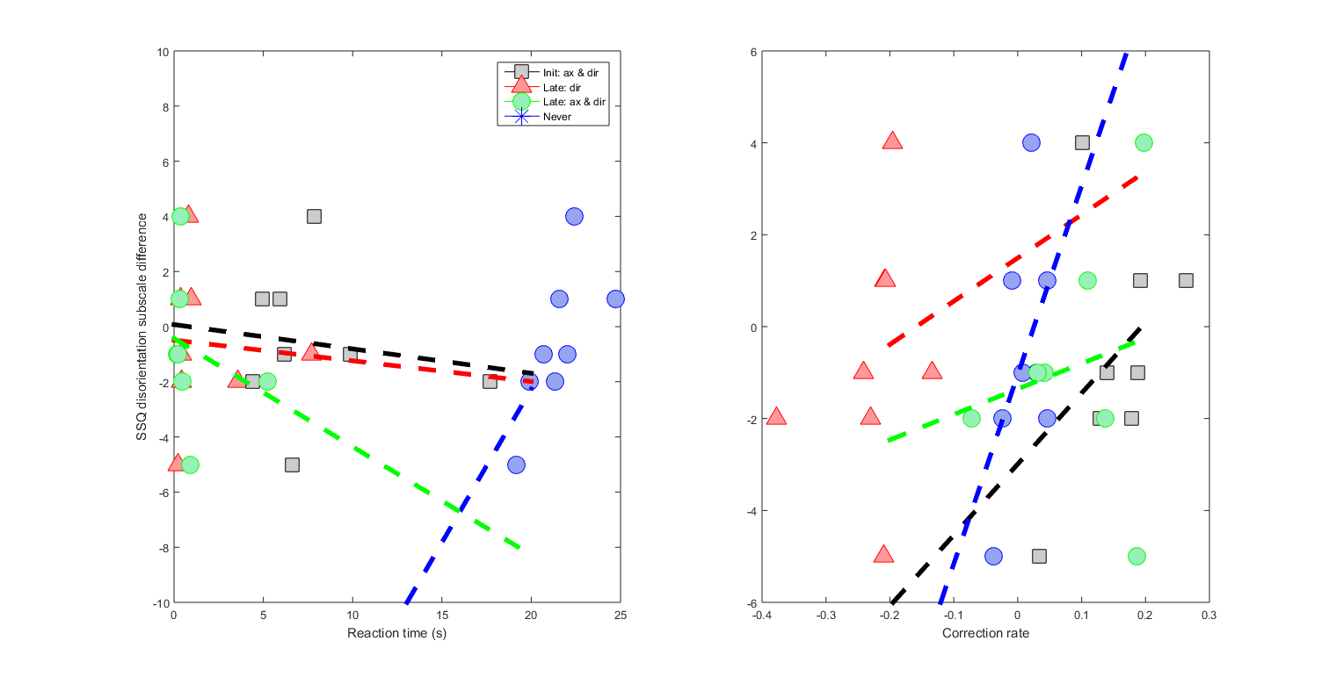

**Figure : (Table calculation) SSQ disorientation subscale**

Translation

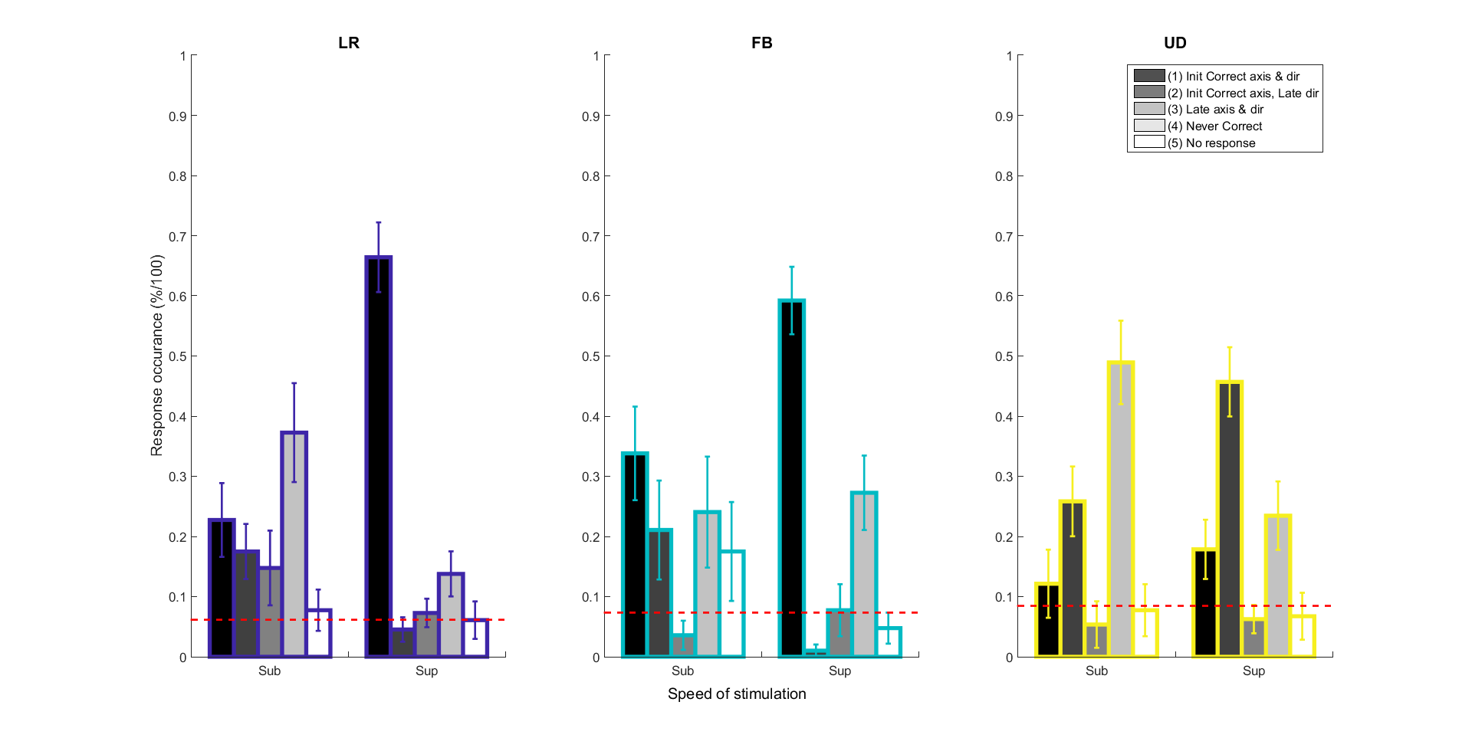

**Figure: (Table calculation) Response occurrence**

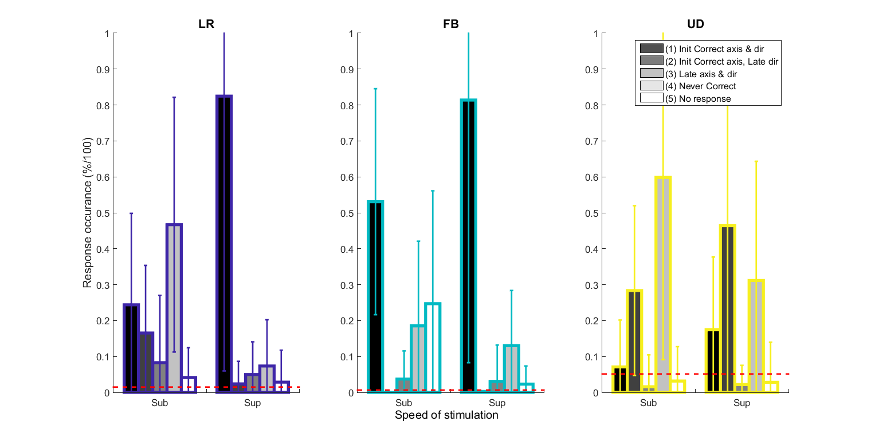

**Figure: (Stacking calculation) Response occurrence**

**Figure : (Table calculation) Reaction time and Correction rate** for Initial and Late response above the 95% lower confidence interval.

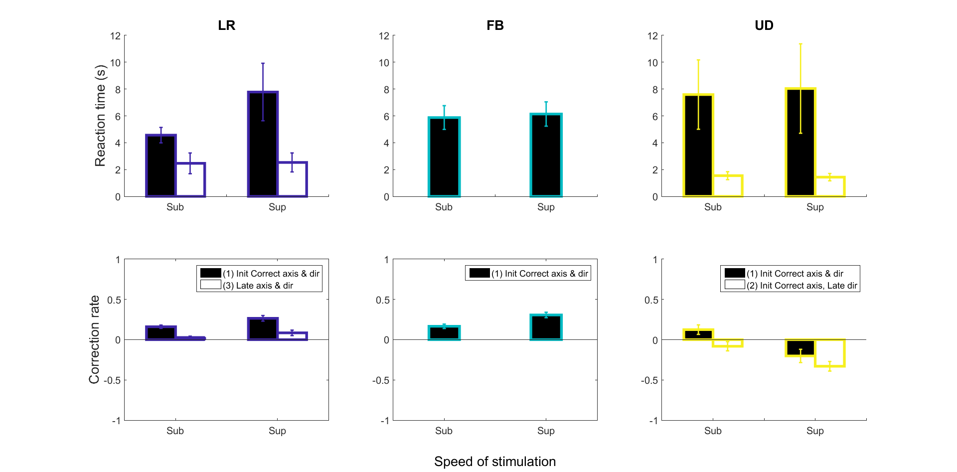

* RT UD sup (1) and (2) are different (p < 0.0391)
* CR LR (1) sub is different than sup (p < 0.0234)
* CR FB (1) sub is different than sup (p < 0.002)
* CR UD (2) sub is different than sup (p < 0.0488)

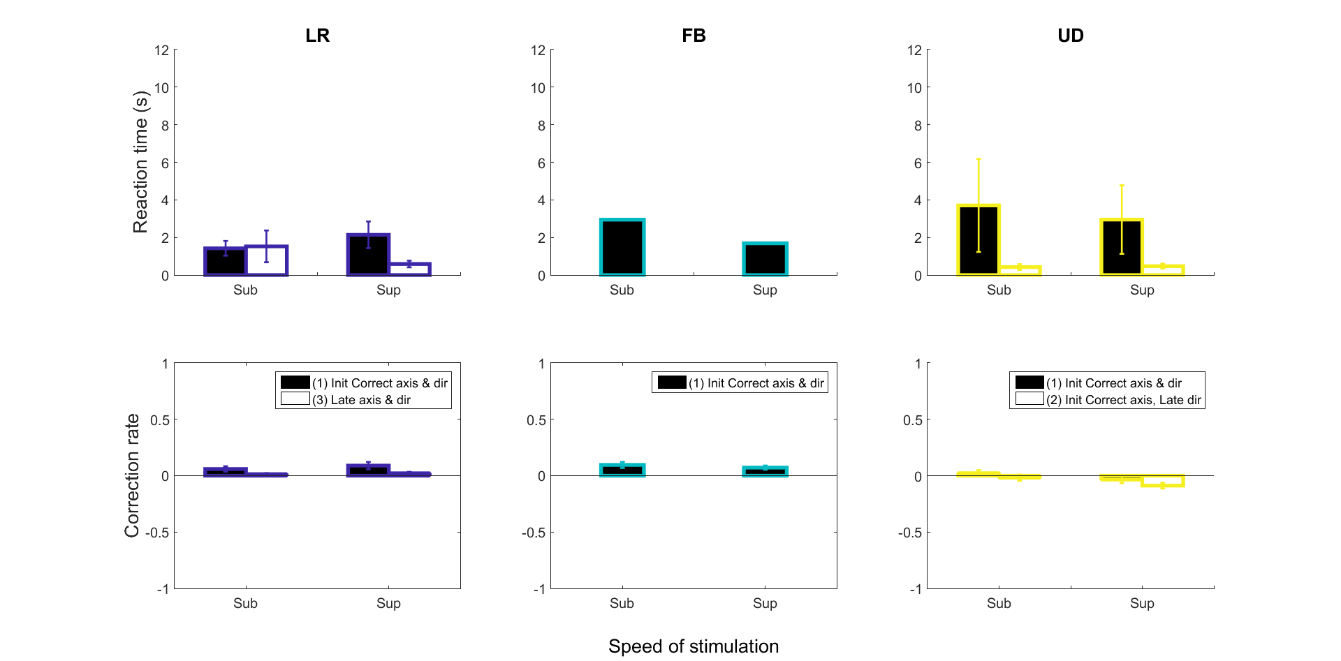

**Figure : (Stacking calculation) Response time and Correction rate** for Initial and Late response above the 95% lower confidence interval

* RT LR sup (1) and (3) are different (p < 0.0156)

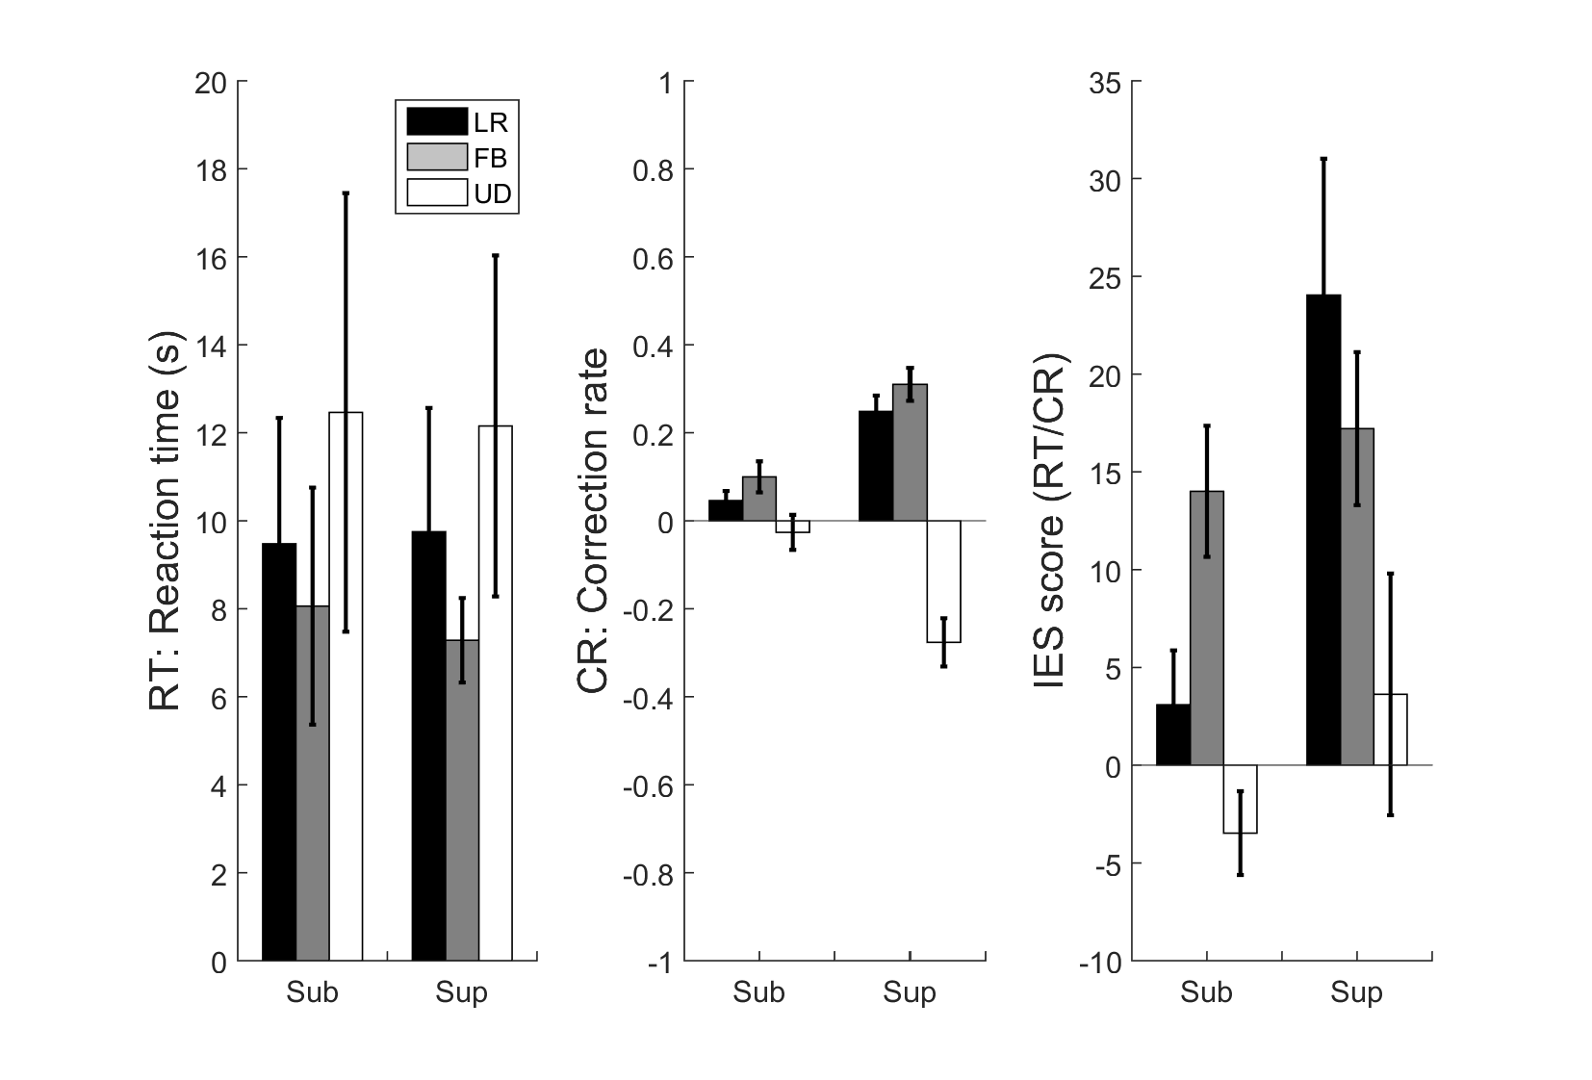

**Figure : (Table calculation) Summary of Detection and Correction **3 categories** participants**

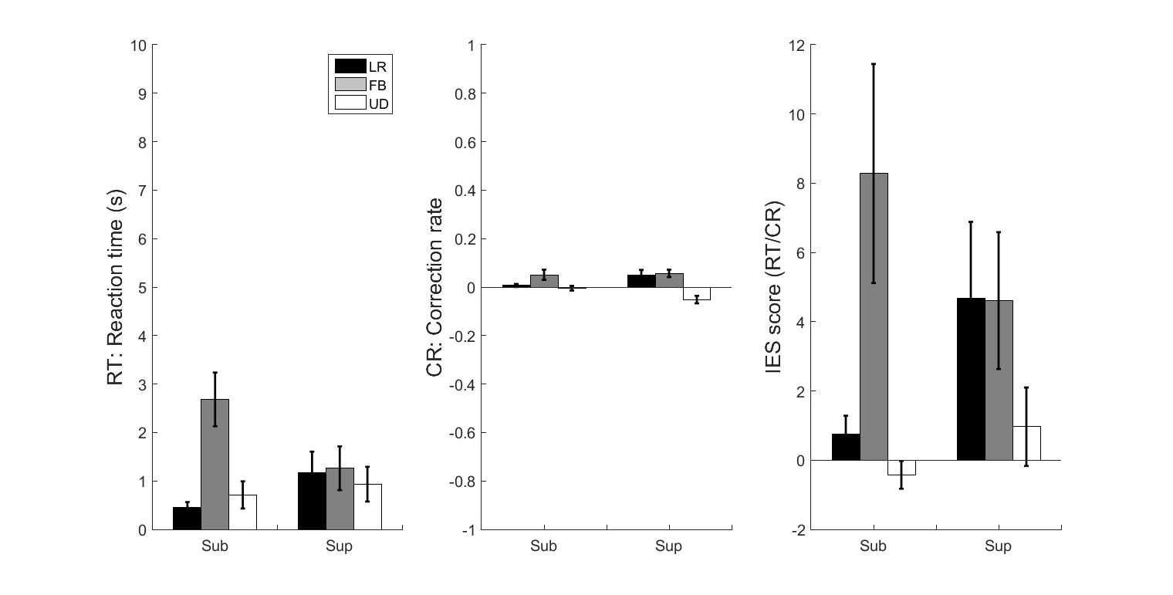

**Figure : (Stacking calculation) Summary of Detection and Correction ** 3 categories** participants**

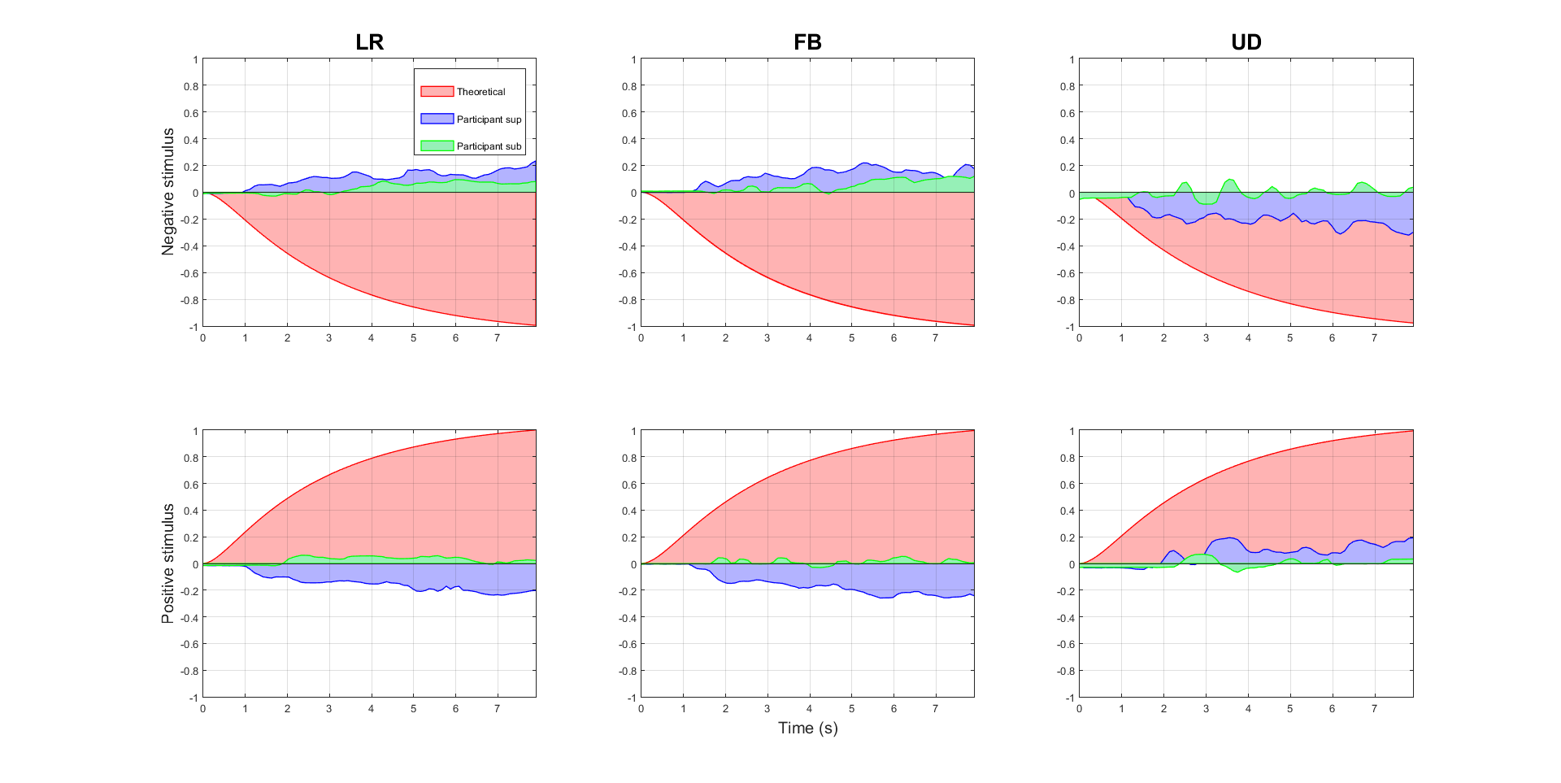

**Figure : Joystick and stimulus trajectories for sub-threshold and sup-threshold stimulation**

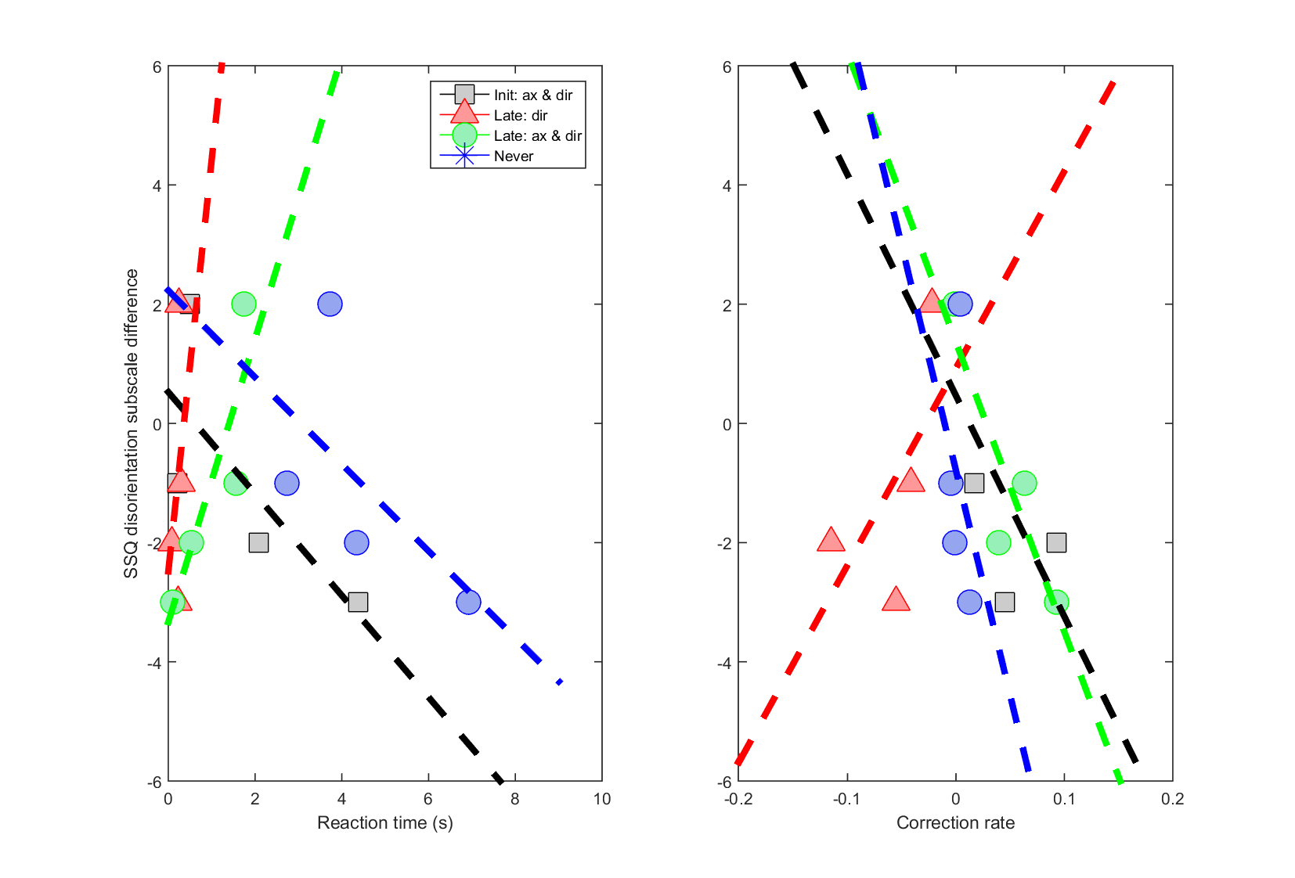

**Figure : (Stacking calculation) SSQ disorientation subscale**

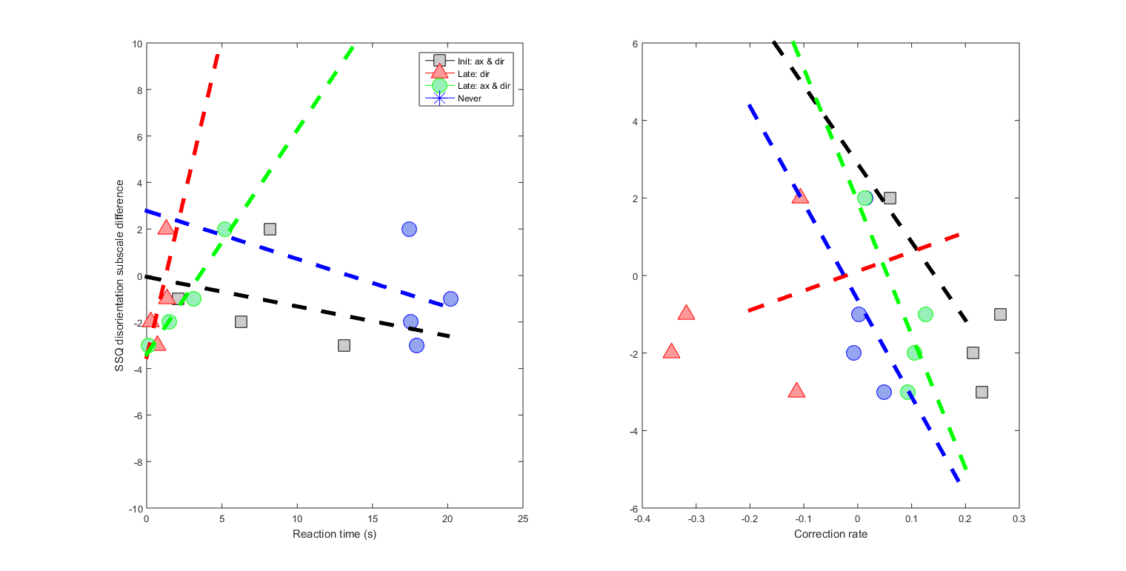

**Figure : (Table calculation) SSQ disorientation subscale**