New Figures for Paper revision, with captions.

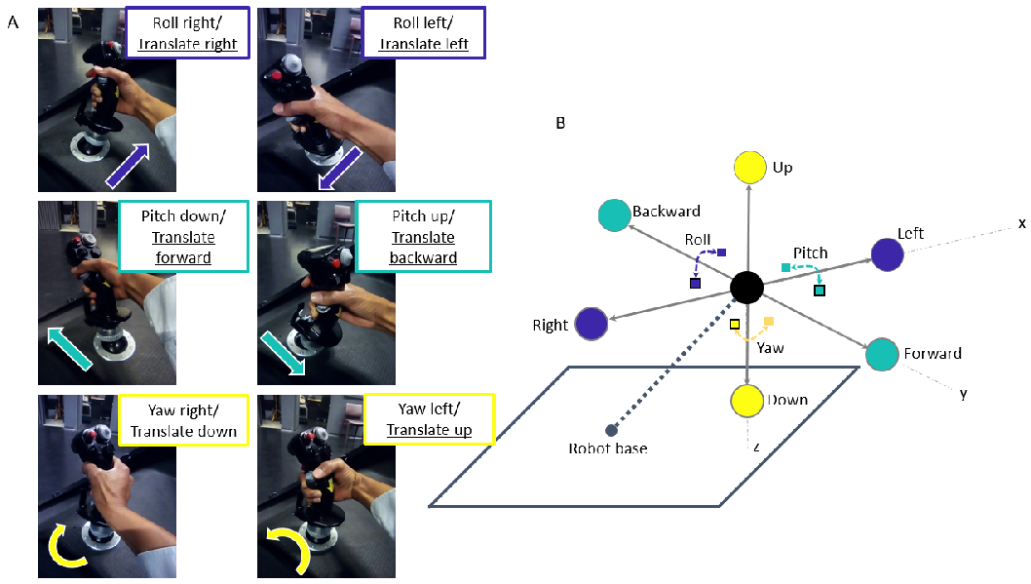Figure 1: Figure 1A shows the mapping of participant’s joystick movements to the movement of the cabin. The simulator cabin, represented by the black sphere in Figure 1B, could move in both translation (left/right, forward/backward, up/down) and rotation (roll, pitch, yaw) via the input stimulus and/or participant control. The black outlined squares and circles in Figure 1B denote positive directional movement (right, forward, down), where squares and circles correspond to rotational and translation movement respectively. Non-outlined squares and circles indicate negative directional movement (left, backward, up).

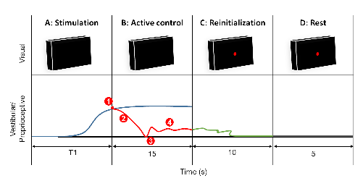

Figure 2: Task procedure. Each trial consisted of four phases: (A) motion stimulation of the cabin with an unknown forcing function, (B) participant motion detection and afterwards active control, (C) cabin reinitialization to the initial orientation or position, (D) cabin and participant at rest. For each trial there was a visual (top) and vestibular/proprioceptive (bottom) aspect. Participants sat in the interior of the cabin without any light, during phase A and B the cabin projection system projected a black image onto the interior surface of the cabin, in front of the participant. And, during phase C and D a black image with a red dot was projected to denote that participants should release the joystick and rest. With regard to motion, the bottom portion depicts typical cabin movement for one-trial where: the blue line in phase A and B corresponds to the second-order forcing function that actively perturbed the cabin, the red line during phase B denotes the participant's movements to counteract the perturbation after motion detection at T1 seconds, the green line during phase C denotes the automatic reinitialization of the cabin to the initial orientation or position, the grey line during phase D denotes a stationary period where the cabin did not move. Reinitialization time was variable depending on the location of the cabin at the end of each trial, therefore the time that the cabin remained idle for the remainder of reinitialization and rest also varied. At T1 seconds, a variable time that depends on the participant's ability to detect the perturbation, denoted by (1). Corrective compensation to counteract the perturbation is depicted by (2). (3) denotes typical release motion of the joystick when participants believe they have returned to the initial orientation or position, whereupon (4) depicts small continuous corrections to maintain orientation or position about the initial location.

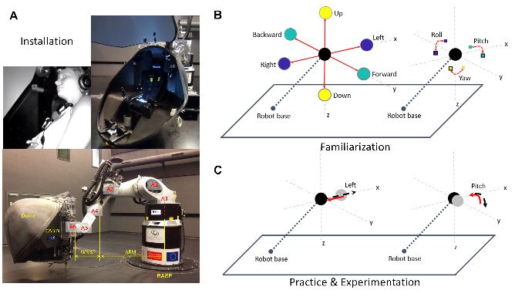Figure 3: Sequential simulator movements during each experimental session: (A) installation, (B) familiarization, (C) practice and experimental trials. A depicts the experimental installation process consisting of: opening cabin door, participant installation, closing cabin door and movement of cabin to starting position. B demonstrates the possible orientational (right) and directional (left) motion of the cabin for translational and rotational experiments, respectively. During familiarization (B), for both rotational (right) and translation (left) experiments, participants moved the joystick in all 3 axes directions one-at-a-time to become familiar with their control movements on the movement of the cabin. C demonstrates compensatory orientational and directional movement of the cabin for one trial in the pitch and left directions respectively; red solid lines indicate participant control and the black dashed lines indicate the unknown movement stimuli. During the 12 practice trials and 30 experimental trials, participants performed the whole-body compensatory movement task illustrated in C.

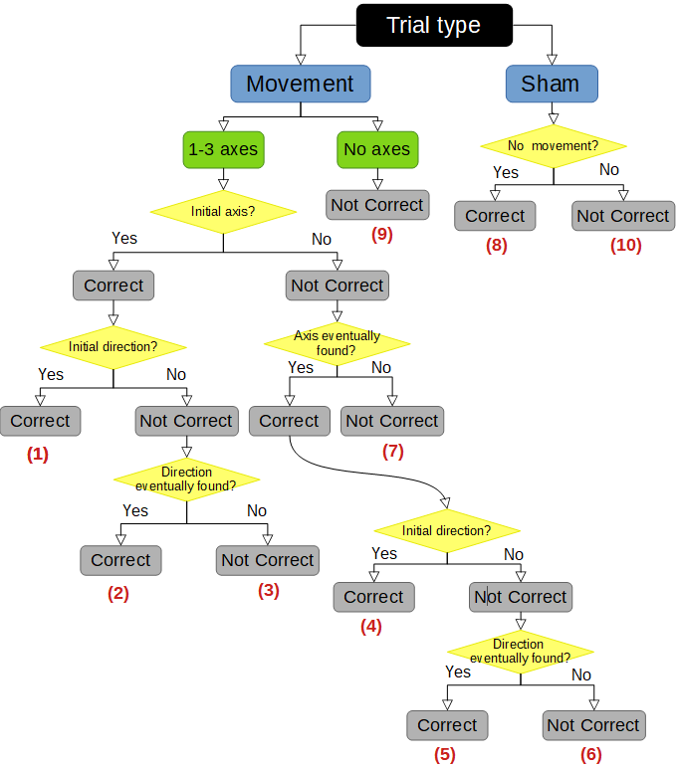

Figure 4 : Flow chart of selection process for detection response profiles, where correct response profiles 1, 2, 4, 5, and 8 denote non-SD occurence and wrong response profiles 3, 6, 7, 9, and 10 denote SD occurence.

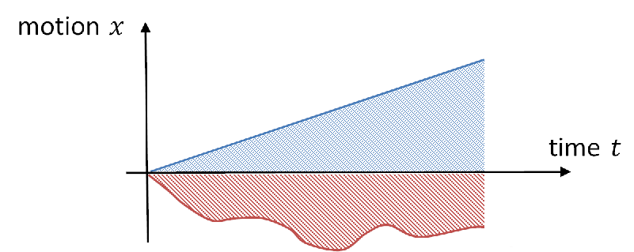

Figure 5 : Illustration of the typical negative input stimulus and subject response shown in red and blue respectively.

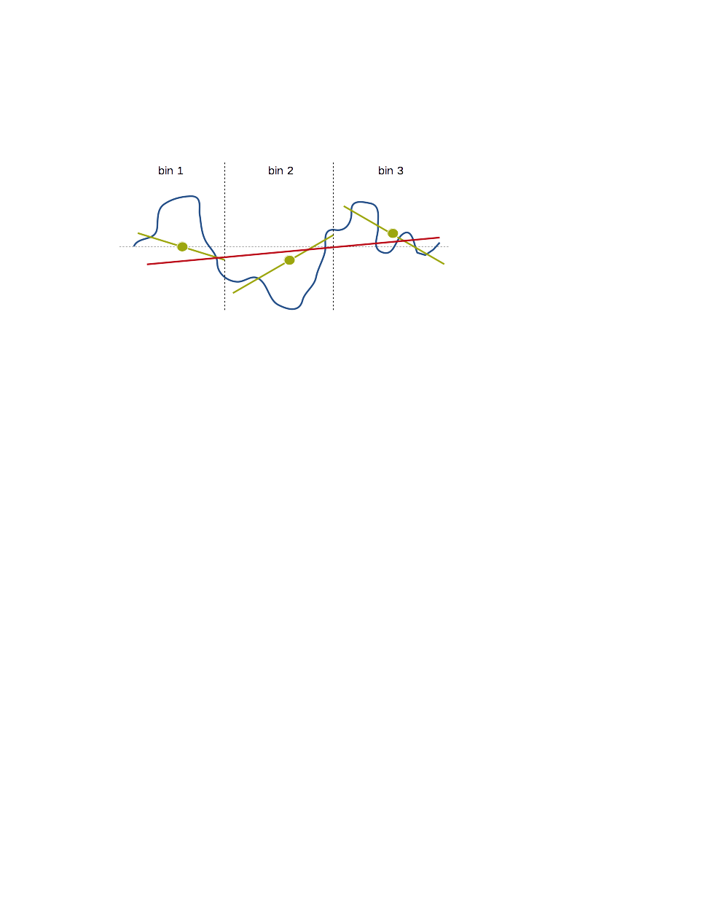

Figure 6 : A depiction of RMSE trend calculation per trial. The green lines represent local calculated slopes per bin, and the red lines show the final RMSE trend slope per trial. Three bins or more result in a similarly accurate RMSE trend.

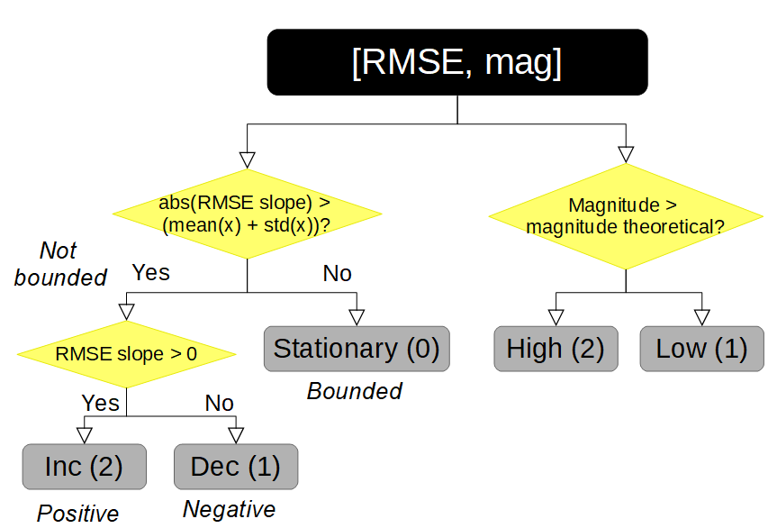

Figure 7 : Flow chart of possible control response profile combinations; three possible control responses for the Root Mean Squared Error (RMSE) of joystick error and two possible responses for joystick error magnitude created five final control profiles.

Results :

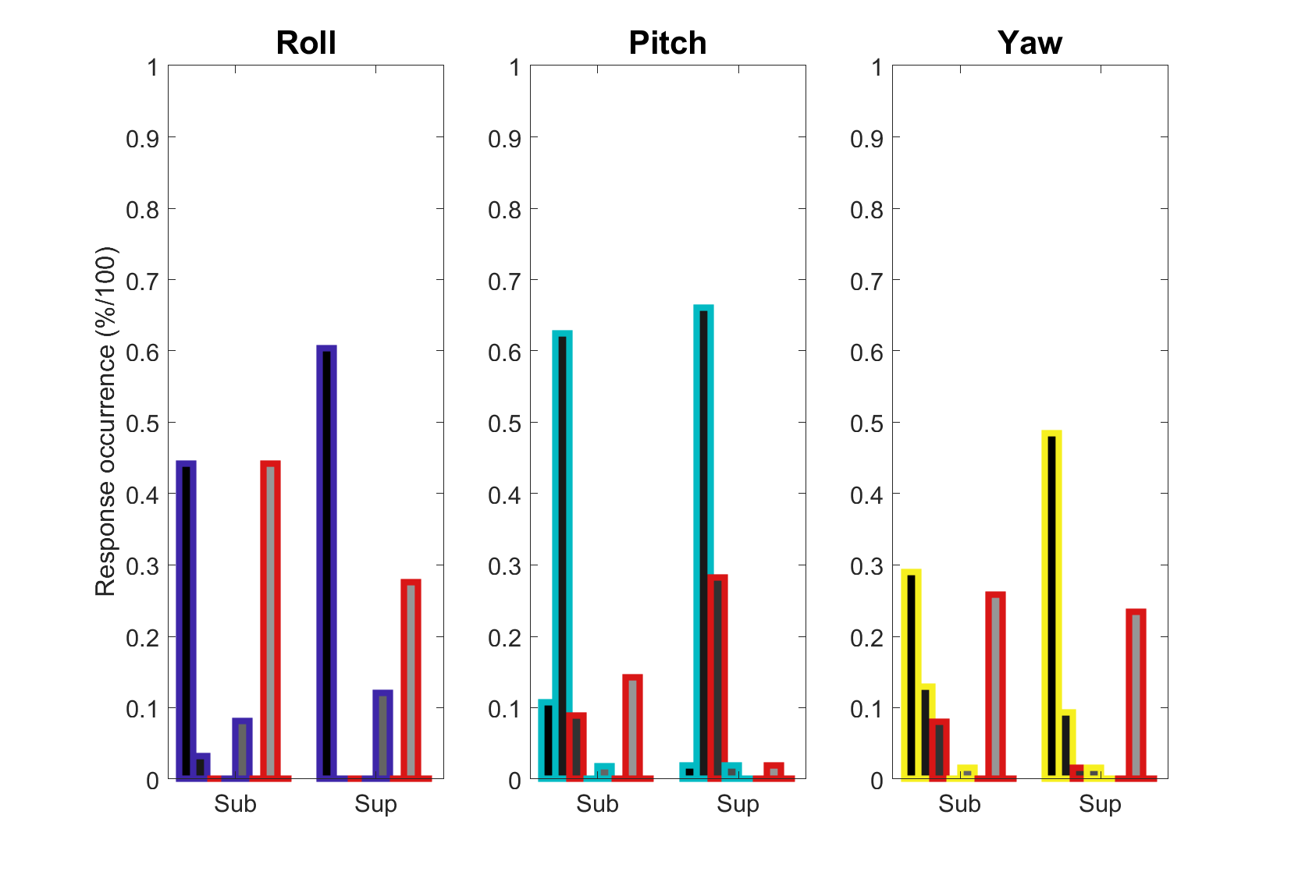Figure 8 : Full 8 group response occurrence metric for rotational stimulation, comparisons can only be made between response type and speed categories per each axis.

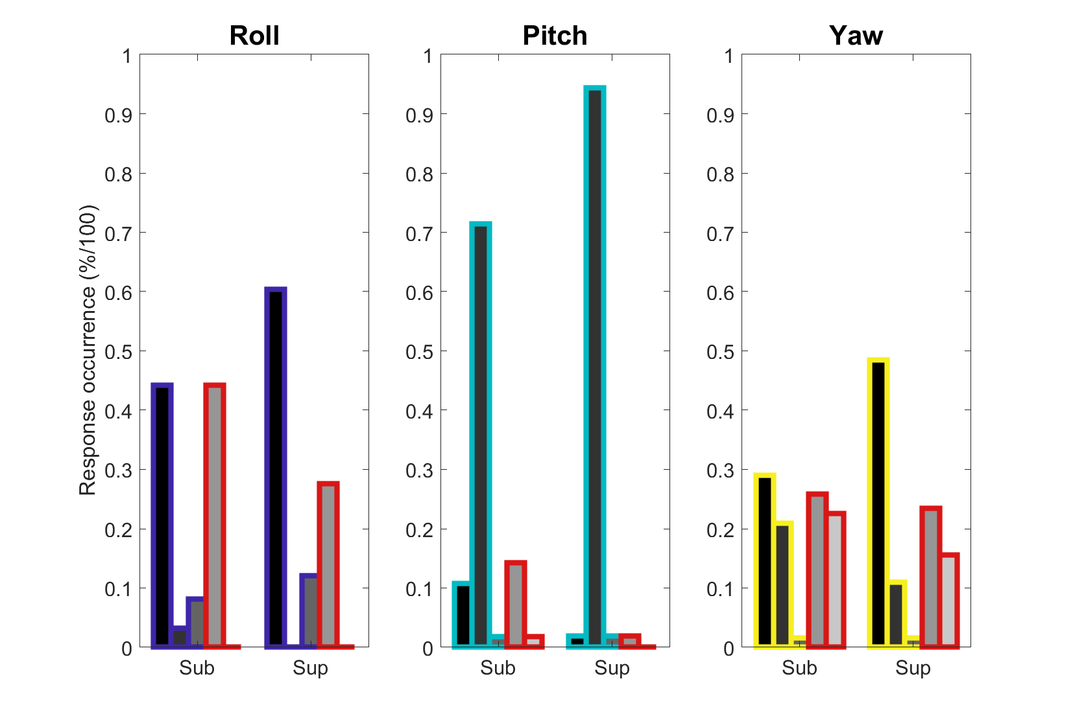Figure 8a : Reduced 5 group response occurrence metric for rotational stimulation, comparisons can only be made between response type and speed categories per each axis.

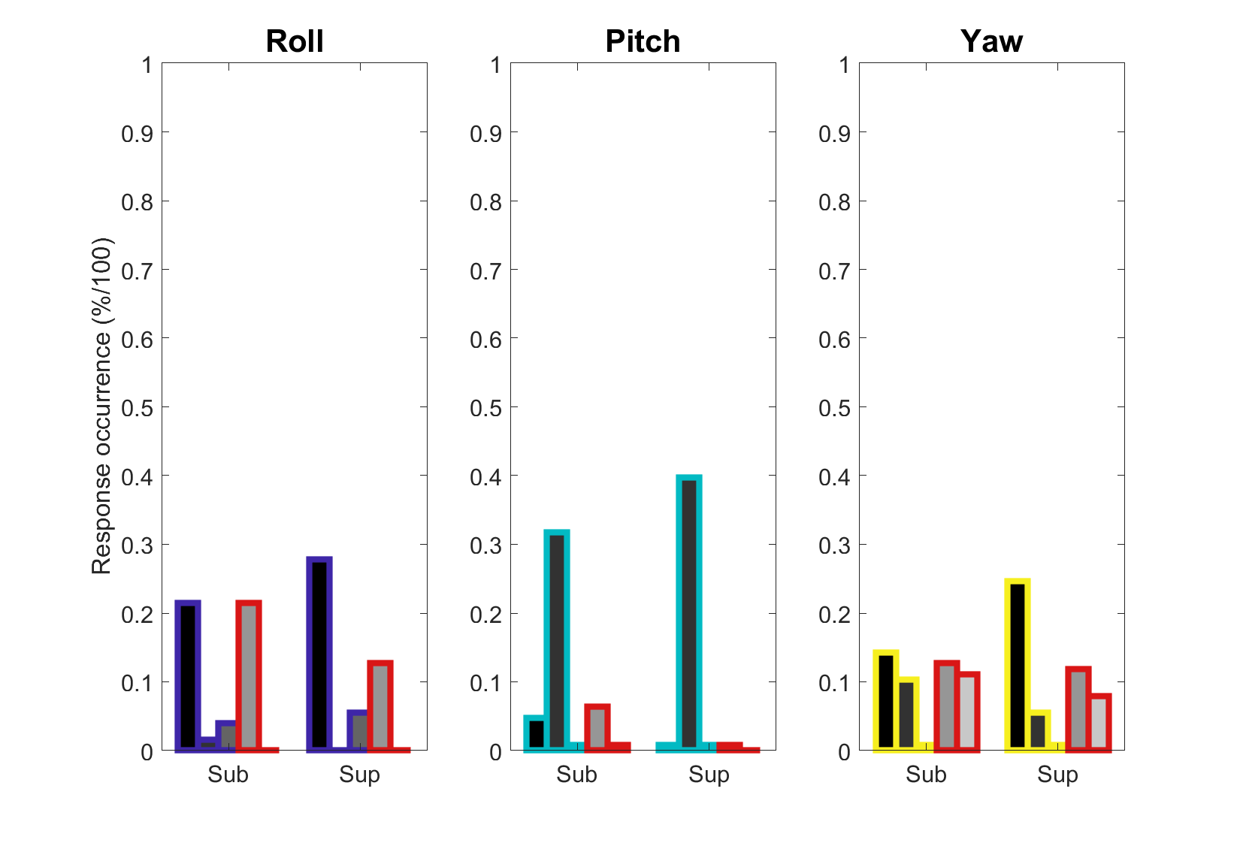Figure 8b : Reduced 5 group response occurrence metric for rotational stimulation, comparisons can be made across all response types and speed categories including sub and sup categories.