3 Results
For both rotational and translational experiments, participant’s detection and correction behavior was quantified with respect to stimulation speed, axis, and direction. Rotational and translational experimental results can not be directly compared because physiologically the body detects these motions differently.

3.1 Response profile
Stimulus motion detection was quantified using the five response occurrence profiles and initial reaction time to compensate the stimulus. Figures 6 and 7 show the mean response occurrence across participants for axes and speed conditions, for rotation and translation respectively. Relevant response occurrence categories, for reaction time, were selected based on mean significance via the 95% confidence interval test. In the following subsections, each axis/direction (roll, pitch, yaw, LR, FB, UD) are discussed in detail.

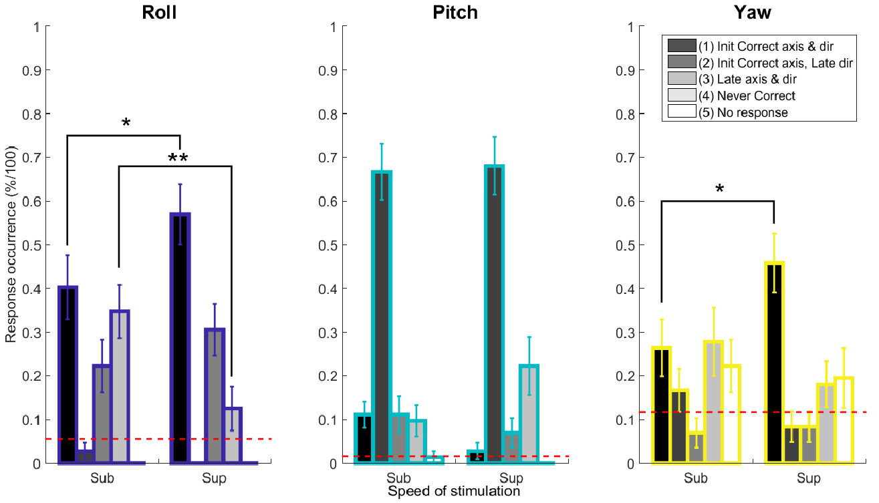
Figure 6: Response occurrence metric for rotational stimulation. Mean response occurrences for roll, pitch, and yaw axes were compared for near sub-threshold and supra-threshold speed stimulations; Wilcoxon signed rank test, sum rank test, and Friedman test were used to determine significance such that significant relationships were represented by (*:p < 0.05, **: (Bonferroni correction) p < 0.0167).
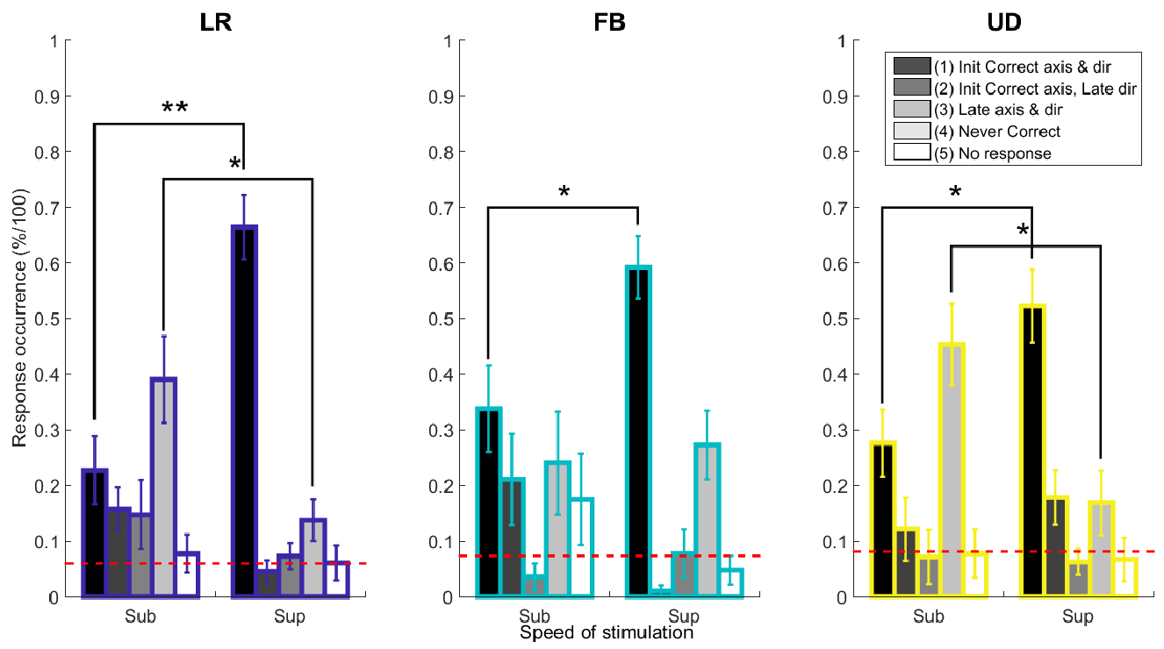
Figure 7: Response occurrence metric for translational stimulation. Mean response occurrences for LR, FB, and UD axes were compared for sub and sup speed stimulation; Wilcoxon signed rank test, sum rank test, and Friedman test were used to determine significance such that significant relationships were represented by (*:p < 0.05, **: (Bonferroni correction) p < 0.0167).
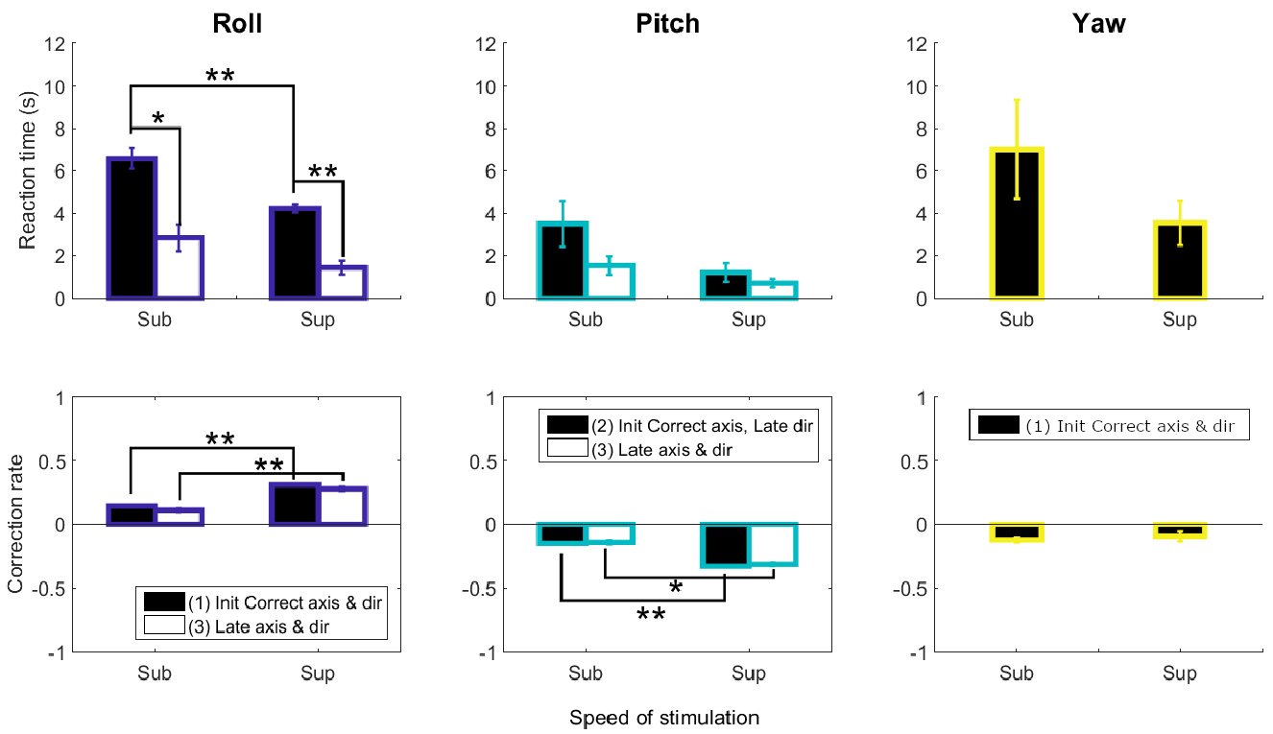
Figure 8: Reaction time and correction rate for rotational stimulation. Mean reaction time and correction rate for roll, pitch, and yaw axes were compared for sub and sup speed stimulation; Wilcoxon signed rank test, sum rank test, and Friedman test were used to determine significance such that significant relationships were represented by (*:p < 0.05, **: (Bonferroni correction) p < 0.0167).
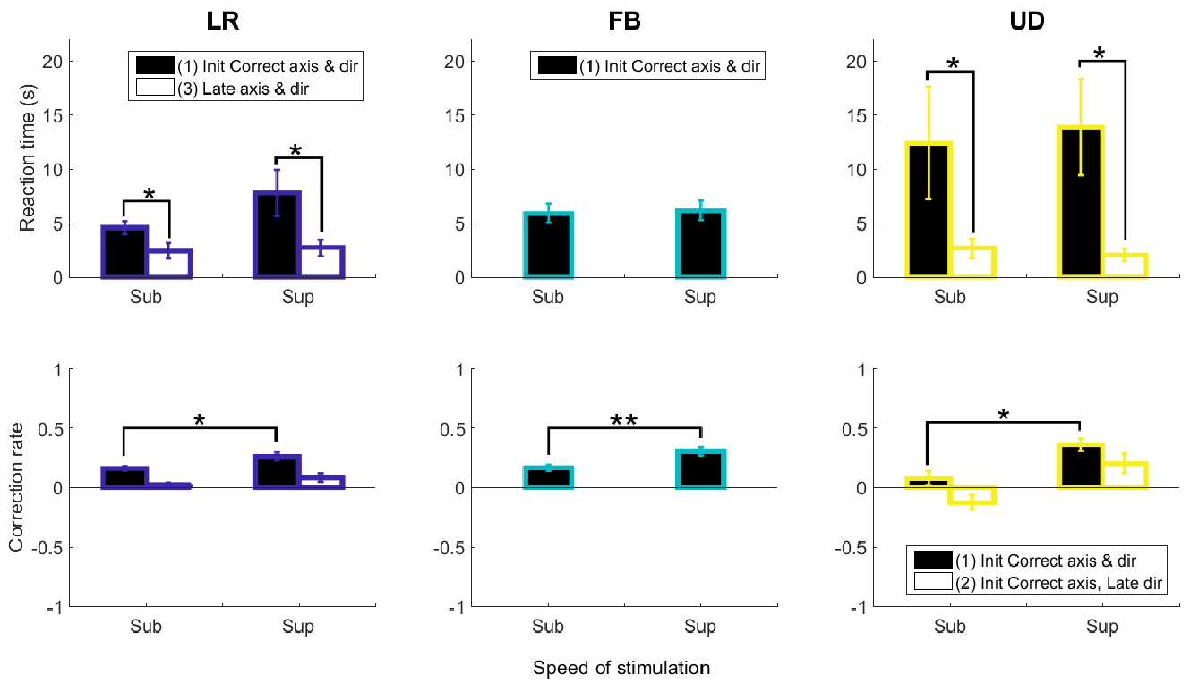
Figure 9: Reaction time and correction rate for translational stimulation. Mean reaction time and correction rate for LR, FB, and UD axes were compared for sub and sup-threshold speed stimulation; Wilcoxon signed rank test, sum rank test, and Friedman test were used to determine significance such that significant relationships were represented by (*:p < 0.05, **: (Bonferroni correction) p < 0.0167).

3.1.1 Detection: speed
Regardless of the motion stimulation axis or direction, faster supra motion stimulation allowed for more accurate and faster detection than slower sub-threshold stimulation. Specifically, all axes and orientation direction stimulation, except for pitch, had significance between supra and sub-threshold speed as follows:

- Roll: ideal detection (Category 1), where no errors were made in initial detection of axis and direction, was significantly more frequent for the faster supra-threshold speed condition than the slower speed condition (two-sided Wilcoxon signed rank test: p=0.0549 and Friedman test: p=0.0325, two-sided Wilcoxon signed rank test: p=0.000244, two-sided Wilcoxon rank sum test: p=0.000145, and Friedman test: p=0.000311; Bonferroni correction requiring: p < 0.0167).
- LR: Category 1 supra speed condition was slower than sub-threshold speed condition (two-sided Wilcoxon signed rank test: p=0.00024, two-sided Wilcoxon rank sum test: p=0.00028, and Friedman test: p=0.0013; Bonferroni correction requiring: p < 0.0167). Inversely, during near sub-threshold speeds, in comparison to near supra-threshold speeds, roughly 40% of the time participants never succeeded in detecting the correct axis and direction indicated by Category 4 (two-sided Wilcoxon signed rank test: p=0.0123, two-sided Wilcoxon rank sum test: p=0.0073; Bonferroni correction requiring: p < 0.025).
- FB: Initial Category 1 motion was more accurately detected during supra-threshold speed, comparison to the slower near sub-threshold speed condition (two-sided Wilcoxon rank sum test: p=0.0113).
- UD: participants detected initial motion more accurately during supra-threshold speed, in comparison to the near sub-threshold speed condition (two-sided Wilcoxon signed rank test: p=0.0017 and Friedman test: p=0.0075). Inversely, at near sub-threshold speeds, in comparison to near supra-threshold speeds, roughly 45% of the time participants did not succeed in detecting the correct axis and direction (two-sided Wilcoxon signed rank test: p=0.0129 and two-sided Wilcoxon rank sum test: p=0.0061; Bonferroni correction requiring: p < 0.025).

3.1.2 Detection: response time and detection strategy
Additionally, across the six motion axes/directions regardless of speed stimulation, Category 1 responses took approximately a 2-4s difference longer than Category 3 responses. This indicated that participants employed at least two types of detection strategies: (1) a sensorial strategy of sensing when orientation and/or direction changed and then responding correctly and (2) a searching strategy consisting of self-generated motion interacting with the perturbation stimulus to create additional motion cues about the correct stimulus orientation and/or direction. Category 1 responses predominately demonstrate a sensorial strategy because consistent correct initial responses are not statistically possible without sensorial feedback information. Similarly, Category 3 responses represent a searching strategy because initial incorrect axis and direction are likely to occur if the joystick is moved in any direction, without considering initial sensory feedback. Sensing the correct movement orientation using a sensorial strategy, takes more time than searching with the joystick in any direction to gather information about the movement stimulus. Therefore, reaction time is an indicator for identifying motion detection policy.

3.1.2.1 Sensorial: Roll, LR, FB, UD
Sensorial detection indicates that participants significantly initially detected motion correctly and reaction times were beyond 4 seconds; Category 1 detection was greater than any other detection category and response times were greater then 4 seconds. Figure 6 and 7 show the following significances indicating this pattern for each axis:
- Roll: Figure 8 shows that Category 3 responses (late axis and direction) had a significantly quicker reaction time than Category 1 responses, for both near supra-threshold (two-sided Wilcoxon signed rank test: p=0.00048, two-sided Wilcoxon rank sum test: p=0.000028, and Friedman test p=0.00031; Bonferroni correction requiring: p < 0.0167) and near sub-threshold (two-sided Wilcoxon rank sum test: p=0.0313) conditions. In addition, Category 1 and 3 profiles for both stimuli speeds were greater than the 95% confidence interval, indicating that participants used more sensorial detection strategies then searching detection.
- LR: No significant differences in reaction time between supra-threshold and sub-threshold speeds for Category 1 were found, despite the fact that mean supra reaction times were longer than sub speed reaction times. However, Category 1 reaction time was significantly longer than Category 3, for both slow sub-threshold condition (Friedman test: p=0.0253) and fast supra speed condition (Friedman test: p=0.0143). Participants predominately used a Category 1 sensorial strategy for both fast and slow speed, a searching strategy was used less for fast speeds than slow speeds. For slow speed, searching strategy often resulted in never finding the correct axis or direction.
- FB: No significant differences between near supra-threshold and sub-threshold stimulation reaction times were observed. Considering the three correct response categories, only Category 1 response occurrence behavior was above the lower confidence interval selection criteria for both near supra-threshold and sub-threshold stimulation. This indicates that participants were more able to initially detect FB stimuli motion. Category 1 detection indicates that participants were ideally detecting FB stimuli motion, without any initial errors. Additionally, category 1 detection, in comparison to the category 2 and 3 detection, often had greater response times (approximately 5 seconds or greater) indicating a sensorial detection strategy, in comparison to a searching detection strategy.
- UD: Reaction times for both speed conditions were greater than 10 seconds, suggesting that participants struggled to detect initial vertical motion; a reaction time of 10-12 second was almost twice as long as the needed wait for the other 5 axis/direction conditions. This result is in alignment with translational literature findings where vertical motion has been observed to be more difficult to perceive than longitudinal or lateral motion (Bermudez Rey et al, 2016). Additionally, the mean reaction times for Category 1 responses were statistically larger than Category 2 responses (two-sided Wilcoxon rank sum test: p=0.012 and Friedman test: p=0.0047; Bonferroni correction requiring: p < 0.025). Participants were willing to wait longer to correctly initially detect motion, otherwise when motion was slow participants rarely succeeded to find the correct axis and direction using a searching strategy.
- Yaw: Figure 6 indicates that participants detected initial motion more accurately during supra-threshold speed, in comparison to the slower near sub-threshold speed condition. Category 1, for both near supra-threshold and sub-threshold stimulation, was more prevalent than the other responses indicating that participants were detecting motion sensorially, despite the lower response occurrence percentage than the other axes and directions.

3.1.2.2 Mixed sensorial and searching: Pitch

Regardless of speed differences no significant detection differences were found for pitch, as shown in Figure 6. Contrary to the other five axis/direction conditions, regardless of speed, participants predominately made initial errors in detecting the correct direction (Category 2) instead of predominately detecting ideally or never succeeding in detection (Category 1 or 4 respectively).

No significant differences between speeds were found for relevant response Categories 2 and 3 above the 95% confidence interval. However, similar to general speed and response time trends, the faster supra speed condition had quicker response times than the slower speed condition. Additionally, Category 2, a response that requires the usage of more sensorial information than Category 3, had slower initial reaction times regardless of speed in comparison to Category 3. The fact that participants predominately used Category 2 and 3 responses indicate that participants were using both sensorial and searching strategies, but had difficulty in sensorially detecting direction correctly.

3.2 Control profile
Control behavior was quantified using an absolute metric called CR and three real-time relative measures to describe global relative control response occurrence. The absolute metric allows control performance to be evaluated with respect to the stimuli, and give a measure for how well the participants controlled for each condition. Regardless of the axes, participants had large drift error with respect to the theoretical stimuli; roll had the lowest absolute error in comparison to the other axes, and sub speed had more error and supra-threshold speed. The bottom row of Figures 8 and 9 depict the large absolute error for all axes for rotation and translation stimulation respectively, characterized by the CR metric that is the ratio of the participant response to the theoretical trajectory.
However, it is very difficult to know the absolute error between one’s position and the initial stimuli/heading because there is no feedback with respect to the initial starting position. Therefore minimizing error is unlikely for this task, and absolute performance error indicate that participants could not minimize error and perform the compensatory vestibular task. Contrary to intuition, that error should be minimized, the goal of a vestibular compensatory task is to maintain real-time stationarity with respect to the continuous vestibular stimuli. The human vestibular system gives relative short-time information about body orientation and acceleration; memory of accumulated perturbations can not be accurately measured nor can initial orientation after a certain sustained period of time be remembered. The feeling of non real-time motion indicates that participants are continuously counteracting the stimuli, but this does not necessary mean that they are reducing absolute error with respect to the initial reference. Thus we quantified real-time relative response with respect to the absolute response to shed light on moment-to-moment control trends, to understand the importance of vestibular only feedback during a realistic compensatory flight situation.
In general, considering real-time stationarity, three trends were observed. The less informative the real-time vestibular feedback, the less participants were able to respond; here the ratio between relative stationarity and motion control was close to one indicating that the participants were not actively moving the joystick. However, the more informative the real-time vestibular feedback, participants responded using unnecessarily strong amplitude and frequency control and thus had a small ratio between relative stationarity and motion control. Finally, if an instance of directional information was felt but real-time vestibular feedback was less informative participants overcompensated in response to the stimuli. Overcompensation was observed during sub-threshold, than supra, for difficult to detect axes like yaw and pitch in comparison to easier to detect motion axes as roll.
Figure 10 and 11 depicts the mean control occurrence behavior due to stationarity consideration, across trials that meet the 95% confidence interval criteria for detection, across participants for axes and speed conditions, for rotation and translational conditions respectively.

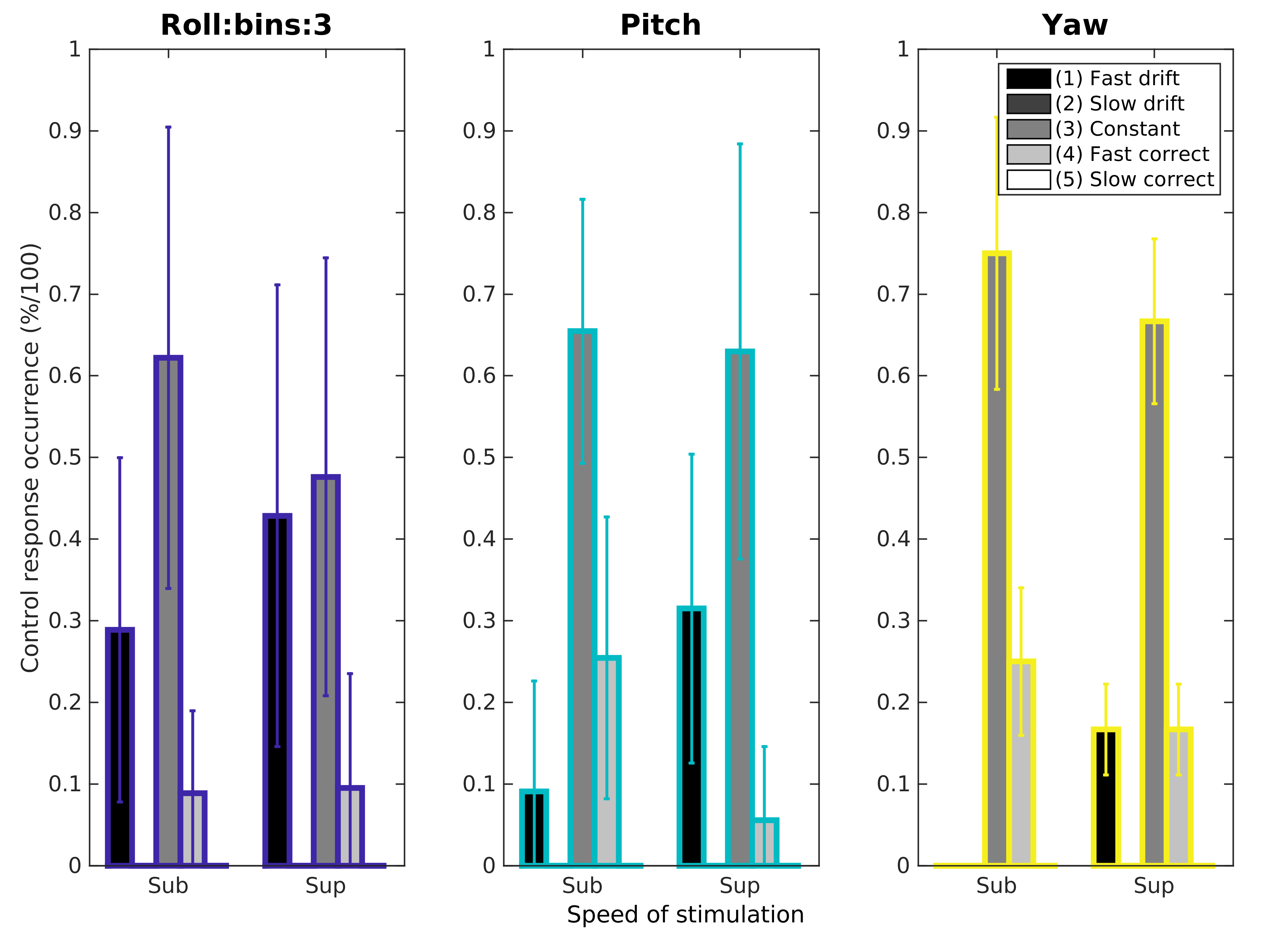

Figure 10: Relative control occurrence metric due to stationarity consideration for rotational stimulation, with real-time statistical deadzone.

Need to put figure here
Figure 11: Relative control occurrence metric due to stationarity consideration for translational stimulation, with real-time statistical deadzone.

Regardless of axis stimulation, control behavior was observed to have two types of patterns: (1) sufficient vestibular only control, and (2) adaptive vestibular only control.

3.2.1 Sufficient vestibular only control: Roll, LR, FB, UD
Sufficient absolute control indicated that participants were able to control error at a decent amount, nor good or bad, such that faster/supra speed error control was better than slower/sub-threshold speed. Figure 8 (Roll, the bottom row),response occurrence for categories 1 and 3 showed greater compensatory correction in the opposite direction of the stimulus for near supra-threshold in comparison to sub-threshold stimulation (two-sided Wilcoxon signed rank test: p = 0.0234). Figure 9 (LR CR, the bottom row), for Category 1, correction was larger for supra-threshold than near sub-threshold stimulation (two-sided Wilcoxon signed rank test: p = 0.0234). The difference between supra and sub indicates that absolute error correction was better significantly for faster speed stimuli. Figure 9 FB CR Category 2, supra-threshold conditions were significantly larger than near sub-threshold (two-sided Wilcoxon signed rank test: p = 0.002, two-sided Wilcoxon rank sum test: p = 0.0077, and Friedman test: p = 0.0114; Bonferroni correction requiring: p < 0.0167). UD CR Category 1 showed significantly larger correct compensatory correction for near supra-threshold in comparison to near sub-threshold stimulation (two-sided Wilcoxon signed rank test: p = 0.0098 and two-sided Wilcoxon rank sum test: p = 0.0054; Bonferroni correction requiring: p < 0.0250).
Need to put relative control results here

3.2.2 Adaptive vestibular only control: Pitch, Yaw
Regarding absolute control, Figure 8 shows greater pitch compensatory correction in the same direction of the stimulus for near supra-threshold in comparison to sub-threshold stimulation (two-sided Wilcoxon signed rank test: Category 1 p = 1.2e⁻⁴ and Category 3 p = 0.0156, two-sided Wilcoxon rank sum test: Category 1 p = 1.9e⁻⁶ and Category 3 p = 6.6e⁻⁴, and Friedman test: Category 1 p = 1.8e⁻⁴ and Category 3 p = 0.0027; Bonferroni correction requiring: p < 0.0167).
Absolute yaw CR Category 2 for supra-threshold conditions was not significantly larger than CR during near sub-threshold. However, CR was smallest during yaw in comparison to roll and pitch, indicating that absolute error between joystick and the stimuli was largest; participants could not accurately detect motion in yaw regardless of speed.
Need to put relative control results here

3.3 Classification: SD and control prediction
SVM supervised linear analysis was used to classify the presence of perceived disorientation (SD) and control behavior, per trial across axis and speed conditions. The label for SD was constructed by using the detection response profile, such that successful detection responses (Categories 1-3) were considered as non-SD state and the unsuccessful detection responses (Category 4-5) were considered as SD state. The supervised label for control behavior was constructed by using the control response profile, where drift control behavior (Category 1-2) and corrective behavior (Category 4-5) were distinguished such that constant stationarity deadzone was set to zero. The supervised label for control behavior was constructed using the control response profile for constant stationarity deadzone set to 30%, where drift and corrective behavior were equivalent across trials per participant. Constant (Category 3) behavior was labeled as stable successful stationary control and drift/corrective (Category 1,2,4,5) behavior was labeled as unstable task control. Initial classification analysis with a supervised linear SVM model produced satisfactory above chance results, therefore feature space was explored instead of comparing prediction accuracy of various classifiers.
Additionally, feature space was of interest because identification of predictive disorientation and control parameters were the goal of this work. Joystick movement was used as a transformable feature parameter because joystick movement is one of the few non-invasive parameters that contain real-time pilot behavior. Five joystick features were used for model construction and predictive testing: (1) position, (2) velocity, (3) acceleration, (4) integral error with respect to theoretical stimuli, (5) frequency of joystick via FFT. The entire joystick movement traced from the start to the end of the trial was used for SD prediction. Joystick movement from the moment of correct detection to the end of the trial was considered for control behavior prediction. Trials shorter than 0.6 seconds (150 data points, with 250Hz sample rate), after correct detection, were not included due to insufficient length of time-series. Joystick data per trial for each participant was stacked in a matrix, where 15% of the matrix was “held-out”/not included in the construction of the predictive model. The excluded 15% of the data was used to test the predictive capability of the SMV model, trained with a particular feature type. Table 2 shows SD and control behavior SVM prediction accuracy and precision, for the five features for both rotation and translation stimulation conditions.

 | Rotation |  |  |  | Translation
 | SD/non-SD |  | Corr/drift |  | SD/non-SD |  | Corr/drift
 | Accuracy | Precision | Accuracy | Precision | Accuracy | Precision | Accuracy | Precision
Feature 1 | 0.71 | 0.06 | 0.73 | 0 | 0.75 | 0 | 0.73 | 0.08
Feature 2 | 0.61 | 0.18 | 0.53 | 0.18 | 0.54 | 0.08 | 0.58 | 0.25
Feature 3 | 0.68 | 0.35 | 0.53 | 0.76 | 0.56 | 0.25 | 0.5 | 0.17
Feature 4 | 0.77 | 0 | 0.72 | 0 | 0.77 | 0 | 0.77 | 0
Feature 5 | 0.77 | 0.58 | 0.65 | 0.65 | 0.88 | 0.67 | 0.85 | 0.67
Table 2: SVM supervised classification prediction results for SD detection and control behavior.
For rotational stimuli motion, joystick amplitude and frequency features similarly predicted perceptual motion disorientation. However, considering translational stimuli motion, joystick frequency was more performant (88% accuracy) at predicting perceived motion disorientation than joystick amplitude (75% accuracy). It is logical that frequency is more performant than amplitude at predicting SD for translation because translational stimuli conditions induced more searching behavior in comparison to direct sensorial detection, during the detection phase of the task.
3.4 Perceived motion and physical disorientation
We evaluated the correlation between subjective physical disorientation and perceptual motion disorientation. Physical disorientation was monitored before and after the experiment using the SSQ disorientation subscale, such that the difference in before and after measures were attributed to the experienced task.
Correlations between physical disorientation and perceptual motion disorientation were evaluated in two ways: (1) detection response profiles compared with SSQ disorientation subscale differences across participants, and (2) greatest accumulated SD binary classification label per experiment across participants compared with SSQ disorientation subscale differences. Table 3 shows the trend between the SSQ disorientation subscale and detection response profile, demonstrating that physical disorientation was observed for unsuccessful detection response profiles. No significant correlations were found between the accumulated SD label and SSQ disorientation subscale differences. The mixed result indicates that there was not enough SSQ data such that participants that felt sick, to achieve a significant correlation with motion detection.
Category | SSQ -5 (%) | SSQ -3 (%) | SSQ -2 (%) | SSQ -1 (%) | SSQ 1 (%) | SSQ 2 (%) | SSQ 4 (%)
1 | 16.67 | 38.10 | 24.07 | 30.39 | 35 | 14.71 | 23.33
2 | 13.33 | 9.52 | 10.74 | 20.21 | 23.33 | 2.94 | 26.67
3 | 26.67 | 2.38 | 17.78 | 8.55 | 3.33 | 11.76 | 6.67
4 | 40 | 30.95 | 30 | 22.43 | 11.67 | 20.59 | 30
5 | 3.33 | 19.05 | 17.41 | 18.42 | 26.67 | 50 | 13.33
Table 3: Occurrence response category per reported SSQ disorientation subscale difference, for both rotational and translational experiments. Category 1, in bold, represents initial correct axis and direction detection, and depicts increased response occurrence as disorientation difference changes from negative to positive. Increased Category 1 responses indicate higher SSQ scores before the experiment as compared to after the experiment. Conversely, Category 4, represents incorrect responses, shows decreased response occurrence as disorientation difference transitions from negative to positive.

