Predicting spatial disorientation from motion control during near-threshold simulated flight.
Authors: Jamilah Foucher α, Anne-Claire Collet, Kevin Le Goff, Thomas Rakotomamonjy, Valerie Juppet, Thomas Descatoire, Jerémie Landrieu, Marielle Plat-Robain, François Denquin, Jean-Christophe Sarrazin and Benoît Bardy α
1 EuroMov Digital Health in Motion, Univ Montpellier IMT Mines Ales, Montpellier, France
2 DTIS, ONERA, Salon de Provence, France
3 AIRBUS, Toulouse, France
4 AIRBUS Helicopters, Marignane, France
5 Human Design Group, Toulouse, France
α Authors contributed equally to this work
Running head: Predicting spatial disorientation (SD) while being lost in translation and rotation
Manuscript type: Research article
Exact word count:
Text word count:
Reference word count:
Correspondence:
Jamilah Foucher
j622amilah@gmail.com
Acknowledgments:
This project was supported by the French Department of Civil Aviation (DGAC) and by the European Union (FEDER iMOSE). The authors thank Arthur Grunwald (Technion, Israel Institute of Technology) for his valuable contribution to the conceptualization of these experiments.

Abstract
Objective: Perceived motion detection and control were quantified, using vestibular and proprioceptive stimulation, demonstrating that classification analysis can be used to predict disorientation and control.
Background: In aeronautics, Spatial Disorientation (SD) includes situations in which the aviator fails to perceive correctly aircraft attitude, position or motion. SD is often quantified in terms of task and accident context, making it difficult to develop a generalized and fundamental understanding of the occurrence of SD and viable solutions.
Method: A full-body rotational and translational compensatory tracking task was employed to investigate closed-loop motion perception and control, during near sub- and supra-threshold conditions. We quantified motion perception and control using detection response profiles based on behavior, and predicted SD using supervised classification.
Results: Slow difficult to detect sub-threshold motion induced less correct perceived detection than faster detectable supra-threshold motion. Additionally, correct detection response time revealed participant strategy, where quicker and slower times indicated a searching and sensory-detection strategy respectively. Absolute motion control analysis confirmed that vestibular dead reckoning was better for fast supra speed and certain axes. Support Vector Machine (SVM) classification sufficiently predicted both perceived motion disorientation behavior.
Conclusion: Perceived motion disorientation can be quantified and predicted based on task relevant behavior (e.g., joystick).
Application: These measures can be used to monitor the onset of SD, thus understanding the cause, and evaluate the effectiveness of SD solutions.
Keywords: aviation, vestibular, proprioceptive, sub-threshold, supra-threshold.
Précis: Perceived closed-loop motion detection and control were quantified and predicted, using a full-body rotational and translational compensatory tracking task, for two movement speeds at and above the threshold of human motion detection. SVM analysis successfully predicted perceived motion disorientation response behavior.

1 Introduction
% Introduce SD in context of flight, types of SD, pros and cons
SD, in aviation, is the failure to perceive orientation, position, or movement. It is caused by multiple factors including environmental references and conditions, experience, and stress. There are diverse types of SD symptoms, ranging from confusion to physical sickness, and currently there is no proven method or solution to prevent it (Perdriel, 1980; D. G. Newman, 2007; Bles, 2008; Previc & Ercoline, 2004; Gibb, Gray, & Scharff, 2010). International studies on the frequency and severity of SD accidents show that the cause of 6-32% of major accidents are due to SD, similarly 15-26% of fatal accidents are a result of SD (D. G. Newman, 2007). Recovery from SD is strongly connected to the pilot's awareness of the situation, and his/her ability to perform corrective control, despite the disorientation, to maintain aerodynamic stability; 80% and 30% of SD incidents are caused by unrecognized and recognized situations respectively (Bles, 2008). Currently, SD is treated by educating pilots of the signs and symptoms of SD, and instructing them to fly below the physiological thresholds of the human vestibular system. Treating SD has been challenging because SD is often defined with respect to a specific aeronautical context. SD definitions focus on flight performance errors but seldom include context independent behavioral, perceptual or physiological trends. Due to the fact that SD is studied case-by-case in an aeronautical context, there is little general understanding of the onset of SD and orientation, position, or movement perception with respect to environmental references.

% 2) Links motion detection (vestibular stimulation) to SD, negatives and recommendation
Vestibular stimulation is an important source of motion detection (Angelaki & Cullen, 2008). Vestibular thresholds from motion perception research were used as an indicator to be aware of SD; angular and linear vestibular thresholds were compared for various whole-body stimulation experimental paradigms. Experimental paradigms included the usage of different experimental conditions such as, acceleration amplitude, trajectory of stimuli, sequence and exposure time of movement and non-movement events, movement direction with respect to the orientation of the head (Young, Meiry, & Li, 1966; Guedry, 1974; Melvill & Young, 1978; Benson, Spencer, & Stott, 1986; Benson, Hutt, & Brown, 1989). However motion perception thresholds vary depending on the experimental context, thus it is unclear as to which thresholds can be applied to SD awareness. Motion perception research within the last 20 years has adopted robotic simulation tools and standardized experimental paradigms, including a greater range of motion test frequencies, allowing for more precise and consistent motion detection boundaries for a large variety of perceptual situations. Despite having various reliable perceptual boundaries, again it remains uncertain how to reliably use thresholds to assist with SD. It would be more of interest to use more descriptive markers for disorientation, such as physiological and/or human factors with respect to aircraft control, because SD arises from the interaction of multiple sensory information with respect to environmental references.

% 3) General vestibular motion perception research
Vestibular motion perception can be studied by decoupling several crucial context-driven parameters: 1) stimuli direction and rate, 2) continuous vs non-continuous stimuli, 3) pilot control vs non-control of with respect to stimuli, 4) orientation and/or movement of the pilot's body during exposure to stimuli. Depending on the context parameters and the stimuli trajectory, the vestibular-proprioceptive system detects motion differently and thus behavioral responses are different (Haburcakova et al, 2012; Soyka et al, 2011; Bermudez Rey et al, 2016; Karmali et al, 2017; Valko et al, 2012; Hartmann et al, 2014). In controlled laboratory studies it is of interest to study behavior where the pilot is in a stationary situation, in order to understand physiological function. Therefore, stimuli direction and rate are used in a non-continuous manner, few directional and rate changes, where the pilot is immobile upright or supine (Valko et al, 2012; Roditi et al, 2012). However, considering realistic situations such as flight, static-state motion detection behavior is not equivalent to behavioral responses in a dynamic situation. Thus, it is of interest to study motion perception (detection and control) in a dynamic situational context where the pilot is unconstrained and can interact with the stimuli. In flight, pilots are constantly in motion at different body orientations that could allow for differences in perceived orientation, position, and motion with respect to references, perhaps leading to SD.

% 4) Motion perception research related to SD specifically
Motion perception and its effects on disorientation are being investigated more in applied contexts, such as in aviation and online search. For instance, directional perception/SD was investigated in a realistic helicopter task where participants were asked to point towards the sky (Cheung et al, 2000). Similarly, continuous heading detection was investigated using a compensatory task such that perceived heading was measured with respect to a remembered target (Sargent et al, 2008). These applied studies are useful and give insightful information about motion perception in realistic contexts. However, there is a lack of studies investigating motion perception during a simple yet realistic online aviation context, to determine if pilot behavior can predict different disorientation or control states. Here we propose a bi-directional rotational and translational motion perception task in a loosely constrained flight-like environment, to quantify natural detection and control behavior at reasonable sensed and non-sensed vestibular threshold limits. In an online flight context, it is more accurate to predict states of disorientation or control from modeled physiological or movement signatures than using vestibular thresholds. The motivation of this proposed work is not to identify vestibular thresholds and report corresponding behavior, but to identify a reasonable model to predict states of disorientation or control.

% 5) Our work – motion perception related to SD
The goal of this work is thus to evaluate vestibular and proprioceptive motion perception in terms of movement detection and control in a realistic flight context. A vestibular whole-body compensatory task in darkness was used to produce realistic motion cues that a pilot might experience, where motion detection and control behavior was quantified and categorized.
% SD statistical analysis and prediction
The occurrence of motion disorientation was quantified and predicted, to demonstrate that disorientation can be identified from behavioral markers such as joystick control. We expected to find SD behavioral movement signatures from joystick information, to demonstrate that task-dependent behavior can be a marker to predict SD.
% Control statistical analysis ( do I redo the prediction?? )
Similar to SD prediction, we hypothesize that control behavior can also be predicted sufficiently. Prediction of motion control behavior would demonstrate that behavioral pilot monitoring is possible and the classified control behaviors tell us what potential sensory references the pilot is following.
% Physical sickness related to SD
Finally, the relationship between physical sickness symptoms and motion disorientation were investigated to identify potential physical markers for SD; physical sickness was quantified using a generalized disorientation test for humans called the Simulator Sickness Questionnaire (SSQ) (Kennedy et al, 1993; Bouchard et al, 2007). We hypothesized that participants who correctly detected motion, implying they do not have SD, will additionally not have physical sickness.

2 Methods

Two identical setup and task designed experiments were performed, such that motion stimuli differed to explore detection and control response for rotational and translational motion. A 6-degree-of-freedom position controlled KUKA-based motion simulator system (KR 500-3 MT adapted by BEC GmbH motion simulators, KUKA Roboter GmbH, Germany) and a network of Workstations were used to provide sensory stimulation (Bellmann, 2011). A forcing function, where the dynamics were unknown to the participants, continuously and slowly perturbed the orientation or position of the simulator cabin. When participants detected the perturbation, their task was to cancel the deviation with respect to the initial orientation (Experiment 1) or position (Experiment 2) of the cabin based on the perception of the felt directional stimuli i.e., using vestibular and proprioceptive cues; no visual stimulation was present.

2.1 Identification of near sub-threshold and supra-threshold rate stimulation values
Before conducting both experiments, a calibration phase was conducted with 23 naive participants (5 in Experiment 1 and 18 in Experiment 2) to identify the near sub-threshold and supra-threshold stimulation values. They were asked, while seating upright in the simulator to verbally report which direction they believed they were moving, directly after stimulation; For the rotational experiment, the chosen near sub-threshold was 0.5 Hz (deg/s) and the supra-threshold was 1.25 Hz (deg/s). For the translational experiment, the chosen near sub-threshold was XX Hz (deg/s) and the supra-threshold was XX Hz (deg/s). Method and procedure for threshold selection are detailed in Supplementary Materials.

Near sub-threshold and supra-threshold values were chosen in correspondence to reports from both older and recent literature. Considering older literature, Mulder's law states that αΤ= 2.5 deg/s where α denotes the acceleration magnitude and Τ corresponds to time (Previc et al, 2004). Regarding slow movement, recent human perceptual thresholds during whole-body stimulation has shown that threshold responses tend to increase with frequencies of 0.5 Hz or lower, indicating a sensory sub-threshold limitation. Additionally, regarding whole-body stimulation during fast motion, threshold responses tend to decrease with frequencies of 1 Hz or greater, denoting a near supra-threshold boundary (Karmali et al, 2016; Karmali et al, 2017; Crane et al, 2016; Benson et al, 1986; Bermudez Rey et al, 2016). Five participants were principally used to confirm the near sub-threshold limit reported in literature, they could detect the axis and direction of movement with less than 50% accuracy. The authors do not claim that all participants could not detect the movement, therefore this lower limit perceptual stimulation was called “near sub-threshold". The supra-threshold was chosen with respect to reported values in literature, a rate slightly higher than 1 Hz was chosen to ensure supra-threshold simulation (Previc et al, 2004).

For the translational experiment, selection of the near sub-threshold value was more difficult to determine, in comparison to the rotational experiment, because detection of near sub-threshold movement varied depending on each participant. Translational threshold values reported in the literature were used to create a list of ten, near sub-threshold and supra-threshold, test values to validate using a population of 18 participants (Melvill et al, 1978; Crane et al, 2016). Table 1 shows the tested values where the selected near sub-threshold and supra-threshold values are denoted in bold font; selected threshold values were 3.75 Hz (cm/s) and 15 Hz (cm/s) respectively. The UD direction was not tested because vertical movement thresholds are known to be greater than lateral and longitudinal motion thresholds, thus thresholds were fit to LR and FB stimulations.

Acceleration (g) | Target speed (cm/s) | Number of tests | FB success (%) | LR success (%)
0 | 0 | 15 | 80.00 | 66.67
0.003 | 3.75 | 30 | 33.33 | 37.93
0.004 | 5.00 | 60 | 51.67 | 48.33
0.006 | 7.50 | 10 | 60.00 | 40.00
0.008 | 10.00 | 27 | 59.26 | 48.15
0.010 | 12.50 | 18 | 61.11 | 72.22
0.011 | 15.00 | 102 | 82.35 | 88.24
0.013 | 17.50 | 23 | 91.30 | 82.60
0.015 | 20.00 | 75 | 86.67 | 94.67
0.017 | 22.50 | 15 | 93.33 | 100.00

Table 1: Pre-test data for selection of translational near sub-threshold and supra-threshold speed thresholds.

2.2 Study design
In the rotation experiment, the attitude of the cabin was modified in one of the three rotation axes: roll, pitch, and yaw. In the translation experiment, the cabin was moved along one of the three axes: left/right, forward/backward and up/down. Figure 1A shows both rotational and translational directions of cabin movement.

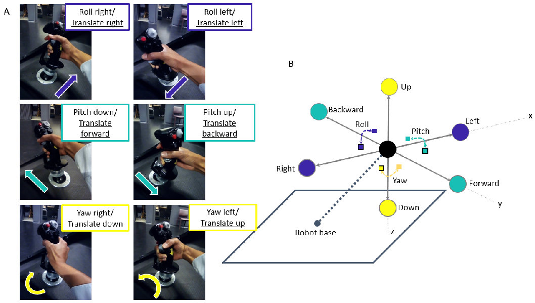
Figure 1: Figure 1A shows the mapping of participant’s joystick movements to the movement of the cabin. The simulator cabin, represented by the black sphere in Figure 1B, could move in both translation (left/right, forward/backward, up/down) and rotation (roll, pitch, yaw) via the input stimulus and/or participant control. The black outlined squares and circles in Figure 1B denote positive directional movement (right, forward, down), where squares and circles correspond to rotational and translation movement respectively. Non-outlined squares and circles indicate negative directional movement (left, backward, up).

Minuscule sinusoidal vibrational noise, 1-2cm in amplitude, was added to the non-stimulated axes to mask the sound of the motor for the selected stimulus. Due to the fact that vibrational noise was present, participants were exposed to a more realistic aviation environment. Furthermore, the additional vibration helped to reduce movement detection thresholds such that the task was realistically challenging (Chaudhuri et al, 2013).

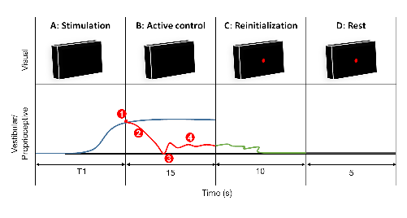

Figure 2: Task procedure. Each trial consisted of four phases: (A) motion stimulation of the cabin with an unknown forcing function, (B) participant motion detection and afterwards active control, (C) cabin reinitialization to the initial orientation or position, (D) cabin and participant at rest. For visual, red dot denotes that participants should release the joystick and rest. For vestibular/proprioceptive, blue corresponds to the forcing function that actively perturbed the cabin, red line denotes the participant's movements to counteract the perturbation after motion detection at T1 seconds, green line during phase C denotes automatic reinitialization of the cabin, and grey line during phase D denotes a stationary period. (1) detection of xxxxx; (2) corrective compensation; (3) typical release motion of the joystick signaling return to initial orientation or position; (4) typical small corrections to maintain orientation or position about the initial location. Se text for details.
A single trial was composed of four different phases:
- A second-order transfer function response served as the forcing function unknown to participants, perturbed the cabin orientation or position for 20 s (rotation) and 8 s (translation) maximum with an acceleration ramp of respectively 5.8 s and 3.8 s. A second-order response was chosen because the motion simulator is sensitive to abrupt motion, especially during starting and stopping; the second-order function was 1/(s2 + (3.6π)/T s + π/(0.9T)) where T = 4. Similarly, in order to obtain constant stimulus velocity at the chosen near sub-threshold and supra-threshold values, a second-order system was of interest because the response slope can be tuned to correspond to the chosen movement rates. Rotational and translational experiments had different stimulation lengths due to the physical constraints of the motion simulator.
- During phase A the participant could move the cabin with the joystick in any of the three rotational or translational axes to counteract the perturbation, as shown in Figure 3B. Figure 3B depicts the mapping of the participant’s actions on the 3-axes joystick, which corresponded to the movement of the cabin. If participants responded within the defined temporal window of phase A, phase A stopped and they had 15 additional seconds to maintain the cabin stationary by counteracting the perturbation.
- The cabin returned to the initial starting location in roughly 10s. If participants did not respond within the defined temporal window of phase A, the re-positioning event would begin automatically.
- The cabin remained stationary at the starting location for 5s in order to avoid possible over stimulation or aftereffects. Figure 2 shows a typical situation of the four phases in sequential order, the blue line in phase A and B depicts the second-order forcing function that actively perturbed the cabin; during phases A and B participants viewed a black screen indicating that they should actively counteract the perturbation. At T1 seconds the participant detected (1) and counteracted (2) the stimulation, depicted by the red line; typically after participants initially counteracted the perturbation (3), small and frequent correction movements (4) were used.

For both rotational and translational experiments, participants could move the joystick in six unique directions: right (roll right or translate right), left (roll left or translate left), forward (pitch forward or translate forward), backward (pitch backward or translate backward), counter-clockwise (yaw left or translate up), clockwise (yaw right or translate down). Finally, the green line depicts the automatic re-positioning of the cabin in 10s; during events C and D the participant saw a red dot which indicated that s/he could rest.

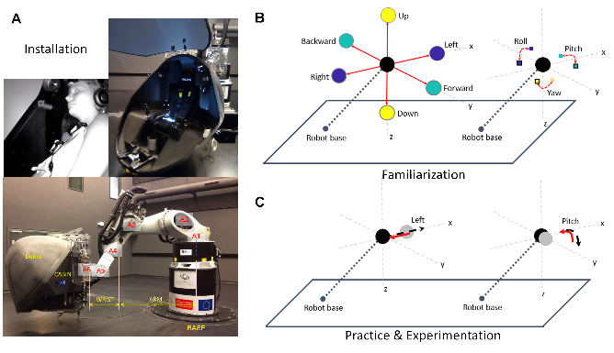
Figure 3: Sequential simulator movements during each experimental session: (A) installation, (B) familiarization, (C) practice and experimental trials. A depicts the experimental installation process consisting of: opening cabin door, participant installation, closing cabin door and movement of cabin to starting position. B demonstrates the possible orientational (right) and directional (left) motion of the cabin for translational and rotational experiments, respectively. During familiarization (B), for both rotational (right) and translation (left) experiments, participants moved the joystick in all 3 axes directions one-at-a-time to become familiar with their control movements on the movement of the cabin. C demonstrates compensatory orientational and directional movement of the cabin for one trial in the pitch and left directions respectively; red solid lines indicate participant control and the black dashed lines indicate the unknown movement stimuli. During the 12 practice trials and 30 experimental trials, participants performed the whole-body compensatory movement task illustrated in C.

At the bottom of Figure 3A, the six-axis KUKA motion simulator is shown where: axis A1 controls yaw motion about the base, axis A2 is positioned at the base and controls vertical and longitudinal movement, axis A3 is positioned between the base and the cabin such that it controls vertical motion, axis A4 is positioned near the cabin and turns in the roll orientation, axis A5 is positioned at the cabin and controls pitch movement, axis A6 is positioned at the cabin and controls roll movement. The rotational roll link A4 can be used in conjunction with A5 and A6 to produce a small yaw movement with respect to the cabin. If A4 is rotated 90◦ at the same time that A6 is rotated −90◦, the participant will remain stationary while preparing the joints to perform the yaw motion about the cabin. Then A5 (pitch) can be used to move the cabin in the yaw direction with respect to the cabin. During yaw condition, the cabin was first moved with respect to the cabin (A4: ±90◦, A6: ± − 90◦, A5: ±40◦) and then with respect to the base (A1: ±54 cm); first the small yaw with respect to the cabin was launched and then the large yaw with respect to the base was executed when the small yaw was at its maximum. During the experimental conceptualization, (A4, A5, A6) was used only to provide small yaw stimulation, however it was decided to add A1 to enlarge the rotational movement range despite adding a small translational component. The added translation component due to the presence of A1 movement was calculated to be below sub-threshold perception at 2.2 cm/s, therefore the added presence of A1 should not influence the perception of yaw.

One trial was composed of three or four events, phase B did not occur if the participant did not respond during phase A, and each trial was at maximum 50 s long in the rotational experiment (20 + 15 + 10 + 5) and 38 s long in translational experiment (8 + 15 + 10 + 5). For example, for the rotational experiment, initial stimulation was roughly 5 s however participants had 20 s to respond by correcting with the joystick. If participants detected the movement and corrected using the joystick, 15 additional seconds were added from the point at which the joystick was moved. If participants did not move the joystick, the trial finished after 20 s.

There were a total of 42 trials, the experimental familiarization practice phase consisted of 12 trials, each of the 3 axes were stimulated in both negative and positive directions at near sub-threshold and supra-threshold movement speeds. Similarly, the experimental phase consisted of 30 randomized trials, such that 15 trials with unique experimental conditions were repeated twice; negative near supra-threshold, negative near sub-threshold, no-movement, positive near sub-threshold, positive near supra-threshold) for each of the 3 axes (roll/lateral, pitch/longitudinal, yaw/vertical). No-movement trials were included as sham trials to test whether participants could indeed detect the presents of movement during movement trials.

2.3 Experimental protocol
The experiment took approximately 90 minutes and consisted of four sections: (1) arrival/ questionnaires/ instruction, (2) familiarization, (3) experimental session (rotational or translational stimulation), (4) questionnaire/discussion.

Two questionnaires were administered before the experimental phase, a claustrophobia assessment (Radomsky, 2001; Radomsky, 206) and general simulator sickness questionnaire (SSQ) (Kennedy, 1993; Bouchard, 2007). All questionnaires were administered in the native fluently spoken language for each participant, French or English. The claustrophobia questionnaire consisted of two sections, where the first section measured fear of suffocation (14 questions) and the second section assessed fear of restriction (12 questions). The claustrophobia questionnaire was used as a screening method to assess whether participants could enter the simulator and perform the task relatively stress-free; participants who scored 40 points or lower, indicating that they were not claustrophobic, were initially recruited and participants scoring higher than 40 were recruited last. For both rotational and translational experiments all participants scored “non-claustrophobic”, rotational results were mean=10.94, max=38, min=0 and translational results were mean=8.77, max=9, min=0. The SSQ consisted of 16 questions and measured the participants’ general physical state. The SSQ was administered before and after the experiment to measure the effects of the experiment in terms of disorientation. Therefore, analysis is not in terms of the SSQ score, but in terms of the difference in SSQ score before and after the task. Negative difference values indicate that the participant reported higher SSQ scores after the experiment than before, denoting that participants were negatively affected by the task in terms of three-subscales: nausea, ocular motor, and disorientation. Conversely, positive difference values imply that higher SSQ scores were reported before the experiment in comparison to after the experiment, expressing that the task positively affected participants. Due to the interest of motion detection and correction effects on disorientation, only the SSQ disorientation subscale difference was compared with detection and correction results.

After describing the experimental task and the completion of the questionnaires, participants were securely installed, using the safety harness and communication headphones, in the motion simulator. They were asked to moderately move the joystick in one axis direction at a time, to compensate the unknown perturbation. They were given the same instructions to return the cabin to the initial position/orientation when they thought that they had moved away from the initial position/orientation; They were not told to act as fast or accurate as possible. The reaction speed and/or strategy that participants adopted were chosen by the participants themselves. Participants were free to look and/or fixate where they wished, and they could freely move their body and head as long as it did not interfere with the task, in order to simulate a realistic flight scenario.

Once the participant was installed in the cabin, the cabin door was closed and all communication between the participant and experimenter were performed via a camera interface system which facilitated two-way auditory communication. The experimenter additionally could visually monitor the well-being of the participant in the cabin. The left portion of Figure 3A shows the sequence of steps performed during the usage of the motion simulator. The installation process, shown on the left from top to bottom, illustrates the simulator with the (1) cabin door open on the ground, (2) participant installation, (3) cabin door closed on the ground.

2.4 Participants
18 and 14 healthy volunteers with normal or corrected vision, and no particular flight experience performed the rotational and translational near sub-threshold tasks (males and females, 32±10 SD years old): 4 of the 32 participants reported having novice time-limited (45 minutes, 2 hours, 40 hours, 45 hours) piloting experiences. 4 of the 18 rotational and 4 of the 14 translational participants were over the age of 40. The participants that performed the rotational experiment were not the same as participants that performed the translational experiment. Therefore, there were no confounds due to experimental ordering, learning, carryover, or fatigue. The same participant population, university students and personal, were used for both experiments therefore it is likely that both experimental populations were similar.

2.5 Data analysis
Simulator and participant movements were collected at 252 Hz, the sampling frequency of the KUKA controller, and later down-sampled to 10 Hz for analysis. 10 Hz was chosen as a desirable sampling frequency because human response movements for this task are less than 10 Hz (Farmer, 1999). Four detection and correction performance metrics were selected for statistical analysis: (1) detection response occurrence profile consisting of five categories that organized participant responses, (2) detection reaction time, (3) correction rate (CR), (4) control response occurrence profile consisting of five categories that organized participant behavior.

2.5.1 Detection response profile analysis
Detection of correct stimuli was categorized into ten possible categories based on the selection of axis and axial direction. Figure 4 depicts a flow chart and the possible participant choices based on response movement.
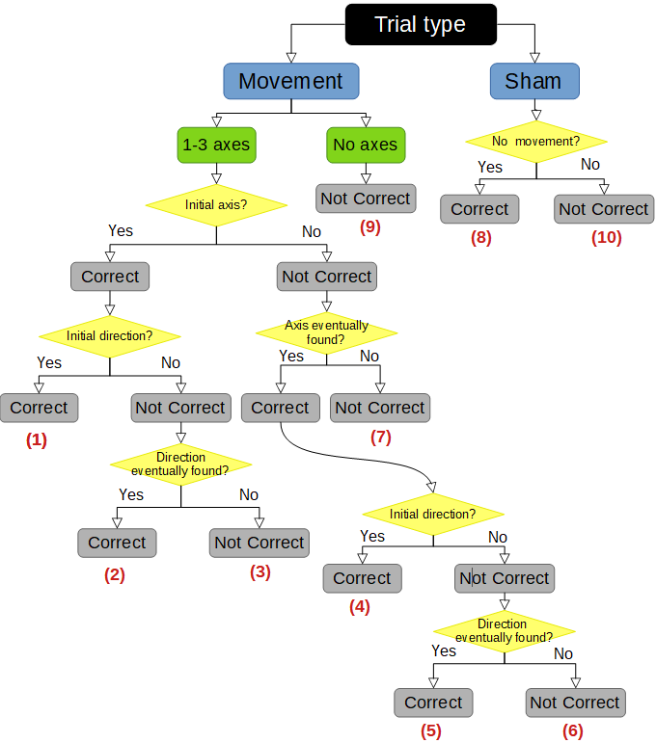
Figure 4: Flow chart of selection process for detection response profiles, where correct response profiles 1, 2, 4, 5, and 8 denote non-SD occurrence and wrong response profiles 3, 6, 7, 9, and 10 denote SD occurrence.

Detection response occurrence profiles were reduced to five categories:
- Initial Correct axis & direction: trials where the first response was with the correct axis and direction (Category 1)
- Initial Correct axis, late direction: trials where the first response was with the correct axis, but later found the correct direction (Category 2)
- Late axis & direction: trials where the first response was with the wrong axis and direction, but later found the correct axis and direction (Category 3)
- Never Correct: trials where participants acted on the joystick but never found the correct axis and direction (Category 4)
- No response: trials in which participants did not respond (Category 5).
The 95% confidence interval around the mean of near sub-threshold and supra-threshold categories were used to determine the response occurrence categories different from zero. Response occurrence categories above the lower confidence interval were further evaluated in terms of detection reaction time and CR. Reaction time was determined as XXXXXX. CR was calculated as the area under the joystick command divided by the negative input stimulus, which is considered to be the theoretically ideal correction command.

Let x denote here the considered motion variable, homogeneous to a displacement for translational motions, and to an angle for rotational ones. The total motion of the cabin is the sum of the theoretical motion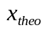and the motion commanded by the joystick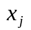:
(1)
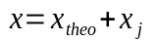.
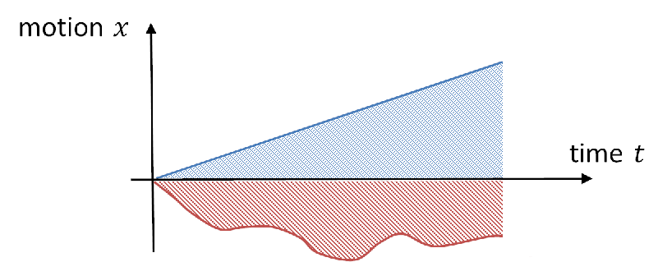

Figure 5: Illustration of the typical negative input stimulus and subject response shown in red and blue respectively.

Figure 5 depicts a typical input stimulus, shown in red, and the participant’s compensatory response to the stimulus indicated in blue. The shaded areas under the blue and red lines were used to calculate the CR metric, which is the ratio of the participant response to the theoretical trajectory. The CR metric was used to quantify the correction behavior exhibited by the participant with respect to theoretically perfect correction.
The correction rate can be expressed as:
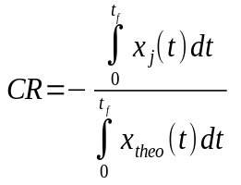
(2)
where 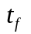 was the duration of the trial before cabin reinitialization. Correct compensatory joystick movement with respect to the input stimulus should be opposite in sign, the CR ratio will be positive. However, if the participant moved the joystick in the same direction as the input stimulus, the CR ratio will be negative such that the cabin drift is amplified. Ratio values equal to one or greater than one indicate optimal compensation of the stimulus and overcompensation, respectively.

2.5.2 Control response profile analysis
Detection profiles greater than the 95% confidence interval were only considered in the control response profile analysis. Control response was evaluated by three metrics, per trial: (1) Root mean square error (RMSE) trend (increasing, decreasing, bounded) of theoretical movement and participant joystick movement, (2) participant joystick amplitude (Fast Fourier Transform (FFT) cutoff magnitude) compared with theoretical amplitude, (3) participant joystick frequency (FFT cutoff frequency) compared with theoretical frequency. Standard FFT gain bandwidth analysis, 3db drop, to obtain the cutoff frequency was used to capture dominant joystick motion in terms of magnitude and frequency. Integer values were assigned to representative states for each of the three metrics.

RMSE trend had three states indicating increasing error (drift), decreasing error (correction), and bounded error (stationarity). Figure 6 displays how the RMSE trend was calculated per trial, where local slopes shown in green were calculated for each bin and a final trial slope shown in red was calculated using the local slopes. RMSE trend across trials were evaluated per participant to calculate two outlier bounds, to distinguish statistically significant drifting (positive slope) and correcting (negative slope) behavior from stationary behavior per trial; two standard deviations was found to be a fair threshold for identifying outliers.
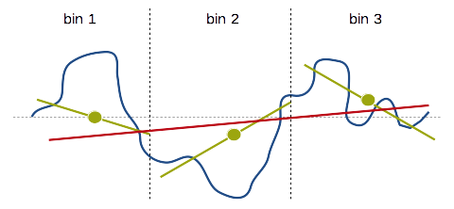

Figure 6: A depiction of RMSE trend calculation per trial. The green lines represent local calculated slopes per bin, and the red lines show the final RMSE trend slope per trial. Three bins or more result in a similarly accurate RMSE trend.

FFT cutoff magnitude had two states depicting low and high joystick amplitude movements, where low and high indicates trial joystick amplitude less than and greater than the trial theoretical amplitude respectively. Similarly, FFT cutoff frequency had two low and high states, such that low and high states indicated trial joystick frequency less than and greater than the trial theoretical frequency respectively.

The trial theoretical amplitude and frequency are the required optimal amplitude and frequency, to properly correct the cabin respectively. For each trial where detection was correct (Categories 1, 2, 3), the three metrics were calculated using joystick data from the detection point to the end of the trial. Twelve unique combinations were created from the integer states using the three metrics simultaneously. One example of the 12 unique combinations is a trial with an increasing RMSE trend, high joystick amplitude, and high joystick frequency. The 12 control response profiles were condensed into five final control profiles, because joystick frequency movement was similar across all participants and trials; joystick frequency was below the required theoretical frequency movement. Figure 7 depicts a flow chart of how the 12 categories were reduced into the five control profiles.

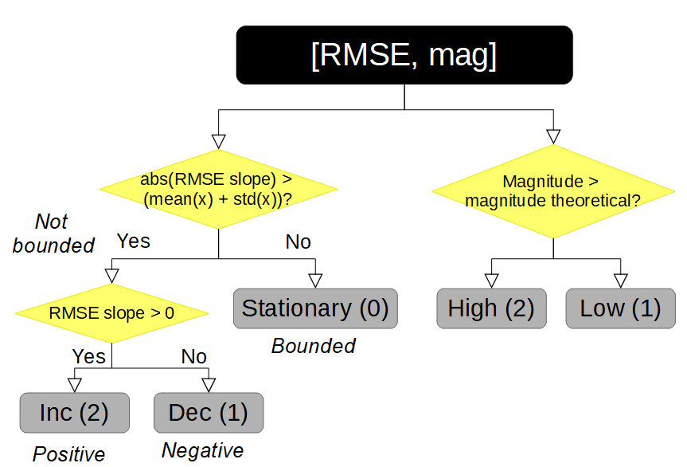
Figure 7: Flow chart of possible control response profile combinations; three possible control responses for the Root Mean Squared Error (RMSE) of joystick error and two possible responses for joystick error magnitude created five final control profiles.

The five final control profiles consist of:
- Fast drift (2,2): increasing RMSE trend and high joystick amplitude compared with theoretical amplitude
- Slow drift (2,1): increasing RMSE trend and low joystick amplitude compared with theoretical amplitude
- Startionary(0): bounded RMSE trend and low or high joystick amplitude compared with theoretical amplitude
- Fast correction (1,2): decreasing RMSE trend and high joystick amplitude compared with theoretical amplitude
- Slow correction (1,1): decreasing RMSE trend and high joystick amplitude compared with theoretical amplitude.
The five control categories were used to evaluate relative control behavior, with respect to the absolute CR control behavior measure. The relative measure allows for direct interpretation of control behavior, and the absolute measure allows for the determination of vestibular only dead reckoning ability.

2.5.3 Classification
A binary label was created from both the detection and correction profiles to classify: (1) detection (non-SD) vs. non-detection (SD) and (2) reasonable control (stationarity) vs poor control (outliers) respectively per trial. A typical and reliable classification method, linear Support Vector Machine (SVM), was selected to perform supervised classification analysis for identification of both SD and appropriate control (Christianini & Shawe-Taylor, 2000). Mathworks Matlab SVM toolbox and functions fitcsvm, kfoldLoss, and predict were used to construct the decoder and test the decoder model (per trial) using 15% of the total data for both rotation and translation. Detection and control classification was performed for each speed condition (sub, supra) and across speed conditions.
Additional classifiers were not used for comparison with SVM because the basic linear SVM algorithm produced sufficiently reliable more than chance prediction results, therefore joystick movement features were explored and compared. Explored joystick features included : (1) joystick position, (2) joystick velocity, (3) joystick acceleration, (4) joystick position error with respect to the stimuli, (5) joystick frequency (discrete Fourier transform).

2.5.4 Physical disorientation
Finally, response occurrence categories were related to the SSQ disorientation sub-scale (R. S. Kennedy et al., 1993; Bouchard et al., 2007). Non-parametric tests (Friedman test, a test equivalent to 2-factor ANOVA) and Wilcoxon tests (two-sided rank test and rank sum test) with Bonferroni correction were used to calculate both detection and correction results; Mathworks Matlab was used for all analyses.

3 Results
For both rotational and translational experiments, participant’s detection and correction behavior was quantified with respect to stimulation speed, axis, and direction. Rotational and translational experimental results can not be directly compared because physiologically the body detects these motions differently.

3.1 Response profile
Stimulus motion detection was quantified using the five response occurrence profiles and initial reaction time to compensate the stimulus. Figures 6 and 7 show the mean response occurrence across participants for axes and speed conditions, for rotation and translation respectively. Relevant response occurrence categories, for reaction time, were selected based on mean significance via the 95% confidence interval test. In the following subsections, each axis/direction (roll, pitch, yaw, LR, FB, UD) are discussed in detail.
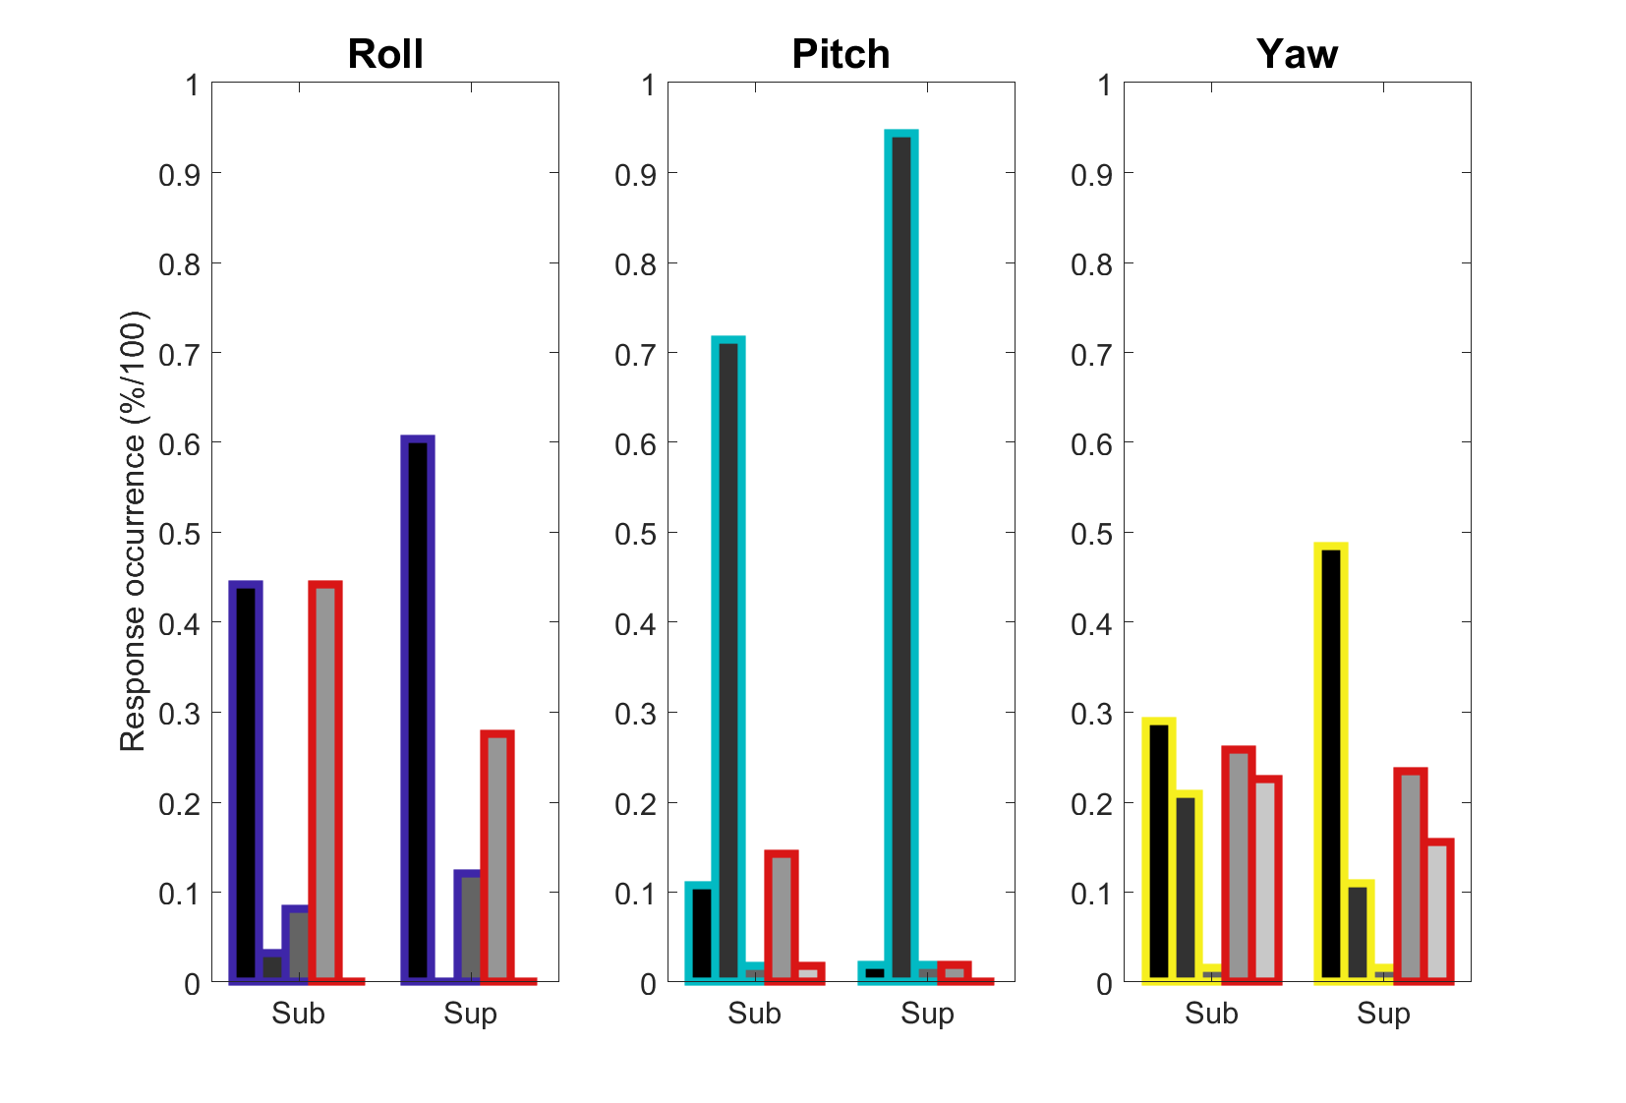

(Needs legend, 95% confidence interval line, and error bars for each axis group) Figure 6: Response occurrence metric for rotational stimulation. Mean response occurrences for roll, pitch, and yaw axes were compared for near sub-threshold and supra-threshold speed stimulations; Wilcoxon signed rank test, sum rank test, and Friedman test were used to determine significance such that significant relationships were represented by (*:p < 0.05, **: (Bonferroni correction) p < 0.0167).

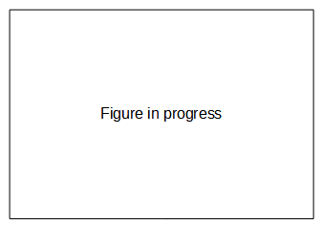

Figure 7: Response occurrence metric for translational stimulation. Mean response occurrences for LR, FB, and UD axes were compared for sub and sup speed stimulation; Wilcoxon signed rank test, sum rank test, and Friedman test were used to determine significance such that significant relationships were represented by (*:p < 0.05, **: (Bonferroni correction) p < 0.0167).

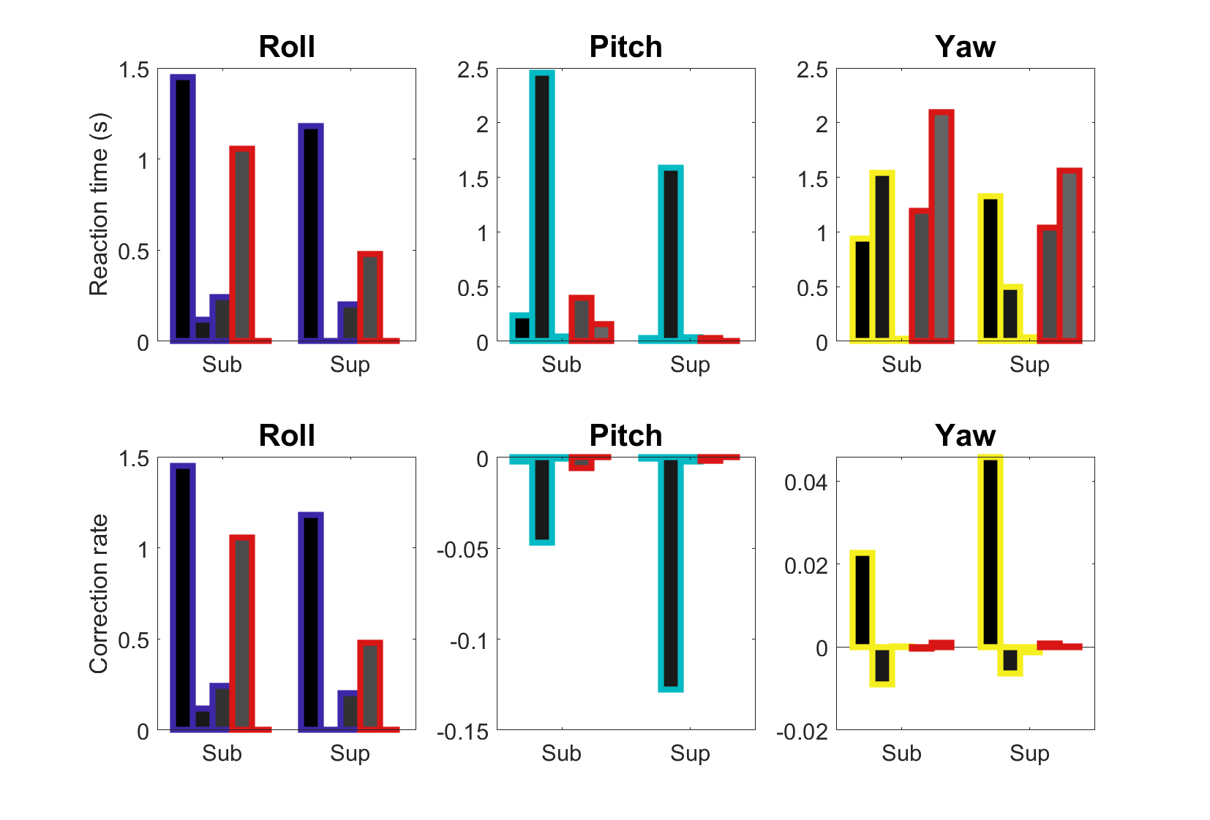

(Needs legend, only categories from 95% confidence interval groups, and error bars for each axis group) Figure 8: Reaction time and correction rate for rotational stimulation. Mean reaction time and correction rate for roll, pitch, and yaw axes were compared for sub and sup speed stimulation; Wilcoxon signed rank test, sum rank test, and Friedman test were used to determine significance such that significant relationships were represented by (*:p < 0.05, **: (Bonferroni correction) p < 0.0167).

Figure 9: Reaction time and correction rate for translational stimulation. Mean reaction time and correction rate for LR, FB, and UD axes were compared for sub and sup-threshold speed stimulation; Wilcoxon signed rank test, sum rank test, and Friedman test were used to determine significance such that significant relationships were represented by (*:p < 0.05, **: (Bonferroni correction) p < 0.0167).

3.1.1 Detection: speed
Regardless of the motion stimulation axis or direction, faster supra motion stimulation allowed for more accurate and faster detection than slower sub-threshold stimulation. In detail below for each axes and orientation direction stimulation, significance between supra and sub-threshold speed are discussed.
Discussion of difference between sup and sub-threshold response occurrence.
- Roll : Need to redo previous tests used, two-sided Wilcoxon signed rank test, two-sided Wilcoxon rank sum test, and Friedman test
- Pitch : Need to redo previous tests used, two-sided Wilcoxon signed rank test, two-sided Wilcoxon rank sum test, and Friedman test
- Yaw : Need to redo previous tests used, two-sided Wilcoxon signed rank test, two-sided Wilcoxon rank sum test, and Friedman test
- LR : Need to redo previous tests used, two-sided Wilcoxon signed rank test, two-sided Wilcoxon rank sum test, and Friedman test
- FB : Need to redo previous tests used, two-sided Wilcoxon signed rank test, two-sided Wilcoxon rank sum test, and Friedman test
- UD : Need to redo previous tests used, two-sided Wilcoxon signed rank test, two-sided Wilcoxon rank sum test, and Friedman test

3.1.2 Detection: response time and detection strategy
Additionally, across the six motion axes/directions regardless of speed stimulation, Category 1 responses took approximately a 1-2s difference longer than Category 3 responses. This indicated that participants employed at least two types of detection strategies: (1) a sensorial strategy of sensing when orientation and/or direction changed and then responding correctly and (2) a searching strategy consisting of self-generated motion interacting with the perturbation stimulus to create additional motion cues about the correct stimulus orientation and/or direction. Category 1 responses predominately demonstrate a sensorial strategy because consistent correct initial responses are not statistically possible without sensorial feedback information. Similarly, Category 3 responses represent a searching strategy because initial incorrect axis and direction are likely to occur if the joystick is moved in any direction, without considering initial sensory feedback. Sensing the correct movement orientation using a sensorial strategy, takes more time than searching with the joystick in any direction to gather information about the movement stimulus. Therefore, reaction time is an indicator for identifying motion detection policy.

3.1.2.1 Sensorial: Roll, Yaw, Need to confirm if LR, FB, UD follow this pattern
Sensorial detection indicates that participants significantly initially detected motion correctly and reaction times were beyond 1 second; Category 1 detection was greater than any other detection category and response times were 1 second or greater. Figure 6 and 7 show the following significances indicating this pattern for each axis:
Discussion of difference between Category 1 and 3 for sup and sub-threshold response time.
- Roll: Need to redo previous tests used, two-sided Wilcoxon signed rank test, two-sided Wilcoxon rank sum test, and Friedman test
- Yaw: Need to redo previous tests used, two-sided Wilcoxon signed rank test, two-sided Wilcoxon rank sum test, and Friedman test
- LR: Need to redo previous tests used, two-sided Wilcoxon signed rank test, two-sided Wilcoxon rank sum test, and Friedman test
- FB: Need to redo previous tests used, two-sided Wilcoxon signed rank test, two-sided Wilcoxon rank sum test, and Friedman test
- UD: Need to redo previous tests used, two-sided Wilcoxon signed rank test, two-sided Wilcoxon rank sum test, and Friedman test

3.1.2.2 Mixed sensorial and searching: Pitch

- Pitch : Short discussion of difference between Categories 1, 2, 3 and state any statistical differences. Need to redo previous tests used, two-sided Wilcoxon signed rank test, two-sided Wilcoxon rank sum test, and Friedman test

3.2 Control profile
Control behavior was quantified using CR and three real-time relative measures to describe global relative control response occurrence. The bottom row of Figures 8 and 9 depict the large absolute error for all axes for rotation and translation stimulation respectively, characterized by CR.

In this task, it was very difficult for the participants to know the absolute error between one’s position and the initial stimuli/heading because there was no feedback with respect to the initial starting position. Thus even if participants were continuously counteracting the stimuli, it does not necessarily mean that they were reducing absolute error with respect to the initial reference. Thus we quantified real-time relative response with respect to the absolute response to shed light on moment-to-moment control trends, to understand the importance of vestibular only feedback during a realistic compensatory flight situation.
In general, considering real-time stationarity, three trends were observed. The less informative the real-time vestibular feedback, the less participants were able to respond; here the ratio between relative stationarity and motion control was close to one indicating that the participants were not actively moving the joystick. However, the more informative the real-time vestibular feedback, participants responded using unnecessarily strong amplitude and frequency control and thus had a small ratio between relative stationarity and motion control. Finally, if an instance of directional information was felt but real-time vestibular feedback was less informative participants overcompensated in response to the stimuli.
Figure 10 and 11 depicts the mean control occurrence behavior due to stationarity consideration, across trials that meet the 95% confidence interval criteria for detection, across participants for axes and speed conditions, for rotation and translational conditions respectively.

Figure 10: Relative control occurrence metric due to stationarity consideration for rotational stimulation, with real-time statistical deadzone.

Figure 11: Relative control occurrence metric due to stationarity consideration for translational stimulation, with real-time statistical deadzone.

Regardless of axis stimulation, control behavior was observed to have two types of patterns: (1) sufficient vestibular only control, and (2) adaptive vestibular only control. Sufficient absolute control indicated that participants were able to control error to an acceptable amount, nor good or bad, such that faster/supra speed error control was better than slower/sub-threshold speed.

3.2.1 Sufficient vestibular only control: Need to confirm if Roll, LR, FB, UD go here
Discussion of difference between sup and sub-threshold control response occurrence.
- Roll : Need to redo previous tests used, two-sided Wilcoxon signed rank test, two-sided Wilcoxon rank sum test, and Friedman test
- LR : Need to redo previous tests used, two-sided Wilcoxon signed rank test, two-sided Wilcoxon rank sum test, and Friedman test
- FB : Need to redo previous tests used, two-sided Wilcoxon signed rank test, two-sided Wilcoxon rank sum test, and Friedman test
- UD : Need to redo previous tests used, two-sided Wilcoxon signed rank test, two-sided Wilcoxon rank sum test, and Friedman test
3.2.2 Adaptive vestibular only control: Need to confirm if Pitch, Yaw go here
- Pitch : Need to redo previous tests used, two-sided Wilcoxon signed rank test, two-sided Wilcoxon rank sum test, and Friedman test
- Yaw : Need to redo previous tests used, two-sided Wilcoxon signed rank test, two-sided Wilcoxon rank sum test, and Friedman test

3.3 Classification: SD and control prediction
SVM supervised linear analysis was used to classify the presence of perceived disorientation (SD) and control behavior, per trial across axis and speed conditions. The label for SD was constructed by using the detection response profile, such that successful detection responses (Categories 1-3) were considered as non-SD state and the unsuccessful detection responses (Category 4-5) were considered as SD state. The supervised label for control behavior was constructed by using the control response profile, where drift or corrective control behavior (Categories 1,2,4,5) and stationarity behavior (Category 3) were distinguished. Constant (Category 3) behavior was labeled as stable successful stationary control and drift/corrective (Category 1,2,4,5) behavior was labeled as unstable task control. Initial classification analysis with a supervised linear SVM model produced satisfactory above chance results, therefore feature space was explored instead of comparing prediction accuracy of various classifiers.
Additionally, feature space was of interest because identification of predictive disorientation and control parameters were the goal of this work. Joystick movement was used as a transformable feature parameter because joystick movement is one of the few non-invasive parameters that contain real-time pilot behavior. Five joystick features were used for model construction and predictive testing: (1) position, (2) velocity, (3) acceleration, (4) integral error with respect to theoretical stimuli, (5) frequency of joystick via FFT. The entire joystick movement traced from the start to the end of the trial was used for SD prediction. Joystick movement from the moment of correct detection to the end of the trial was considered for control behavior prediction. Trials shorter than 0.6 seconds (150 data points, with 250Hz sample rate), after correct detection, were not included due to insufficient length of time-series. Joystick data per trial for each participant was stacked in a matrix, where 15% of the matrix was “held-out”/not included in the construction of the predictive model. The excluded 15% of the data was used to test the predictive capability of the SMV model, trained with a particular feature type. Table 2 shows SD and control behavior SVM prediction accuracy and precision, for the five features for both rotation and translation stimulation conditions.
Need to re-run results for detection and control
 | Rotation |  |  |  | Translation
 | SD/non-SD |  | Corr-drift/Constant |  | SD/non-SD |  | Corr-drift/Constant
 | Accuracy | Precision | Accuracy | Precision | Accuracy | Precision | Accuracy | Precision
Feature 1
Feature 2
Feature 3
Feature 4
Feature 5
Table 2: SVM supervised classification prediction results for SD detection and control behavior.

3.4 Perceived motion and physical disorientation
We evaluated the correlation between subjective physical disorientation and perceptual motion disorientation. Physical disorientation was monitored before and after the experiment using the SSQ disorientation subscale, such that the difference in before and after measures were attributed to the experienced task.
Correlations between physical disorientation and perceptual motion disorientation were evaluated in two ways: (1) detection response profiles compared with SSQ disorientation subscale differences across participants, and (2) greatest accumulated SD binary classification label per experiment across participants compared with SSQ disorientation subscale differences. Table 3 shows the trend between the SSQ disorientation subscale and detection response profile, demonstrating that physical disorientation was observed for unsuccessful detection response profiles.
Need to re-run results
Category | SSQ -5 (%) | SSQ -3 (%) | SSQ -2 (%) | SSQ -1 (%) | SSQ 1 (%) | SSQ 2 (%) | SSQ 4 (%)
1
2
3
4
5
Table 3: Occurrence response category per reported SSQ disorientation subscale difference, for both rotational and translational experiments. Category 1, in bold, represents initial correct axis and direction detection, and depicts increased response occurrence as disorientation difference changes from negative to positive. Increased Category 1 responses indicate higher SSQ scores before the experiment as compared to after the experiment. Conversely, Category 4, represents incorrect responses, shows decreased response as disorientation difference transitions from negative to positive.

4 Discussion
These results should not drastically change, so I temporarily left as in the previous version
This work contributes five main key findings for practical aviation applied research related to vestibular only stimulation: (1) fast motion supra-threshold stimuli was easier to detect than slow sub-threshold speed, (2) reaction time depicted sensorial versus searching detection behavior, (3) sufficient or adaptive control behavior could be determined by absolute metrics, (4) motion disorientation was predicted by supervised classification using joystick movements, (5) physical disorientation did not correlate with perceived motion disorientation. Fast supra-threshold speed produced significantly more accurate initial detection of motion than sub-threshold speed, for all direction stimulation except for pitch. However for pitch, the control occurrence metric shows that participants over-corrected more during sub-threshold speed, implying that participants were receiving more continuous motion information for fast speed than for slow speed. Thus, regardless of directional stimulation, fast motion provides more vestibular information than slow motion, influencing motion detection and control. Slower reaction times (at least 2 seconds) in response to motion stimuli indicated that participants were relying on sensory information, however quick reaction times indicated that participants were using a searching strategy such that combined self-generated motion and stimuli was sensorially felt. We demonstrated that both absolute and relative measures are needed to capture orientation control behavior. The CR metric explained absolute performance, however our relative metric described path integration in real-time during continuous perturbation; the relative metric was temporally windowed joystick error trend with respect to the stimuli. The absolute CR metric showed that participants could not precisely return the cabin position back to the initial starting location, implying that for a vestibular compensatory task real-time dead reckoning was not possible regardless of speed or directional motion. Previous work, using a TCT task with vestibular only information, indicated similarly that participants were unable to calculate global/absolute distances by using accumulated vestibular felt distances from a reference such that precise dead reckoning can be achieved. Despite the fact that participants could not return to the initial starting location, the CR metric showed that depending on the axis and speed of the stimulation participants were able to perform dead reckoning better. Faster speed and roll/LR/FB/UD axes had more accurate error minimization with respect to the initial point than slower speed and pitch/yaw axes, respectively. Our relative metric using joystick error trend revealed that participants were maintaining stationarity but were unsuccessful at exactly counteracting the stimuli, thus producing “moments of stationarity” while the cabin heading drifted away from the initial starting point with the stimuli. Participants were susceptible to drifting because they could not correctly modulate their joystick frequency and amplitude control, such that frequency movements were lower than theoretical stimuli movements and the amplitude was larger than necessary. Considering the physiological function of the vestibular system, maintaining stationarity is likely the best that one could do with limited memory of successive vestibular inputs that influence an adaptive reference. It seems plausible that there is a restriction on the amount of functional step-by-step vestibular information, because initial references to calculate acceleration are often updated based on the moving fluid in the otolith organs (saccule and utricle). The nature of the vestibular system is to constantly update orientation referential points to give accurate estimations of real-time motion, thus storing large amounts of past step-by-step vestibular information would probably not be effective for achieving its main task of giving accurate real-time estimations of motion change. Satisfactory absolute and relative control was achieved for roll, LR, FB, and UD directional stimuli regardless of speed. Adaptive and often over-corrective control occurred for pitch and yaw directional stimuli regardless of speed.
Since joystick information could be used to effectively capture participant control behavior, it was likely that joystick movement could also capture when participants were disoriented and unable to detect correct motion axis and direction. Using supervised SVM classification analysis we demonstrated that joystick amplitude and frequency features best predict trials when participants were disoriented versus not disoriented, at accuracies of XX% or greater. Physiological self-reports were not correlated to perceived motion, such that physical sickness did not imply motion disorientation. However, due to the small sample size of participants that reported physical sickness differences before and after the experiment, the relationship between physical sickness and motion disorientation is unclear. Physiological measures may be a more effective indicator for physical sickness than subjective questionnaire self-assessment because psychological measures could be analyzed for all participants with respect to motion disorientation, regardless of whether participants felt sick or not.

Key points:
- Fast supra-threshold speed was easier to detect than sub-threshold speed, regardless of axis and direction.
- Participant detection strategy was characterized by reaction time, where sensorial Category 1 reaction times were slower than searching Category 3 reaction times regardless of axis and direction. When motion was easier to detect, such as for fast supra-threshold speed or axes roll/LR/FB/UD, participants detected motion using vestibular information. When motion was difficult to detect, participants moved the joystick in a searching manner to generate self-motion to better detect movement.
- Absolute and relative measures are jointly needed to capture orientation control behavior; the absolute CR metric captures overall performance with respect to the stimuli (dead reckoning) and the relative metric described short-term error trends.
- Accurate real-time path integration/dead reckoning was not possible during the vestibular compensatory task, regardless of speed or directional motion. However, dead reckoning was significantly better for faster supra-threshold speed than slow near sub-threshold speed.
- The main purpose of using a vestibular compensatory task was not to measure dead reckoning, but to understand vestibular functioning during realistic flight. Considering vestibular functioning, it is known that humans can not perform vestibular only dead reckoning accurately, and moments of stationarity while drifting away from the starting position will be the best achievable behavior. A relative metric was used to quantify behavior, the tabulated result categories gave expected behavior for this task, equal amounts of drifting and stationarity; only successful detection and active control data was used to ensure that participants were actively controlling during stationarity.
- Perceptual motion disorientation (SD/non-SD) and control behavior can be accurately (71% or greater) predicted using a supervised linear SVM classifier.
- Position amplitude and frequency features for rotational stimuli similarly predict SD best. However, frequency features are more preformant at predicting SD for translational stimuli because searching strategies were more frequently employed during translational motion detection.
- There was no significant correlation between motion detection, using the SD binary classification label, and physical sickness. However, there was a trend such that the more physical sickness corresponded with an unsuccessful detection profile. This mixed result indicates that physical sickness may be better captured using a continuous measure, such as a physiological measure, instead of a discrete questionnaire measure; the lack of physically sick participants during both studies did not provide enough data to have a meaningful correlation between physical sickness/disorientation and perceived disorientation.

References:
Angelaki, D. E., & Cullen, K. E. (2008). Vestibular system: The many facets of a multimodal sense. Annual Review of Neuroscience, 31(1), 125–150.
Barmack, N. H. (1981). A comparison of the horizontal and vertical vestibulo-ocular reflexes of the rabbit. J Physiol, 314, 547–564.
B. Cheung, C. J. B. P. G., K. Hofer. (2000). Underwater disorientation as induced by two helicopter ditching devices. Aviation, Space, and Environmental Medicine, 71, 879-888.
Bellmann T, Heindl J, Hellerer M, Kuchar R, Sharma K & Hirzinger G (2011). The DLR Robot Motion Simulator Part I: Design and setup. 2011 IEEE International Conference on Robotics and Automation, Shanghai, 4694-4701.
Benson, A. J., Bischof, N., Collins, W. E., Fregly, A. R., Graybiel, A., Guedry, F. E., & Johnson, W. H. (1974). Handbook of sensory physiology volume v1/2 - vestibular system part 2: Psychophysics, applied aspects and general interpretations. New York: Springer-Verlag Berlin Heidelberg.
Benson, A. J., Hutt, E. C., & Brown, S. F. (1989). Thresholds for the perception of whole body angular movement about a vertical axis. Aviat Space Environ Med, 60, 205–213.
Benson, A. J., Spencer, M. B., & Stott, J. R. (1986). Thresholds for the detection of the direction of whole-body, linear movement in the horizontal plane. Aviat Space Environ Med, 57, 1088–1096.
Bermudez-Rey, M. C., Clark, T. K., Wang, W., Leeder, T., Bian, Y., & Merfeld, D. M. (2016). Vestibular perceptual thresholds increase above the age of 40. Frontiers in Neurology, 7.
Bles, W. (2008). Spatial disorientation training – demonstration and avoidance (Tech. Rep.). Soesterberg, Netherlands: Research and Technology Organisation (RTO) North Atlantic Treaty Organisation (NATO).
Bouchard, S., Robillard, G., & Renaud, P. (2007). Revising the factor structure of the simulator sickness questionnaire. Annual Review of CyberTherapy and Telemedicine, 5, 117–122. Bringoux, L., Schmerber, S., Nougier, V., Dumas, G., Barraud, P., & Raphel, C. (2002). Perception of slow pitch and roll body tilts in bilateral labyrinthine-defective subjects. Neuropsychologia, 40, 367–372.
Bronstein, A. (2013). Oxford textbook of vertigo and imbalance. Oxford: Oxford University Press.
Bruyer, R., & Brysbaert, M. (2011). Combining speed and accuracy in cognitive psychology: Is the inverse efficiency score (IES) a better dependent variable than the mean reaction time (RT) and the percentage of errors (PE)? Psychologica Belgica, 51(1), 5–13.
C. Haburcakova, D. M. M., R. F. Lewis. (2012). Frequency dependence of vestibuloocular reflex thresholds. J Neurophysiol, 107, 973-983.
Christianini, N., & Shawe-Taylor, J. (2000). An introduction to support vector machines and other kernel-based learning methods. Cambridge: Cambridge University Press.
Crane, B. T. (2016). Perception of combined translation and rotation in the horizontal plane in humans. J Neurophysiol, 116, 1275-1285.
Day, B. L., & Fitzpatrick, R. C. (2005). The vestibular system. Current Biology, 15(15), 583–586. Draheim, C., Hicks, K. L., & Engle, R. W. (2016). Combining reaction time and accuracy: The relationship between working memory capacity and task switching as a case example. Perspectives on Psychological Science, 11(1), 133–155.
Eriksson, L., & von Hofsten, C. (2005). Effects of visual flow display of flight maneuvers on perceived spatial orientation. Human Factors, 47(2), 378–393.
Eriksson, L., von Hofsten, C., Tribukait, A., Eiken, O., Andersson, P., & Hedstro ̈m, J. (2008, September). Visual flow scene effects on the somatogravic illusion in non-pilots. Aviation, Space, and Environmental Medicine, 79(9), 860–866.
Farmer, S. F. (1999, May). Pulsatile central nervous control of human movement. The Journal of Physiology, 3–3. (GAMA), G. A. M. A. (2017). 2016 general aviation statistical databook and 2017 industry outlook (Tech. Rep.). Washington, DC: GAMA.
Gibb, R., Gray, R., & Scharff, L. (2010). Aviation visual perception research, misperception and mishaps. Farnham, Surrey, England; Burlington, VT: Ashgate.
Gillingham, K. K., & Previc, F. H. (1993). Spatial orientation in flight (Tech. Rep. No. AL-TR- 1993-0022). Armstrong Laboratory (AFMC).
Gillingham, K. K., & Wolfe, J. W. (1986, dec). Spatial orientation in flight (Tech. Rep. No. USAFSAM-TR-85-31). Brooks Air Force Base, Texas: USAF School of Aerospace Medicine.
Grabherr, L., Nicoucar, K., Mast, F. W., & Merfeld, D. M. (2008). Vestibular thresholds for yaw rotation about an earth-vertical axis as a function of frequency. Exp Brain Res, 186, 677–681.
Gracio, B. J., de Winkel, K. N., Groen, E. L., Wentink, M., & Bos, J. E. (2013). The time constant of the somatogravic illusion. Exp Brain Res, 224(3), 313–321.
Gradwell, D. P., & Rainford, D. J. (2016). Ernsting’s aviation and space medicine, 5th edition. Boca Raton, FL: CRC Press Taylor & Francis Group.
Green, A. M., & Angelaki, D. E. (2003). Resolution of sensory ambiguities for gaze stabilization requires a second neural integrator. J Neurosci, 23, 9265–9275.
Guedry, F. E. (1974). Psychophysics of vestibular sensation. In H. H. Kornhuber (Ed.), Vestibular system part 2: Psychophysics, applied aspects and general interpretations (Vol. 6, pp. 3–154). Springer.
Hess, R. A. (1990). Model for human use of motion cues in vehicular control. Journal of Guidance, Control, and Dynamics, 13(3), 476–482.
Jongkees, L. B. (1961). The influence of some drugs upon the function of the labyrinth. Acta Otolaryngol, 52, 281–285.
J. Sargent, J. P. J. A., S. Dopkins. (2008). Exploring the process of progressive disorientation. Acta Psychol, 129, 234–242.
Karmali, F., Bermudez-Rey, M. C., Clark, T. K., Wang, W., & Merfeld, D. M. (2017). Multivariate analyses of balance test performance, vestibular thresholds, and age. Frontiers in Neurology,
Karmali, F., Chaudhuri, S. E., Yi, Y., & Merfeld, D. M. (2016). Determining thresholds using adaptive procedures and psychometric fits: evaluating efficiency using theory, simulations, and human experiments. Exp Brain Res, 234, 773–789.
Kennedy, Q., Taylor, J. L., Reade, G., & Yesavage, J. A. (2010). Age and expertise effects in aviation decision making and flight control in a flight simulator. Aviat Space Environ Med, 81, 489–497.
Kennedy, R. S., Lane, N. E., Berbaum, K. S., & Lilienthal, M. G. (1993). Simulator sickness questionnaire: An enhanced method for quantifying simulator sickness. International Journal of Aviation Psychology, 3(3), 203–220.
Kingma, H. (2005). Thresholds for perception of direction of linear acceleration as a possible evaluation of the otolith function. BMC Ear, Nose and Throat Disorders, 5(5).
Kitchen, B. J. (1983). Horizontal and vertical eye deviations in response to linear accelerations (Unpublished master’s thesis). Massachusetts Institute of Technology, Cambridge, Massachusetts.
Landrieu, J., Abdur-Rahim, J., Sarrazin, J.-C., & Bardy, B. (2017). Time-to-collision estimates during congruent visuo-vestibular stimulation. In Studies in perception and action xiv: 19th international conference on perception and action (ipca) (pp. 109–112). Seoul.
Lawson, B. D., Williams, H. P., Newman, M. C., McGrath, B. J., & Rupert, A. H. (2017). Understanding of a key aspect of situation awareness: a research and development agenda to refine the model of spatial orientation (Tech. Rep. No. USAARL 2017-14). Fort Rucker, AL: U.S. Army Aeromedical Research Laboratory.
Loomis, J. M., Klatzky, R. L., Golledge, R. G., Cicinelli, J. G., Pellegrino, J. W., & Fry, P. A. (1993). Nonvisual navigation by blind and sighted: Assessment of path integration ability. Journal of Experimental Psychology: General, 122, 73–91.
Mardirossian, V., Karmali, F., & Merfeld, D. M. (2014). Thresholds for human perception of roll tilt motion: patterns of variability based on visual, vestibular, and mixed cues. Otol Neurotol, 35, 857–860.
Mars, F. (2001). La desorientation spatiale en aeronautique: Apport des neurosciences int ́egratives `a la conception des postes de pilotage (Unpublished doctoral dissertation). Universit ́e de la M ́editerran ́ee Aix Marseille II, Marseille Cedex 07, France.

Matthews, S., Previc, F., & Bunting, A. (2002, april). Usaf spatial disorientation survey. In Presented at rto hfm symposium on “spatial disorientation in military vehicles: Causes, consequences and cures” and published in rto-mp-086.
McCabe, B. F. (1964). Nystagmus response of the otolith organs. Laryngscope V , 76 .
McRuer, D., & Jex, H. (1967, September). A review of quasi-linear pilot models. IEEE Transactions on Human Factors in Electronics, HFE-8(3), 231–249.
Melvill, J. G., & Young, L. R. (1978). Subjective detection of vertical acceleration: a velocity-dependent response. Acta Otolaryngology, 85, 45—53.
Merfeld, D., Park, S., Gianna-Poulin, C., Black, F. O., & Wood, S. (2005). Vestibular perception and action employ qualitatively different mechanisms. i. frequency response of vor and perceptual responses during translation and tilt. Journal of Neurophysiology, 94, 186–198. Merfeld, D. M. (2011, May). Signal detection theory and vestibular thresholds: I. basic theory and practical considerations. Experimental Brain Research, 210(3–4), 389–405. 34

M. Hartmann, I. M. E. J. H. F. W. M., K. Haller. (2014). Direction detection thresholds of passive self-motion in artistic gymnasts. Exp Brain Res, 232, 1249-1258.

Newman, D. G. (2007). An overview of spatial disorientation as a factor in aviation accidents and incidents. Canberra City, A.C.T.: Australian Transport Safety Bureau.

Newman, M., Lawson, B., Rupert, A., & McGrath, B. (2012, May). The role of perceptual modeling in the understanding of spatial disorientation during flight and ground-based simulator training. In Aiaa modeling and simulation technologies conference. Minneapolis.

Perdriel, G. (Ed.). (1980). Spatial disorientation in flight, current problems: papers (No. 287). London.

Previc, F. H., & Ercoline, W. R. (2004). Spatial disorientation in aviation. Reston ,VA: American Institute of Aeronautics and Astronautics.

Radomsky, A. S., Ouimet, A. J., Ashbaugh, A. R., Paradis, M. R., Lavoie, S. L., & O’Connor, K. P. (2006). Psychometric properties of the french and english versions of the claustrophobia questionnaire (cl). Journal of Anxiety Disorders, 20, 818–828.

Radomsky, A. S., Rachman, S., Thordarson, D. S., McIsaac, H. K., & Teachman, B. A. (2001). The claustrophobia questionnaire. Journal of Anxiety Disorders, 15(4), 287–297.

Richerson, S. J., Faulkner, L. W., Robinson, C. J., Redfern, M. S., & Purucker, M. C. (2003). Acceleration threshold detection during short anterior and posterior perturbations on a translating platform. Gait & Posture, 18, 11–19.

Roditi, R. E., & Crane, B. T. (2012). Directional asymmetries and age effects in human self-motion perception. Journal of the Association for Research in Otolaryngology, 13, 381-401.

Rupert, A. H., Woo, G., Christopher, J., & Lawson, B. (2016, March). Countermeasures for loss of situation awareness: Spatial orientation modeling to reduce mishaps. In 2016 ieee aerospace conference (pp. 1–9).

S. E. Chaudhuri, D. M. M., F. Karmali. (2013). Whole body motion-detection tasks can yield much lower thresholds than direction-recognition tasks: implications for the role of vibration. J Neurophysiol, 110, 2764–2772.

Sjoberg, A. A. (1931). Experimentelle studien uber den auslosungs-mechanismus der seekrankeit. Acta Otolaryngol, Suppl. 14.

Soyka, F., Giordano, P. R., Barnett-Cowan, M., & Bulthoff, H. H. (2012). Modeling direction 35 discrimination thresholds for yaw rotations around an earth-vertical axis for arbitrary motion profiles. Exp Brain Res, 220, 89-99.
Soyka, F., Giordano, P. R., Beykirch, K., & Bulthoff, H. H. (2011). Predicting direction detection thresholds for arbitrary translational acceleration profiles in the horizontal plane. Exp Brain Res, 209, 95-107.
Stoffregen, T., Pagulayan, R., Smart, L., & Bardy, B. (2003). On the nature and evaluation of fidelity in virtual environments. In L. Hettinger & M. Haas (Eds.), Virtual and adaptive environments (p. 111-128). CRC Press.
Thompson, L., Lawson, B., Newman, M., McGrath, B., Brill, J., & Rupert, A. (2016, November). Design considerations and research needs for expanding the current perceptual model of spatial orientation into an in-cockpit spatial disorientation warning system (Tech. Rep. No. AD1031427). Fort Rucker, AL: Army Aeromedical Research Lab.

Valko, Y., Lewis, R. F., Priesol, A. J., & Merfeld, D. M. (2012). Vestibular labyrinth contributions to human whole-body motion discrimination. J Neurosci, 32, 13537-13542.

Vold, H., Crowley, J., & Rocklin, G. (1984). New ways of estimating frequency response functions. Sound and Vibration, 18, 34–38.

Young, L. R., Meiry, J. L., & Li, Y. T. (1966). Control engineering approaches to human dy- namic space orientation (Tech. Rep. No. SP-115). National Academy of Science Workshop on Orientation in the Exploration of Space NASA.

Zaichik, L., Rodchenko, V., Rufov, I., Yashin, Y., & White, A. (1999). Acceleration perception (Tech. Rep.). Portland, OR: In: American Institute of Aeronautics & Astronautics (AIAA) modeling and simulation technologies conference—a collection of technical papers.

Zupan, L. H., & Merfeld, D. M. (2008). Interaural self-motion linear velocity thresholds are shifted by roll vection. Exp Brain Res, 191, 505–511.

Zupan, L. H., Merfeld, D. M., & Darlot, C. (2002). Using sensory weighting to model the influence of canal, otolith and visual cues on spatial orientation and eye movements. Biological Cybernetics, 86(3), 209–230.

Biographies:

