Predicting spatial disorientation from motion control during near-threshold simulated flight.
Authors: Jamilah Foucher α, Anne-Claire Collet, Kevin Le Goff, Thomas Rakotomamonjy, Valerie Juppet, Thomas Descatoire, Jerémie Landrieu, Marielle Plat-Robain, François Denquin, Jean-Christophe Sarrazin and Benoît Bardy α
1 EuroMov Digital Health in Motion, Univ Montpellier IMT Mines Ales, Montpellier, France
2 DTIS, ONERA, Salon de Provence, France
3 AIRBUS, Toulouse, France
4 AIRBUS Helicopters, Marignane, France
5 Human Design Group, Toulouse, France
α Authors contributed equally to this work
Running head: Predicting spatial disorientation (SD) while being lost in translation and rotation
Manuscript type: Research article
Exact word count:
Text word count:
Reference word count:
Correspondence:
Jamilah Foucher
j622amilah@gmail.com
Acknowledgments:
This project was supported by the French Department of Civil Aviation (DGAC) and by the European Union (FEDER iMOSE). The authors thank Arthur Grunwald (Technion, Israel Institute of Technology) for his valuable contribution to the conceptualization of these experiments.

Abstract
Objective: Perceived motion detection and control were quantified, using vestibular and proprioceptive stimulation, demonstrating that classification analysis can be used to predict disorientation and control.
Background: In aeronautics, Spatial Disorientation (SD) includes situations in which the aviator fails to perceive correctly aircraft attitude, position or motion. SD is often quantified in terms of task and accident context, making it difficult to develop a generalized and fundamental understanding of the occurrence of SD and viable solutions.
Method: A full-body rotational and translational compensatory tracking task was employed to investigate closed-loop motion perception and control, during near sub- and supra-threshold conditions. We quantified motion perception and control using detection response profiles based on behavior, and predicted SD using supervised classification.
Results: Slow difficult to detect sub-threshold motion induced less correct perceived detection than faster detectable supra-threshold motion. Additionally, correct detection response time revealed participant strategy, where quicker and slower times indicated a searching and sensory-detection strategy respectively. Absolute motion control analysis confirmed that vestibular dead reckoning was better for fast supra speed and certain axes. Support Vector Machine (SVM) classification sufficiently predicted both perceived motion disorientation behavior.
Conclusion: Perceived motion disorientation can be quantified and predicted based on task relevant behavior (e.g., joystick).
Application: These measures can be used to monitor the onset of SD, thus understanding the cause, and evaluate the effectiveness of SD solutions.
Keywords: aviation, vestibular, proprioceptive, sub-threshold, supra-threshold.
Précis: Perceived closed-loop motion detection and control were quantified and predicted, using a full-body rotational and translational compensatory tracking task, for two movement speeds at and above the threshold of human motion detection. SVM analysis successfully predicted perceived motion disorientation response behavior.

1 Introduction
% Introduce SD in context of flight, types of SD, pros and cons
SD, in aviation, is the failure to perceive orientation, position, or movement. It is caused by multiple factors including environmental references and conditions, experience, and stress. There are diverse types of SD symptoms, ranging from confusion to physical sickness, and currently there is no proven method or solution to prevent it (Perdriel, 1980; D. G. Newman, 2007; Bles, 2008; Previc & Ercoline, 2004; Gibb, Gray, & Scharff, 2010). International studies on the frequency and severity of SD accidents show that the cause of 6-32% of major accidents are due to SD, similarly 15-26% of fatal accidents are a result of SD (D. G. Newman, 2007). Recovery from SD is strongly connected to the pilot's awareness of the situation, and his/her ability to perform corrective control, despite the disorientation, to maintain aerodynamic stability; 80% and 30% of SD incidents are caused by unrecognized and recognized situations respectively (Bles, 2008). Currently, SD is treated by educating pilots of the signs and symptoms of SD, and instructing them to fly below the physiological thresholds of the human vestibular system. Treating SD has been challenging because SD is often defined with respect to a specific aeronautical context. SD definitions focus on flight performance errors but seldom include context independent behavioral, perceptual or physiological trends. Due to the fact that SD is studied case-by-case in an aeronautical context, there is little general understanding of the onset of SD and orientation, position, or movement perception with respect to environmental references.

% 2) Links motion detection (vestibular stimulation) to SD, negatives and recommendation
Vestibular stimulation is an important source of motion detection (Angelaki & Cullen, 2008). Vestibular thresholds from motion perception research were used as an indicator to be aware of SD; angular and linear vestibular thresholds were compared for various whole-body stimulation experimental paradigms. Experimental paradigms included the usage of different experimental conditions such as, acceleration amplitude, trajectory of stimuli, sequence and exposure time of movement and non-movement events, movement direction with respect to the orientation of the head (Young, Meiry, & Li, 1966; Guedry, 1974; Melvill & Young, 1978; Benson, Spencer, & Stott, 1986; Benson, Hutt, & Brown, 1989). However motion perception thresholds vary depending on the experimental context, thus it is unclear as to which thresholds can be applied to SD awareness. Motion perception research within the last 20 years has adopted robotic simulation tools and standardized experimental paradigms, including a greater range of motion test frequencies, allowing for more precise and consistent motion detection boundaries for a large variety of perceptual situations. Despite having various reliable perceptual boundaries, again it remains uncertain how to reliably use thresholds to assist with SD. It would be more of interest to use more descriptive markers for disorientation, such as physiological and/or human factors with respect to aircraft control, because SD arises from the interaction of multiple sensory information with respect to environmental references.

% 3) General vestibular motion perception research
Vestibular motion perception can be studied by decoupling several crucial context-driven parameters: 1) stimuli direction and rate, 2) continuous vs non-continuous stimuli, 3) pilot control vs non-control of with respect to stimuli, 4) orientation and/or movement of the pilot's body during exposure to stimuli. Depending on the context parameters and the stimuli trajectory, the vestibular-proprioceptive system detects motion differently and thus behavioral responses are different (Haburcakova et al, 2012; Soyka et al, 2011; Bermudez Rey et al, 2016; Karmali et al, 2017; Valko et al, 2012; Hartmann et al, 2014). In controlled laboratory studies it is of interest to study behavior where the pilot is in a stationary situation, in order to understand physiological function. Therefore, stimuli direction and rate are used in a non-continuous manner, few directional and rate changes, where the pilot is immobile upright or supine (Valko et al, 2012; Roditi et al, 2012). However, considering realistic situations such as flight, static-state motion detection behavior is not equivalent to behavioral responses in a dynamic situation. Thus, it is of interest to study motion perception (detection and control) in a dynamic situational context where the pilot is unconstrained and can interact with the stimuli. In flight, pilots are constantly in motion at different body orientations that could allow for differences in perceived orientation, position, and motion with respect to references, perhaps leading to SD.

% 4) Motion perception research related to SD specifically
Motion perception and its effects on disorientation are being investigated more in applied contexts, such as in aviation and online search. For instance, directional perception/SD was investigated in a realistic helicopter task where participants were asked to point towards the sky (Cheung et al, 2000). Similarly, continuous heading detection was investigated using a compensatory task such that perceived heading was measured with respect to a remembered target (Sargent et al, 2008). These applied studies are useful and give insightful information about motion perception in realistic contexts. However, there is a lack of studies investigating motion perception during a simple yet realistic online aviation context, to determine if pilot behavior can predict different disorientation or control states. Here we propose a bi-directional rotational and translational motion perception task in a loosely constrained flight-like environment, to quantify natural detection and control behavior at reasonable sensed and non-sensed vestibular threshold limits. In an online flight context, it is more accurate to predict states of disorientation or control from modeled physiological or movement signatures than using vestibular thresholds. The motivation of this proposed work is not to identify vestibular thresholds and report corresponding behavior, but to identify a reasonable model to predict states of disorientation or control.

% 5) Our work – motion perception related to SD
The goal of this work is thus to evaluate vestibular and proprioceptive motion perception in terms of movement detection and control in a realistic flight context. A vestibular whole-body compensatory task in darkness was used to produce realistic motion cues that a pilot might experience, where motion detection and control behavior was quantified and categorized.
% SD statistical analysis and prediction
The occurrence of motion disorientation was quantified and predicted, to demonstrate that disorientation can be identified from behavioral markers such as joystick control. We expected to find SD behavioral movement signatures from joystick information, to demonstrate that task-dependent behavior can be a marker to predict SD.
% Physical sickness related to SD
Finally, the relationship between physical sickness symptoms and motion disorientation were investigated to identify potential physical markers for SD; physical sickness was quantified using a generalized disorientation test for humans called the Simulator Sickness Questionnaire (SSQ) (Kennedy et al, 1993; Bouchard et al, 2007). We hypothesized that participants who correctly detected motion, implying they do not have SD, will additionally not have physical sickness.

2 Methods

Two identical setup and task designed experiments were performed, such that motion stimuli differed to explore detection and control response for rotational and translational motion. A 6-degree-of-freedom position controlled KUKA-based motion simulator system (KR 500-3 MT adapted by BEC GmbH motion simulators, KUKA Roboter GmbH, Germany) and a network of Workstations were used to provide sensory stimulation (Bellmann, 2011). A forcing function, where the dynamics were unknown to the participants, continuously and slowly perturbed the orientation or position of the simulator cabin. When participants detected the perturbation, their task was to cancel the deviation with respect to the initial orientation (Experiment 1) or position (Experiment 2) of the cabin based on the perception of the felt directional stimuli i.e., using vestibular and proprioceptive cues; no visual stimulation was present.

2.1 Identification of near sub-threshold and supra-threshold rate stimulation values
Before conducting both experiments, a calibration phase was conducted with 23 naive participants (5 in Experiment 1 and 18 in Experiment 2) to identify the near sub-threshold and supra-threshold stimulation values. They were asked, while seating upright in the simulator to verbally report which direction they believed they were moving, directly after stimulation; For the rotational experiment, the chosen near sub-threshold was 0.5 Hz (deg/s) and the supra-threshold was 1.25 Hz (deg/s). For the translational experiment, the chosen near sub-threshold was XX Hz (deg/s) and the supra-threshold was XX Hz (deg/s). Method and procedure for threshold selection are detailed in Supplementary Materials.

2.2 Study design
In the rotation experiment, the attitude of the cabin was modified in one of the three rotation axes: roll, pitch, and yaw. In the translation experiment, the cabin was moved along one of the three axes: left/right, forward/backward and up/down. Figure 1A shows both rotational and translational directions of cabin movement.

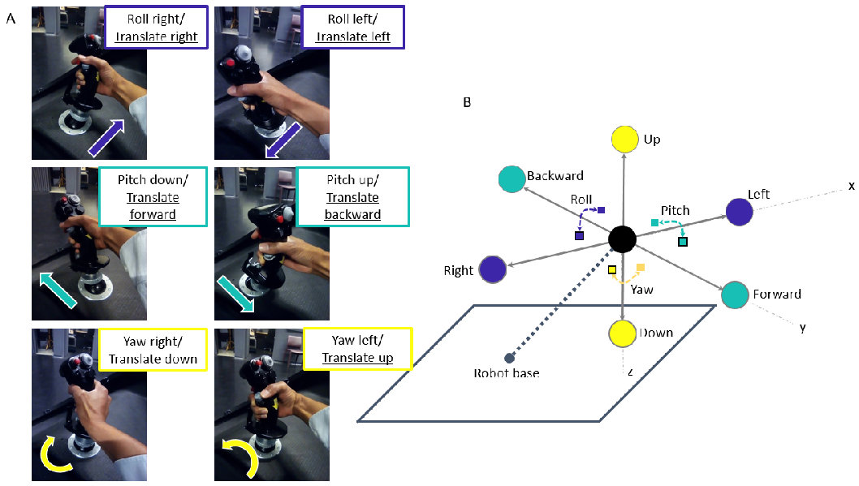
Figure 1: Figure 1A shows the mapping of participant’s joystick movements to the movement of the cabin. The simulator cabin, represented by the black sphere in Figure 1B, could move in both translation (left/right, forward/backward, up/down) and rotation (roll, pitch, yaw) via the input stimulus and/or participant control. The black outlined squares and circles in Figure 1B denote positive directional movement (right, forward, down), where squares and circles correspond to rotational and translation movement respectively. Non-outlined squares and circles indicate negative directional movement (left, backward, up).

Minuscule sinusoidal vibrational noise, 1-2cm in amplitude, was added to the non-stimulated axes to mask the sound of the motor for the selected stimulus. Due to the fact that vibrational noise was present, participants were exposed to a more realistic aviation environment. Furthermore, the additional vibration helped to reduce movement detection thresholds such that the task was realistically challenging (Chaudhuri et al, 2013).

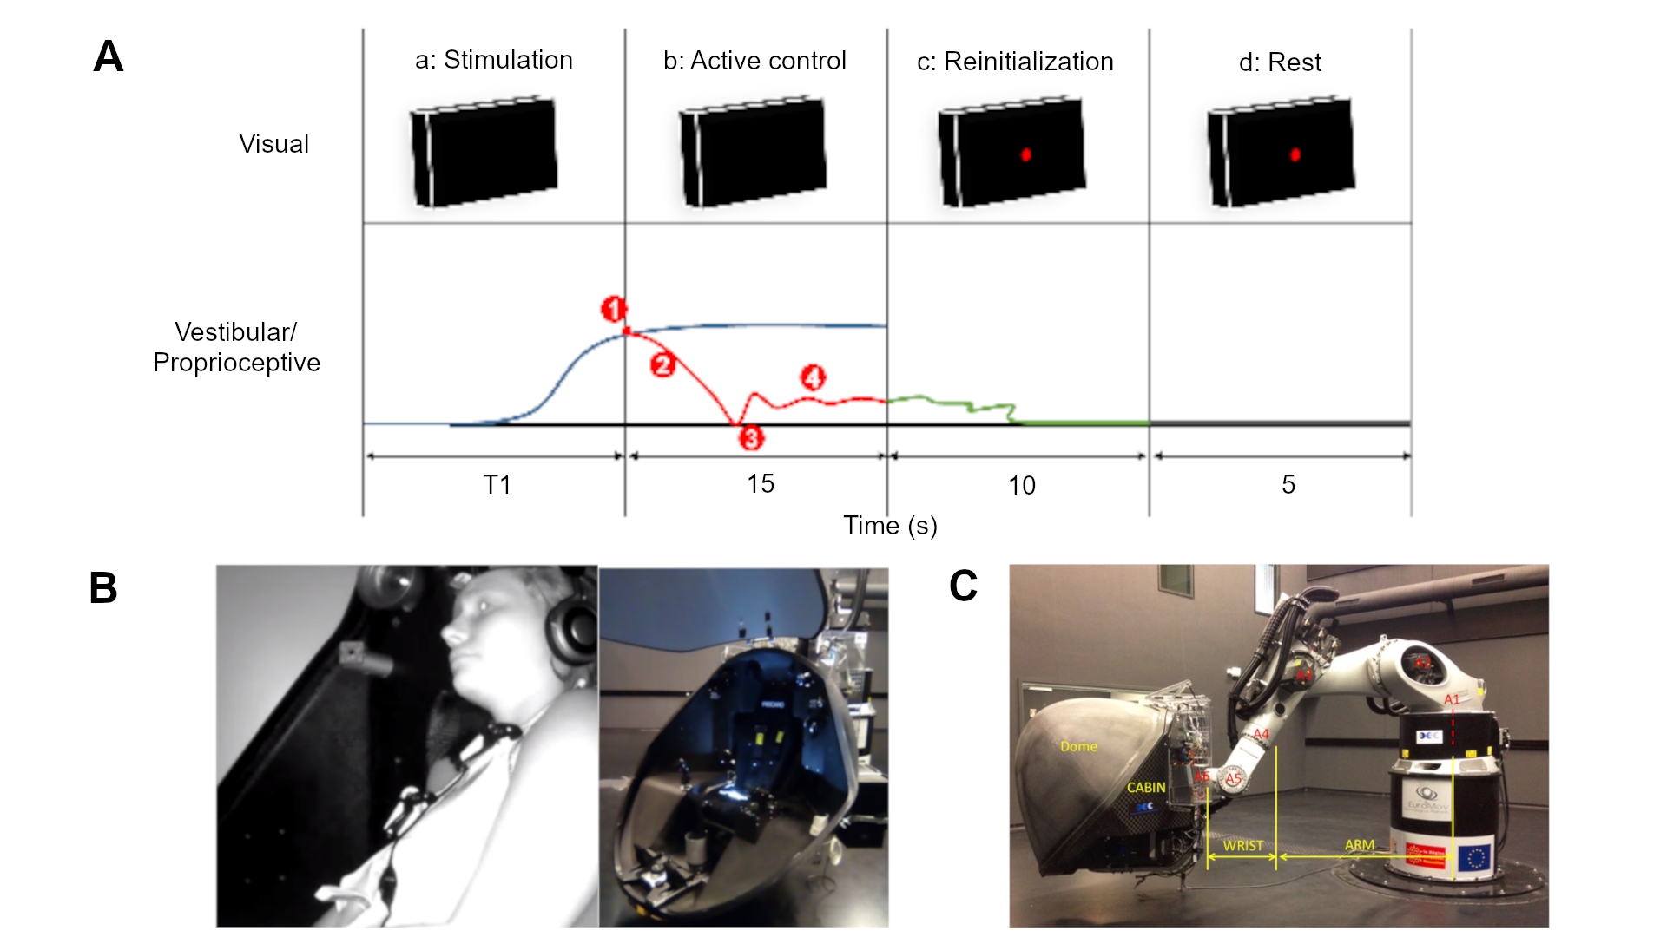

Figure 2: Task procedure and simulator installation. A denotes the experimental design where each trial consisted of four phases: (a) motion stimulation of the cabin with an unknown forcing function, (b) participant motion detection and afterwards active control, (c) cabin reinitialization to the initial orientation or position, (d) cabin and participant at rest. For visual, red dot denotes that participants should release the joystick and rest. For vestibular/proprioceptive, blue corresponds to the forcing function that actively perturbed the cabin, red line denotes the participant's movements to counteract the perturbation after motion detection at T1 seconds, green line during phase c denotes automatic reinitialization of the cabin, and grey line during phase d denotes a stationary period. (1) detection of orientational or translational self-motion; (2) corrective compensation; (3) typical release motion of the joystick signaling return to initial orientation or position; (4) typical small corrections to maintain orientation or position about the initial location. B depicts the experimental simulator cabin in which each participant performed the detection and control task. C shows an exterior view of the six-axis KUKA motion simulator, consisting of the participant cabin and the robotic arm. See text for details.
A single trial was composed of four different phases:
- A second-order transfer function response served as the forcing function unknown to participants, perturbed the cabin orientation or position for 20 s (rotation) and 8 s (translation) maximum with an acceleration ramp of respectively 5.8 s and 3.8 s. A second-order response was chosen because the motion simulator is sensitive to abrupt motion, especially during starting and stopping; the second-order function was 1/(s2 + (3.6π)/T s + π/(0.9T)) where T = 4. Similarly, in order to obtain constant stimulus velocity at the chosen near sub-threshold and supra-threshold values, a second-order system was of interest because the response slope can be tuned to correspond to the chosen movement rates. Rotational and translational experiments had different stimulation lengths due to the physical constraints of the motion simulator.
- During phase A the participant could move the cabin with the joystick in any of the three rotational or translational axes to counteract the perturbation, as shown in Figure 3B. Figure 3B depicts the mapping of the participant’s actions on the 3-axes joystick, which corresponded to the movement of the cabin. If participants responded within the defined temporal window of phase A, phase A stopped and they had 15 additional seconds to maintain the cabin stationary by counteracting the perturbation.
- The cabin returned to the initial starting location in roughly 10s. If participants did not respond within the defined temporal window of phase A, the re-positioning event would begin automatically.
- The cabin remained stationary at the starting location for 5s in order to avoid possible over stimulation or aftereffects. Figure 2 shows a typical situation of the four phases in sequential order, the blue line in phase A and B depicts the second-order forcing function that actively perturbed the cabin; during phases A and B participants viewed a black screen indicating that they should actively counteract the perturbation. At T1 seconds the participant detected (1) and counteracted (2) the stimulation, depicted by the red line; typically after participants initially counteracted the perturbation (3), small and frequent correction movements (4) were used.

One trial was composed of three or four events, phase B did not occur if the participant did not respond during phase A, and each trial was at maximum 50 s long in the rotational experiment (20 + 15 + 10 + 5) and 38 s long in translational experiment (8 + 15 + 10 + 5). For example, for the rotational experiment, initial stimulation was roughly 5 s however participants had 20 s to respond by correcting with the joystick. If participants detected the movement and corrected using the joystick, 15 additional seconds were added from the point at which the joystick was moved. If participants did not move the joystick, the trial finished after 20 s.

There were a total of 42 trials, the experimental familiarization practice phase consisted of 12 trials, each of the 3 axes were stimulated in both negative and positive directions at near sub-threshold and supra-threshold movement speeds. Similarly, the experimental phase consisted of 30 randomized trials, such that 15 trials with unique experimental conditions were repeated twice; negative near supra-threshold, negative near sub-threshold, no-movement, positive near sub-threshold, positive near supra-threshold) for each of the 3 axes (roll/lateral, pitch/longitudinal, yaw/vertical). No-movement trials were included as sham trials to test whether participants could indeed detect the presents of movement during movement trials.

2.3 Experimental protocol
The experiment took approximately 90 minutes and consisted of four sections: (1) arrival/ questionnaires/ instruction, (2) familiarization, (3) experimental session (rotational or translational stimulation), (4) questionnaire/discussion.

After describing the experimental task and the completion of the questionnaires, participants were securely installed, using the safety harness and communication headphones, in the motion simulator. They were asked to moderately move the joystick in one axis direction at a time, to compensate the unknown perturbation. They were given the same instructions to return the cabin to the initial position/orientation when they thought that they had moved away from the initial position/orientation; They were not told to act as fast or accurate as possible. The reaction speed and/or strategy that participants adopted were chosen by the participants themselves. Participants were free to look and/or fixate where they wished, and they could freely move their body and head as long as it did not interfere with the task, in order to simulate a realistic flight scenario.
Once the participant was installed in the cabin, the cabin door was closed and all communication between the participant and experimenter were performed via a camera interface system which facilitated two-way auditory communication. The experimenter additionally could visually monitor the well-being of the participant in the cabin. The left portion of Figure 3A shows the sequence of steps performed during the usage of the motion simulator. The installation process, shown on the left from top to bottom, illustrates the simulator with the (1) cabin door open on the ground, (2) participant installation, (3) cabin door closed on the ground.

2.4 Participants
18 and 14 healthy volunteers with normal or corrected vision, and no particular flight experience performed the rotational and translational near sub-threshold tasks (males and females, 32±10 SD years old): 4 of the 32 participants reported having novice time-limited (45 minutes, 2 hours, 40 hours, 45 hours) piloting experiences. 4 of the 18 rotational and 4 of the 14 translational participants were over the age of 40. The participants that performed the rotational experiment were not the same as participants that performed the translational experiment. Therefore, there were no confounds due to experimental ordering, learning, carryover, or fatigue. The same participant population, university students and personal, were used for both experiments therefore it is likely that both experimental populations were similar.

2.5 Data analysis
(This section talks about the general analysis methods that were used and why – it gives a general description of: 1) preprocessing, 2) brief description of analysis methods)

1) pre-processing,
Simulator and participant movements were collected at 252 Hz, the sampling frequency of the KUKA controller, and later down-sampled to 10 Hz for analysis. 10 Hz was chosen as a desirable sampling frequency because human response movements for this task are less than 10 Hz (Farmer, 1999). In addition, a data standardization pre-processing analysis was performed to ensure that robotic motion and participant response was similar for all participants. Trials that were dissimilar due to real-time system delays were removed; XXXX percent of the total collected data was removed from the analysis. See the Supplementary materials section for the steps used to standardize the data.

2) brief description of analysis methods – we can include why we used them
As previously mentioned, the goal of the experiment was to determine whether a pilot with vestibular-only information was disoriented; disoriented means an inability to detect directional motion and/or perform a corresponding action with respect to the motion such as dead-reckoning. In order to quantify, model, and predict pilot disorientation machine learning analysis was used: 1) metric-discovery and label creation for disorientation related to detection and active control of directional motion stimuli, and 2) joystick feature selection and disorientation classification. Detection label creation was performed by logically categorizing detection response, and active control label creation was quantified by categorizing accumulated error (both absolute and relative). Using a typical linear classifier, Support Vector Machine (SVM), we classify both detection and active control disorientation via joystick data. Different features of joystick data are additionally investigated, to determine what types of action components (such as position, velocity, acceleration) provide discriminatory information related to disorientation. The metrics used for label creation shed light on psychophysical human response and control during vestibular-only dead-reckoning.

2.5.1 Metric-discovery and label creation for disorientation detection
Detection of correct stimuli was categorized into ten possible categories based on the selection of axis and axial direction. See the Supplementary materials section for a detailed flow chart of the possible participant choices based on response movement.

The ten detection response occurrence profiles were reduced to five categories:
- Initial Correct axis & direction: trials where the first response was with the correct axis and direction (Category 1)
- Initial Correct axis, late direction: trials where the first response was with the correct axis, but later found the correct direction (Category 2)
- Late axis & direction: trials where the first response was with the wrong axis and direction, but later found the correct axis and direction (Category 3)
- Never Correct: trials where participants acted on the joystick but never found the correct axis and direction (Category 4)
- No response: trials in which participants did not respond (Category 5).
Two types of labels were tested for predicting disorientation detection: 1) Category 1 was labeled as ‘non-disoriented’ because the participant initially detected axis and direction correctly and Categories 2-5 were labeled as ‘disoriented’, 2) Categories 1-3 were labeled as ‘non-disoriented’ because the participant eventually detected the axis and direction correctly and Categories 4-5 were labeled as ‘disoriented’.

(Reaction time)
In addition to categorizing the detection response for machine learning disorientation prediction, we also were interested in describing human behavioral response from a psychophysical perspective. Therefore we investigated the relationship of reaction time with each detection category; reaction time was the time required before the participant found the correct axis and direction. The 95% confidence interval around the mean of near sub-threshold and supra-threshold categories were used to determine the response occurrence categories different from zero. Response occurrence categories above the lower confidence interval were further evaluated in terms of detection reaction time.

2.5.3 SD classification
Two types of labels was created from the detection profiles to classify detection (non-SD) vs. non-detection (SD) per trial; the entire trial data was used for detection classification
Support Vector Machine (SVM), was selected to perform supervised classification analysis for identification of SD (Christianini & Shawe-Taylor, 2000).
Detection classification was performed for each speed condition (sub, supra) and across speed conditions.
Additional classifiers were not used for comparison with SVM because the basic linear SVM algorithm produced sufficiently reliable more than chance prediction results, therefore joystick movement features were explored and compared. Explored joystick features included : (1) joystick signal (velocity control joystick), (2) 1st derivative of the joystick signal (human movement metric : acceleration), (3) 2nd derivative of the joystick signal (human movement metric : jerk), (4) frequency response of joystick position via FFT (control theory metric : human-in-the-loop), (5) frequency of joystick (signal processing metric : estimate the period of the signal), (6) frequency of joystick (bandwidth cutoff/0.3 decibel drop of the frequency response of joystick via FFT (control theory metric : human-in-the-loop)).

2.5.4 Physical disorientation
Finally, response occurrence categories were related to the SSQ disorientation sub-scale (R. S. Kennedy et al., 1993; Bouchard et al., 2007). Non-parametric tests (Friedman test, a test equivalent to 2-factor ANOVA) and Wilcoxon tests (two-sided rank test and rank sum test) with Bonferroni correction were used to calculate both detection and correction results. Python was used for all analyses, using packages numpy, pandas, scipy, sklearn, seaborn/plotly/matplotlib.

3 Results
For both rotational and translational experiments, participant’s detection and correction behavior was quantified with respect to stimulation speed, axis, and direction. Rotational and translational experimental results can not be directly compared because physiologically the body detects these motions differently.

3.1 Response profile
Stimulus motion detection was quantified using the five response occurrence profiles and initial reaction time to compensate the stimulus. Figures 3 and 4 show the mean response occurrence across participants for axes and speed conditions, for rotation and translation respectively. Relevant response occurrence categories, for reaction time, were selected based on mean significance via the 95% confidence interval test. In the following subsections, each axis/direction (roll, pitch, yaw, LR, FB, UD) are discussed in detail.

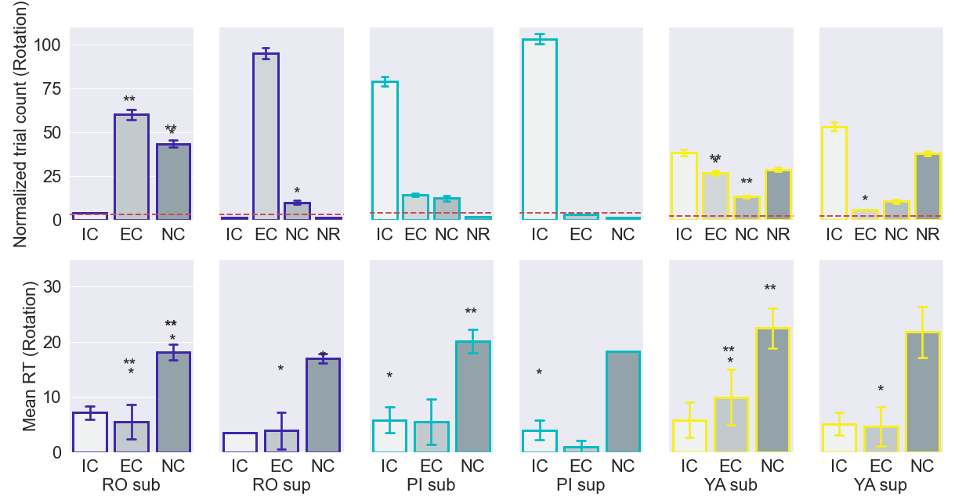
Figure 3: Response occurrence (top row) and reaction time (bottom row) for rotational stimulation. Mean response occurrences for roll, pitch, and yaw axes were compared for near sub-threshold and supra-threshold speed stimulations; Wilcoxon signed rank test, and sum rank test were used to determine significance such that significant relationships were represented by (*:p < 0.05, **: (Bonferroni correction) p < 0.0167). The bottom row shows the reaction time for rotational stimulation. Mean reaction time for roll, pitch, and yaw axes were compared for sub and sup speed stimulation; Wilcoxon signed rank test and sum rank test were used to determine significance such that significant relationships were represented by (*:p < 0.05, **: (Bonferroni correction) p < 0.0167).

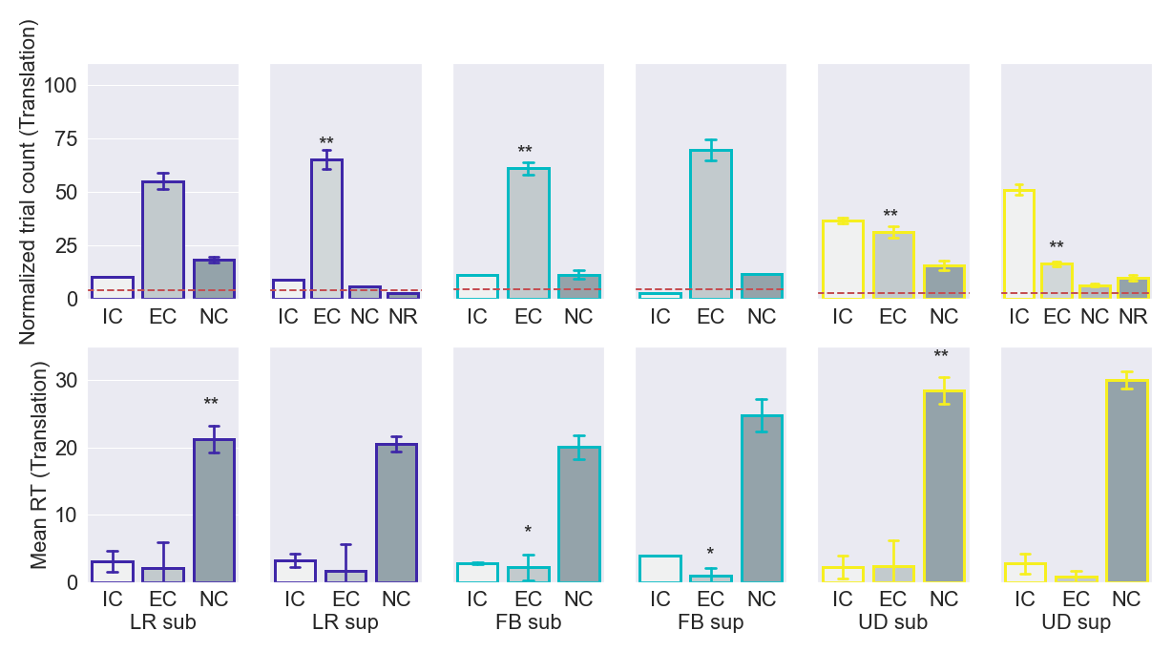
Figure 4: Response occurrence (top row) and reaction time (bottom row) for translational stimulation. Mean response occurrences for LR, FB, and UD axes were compared for sub and sup speed stimulation; Wilcoxon signed rank test, sum rank test, and Friedman test were used to determine significance such that significant relationships are reported where (*:p < 0.05, **: (Bonferroni correction) p < 0.0167).

3.3 Classification: SD prediction
SVM supervised linear analysis was used to classify the presence of perceived disorientation (SD) and control behavior, per trial across axis and speed conditions.
Two labels for SD were constructed by using the detection response profile; two labels were used to evaluate how perceptual disorientation should be defined. The first label, called lenient, allows for mistakes to be initially made; Categories IC and EC are considered as non-SD state and unsuccessful detection responses (Category NC and NR) were considered as SD state.
The second label, called strict, does not allow for initial errors; initial successful detection response (Category IC) was considered as non-SD state and Categories EC, NC, and NR were considered as SD state.
Initial classification analysis with a supervised linear SVM model produced satisfactory above chance results, therefore feature space was explored instead of comparing prediction accuracy of various classifiers.
Additionally, feature space was of interest because identification of predictive disorientation and control parameters were the goal of this work. Joystick movement was used as a transformable feature parameter because joystick movement is one of the few non-invasive parameters that contained real-time pilot behavior. Five joystick features were used for model construction and predictive testing: (1) joystick signal (velocity control joystick), (2) 1st derivative of the joystick signal (human movement metric : acceleration), (3) 2nd derivative of the joystick signal (human movement metric : jerk), (4) frequency response of joystick position via FFT (control theory metric : human-in-the-loop), (5) frequency of joystick (signal processing metric : estimate the period of the signal), (6) frequency of joystick (bandwidth cutoff/0.3 decibel drop of the frequency response of joystick via FFT (control theory metric : human-in-the-loop)).
The entire joystick movement traced from the start to the end of the trial was used for SD prediction.
Trials were at least 16 seconds long, and each trial length was set to the maximum trial data point length. Interpolation was used to resize each trial with differing time length, via the python interp1d function.
Joystick data per trial for each participant was stacked in a matrix, where 25% of the matrix was “held-out”/not included in the construction of the predictive model. The excluded 25% of the data was used to test the predictive capability of the SVM model, trained with both individual and all feature types.
Please see the appendix section for the classification pipeline for predicting SD.
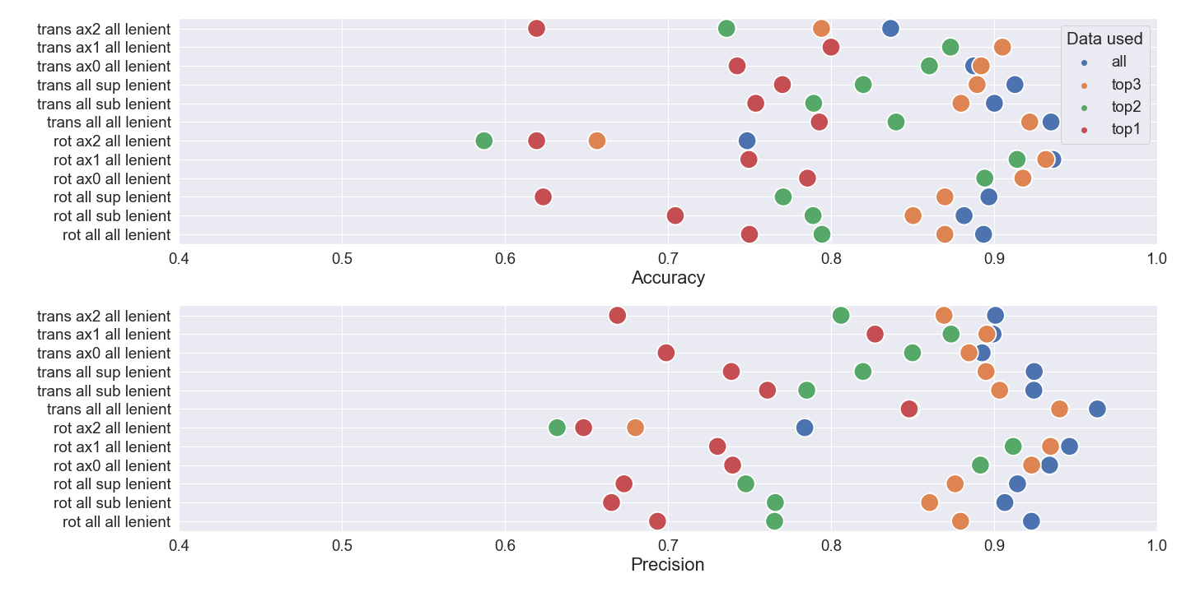
Figure 5: SVM prediction accuracy and precision of test data, for four models using the lenient label. Circle colors blue, orange, green and red correspond to, 1) all six features, 2) the top 3 important features via permutation importance, 3) the top 2 important features, and 4) the top important feature. Regarding notation, ax0, ax1, ax2 indicate roll, pitch, yaw for the rotational task and LR, FB, UD for the translational task. Additionally, sup and sub denote supra and sub stimulation respectively.

Figure 5 the SVM prediction accuracy and precision, for rotation and translation data using the lenient label, for four models using : 1) all six features, 2) the top 3 important features via permutation importance, 3) the top 2 important features, 4) the top important feature.
Models using all of the features, indicated by the blue circles, outperform other models in terms of prediction accuracy regardless of the data used, such as only supra data or axis2 data.

Similarly, the precision measure shows that true positives with respect to positive responses are higher when all of the data is used, implying that less false positives are given.

Models with at least the top 2 features or more, are sufficient to accurately predict SD per trial.

Additionally, models using all of the data instead of a subset of the data, provided similarly accurate performing models. Therefore in order to predict SD in a specific circumstance, like roll, one can use data from any context and SD will be accurately predicted for a specific context.

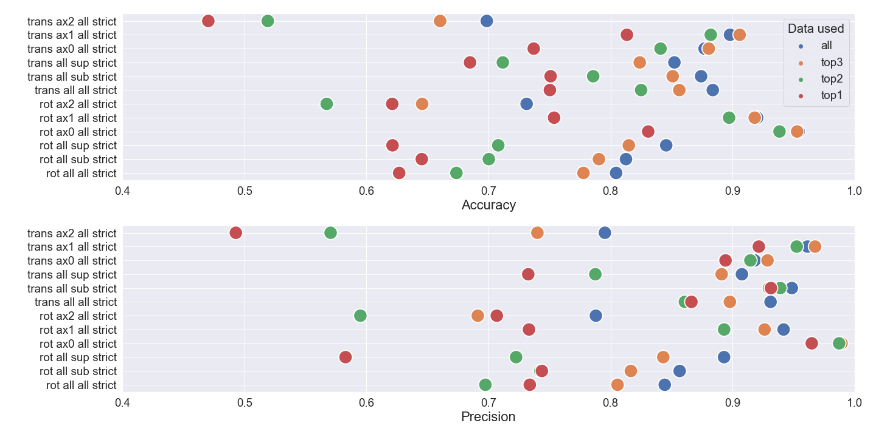
Figure 6: SVM prediction accuracy and precision of test data, for four models using the strict label. Circle colors blue, orange, green and red correspond to, 1) all six features, 2) the top 3 important features via permutation importance, 3) the top 2 important features, and 4) the top important feature. Regarding notation, ax0, ax1, ax2 indicate roll, pitch, yaw for the rotational task and LR, FB, UD for the translational task. Additionally, sup and sub denote supra and sub stimulation respectively.
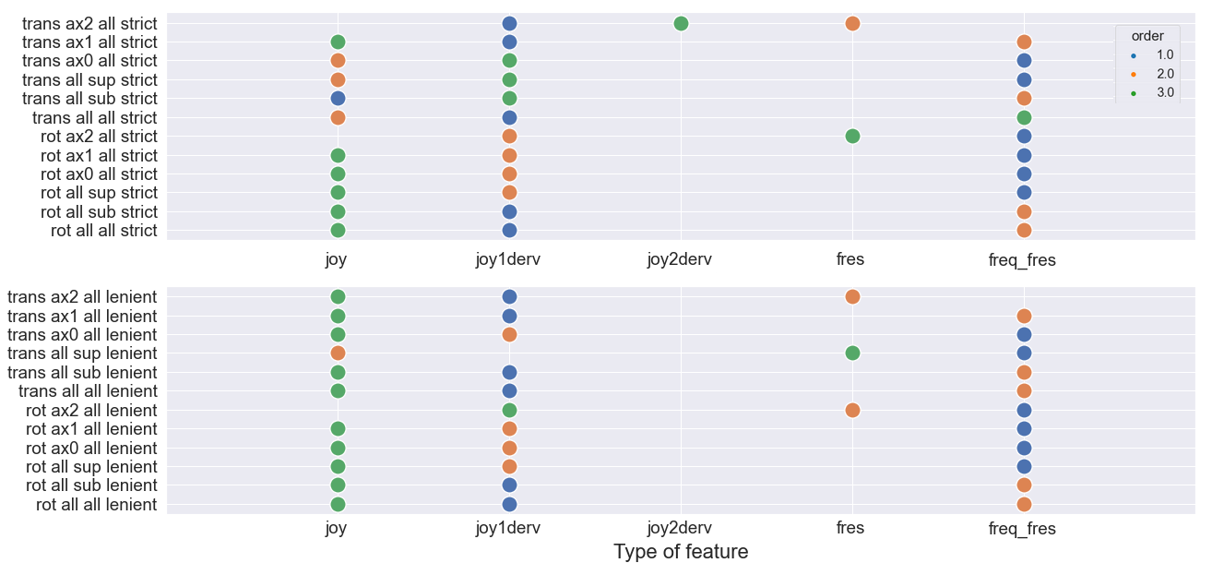

Figure 7: Feature order importance based on permutation importance, for each model. Blue, orange and green circles indicate most important feature, second most important feature, and third most important feature.

Feature order importance allows for us to know which aspect of the joystick signal contains key information to detect a disorientation trial from a non-disorientation trial.
Considering models where all the data was used, called ‘all all’ in the figures 6 and 7, the derivative of the joystick signal, the bandwidth cutoff frequency, and the joystick signal contain the most key information in discerning SD, from most to least important.
Therefore changes in the joystick velocity control signal, known as acceleration, and frequency movements are different when a person is disoriented/completely lost versus non-disoriented/aware.
Comparing the strict with the lenient disorientation label, the same trend in key features remains the same regardless if mistakes are allowed to be made or not.
Thus, even if one makes mistakes, their acceleration and frequency movements are different than being completely lost or disoriented.
Finally, the decision to choose a strict label convention where no mistakes are allowed in comparison to a lenient label where mistakes can be made to discern SD depends on the application and the quantity of data available to represent a non-SD state.
For example in flight where a mistake could cause life or death, a strict label convention may be more advantageous than a lenient label where mistakes can be made.
However, a strict label results is less accurate prediction of SD, than a lenient label, because there are less data/examples that describe perfect initial response behavior; even-though the classes were padded to have equivalent class representation. Perfect behavioral data in any task is statistically rare, thus building an accurate model using a strict label convention maybe more challenging.

3.4 Perceived motion and physical disorientation
We evaluated the correlation between subjective physical disorientation and perceptual motion disorientation.
Physical disorientation was monitored before and after the experiment using the SSQ disorientation subscale, such that the difference in before and after measures were attributed to the experienced task.
SSQ = before SSQ score – after SSQ score
Negative SSQ means that the task made the participant disoriented (ie : they felt better before), and positive SSQ means that the task rendered the participant less disoriented (ie : they felt better after).
Twenty of the 31 total participants did not feel any difference in terms of physical disorientation over the entire experiment.
The remaining twelve participants (a combination of average to worst performers) reported a difference in physical disorientation, see Table 3 for a percentage of their summed trial performance per category per SSQ difference report.
For instance, a participant who reported a 6 after the experiment and a 4 before the experiment would have their trial performance categories (ie : 8 trials were category 2, 6 trials were category 1, etc) associated with the SSQ score of -2.
Table 3 demonstrates that more negative physical disorientation was observed for unsuccessful initial detection response profiles (EC and NC) than for successful detection response or no response.

Category | SSQ -5 (%)  felt better before | SSQ -3 (%) felt better before | SSQ -2 (%)  felt better before | SSQ -1 (%)  felt better before | SSQ 1 (%)  felt better after | SSQ 2 (%)  felt better after | SSQ 4 (%)  felt better after
IC (I) | 3.9 | 7.79 | 18.18 | 19.48 | 31.17 | 3.9 | 15.58
EC (2,4,5) | 7.79 | 11.69 | 29.87 | 22.08 | 19.48 | 1.3 | 7.79
NC (3,6,7) | 7.69 | 2.56 | 41.03 | 30.77 | 5.13 | 5.13 | 7.69
NR (9) | 0 | 3.23 | 22.58 | 22.58 | 29.03 | 9.68 | 12.9

Table 3: Occurrence response category per reported SSQ disorientation subscale difference, for both rotational and translational experiments. The bold negative SSQ values for categories EC and NC highlight that more negative physical disorientation was present for unsuccessful initial attempts to detect motion.
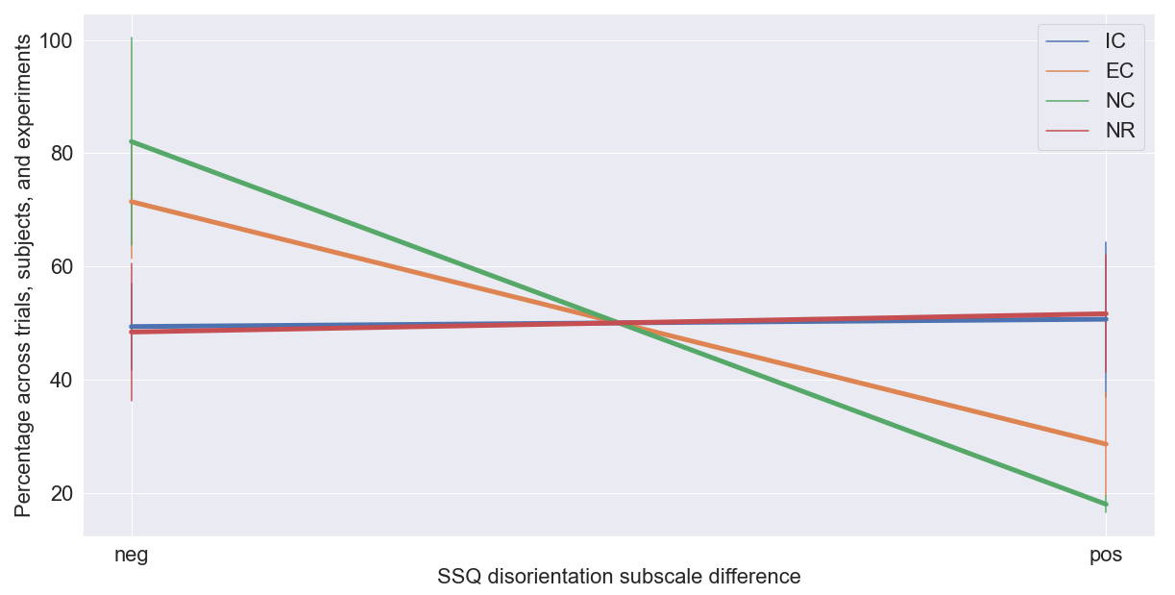
Figure 8: Condensed table percentages. Summed table percentages for negative and positive SSQ disorientation difference per response category.
The negative and positive SSQ disorientation differences per response category were summed respectively, to evaluate significance between IC negative and NC or EC negative.
Physically disoriented good performers (IC) do not report significantly less physical disorientation than poor performers (EC : p < 0.125 Wilcoxon signed rank, p < 0.31 Wilcoxon sumrank, NC : p < 0.375 Wilcoxon signed rank, p < 0.77 Wilcoxon sumrank).

4 Discussion
To be written

References:
Angelaki, D. E., & Cullen, K. E. (2008). Vestibular system: The many facets of a multimodal sense. Annual Review of Neuroscience, 31(1), 125–150.
Barmack, N. H. (1981). A comparison of the horizontal and vertical vestibulo-ocular reflexes of the rabbit. J Physiol, 314, 547–564.
B. Cheung, C. J. B. P. G., K. Hofer. (2000). Underwater disorientation as induced by two helicopter ditching devices. Aviation, Space, and Environmental Medicine, 71, 879-888.
Bellmann T, Heindl J, Hellerer M, Kuchar R, Sharma K & Hirzinger G (2011). The DLR Robot Motion Simulator Part I: Design and setup. 2011 IEEE International Conference on Robotics and Automation, Shanghai, 4694-4701.
Benson, A. J., Bischof, N., Collins, W. E., Fregly, A. R., Graybiel, A., Guedry, F. E., & Johnson, W. H. (1974). Handbook of sensory physiology volume v1/2 - vestibular system part 2: Psychophysics, applied aspects and general interpretations. New York: Springer-Verlag Berlin Heidelberg.
Benson, A. J., Hutt, E. C., & Brown, S. F. (1989). Thresholds for the perception of whole body angular movement about a vertical axis. Aviat Space Environ Med, 60, 205–213.
Benson, A. J., Spencer, M. B., & Stott, J. R. (1986). Thresholds for the detection of the direction of whole-body, linear movement in the horizontal plane. Aviat Space Environ Med, 57, 1088–1096.
Bermudez-Rey, M. C., Clark, T. K., Wang, W., Leeder, T., Bian, Y., & Merfeld, D. M. (2016). Vestibular perceptual thresholds increase above the age of 40. Frontiers in Neurology, 7.
Bles, W. (2008). Spatial disorientation training – demonstration and avoidance (Tech. Rep.). Soesterberg, Netherlands: Research and Technology Organisation (RTO) North Atlantic Treaty Organisation (NATO).
Bouchard, S., Robillard, G., & Renaud, P. (2007). Revising the factor structure of the simulator sickness questionnaire. Annual Review of CyberTherapy and Telemedicine, 5, 117–122. Bringoux, L., Schmerber, S., Nougier, V., Dumas, G., Barraud, P., & Raphel, C. (2002). Perception of slow pitch and roll body tilts in bilateral labyrinthine-defective subjects. Neuropsychologia, 40, 367–372.
Bronstein, A. (2013). Oxford textbook of vertigo and imbalance. Oxford: Oxford University Press.
Bruyer, R., & Brysbaert, M. (2011). Combining speed and accuracy in cognitive psychology: Is the inverse efficiency score (IES) a better dependent variable than the mean reaction time (RT) and the percentage of errors (PE)? Psychologica Belgica, 51(1), 5–13.
C. Haburcakova, D. M. M., R. F. Lewis. (2012). Frequency dependence of vestibuloocular reflex thresholds. J Neurophysiol, 107, 973-983.
Chih-Chung Chang and Chih-Jen Lin, LIBSVM : a library for support vector machines. ACM Transactions on Intelligent Systems and Technology, 2:27:1--27:27, 2011. Software available at http://www.csie.ntu.edu.tw/~cjlin/libsvm
Christianini, N., & Shawe-Taylor, J. (2000). An introduction to support vector machines and other kernel-based learning methods. Cambridge: Cambridge University Press.
Crane, B. T. (2016). Perception of combined translation and rotation in the horizontal plane in humans. J Neurophysiol, 116, 1275-1285.
Day, B. L., & Fitzpatrick, R. C. (2005). The vestibular system. Current Biology, 15(15), 583–586. Draheim, C., Hicks, K. L., & Engle, R. W. (2016). Combining reaction time and accuracy: The relationship between working memory capacity and task switching as a case example. Perspectives on Psychological Science, 11(1), 133–155.
Eriksson, L., & von Hofsten, C. (2005). Effects of visual flow display of flight maneuvers on perceived spatial orientation. Human Factors, 47(2), 378–393.
Eriksson, L., von Hofsten, C., Tribukait, A., Eiken, O., Andersson, P., & Hedstro ̈m, J. (2008, September). Visual flow scene effects on the somatogravic illusion in non-pilots. Aviation, Space, and Environmental Medicine, 79(9), 860–866.
Farmer, S. F. (1999, May). Pulsatile central nervous control of human movement. The Journal of Physiology, 3–3. (GAMA), G. A. M. A. (2017). 2016 general aviation statistical databook and 2017 industry outlook (Tech. Rep.). Washington, DC: GAMA.
Gibb, R., Gray, R., & Scharff, L. (2010). Aviation visual perception research, misperception and mishaps. Farnham, Surrey, England; Burlington, VT: Ashgate.
Gillingham, K. K., & Previc, F. H. (1993). Spatial orientation in flight (Tech. Rep. No. AL-TR- 1993-0022). Armstrong Laboratory (AFMC).
Gillingham, K. K., & Wolfe, J. W. (1986, dec). Spatial orientation in flight (Tech. Rep. No. USAFSAM-TR-85-31). Brooks Air Force Base, Texas: USAF School of Aerospace Medicine.
Grabherr, L., Nicoucar, K., Mast, F. W., & Merfeld, D. M. (2008). Vestibular thresholds for yaw rotation about an earth-vertical axis as a function of frequency. Exp Brain Res, 186, 677–681.
Gracio, B. J., de Winkel, K. N., Groen, E. L., Wentink, M., & Bos, J. E. (2013). The time constant of the somatogravic illusion. Exp Brain Res, 224(3), 313–321.
Gradwell, D. P., & Rainford, D. J. (2016). Ernsting’s aviation and space medicine, 5th edition. Boca Raton, FL: CRC Press Taylor & Francis Group.
Green, A. M., & Angelaki, D. E. (2003). Resolution of sensory ambiguities for gaze stabilization requires a second neural integrator. J Neurosci, 23, 9265–9275.
Guedry, F. E. (1974). Psychophysics of vestibular sensation. In H. H. Kornhuber (Ed.), Vestibular system part 2: Psychophysics, applied aspects and general interpretations (Vol. 6, pp. 3–154). Springer.
Hess, R. A. (1990). Model for human use of motion cues in vehicular control. Journal of Guidance, Control, and Dynamics, 13(3), 476–482.
Jongkees, L. B. (1961). The influence of some drugs upon the function of the labyrinth. Acta Otolaryngol, 52, 281–285.
J. Sargent, J. P. J. A., S. Dopkins. (2008). Exploring the process of progressive disorientation. Acta Psychol, 129, 234–242.
Karmali, F., Bermudez-Rey, M. C., Clark, T. K., Wang, W., & Merfeld, D. M. (2017). Multivariate analyses of balance test performance, vestibular thresholds, and age. Frontiers in Neurology,
Karmali, F., Chaudhuri, S. E., Yi, Y., & Merfeld, D. M. (2016). Determining thresholds using adaptive procedures and psychometric fits: evaluating efficiency using theory, simulations, and human experiments. Exp Brain Res, 234, 773–789.
Kennedy, Q., Taylor, J. L., Reade, G., & Yesavage, J. A. (2010). Age and expertise effects in aviation decision making and flight control in a flight simulator. Aviat Space Environ Med, 81, 489–497.
Kennedy, R. S., Lane, N. E., Berbaum, K. S., & Lilienthal, M. G. (1993). Simulator sickness questionnaire: An enhanced method for quantifying simulator sickness. International Journal of Aviation Psychology, 3(3), 203–220.
Kingma, H. (2005). Thresholds for perception of direction of linear acceleration as a possible evaluation of the otolith function. BMC Ear, Nose and Throat Disorders, 5(5).
Kitchen, B. J. (1983). Horizontal and vertical eye deviations in response to linear accelerations (Unpublished master’s thesis). Massachusetts Institute of Technology, Cambridge, Massachusetts.
Landrieu, J., Abdur-Rahim, J., Sarrazin, J.-C., & Bardy, B. (2017). Time-to-collision estimates during congruent visuo-vestibular stimulation. In Studies in perception and action xiv: 19th international conference on perception and action (ipca) (pp. 109–112). Seoul.
Lawson, B. D., Williams, H. P., Newman, M. C., McGrath, B. J., & Rupert, A. H. (2017). Understanding of a key aspect of situation awareness: a research and development agenda to refine the model of spatial orientation (Tech. Rep. No. USAARL 2017-14). Fort Rucker, AL: U.S. Army Aeromedical Research Laboratory.
Loomis, J. M., Klatzky, R. L., Golledge, R. G., Cicinelli, J. G., Pellegrino, J. W., & Fry, P. A. (1993). Nonvisual navigation by blind and sighted: Assessment of path integration ability. Journal of Experimental Psychology: General, 122, 73–91.
Mardirossian, V., Karmali, F., & Merfeld, D. M. (2014). Thresholds for human perception of roll tilt motion: patterns of variability based on visual, vestibular, and mixed cues. Otol Neurotol, 35, 857–860.
Mars, F. (2001). La desorientation spatiale en aeronautique: Apport des neurosciences int ́egratives `a la conception des postes de pilotage (Unpublished doctoral dissertation). Universit ́e de la M ́editerran ́ee Aix Marseille II, Marseille Cedex 07, France.

Matthews, S., Previc, F., & Bunting, A. (2002, april). Usaf spatial disorientation survey. In Presented at rto hfm symposium on “spatial disorientation in military vehicles: Causes, consequences and cures” and published in rto-mp-086.
McCabe, B. F. (1964). Nystagmus response of the otolith organs. Laryngscope V , 76 .
McRuer, D., & Jex, H. (1967, September). A review of quasi-linear pilot models. IEEE Transactions on Human Factors in Electronics, HFE-8(3), 231–249.
Melvill, J. G., & Young, L. R. (1978). Subjective detection of vertical acceleration: a velocity-dependent response. Acta Otolaryngology, 85, 45—53.
Merfeld, D., Park, S., Gianna-Poulin, C., Black, F. O., & Wood, S. (2005). Vestibular perception and action employ qualitatively different mechanisms. i. frequency response of vor and perceptual responses during translation and tilt. Journal of Neurophysiology, 94, 186–198. Merfeld, D. M. (2011, May). Signal detection theory and vestibular thresholds: I. basic theory and practical considerations. Experimental Brain Research, 210(3–4), 389–405. 34

M. Hartmann, I. M. E. J. H. F. W. M., K. Haller. (2014). Direction detection thresholds of passive self-motion in artistic gymnasts. Exp Brain Res, 232, 1249-1258.

Newman, D. G. (2007). An overview of spatial disorientation as a factor in aviation accidents and incidents. Canberra City, A.C.T.: Australian Transport Safety Bureau.

Newman, M., Lawson, B., Rupert, A., & McGrath, B. (2012, May). The role of perceptual modeling in the understanding of spatial disorientation during flight and ground-based simulator training. In Aiaa modeling and simulation technologies conference. Minneapolis.

Perdriel, G. (Ed.). (1980). Spatial disorientation in flight, current problems: papers (No. 287). London.

Previc, F. H., & Ercoline, W. R. (2004). Spatial disorientation in aviation. Reston ,VA: American Institute of Aeronautics and Astronautics.

Radomsky, A. S., Ouimet, A. J., Ashbaugh, A. R., Paradis, M. R., Lavoie, S. L., & O’Connor, K. P. (2006). Psychometric properties of the french and english versions of the claustrophobia questionnaire (cl). Journal of Anxiety Disorders, 20, 818–828.

Radomsky, A. S., Rachman, S., Thordarson, D. S., McIsaac, H. K., & Teachman, B. A. (2001). The claustrophobia questionnaire. Journal of Anxiety Disorders, 15(4), 287–297.

Richerson, S. J., Faulkner, L. W., Robinson, C. J., Redfern, M. S., & Purucker, M. C. (2003). Acceleration threshold detection during short anterior and posterior perturbations on a translating platform. Gait & Posture, 18, 11–19.

Roditi, R. E., & Crane, B. T. (2012). Directional asymmetries and age effects in human self-motion perception. Journal of the Association for Research in Otolaryngology, 13, 381-401.

Rupert, A. H., Woo, G., Christopher, J., & Lawson, B. (2016, March). Countermeasures for loss of situation awareness: Spatial orientation modeling to reduce mishaps. In 2016 ieee aerospace conference (pp. 1–9).

S. E. Chaudhuri, D. M. M., F. Karmali. (2013). Whole body motion-detection tasks can yield much lower thresholds than direction-recognition tasks: implications for the role of vibration. J Neurophysiol, 110, 2764–2772.

Sjoberg, A. A. (1931). Experimentelle studien uber den auslosungs-mechanismus der seekrankeit. Acta Otolaryngol, Suppl. 14.

Soyka, F., Giordano, P. R., Barnett-Cowan, M., & Bulthoff, H. H. (2012). Modeling direction 35 discrimination thresholds for yaw rotations around an earth-vertical axis for arbitrary motion profiles. Exp Brain Res, 220, 89-99.
Soyka, F., Giordano, P. R., Beykirch, K., & Bulthoff, H. H. (2011). Predicting direction detection thresholds for arbitrary translational acceleration profiles in the horizontal plane. Exp Brain Res, 209, 95-107.
Stoffregen, T., Pagulayan, R., Smart, L., & Bardy, B. (2003). On the nature and evaluation of fidelity in virtual environments. In L. Hettinger & M. Haas (Eds.), Virtual and adaptive environments (p. 111-128). CRC Press.
Thompson, L., Lawson, B., Newman, M., McGrath, B., Brill, J., & Rupert, A. (2016, November). Design considerations and research needs for expanding the current perceptual model of spatial orientation into an in-cockpit spatial disorientation warning system (Tech. Rep. No. AD1031427). Fort Rucker, AL: Army Aeromedical Research Lab.

Valko, Y., Lewis, R. F., Priesol, A. J., & Merfeld, D. M. (2012). Vestibular labyrinth contributions to human whole-body motion discrimination. J Neurosci, 32, 13537-13542.

Vold, H., Crowley, J., & Rocklin, G. (1984). New ways of estimating frequency response functions. Sound and Vibration, 18, 34–38.

Young, L. R., Meiry, J. L., & Li, Y. T. (1966). Control engineering approaches to human dy- namic space orientation (Tech. Rep. No. SP-115). National Academy of Science Workshop on Orientation in the Exploration of Space NASA.

Zaichik, L., Rodchenko, V., Rufov, I., Yashin, Y., & White, A. (1999). Acceleration perception (Tech. Rep.). Portland, OR: In: American Institute of Aeronautics & Astronautics (AIAA) modeling and simulation technologies conference—a collection of technical papers.

Zupan, L. H., & Merfeld, D. M. (2008). Interaural self-motion linear velocity thresholds are shifted by roll vection. Exp Brain Res, 191, 505–511.

Zupan, L. H., Merfeld, D. M., & Darlot, C. (2002). Using sensory weighting to model the influence of canal, otolith and visual cues on spatial orientation and eye movements. Biological Cybernetics, 86(3), 209–230.

Biographies:

