Supplementary Materials :

2 Methods

2.1 Identification of near sub-threshold and supra-threshold rate stimulation values
Near sub-threshold and supra-threshold values were chosen in correspondence to reports from both older and recent literature. Considering older literature, Mulder's law states that αΤ= 2.5 deg/s where α denotes the acceleration magnitude and Τ corresponds to time (Previc et al, 2004). Regarding slow movement, recent human perceptual thresholds during whole-body stimulation has shown that threshold responses tend to increase with frequencies of 0.5 Hz or lower, indicating a sensory sub-threshold limitation. Additionally, regarding whole-body stimulation during fast motion, threshold responses tend to decrease with frequencies of 1 Hz or greater, denoting a near supra-threshold boundary (Karmali et al, 2016; Karmali et al, 2017; Crane et al, 2016; Benson et al, 1986; Bermudez Rey et al, 2016). Five participants were principally used to confirm the near sub-threshold limit reported in literature, they could detect the axis and direction of movement with less than 50% accuracy. The authors do not claim that all participants could not detect the movement, therefore this lower limit perceptual stimulation was called “near sub-threshold". The supra-threshold was chosen with respect to reported values in literature, a rate slightly higher than 1 Hz was chosen to ensure supra-threshold simulation (Previc et al, 2004).

For the translational experiment, selection of the near sub-threshold value was more difficult to determine, in comparison to the rotational experiment, because detection of near sub-threshold movement varied depending on each participant. Translational threshold values reported in the literature were used to create a list of ten, near sub-threshold and supra-threshold, test values to validate using a population of 18 participants (Melvill et al, 1978; Crane et al, 2016). Table 1 shows the tested values where the selected near sub-threshold and supra-threshold values are denoted in bold font; selected threshold values were 3.75 Hz (cm/s) and 15 Hz (cm/s) respectively. The UD direction was not tested because vertical movement thresholds are known to be greater than lateral and longitudinal motion thresholds, thus thresholds were fit to LR and FB stimulations.

Acceleration (g) | Target speed (cm/s) | Number of tests | FB success (%) | LR success (%)
0 | 0 | 15 | 80.00 | 66.67
0.003 | 3.75 | 30 | 33.33 | 37.93
0.004 | 5.00 | 60 | 51.67 | 48.33
0.006 | 7.50 | 10 | 60.00 | 40.00
0.008 | 10.00 | 27 | 59.26 | 48.15
0.010 | 12.50 | 18 | 61.11 | 72.22
0.011 | 15.00 | 102 | 82.35 | 88.24
0.013 | 17.50 | 23 | 91.30 | 82.60
0.015 | 20.00 | 75 | 86.67 | 94.67
0.017 | 22.50 | 15 | 93.33 | 100.00

Table 1: Pre-test data for selection of translational near sub-threshold and supra-threshold speed thresholds.

2.2 Study design

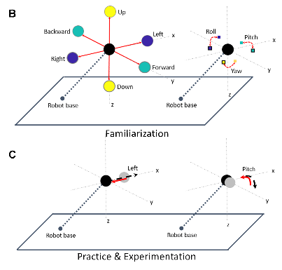

Figure 3 : (B) familiarization, (C) practice and experimental trials. A depicts the experimental installation process consisting of: opening cabin door, participant installation, closing cabin door and movement of cabin to starting position. B demonstrates the possible orientational (right) and directional (left) motion of the cabin for translational and rotational experiments, respectively. During familiarization (B), for both rotational (right) and translation (left) experiments, participants moved the joystick in all 3 axes directions one-at-a-time to become familiar with their control movements on the movement of the cabin. C demonstrates compensatory orientational and directional movement of the cabin for one trial in the pitch and left directions respectively; red solid lines indicate participant control and the black dashed lines indicate the unknown movement stimuli. During the 12 practice trials and 30 experimental trials, participants performed the whole-body compensatory movement task illustrated in C.

At the bottom of Figure 3A, the six-axis KUKA motion simulator is shown where: axis A1 controls yaw motion about the base, axis A2 is positioned at the base and controls vertical and longitudinal movement, axis A3 is positioned between the base and the cabin such that it controls vertical motion, axis A4 is positioned near the cabin and turns in the roll orientation, axis A5 is positioned at the cabin and controls pitch movement, axis A6 is positioned at the cabin and controls roll movement. The rotational roll link A4 can be used in conjunction with A5 and A6 to produce a small yaw movement with respect to the cabin. If A4 is rotated 90◦ at the same time that A6 is rotated −90◦, the participant will remain stationary while preparing the joints to perform the yaw motion about the cabin. Then A5 (pitch) can be used to move the cabin in the yaw direction with respect to the cabin. During yaw condition, the cabin was first moved with respect to the cabin (A4: ±90◦, A6: ± − 90◦, A5: ±40◦) and then with respect to the base (A1: ±54 cm); first the small yaw with respect to the cabin was launched and then the large yaw with respect to the base was executed when the small yaw was at its maximum. During the experimental conceptualization, (A4, A5, A6) was used only to provide small yaw stimulation, however it was decided to add A1 to enlarge the rotational movement range despite adding a small translational component. The added translation component due to the presence of A1 movement was calculated to be below sub-threshold perception at 2.2 cm/s, therefore the added presence of A1 should not influence the perception of yaw.

2.3 Experimental protocol

Two questionnaires were administered before the experimental phase, a claustrophobia assessment (Radomsky, 2001; Radomsky, 2006) and general simulator sickness questionnaire (SSQ) (Kennedy, 1993; Bouchard, 2007). All questionnaires were administered in the native fluently spoken language for each participant, French or English. The claustrophobia questionnaire consisted of two sections, where the first section measured fear of suffocation (14 questions) and the second section assessed fear of restriction (12 questions). The claustrophobia questionnaire was used as a screening method to assess whether participants could enter the simulator and perform the task relatively stress-free; participants who scored 40 points or lower, indicating that they were not claustrophobic, were initially recruited and participants scoring higher than 40 were recruited last. For both rotational and translational experiments all participants scored “non-claustrophobic”, rotational results were mean=10.94, max=38, min=0 and translational results were mean=8.77, max=9, min=0. The SSQ consisted of 16 questions and measured the participants’ general physical state. The SSQ was administered before and after the experiment to measure the effects of the experiment in terms of disorientation. Therefore, analysis is not in terms of the SSQ score, but in terms of the difference in SSQ score before and after the task. Negative difference values indicate that the participant reported higher SSQ scores after the experiment than before, denoting that participants were negatively affected by the task in terms of three-subscales: nausea, ocular motor, and disorientation. Conversely, positive difference values imply that higher SSQ scores were reported before the experiment in comparison to after the experiment, expressing that the task positively affected participants. Due to the interest of motion detection and correction effects on disorientation, only the SSQ disorientation subscale difference was compared with detection and correction results.

Once the participant was installed in the cabin, the cabin door was closed and all communication between the participant and experimenter were performed via a camera interface system which facilitated two-way auditory communication. The experimenter additionally could visually monitor the well-being of the participant in the cabin. The left portion of Figure 3A shows the sequence of steps performed during the usage of the motion simulator. The installation process, shown on the left from top to bottom, illustrates the simulator with the (1) cabin door open on the ground, (2) participant installation, (3) cabin door closed on the ground.

2.5 Data analysis

Pre-processing
A pre-processing analysis step needed to be performed to ensure that the data was collected properly. The robotic simulator performed motion stimulation in real-time (real-time Linux kernel), real-time experimentations may have system delays that could influence the robotic trajectory and/or participant ability to respond correctly via the joystick.

Sometimes the robot moved faster or slower than desired because the system sampling frequency increased or decreased to account for system constraints. When the system sampling frequency was faster or slower than expected, the perepheral equipement like the participant joystick controlled the cabin motion poorly or did not control the cabin motion at all.

Because of these processing and thus execution errors that are due to the real-time functionality of the motion simulator, it is necessary to remove all trials that have frequency or joystick-cabin related defects such that experimental defects are not confused with participant response.

We checked for the following defects :
- temporal gaps in data
- trials that had less time than the expected trial length (denoting the system sampling frequency was much faster than desired)
- The cabin insufficiently moving (or not moving) for sufficient joystick movement
- The cabin insufficiently moving for irradic/spike joystick movement
- The cabin moving after 5 seconds or longer, after the joystick was moved (long delay between joystick movement and cabin movement)

Additionally, experiments were adminstered by different experimentors over a period of two years, the change in joystick and cabin direction could have be accidentally modified. Therefore, by averaging all participant data across trials, we statisically prove the correct joystick-cabin direction on all axes, and the correct margin the joystick needed to be moved in order for the cabin to move.

Detection response profile analysis
As explained in section 2.5.1, detection of correct stimuli were categorized into ten possible categories based on the selection of axis and axial direction. Figure 4 depicts a flow chart and the possible participant choices based on response movement. The blue squares indicate the experimental trial type : the presense of motion stimuli denoted by «Movement» and no presence of motion stimuli denoted by «Sham». For «Movement» activity, the green squares indicate participant response acitvity such that «1-3 axes» means that the participant moved the joystick on one or more axes and «No axes» means that the participant did not move the joystick. The yellow diamonds denote a decision process based on the question asked within the diamond. For example, for «Movement» activity where the participant responded using one or more joystick movements, the following question is posed: «Is the simulus axis the same as the axis in which the participant initally moved the joystick?». If yes, the axis was noted as correct and then the initial direction was confirmed in a similar manner. For example, «Is the simulus cabin command direction opposite to the participant’s initally moved joystick direction?». The red numbers indicate the total number of possible categories based on the logical progression of performing the task correctly, first finding the correct axis and then findings the correct direction to counteract the vestibular stimuli.

.
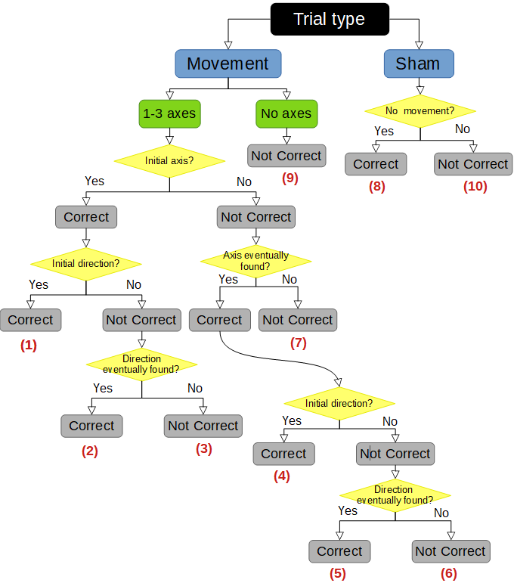
Figure 4: Flow chart of selection process for detection response profiles, where correct response profiles 1, 2, 4, 5, and 8 denote non-SD occurrence and wrong response profiles 3, 6, 7, 9, and 10 denote SD occurrence.

Control response profile analysis

Absolute error
Absolute error quantification idea 1 (old idea)
Let x denote here the considered motion variable, homogeneous to a displacement for translational motions, and to an angle for rotational ones. The total motion of the cabin is the sum of the theoretical motion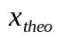and the motion commanded by the joystick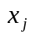:
(1)
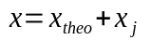.
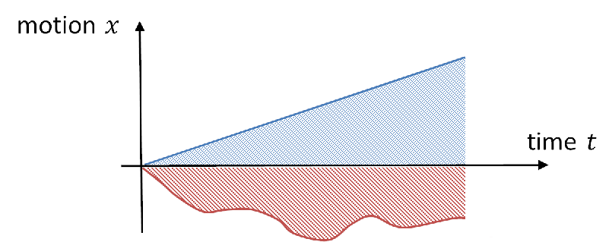

Figure 5: Illustration of the typical negative input stimulus and subject response shown in red and blue respectively.

Figure 5 depicts a typical input stimulus, shown in red, and the participant’s compensatory response to the stimulus indicated in blue. The shaded areas under the blue and red lines were used to calculate the CR metric, which is the ratio of the participant response to the theoretical trajectory. The CR metric was used to quantify the correction behavior exhibited by the participant with respect to theoretically perfect correction.
The correction rate can be expressed as:
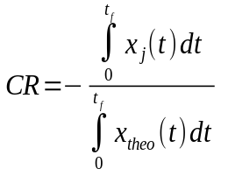
(2)
where 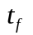 was the duration of the trial before cabin reinitialization. Correct compensatory joystick movement with respect to the input stimulus should be opposite in sign, the CR ratio will be positive. However, if the participant moved the joystick in the same direction as the input stimulus, the CR ratio will be negative such that the cabin drift is amplified. Ratio values equal to one or greater than one indicate optimal compensation of the stimulus and overcompensation, respectively.
Absolute error quantification idea 2
(simpliest: original): fit a line to data (no bins) determine if line is bounded, increasing, or decreasing
- label for SVM control classification per trial : bounded or unbounded
- This gives us the trend of the incremental error profile, this is equivalent to bin=1 where predicted_perfect=0; absolute error = sum (inc error)

Relative error

Relative quantification idea 1 (old idea)

bin the data progressively (from 1 bin to n bins), predict what perfect control should be per bin (basically return to initial), subtract predicted control from actual per bin to get incremental error per bin
- Q: what is the bin length (time needed to response, if a control decision is made based from the previous bin) that humans use?
- answer is obtained from the error profile (evenly distributed error profile perhaps) - intuitively the distance from peak to peak is the time response needed for large corrections, but it is unclear for small corrections
- Based on error profile --- seems logical to select the optimal bin length -- using this likely used human time response (bin length), then you can do regression analysis and obtain me (DONE)
Detection profiles greater than the 95% confidence interval were only considered in the control response profile analysis. Control response was evaluated by three metrics, per trial: (1) Root mean square error (RMSE) trend (increasing, decreasing, bounded) of theoretical movement and participant joystick movement, (2) participant joystick amplitude (Fast Fourier Transform (FFT) cutoff magnitude) compared with theoretical amplitude, (3) participant joystick frequency (FFT cutoff frequency) compared with theoretical frequency. Standard FFT gain bandwidth analysis, 3db drop, to obtain the cutoff frequency was used to capture dominant joystick motion in terms of magnitude and frequency. Integer values were assigned to representative states for each of the three metrics.

RMSE trend had three states indicating increasing error (drift), decreasing error (correction), and bounded error (stationarity). Figure 6 displays how the RMSE trend was calculated per trial, where local slopes shown in green were calculated for each bin and a final trial slope shown in red was calculated using the local slopes. RMSE trend across trials were evaluated per participant to calculate two outlier bounds, to distinguish statistically significant drifting (positive slope) and correcting (negative slope) behavior from stationary behavior per trial; two standard deviations was found to be a fair threshold for identifying outliers.
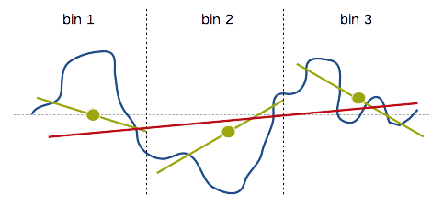

Figure 6: A depiction of RMSE trend calculation per trial. The green lines represent local calculated slopes per bin, and the red lines show the final RMSE trend slope per trial. Three bins or more result in a similarly accurate RMSE trend.

FFT cutoff magnitude had two states depicting low and high joystick amplitude movements, where low and high indicates trial joystick amplitude less than and greater than the trial theoretical amplitude respectively. Similarly, FFT cutoff frequency had two low and high states, such that low and high states indicated trial joystick frequency less than and greater than the trial theoretical frequency respectively.

The trial theoretical amplitude and frequency are the required optimal amplitude and frequency, to properly correct the cabin respectively. For each trial where detection was correct (Categories 1, 2, 3), the three metrics were calculated using joystick data from the detection point to the end of the trial. Twelve unique combinations were created from the integer states using the three metrics simultaneously. One example of the 12 unique combinations is a trial with an increasing RMSE trend, high joystick amplitude, and high joystick frequency. The 12 control response profiles were condensed into five final control profiles, because joystick frequency movement was similar across all participants and trials; joystick frequency was below the required theoretical frequency movement. Figure 7 depicts a flow chart of how the 12 categories were reduced into the five control profiles.

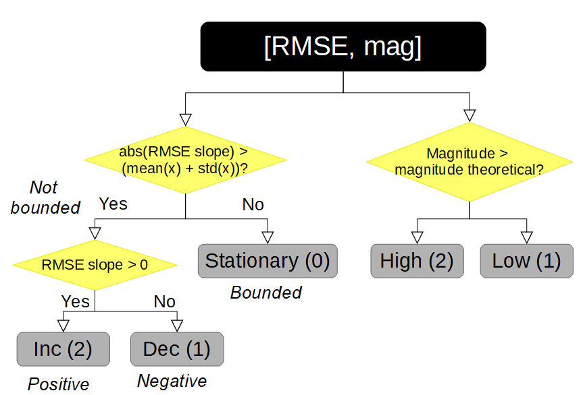
Figure 7: Flow chart of possible control response profile combinations; three possible control responses for the Root Mean Squared Error (RMSE) of joystick error and two possible responses for joystick error magnitude created five final control profiles.

The five final control profiles consist of:
- Fast drift (2,2): increasing RMSE trend and high joystick amplitude compared with theoretical amplitude
- Slow drift (2,1): increasing RMSE trend and low joystick amplitude compared with theoretical amplitude
- Startionary(0): bounded RMSE trend and low or high joystick amplitude compared with theoretical amplitude
- Fast correction (1,2): decreasing RMSE trend and high joystick amplitude compared with theoretical amplitude
- Slow correction (1,1): decreasing RMSE trend and high joystick amplitude compared with theoretical amplitude.
The five control categories were used to evaluate relative control behavior, with respect to the absolute CR control behavior measure. The relative measure allows for direct interpretation of control behavior, and the absolute measure allows for the determination of vestibular only dead reckoning ability.

