1 Introduction

Point of part/paper : We want to know about their motor policy and how error relates to their motor policy/sequence.
Q1 : what strategy did they use ? A1 : the motor sequence
Q2 : how does their strategy relate to task performance/error ? A2 : correlate error /cabin_position to each motor sequence

in control theory, behavior is studied in terms of error however it is difficult to extract functional time-dependent behavior in terms of error without a given reference, such that the reference gives meaning to the error from moment-to-moment. Classification techniques

Motor control has been quantified in terms of error with respect to a reference, however it is difficult to understand the strategy of the motor movement. Energy expenditure modeling has been used to explain the strategy for why certain motor motions are used in one context versus another.

However, in the event where one would like to quantify movement without a reference, classical error approaches can not be used. In such situations, basically most everyday life situations, motor movement can be studied in terms of the trajectory. Attributes about the trajectory, such as frequency, variance, can be characterised to give meaning/insight to the trajectory in the given context.

Newer classification techniques are based on using trajectory attributes, to build a model that can identify similar trajectories. Therefore, when a crucial reference, that gives meaning to a trajectory, is unknown machine learning/signal processing techniques are key to decompossing the signal to extract temporal attributes and thus meaning of the trajectory in the given context.

% Control statistical analysis
Similar to SD prediction, we hypothesize that control behavior can also be predicted sufficiently. Prediction of motion control behavior would demonstrate that behavioral pilot monitoring is possible and the classified control behaviors tell us what potential sensory references the pilot is following.

There are two approaches to construct a classification model for predicting joystick pilot control per trial. The supervised classification approach is to know the performance per trial and thus calculate a label based on control performance. In order to acccomplish this approach, one must know what is perfect control behavior for the task, thus one must simulate perfect vestibular dead-reckoning performance using a controller. Ideally perfect behavior for this task is to achieve zero error, however achieving zero error in a vestibular dead-reckoning task is inhumanly impossible, therefore in order to learn about human performance it is necessary to simulate a perfect response to the stimuli. In order to simulate a perfect response to each stimuli, the input stimuli signal is needed and a human-in-the-loop model (ie : PID controller) can be used to simulate the response. Unfortunately, due to system constraints, minimization of system delays to keep the data synchronized, only a limited amount of data could be saved and the input signal was not a priority signal to save. Without the exact input signal, even knowing the rate of input stimulation, one can not replicate the exact experimental input that each participant received.

Therefore, an unsupervised classification approach can be used to generate labels per trial based on the joystick data. We demonstrate trial prediction using unsupervised labeling for classification. A possible negative to this approach is that smaller temporal trends within the trial may not be observed, that could give insight into performance.

Due to the fact that smaller temporial trends may not be observed, we devised a third approach where we deconstruct the temporal signal into bins/segments, called micro behavior, and we construct a supervised label for each bin within the trial. The within trial label is a sequence of numbers indicating statistically significant behavior.

2 Methods

2.5 Data analysis

Unsupervised classification
label creation using CCA and PCA, classification of motor movement

Supervised classification micro (need a name)
1) binning of data to separate micro behavior within a continuous time-series (trial) - two methods (task based and change-point analysis)

2)

3 Results

1.0 Unsupervised classification: motor control prediction per trial
Need to perform PCA and classify with the components

1.1 Supervised macro classification: motor control prediction per trial (behavior prediction)
The supervised label for classifying control behavior was constructed by using the a statistical method to convert micro signal trends into a macro signal.
Similar to SD classification, feature space was explored using the same six features described in the previous subsection.
Joystick movement from the time of correct identification of both axis and direction to the end of the trial was used for control policy prediction.
Interpolation was used to resize each trial with differing time length to the length of the longest trial.
The statistical procedure for identifying significant changes in micro behavior was performed, transforming the joystick data into a binary sequence.
The procedure includes identifying a bin/window for cutting the trial joystick data such that micro behaviors are separated. Identifying the cutting bin size was performed using two techniques : 1) find the time-scale for temporal changes in the data for the task (by evaluating the bin size with respect to summed error across the population), 2) change-point analysis per subject and trial.
For each trial the slope of the joystick data per bin was calculated.
A statistical threshold measure was used to evaluate whether the slope per bin was significant ; the population mean and standard deviation of the slope across all conditions. Slope bin trial values larger than 1 std from the population mean is a significant increase (positive slope) or decrease (negative slope), otherwise it is stationary motion. A micro behavior label was created such that the bin data was given the following assignment : stationary = 0, increase=1, decrease=-1.
Then per trial, the micro label bin sequence of 0, 1, or -1 was evaluated, such that repeating macro behaviors could be found from the sequences. Unique sequences within subject and across subject for rotational and translational tasks were found and organized by the number of sequence changes. Unique means that the sequence repeated across trials and conditions, thus the sequence is a unique motor signature.
For example, a sequence of -1 1 0 would be considered a 3 change sequence and 1 1 0 1 would be considered a 4 change sequence. Finally, several unique 3-4 change sequences were selected as key sequences in which we could use as a label for trial performance classification ; 3-4 change sequences were selected because 3 to 4 significant changes in motor behavior is ideal and relavant behavior for the tracking task. Unique sequences were chooses as labels based on their count frequency across all conditions, the most counted sequences were dimmed to be an important motor control signatures.

Below in Figure 1, seven unique motor behavior sequences for 3 change behavior were found for the rotation task across all conditions.
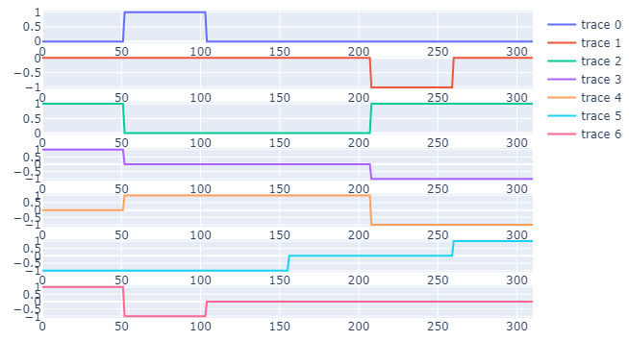
Figure 1: Micro motor behavioral labels for rotation. The most frequently appearing statistically proven motor behavioral sequences for 3 change behavior. A value of 1, 0, and -1 indicate sigificant increase, stationary, and decrease of the joystick signal.

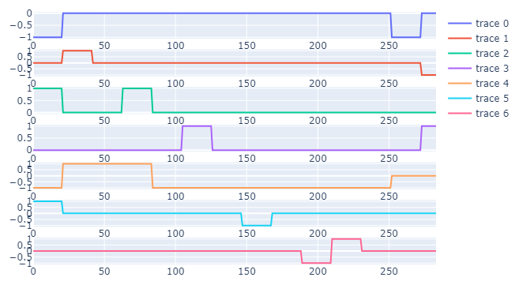
Figure 2: Micro motor behavioral labels for translation. The most frequently appearing statistically proven motor behavioral sequences for 4 change behavior. A value of 1, 0, and -1 indicate sigificant increase, stationary, and decrease of the joystick signal.

Need to count these key motor sequences across all trials, and select the most counted 3 to 4 sequences as labels
Use these labels, to classify performance per trial
Give meaning to each sequence – for example a 1 -1 1 0 is ideal behavior for the task, they overshot (1), then corrected with undershooting (-1) , overshot again (1), then maintain movements in a certain range (0). Sequences ending with 0 are motor signatures where participants were able to stablize their performance by the end of the trial, individuals who have a 0 at the end often are be good performers.

1.2 Supervised micro classification: motor control prediction per bin (real-time tracking of behavior)
Significant changes in motor control performance can also be monitored on a short time scale using a classifer, similar to a controller. We demonstrate that significant increases and decreases in joystick behavior can be predicted using a classification approach, to perhaps signal dangerous real-time joystick manipulation.
Two simple statistical methods were used to create a threshold for what is considered a significant increase or decrease in joystick motion, each method is called label 1 and 2 respectively.
Label 1 (asm) calculates the population mean and standard deviation of the slope across all conditions. Slope bin trial values larger than 1 standard deviation from the population mean is a significant increase (positive slope) or decrease (negative slope), otherwise it is stationary motion (label : stationary = 0, increase=1, decrease=-1)
Label 2 (ttest) tests if the joystick data per bin is different from zero via the t-test. A p-value of 0.05 or less is considered acceptance of the null-hypothesis, thus significant behavior. If the data is considered significant, the sign of the slope of the data is checked and then labeled increase or decrease. If data is not significantly different, it is considered stationary motion (label : stationary = 0, increase=1, decrease=-1).

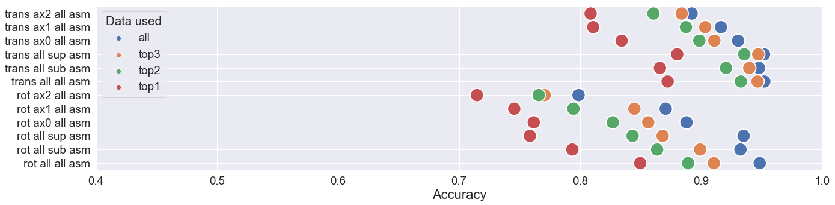
Figure 3: SVM prediction accuracy and precision of test data, for four models using the asm label. Circle colors blue, orange, green and red correspond to, 1) all six features, 2) the top 3 important features via permutation importance, 3) the top 2 important features, and 4) the top important feature. Regarding notation, ax0, ax1, ax2 indicate roll, pitch, yaw for the rotational task and LR, FB, UD for the translational task. Additionally, sup and sub denote supra and sub stimulation respectively.

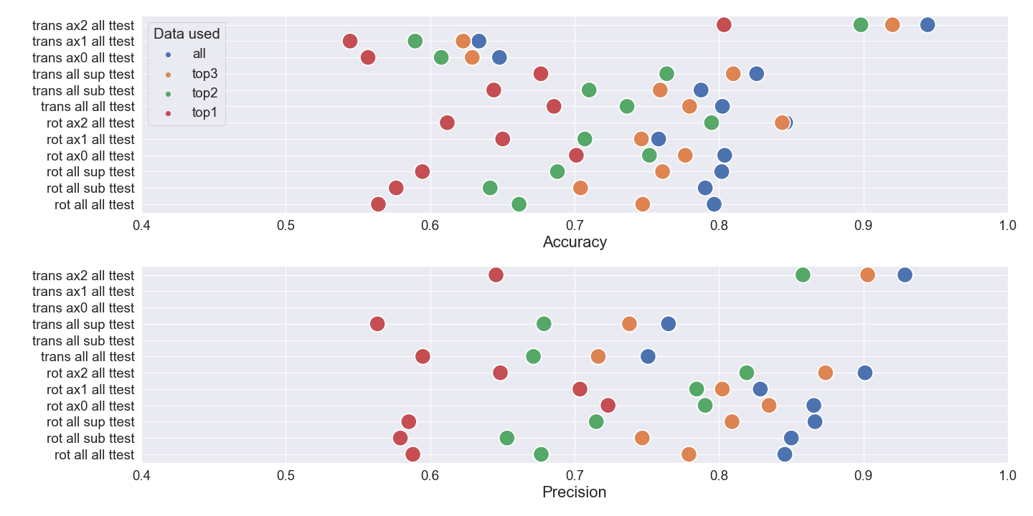
Figure 4: SVM prediction accuracy and precision of test data, for four models using the t-test label. Circle colors blue, orange, green and red correspond to, 1) all six features, 2) the top 3 important features via permutation importance, 3) the top 2 important features, and 4) the top important feature. Regarding notation, ax0, ax1, ax2 indicate roll, pitch, yaw for the rotational task and LR, FB, UD for the translational task. Additionally, sup and sub denote supra and sub stimulation respectively.

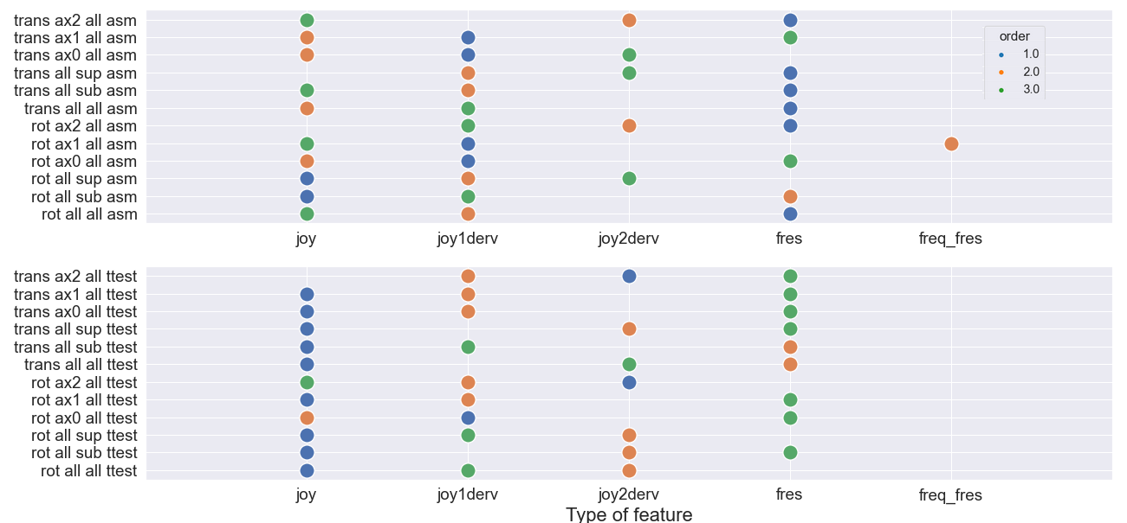
Figure 5: Feature order importance based on permutation importance, for each model. Blue, orange and green circles indicate most important feature, second most important feature, and third most important feature.

