Predicting spatial disorientation from motion control during near-threshold simulated flight.
Authors: Jamilah Foucher α, Anne-Claire Collet, Kevin Le Goff, Thomas Rakotomamonjy, Valerie Juppet, Thomas Descatoire, Jerémie Landrieu, Marielle Plat-Robain, François Denquin, Jean-Christophe Sarrazin and Benoît Bardy α
1 EuroMov Digital Health in Motion, Univ Montpellier IMT Mines Ales, Montpellier, France
2 DTIS, ONERA, Salon de Provence, France
3 AIRBUS, Toulouse, France
4 AIRBUS Helicopters, Marignane, France
5 Human Design Group, Toulouse, France
α Authors contributed equally to this work
Running head: Predicting spatial disorientation (SD) while being lost in translation and rotation
Manuscript type: Research article
Exact word count:
Text word count:
Reference word count:
Correspondence:
Jamilah Foucher
j622amilah@gmail.com
Acknowledgments:
This project was supported by the French Department of Civil Aviation (DGAC) and by the European Union (FEDER iMOSE). The authors thank Arthur Grunwald (Technion, Israel Institute of Technology) for his valuable contribution to the conceptualization of these experiments.

Abstract
Objective: Perceived motion detection was quantified, using vestibular and proprioceptive stimulation, demonstrating that classification analysis can be used to predict disorientation.
Background: In aeronautics, Spatial Disorientation (SD) includes situations in which the aviator fails to perceive correctly aircraft attitude, position or motion. SD is often quantified in terms of task and accident context, making it difficult to develop a generalized and fundamental understanding of the occurrence of SD and viable solutions.
Method: A full-body rotational and translational compensatory tracking task was employed to investigate closed-loop motion perception, during near sub- and supra-threshold conditions. We quantified motion perception using detection response profiles based on behavior, and predicted SD using supervised classification.
Results: Slow difficult to detect sub-threshold motion induced less correct perceived detection than faster detectable supra-threshold motion. Additionally, correct detection response time revealed participant strategy, where quicker and slower times indicated a searching and sensory-detection strategy respectively. Support Vector Machine (SVM) classification sufficiently predicted perceived motion disorientation behavior.
Conclusion: Perceived motion disorientation can be quantified and predicted based on task relevant behavior (e.g., joystick).
Application: These measures can be used to monitor the onset of SD, thus understanding the cause, and evaluate the effectiveness of SD solutions.
Keywords: aviation, vestibular, proprioceptive, sub-threshold, supra-threshold.
Précis: Perceived closed-loop motion detection were quantified and predicted, using a full-body rotational and translational compensatory tracking task, for two movement speeds at and above the threshold of human motion detection. SVM analysis successfully predicted perceived motion disorientation response behavior.

1 Introduction
% Introduce SD in context of flight, types of SD, pros and cons
SD, in aviation, is the failure to perceive orientation, position, or movement. It is caused by multiple factors including environmental references and conditions, experience, and stress. There are diverse types of SD symptoms, ranging from confusion to physical sickness, and currently there is no proven method or solution to prevent it (Bles, 2008; Gibb, 2010; Perdriel, 1980; Previc, 2004; Newman, 2007). International studies on the frequency and severity of SD accidents show that the cause of 6-32% of major accidents are due to SD, similarly 15-26% of fatal accidents are a result of SD (Newman, 2007). Recovery from SD is strongly connected to the pilot's awareness of the situation, and his/her ability to perform corrective control, despite the disorientation, to maintain aerodynamic stability; 80% and 20% of SD incidents are caused by unrecognized and recognized situations respectively (Bles, 2008). Currently, SD is treated by educating pilots of the signs and symptoms of SD, and instructing them to fly below the physiological thresholds of the human vestibular system. Treating SD has been challenging because SD is often defined with respect to a specific aeronautical context. SD definitions focus on flight performance errors but seldom include context independent behavioral, perceptual or physiological trends. Due to the fact that SD is studied case-by-case in an aeronautical context, there is little general understanding of the onset of SD and orientation, position, or movement perception with respect to environmental references.

% 2) Links motion detection (vestibular stimulation) to SD, negatives and recommendation
Vestibular stimulation is an important source of motion detection (Angelaki, 2008). Vestibular thresholds from motion perception research were used as an indicator to be aware of SD; angular and linear vestibular thresholds were compared for various whole-body stimulation experimental paradigms. Experimental paradigms included the usage of different experimental conditions such as, acceleration amplitude, trajectory of stimuli, sequence and exposure time of movement and non-movement events, movement direction with respect to the orientation of the head (Young, 1966; Guedry, 1974; Melvill, 1978; Benson,1986; Benson, 1989). However motion perception thresholds vary depending on the experimental context, thus it is unclear as to which thresholds can be applied to SD awareness. Motion perception research within the last 20 years has adopted robotic simulation tools and standardized experimental paradigms, including a greater range of motion test frequencies, allowing for more precise and consistent motion detection boundaries for a large variety of perceptual situations. Despite having various reliable perceptual boundaries, again it remains uncertain how to reliably use thresholds to assist with SD. It would be more of interest to use more descriptive markers for disorientation, such as physiological and/or human factors with respect to aircraft control, because SD arises from the interaction of multiple sensory information with respect to environmental references.

% 3) General vestibular motion perception research
Vestibular motion perception can be studied by decoupling several crucial context-driven parameters: 1) stimuli direction and rate, 2) continuous vs non-continuous stimuli, 3) pilot control vs non-control of with respect to stimuli, 4) orientation and/or movement of the pilot's body during exposure to stimuli. Depending on the context parameters and the stimuli trajectory, the vestibular-proprioceptive system detects motion differently and thus behavioral responses are different (Haburcakova et al, 2012; Soyka et al, 2011; Bermudez Rey et al, 2016; Karmali et al, 2017; Valko et al, 2012; Hartmann et al, 2014). In controlled laboratory studies it is of interest to study behavior where the pilot is in a stationary situation, in order to understand physiological function. Therefore, stimuli direction and rate are used in a non-continuous manner, few directional and rate changes, where the pilot is immobile upright or supine (Valko et al, 2012; Roditi et al, 2012). However, considering realistic situations such as flight, static-state motion detection behavior is not equivalent to behavioral responses in a dynamic situation. Thus, it is of interest to study motion perception (detection and control) in a dynamic situational context where the pilot is unconstrained and can interact with the stimuli. In flight, pilots are constantly in motion at different body orientations that could allow for differences in perceived orientation, position, and motion with respect to references, perhaps leading to SD.

% 4) Motion perception research related to SD specifically
Motion perception and its effects on disorientation are being investigated more in applied contexts, such as in aviation and online search. For instance, directional perception/SD was investigated in a realistic helicopter task where participants were asked to point towards the sky (Cheung et al, 2000). Similarly, continuous heading detection was investigated using a compensatory task such that perceived heading was measured with respect to a remembered target (Sargent et al, 2008). These applied studies are useful and give insightful information about motion perception in realistic contexts. However, there is a lack of studies investigating motion perception during a simple yet realistic online aviation context, to determine if pilot behavior can predict different disorientation states. Here we propose a bi-directional rotational and translational motion perception task in a loosely constrained flight-like environment, to quantify natural detection behavior at reasonable sensed and non-sensed vestibular threshold limits. In an online flight context, it is more accurate to predict states of disorientation from modeled physiological or movement signatures than using vestibular thresholds. The motivation of this proposed work is not to identify vestibular thresholds and report corresponding behavior, but to identify a reasonable model to predict states of disorientation.

% 5) Our work – motion perception related to SD
The goal of this work is thus to evaluate vestibular and proprioceptive motion perception in terms of movement detection in a realistic flight context. A vestibular whole-body compensatory task in darkness was used to produce realistic motion cues that a pilot might experience, where motion detection behavior was quantified and categorized.
% SD statistical analysis and prediction
The occurrence of motion disorientation was quantified and predicted, to demonstrate that disorientation can be identified from behavioral markers such as joystick control. We expected to find SD behavioral movement signatures from joystick information, to demonstrate that task-dependent behavior can be a marker to predict SD.
% Physical sickness related to SD
Finally, the relationship between physical sickness symptoms and motion disorientation were investigated to identify potential physical markers for SD; physical sickness was quantified using a generalized disorientation test for humans called the Simulator Sickness Questionnaire (SSQ) (Kennedy et al, 1993; Bouchard et al, 2007). We hypothesized that participants who correctly detected motion, implying they do not have SD, will additionally not have physical sickness.

2 Methods

Two identical setup and task designed experiments were performed, such that motion stimuli differed to explore detection and control response for rotational and translational motion. A 6-degree-of-freedom position controlled KUKA-based motion simulator system (KR 500-3 MT adapted by BEC GmbH motion simulators, KUKA Roboter GmbH, Germany) and a network of Workstations were used to provide sensory stimulation (Bellmann, 2011). A forcing function, where the dynamics were unknown to the participants, continuously and slowly perturbed the orientation or position of the simulator cabin. When participants detected the perturbation, their task was to cancel the deviation with respect to the initial orientation (Experiment 1) or position (Experiment 2) of the cabin based on the perception of the felt directional stimuli i.e., using vestibular and proprioceptive cues; no visual stimulation was present.

2.1 Identification of near sub-threshold and supra-threshold rate stimulation values
Before conducting both experiments, a calibration phase was conducted with 23 naive participants (5 in Experiment 1 and 18 in Experiment 2) to identify the near sub-threshold and supra-threshold stimulation values. They were asked, while seating upright in the simulator to verbally report which direction they believed they were moving, directly after stimulation; For the rotational experiment, the chosen near sub-threshold was 0.5 Hz (deg/s) and the supra-threshold was 1.25 Hz (deg/s). For the translational experiment, the chosen near sub-threshold was XX Hz (deg/s) and the supra-threshold was XX Hz (deg/s). Method and procedure for threshold selection are detailed in Supplementary Materials.

2.2 Study design
In the rotation experiment, the attitude of the cabin was modified in one of the three rotation axes: roll, pitch, and yaw. In the translation experiment, the cabin was moved along one of the three axes: left/right, forward/backward and up/down. Figure 1A shows both rotational and translational directions of cabin movement.

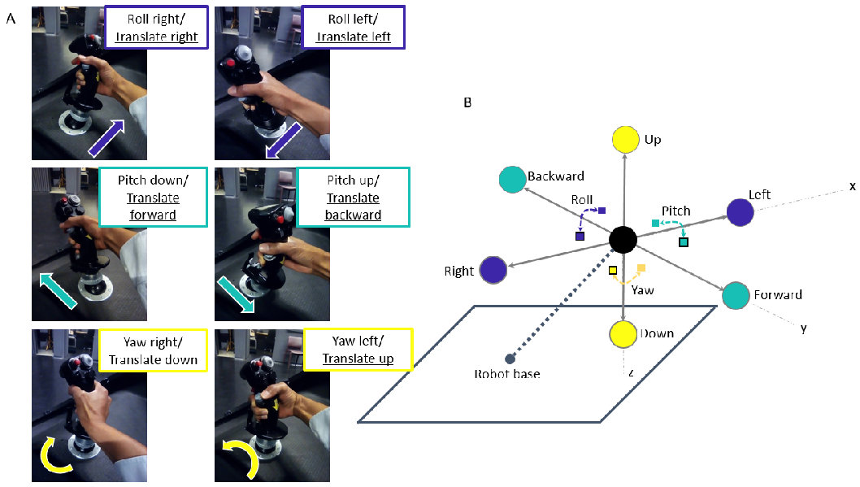
Figure 1: Figure 1A shows the mapping of participant’s joystick movements to the movement of the cabin. The simulator cabin, represented by the black sphere in Figure 1B, could move in both translation (left/right, forward/backward, up/down) and rotation (roll, pitch, yaw) via the input stimulus and/or participant control. The black outlined squares and circles in Figure 1B denote positive directional movement (right, forward, down), where squares and circles correspond to rotational and translation movement respectively. Non-outlined squares and circles indicate negative directional movement (left, backward, up).

Minuscule sinusoidal vibrational noise, 1-2cm in amplitude, was added to the non-stimulated axes to mask the sound of the motor for the selected stimulus. Due to the fact that vibrational noise was present, participants were exposed to a more realistic aviation environment. Furthermore, the additional vibration helped to reduce movement detection thresholds such that the task was realistically challenging (Chaudhuri et al, 2013).

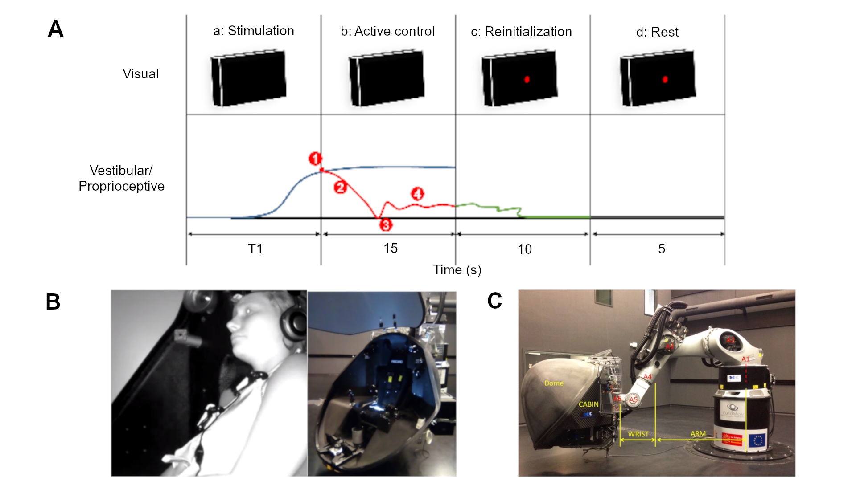

Figure 2: Task procedure and simulator installation. A denotes the experimental design where each trial consisted of four phases: (a) motion stimulation of the cabin with an unknown forcing function, (b) participant motion detection and afterwards active control, (c) cabin reinitialization to the initial orientation or position, (d) cabin and participant at rest. For visual, red dot denotes that participants should release the joystick and rest. For vestibular/proprioceptive, blue corresponds to the forcing function that actively perturbed the cabin, red line denotes the participant's movements to counteract the perturbation after motion detection at T1 seconds, green line during phase c denotes automatic reinitialization of the cabin, and grey line during phase d denotes a stationary period. (1) detection of orientational or translational self-motion; (2) corrective compensation; (3) typical release motion of the joystick signaling return to initial orientation or position; (4) typical small corrections to maintain orientation or position about the initial location. B depicts the experimental simulator cabin in which each participant performed the detection and control task. C shows an exterior view of the six-axis KUKA motion simulator, consisting of the participant cabin and the robotic arm. See text for details.
A single trial was composed of four different phases:
- A second-order transfer function response served as the forcing function unknown to participants, perturbed the cabin orientation or position for 20 s (rotation) and 8 s (translation) maximum with an acceleration ramp of respectively 5.8 s and 3.8 s. A second-order response was chosen because the motion simulator is sensitive to abrupt motion, especially during starting and stopping; the second-order function was 1/(s2 + (3.6π)/T s + π/(0.9T)) where T = 4. Similarly, in order to obtain constant stimulus velocity at the chosen near sub-threshold and supra-threshold values, a second-order system was of interest because the response slope can be tuned to correspond to the chosen movement rates. Rotational and translational experiments had different stimulation lengths due to the physical constraints of the motion simulator.
- During phase A the participant could move the cabin with the joystick in any of the three rotational or translational axes to counteract the perturbation, as shown in Figure 3B. Figure 3B depicts the mapping of the participant’s actions on the 3-axes joystick, which corresponded to the movement of the cabin. If participants responded within the defined temporal window of phase A, phase A stopped and they had 15 additional seconds to maintain the cabin stationary by counteracting the perturbation.
- The cabin returned to the initial starting location in roughly 10s. If participants did not respond within the defined temporal window of phase A, the re-positioning event would begin automatically.
- The cabin remained stationary at the starting location for 5s in order to avoid possible over stimulation or aftereffects. Figure 2 shows a typical situation of the four phases in sequential order, the blue line in phase A and B depicts the second-order forcing function that actively perturbed the cabin; during phases A and B participants viewed a black screen indicating that they should actively counteract the perturbation. At T1 seconds the participant detected (1) and counteracted (2) the stimulation, depicted by the red line; typically after participants initially counteracted the perturbation (3), small and frequent correction movements (4) were used.

One trial was composed of three or four events, phase B did not occur if the participant did not respond during phase A, and each trial was at maximum 50 s long in the rotational experiment (20 + 15 + 10 + 5) and 38 s long in translational experiment (8 + 15 + 10 + 5). For example, for the rotational experiment, initial stimulation was roughly 5 s however participants had 20 s to respond by correcting with the joystick. If participants detected the movement and corrected using the joystick, 15 additional seconds were added from the point at which the joystick was moved. If participants did not move the joystick, the trial finished after 20 s.

There were a total of 42 trials, the experimental familiarization practice phase consisted of 12 trials, each of the 3 axes were stimulated in both negative and positive directions at near sub-threshold and supra-threshold movement speeds. Similarly, the experimental phase consisted of 30 randomized trials, such that 15 trials with unique experimental conditions were repeated twice; negative near supra-threshold, negative near sub-threshold, no-movement, positive near sub-threshold, positive near supra-threshold) for each of the 3 axes (roll/lateral, pitch/longitudinal, yaw/vertical). No-movement trials were included as sham trials to test whether participants could indeed detect the presents of movement during movement trials.

2.3 Experimental protocol
The experiment took approximately 90 minutes and consisted of four sections: (1) arrival/ questionnaires/ instruction, (2) familiarization, (3) experimental session (rotational or translational stimulation), (4) questionnaire/discussion.

After describing the experimental task and the completion of the questionnaires, participants were securely installed, using the safety harness and communication headphones, in the motion simulator. They were asked to moderately move the joystick in one axis direction at a time, to compensate the unknown perturbation. They were given the same instructions to return the cabin to the initial position/orientation when they thought that they had moved away from the initial position/orientation; They were not told to act as fast or accurate as possible. The reaction speed and/or strategy that participants adopted were chosen by the participants themselves. Participants were free to look and/or fixate where they wished, and they could freely move their body and head as long as it did not interfere with the task, in order to simulate a realistic flight scenario.
Once the participant was installed in the cabin, the cabin door was closed and all communication between the participant and experimenter were performed via a camera interface system which facilitated two-way auditory communication. The experimenter additionally could visually monitor the well-being of the participant in the cabin. The left portion of Figure 3A shows the sequence of steps performed during the usage of the motion simulator. The installation process, shown on the left from top to bottom, illustrates the simulator with the (1) cabin door open on the ground, (2) participant installation, (3) cabin door closed on the ground.

2.4 Participants
18 and 14 healthy volunteers with normal or corrected vision, and no particular flight experience performed the rotational and translational near sub-threshold tasks (males and females, 32±10 SD years old): 4 of the 32 participants reported having novice time-limited (45 minutes, 2 hours, 40 hours, 45 hours) piloting experiences. 4 of the 18 rotational and 4 of the 14 translational participants were over the age of 40. The participants that performed the rotational experiment were not the same as participants that performed the translational experiment. Therefore, there were no confounds due to experimental ordering, learning, carryover, or fatigue. The same participant population, university students and personal, were used for both experiments therefore it is likely that both experimental populations were similar.

2.5 Data analysis
(This section talks about the general analysis methods that were used and why – it gives a general description of: 1) preprocessing, 2) brief description of analysis methods)

1) pre-processing,
Simulator and participant movements were collected at 252 Hz, the sampling frequency of the KUKA controller, and later down-sampled to 10 Hz for analysis. 10 Hz was chosen as a desirable sampling frequency because human response movements for this task are less than 10 Hz (Farmer, 1999). In addition, a data standardization pre-processing analysis was performed to ensure that robotic motion and participant response was similar for all participants. Trials that were dissimilar due to real-time system delays were removed; 40% of rotational and 50% of translational trial data was removed from the analysis. See the Supplementary materials section for the steps used to standardize the data.

2) brief description of analysis methods – we can include why we used them
As previously mentioned, the goal of the experiment was to determine whether a pilot with vestibular-only information was disoriented; disoriented means an inability to detect directional motion and/or perform a corresponding action with respect to the motion such as dead-reckoning. In order to quantify, model, and predict pilot disorientation, machine learning analysis was used: 1) metric-discovery and label creation for disorientation related to detection of directional motion stimuli, and 2) joystick feature selection and disorientation classification. Detection label creation was performed by logically categorizing detection response. Using a typical linear classifier, Support Vector Machine (SVM), we classify disorientation detection via joystick data. Different features of joystick data are additionally investigated, to determine what types of action components (such as acceleration, jerk, and frequency traits) provide discriminatory information related to disorientation. The metrics used for label creation shed light on psychophysical human response during vestibular-only dead-reckoning.

2.5.1 Metric-discovery and label creation for disorientation detection
Detection of correct stimuli was categorized into ten possible categories based on the selection of axis and axial direction. See the Supplementary materials section for a detailed flow chart of the possible participant choices based on response movement.

The ten detection response occurrence profiles were reduced to five categories:
- Initial Correct axis & direction : trials where the first response was with the correct axis and direction (IC : Category 1)
- Eventually Correct axis or dir: trials where the first response was with an incorrect axis or direction (EC : Category 2, 4, 5)
- Never Correct: trials where participants acted on the joystick but never found the correct axis and/or direction (NC : Category 3, 6, 7)
- No response: trials in which participants did not respond (NR : Category 9).
Two types of labels were tested for predicting disorientation detection: 1) lenient : mistakes are allowed to be made thus IC and EC categories were labeled as ‘non-disoriented’ and NC and NR were labeled as disorientation, 2) strict : no mistakes are allowed where IC was labeled as not disorientation and EC, NC, and NR were designated as disoriented.

(Reaction time)
In addition to categorizing the detection response for machine learning disorientation prediction, we also were interested in describing human behavioral response from a psychophysical perspective. Therefore we investigated the relationship of reaction time with each detection category; reaction time was the time required before the participant found the correct axis and direction. The 95% confidence interval around the mean of near sub-threshold and supra-threshold categories were used to determine the response occurrence categories different from zero. Response occurrence categories above the lower confidence interval were further evaluated in terms of detection reaction time. The Kolmogorov-Smirnov (kstest) was used to evaluate where to use a parametric or non-parametric two-sample comparison test for within and across axis comparisons. All kstest results returned non-parametric distributions, thus non-parametric two-sample tests were used. Uneven two-sample data vectors were compared using wilcoxon sum rank test. The Wilcoxon signed rank test required that equal length vectors be compared, thus shorter length vectors were padded with nan values.

2.5.3 SD classification
Model construction
Eight semi-supervised classification models were compared to classify the presence of perceived disorientation (SD), per trial across axis and speed conditions. The eight models include both decision tree and optimization function driven algorithms: Stochastic Gradient Descent (SGD), Linear Discriminant Analysis (LDA), Random Forest (RF), Gradient Boosting Classifier (GBC), Decision Tree (DT), Two-layer Multilayer perceptron (MLP), Gaussian Naive Bayes (GNB), optimized Support Vector Machine (NuSVC). Multiple models were compared in order to understand which types of predictive models best identified trends for the piloting task, for various experimental conditions.
Three labels for SD were constructed by using the detection response profile, the labels were used to evaluate how the definition of perceptual disorientation could influence disorientation prediction. The first label, called lenient, allowed for mistakes to be initially made; Categories IC and EC are considered as non-SD state and unsuccessful detection responses (Category NC and NR) were considered as SD state. The second label, called strict, did not allow for initial errors; initial successful detection response (Category IC) was considered as non-SD state and Categories EC, NC, and NR were considered as SD state. For both binary labels vectors, a value of 0 was assigned to each trial where no-SD occurred and 1 was assigned to each trial where SD occurred. Finally, the third label, called complex, categorized the level of disorientation based on a range of performed mistakes. Initial successful detection response (Category IC) was considered as non-SD state, mild-SD state was considered to be Category EC where the response was eventually correct, and incorrect detection responses (Category NC and NR) were considered as SD state. This multi-label vector assigned 0, 1, and 2 to no-SD, mild-SD, and SD trials, respectively.
Features refer to the unique types of data the participant generated during each experimental trial. We used participant joystick movement, a non-invasive measure containing real-time piloting behavior, and transformed the joystick measure to decouple known human motion control function. It is known that human motion control involves coordinating position, velocity, and acceleration information in order to produce smooth motor behavior (citation of human motor). Many works model smooth human motor control function using a linear combination of position, velocity, and acceleration information (citation). Therefore, instead of only using the joystick measure as the only feature, we used this domain-specific modeling information and decoupled the joystick measure into position, velocity, acceleration, and frequency features. By organizing the features in this manner, we not only obtain a predictive SD model but we can rank the importance of which types of human motor movements correlate with spatial disorientation.
Five features were used for model construction and predictive testing: (1) joystick signal (velocity control joystick), (2) 1st derivative of the joystick signal (human movement metric : acceleration), (3) 2nd derivative of the joystick signal (human movement metric : jerk), (4) frequency response of joystick position via FFT (control theory metric : human-in-the-loop), (5) frequency of joystick (signal processing metric : estimate the period of the signal), (6) frequency of joystick (bandwidth cutoff/0.3 decibel drop of the frequency response of joystick via FFT (control theory metric : human-in-the-loop)). The entire joystick movement traced from the start to the end of the trial was used for SD prediction. Trials were at least 16 seconds long, and each trial length was set to the maximum trial data point length. Interpolation was used to resize each trial with differing time length, via the python interp1d function. Joystick data per trial for each participant was stacked into the feature matrix, 25% of the matrix and the corresponding label was “held-out”/not included in the construction of the predictive model. The excluded 25% of the data was used to test the predictive capability of the eight models, trained with both individual and all feature types. Please see the appendix section for a detailed description of the classification pipeline for predicting SD.

Model evaluation
Classification accuracy and Receiver Operating Characteristic Area Under the Curve (ROC-AUC) measures were used to evaluate model performance. Accuracy measures the true positive and negative count over the total number of samples, (TP+TN)/(TP + TN + FP + FN). Accuracy only gives information about how the model can accept data. ROC-AUC is a common measure to evaluate performance of classification models, it is the area under the false positive rate FPR=FP/(FP+TN) versus the true positive rate TPR=TP(TP+FN) (citation). A ROC-AUC score of 1 indicates perfect prediction of all labeled classes, whereas a score of 0.5 or lower indicates prediction of all labeled classes is poor and at or below chance level. The ROC-AUC is needed in addition to the Accuracy to determine if false positive values are balanced with true positive values, ensuring that the model can accurately reject and accept data.
Finally, feature importance was of interest because each feature provides distinct information about disorientation. It was of interest to understand which feature/s could convey the most informative information about the occurrence of perceptual disorientation. Feature importance is calculated such that each feature is shuffled individually and model accuracy is calculated for each shuffled feature. Unshuffled model prediction accuracy is subtracted with each of the shuffled feature prediction accuracy scores. The change in prediction accuracy for each shuffled feature is ranked, such that the feature with largest change in prediction accuracy is considered the most important feature. Sklearn's permutation_importance function was used to identify feature importance.

2.5.4 Physical disorientation
Finally, response occurrence categories were related to the SSQ disorientation sub-scale (R. S. Kennedy et al., 1993; Bouchard et al., 2007). Non-parametric tests for distribution comparison, Wilcoxon tests (two-sided rank test and rank sum test) with Bonferroni correction, were used to evaluate detection results. Python was used for all analyses, using packages numpy, pandas, scipy, sklearn, seaborn/plotly/matplotlib.

3 Results
For both rotational and translational experiments, participant’s detection behavior was quantified with respect to stimulation speed and axis. Rotational and translational experimental results were not be directly compared for subsection 3.1, axis responses, because physiologically the body detects axis and directional motions differently. However, in subsection 3.2 regarding performance rank, overall task difficulty for rotational and translational tasks are compared.

3.1 Response profile
Stimulus motion detection was quantified using the five response occurrence profiles and initial reaction time to compensate the stimulus.
Figures 3 and 4 show the summed response occurrence count (top), mean response occurrence count (middle), and mean reaction time (bottom) per detection performance category, across participants for axes and speed conditions, for rotation and translation respectively.
Relevant response occurrence categories, were selected based on summed count significance per axis condition via the 95% confidence interval test. Summed count categories above the red dashed line are categories of interest because there are sufficient count samples, across subjects, to perform statistical comparisons of categories within (ie: sub versus sup) and across axis (ie: RO sub versus PI sub versus YA sub) conditions. The top row shows the normalized summed count per response category for each axis and speed condition; the total trial count per participant was 36 not including sham trials. The total trial count per participant was normalized to 36 such that interpretation of results would be coherent with the experimental design. Participants may have less total trials than 36 trials because trials that did not follow the experimental expectations were removed during pre-processing standardization (ie: trials where the cabin did not follow joystick movement correctly). For rotation the summed bars in the top row equal 648 which is the 18 participants multiplied by 36 trials; the top row represents the distribution of trial responses per response category. Similarly for translation the summed bars in the top row equal 504 which is the 14 participants multiplied by 36 trials. The middle row is a different visualization of the same normalized count data, except it displays the mean count. The mean count represents the frequency of selecting a response category across participants. Lastly, the bottom row displays the mean reaction time taken for each response category. Bars without error bars have a single sample value or several participants had the same count value. Single sample bar values may exist due is a lack of data because roughly 60% (rotation) and 50% (translation) of all data was accepted due to the rigorous standardization process of only accepting trials that followed the experimental design.
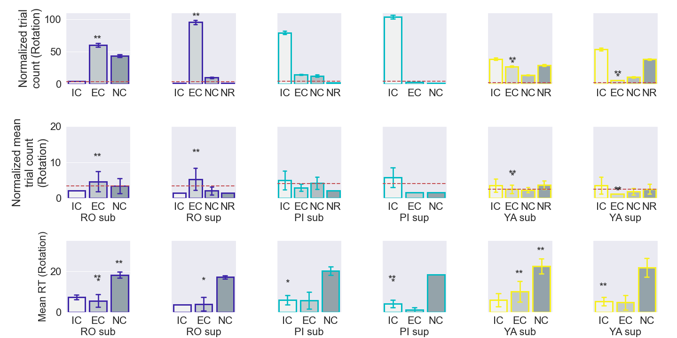
Figure 3: Summed response occurrence count (top row), mean response occurrence count (middle), and mean reaction time (bottom row) for rotational stimulation. All 3 metrics (summed count, mean count, and mean RT) were compared for near sub-threshold and supra-threshold speed stimulations for roll, pitch, and yaw axes respectively; Wilcoxon signed rank test, and sum rank test were used to determine significance such that significant relationships were represented by (* within axis comparison of sub and sup, **: across axes comparison). Bonferroni correction : p < 0.0167 was used as the significance threshold, p < 0.05 are mentioned as slight significant relationships.

3.1.1 Detection: speed comparison (within axis condition)
Regardless of the motion stimulation axis or direction, faster supra motion stimulation allowed for more accurate and faster detection than slower sub-threshold stimulation. In detail below for each axes and orientation direction stimulation, significance between supra and sub-threshold speed are discussed.

- Roll : There was a slight significance between sub and sup for the never correct (NC) count (Kolmogorov-Smirnov : nonnormal distribution, signedrank :p < 0.000244, sumrank : p < 0.026562, bartlett: p < 0.267095, n=13) ; not reported on Figure 3. Therefore, when the motion stimuli was slow (sub) more participants could not detect the correct axis and/or direction, whereas when the motion was faster (supra) less participants could never detect the correctly. Additionally, EC was the highest counted category amonsgt the other detection categories, in particular the EC supra category was higher than the EC sub category. Therefore, faster supra motion stimulation allowed for more accurate roll detection.

Regarding reaction time for when mistakes were made (EC), participants responded faster for supra stimuli in comparison to slower sub stimuli (Kolmogorov-Smirnov : nonnormal distribution, signedrank : p < 1.841592e-04, sumrank : p < 0.000977, bartlett : p < 0.764513, n=66).

- Pitch : Count : IC was the highest counted category amonsgt the other detection categories, in particular the IC supra category was higher than the IC sub category (Kolmogorov-Smirnov : nonnormal distribution, signedrank :p < 0.081429 , sumrank :p < 0.201736, bartlett : p < 0.869016, n=18) ; not reported on Figure 3. Similar to roll, faster supra motion stimulation allowed for more accurate pitch detection.
Reaction Time : Regarding reaction time for accurate performance (IC), participants
responded faster for fast supra stimuli in comparison to slower sub stimuli (Kolmogorov- Smirnov : nonnormal distribution, signedrank : p < 3.883234e-07, sumrank : p < 0.000004, bartlett : p < 0.065273, n=65).

- Yaw : Count : The eventually correct (EC) count for sub condition was significantly higher than for the supra condition (Kolmogorov-Smirnov : nonnormal distribution, signedrank:p < 0.000977, sumrank:p < 0.001837, bartlett : p < 0, n=11); reported by the single * on Figure 3. When motion was slower (sub) more participants eventually found the correct axis and direction, than when motion was faster. IC was the highest counted category amonsgt the other detection categories, in particular the IC supra category was higher than the IC sub category
Reaction Time : Similar to roll and pitch, participants responded faster for EC supra stimui in
comparison to EC sub stimuli (Kolmogorov-Smirnov : nonnormal distribution, signedrank:p < 2.319336e-03, sumrank:p < 0.033222, bartlett : p < 0.526345, n=14) ; slight significance not reported on Figure 3.

- LR : Count : EC was the highest counted category amonsgt the other detection categories, in particular the EC supra category was higher than the EC sub category.

- FB : Count : EC was the highest counted category amonsgt the other detection categories, in particular the EC supra category was higher than the EC sub category.

- UD : Count : IC was the highest counted category amonsgt the other detection categories, in particular the IC supra category was higher than the IC sub category

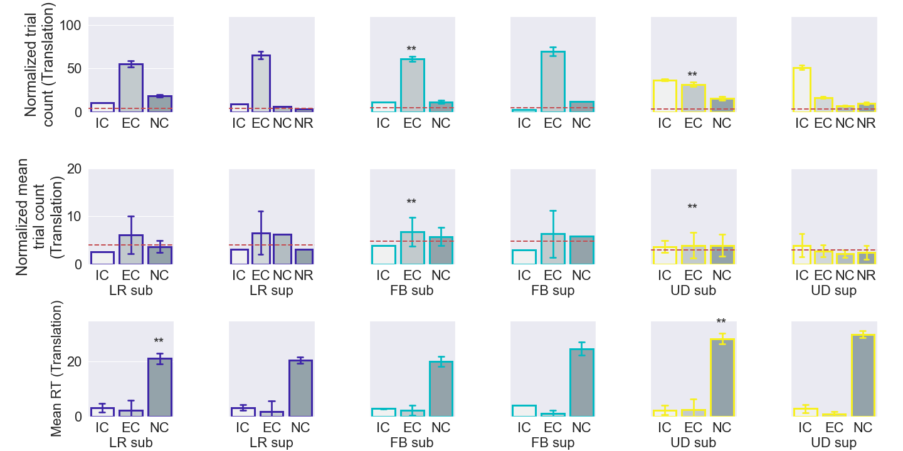
Figure 4: Summed response occurrence count (top row), mean response occurrence count (middle), and mean reaction time (bottom row) for translational stimulation. All 3 metrics (summed count, mean count, and mean RT) were compared for near sub-threshold and supra-threshold speed stimulations for LR, FB, and UD axes respectively; Wilcoxon signed rank test, and sum rank test were used to determine significance such that significant relationships were represented by (* within axis comparison of sub and sup, **: across axes comparison). Bonferroni correction : p < 0.0167 was used as the significance threshold, p < 0.05 are mentioned as slight significant relationships.

3.1.2 Detection : axes comparisons (across axes per speed condition)
The same speed condition and response category were compared across axes, in order to identify difficulty of task with respect to axis. Difficulty of the yaw task in comparison to the roll and pitch task, can be seen with the NR category count. For yaw the count for NR category was higher than the 95% CI threshold, whereas for roll and pitch the count for NR was lower than the CI threshold or zero. Thus, for yaw, regardless of speed stimulation, a significant number of participants did not feel as if they were moving and thus did not respond. In summary, yaw motion was the most difficult to detect of the 3 tasks, seen by the largest number of NR responses. Thus, participants either detected initially correct yaw or did not detect any motion during fast motion. And during slow motion, they either detected motion with difficulty (often making mistakes) or did not detect any motion.
Roll and Yaw EC count shows functional difference between roll and yaw tasks. Considering slow motion and EC, roll EC sub count was significantly higher than yaw EC sub count (Kolmogorov-Smirnov : nonnormal distribution, signedrank:p < 0.008057, sumrank:p < 0.000864, bartlett : p < 0.009853, n=13). Similarly, considering fast motion and categories where initial mistakes were made, roll EC sup count was significantly higher than yaw EC sup count, (Kolmogorov-Smirnov : nonnormal distribution, signedrank:p < 0.000008 , sumrank:p < 0.000796, bartlett : p < 0, n=18).
These results show that roll and yaw were both challenging for different reasons, in yaw participants either detected correctly (IC) or did not feel any motion (NR). Whereas in roll, participants could not initially detect the correct axis and/or direction, but they could eventually find the correct axis after several mistakes.
Pitch and Yaw IC count shows that participants were more precise during pitch. Regardless of speed, there was a slight significance for pitch IC count being higher than yaw IC count (IC sub : Kolmogorov-Smirnov : nonnormal distribution, signedrank:p < 0.003357, sumrank:p < 0.017854, bartlett : p < 0.233839, n=16 ; IC sup : Kolmogorov-Smirnov : nonnormal distribution, signedrank:p < 0.000107, sumrank:p < 0.030060, bartlett : p < 0.580689, n=18). This implies that pitch was the least difficult task, and yaw was the most difficult task.
Task difficulty correlates with longer RT. Roll EC NC responses were faster than yaw EC NC responses (NC sub RO YA : Kolmogorov-Smirnov : nonnormal distribution, signedrank:p < 0.000005, sumrank:p < 0.008633, bartlett:p < 8.492329e-04, n=21 ; EC sub RO YA : Kolmogorov-Smirnov : nonnormal distribution, signedrank:p < 0.000147, sumrank:p < 0.003698, bartlett:p < 2.780069e-02, n=29). This means that the roll task was easier to perceive motion than the yaw task, participants could perceive motion faster and thus responded faster for roll. Simiarly to roll, the pitch task was easier to perceive motion than the yaw task. Pitch IC sup responses were faster than yaw IC sup responses (Kolmogorov-Smirnov : nonnormal distribution, signedrank:p < 0.000200, sumrank:p < 0.000670, bartlett : p <.3.692384e-01, n=65).
A searching detection strategy, in comparison to a sensorial detection strategy, was used when participants were completely lost. Roll NC sub responses were faster than pitch NC sub responses (Kolmogorov-Smirnov : nonnormal distribution, signedrank:p < 0.000131, sumrank:p < 0.054280, bartlett : p < 1.659793e-01, n=21). When participants had difficulty in sensing motion, participants responded faster during roll in comparison to pitch. It is unlikely that participants could perceive roll better than pitch, because pitch had more perfect responses than roll, thus it is likely that participants stopped waiting to sensorially detect motion and started a searching strategy or felt false movement. A searching strategy consists of self-generated motion by interacting with the perturbation stimulus to create additional motion cues about the correct stimulus orientation and/or direction.
Translational task difficulty : UD, LR, FB were the least to most difficult for the translational experiment. In particular, FB EC sub count was significantly higher than UD EC sub count (Kolmogorov-Smirnov : nonnormal distribution, signedrank:p < 0.007812, sumrank:p < 0.016145, bartlett : p < 0.740714, n=9). This emphasizes the fact that participants made more initial mistakes for FB than UD, UD has more IC responses showing that participants made less mistakes. LR response behavior is similar to FB, where there are more counts for EC than any other category, however LR has a slightly larger count of IC than FB.
LR NC sub responses were significantly faster than UD NC sub responses (Kolmogorov-Smirnov : nonnormal distribution, signedrank:p < 0.015625, sumrank:p < 0.00270, bartlett:p < 9.953192e-01, n=7). This implies that participants were likely to use a searching strategy for LR than UD. Since participants could detect UD better than LR, it is likely that participants stopped waiting to sensorially detect motion in LR and started a searching strategy or felt false movement.

3.2 Participant detection performance rank
A participant detection performance rank score was created in order to understand how well participants performed with respect to perfect performance and with respect to each other. The performance rank score was calculated per subject across trials, evaluating how many times the participant achieved a certain detection category :
(IC count)*2 + (EC count)*1 + (NC count)*0 + (NR count)*0.

IC performance was the desired behavior for the task so a weight of 2 was given to each IC trial. EC was also desired task behavior because participants were able to eventually find the correct axis and direction, however mistakes were made, thus a weight of one was given to each EC trial. NC and NR performance trials were not the desired task behavior so they were given no credit.

The maximum achievable rank score was 72, if the participant performed IC detection for all 36 stimuli trials; as a reminder each participant received 42 trials and 6 trials were no stimuli sham trials.

Including both rotational and translational tasks, the highest rank score was 55 and the lowest score was 11. On average, participants received a rank score of 37. Therefore, the best performer, regardless of rotation or translation, achieved (55/72)*100=76.38% accuracy for the task. And, the average performer was only able to achieve (37/72)*100=51.38% accuracy for the task. The same task accuracy statistic was calculated for sub and supra conditions individually, for both rotation and translation separately, and similar results were found. Best performer accuracy : rot sub=(30/36)*100=83.33%, trans sub=(27/36)*100=75%, rot sup=(29/36)*100=80.5%, trans sup=(28/36)*100=77.7%. Average performer accuracy : rot sub=(17/36)*100=47.2%, trans sub=(20/36)*100=55.5%, rot sup=(20/36)*100=55.5%, trans sup=(21/36)*100=58.3%. Worst performer accuracy : rot sub=(5/36)*100=11.1%, trans sub=(0/36)*100=0%, rot sup=(11/36)*100=30.5%, trans sup=(9/36)*100=25%. This shows that the detection task was challenging for the average person, regardless of the main speed condition (sub, supra) and the directional stimulation, however it was neither impossible to perform the task with reasonable success.

Finally, the participants were divided into 3 categories, by using 1 standard deviation from the mean rank score as a margin for average performance, to summarize performance with respect to each experiment. Best performers were greater than the mean rank score plus 1 standard deviation, and worst performers were less than the mean rank score minus 1 standard deviation.

The participant distribution count for the Rotational experiment was: 5 best performers, 11 average performers, 2 worst performers. And, similarly, the participant distribution count for the Translational task was: 2 best performers, 11 average performers, 1 worst performers.

Based on the fact that the participant distribution count for best, average, and worst performance are similar for the rotational and translational task, this shows that both tasks were similarly challenging in terms of motion detection. Therefore, translational detection may not more difficult than rotational detection in a realistic environment, despite the fact that one might think that translation is more difficult because there is less gravity-driven inner-ear stimulation in translation than rotation

3.3 Classification: SD prediction
Classification accuracy, shown in Figure 5, was used to evaluate the predictive ability of each of the eight models; a value of 1 and 0 correspond to 100% and 0% perfect prediction. These accuracy results not only directly tell us which models are superior than others for a compensatory tracking pilot task, they also indirectly tell us about the data.
Figure 5 shows that decision tree type models (DT, GBC, RF) were superior to optimization based models (SGD, LDA, MLP, GNB, NuSVC), regardless of the experiment type (rot, trans), axis, and speed. Indirectly, this implies that important associations for SD prediction are not related to temporal or ordered information, because decision tree based models can not capture temporal patterns. We performed analysis for both originally ordered features and reordered features with a gaussian distribution, accuracy results were similar for both analyses; gaussian distribution results are shown in Figure 5. Thus further demonstrating that temporal ordering of movements is not an indicator for SD but rather the amplitude value. Additionally, it is likely that more data is required for the optimization based algorithms to find relevant patterns within feature space with respect to the labels. Implying that participant responses during SD and non-SD were similar with respect to amplitude.
In comparing the three different semi-supervised labels, better accuracy can be obtained for optimization based models using a binary label in comparison to a multi-label (averaged lenient and strict versus complex: Kolmogorov-Smirnov : nonnormal distribution, sumrank:p < 0.02, n=5). In particular, the lenient label for the translational task produced higher accuracy for optimization based models (trans lenient versus complex: Kolmogorov-Smirnov : nonnormal distribution, sumrank:p < 0.0143, n=5). However, regardless of the labels, there was no difference in accuracy for the decision tree based models. Indirectly, regarding optimization based models, this again indicates that SD and non-SD responses were similar. Labeling with respect to correctness, the lenient label, better separates data with respect to amplitude than labeling based on initial correctness.

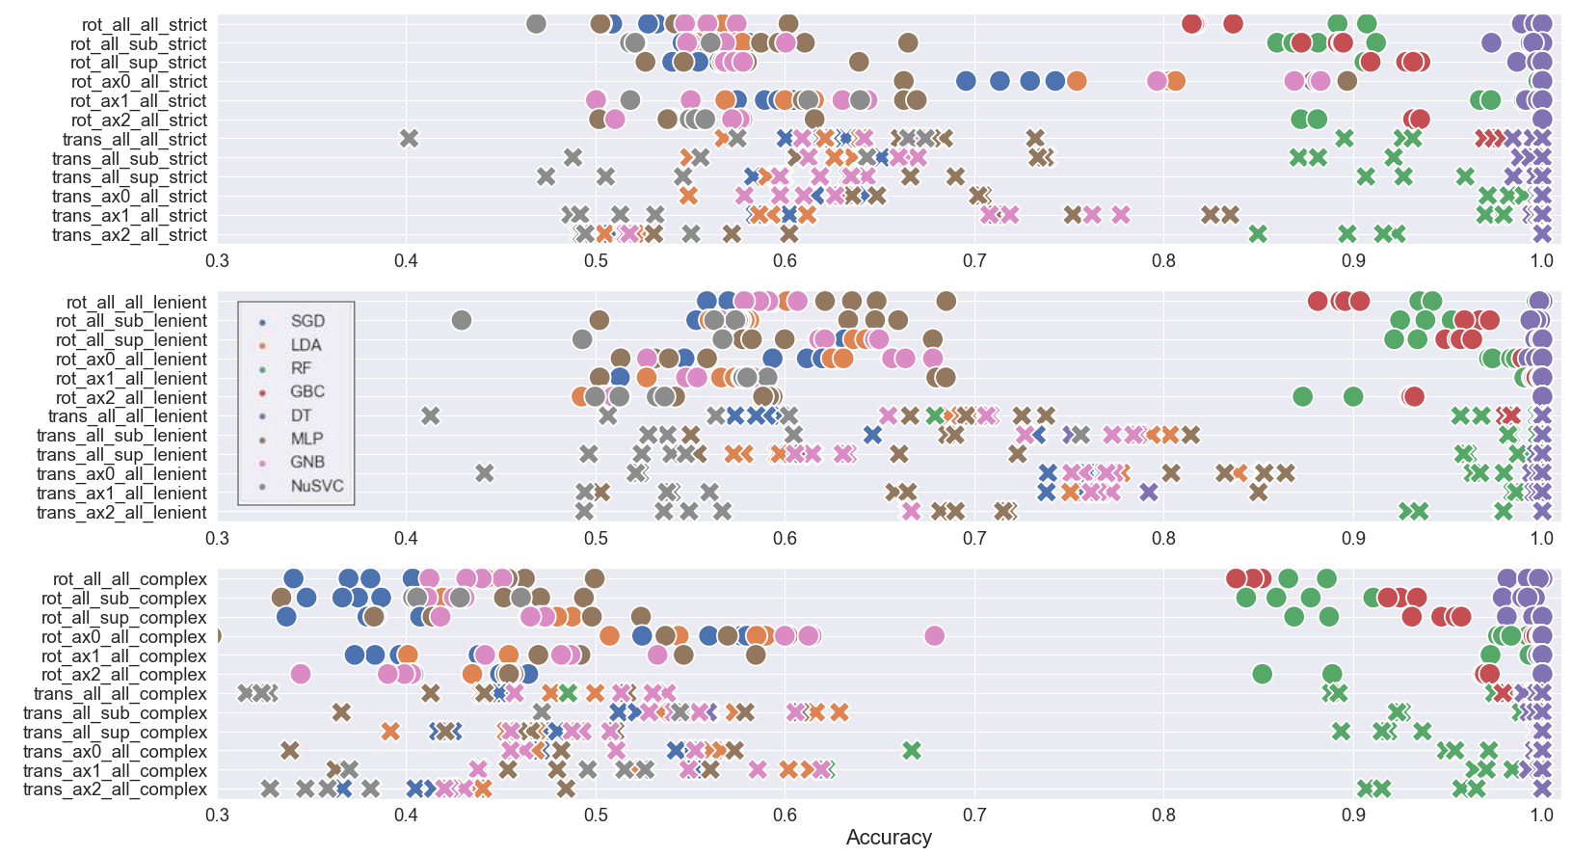
Figure 5: Test data prediction accuracy for the eight models for different: experimental data subsections, semi-supervised label (strict, lenient, complex), and number of features used. For visual ease, circles and crosses correspond to the rotation and translation experiment types, respectively. Blue, orange, green, red, purple, brown, magenta, and gray correspond to the SGD, LDA, RF, GBC, DT, MLP, GNB, and NuSVC models. Regarding notation, ax0, ax1, ax2 indicate roll, pitch, yaw for the rotational task and LR, FB, UD for the translational task. Additionally, sup, sub, and all denote supra speed stimulation trials, sub speed stimulation trials, and all trials, respectively.
Finally, we investigated whether modeling a subset of the data, such as a specific experimental axis and/or speed condition, would result in better prediction of SD in comparison to using all of the data. For each models we grouped mean accuracy for speed and axes conditions, for example rot_all_sub_strict and rot_all_sup_strict model accuracy values were averaged to represent mean accuracy per model for rotational speed condition or subset of data. Similarly for axis conditions, ax0, ax1, and ax2 per label and experiment type were averaged per model to represent mean accuracy for axis subset of data. The grouped speed and axis mean accuracies were compared with model accuracies for when all data was used respectively. No significant differences were found with regard to using all of the data in comparison to only speed stimulus data or only axis stimulus data, except for 4 cases. Rotation axis data subset had higher accuracy for strict and complex than using all of the data (rot axis strict versus all data: Kolmogorov-Smirnov : nonnormal distribution, signedrank:p < 0.008, n=8 ; rot axis complex versus all data: Kolmogorov-Smirnov : nonnormal distribution, signedrank:p < 0.015, n=8). There appears to be a predictive effect with using an initial correct label convention for separate axis data. Additionally, translational axis and speed data subset for the complex label had higher accuracy than using all of the data (trans speed complex versus all data: Kolmogorov-Smirnov : nonnormal distribution, signedrank:p < 0.02, n=8 ; trans axis complex versus all data: Kolmogorov-Smirnov : nonnormal distribution, signedrank:p < 0.05, n=8). It is likely that using subset speed and axis data, instead of all of the data, helped to reduce variability such that distinguishing patterns could be found.

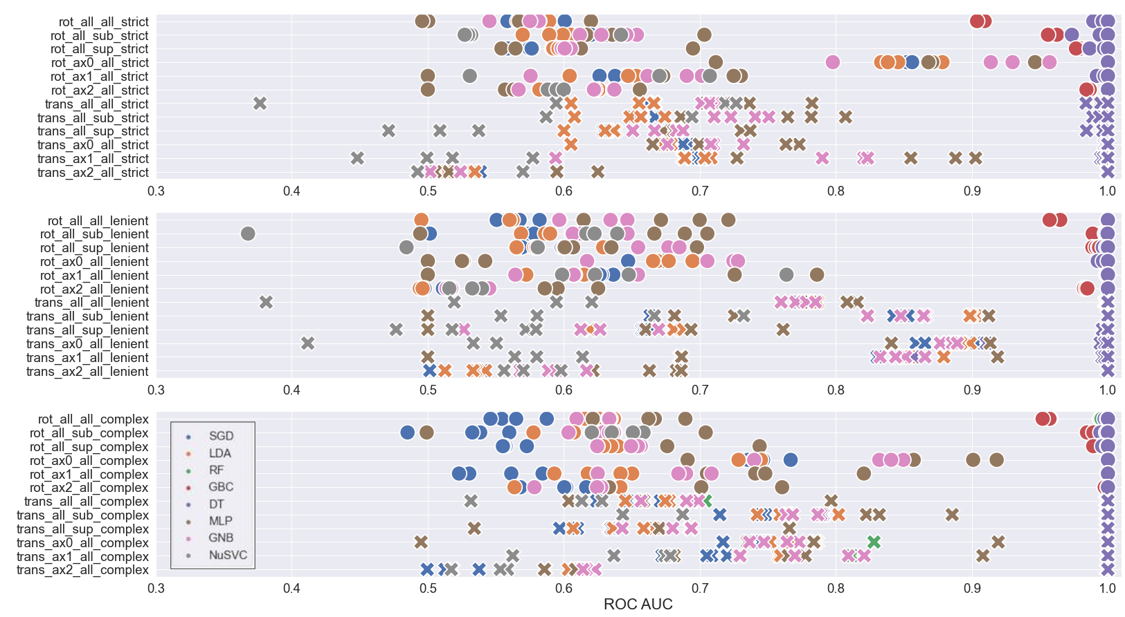
Figure 6: Test data prediction ROC AUC for the eight models for different experimental subsets of the data per semi-supervised label (strict, lenient, complex). Circles and crosses correspond to the rotation and translation experiment types, respectively. Blue, orange, green, red, purple, brown, magenta, and gray correspond to the SGD, LDA, RF, GBC, DT, MLP, GNB, and NuSVC models. Regarding notation, ax0, ax1, ax2 indicate roll, pitch, yaw for the rotational task and LR, FB, UD for the translational task. Similarly, sup, sub, and all denote supra speed stimulation trials, sub speed stimulation trials, and all trials, respectively.

The Receiver Operating Characteristic Area Under the Curve (ROC-AUC) measure, shown in Figure 6, was used to evaluate the model's predictive ability with respect to the label value, to evaluate whether the models could predict correctly regardless of the label value. Figure 6 shows the same three main results as the accuracy results shown in Figure 5, indicating that the models are reliable in terms of identifying SD and non-SD data, and thus the accuracy value based on true positive and negative counts can be trusted. The 3 summarized main results were: 1) decision tree type models (DT, GBC, RF) have almost perfect prediction and the majority of optimization based models (SGD, LDA, MLP, GNB, NuSVC) have above chance level predition regardless of the class label value (averaged lenient and strict versus complex: Kolmogorov-Smirnov : nonnormal distribution, sumrank:p < 0.02, n=5). 2) Decision tree models predict well regardless of initial correctness or overall correctness label usage, however optimization based models predict best when labels are constructed with respect to overall correctness via the lenient label (trans lenient versus complex: Kolmogorov-Smirnov : nonnormal distribution, sumrank:p < 0.027, n=5). 3) Models using all of the data instead of a subset of the data, provided similarly accurate performing models except for 4 cases. Rotation axis data subset had higher accuracy for strict and complex compared with using all of the data (rot axis strict versus all data: Kolmogorov-Smirnov : nonnormal distribution, signedrank:p < 0.05, n=8 ; rot axis complex versus all data: Kolmogorov-Smirnov : nonnormal distribution, signedrank:p < 0.015, n=8). Translational axis and speed data subset for the complex label had higher accuracy in comparison to using all of the data (trans speed complex versus all data: Kolmogorov-Smirnov : nonnormal distribution, signedrank:p < 0.02, n=8; trans axis complex versus all data: Kolmogorov-Smirnov : nonnormal distribution, signedrank:p < 0.05, n=8).

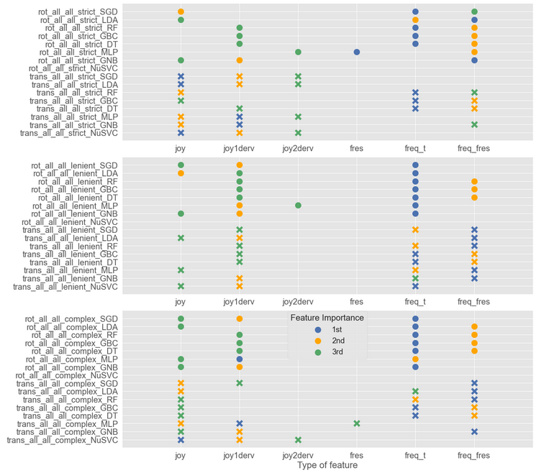
Figure 7: Feature order importance based on permutation importance, for each model. Blue, orange and green circles indicate most important feature, second most important feature, and third most important feature.

Feature order importance allows for us to know which aspect of the joystick signal contains key information to detect spatial disorientation. Figure 7 shows the feature importance for models where all the data was used, called ‘all all’ in Figures 5 and 6. Three main findings were identified: 1) decision tree models perform optimally using extracted temporal information features, 2) optimization based model feature importance identified more temporal features as being important than constant features, 3) semi-supervised labels did not influence feature importance for decision tree models however the strict label for optimization based models identified only temporal features as being important.

Extracted temporal information, such as the signal's natural frequency, that was transformed into a constant scalar feature greatly improved decision tree model prediction accuracy. Regardless of the semi-supervised label type and experiment, decision tree models relied on natural frequency based features, more than position based features, to predict SD. It is likely that these models found stronger patterns with natural frequency features because these feature values repeat per trial, instead of having a unique temporal trace like position based and the frequency response features. Decision tree model prediction accuracy was tested only using the four temporal features, and accuracy results were substantially less accurate at an average of 0.7 in comparison to 0.9 when the two natural frequency constant features were included. Decision tree models are good at finding recurring/mode-like patterns between the features and the corresponding labels, whereas the optimization models are good at finding recurring patterns coupled with specific constraints such as causality. In general, feature importance for decision tree models, from most to least important, were: 1) constant natural frequency of the joystick signal using a periodic estimation method, 2) constant natural frequency of the joystick signal using a frequency response method, and 3) the derivative of the joystick signal.
Optimization based models where shown to be more sensitive to temporal features than the decision tree models, where more temporal features were identified to be important than constant natural frequency features. By average, feature importance for optimization based models, from most to least important, were: 1) constant natural frequency of the joystick signal using periodic estimation, 2) the derivative of the joystick signal, 3) the joystick signal.
Finally, considering the decision tree models, Figure 7 shows that regardless of the semi-supervised label the feature importance order remained the same, with freq_t and freq_fres being most important and second most important. When evaluating the optimization models, feature importance order was similar for lenient and complex semi-supervised labels, with freq_t or freq_fres being the most important. However, the first and second important features for the strict label contained more temporal features, such as joy and joy1derv, than natural frequency features. In Figure 7, there are more blue and orange markers in the unboxed areas under joy and joy1derv for the strict label, than there are for the lenient and complex labels. Indirectly, this implies that the trials that were identified as non-SD did not have distinctive information about the signal’s natural frequency, so no strong assocation was made for natual frequency features. This also implies that there maybe too few data/examples that describe perfect initial response behavior or lack of distinctive variety of a non-SD event; even-though the classes were padded to have equivalent class representation.

3.4 Perceived motion and physical disorientation
We evaluated the correlation between subjective physical disorientation and perceptual motion disorientation.
Physical disorientation was monitored before and after the experiment using the SSQ disorientation subscale, such that the difference in before and after measures were attributed to the experienced task.
SSQ = before SSQ score – after SSQ score
Negative SSQ means that the task made the participant disoriented (ie : they felt better before), and positive SSQ means that the task rendered the participant less disoriented (ie : they felt better after).
Twenty of the 31 total participants did not feel any difference in terms of physical disorientation over the entire experiment.
Considering, the performance rank score mentioned in 3.1, roughly1/3 of average detectors, 1/3 of best detectors, and 2/3 of worst detectors felt physical disorientation. The 2/3 worst detection ratio is reported for completeness, however this measure is disregarded because it is based on only 3 participants. Thus, 1/3 of the population regardless of performance felt physical disorientation.
To investigate further whether there was a relationship between physical disorientation and detection performance, detection performance for the 12 participants who reported physical disorientation was evaluated; see Table 3 for a percentage of their summed trial performance per category per SSQ difference report.
For instance, a participant who reported a 6 after the experiment and a 4 before the experiment would have their trial performance categories (ie : 8 trials were category 2, 6 trials were category 1, etc) associated with the SSQ score of -2.
Table 3 demonstrates that more negative physical disorientation was observed for unsuccessful initial detection response profiles (EC and NC) than for successful detection response or no response.
Category | SSQ -5 (%)  felt better before | SSQ -3 (%) felt better before | SSQ -2 (%)  felt better before | SSQ -1 (%)  felt better before | SSQ 1 (%)  felt better after | SSQ 2 (%)  felt better after | SSQ 4 (%)  felt better after
IC (I) | 5.35 | 8.44 | 17.72 | 23.62 | 24.50 | 8.91 | 11.46
EC (2,4,5) | 10.14 | 12.01 | 28.97 | 26.57 | 14.06 | 2.82 | 5.43
NC (3,6,7) | 10.32 | 2.72 | 38.51 | 26.29 | 5.16 | 11.47 | 5.53
NR (9) | 0 | 3.44 | 20.77 | 18.66 | 25.96 | 21.81 | 9.35

Table 3: Occurrence response category per reported SSQ disorientation subscale difference, for both rotational and translational experiments. The bold negative SSQ values for categories EC and NC highlight that more negative physical disorientation was present for unsuccessful initial attempts to detect motion.

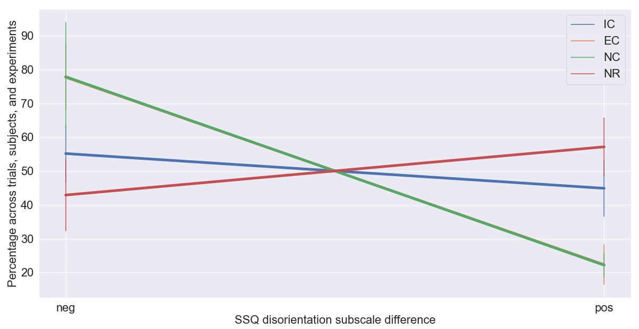
Figure 8: Condensed table percentages. Summed table percentages for negative and positive SSQ disorientation difference per response category.
The negative and positive SSQ disorientation differences per response category were summed respectively, to evaluate significance between IC negative and NC or EC negative.
Physically disoriented good performers (IC) do not report significantly less physical disorientation than poor performers (EC : p < 0.125 Wilcoxon signed rank, p < 0.248 Wilcoxon sumrank, NC : p < 0.625 Wilcoxon signed rank, p < 0.563 Wilcoxon sumrank).
In summary, we report no significant relationship between physical disorientation and motion detection. There is only a trend that EC and NC performers, that feel physical disorientation, felt better before the task than after. Implying that participants became fatigued while trying to perform the task, when detection was not easy for them. For IC performers, that feel physical disorientation, there was no trend in terms of feel better before or after. Implying that participants who could detect easily, felt discomfort for other reason not related to the experiment.
There was a slight trend for NR performers, that feel physical disorientation, such that they felt better after the task than before. Showing that participants who did not respond, became comfortable and relaxed in the dark experimental setting.

4 Discussion

5 Key Points
1) Speed stimuli (sub, supra) per axis comparisons showed that supra speed in comparison to sub-threshold speed allowed for more accurate and faster response, regardless of axis and for rotation and translation experiments. In particular, participants responded significantly faster during supra in comparison to sub for RO, PI in the rotational experiment. The average RT for YA rotation and the translational axes also show that participants responded faster during supra than sub, however an effect without statistical significance due to the possible lack of data.
2) Speed stimuli (sub, supra) per response category comparisons across axes showed task difficulty with respect to axis. Pitch, Roll, Yaw and UD, LR, FB were the least to most difficult rotational and translational axes tasks respectively; regardless of speed stimulation in a naturalistic environment. Longer reaction times (>12s) corresponded with incorrect responses (NC) regardless of task difficulty, as correct responses (IC, EC) had significantly shorter reaction times than NC. Longer reaction times corresponded with task difficulty, as longer reaction times were observed for yaw in comparison to roll and pitch (easier axes to detect motion).
3) Evaluating task difficulty or participant performance for both rotational and translational tasks, best performers achieved 76% accuracy and average performers achieved 51% accuracy. The percentage remained the same when considering differences in speed (sup versus sub); thus participants adapted similarly when speed differences were present.
4) Evaluating the distribution of participant performance with respect to rotation and translation stimuli, showed that there was a similar distribution of best, average, and worst performers regardless of rotational or translational stimuli. Thus, translational detection may not be more difficult than rotational detection in a realistic environment.
5) SD detection can be predicted from joystick data. No significant difference were found in prediction accuracy when using all six joystick features, the top 3, 2, or 1 important features. Thus, building a model on a single important feature is sufficient to predict SD.
6) Decision tree type models (DT, GBC, RF) were superior, to optimization based models (SGD, LDA, MLP, GNB, NuSVC), in test accuracy prediction regardless of the experiment (rot, trans), axis, speed, and semi-supervised label.

7) Decision tree models are able to learn association between the features and the label, regardless of semi-supervised label construction. However, optimization based models predicted best when labels were constructed with respect to overall correctness via the lenient label.
8) Models using all of the data instead of a subset of the data, provided similarly accurate performing models. Therefore in order to predict SD in a specific circumstance, like roll, one can use data from any context and SD will be accurately predicted for a specific context.
9) Three main findings were identified during feature importance investigation: 1) decision tree models perform best using extracted temporal information features, 2) optimization based model feature importance identified more temporal features as being important than constant natural frequency features, 3) semi-supervised labels did not influence feature importance for decision tree models however the strict label for optimization based models identified only temporal features as being important implying a lack of distinctive variety for non-SD data. The strict label is less realistically represenative of non-SD, because perfect behavioral data in any task is statistically rare, thus building an accurate model using a strict label convention maybe more challenging. Similarly, for the complex semi-supervised label there is lack of represntative data for each of the SD cases, overfitting (training predictions are higher than test predictions) is observed for both strict and complex labels supporting a lack of data for these labeling conventions. The lenient label, labeling with respect to overall correctness regardless if mistakes are made, was shown to be the best labeling convention as: 1) overfitting is not observed for our small dataset (test and training predictions are similar), 2) both natural frequency and temporal features are selected as important features thus a diversity of realistic patterns are captured, 3) both decision tree and optimization based models reasonably predict the test data.
10) The decision to choose a strict or complex label convention, where no mistakes are allowed, in comparison to a lenient label, where mistakes can be made, to discern SD depends on the application and the quantity of data available to represent a non-SD state. If very little data is present, a lenient labeling convention is ideal in predicting SD.
11) One-third of participants felt physical disorientation during the task, however no significant relationship between physical disorientation and motion detection was found. There was a trend where participants who initially detected unsuccessfully felt worst after the experiment than participants who did initially detected successfully or did not try. More sample points regarding physical disorientation are needed during the experiment, instead of a sample before and after the task, in order to determine if physical disorientation is correlated with motion detection.

References:

Biographies:

