Supplementary Materials:

A. Identification of speed stimulation values
Near sub-threshold and supra-threshold speed values were chosen in correspondence to reports from both older and recent literature. Considering older literature, Mulder's law states that αΤ= 2.5 deg/s where α denotes the acceleration magnitude and Τ corresponds to time (Previc et al, 2004). Regarding slow movement, recent human perceptual thresholds during whole-body stimulation has shown that threshold responses tend to increase with frequencies of 0.5 Hz or lower, indicating a sensory sub-threshold limitation. Additionally, regarding whole-body stimulation during fast motion, threshold responses tend to decrease with frequencies of 1 Hz or greater, denoting a near supra-threshold boundary (Karmali et al, 2016; Karmali et al, 2017; Crane et al, 2016; Benson et al, 1986; Bermudez Rey et al, 2016). Five participants were principally used to confirm the near sub-threshold limit reported in literature, they could detect the axis and direction of movement with less than 50% accuracy. The authors do not claim that all participants could not detect the movement, therefore this lower limit perceptual stimulation was called “near sub-threshold". The supra-threshold was chosen with respect to reported values in literature, a rate slightly higher than 1 Hz was chosen to ensure supra-threshold simulation (Previc et al, 2004).

For the translational experiment, selection of the near sub-threshold value was more difficult to determine, in comparison to the rotational experiment, because detection of near sub-threshold movement varied depending on each participant. Translational threshold values reported in the literature were used to create a list of ten, near sub-threshold and supra-threshold, test values to validate using a population of 18 participants (Melvill et al, 1978; Crane et al, 2016). Table 1 shows the tested values where the selected near sub-threshold and supra-threshold values are denoted in bold font; selected threshold values were 3.75 Hz (cm/s) and 15 Hz (cm/s) respectively. The UD direction was not tested because vertical movement thresholds are known to be greater than lateral and longitudinal motion thresholds, thus thresholds were fit to LR and FB stimulations.

Acceleration (g) | Target speed (cm/s) | Number of tests | FB success (%) | LR success (%)
0 | 0 | 15 | 80.00 | 66.67
0.003 | 3.75 | 30 | 33.33 | 37.93
0.004 | 5.00 | 60 | 51.67 | 48.33
0.006 | 7.50 | 10 | 60.00 | 40.00
0.008 | 10.00 | 27 | 59.26 | 48.15
0.010 | 12.50 | 18 | 61.11 | 72.22
0.011 | 15.00 | 102 | 82.35 | 88.24
0.013 | 17.50 | 23 | 91.30 | 82.60
0.015 | 20.00 | 75 | 86.67 | 94.67
0.017 | 22.50 | 15 | 93.33 | 100.00
Table 1: Pre-test data for selection of translational near sub-threshold and supra-threshold speed thresholds.
B. Study design

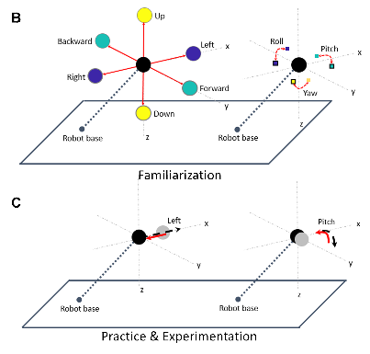
Figure 3 : (B) familiarization, (C) practice and experimental trials. A depicts the experimental installation process consisting of: opening cabin door, participant installation, closing cabin door and movement of cabin to starting position. B demonstrates the possible orientational (right) and directional (left) motion of the cabin for translational and rotational experiments, respectively. During familiarization (B), for both rotational (right) and translation (left) experiments, participants moved the joystick in all 3 axes directions one-at-a-time to become familiar with their control movements on the movement of the cabin. C demonstrates compensatory orientational and directional movement of the cabin for one trial in the pitch and left directions respectively; red solid lines indicate participant control and the black dashed lines indicate the unknown movement stimuli. During the 12 practice trials and 30 experimental trials, participants performed the whole-body compensatory movement task illustrated in C.

At the bottom of Figure 3A, the six-axis KUKA motion simulator is shown where: axis A1 controls yaw motion about the base, axis A2 is positioned at the base and controls vertical and longitudinal movement, axis A3 is positioned between the base and the cabin such that it controls vertical motion, axis A4 is positioned near the cabin and turns in the roll orientation, axis A5 is positioned at the cabin and controls pitch movement, axis A6 is positioned at the cabin and controls roll movement. The rotational roll link A4 can be used in conjunction with A5 and A6 to produce a small yaw movement with respect to the cabin. If A4 is rotated 90◦ at the same time that A6 is rotated −90◦, the participant will remain stationary while preparing the joints to perform the yaw motion about the cabin. Then A5 (pitch) can be used to move the cabin in the yaw direction with respect to the cabin. During yaw condition, the cabin was first moved with respect to the cabin (A4: ±90◦, A6: ± − 90◦, A5: ±40◦) and then with respect to the base (A1: ±54 cm); first the small yaw with respect to the cabin was launched and then the large yaw with respect to the base was executed when the small yaw was at its maximum. During the experimental conceptualization, (A4, A5, A6) was used only to provide small yaw stimulation, however it was decided to add A1 to enlarge the rotational movement range despite adding a small translational component. The added translation component due to the presence of A1 movement was calculated to be below sub-threshold perception at 2.2 cm/s, therefore the added presence of A1 should not influence the perception of yaw.

C. Experimental protocol

Two questionnaires were administered before the experimental phase, a claustrophobia assessment (Radomsky, 2001; Radomsky, 2006) and general simulator sickness questionnaire (SSQ) (Kennedy, 1993; Bouchard, 2007). All questionnaires were administered in the native fluently spoken language for each participant, French or English. The claustrophobia questionnaire consisted of two sections, where the first section measured fear of suffocation (14 questions) and the second section assessed fear of restriction (12 questions). The claustrophobia questionnaire was used as a screening method to assess whether participants could enter the simulator and perform the task relatively stress-free; participants who scored 40 points or lower, indicating that they were not claustrophobic, were initially recruited and participants scoring higher than 40 were recruited last. For both rotational and translational experiments all participants scored “non-claustrophobic”, rotational results were mean=10.94, max=38, min=0 and translational results were mean=8.77, max=9, min=0. The SSQ consisted of 16 questions and measured the participants’ general physical state. The SSQ was administered before and after the experiment to measure the effects of the experiment in terms of disorientation. Therefore, analysis is not in terms of the SSQ score, but in terms of the difference in SSQ score before and after the task. Negative difference values indicate that the participant reported higher SSQ scores after the experiment than before, denoting that participants were negatively affected by the task in terms of three-subscales: nausea, ocular motor, and disorientation. Conversely, positive difference values imply that higher SSQ scores were reported before the experiment in comparison to after the experiment, expressing that the task positively affected participants. Due to the interest of motion detection and correction effects on disorientation, only the SSQ disorientation subscale difference was compared with detection and correction results.

Once the participant was installed in the cabin, the cabin door was closed and all communication between the participant and experimenter were performed via a camera interface system which facilitated two-way auditory communication. The experimenter additionally could visually monitor the well-being of the participant in the cabin. The left portion of Figure 3A shows the sequence of steps performed during the usage of the motion simulator. The installation process, shown on the left from top to bottom, illustrates the simulator with the (1) cabin door open on the ground, (2) participant installation, (3) cabin door closed on the ground.

D. Standardization of data during data pre-processing
A pre-processing analysis step needed to be performed to ensure that the data was collected properly. The robotic simulator performed motion stimulation in real-time (real-time Linux kernel), real-time experimentations may have system delays that could influence the robotic trajectory and/or participant ability to respond correctly via the joystick.

Sometimes the robot moved faster or slower than desired because the system sampling frequency increased or decreased to account for system constraints. When the system sampling frequency was faster or slower than expected, the perepheral equipement like the participant joystick controlled the cabin motion poorly or did not control the cabin motion at all.

Because of these processing and thus execution errors that are due to the real-time functionality of the motion simulator, it is necessary to remove all trials that have frequency or joystick-cabin related defects such that experimental defects are not confused with participant response.

We checked for the following defects :
- temporal gaps in data
- trials that had less time than the expected trial length (denoting the system sampling frequency was much faster than desired)
- The cabin insufficiently moving (or not moving) for sufficient joystick movement
- The cabin insufficiently moving for irradic/spike joystick movement
- The cabin moving after 5 seconds or longer, after the joystick was moved (long delay between joystick movement and cabin movement)

Additionally, experiments were adminstered by different experimentors over a period of two years, the change in joystick and cabin direction could have be accidentally modified. Therefore, by averaging all participant data across trials, we statisically prove the correct joystick-cabin direction on all axes, and the correct margin the joystick needed to be moved in order for the cabin to move. This secondary checing process that the experimental data followed the experimental design is called standardization within the paper. 60 % of the rotational trial data and 50 % of the translational trial data were accepted as valid trials that followed the experimental design criteria. The majority of trials that were removed were due to slow and fast system frequency sampling rates, thus discarding trials that had recorded timestamps less than 16 seconds. The second reason for discarding trials was due to the fact that the cabin did not respond within a reasonable period of time after joystick movement, or the cabin did not move in the correct direction with respect to the joystick movement. Errors were expected as the system is a new experimental test platform where many nodes/computers need to work in synchrony.

E. Detection response profile analysis
As explained in section 2.5.1, detection of correct stimuli were categorized into ten possible categories based on the selection of axis and axial direction. Figure 4 depicts a flow chart and the possible participant choices based on response movement. The blue squares indicate the experimental trial type : the presense of motion stimuli denoted by «Movement» and no presence of motion stimuli denoted by «Sham». For «Movement» activity, the green squares indicate participant response acitvity such that «1-3 axes» means that the participant moved the joystick on one or more axes and «No axes» means that the participant did not move the joystick. The yellow diamonds denote a decision process based on the question asked within the diamond. For example, for «Movement» activity where the participant responded using one or more joystick movements, the following question is posed: «Is the simulus axis the same as the axis in which the participant initally moved the joystick?». If yes, the axis was noted as correct and then the initial direction was confirmed in a similar manner. For example, «Is the simulus cabin command direction opposite to the participant’s initally moved joystick direction?». The red numbers indicate the total number of possible categories based on the logical progression of performing the task correctly, first finding the correct axis and then findings the correct direction to counteract the vestibular stimuli.

.
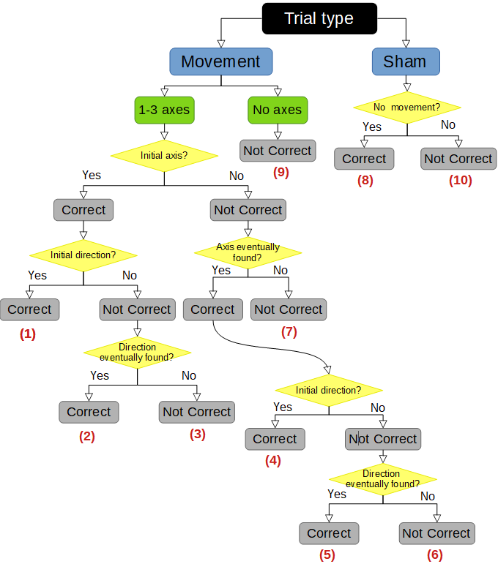
Figure 4: Flow chart of selection process for detection response profiles, where correct response profiles 1, 2, 4, 5, and 8 denote non-SD occurrence and wrong response profiles 3, 6, 7, 9, and 10 denote SD occurrence.

F. SD Classification: Training accuracy

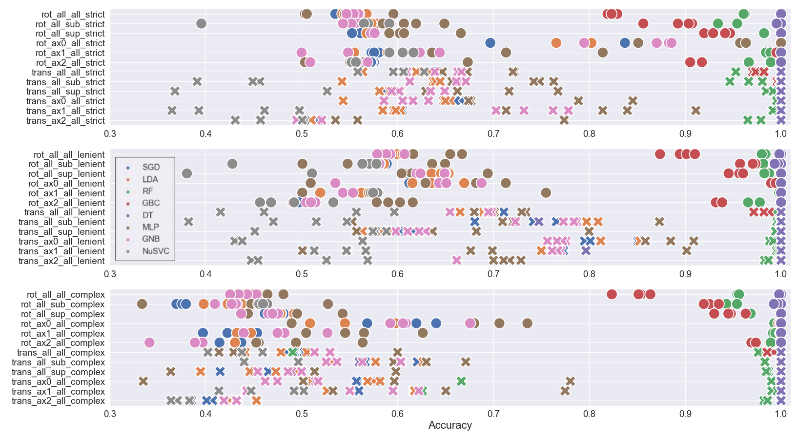
Prediction classification accuracy using training data, to observe whether the models overfit the training data.

Training data prediction accuracy for the eight models for different: experimental data subsections, semi-supervised label (strict, lenient, complex), and number of features used. For visual ease, circles and crosses correspond to the rotation and translation experiment types, respectively. Blue, orange, green, red, purple, brown, magenta, and gray correspond to the SGD, LDA, RF, GBC, DT, MLP, GNB, and NuSVC models. Regarding notation, ax0, ax1, ax2 indicate roll, pitch, yaw for the rotational task and LR, FB, UD for the translational task. Additionally, sup, sub, and all denote supra speed stimulation trials, sub speed stimulation trials, and all trials, respectively.

