Project Title
University of Toronto

Abstract
[Abstract to be written by the team.]

Attestation of Teamwork
[Team contribution breakdown to be added.]

1. Introduction
[Teammate fills in the introduction and motivation.]

2. Preliminaries and Problem Formulation
[Teammate fills in problem formulation and background concepts.]

3. Design

3.1 SVM-Based Intrusion Detection
We design an SVM-based classifier for IEC 104 SCADA network intrusion detection that distinguishes normal traffic from six attack types (flood, fuzzy, MITM, IEC-104 starvation, NTP DDoS, and port scan). The system follows a three-phase improvement pipeline:
Phase 1 (Baseline) uses a linear-kernel SVM with default parameters on raw, unscaled features. This establishes a performance floor by deliberately omitting scaling, non-linear kernels, and class balancing.
Phase 2 (Improved) addresses each baseline weakness: StandardScaler normalises features to zero-mean unit-variance, ANOVA F-test selects the 30 most discriminative features, an RBF kernel captures non-linear decision boundaries, and class_weight=‘balanced’ up-weights minority classes inversely proportional to their frequency.
Phase 3 (Optimised) performs exhaustive hyperparameter tuning via GridSearchCV over C ∈ {0.1, 1, 10, 100}, γ ∈ {scale, auto, 0.01, 0.1}, and kernel ∈ {rbf, poly}, evaluated with 5-fold stratified cross-validation scored by weighted-F1.
[Teammate’s model design goes here (Section 3.2).]

4. Methodology

4.1 SVM Methodology
Data Preprocessing. The dataset comprises 7 CSV files from CICFlowMeter containing 84 columns per flow. We drop four metadata columns (Flow ID, Src/Dst IP, Timestamp) that encode host identity rather than traffic patterns, replace infinite values and NaNs with column medians, and encode the target label via LabelEncoder. A 75/25 stratified train-test split preserves class proportions.
Feature Selection. ANOVA F-test ranks features by their between-class to within-class variance ratio. We retain the top 30 features; the highest-scoring features (SYN Flag Count, Fwd PSH Flags, FIN Flag Count) align with known IEC 104 attack signatures where attackers produce anomalous TCP flag patterns.
Multi-Seed Evaluation. To reduce sensitivity to a single train-test split, we run the full three-phase pipeline with five different random seeds ({42, 123, 256, 789, 1024}) and report the averaged metrics with standard deviations. Each seed controls the stratified split, the SVM’s internal randomisation, and the cross-validation fold assignment.
Implementation. The system is implemented in Python using scikit-learn (SVC, GridSearchCV, StandardScaler, SelectKBest), pandas for data handling, and matplotlib/seaborn for visualisation.
[Teammate’s methodology goes here (Section 4.2).]

5. Numerical Experiments

5.1 SVM Results
Table 1 presents the averaged performance metrics across five random seeds for each improvement phase.
Table 1: SVM performance across improvement phases (mean ± std over 5 seeds)
Metric | Phase 1 (Baseline) | Phase 2 (Improved) | Phase 3 (Optimised)
Accuracy | 0.964 ± 0.002 | 0.999 ± 0.000 | 1.000 ± 0.000
F1 (weighted) | 0.957 ± 0.003 | 0.999 ± 0.000 | 1.000 ± 0.000
F1 (macro) | 0.449 ± 0.022 | 0.894 ± 0.015 | 0.933 ± 0.010
Precision (wt) | 0.959 ± 0.003 | 1.000 ± 0.000 | 1.000 ± 0.000
Recall (wt) | 0.964 ± 0.002 | 0.999 ± 0.000 | 1.000 ± 0.000

The baseline achieves 96.4% accuracy but only 44.9% macro-F1, indicating near-complete failure on minority classes. Phase 2 delivers the largest improvement: adding scaling, feature selection, RBF kernel, and class balancing lifts macro-F1 from 0.449 to 0.894. Phase 3’s GridSearchCV further refines performance to 93.3% macro-F1 and perfect weighted accuracy, selecting a polynomial kernel with C=100 and γ=0.1 as the optimal configuration.
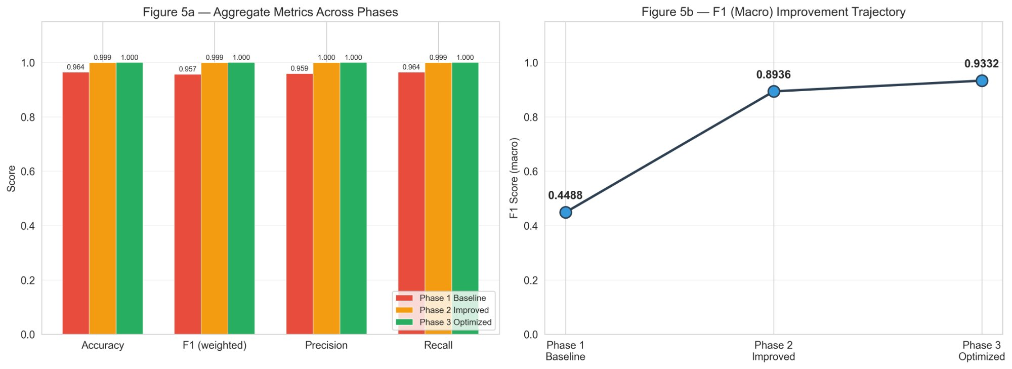
Figure 1: SVM performance metrics across phases (left) and F1 macro improvement trajectory (right).
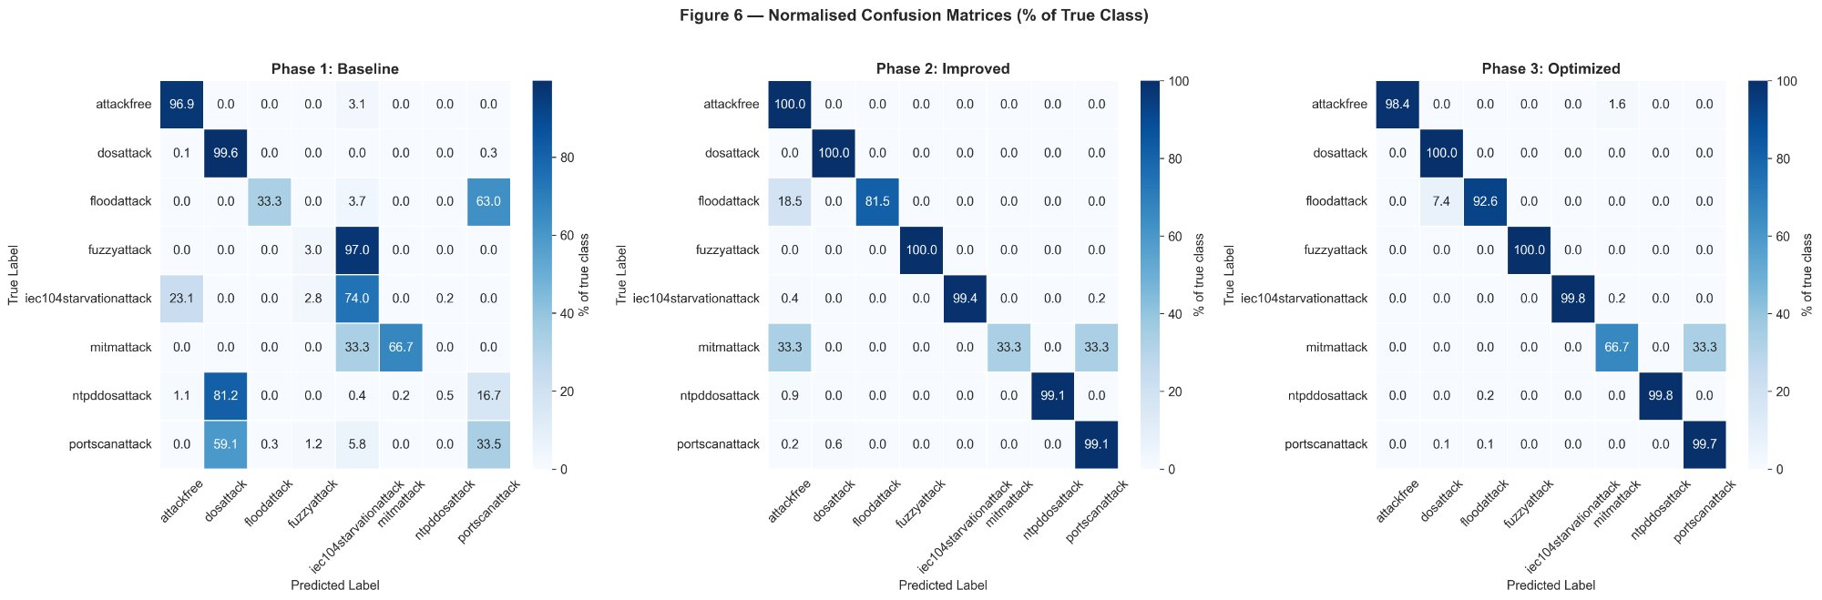
Figure 2: Normalised confusion matrices (% of true class) for each SVM phase.
[Teammate’s results, figures, and tables go here (Section 5.2).]

6. Discussion

6.1 SVM Analysis
Impact of preprocessing. The dominant improvement comes from Phase 2, not Phase 3. Feature scaling alone is critical for SVMs because the RBF kernel’s distance computation is dominated by high-range features (e.g., Flow Bytes/s in the tens of millions) without normalisation. Class balancing via inverse-frequency weighting was equally important — without it, the SVM effectively ignores classes with fewer than 100 samples.
Remaining challenges. MITM attack detection remains the weakest point (F1 ≈ 0.57–0.67 across seeds), attributable to its extremely small sample size (26 flows). Flood attack detection also shows higher variance across seeds. These results suggest that data augmentation or specialised sampling strategies could further improve minority-class performance.
Multi-seed robustness. The low standard deviations across five seeds (≤0.022 for all metrics) confirm that the results are not artefacts of a single fortunate split. The optimised model consistently achieves near-perfect weighted metrics regardless of the random initialisation.
[Teammate’s discussion goes here (Section 6.2).]

7. Conclusions
[Conclusions to be written by the team.]

References
[References to be added.]

Appendix

A. SVM Supplementary Figures
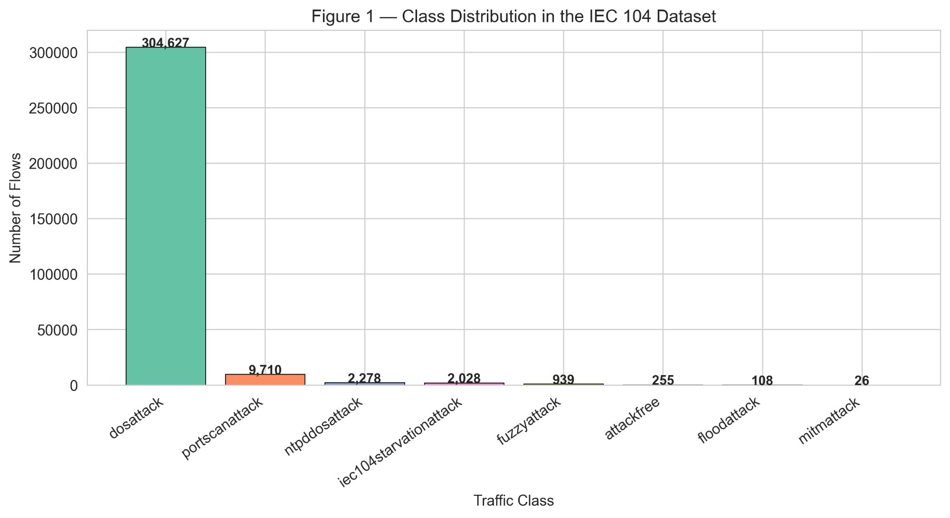
Figure A1: Class distribution in the IEC 104 dataset. dosattack dominates (304,627) while mitmattack has only 26 samples.
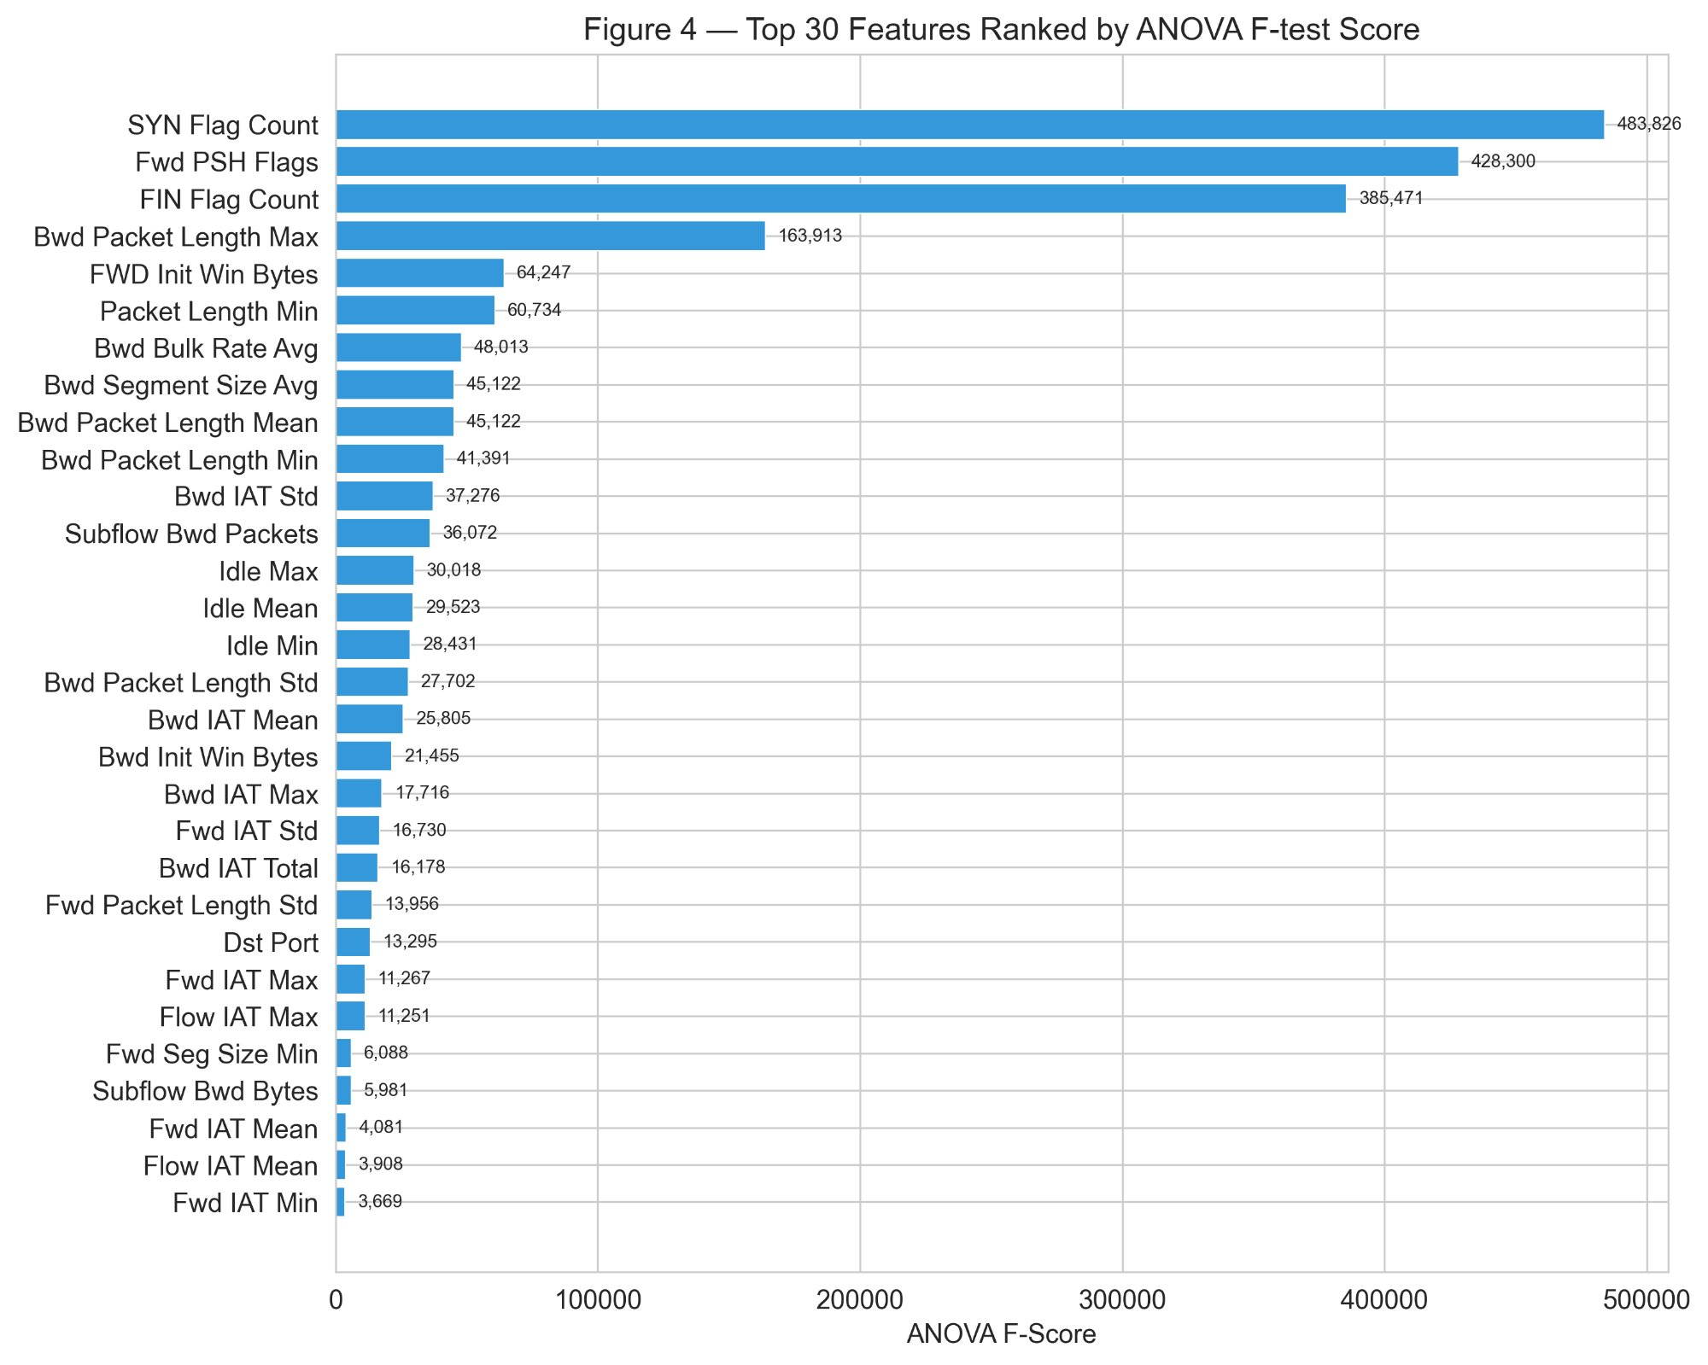
Figure A2: Top 30 features ranked by ANOVA F-test score.

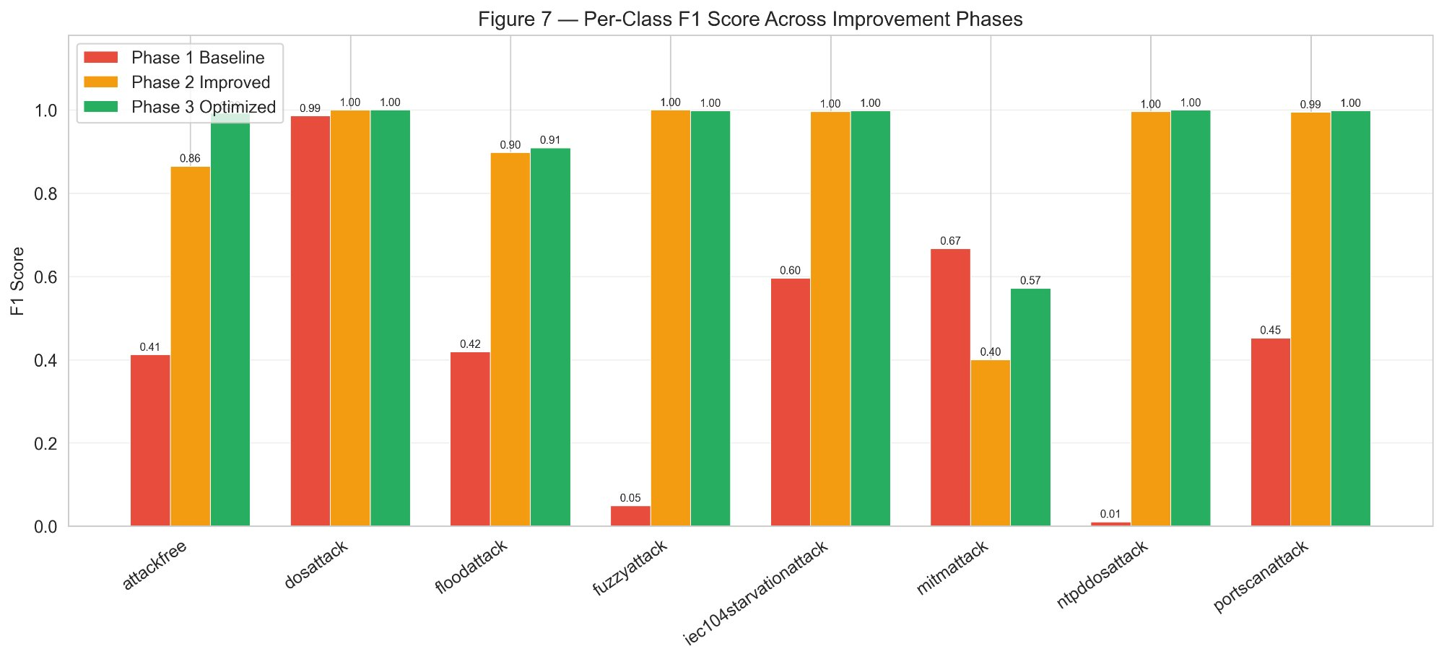
Figure A3: Per-class F1 score across improvement phases.
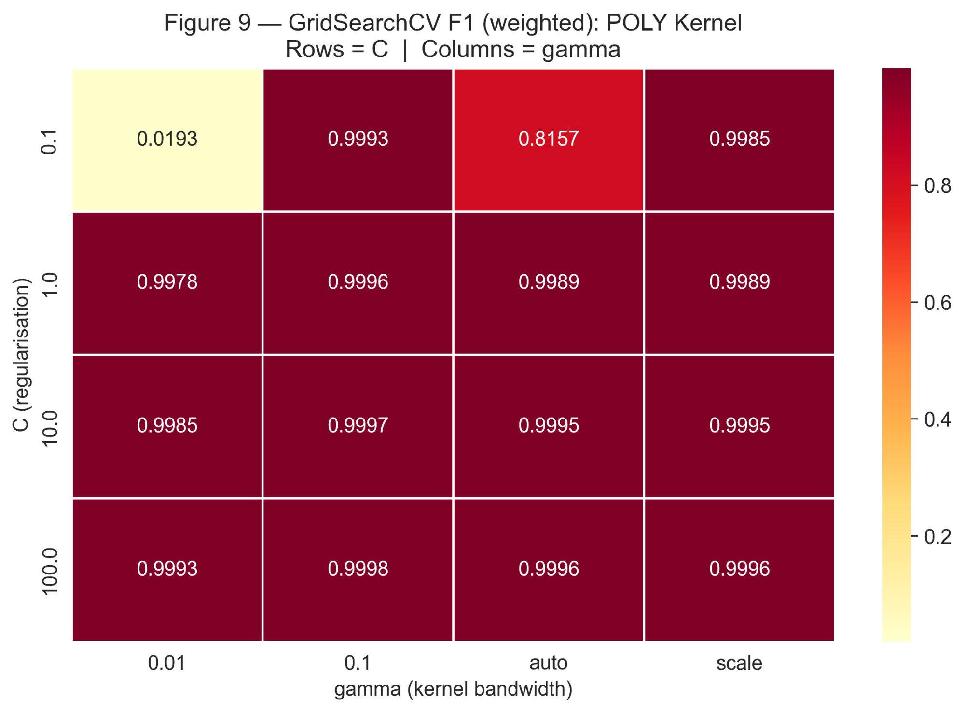
Figure A4: GridSearchCV heatmap showing weighted-F1 for the polynomial kernel across C and gamma values.
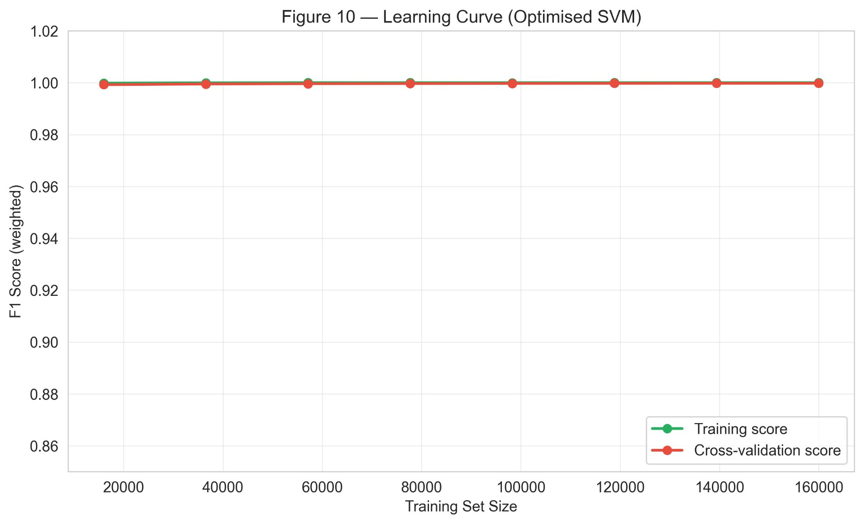
Figure A5: Learning curve for the optimised SVM. Training and cross-validation scores converge near 1.0.

