Project Title
University of Toronto

Abstract
[Abstract to be written by the team.]

Attestation of Teamwork
[Team contribution breakdown to be added.]

1. Introduction
[Introduction and motivation to be added.]

2. Preliminaries and Problem Formulation
[Problem formulation and background concepts to be added.]

3. Design

3.1 SVM-Based Intrusion Detection
We design an SVM-based classifier for IEC 104 SCADA network intrusion detection that distinguishes normal traffic from six attack types (flood, fuzzy, MITM, IEC-104 starvation, NTP DDoS, and port scan). The system follows a three-phase improvement pipeline:
Phase 1 (Baseline) uses a linear-kernel SVM with default parameters on raw, unscaled features. This establishes a performance floor by deliberately omitting scaling, non-linear kernels, and class balancing.
Phase 2 (Improved) addresses each baseline weakness: StandardScaler normalises features to zero-mean unit-variance, ANOVA F-test selects the 30 most discriminative features, an RBF kernel captures non-linear decision boundaries, and class_weight=‘balanced’ up-weights minority classes inversely proportional to their frequency.
Phase 3 (Optimised) performs exhaustive hyperparameter tuning via GridSearchCV over C ∈ {0.1, 1, 10, 100}, γ ∈ {scale, auto, 0.01, 0.1}, and kernel ∈ {rbf, poly}, evaluated with 5-fold stratified cross-validation scored by weighted-F1.

3.2 Feedforward Neural Network (FNN)
A feedforward neural network (FNN) was designed as a complementary classifier for the same network traffic classification task. The model consists of fully connected layers with ReLU activation functions. The output layer uses a softmax function for multi-class classification. Cross-entropy loss was used as the objective function, and the Adam optimiser was applied for training.

4. Methodology

4.1 SVM Methodology
Data Preprocessing. The dataset comprises 7 CSV files from CICFlowMeter containing 84 columns per flow. We drop four metadata columns (Flow ID, Src/Dst IP, Timestamp), replace infinite values and NaNs with column medians, and encode the target label via LabelEncoder. A 75/25 stratified train-test split preserves class proportions.
Feature Selection. ANOVA F-test ranks features by their between-class to within-class variance ratio. We retain the top 30 features; the highest-scoring features (SYN Flag Count, Fwd PSH Flags, FIN Flag Count) align with known IEC 104 attack signatures.
Multi-Seed Evaluation. We run the full three-phase pipeline with five different random seeds ({42, 123, 256, 789, 1024}) and report the averaged metrics with standard deviations.
Implementation. Python using scikit-learn (SVC, GridSearchCV, StandardScaler, SelectKBest), pandas, and matplotlib/seaborn.

4.2 FNN Methodology
Data Preprocessing. Non-numeric and irrelevant features (Flow ID, IP addresses, timestamps, ports) were removed. Remaining features were converted to numeric format, missing values filled with zeros, and samples with missing labels removed.
Data Splitting. 80/20 stratified split to ensure both training and validation sets maintain similar class distributions.
Dataset Balancing. To address severe class imbalance (dosattack dominating the dataset), resampling was applied: majority classes were downsampled while minority classes were kept or upsampled, producing a more balanced distribution.
Training. The FNN was trained for 20 epochs using the Adam optimiser with cross-entropy loss.

5. Numerical Experiments

5.1 SVM Results
Table 1 presents the averaged performance metrics across five random seeds for each improvement phase.
Table 1: SVM performance across improvement phases (mean ± std over 5 seeds)
Metric | Phase 1 (Baseline) | Phase 2 (Improved) | Phase 3 (Optimised)
Accuracy | 0.964 ± 0.002 | 0.999 ± 0.000 | 1.000 ± 0.000
F1 (weighted) | 0.957 ± 0.003 | 0.999 ± 0.000 | 1.000 ± 0.000
F1 (macro) | 0.449 ± 0.022 | 0.894 ± 0.015 | 0.933 ± 0.010
Precision (wt) | 0.959 ± 0.003 | 1.000 ± 0.000 | 1.000 ± 0.000
Recall (wt) | 0.964 ± 0.002 | 0.999 ± 0.000 | 1.000 ± 0.000

The baseline achieves 96.4% accuracy but only 44.9% macro-F1, indicating failure on minority classes. Phase 2 lifts macro-F1 from 0.449 to 0.894. Phase 3’s GridSearchCV reaches 93.3% macro-F1, selecting a polynomial kernel with C=100 and γ=0.1.
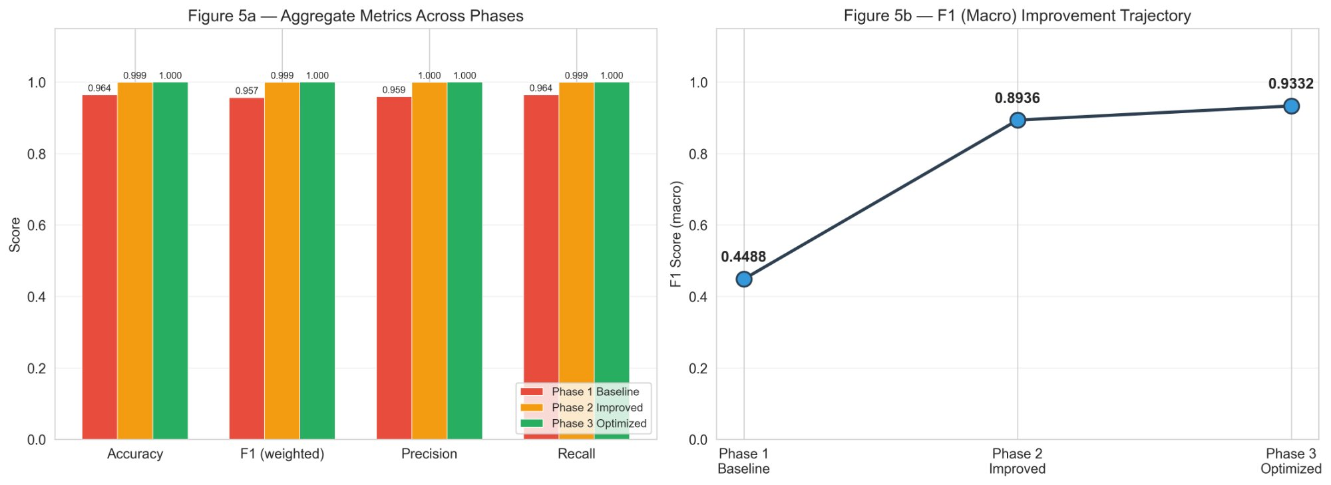
Figure 1: SVM performance metrics across phases (left) and F1 macro trajectory (right).
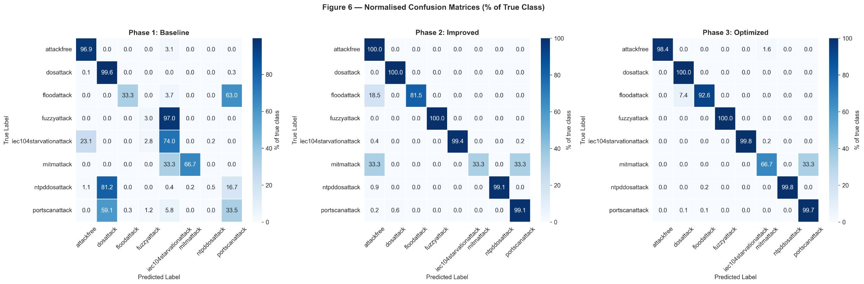
Figure 2: Normalised confusion matrices (% of true class) for each SVM phase.

5.2 FNN Results
The FNN was trained for 20 epochs. On the original imbalanced dataset, validation accuracy reached 100% almost immediately. After applying dataset balancing through resampling, the model exhibited a more reasonable convergence, with validation accuracy stabilising at approximately 99.6%.
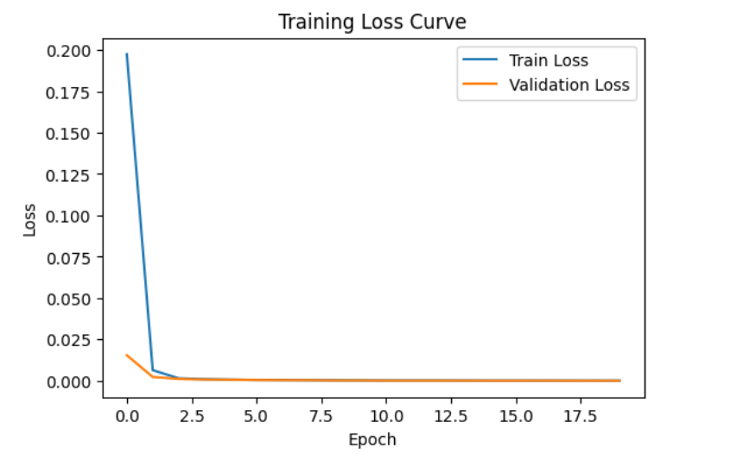
Figure 3: FNN training loss and validation accuracy over 20 epochs.
While overall accuracy decreased slightly after balancing, the model learned more evenly across all classes, producing classification results with greater practical significance.

6. Discussion

6.1 SVM Analysis
Impact of preprocessing. The dominant improvement comes from Phase 2, not Phase 3. Feature scaling is critical for SVMs because the RBF kernel’s distance computation is dominated by high-range features without normalisation. Class balancing was equally important — without it, the SVM ignores classes with fewer than 100 samples.
Remaining challenges. MITM detection remains the weakest point (F1 ≈ 0.57–0.67), attributable to its small sample size (26 flows). Data augmentation could further improve minority-class performance.
Multi-seed robustness. Low standard deviations (≤0.022) confirm results are not artefacts of a single fortunate split.

6.2 FNN Analysis
Effect of dataset balancing. The original imbalanced dataset caused the FNN to reach near-100% accuracy immediately, but this masked poor minority-class performance. After resampling, accuracy stabilised at 99.6% with more balanced learning across all classes.
Data leakage concerns. The extremely high accuracy on both models suggests features are highly informative, but may also indicate the lab-simulated dataset is relatively simple. Further validation on unseen operational data is necessary.

6.3 Model Comparison
Both SVM and FNN achieved near-perfect accuracy on the balanced dataset. The SVM’s three-phase approach demonstrates how preprocessing and tuning contribute to performance, while the FNN’s rapid convergence highlights the dataset’s high separability. Based on the literature, Random Forest is more widely adopted in practice for SCADA IDS as it offers a good balance of accuracy, interpretability, and training speed on constrained resources.

7. Conclusions
This project demonstrated that both SVM and FNN models can achieve high classification accuracy for IEC 104 SCADA intrusion detection. Proper data preprocessing — particularly feature scaling, feature selection, and class balancing — is critical to robust performance on imbalanced datasets. The SVM’s three-phase pipeline showed that scaling and class balancing contribute far more than hyperparameter tuning alone. The current high accuracy is largely attributed to training on lab-simulated data; a retraining phase with actual operational data would be required for production readiness.

References
[References to be added.]

Appendix

A. SVM Supplementary Figures
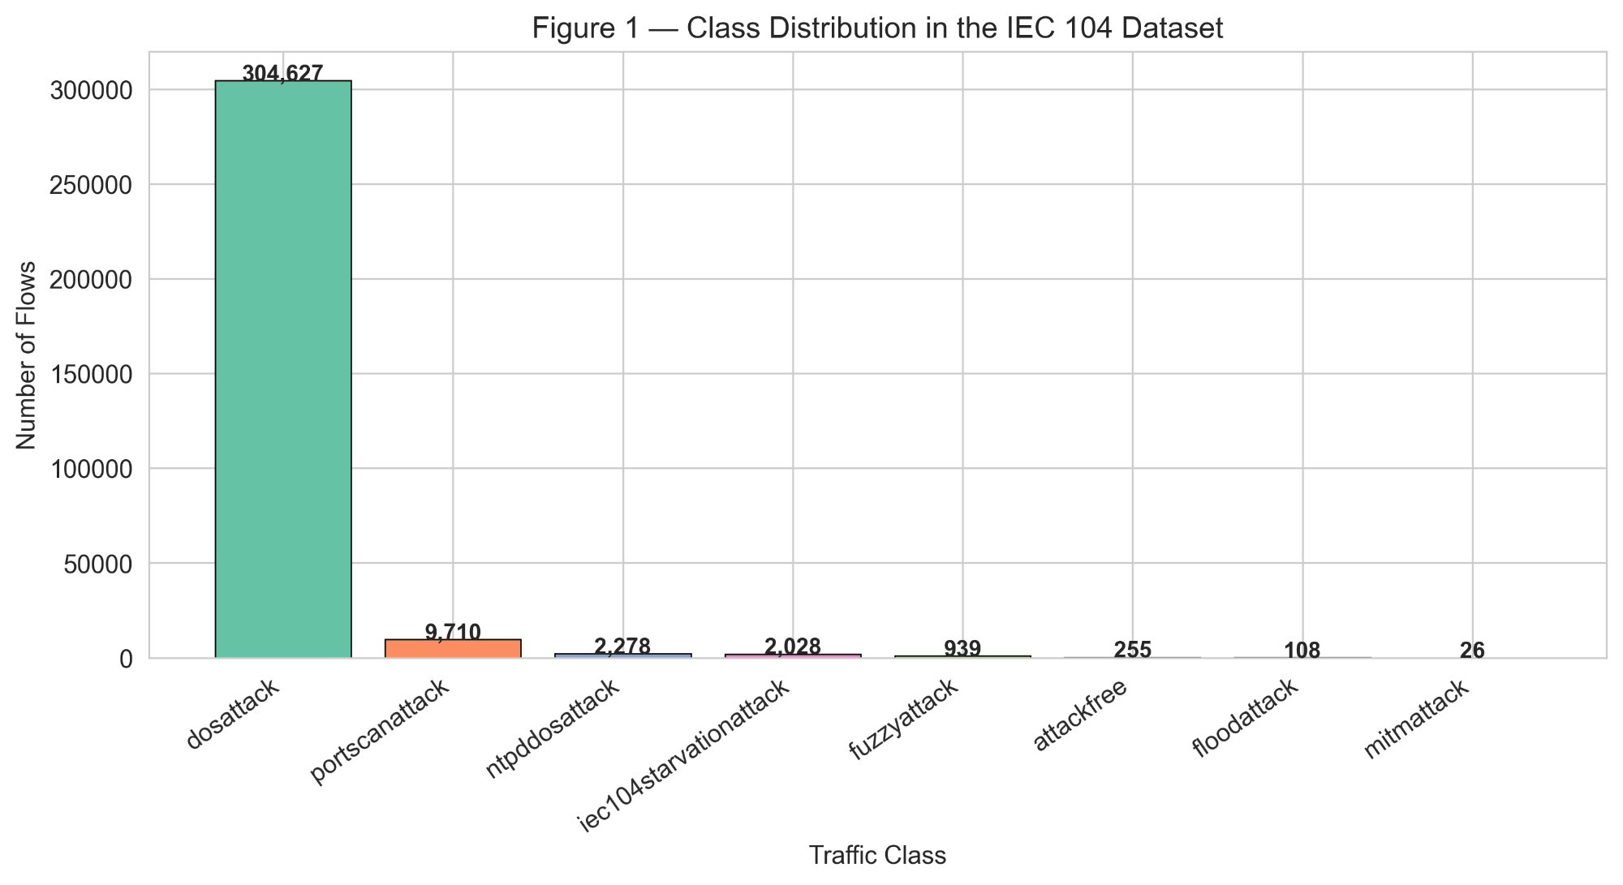
Figure A1: Class distribution in the IEC 104 dataset.
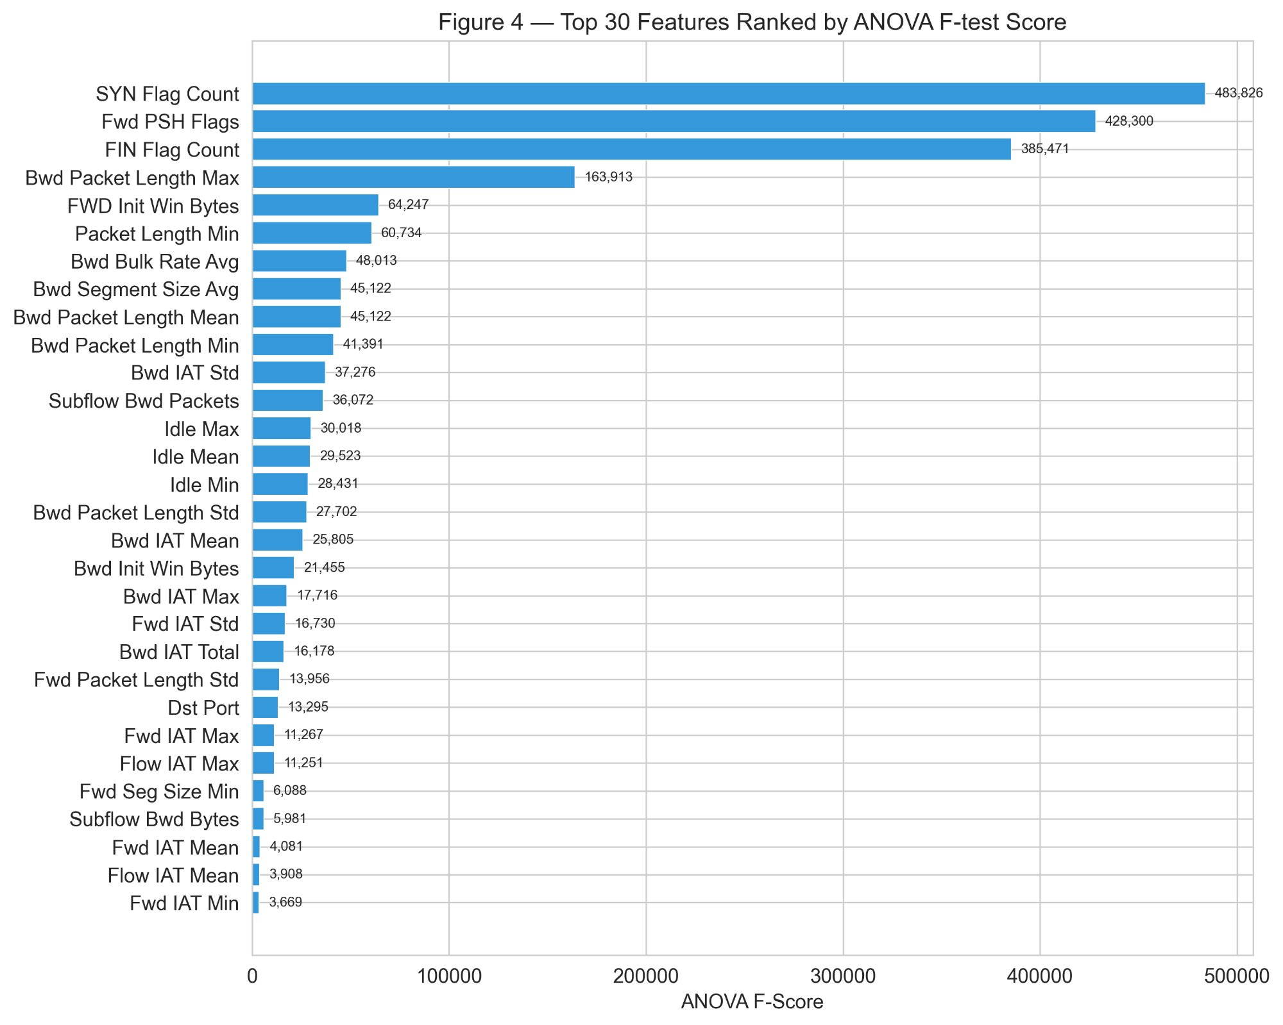
Figure A2: Top 30 features ranked by ANOVA F-test score.

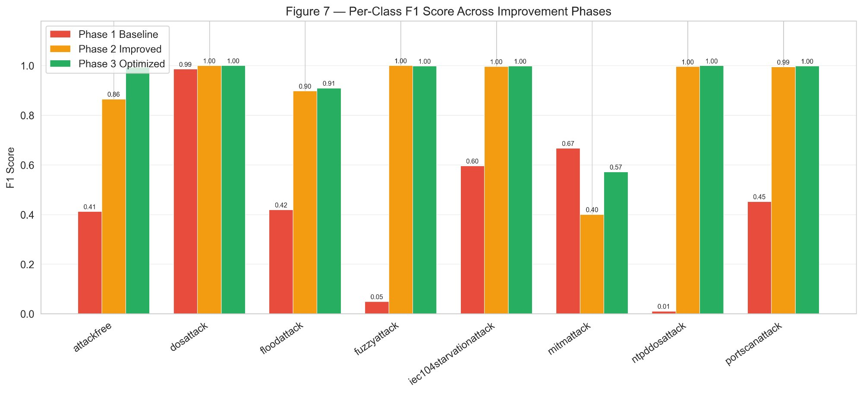
Figure A3: Per-class F1 score across improvement phases.
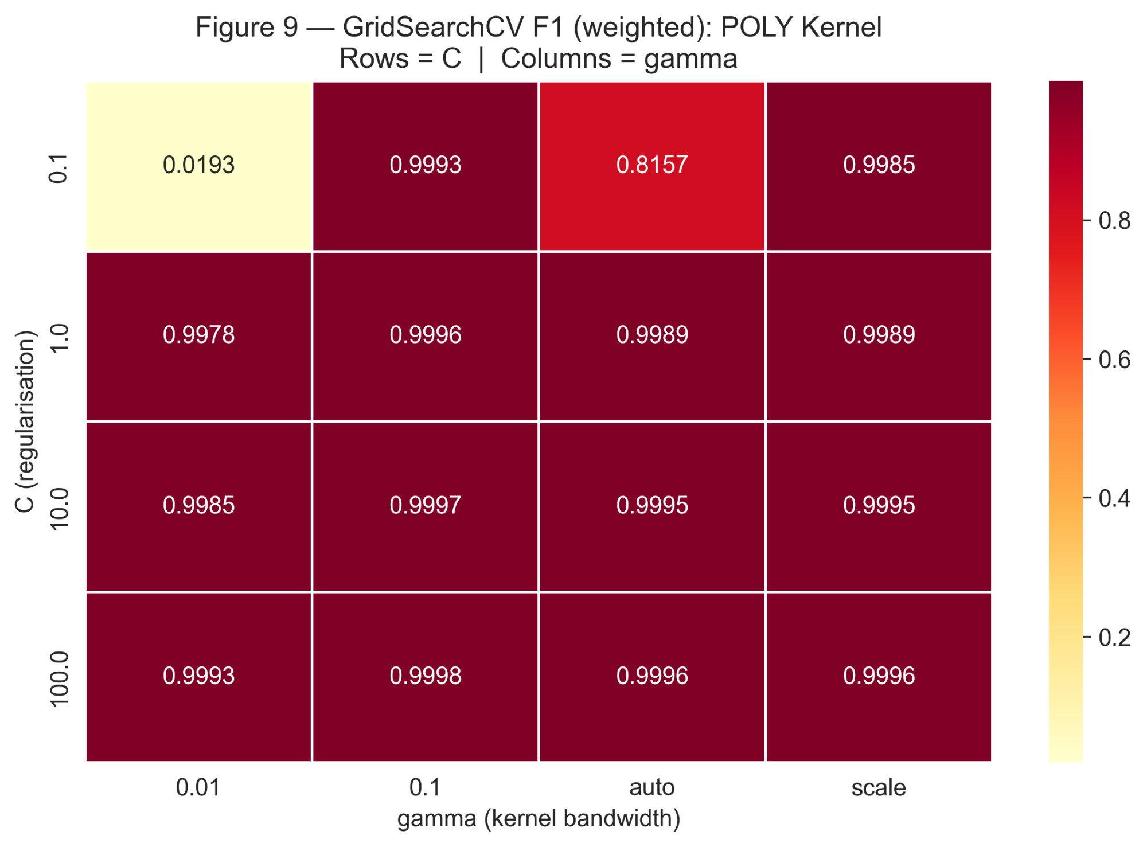
Figure A4: GridSearchCV heatmap for the polynomial kernel.
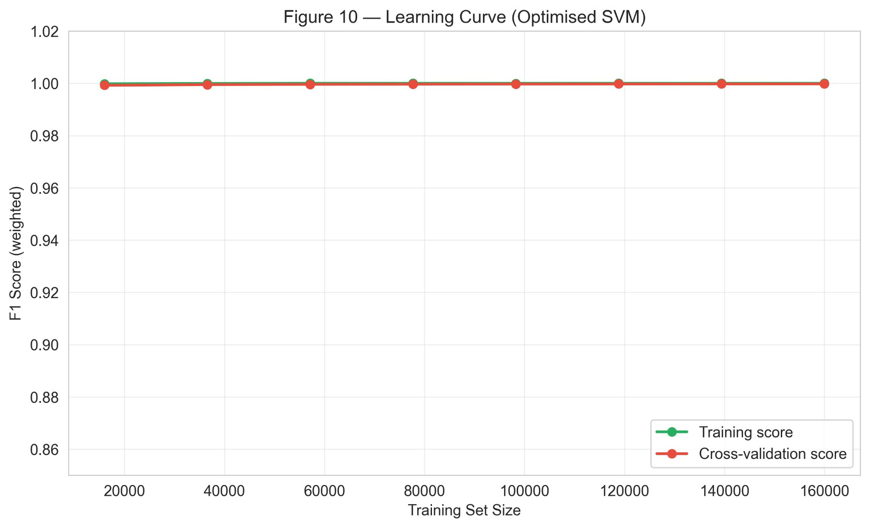
Figure A5: Learning curve for the optimised SVM.

AI Usage
[Explain how AI was used in this project.]

