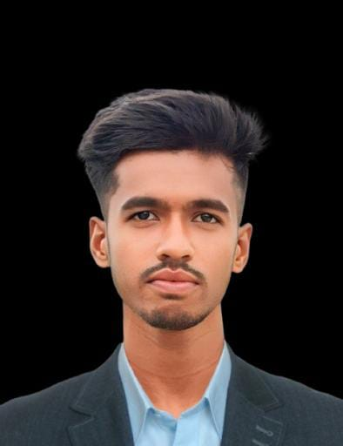
Jakirul Islam
Ilshamari, Balijuri, Madarganj, Jamalpur
Gmail: jakirul.islam.jakir007@gmail.com
Phone: +8801976753448

Career Objective
Looking for a job where I can utilize my technical skills and experience.
Experience
Feb – Dec 2025  C. P. Bangladesh Co., Ltd  Electrical Technical – Maintenance | DOL (Direct On Line) Starter Wiring & Installation  Star-Delta Starter Basic Connection  Forward & Reverse Motor Control Circuit  Single Phase Motor Connection (Capacitor Start / Run)  Three Phase Motor Terminal Connection (Star / Delta)  Contactor & Overload Relay Setup  Timer Relay Connection (Star-Delta Control)  Push Button (Start/Stop) Control Wiring  Motor Protection Setup (MCB, MPCB, Overload)  Motor Fault Finding (No Start / Overheat / Low RPM)  Motor Direction Changing (Phase Sequence Change)  Basic Control Panel Wiring & Cable Dressing  Reading Electrical Diagram (Single Line / Control Circuit)

Training
Nov 2024 – Jan 2025  Electrical Installation & Maintenance  Technical Training Center, Jamalpur | Basic Electrical Knowledge, Electrical House wiring, CT, PT, Star delta, Motor and relay controlling etc.

Academic Qualification
Higher Secondary Certificate(HSC)
Mahmudpur Kazaikata Ideal Technical institute, Jamalpur (GPA:4.92)
Session: 2021-22, Sub: Digital Technology in Business
Secondary School Certificate(SSC)
Mohisbathan R.M high School (GPA:4.50)
Session: 2019-20, Group: Science

Career and Application Information
Looking For | : Entry Level Job
Available For | : Full Time
Preferred Job Category | : Production, Electrical Installation and Maintenance
Preferred District | : Anywhere in Bangladesh

Technical Skills
- Electrical Controlling, Installation and Maintenance
- Electrical Machine Troubleshooting
- Computer : MS Word, PowerPoint, Excel

Personal Details:
Father’s Name | : | Rejaul Karim
Mother’s Name | : | Julekha Begum
Date of Birth | : | 1 Mar 2003
Gender | : | Male
Height | : | 5.6
Weight(Kg) | : | 52
Marital Status | : | Married
Nationality | : | Bangladeshi
National Id No. | : | 7817517803
Religion | : | Islam
Permanent Address | : | Ilshamari, Maderganj, Jamalpur
Current Location | : | Same as Present Address
Blood Group | : | O+

Reference
 |  | Reference 01
Name | : | Mohammad Jubaid Hossen
Organization | : | Walton Digi-Tech Industries Ltd
Designation | : | First Sr. Deputy Assistant Director
ID | : | 66415
Address | : | Building-3, 3rd Floor, R&I Room, ID-66415
Mobile | : | +8801678860447
Email | : | wdc.pcb.design12@waltonbd.com
Relation | : | Brother

