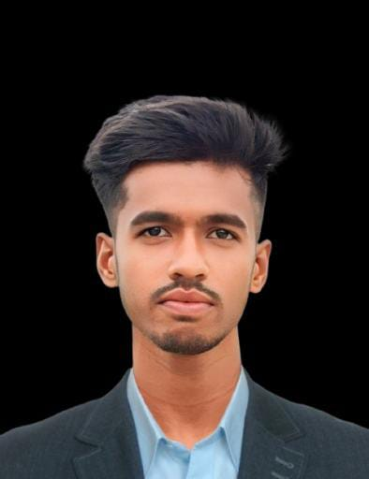
Jakirul Islam
Ilshamari, Balijuri, Madarganj, Jamalpur
Gmail: jakirul.islam.jakir007@gmail.com
Phone: +8801976753448

Career Objective
Looking for Electrical Technician job. I have Basic Electrical knowledge and done House wiring and maintenance knowledge
Training
Nov 2024 – January 2025  Electrical Installation & Maintenance  Technical Training Center, Jamalpur | Electrical House wiring, CT, PT, Star delta, Motor controlling etc

Academic Qualification
Higher Secondary Certificate(HSC)
Mahmudpur Kazaikata Ideal Technical institute, Jamalpur (GPA:4.92)
Session: 2021-22, Sub: Digital Technology in Business
Secondary School Certificate(SSC)
Mohisbathan R.M high School (GPA:4.50)
Session: 2019-20, Group: Science

Career and Application Information
Looking For | : Entry Level Job
Available For | : Full Time
Preferred Job Category | : Production, Electrical Installation and Maintenance
Preferred District | : Anywhere in Bangladesh

Technical Skills
- Electrical House Wiring, Installation and Maintenance
- Basic Electrical Knowledge
- Computer : MS Word, PowerPoint, Excel

Personal Details:
Father’s Name | : | Rejaul Karim
Mother’s Name | : | Julekha Begum
Date of Birth | : | 1 Mar 2003
Gender | : | Male
Height | : | 5.6
Weight(Kg) | : | 52
Marital Status | : | Married
Nationality | : | Bangladeshi
National Id No. | : | 7817517803
Religion | : | Islam
Permanent Address | : | Ilshamari, Maderganj, Jamalpur
Current Location | : | Same as Present Address
Blood Group | : | O+

Reference
 |  | Reference 01
Name | : | Mohammad Jubaid Hossen
Organization | : | Walton Digi-Tech Industries Ltd
Designation | : | Deputy Assistant Director
Address | : | Building-3, 3rd Floor, R&I Room, ID-66415
Mobile | : | +8801678860447
Email | : | wdc.pcb.design12@waltonbd.com
Relation | : | Brother

