Part 3 — Complete Submission
  - Testing, Deployment and Handover · every project deliverable (01–12) in one document
Gift of the Givers project team — APPR6312 Portfolio of Evidence
2 November 2026
Table of Contents
Note to the marker: problem with our Azure account 1
Deliverable 01: Product Requirements 3
Deliverable 02: Technical Requirements 14
Deliverable 03: Application Flow 22
Deliverable 04: Design Brief 36
Deliverable 05: Backend Schema 47
Deliverable 06: Implementation Plan 56
Deliverable 07: CI/CD and Release 65
Deliverable 08: Professional Engineering Audit 71
Deliverable 08-A: Audit Addendum — Remediation Review 144
Deliverable 09: Part 3 — Testing, Deployment and Handover 183
Deliverable 10: User Manual 205
Deliverable 11: Azure Deployment and GitHub Sync Guide 222
Deliverable 12: Team Contribution Report 234

Note to the marker: problem with our Azure account
We have a problem with our Azure account. Because of it, we could not complete the deployment to Azure before this submission: the live web app still shows the Azure “waiting for your content” page, and the deployment stages of the pipeline (C.1 web app, C.2 Azure Function, C.3 SQL database) have not yet run in Azure DevOps. The Azure DevOps access token we had for connecting GitHub to Azure DevOps was rejected (HTTP 401 Unauthorized) when we tested it on 2 November 2026.
Everything needed for the deployment is in place and documented: the pipeline (azure-pipelines.yml and pipelines/templates), the step-by-step Azure set-up and GitHub-to-Azure sync guide (Deliverable 11), the database migration and rollback scripts, and the rollback and restore procedures. The testing work (unit, integration, load, stress and Selenium UI tests) is complete, and its evidence is in Deliverable 09 and in docs/evidence/part3 in the repository.
As soon as the account problem is resolved, a team member will follow Deliverable 11, run the pipeline and add the deployment screenshots listed in Deliverable 09, section 10.

Deliverable 01: Product Requirements
What the Relief Management System must do, for whom, and how we know each requirement is met.
Version 2.0 · 2026-11-02 · Status: Current — reflects the system after audit remediation

1. Purpose and vision
The Relief Management System supports a humanitarian non-profit (modelled on the Gift of the Givers Foundation) in three areas:
- Raising money transparently. The public can donate online. Every rand shown as “raised” can be traced to a confirmed payment or a staff-recorded offline contribution.
- Mobilising people. Volunteers apply online. Staff review them and assign them to relief projects.
- Accountability to donors. Donors see their history and download donation certificates for confirmed gifts.
Product principle — honesty over polish. The system never shows a figure, status or document it cannot back with data. Unpaid donations are labelled as such, demonstration content is labelled as demonstration, and statistics are computed from the database.

Context
The project is an academic deliverable (Portfolio of Evidence, “Section B” ERD). It is hosted publicly as a demonstration and uses a real NGO’s name for illustration. It is not affiliated with that organisation. Payments use the PayFast sandbox until real merchant details are configured.

2. Users and roles
Persona | Role | Goals | Key needs
Public visitor | Anonymous | Learn about projects, give, volunteer, ask a question | Fast, mobile-friendly pages; clear trust signals; no account required to donate
Donor | Donor (self-registered) | Track donations, download certificates | Accurate history; certificates only for real payments; privacy
Staff member | Employee (granted by staff) | Run projects, review volunteers, oversee donations | Accurate totals; filters and exports; audit trail; no accidental data exposure
Information Officer | Organisation (offline) | Answer privacy requests (POPIA) | Privacy notice, consent records, data export/deletion
PayFast | External system | Notify payment results | Reachable, idempotent webhook
Role rules:
- Self-registration always creates a Donor. Staff access is granted only by an existing employee (Staff Access page) or by the deployment configuration StaffAccess:BootstrapEmployeeEmails.
- One account may hold both roles.

3. Scope

In scope (current release)
- Public information pages, live impact figures, project listing with funding progress.
- Online donations in ZAR, USD and EUR, paid through PayFast in rand.
- Donation receipts, donor dashboard and history, donation certificates (HTML + PDF).
- Volunteer applications, review, approval/rejection and assignment to projects.
- Contact inquiries and their handling.
- Staff management of projects, project updates, offline funds and funding reconciliation.
- Staff access management and an audit log.
- Privacy notice and consent capture.

Out of scope (this release)
- Automatic recurring billing. Monthly pledges are recorded, but each payment is made separately.
- Live exchange rates (rates are configured).
- Native mobile apps (the site is responsive).
- Multi-organisation or multi-tenant use, and multiple languages.
- Accounting and general-ledger integration.

4. Functional requirements
Priority uses MoSCoW: Must, Should, Could. Status reflects verified behaviour on 2026-11-02 (see the audit addendum).

4.1 Public site
ID | Requirement | Priority | Acceptance criteria | Status | Evidence
FR-01 | Show active relief projects with funding progress | M | Projects list shows title, location, status, raised vs goal in rand; progress capped at 100% visually | Done | HomeController.ReliefProjects, smoke test
FR-02 | Show impact figures computed from live data | M | No hard-coded statistics; figures update when data changes | Done | ImpactStatsViewComponent; test HomePage_ShowsLiveFiguresInsteadOfHardCodedStatistics
FR-03 | Publish a privacy notice | M | Notice explains data, purposes, sharing, retention, rights, cookies | Draft | Views/Home/Privacy.cshtml; legal review pending (F-09)
FR-04 | Contact form | M | Required name, email, subject, message, consent; stored; confirmation page | Done | test Contact_RecordsConsentTimestamp

4.2 Donations and payments
ID | Requirement | Priority | Acceptance criteria | Status | Evidence
FR-10 | Donate without an account | M | Anonymous donors can donate; signed-in donors’ gifts are linked to their account | Done | DonationService.CaptureAsync
FR-11 | Choose currency ZAR / USD / EUR | M | Foreign amounts converted to rand at the configured rate; both values stored and shown | Done | test Donate_ForeignCurrency_IsChargedInRandAtConfiguredRate
FR-12 | Pay securely through PayFast | M | Donor redirected to PayFast with signed fields; card data never touches our servers | Wired | smoke test redirect; end-to-end blocked by F-23
FR-13 | Only confirmed payments count | M | Project totals, dashboards and certificates include only Verified donations | Done | tests Donate_RecordsPendingDonation_…, Notify_Complete_…
FR-14 | Payment confirmation is safe to repeat | M | Duplicate or replayed notifications never add money twice; wrong amount or merchant is refused | Done | tests Notify_*
FR-15 | Double-submission safe | M | Submitting the same form twice creates one donation | Done | test Donate_SameIdempotencyTokenTwice_CreatesOneDonation
FR-16 | Receipt page with live status | M | Found by unguessable reference; shows amount, rand value, project, status | Done | test Receipt_IsFoundByReferenceNotSequentialId
FR-17 | Donations only to active projects | M | Suspended or completed projects are rejected with a message | Done | test Donate_ToSuspendedProject_IsRejectedWithMessage
FR-18 | Monthly pledge | S | Pledge recorded and clearly described as not auto-billed | Pledge only | F-37; billing in the roadmap
FR-19 | Anonymous donation option | S | Name hidden on certificates and staff reports | Done | TaxCertificatePdf.DonorDisplayName

4.3 Donor portal
ID | Requirement | Priority | Acceptance criteria | Status | Evidence
FR-20 | Donor dashboard | M | Confirmed count and rand total, pending count, recent donations with status | Done | DonorController.Dashboard
FR-21 | Donation history and details | M | Only the donor’s own donations; status visible | Done | ownership filter in queries
FR-22 | Donation certificate (HTML + PDF) | M | Only for Verified donations owned by the donor (or staff); marked demonstration until PBO details are configured | Done | test Certificates_OnlyForOwnersOfVerifiedDonations
FR-23 | Account self-service | S | Change password, download or delete personal data | Done | ASP.NET Identity default UI

4.4 Staff portal
ID | Requirement | Priority | Acceptance criteria | Status | Evidence
FR-30 | Manage relief projects | M | Create/edit title, description, location, status, dates, goal, offline funds, image URL; date and amount validation | Done | test EditingOfflineFunds_AdjustsTotalByTheDifference
FR-31 | Post project updates | S | Create/edit updates per project | Done | EmployeeController
FR-32 | Review volunteers | M | Filter by status, view details, approve or reject; applicant notified by email when configured | Done | SetVolunteerStatusAsync
FR-33 | Assign volunteers to projects | S | Only approved volunteers to active projects; no duplicate assignments | Done | AssignVolunteer, unique index
FR-34 | Donation oversight | M | Filter by status, paged list, rand totals of paid donations, CSV export | Done | Donations, ExportDonations
FR-35 | Funding reconciliation | M | Per project: offline + verified vs recorded; recalculate or accept the difference as offline, both audited | Done | test FundingReconciliation_RecalculateUsesOfflinePlusVerifiedOnly
FR-36 | Inquiries | S | Open first, mark handled | Done | Inquiries
FR-37 | Staff access management | M | Grant by email to an existing account; revoke others (not self); audited | Done | test StaffAccess_GrantIsAuditedAndSelfRevokeIsRefused
FR-38 | Audit log | M | All staff changes, access changes, payment events, exports and certificate access, with actor and details | Done | AuditService; test Notify_Complete_… asserts PaymentVerified

4.5 Volunteers
ID | Requirement | Priority | Acceptance criteria | Status | Evidence
FR-40 | Apply to volunteer | M | Name, email, skills, availability required; phone, city, DOB and emergency contact optional; consent required; nothing invented | Done | tests Volunteer_*
FR-41 | Age check | S | A date of birth, if given, must be at least 16 years ago | Done | HomeController.Volunteer

5. Business rules
ID | Rule
BR-01 | A project’s raised figure = offline funds (staff-recorded) + rand value of its Verified donations. Nothing else changes it.
BR-02 | A donation is Pending from submission until a validated PayFast notification marks it Verified (COMPLETE) or Failed (any other status).
BR-03 | PayFast is charged the rand amount: AmountZar = round(Amount × rate, 2), where the rate is stored with the donation.
BR-04 | A certificate exists only for a Verified donation. It is visible to its owner and to staff. Anonymous donations show “Anonymous Donor”.
BR-05 | Certificates are labelled demonstration until Organisation:PboReference is set and Organisation:IsDemo is false.
BR-06 | Public registration never grants staff access.
BR-07 | Every staff change to data or access is written to the audit log in the same transaction.
BR-08 | Personal data is collected only with recorded consent (timestamp per record).
BR-09 | Single-donation limit: 1 to 1,000,000 in the chosen currency.

6. Non-functional requirements (summary)
The details, targets and verification methods are in 02 — Technical Requirements.
Area | Requirement
Security | Role-based access enforced on the server; anti-forgery; rate limiting; security headers; no secrets in source
Privacy | POPIA-aligned notice, consent, minimisation, export and deletion
Reliability | Idempotent payments; concurrency-safe totals; health probes
Usability | Responsive (mobile first for public pages); accessible forms (WCAG 2.2 AA target)
Maintainability | Automated tests on every critical path; CI gates; documented setup

7. Assumptions, constraints and open questions
Type | Item
Assumption | The organisation will provide a PayFast merchant account, PBO number and Information Officer before going live.
Constraint | PayFast settles only in rand.
Constraint | Hosting on Azure App Service, with Azure SQL.
Open question | Retention periods for donation, volunteer and inquiry data (draft values in the privacy notice).
Open question | Should monthly pledges become PayFast subscriptions (needs product and legal sign-off)?
Open question | Which exchange-rate source is authoritative for foreign donations?

8. Glossary
Term | Meaning
ITN | PayFast Instant Transaction Notification: a server-to-server POST that reports a payment result
PBO | Public Benefit Organisation (South African tax status that enables section 18A certificates)
Offline funds | Money raised outside the website (cash, grants, pledges) and recorded by staff
Verified | A donation whose payment PayFast has confirmed
POPIA | Protection of Personal Information Act, 2013 (South Africa)

Deliverable 02: Technical Requirements
Architecture, technology, integration contracts and measurable non-functional requirements for the Relief Management System.
Version 2.0 · 2026-11-02 · Status: Current — reflects the system after audit remediation

1. Architecture overview
The system is a layered ASP.NET Core monolith: MVC controllers and Razor Pages, an application service layer, and EF Core. It has one satellite Azure Function and one shared class library. This fits the scale: one team, one database, and moderate traffic with spikes during disaster appeals.
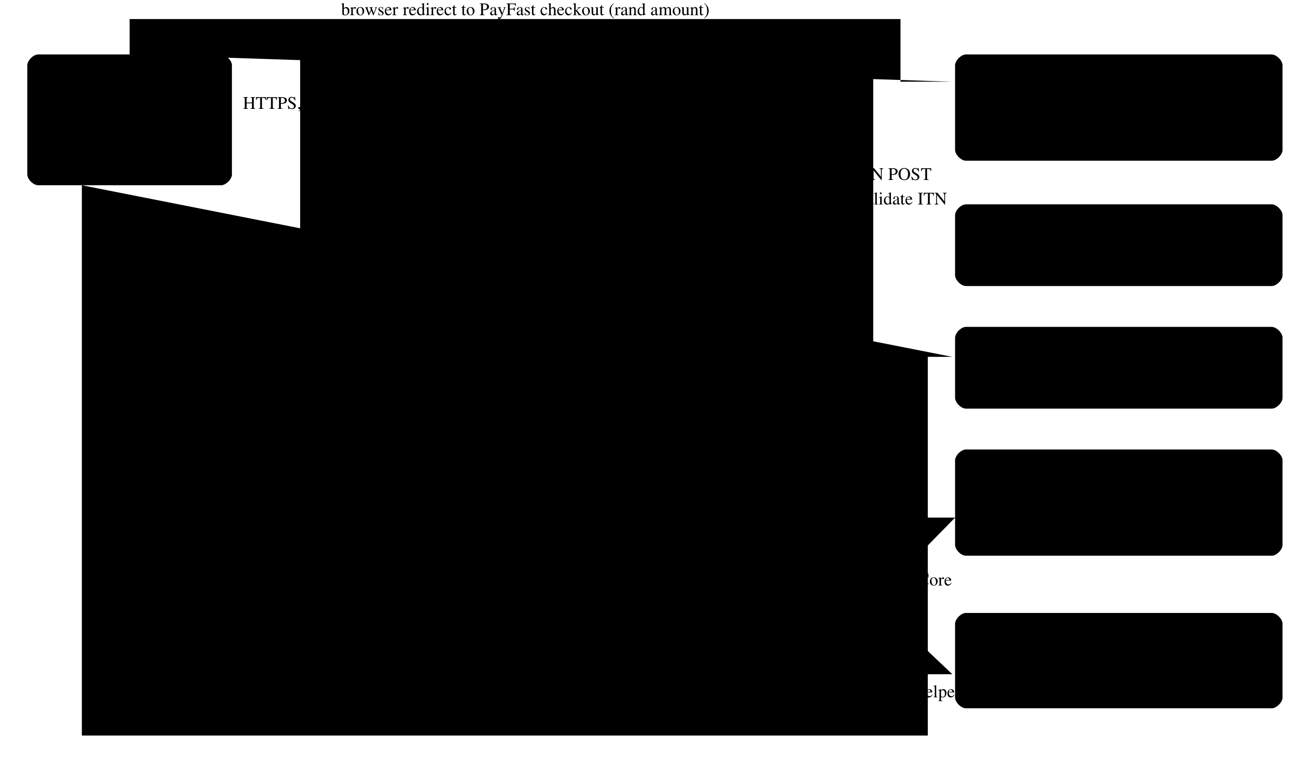
System architecture — components, external services and communication paths
Component | Responsibility | Key files
Web app (GiftOfTheGivers) | Public site, donor and staff portals, PayFast webhook, Identity | Program.cs, Controllers/*, Views/*
DonationService | Capture donations, apply payment notifications, recalculate funding | Services/DonationService.cs
PayFastPaymentService | Build signed checkout URLs; verify ITN signature and validate with PayFast | Services/PayFastPaymentService.cs
CurrencyConverter | Convert to rand at configured rates (fails at startup if a rate is missing) | Services/CurrencyConverter.cs
AuditService | Stage and save audit entries in the caller’s transaction | Services/AuditService.cs
Email | SendGrid when configured, otherwise no-op; Identity emails via IdentityEmailSender | Services/*Email*
TaxCertificatePdf | PDF certificate (QuestPDF); issuer from configuration | Services/TaxCertificatePdf.cs
DbSeeder | Migrations (configurable), roles, bootstrap staff, development demo data | Data/DbSeeder.cs
Azure Function | Key-protected certificate generation by reference | GiftOfTheGivers.Functions/*
Helpers library | Funding and donation calculations, certificate numbering | GiftOfTheGivers.Helpers/*

2. Technology stack
Layer | Technology | Version | Notes
Runtime / SDK | .NET | SDK 10.0.401 (pinned, rollForward: latestFeature) | global.json
Web | ASP.NET Core MVC + Razor Pages | 10.0 | Server-rendered; no SPA
ORM | Entity Framework Core (SQL Server provider) | 10.0.14 | Migrations-first; drift check in CI
Identity | ASP.NET Core Identity (default UI, custom Register page) | 10.0.14 | Roles: Donor, Employee
Database | SQL Server 2022 / Azure SQL / LocalDB | — | decimal(18,2) money, rowversion concurrency
Data Protection | Keys stored in the database | 10.0.14 | Shared across instances
Payments | PayFast (redirect + ITN) | — | Sandbox by default
Email | SendGrid | 9.29.3 | Optional
PDF | QuestPDF | 2026.9.0 | Community licence (confirm eligibility)
Logging | Serilog.AspNetCore | 10.0.0 | Console sink + request logging
UI | Bootstrap 5, Bootstrap Icons 1.11.3 (SRI), Inter | — | wwwroot/lib vendored
Functions | Azure Functions isolated worker | 2.52.0 | HTTP trigger, function key
Tests | xUnit 2.9, Microsoft.AspNetCore.Mvc.Testing, EF InMemory, coverlet | — | 98 tests
Packaging | NuGet lock files, source mapping, audit sources | — | NuGet.config

3. Environments and configuration
Environment | Purpose | Database | Payments | Demo data
Development | Local work | LocalDB or Docker SQL | PayFast sandbox | Yes
Testing (automated) | Integration tests | EF InMemory (isolated per test class) | Fake gateway | No
CI | Build, test, migration verification | SQL Server 2022 container | — | No
Production (Azure) | Public site | Azure SQL | PayFast live (own merchant, passphrase required) | No
All configuration keys are listed in the README. Requirements:
- TR-CFG-01 No secrets in the repository. Use user-secrets locally and App Service or pipeline secrets in Azure.
- TR-CFG-02 Unsafe live payment settings must stop startup: live mode without a passphrase, the sandbox merchant, or localhost/http URLs (PayFastOptionsValidator).
- TR-CFG-03 Every supported currency needs a positive rate, or startup fails (CurrencyConverter).
- TR-CFG-04 Database:MigrateOnStartup=false in production. Apply migrations from the idempotent script.

4. Integration contracts

4.1 PayFast checkout (outbound redirect)
Field | Source | Rule
merchant_id, merchant_key | Configuration | Required when enabled
return_url | PayFast:ReturnUrl or /Donate/Confirmation + ?reference= | Absolute URL
cancel_url | PayFast:CancelUrl or /Home/Donate + ?cancelled= | Absolute URL
notify_url | PayFast:NotifyUrl or /Payments/Notify | Must be publicly reachable in production
email_address | Donor email | Optional
m_payment_id | Donation.TransactionReference (32 hex) | Unique
amount | Donation.AmountZar | Invariant culture, two decimals
item_name | “Donation - {project or General Fund}” | ≤ 100 characters
signature | MD5 of the URL-encoded fields in order (+ passphrase) | Lower-case hex

4.2 PayFast ITN (inbound webhook) — POST /Payments/Notify
Validation, in order. Any failure leaves the donation unchanged:
- Signature recomputed over the posted fields in posted order, then a fixed-time comparison → 400 if wrong.
- Server-to-server POST /eng/query/validate must return VALID (15-second timeout) → 400 otherwise.
- Unknown m_payment_id → 404.
- merchant_id must equal the configured merchant → 400.
- Already Verified → 200, no change (idempotent).
- payment_status = COMPLETE and amount_gross equal to AmountZar → Verified, total incremented once, audit entry PaymentVerified. An amount mismatch → 400.
- Any other status while Pending → Failed, audit entry PaymentFailed.
The webhook is exempt from anti-forgery and rate limiting. Concurrency conflicts on the project row are retried up to three times.

4.3 Azure Function — GET /api/tax-certificate/{reference}
Requires a function key (AuthorizationLevel.Function). The reference must match ^[A-Za-z0-9]{16,100}$. Only Verified donations are returned. Output is an application/pdf attachment. Intended for server-to-server use; donors use the web app, which also checks ownership.

4.4 SendGrid
Optional. Delivery failures are logged and never fail the user’s request.

5. Non-functional requirements
ID | Requirement | Target | Current state | Verification
NFR-SEC-01 | Server-side authorization on every staff and donor route | 100% of routes | Met | Role-matrix integration tests (30 cases)
NFR-SEC-02 | No self-service privilege escalation | Register cannot grant staff | Met | Registration_AlwaysCreatesDonor_…
NFR-SEC-03 | CSRF protection on all state-changing forms | All POSTs except the webhook | Met | Global AutoValidateAntiforgeryToken
NFR-SEC-04 | Abuse limits on public POSTs | ≤ 20 POST/min/IP (configurable) | Met | PublicPosts_AreLimitedPerClient_…
NFR-SEC-05 | Security headers | CSP, frame-ancestors none, nosniff, referrer and permissions policies | Met (CSP allows inline scripts) | Responses_CarrySecurityHeaders
NFR-SEC-06 | No known-vulnerable packages | 0 advisories | Met | CI gate dotnet list package --vulnerable
NFR-SEC-07 | Staff MFA and login lockout | Required for Employee | Not met | Roadmap T-1.3 (F-36)
NFR-PRIV-01 | Consent recorded for personal data | Timestamp per record | Met | PrivacyConsentAt columns, tests
NFR-PRIV-02 | Data minimisation | Optional fields stay empty | Met | Volunteer_WithoutDateOfBirth_…
NFR-PRIV-03 | Retention enforced | Per privacy notice | Not met | Roadmap T-2.4
NFR-INT-01 | Money integrity | Totals = offline + verified | Met | Reconciliation page; tests
NFR-INT-02 | Idempotent payments and submissions | No double counting | Met | Notify_Complete_…, Donate_SameIdempotencyToken…
NFR-INT-03 | Schema matches model | No pending model changes | Met | CI drift check
NFR-REL-01 | Health probes | /health/live (process), /health (database) | Met | Smoke test
NFR-REL-02 | Transient SQL faults retried | EF retry strategy | Met | EnableRetryOnFailure
NFR-REL-03 | Sessions survive restarts and scale-out | Shared Data Protection keys | Met | DataProtectionKeys table
NFR-PERF-01 | Staff lists bounded | ≤ 50 rows per page | Met | Paged queries
NFR-PERF-02 | Page response | p95 < 800 ms at 20 rps (proposed) | Not measured | Load test in roadmap
NFR-A11Y-01 | Accessible forms | WCAG 2.2 AA | Partially verified (code review) | axe/Playwright in roadmap
NFR-OBS-01 | Request logging and correlation | Every request logged | Met (console) | Serilog request logging
NFR-OBS-02 | Alerting on failed payments and health | Alerts | Not met | Roadmap T-1.5
NFR-MNT-01 | Automated tests on critical paths | ≥ 60% line coverage of hand-written code | Met (67.9%) | coverlet in CI
NFR-BCK-01 | Restorable backups | RPO ≤ 24 h, RTO ≤ 4 h (proposed) | Not verified | Restore drill in roadmap (F-17)

6. Data requirements
- Money: decimal(18,2); exchange rates decimal(18,6); all totals in rand.
- Time: UTC everywhere (datetime2). Views label UTC where it matters.
- Identifiers: database ids are internal. Public links use the 32-character transaction reference.
- Integrity is enforced in the database: check constraints for currencies, types, payment methods, statuses, amounts, dates and non-negative funds; unique idempotency key and transaction reference. See 05 — Backend Schema.

7. Engineering standards
Standard | Rule
Code | Nullable reference types on; input models for every form (no entity binding); business logic in services
Auditing | Every staff data change calls IAuditService.Record before SaveChanges
Money | Format with Infrastructure/Money; never ToString("C")
Migrations | One migration per model change, in the same PR; never edit an applied migration; backfill data in the migration
Tests | Integration test for anything touching money, roles or personal data
Dependencies | Lock files enforced (--locked-mode in CI); new private packages need a source-mapping entry

8. Known technical constraints and debt
Item | Impact | Plan
The function references the whole web project | Larger deployment, coupling | Extract a shared data project (T-2.3)
CSP allows 'unsafe-inline' | Weaker XSS defence-in-depth | Move inline scripts to files, then use nonces (T-2.6)
Exchange rates are manual | Foreign amounts may drift from market | Rates provider or rate table (T-2.2)
No infrastructure-as-code | Environment drift | Bicep templates (T-3.1)

Deliverable 03: Application Flow
Site map, user journeys, state machines and route inventory, traced from the screen to the database.
Version 2.0 · 2026-11-02 · Status: Current — reflects the system after audit remediation

1. Site map

Site map by role — every page and the role that can reach it
Navigation rules:
- The top navigation always shows Home, About, Projects, Volunteer, Contact and the Donate Now button.
- Signed-in donors also see Donor Portal. Employees see Employee Portal: Dashboard, Projects, Volunteers, Donations, Funding Reconciliation, Inquiries, Staff Access, Audit Log.
- On the first visit to / in each browser session, the visitor is sent to a short intro animation (skippable, and reduced-motion aware), which then returns them to the home page.

2. Journey J1 — Donate (core journey)
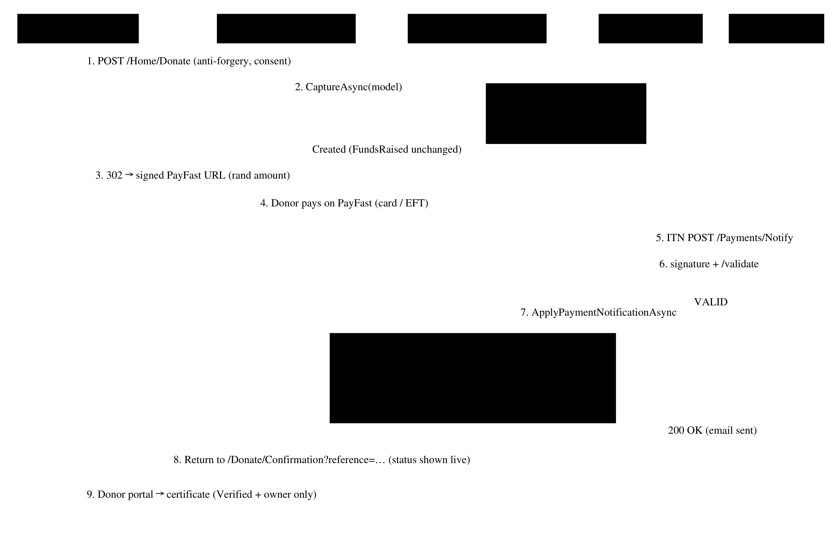
Donation and payment verification sequence
Step | Screen / route | System behaviour | Data
1 | GET /Home/Donate?projectId= | Form shown. Signed-in donors get their name and email pre-filled. Indicative rand equivalent shown for USD/EUR | —
2 | POST /Home/Donate | Anti-forgery, validation (type, currency, amount 1–1,000,000, payment method, consent). Errors re-display the form with a summary | —
3 | DonationService.CaptureAsync | Duplicate token → same donation. Project must be Active. Rand conversion. Insert as Pending | Donations +1 row; project total unchanged
4 | 302 to PayFast | Signed URL for the rand amount; return, cancel and notify URLs carry the reference | —
5 | PayFast | Donor pays by card or EFT, or cancels | —
6 | POST /Payments/Notify (server to server) | Signature → validate → merchant → amount → status | Donations.PaymentStatus, ReliefProjects.FundsRaised, AuditLogs
7 | GET /Donate/Confirmation?reference= | Receipt with live status (Awaiting payment / Paid / Failed) | —
8 | Donor portal | Certificate available once Paid (owner only) | —
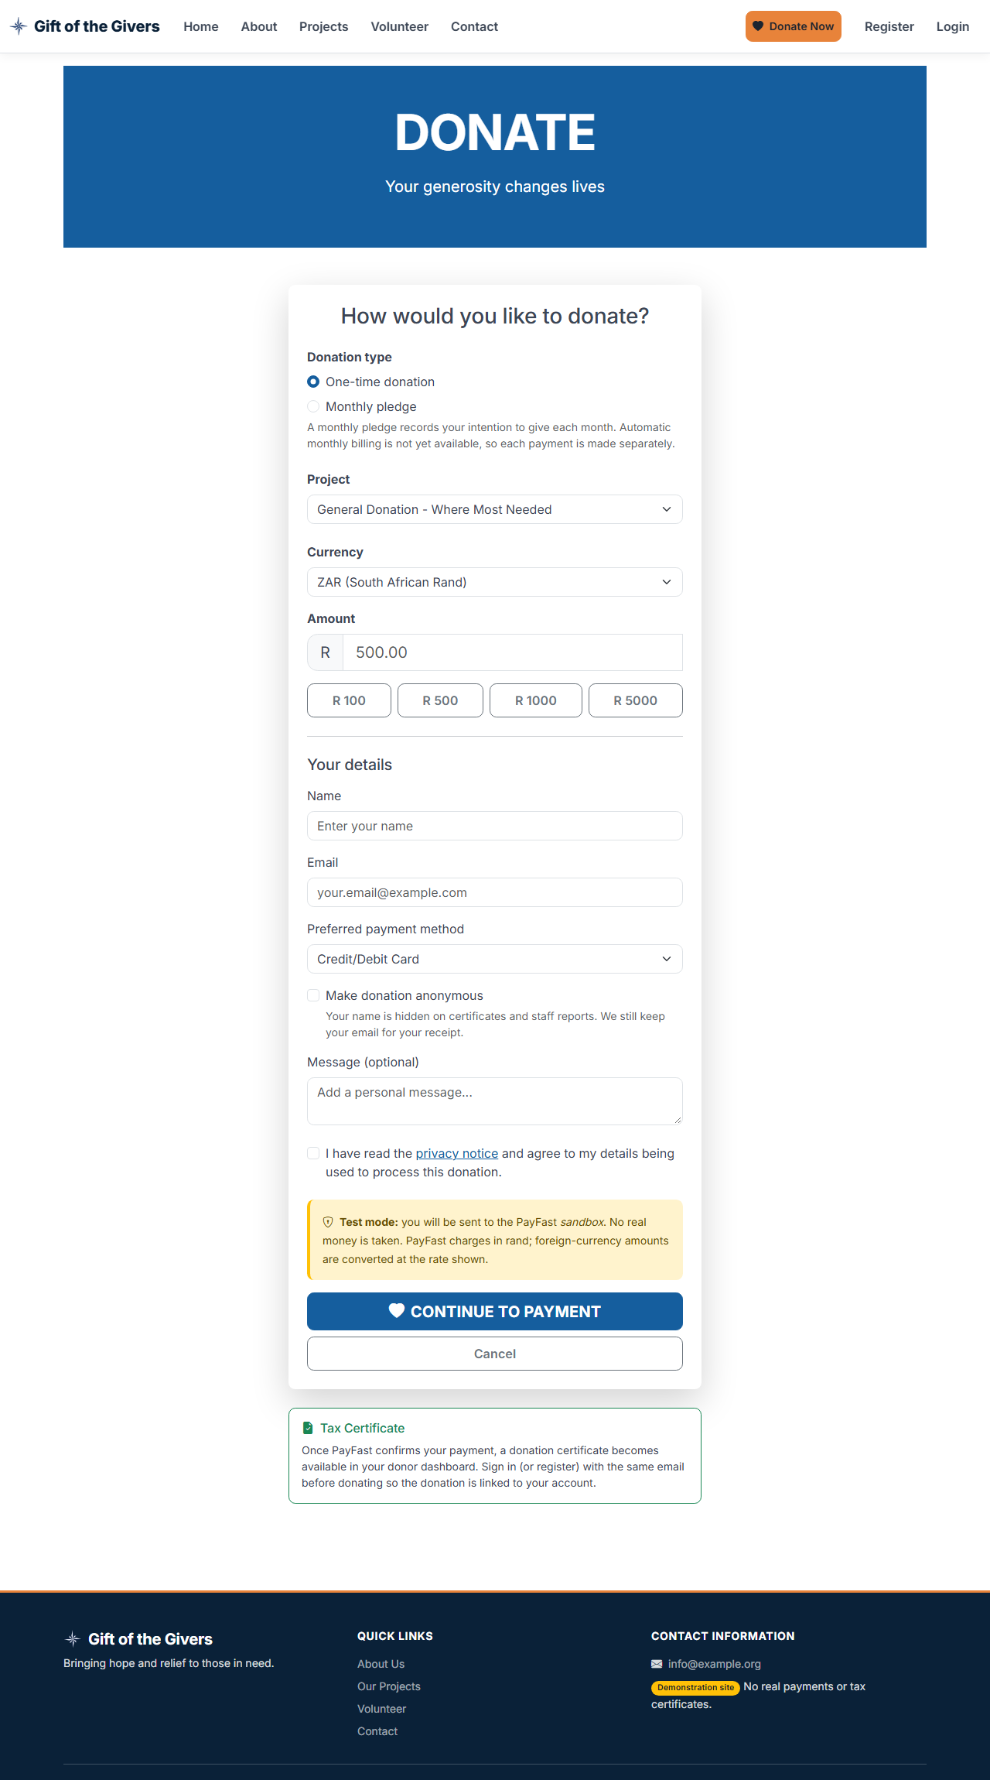
The donation form (desktop)
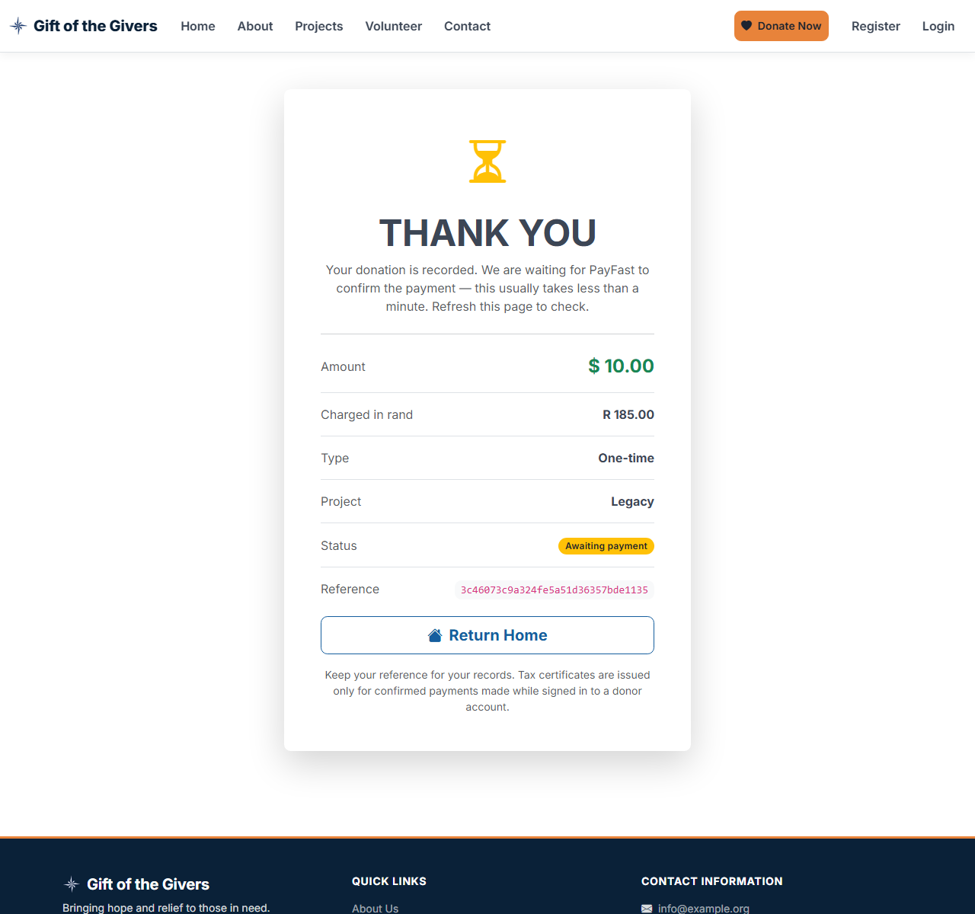
Receipt while the payment is pending (USD 10 charged as R 185.00)

Donate on a 390 px wide phone

Failure and edge paths
Situation | Behaviour
Invalid input (e.g. unknown currency, consent not ticked) | Form re-displayed with errors (HTTP 200); nothing stored
Project suspended or completed | “Not accepting donations” message; nothing stored
Double click / resubmit | Same donation returned (idempotency key); the second redirect goes to the same checkout
Donor cancels on PayFast | Back to Donate with a “payment cancelled, not charged” banner; donation stays Pending
PayFast reports FAILED | Donation marked Failed; totals untouched; receipt offers Try again
ITN replayed | 200, no change
ITN amount or merchant mismatch | 400, donation stays Pending, error logged
Payments disabled (PayFast:Enabled=false) | Donation stored as Pending; receipt explains that nothing was charged
More than 20 POSTs per minute from one IP | 429 Too Many Requests

3. Journey J2 — Register and staff provisioning
Step | Actor | Route | Result
1 | Visitor | GET/POST /Identity/Account/Register | Account created with role Donor (no role choice). Signed in
2a | First staff member | Deployment sets StaffAccess:BootstrapEmployeeEmails | On the next start, the account gets Employee (logged)
2b | Existing employee | GET /Employee/StaffAccess → POST GrantEmployee(email) | Role granted; audit entry EmployeeGranted
3 | Employee | POST RevokeEmployee(userId) | Role removed and security stamp rotated; cannot revoke self; audited
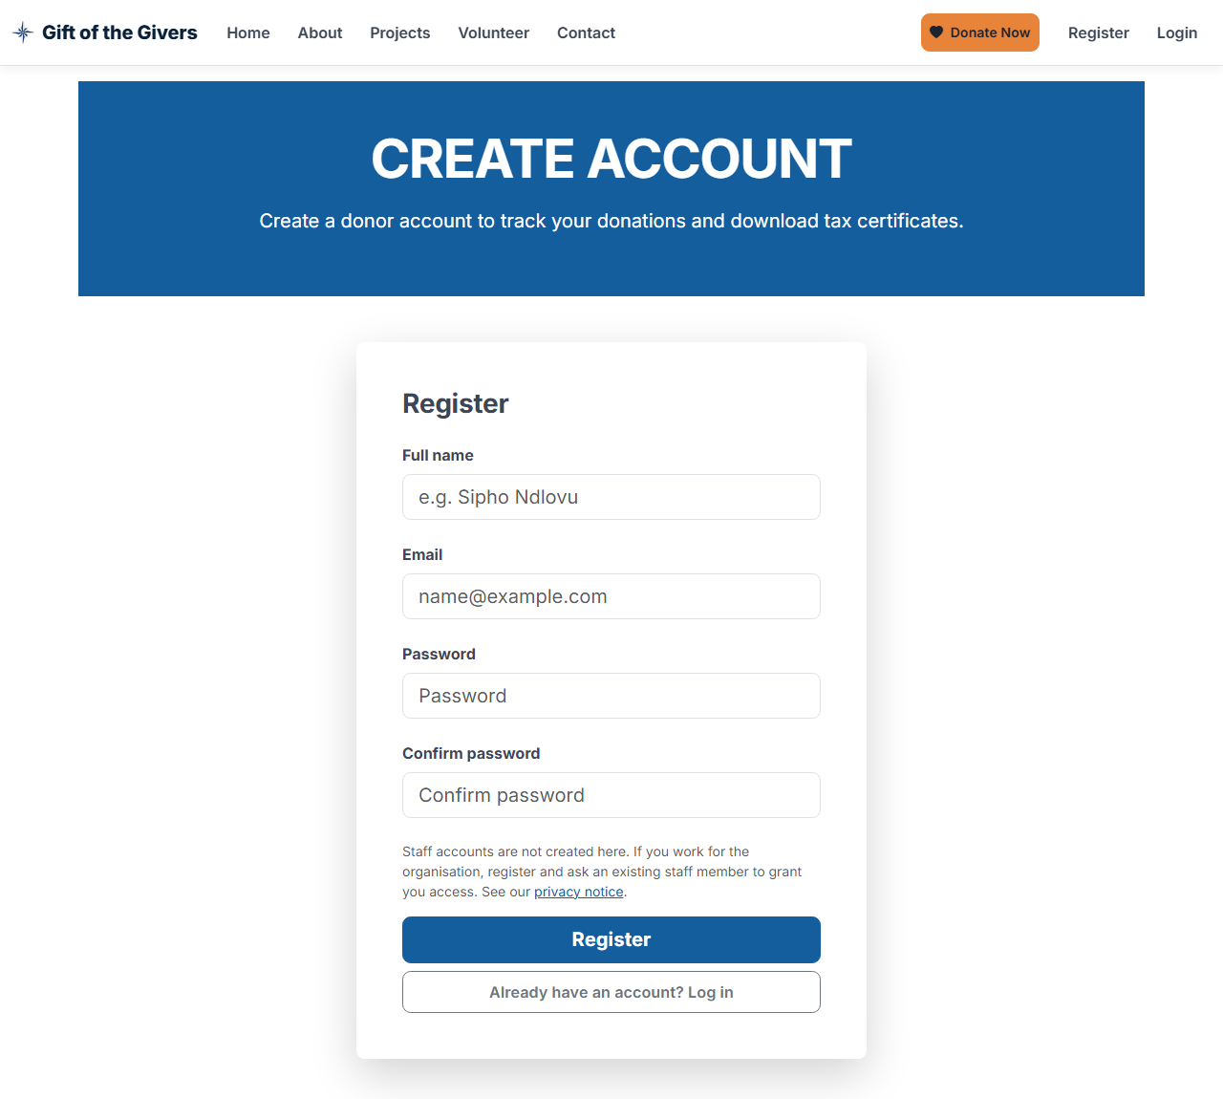
Registration page — no staff option

4. Journey J3 — Volunteer
Step | Actor | Route | Result
1 | Visitor | GET/POST /Home/Volunteer | Validated (consent required; DOB optional, ≥ 16 years); stored as Pending with consent time
2 | Employee | /Employee/Volunteers?status=Pending | Paged list filtered by status
3 | Employee | /Employee/VolunteerDetails/{id} → Approve / Reject | Status set, audit entry, email if configured
4 | Employee | Assign to an active project / Remove | VolunteerAssignments row (unique per pair); audited
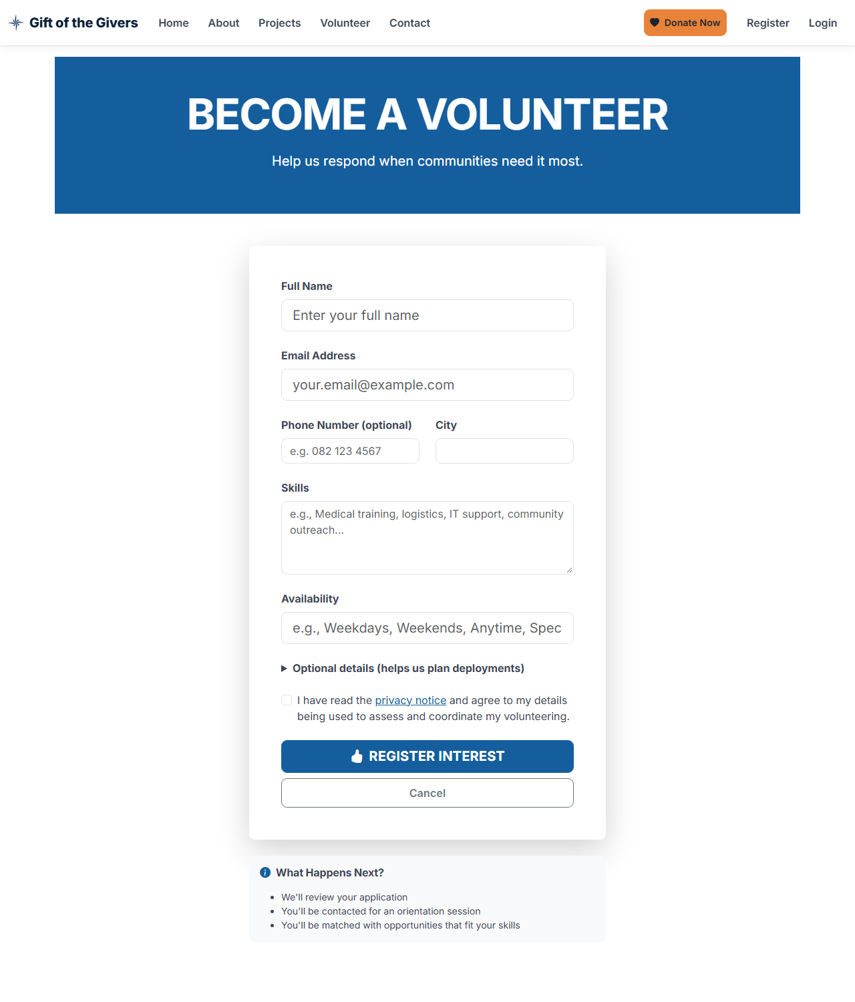
Volunteer application form

5. Journey J4 — Donation certificate
Step | Actor | Route | Rule
1 | Donor | /Donor/MyDonations | Certificate icon only on Paid rows
2 | Donor / Employee | /Donor/TaxCertificate/{id} | 404 unless Verified and (owner or Employee); view audited
3 | Donor / Employee | /Donor/DownloadTaxCertificate/{id} | PDF; download audited; demonstration watermark until PBO configured
— | Legacy links | /Donate/Tax-Certificate/{id}[/download] | 302 to the routes above
— | Integration | Function GET /api/tax-certificate/{reference} + function key | Verified only

6. Journey J5 — Funding reconciliation
- The employee dashboard shows “N projects whose funding total needs review”.
- /Employee/FundingReconciliation lists, per project: offline funds, paid online, expected, recorded, difference, and awaiting payment.
- Recalculate sets recorded = offline + paid (audit FundingRecalculated).
- Accept as offline keeps the recorded total and moves the unexplained difference into offline funds (audit FundingAcceptedAsOffline). Only allowed when the difference is positive.

7. Journey J6 — Contact
POST /Home/Contact stores the inquiry with consent → confirmation page → an acknowledgement email if SendGrid is configured → staff see it at /Employee/Inquiries (open first) → Mark handled (audited).

8. State machines

Donation payment status
From | Event | To | Side effects
— | Form submitted | Pending | None on totals
Pending | ITN COMPLETE, amount and merchant match | Verified | FundsRaised += AmountZar; certificate available; email; audit
Pending | ITN with any other status | Failed | Audit only
Verified | Any ITN | Verified | None (idempotent)
Failed | Any ITN | Failed | None

Volunteer status
From | Event | To
— | Application submitted | Pending
Pending / Rejected | Approve | Approved (ApprovalDate set)
Pending / Approved | Reject | Rejected (ApprovalDate cleared)

Project status
Active ⇄ Suspended → Completed (set by staff). Only Active projects accept donations and new volunteer assignments.

9. Route inventory
Method | Route | Auth | Purpose
GET | /, /Home/About, /Home/ReliefProjects, /Home/Privacy | Public | Information pages
GET/POST | /Home/Donate | Public | Donation form / capture → PayFast
GET | /Donate/Confirmation?reference= | Public (unguessable reference) | Receipt
GET/POST | /Home/Volunteer, /Home/Contact | Public | Applications and inquiries
GET | /Volunteer/Confirmation, /Contact/Confirmation | Public | Confirmations
POST | /Payments/Notify | PayFast signature + validation | ITN webhook
GET | /health, /health/live | Public | Readiness / liveness
* | /Identity/Account/* | Varies | Register (Donor only), Login, Manage
GET | /Donor/Dashboard, /Donor/MyDonations, /Donor/DonationDetails/{id} | Donor | Donor portal
GET | /Donor/TaxCertificate/{id}, /Donor/DownloadTaxCertificate/{id} | Donor (owner) or Employee | Certificates
GET | /Donate/Tax-Certificate/{id}[/download] | Donor or Employee | Legacy redirects
GET | /Employee/Dashboard, ReliefProjects, Volunteers, VolunteerDetails/{id}, Donations, ExportDonations, FundingReconciliation, Inquiries, AuditLog, StaffAccess | Employee | Staff views
GET/POST | /Employee/CreateReliefProject, EditReliefProject/{id}, CreateProjectUpdate, EditProjectUpdate/{id} | Employee | Project management
POST | /Employee/ApproveVolunteer, RejectVolunteer, AssignVolunteer, UnassignVolunteer, MarkInquiryHandled, RecalculateFunding, AcceptFundingAsOffline, GrantEmployee, RevokeEmployee | Employee | Staff actions (audited)
GET | Function /api/tax-certificate/{reference} | Function key | Certificate PDF

Deliverable 04: Design Brief
Visual identity, components, content rules and accessibility requirements, documented from the implemented design system.
Version 2.0 · 2026-11-02 · Status: Current — reflects the implemented UI

1. Design goals
- Trust first. Donors give money to a cause they cannot see. Every screen must look credible and say exactly what will happen. In particular, payment state is always explicit: Awaiting payment, Paid, Failed.
- Urgency without manipulation. Strong calls to action (“Donate Now”) but no fake counters, invented statistics or dark patterns.
- Mobile first for the public. Most visitors arrive from social media on phones. The donate form must work one-handed on a 390 px screen.
- Calm, efficient staff tools. Dense tables, clear filters, confirmations for destructive actions, nothing decorative.
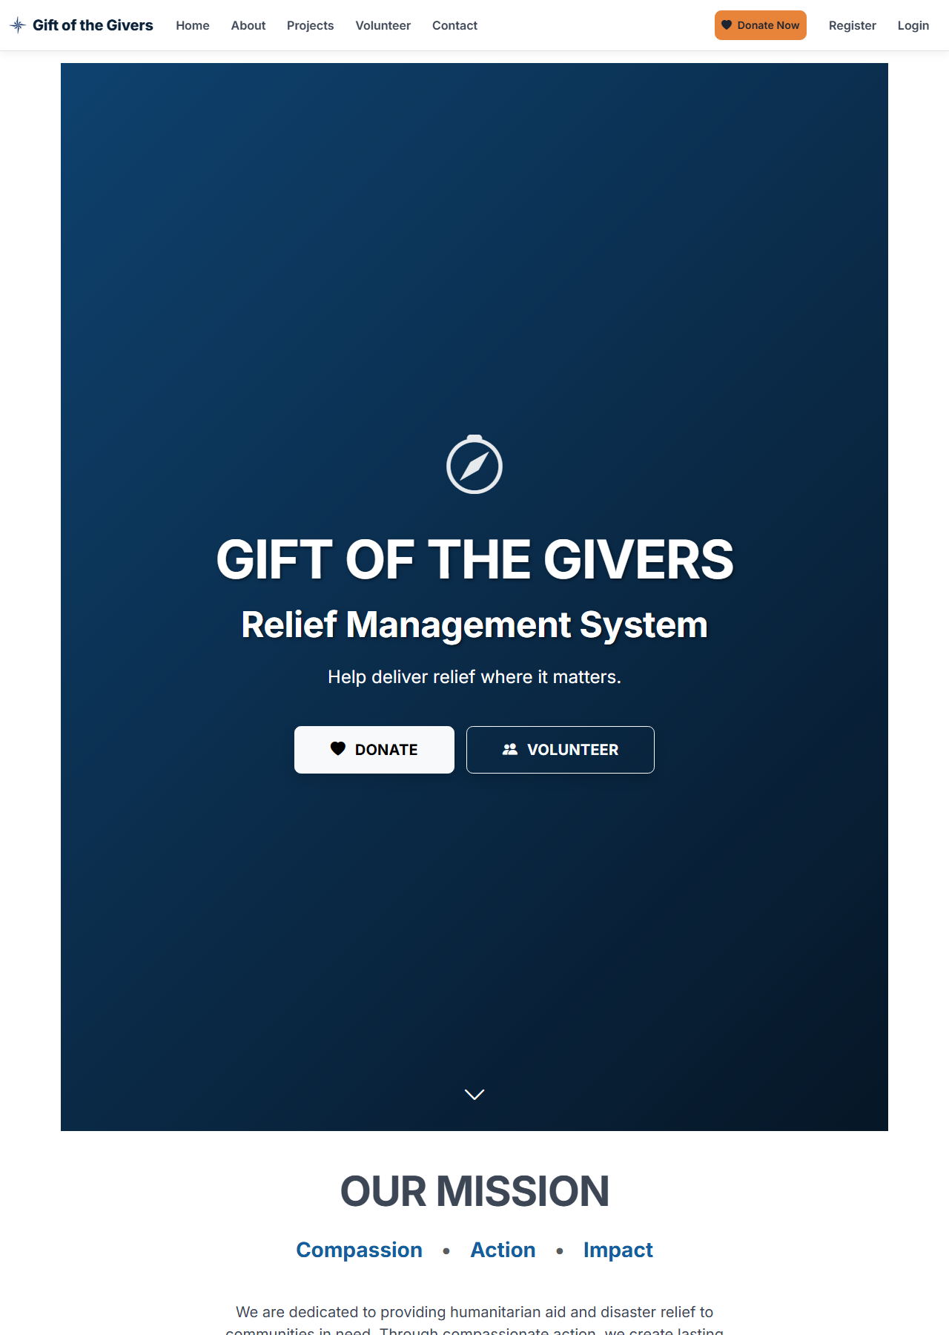
Home page

2. Brand tokens
All tokens live in GiftOfTheGivers/wwwroot/css/site.css (:root) and override Bootstrap 5 variables. Do not hard-code colours in views; use the tokens or Bootstrap utilities mapped to them.
Colour | Hex | Use
Primary | #155E9E | links, primary buttons, headers
Primary dark | #0F4676 | hover, emphasis
Navy | #0A2138 | footer, hero gradient
Accent | #E8833A | Donate Now, highlights
Primary subtle | #E7F0F8 | tints, table heads
Ink | #1B2430 | headings
Body | #3C4655 | body text
Muted | #6B7684 | secondary text
Success | #198754 | Paid, approved
Warning | #FFC107 | Awaiting payment, test mode

Token | Value
Font | Inter (Google Fonts) with a system fallback stack; weights 400–800
Radius | 0.375 / 0.55 / 0.85 / 1.1 rem (sm / default / lg / xl)
Focus ring | Primary at 25% opacity (Bootstrap focus ring)
Breakpoints | Bootstrap defaults; custom rules at ≥ 768 px
Contrast (measured, WCAG 2.x formula): primary #155E9E on white 6.72:1, body #3C4655 on white 9.55:1, muted #6B7684 on white 4.62:1 — all pass AA for normal text. White text on the accent #E8833A is 2.71:1 and fails AA even for large text (3:1). Ink text #1B2430 on the accent is 5.77:1 and passes, so the Donate Now / accent buttons now use ink text, with a lighter hover (#F09A5C, 7.07:1). This fixed design debt item D-03 during remediation.

3. Typography
Use | Style
Page hero titles | display-3/4, uppercase, bold, white on primary band
Section titles | h2–h3, ink colour
Body | 1rem Inter, body colour, line-height ~1.6
Data and references | Monospace (font-monospace, <code>) for transaction references
Money | Always through Money.Format / Money.Zar: “R 1,234.50”, “$ 75.00”, “€ 10.00”. Never culture-dependent ToString("C")

4. Layout
- Public pages: full-width coloured hero band, then content centred in container with max ~8 columns for forms (col-lg-6 for the donate form), and a dark navy footer with three columns.
- Staff pages: container my-5 with page title, lead sentence, filter pills or tabs, a summary card, then a responsive table (table-responsive) and the pager.
- Grid: Bootstrap 12 columns. Cards use shadow-sm (staff) and shadow-lg (primary public forms).

5. Components
Component | Use | Rules
Primary button | Main action per screen | One per form. Labels state the result: “CONTINUE TO PAYMENT”, not “Submit”
Donate Now (accent) | Global navigation | Always visible; links to /Home/Donate; ink text on orange for contrast
Payment status badge | Anywhere a donation is shown | _PaymentStatusBadge: Paid (green), Awaiting payment (amber), Failed (red). Never infer status from other fields
Flash messages | After POST-redirect-GET | _StatusMessages in the layout, role="status", dismissible
Validation summary | Every form | asp-validation-summary="All" with role="alert"; hidden when empty (.validation-summary-valid)
Consent checkbox | Every form collecting personal data | Links to the privacy notice; required on the server
Pager | Staff lists | _Pager: Previous/Next, “Page x of y · n records”
Confirmation | Destructive staff actions | data-confirm="…" on the button (handled in site.js). Never inline JavaScript with user data
Impact stats | Home and About | ImpactStats view component (band or cards); always labelled “Live figures from this system”
Demo badge | Footer, certificates | Shown while Organisation:IsDemo is true

6. Content rules
- No invented numbers. Statistics come from the database or are removed. Narrative examples are labelled illustrative.
- No borrowed identity. Contact details, registration numbers and PBO references come from configuration. Placeholders show “Not configured” instead of fake values.
- Say what happens next. Before payment: “You will be sent to PayFast… No real money is taken (test mode).” After payment: the actual status.
- Plain language at about a Grade 8 reading level; sentence case for body text; uppercase only for hero titles.
- Monthly pledge, not “recurring donation”, until automatic billing exists.

7. States
State | Pattern | Example
Empty | Neutral alert-info with what to do next | “No donations match this filter.”
Loading | Server-rendered pages; no spinners needed. Long actions (PDF) open as downloads | —
Success | Green flash, or a receipt with a green check | Paid receipt
Pending | Amber hourglass and “Awaiting payment” | Receipt before the ITN arrives
Error (validation) | Summary at top + field messages | Donate form
Error (server) | /Home/Error with request id (production) | —
Forbidden | Identity Access Denied page | Donor opening a staff page

8. Accessibility requirements (WCAG 2.2 AA target)
Requirement | Implementation
Labels for every input | asp-for labels; radio groups wrapped in fieldset + legend
Errors announced | Validation summary has role="alert"; flash messages have role="status"
Keyboard | Native controls only; visible focus ring from Bootstrap
Icons | Decorative icons have aria-hidden="true"; icon-only buttons have visually hidden text
Live region | Rand equivalent on the donate form uses aria-live="polite"
Motion | Intro animation honours prefers-reduced-motion and has a Skip button
Tables | scope="col" headers on staff tables
Language | lang="en"
Not yet verified with assistive technology or automated tools. An axe and Playwright suite is in the implementation plan (T-2.5).

9. Screens
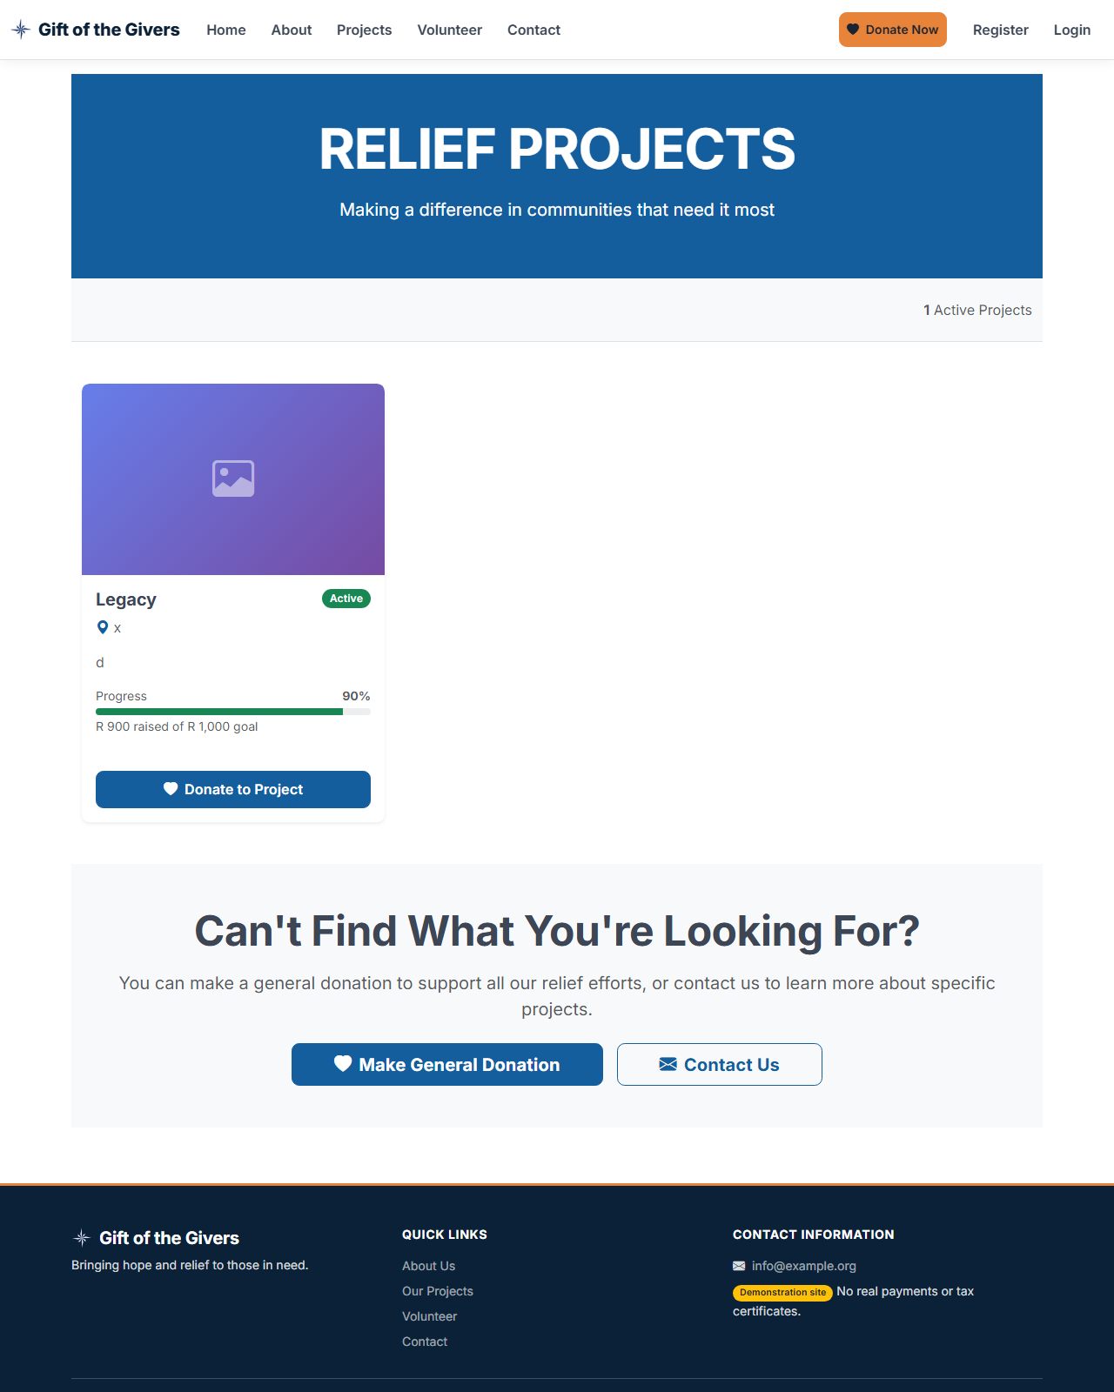
Relief projects with funding progress (rand)
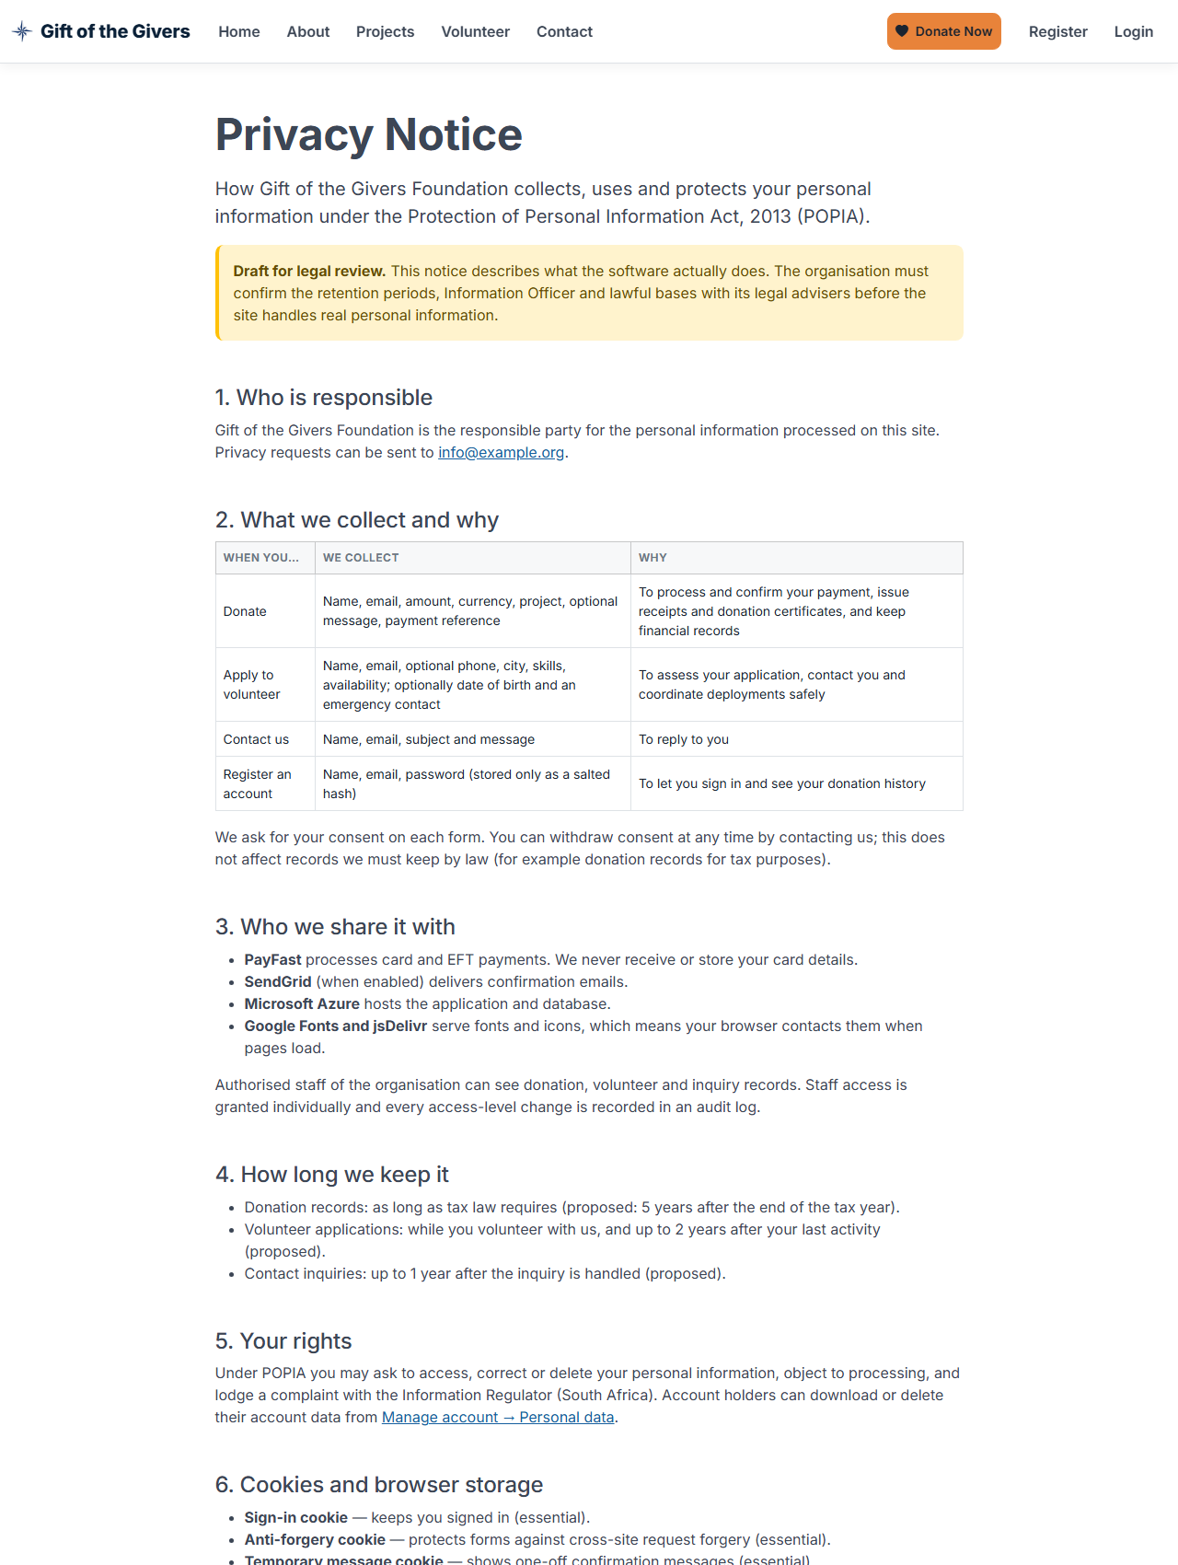
Privacy notice with draft banner

Intro animation (first visit per session; skippable; reduced-motion aware)

10. Design debt
ID | Item | Proposal
D-01 | Inline styles and scripts in several views | Move to site.css / site.js (also enables a strict CSP)
D-02 | Hero bands use bg-primary with large uppercase headings on every page | Reduce on staff pages to save vertical space
D-03 | White text on the accent button (2.71:1) | Fixed: ink text (5.77:1), lighter hover (7.07:1)
D-04 | Staff tables on phones scroll horizontally | Card layout for narrow screens
D-05 | Fonts and icons come from third-party CDNs | Self-host (privacy, reliability)

Deliverable 05: Backend Schema
Database design, constraints, relationships, derived values and migration history for SQL Server / Azure SQL.
Version 2.0 · 2026-11-02 · Status: Current — at migration AuditRemediationNov2026

1. Overview
- Engine: SQL Server 2022, Azure SQL, or LocalDB, through EF Core 10. Migrations are the source of truth; CI fails if the model and migrations differ.
- Context: GiftOfTheGivers/Data/ApplicationDbContext.cs, which extends IdentityDbContext<AppUser> and implements IDataProtectionKeyContext.
- Integrity strategy: constraints in the database (check, unique, foreign key) plus validation in the application. Money is decimal; time is UTC datetime2; concurrency uses rowversion.
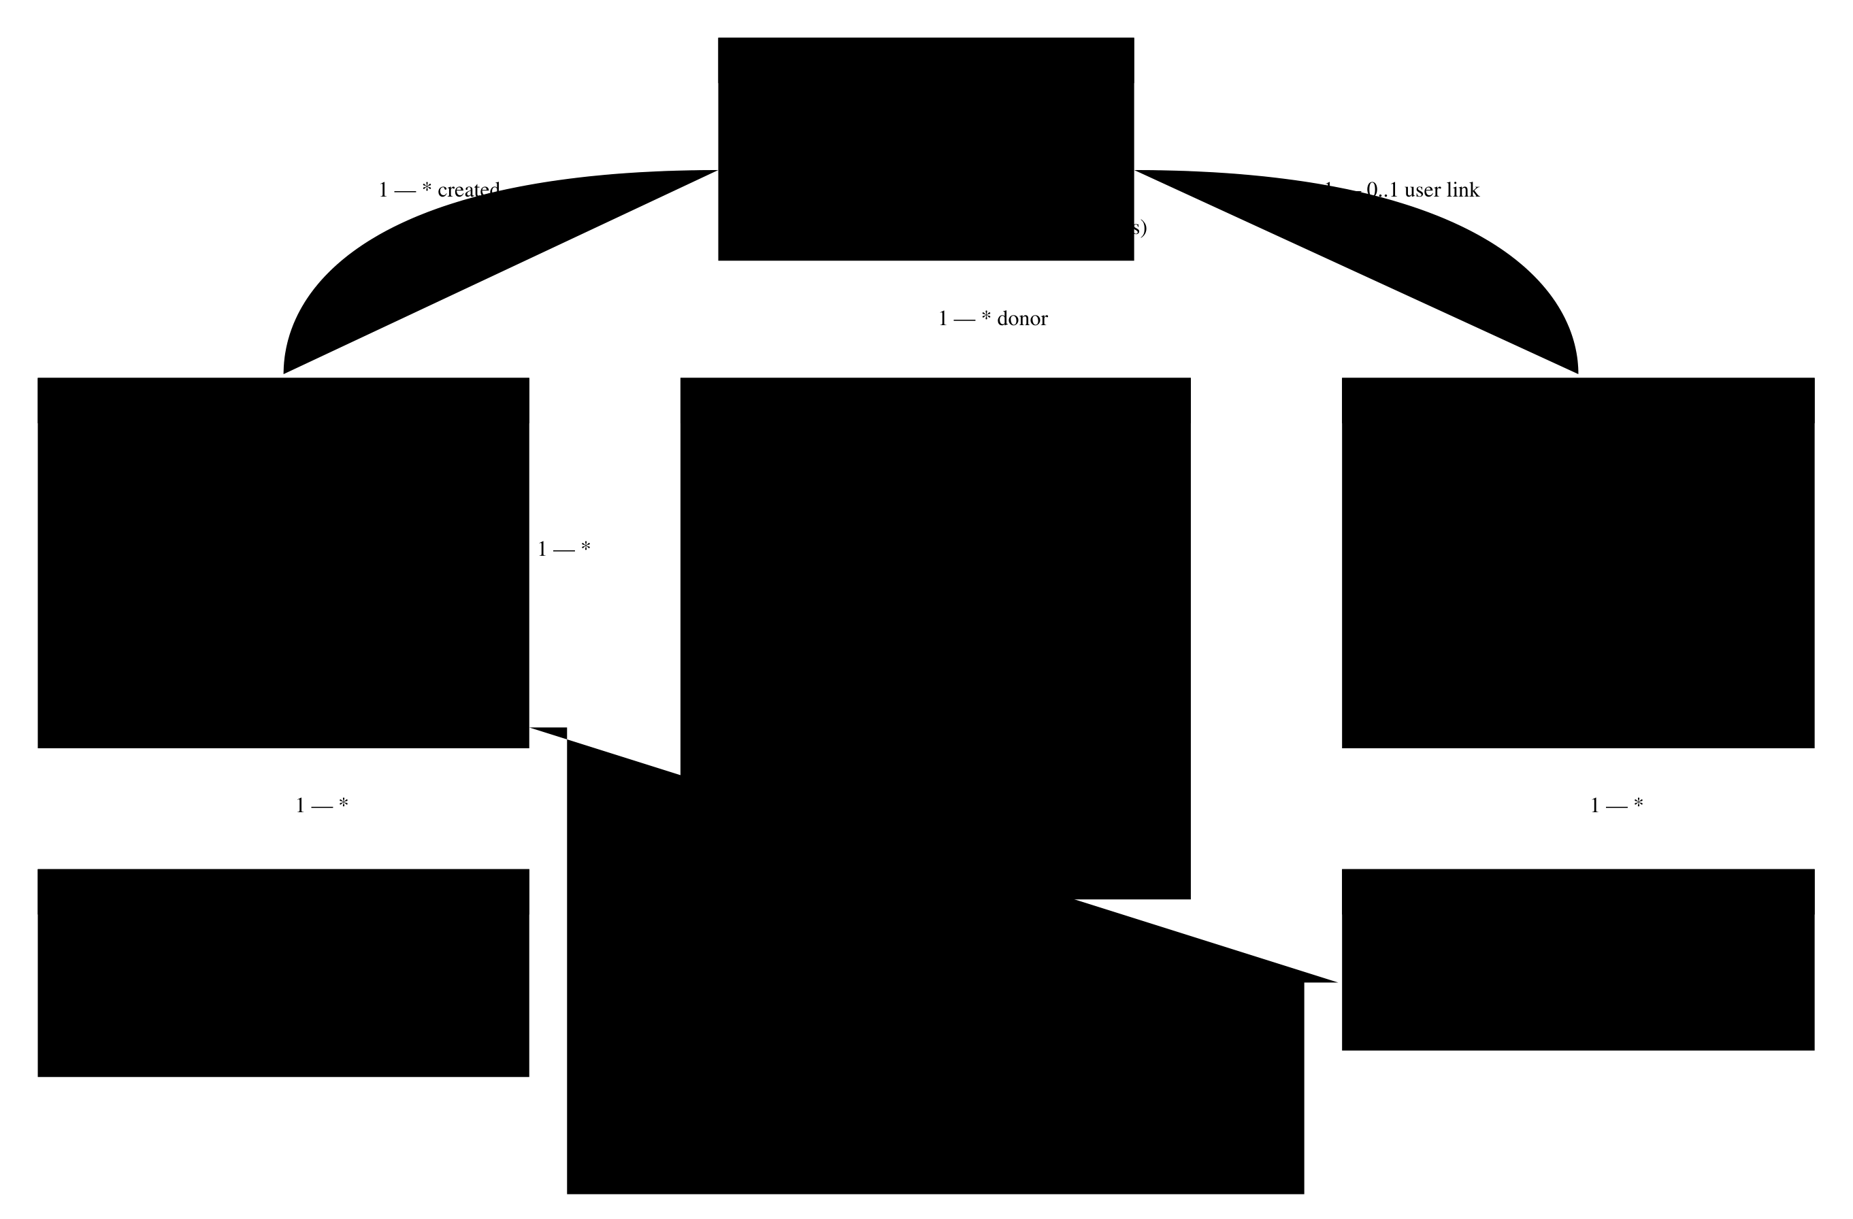
Entity relationship diagram

2. Tables

2.1 ReliefProjects
Column | Type | Null | Rules
Id | int identity | No | PK
CreatedByUserId | nvarchar(450) | Yes | FK → AspNetUsers (Restrict)
Title | nvarchar(200) | No
Description | nvarchar(max) | No | Input limited to 2,000 characters
Location | nvarchar(100) | No
StartDate / EndDate | datetime2 | No / Yes | CK_ReliefProject_Dates: EndDate is null or ≥ StartDate
Status | nvarchar(max) (enum as string) | No | CK_ReliefProject_Status: Active, Completed, Suspended
FundsRequired | decimal(18,2) | No | CK_ReliefProject_FundsRequired_NonNegative
OfflineFundsZar | decimal(18,2) | No | CK_ReliefProject_OfflineFunds_NonNegative; staff-maintained
FundsRaised | decimal(18,2) | No | Derived: OfflineFundsZar + Σ AmountZar of Verified donations
ImageUrl | nvarchar(max) | Yes | http(s) only, ≤ 500 characters (validated)
RowVersion | rowversion | — | Optimistic concurrency token
CreatedDate | datetime2 | No | UTC

2.2 Donations
Column | Type | Null | Rules
Id | int identity | No | PK (internal only, never in public URLs)
DonorId | nvarchar(450) | Yes | FK → AspNetUsers (SetNull when the user is deleted)
ReliefProjectId | int | Yes | FK → ReliefProjects (Restrict); null = General Fund
DonationType | nvarchar(20) | No | CK_Donation_Type: OneTime, Recurring (pledge)
Currency | nvarchar(3) | No | CK_Donation_Currency: ZAR, USD, EUR
Amount | decimal(18,2) | No | CK_Donation_Amount > 0; in the chosen currency
AmountZar | decimal(18,2) | No | CK_Donation_AmountZar > 0; charged to PayFast; used for all totals
ExchangeRateToZar | decimal(18,6) | No | CK_Donation_ExchangeRate > 0; 1 for ZAR
PaymentMethod | nvarchar(50) | No | CK_Donation_PaymentMethod: Card, EFT, Cash
PaymentStatus | int | No | 0 Pending, 1 Verified, 2 Failed
PaymentVerifiedAt | datetime2 | Yes | Set by a verified ITN
ProviderPaymentId | nvarchar(50) | Yes | PayFast pf_payment_id
IdempotencyKey | uniqueidentifier | No | Unique; one donation per form submission
TransactionReference | nvarchar(100) | Yes | Unique; 32 hex characters; PayFast m_payment_id; public receipt key
DonorName / DonorEmail | nvarchar(100) / nvarchar(200) | Yes
IsAnonymous | bit | No | Hides the name on certificates and reports
TaxCertificateIssued | bit | No | True once verified
Notes | nvarchar(500) | Yes
DonationDate | datetime2 | No | UTC
PrivacyConsentAt | datetime2 | Yes | Null only for rows created before remediation
Indexes: DonorId, ReliefProjectId, (DonorId, DonationDate), (PaymentStatus, DonationDate), and unique IdempotencyKey and TransactionReference.

2.3 Volunteers
Column | Type | Null | Rules
Id | int identity | No | PK
UserId | nvarchar(450) | Yes | FK → AspNetUsers (SetNull)
FirstName / LastName | nvarchar(100) | No
Email | nvarchar(200) | No | Indexed
PhoneNumber | nvarchar(20) | Yes | Optional, never invented
Address / City / Province / PostalCode | 200 / 100 / 50 / 10 | Yes
DateOfBirth | datetime2 | Yes | Optional; ≥ 16 years if given
Skills / Availability | nvarchar(max) | No | Input limited to 2,000 / 200 characters
EmergencyContactName / Phone | nvarchar(200) / nvarchar(20) | Yes
Status | nvarchar(450) (enum as string) | No | CK_Volunteer_Status: Pending, Approved, Rejected; index (Status, ApplicationDate)
ApplicationDate / ApprovalDate | datetime2 | No / Yes | UTC
Notes | nvarchar(max) | Yes
PrivacyConsentAt | datetime2 | Yes

2.4 Other tables
Table | Key columns | Notes
VolunteerAssignments | VolunteerId (Cascade), ReliefProjectId (Restrict), AssignedDate | Unique (VolunteerId, ReliefProjectId)
ProjectUpdates | ReliefProjectId (Restrict), PostedByUserId (Restrict), Title(200), Content, ImageUrl, CreatedBy, CreatedDate, LastModifiedDate
Inquiries | Name(200), Email(200), Subject(200), Message(4000), SubmittedDate, Handled, PrivacyConsentAt
AuditLogs | UserId(450), Action(100), TargetEntity(100), TargetId, Details(1000), Timestamp | Index (TargetEntity, TargetId) and Timestamp. Payment events use actor system:payfast
DataProtectionKeys | FriendlyName, Xml | ASP.NET Core key ring shared by all instances
AspNet* | Identity schema (key length 450) | Stores.MaxLengthForKeys = 0 keeps the runtime model matching this schema

3. Relationships and delete behaviour
Relationship | Cardinality | On delete | Reason
User → Donations | 1 : * (optional) | SetNull | Deleting an account must not delete financial records
User → Volunteers | 1 : 0..1 (optional) | SetNull | Same
User → Projects (creator), Updates (poster) | 1 : * | Restrict | Keep authorship; deactivate staff instead of deleting
Project → Donations | 1 : * | Restrict | Financial history must survive
Project → Updates, Assignments | 1 : * | Restrict | Avoid multiple cascade paths in SQL Server
Volunteer → Assignments | 1 : * | Cascade | Assignments have no meaning without the volunteer

4. Derived values and invariants
Invariant | Enforced by
FundsRaised = OfflineFundsZar + Σ(AmountZar where PaymentStatus = Verified) | DonationService (verification), offline-funds delta on edit, RecalculateFundsRaisedAsync, Funding Reconciliation page
A donation is counted once | Status check (Verified short-circuits) + rowversion retry
One donation per form submission | Unique IdempotencyKey, plus catch-and-return of the winning row
Certificate only for paid gifts | Query filter PaymentStatus = Verified in every certificate path
Staff changes are traceable | AuditService.Record staged in the same SaveChanges

5. Concurrency
ReliefProjects.RowVersion protects totals. Payment verification and recalculation retry up to three times on DbUpdateConcurrencyException. A project edit that conflicts shows “changed by someone else, reload”. The EF SQL Server retry strategy (EnableRetryOnFailure) handles transient faults. No user-initiated transactions are used, so it is compatible.

6. Migration history
Migration | Summary | Notes
20260828181123_InitialCreate | Identity, projects, donations, volunteers, updates, assignments
20260924181920_SyncCurrentModel | RowVersion, PaymentStatus, FK changes
20260924191049_P1PaymentsEmailAndStatuses | DonorEmail, IdempotencyKey, AuditLogs, Inquiries, check constraints | Edited during remediation (F-21): the AlterColumn on RowVersion was removed because SQL Server cannot alter a rowversion column, so the migration failed on every empty database
20260924195240_P0Phase0CriticalFixes | Donor FK; raw-SQL check constraints | The raw constraints duplicated EF-managed ones (dropped in the remediation migration)
20260924200101_FixPendingModelChanges | Empty | Symptom of drift-chasing under the suppressed warning
20260925180656_SyncDonorCascade | Donor FK SetNull
(removed) 20260924190000_P0SecurityAndDonationIntegrity | — | Orphan file without a [Migration] attribute; never discovered by EF; deleted
20261102112731_AuditRemediationNov2026 | AmountZar, ExchangeRateToZar, DonorName, PaymentVerifiedAt, ProviderPaymentId, PrivacyConsentAt (×3), OfflineFundsZar, nullable DOB/phone, sized audit columns + Details, DataProtectionKeys, new check constraints and index | Backfills rand values (ZAR exact; USD 18.50 and EUR 20.00 indicative), normalises PaymentMethod (PayPal → Card), sets PaymentVerifiedAt for verified rows, drops the duplicate constraints. Down re-creates them
Verification (2026-11-02, LocalDB): old chain applied to an empty database, legacy rows inserted (ZAR, USD with PayPal, EUR), upgrade applied, values checked, rolled back and re-applied, drift check clean. CI repeats the empty-database apply plus rollback/re-apply on SQL Server 2022 for every push.

7. Data lifecycle and privacy
Data | Retention (proposed, pending legal review) | Deletion path
Donations | 5 years after the end of the tax year | Not deleted; anonymise donor fields on request after retention
Volunteers | 2 years after last activity | Staff deletion (to be built, T-2.4)
Inquiries | 1 year after handled | Scheduled purge (to be built, T-2.4)
Accounts | Until the user deletes them | Identity Delete personal data; donations keep SetNull links
Audit logs | 5 years | Append-only

8. Seed data (Development only)
Roles Donor and Employee are created in every environment. In Development (or with Seed:DemoData=true): two demo accounts, six projects with offline funds, three volunteers (two approved, assigned to two projects), and three donations (two verified, one pending) so dashboards and reconciliation show both states.

Deliverable 06: Implementation Plan
What has been delivered, what remains, and the order to build it in — with acceptance criteria and preliminary estimates.
Version 2.0 · 2026-11-02 · Status: Current — Phase 0 complete, Phase 1 next

1. Planning principles
- Order by dependency, not just severity. Tests and CI gates come before refactors; legal and merchant prerequisites come before real money.
- Every task closes a finding or a requirement. Task IDs reference audit finding IDs (F-nn) or requirement IDs (FR-nn, NFR-…).
- Definition of done (applies to every task): code with an integration test, CI green (tests, vulnerability gate, drift check, migrations on SQL Server), audit entries for staff actions, docs updated, finding status updated in docs/audits/findings-register.json.
- Estimates are preliminary (one developer familiar with ASP.NET Core). The main uncertainties are external: PayFast onboarding, legal review and Azure access.

2. Milestones
Milestone | Exit criteria | Target maturity
M0 — Stabilised (done, 2026-11-02) | No open Critical findings; money integrity; staff access controlled; 98 tests; CI gates | Beta
M1 — Production candidate | F-23 closed (sandbox payment end to end), live environment verified, backups tested, legal review of privacy, staff MFA, monitoring and alerts | Production candidate
M2 — Production | Live merchant, PBO details, first real donation reconciled, runbooks rehearsed | Production ready
M3 — Growth | Recurring billing, live FX, retention automation, reporting | Mature

3. Phase 0 — Audit remediation (complete)
Task | Outcome | Findings closed | Status
T-0.1 | Registration always creates Donor; Staff Access page; bootstrap staff via configuration | F-01 | Done
T-0.2 | Function key, reference lookup, verified-only certificates | F-02 | Done
T-0.3 | DonationService: pending capture, single verified increment, amount/merchant checks, idempotency | F-03, F-04, F-20 | Done
T-0.4 | Rand normalisation (AmountZar, rates) with historical backfill | F-05 | Done
T-0.5 | PayFast checkout wired; return, cancel and receipt by reference; options validator | F-06 (partial) | Done, E2E pending
T-0.6 | Certificates verified-only; issuer from configuration; demo watermark | F-07, F-40 | Done
T-0.7 | Patched crypto packages; source mapping; audit sources | F-08, F-24, F-25 | Done
T-0.8 | Privacy notice, consent capture, no invented data | F-09 (partial), F-32 | Done, legal review pending
T-0.9 | Validation and error display on all forms | F-16 | Done
T-0.10 | Rate limiting, security headers, SRI, Data Protection keys, forwarded headers | F-12, F-15, F-19, F-44 | Done
T-0.11 | Offline funds + Funding Reconciliation | F-03 | Done
T-0.12 | Audit log for all staff actions; paging; navigation | F-28, F-30, F-41 | Done
T-0.13 | Volunteer assignment UI; donation CSV export | FR-33, FR-34 | Done
T-0.14 | Migration chain fixed for empty databases; drift unsuppressed; remediation migration | F-11, F-21, F-22 | Done
T-0.15 | CI: locked restore, coverage, vuln gate, drift, SQL Server migrations; CD gated; publish fixed | F-14, F-34 | Done
T-0.16 | Live impact stats; organisation config; honest copy; accent contrast | F-18, D-03 | Done
T-0.17 | Docs: README, setup, contributing, security, PR template, deliverables 01–08 | F-35 | Done

4. Phase 1 — Production candidate (next)
Task | Problem / evidence | Desired outcome | Areas | Effort | Depends on | Acceptance criteria | Tests
T-1.1 Verify payments end to end | F-23: shared sandbox rejects signatures | Own PayFast sandbox merchant with passphrase; sandbox payment completes and the ITN verifies the donation | Config, ops | 0.5–1 d | PayFast sandbox account; public tunnel or staging URL | A real sandbox payment shows Paid, the project total increases once, audit entry PaymentVerified | Manual script recorded in the addendum; keep the integration tests
T-1.2 Verify the live environment | F-10, F-02 | App Service runs Production; demo accounts removed; old anonymous function removed | Azure | 2–4 h | Azure access | /ApplyDatabaseMigrations absent; no demo logins; function returns 401 without a key | Smoke checklist
T-1.3 Staff MFA and lockout | F-36 | Scaffolded Login with lockoutOnFailure: true; TOTP MFA required for Employees | Identity pages, policy | 1–2 d | — | 5 failed logins lock for 15 min; Employee pages redirect to MFA setup until enabled | Integration tests for lockout and the MFA policy
T-1.4 Backups and restore drill | F-17 | Azure SQL PITR retention confirmed; documented restore to a copy | Ops, docs | 0.5 d | Azure access | Restore performed and timed; RPO/RTO recorded in 07 | Drill record
T-1.5 Monitoring and alerts | F-38 | Application Insights (or OpenTelemetry); alerts on 5xx rate, health failures, ITN rejections | Program.cs, Azure | 1 d | Azure access | Alert fires in a test; dashboards exist | Synthetic check
T-1.6 Production migration step | F-13 | Database:MigrateOnStartup=false; pipeline applies migrate.sql before deploy | Pipelines | 0.5 d | T-1.2 | Deploy log shows the script step; app starts with no pending migrations | Pipeline run
T-1.7 Privacy sign-off | F-09 | Legal review of the notice; Information Officer named; retention periods confirmed | Content, config | External | Organisation | Notice banner removed; Organisation:InformationOfficerEmail set | Content review
T-1.8 Reconcile live data | F-03 | Funding Reconciliation run on the live database after deploy | Ops | 1 h | T-1.6 | All projects balanced or accepted with audit entries | Audit log
T-1.9 Review existing staff accounts | F-01 | Self-registered Employee accounts revoked | Ops | 1 h | T-1.2 | Staff list matches the real team | Audit log

5. Phase 2 — Engineering quality and features
Task | Outcome | Findings / requirements | Effort
T-2.1 | Recurring billing through PayFast subscriptions: subscription token, child donation per ITN, cancel from the donor portal | F-37, FR-18 | 4–6 d
T-2.2 | Exchange-rate table with effective dates (staff-maintained or provider-fed); rate shown on the receipt | F-46 | 2–3 d
T-2.3 | Extract GiftOfTheGivers.Data (DbContext, models, PDF) used by web and function; function deploy job and tests | F-29, F-42 | 2 d
T-2.4 | Retention jobs (purge or anonymise per policy); staff deletion of volunteers and inquiries; data export for privacy requests | NFR-PRIV-03 | 2–3 d
T-2.5 | Playwright smoke tests + axe accessibility checks in CI (donate, volunteer, register, staff pages; desktop and mobile) | NFR-A11Y-01, F-39 | 2 d
T-2.6 | Move inline scripts and styles to files; strict CSP with nonces | F-19, D-01 | 1–2 d
T-2.7 | Reporting: monthly totals per project and currency, volunteer pipeline | FR-34 | 2 d
T-2.8 | Self-host fonts and icons | D-05 | 0.5 d
T-2.9 | Load test (k6) of public pages and the ITN; record p95 | NFR-PERF-02 | 1 d

6. Phase 3 — Strategic
Task | Outcome | Effort
T-3.1 | Bicep IaC for App Service (Standard tier with slots), Azure SQL, Function App, Key Vault | 3–4 d
T-3.2 | Blue/green deploys with slot swap and automatic rollback on failed health | 1–2 d
T-3.3 | Consolidate on one CI system (GitHub Actions or Azure Pipelines) | 1 d
T-3.4 | Notification centre (email templates, retries via a queue) | 3 d

7. Risks to the plan
Risk | Impact | Mitigation
PayFast onboarding delays | Blocks M1/M2 | Start the merchant application now; keep the sandbox path working
Legal review unavailable | Blocks collecting real volunteer data | Keep IsDemo and the draft banner until signed off
Single maintainer | Bus factor | PR template, CI gates, these documents, audit register
Free hosting tier | No slots, cold starts | T-3.1 before real traffic

Deliverable 07: CI/CD and Release
Pipelines, quality gates, secrets, environments, the release procedure, migrations, rollback, backup and recovery.
Version 2.0 · 2026-11-02 · Status: Current — pipelines updated during remediation; release steps partly manual

1. Pipeline overview

CI/CD pipelines as configured in the repository
Pipeline | File | Trigger | Gates / outputs
CI — Build, test, audit | .github/workflows/ci.yml | Push to main, feature/**, fix/**; PR to main | Locked restore → Release build → 98 tests + coverage (artifact) → fail on vulnerable packages → fail on EF model drift
CI — Migrations on SQL Server | same file, job migrations | Same | SQL Server 2022 service container → apply all migrations to an empty DB → roll back the latest and re-apply → migrate.sql (idempotent) artifact
CD | .github/workflows/cd.yml | workflow_run: CI completed successfully on main (push) | Container image to GHCR :sha and :main, OCI labels
Mirror | .github/workflows/mirror-to-azure-devops.yml | Any push | git push --mirror to Azure DevOps
Publish Helpers | .github/workflows/publish-helpers-package.yml | main, tags helpers-v*, manual | SemVer check → explicit AZURE_ARTIFACTS_PAT preflight and feed authentication → helper tests → pack → push to Azure Artifacts
Azure Pipelines | azure-pipelines.yml | Mirrored main, feature/*; PR to main | Locked restore, build, test (TRX), vuln gate, drift check, migrations artifact, webapp zip → DeployDev on main
All GitHub workflows declare least-privilege permissions. CD is the only one with packages: write.
Status. These pipeline definitions were changed during remediation and have not yet run on GitHub or Azure DevOps. Their steps were executed locally where possible (restore, build, tests, vulnerability list, drift check, migrations on LocalDB, idempotent script). Record the first green runs in the next audit.

2. Secrets and variables
Name | Where | Used by | Notes
GITHUB_TOKEN | GitHub (automatic) | CD | packages: write only in CD
AZURE_DEVOPS_REPO_URL, AZURE_DEVOPS_PAT | GitHub secrets | Mirror | PAT scope: Code read and write
AZURE_ARTIFACTS_PAT | GitHub secret | Publish Helpers | Required; the workflow fails early with a setup hint if missing. PAT scope: Packaging read and write; passed via env
azureServiceConnection, azureWebAppName | Azure DevOps variables | DeployDev | Deploy is skipped if empty
App settings (connection string, PayFast__*, SendGrid__ApiKey, Organisation__*, StaffAccess__BootstrapEmployeeEmails__0) | App Service configuration / Key Vault | Runtime | Never in the repository
The CI migrations job uses a throwaway SQL Server password that exists only inside the job’s container. It is not a secret.

3. Branching and protection
- Branches: feature/<name>, fix/<name>; PRs into main using the PR template.
- Required on main: one approval; status checks Build, test, audit and Apply migrations to SQL Server; no direct pushes; linear history recommended.
- Tag releases as vYYYY.MM.N (web app) and helpers-vX.Y.Z (package).

4. Environments
Environment | Hosting | Database | Deploy source | Config highlights
Local | dotnet run / Docker Compose | LocalDB / container | Developer | Development, demo data, sandbox
CI | GitHub runner | SQL Server 2022 service | — | Throwaway
Dev (giftgivers-dev) | Azure App Service (Free F1 today) | Azure SQL | Azure Pipelines DeployDev | Production environment name, sandbox payments, IsDemo=true
Production (planned) | App Service Standard with slots | Azure SQL (PITR) | Same artifact, after approval | Live PayFast (passphrase required), IsDemo=false, MigrateOnStartup=false, ForwardedHeaders:Enabled=true on Linux

5. Release procedure
- Prepare. Merge to main with CI green. Note the commit SHA and the finding IDs closed.
- Database. Download the migrations/migrate.sql artifact from the run. Review it for destructive statements. Take an on-demand backup (or note the PITR timestamp). Apply the script to the target database: it is idempotent, so applying it twice is safe.
- Deploy the webapp artifact (Azure Pipelines DeployDev, or the GHCR image) with Database:MigrateOnStartup=false.
- Verify (smoke checklist):
  - GET /health returns Healthy (database reachable) and /health/live returns 200.
  - Home, Projects, Donate and Privacy return 200; response headers include CSP and X-Frame-Options: DENY.
  - Make a sandbox donation (or a live R 5 test in production), confirm PayFast returns to the receipt, and that the donation shows Paid after the ITN.
  - The Employee dashboard shows no unexpected projects needing review; the audit log shows the PaymentVerified entry.
- Record the release (tag, date, SHA, migration ids, verification result) in the release notes.

Release notes template
Release vYYYY.MM.N — <date> — <sha>
Changes: <summary>; closes F-nn, F-nn
Database: migrations <ids> (backfill: yes/no; destructive: yes/no)
Config changes: <keys>
Verification: health ✔, smoke ✔, sandbox/live payment ✔ (<reference>)
Rollback point: <PITR timestamp / previous artifact>

6. Rollback
Situation | Action
App defect, schema unchanged | Redeploy the previous artifact (or swap slots once T-3.2 exists)
App defect after an additive migration | Redeploy the previous artifact. Additive columns are ignored by older code
Migration defect | dotnet ef database update <previous migration> generates the Down() script. The remediation migration’s Down has been tested (LocalDB). For data loss, restore to a new database from PITR and switch the connection string
Payment issue | Set PayFast:Enabled=false (donations are recorded as Pending and nothing is charged), investigate, re-enable
Backward compatibility: migrations must be additive in the release that introduces them. Drop columns one release later, after no running code uses them.

7. Backup and disaster recovery
Item | Target (proposed) | Current state
Database backups | Azure SQL automated backups with point-in-time restore, retention ≥ 14 days | Depends on the Azure SQL tier — not verified
RPO | ≤ 24 h (PITR gives minutes) | Not measured
RTO | ≤ 4 h | Not measured
Restore drill | Quarterly, restore to a copy and run the smoke checklist | Never performed (finding F-17, task T-1.4)
Configuration backup | App settings exported to Key Vault / IaC | Manual (T-3.1)
Data Protection keys | In the database (backed up with it) | Done
Restore steps (Azure SQL): Portal → SQL database → Restore → point in time → new database name → update the App Service connection string → restart → smoke checklist → record the timings.

8. Monitoring and incident response
Signal | Source | Current | Planned
Liveness / readiness | /health/live, /health (DB check) | Available | App Service health check + alert (T-1.5)
Request logs | Serilog request logging (console) | Available | Application Insights
Payment problems | Log warnings/errors for rejected ITNs, amount or merchant mismatch | Logged | Alert on any rejection
Data integrity | Dashboard card “projects whose funding total needs review” | Available | Weekly review
Security events | Audit log (staff grants and revokes, exports) | Available | Alert on EmployeeGranted
Incident checklist:
- Assess impact (payments? personal data?).
- Contain (disable payments, revoke staff access, rotate secrets).
- Preserve logs and audit entries.
- Fix.
- Reconcile funding.
- Notify (POPIA requires notifying the Information Regulator and affected people after a personal-data compromise).
- Add a finding to the register.

Deliverable 08: Professional Engineering Audit
Baseline audit AUD-2026-11-01 — evidence-based review of the system as found at commit efa2b02 on feature/erd-schema-and-pdf.
Version 1.0 (frozen baseline) · 2026-11-02 · Status: Baseline — superseded by addendum
Read this with the addendum. This document records the system as it was found and is kept unchanged as the baseline for future audits. Remediation work, verification evidence, new findings and the re-scored scorecard are in 08 — Audit Addendum (Remediation Review). Risk IDs R1–R18 below map to stable finding IDs in docs/audits/findings-register.json.

Audit metadata
Item | Value
Repository | jBlack-MC/GiftOfTheGivers-HumanitarianAid (GitHub; mirrored to Azure DevOps)
Branch audited | feature/erd-schema-and-pdf
Commit | efa2b02d252399706574f7fca6eda43a298fd991 (45 commits in history)
Audit date | 2026-11-02
Method | Static inspection of every first-party source, view, config, migration, test, workflow and doc file, plus local execution of the existing restore, build and test commands
Working tree | Clean before and after the audit. No project files were modified; this report is the only file added.

Applications and services discovered
Project | Type | Purpose
GiftOfTheGivers/ | ASP.NET Core MVC + Razor Pages (Identity UI), .NET 10 | The whole product: public site, donor portal, employee portal
GiftOfTheGivers.Helpers/ | .NET class library (packaged to Azure Artifacts) | Three small calculation helpers
GiftOfTheGivers.Functions/ | Azure Functions (isolated worker, v4) | One HTTP function that generates a tax-certificate PDF
GiftOfTheGivers.Tests/ | xUnit | Unit tests
Technologies detected (with evidence): C# / .NET SDK 10.0.401 (global.json), EF Core 10.0.12 on SQL Server / LocalDB / Azure SQL, ASP.NET Core Identity (cookie auth, roles), Bootstrap 5 + jQuery validation (vendored in wwwroot/lib), QuestPDF, SendGrid, PayFast (South African payment gateway), Serilog (console sink), Docker / Docker Compose, GitHub Actions (4 workflows), Azure Pipelines, Azure App Service (README), GHCR, Azure Artifacts.
Not present (verified by search): mobile applications, desktop applications, SPA framework, GraphQL/gRPC/WebSockets, queues or background workers, infrastructure-as-code, Kubernetes, file upload, monitoring/APM integration, backup configuration.

Checks actually executed
Command | Result
dotnet restore GiftOfTheGivers.slnx --locked-mode | Succeeded. NuGet audit raised NU1903 (high) and NU1902 (moderate) for transitive System.Security.Cryptography.Pkcs 9.0.11, plus NU1900 (it could not reach the Azure Artifacts feed for vulnerability data).
dotnet build GiftOfTheGivers.slnx -c Release --no-restore | Succeeded: 0 errors, 11 warnings (all NuGet). All four projects compiled, including Functions.
dotnet test GiftOfTheGivers.slnx -c Release --no-build | Passed: 19 / 19 tests, about 2 s.
Secret-pattern scan of the full git history (values never printed) | No real credentials found. Historical Azure SQL strings are <placeholder> values. The PayFast ID/key in appsettings.json match PayFast’s public sandbox merchant.
Not executed: the app was not run in a browser, and no live site, database, PayFast, SendGrid, Azure or CI system was contacted. Migrations were not applied, and CI pipelines were not observed running. Any statement about runtime UI behaviour, the live deployment or pipeline success comes from code inspection only and says so.

Exclusions and limitations
- Vendored wwwroot/lib/** (Bootstrap, jQuery, jquery-validation) was not reviewed line by line.
- Migration *.Designer.cs files and ApplicationDbContextModelSnapshot.cs are generated. They were inspected only to check that they match the model and that EF can discover each migration.
- wwwroot/intro/intro.js (~400 lines of animation) was skimmed for redirect, skip and reduced-motion behaviour only.
- No requirements document, rubric, user stories or issue tracker is in the repo. Code comments refer to “Section B ERD” and “Portfolio of Evidence Part 1”, which suggests an academic brief that was not supplied. Requirements below come from the README and code comments only.
- Live deployment: Unable to verify from the available evidence which environment (ASPNETCORE_ENVIRONMENT), database or configuration the README’s live Azure site uses.

PART I — PROJECT AND PRODUCT ASSESSMENT

4. Executive Summary
- Intended purpose. A management web app for a humanitarian NGO. It covers public information, donations (ZAR/USD/EUR, one-time or recurring), volunteer applications, contact inquiries, a donor portal (history and Section 18A tax certificates) and an employee portal (projects, project updates, volunteer approval, donation oversight).
- Intended users. The anonymous public, registered donors, and NGO staff (“Employee” role).
- Composition. One ASP.NET Core MVC monolith, one shared SQL Server database, one Azure Function, a helpers NuGet library, and xUnit tests.
- What works (by code inspection; partly by tests): public browsing; volunteer and contact submissions persisted to the DB; employee CRUD for projects and project updates; volunteer approve/reject; donor history; PDF certificate generation; role-based controller authorization; global anti-forgery tokens; a well-built EF model with check constraints, indexes and a rowversion.
- Partially implemented:
  - Payments: a PayFast service and an ITN webhook exist, but the donation flow never redirects to PayFast.
  - Email: a SendGrid service exists but needs configuration.
  - Audit logging: only certificate views are recorded.
  - Recurring donations: a label only.
- Unfinished, disconnected or misleading:
  - Donation totals are inflated by unpaid donations.
  - Tax certificates are issued for unpaid donations and carry a fake tax registration number.
  - The Privacy page is template placeholder text.
  - Home and About statistics are hard-coded.
  - The Inquiries and Audit Log pages are not linked anywhere.
  - One migration file is orphaned.
- Engineered well: the data model and constraints, the use of input models (no over-posting), server-side ownership checks in the web app, lock files, a pinned SDK and tooling, Docker Compose with a health check, the Serilog setup, and the PayFast signature service.
- What blocks safe production use (detail in §56):
  - Anyone can self-register as Employee (staff) and read all volunteer and donor PII.
  - An anonymous Azure Function returns any donor’s tax certificate by sequential ID.
  - Project funding totals can be inflated by anyone without paying, and are double-counted when a payment does complete.
  - The payment flow is not connected.
  - There is no privacy notice or consent, even though the app collects dates of birth, addresses and emergency contacts (POPIA applies in South Africa).
  - A dependency has a known high-severity advisory.
- Priority: fix authorization (registration and the Function), then donation and funding integrity, then the payment wiring, then tests for those flows.
- Health for ongoing development: Moderately healthy. The codebase is small, consistent and compiles cleanly, so incremental work is realistic. The blockers are logic and authorization defects, not structural ones.
Maturity classification: Functional prototype. All core screens and CRUD work. Money, privilege and privacy flows are not production-grade, and the code says so itself (TaxCertificatePdf.cs:9-11, Donate.cshtml “This is a prototype. No actual payment will be processed.”).
Measure | Estimate | Basis and uncertainty
Feature implementation | ~65% of README-claimed features | Payments, recurring donations, emailed certificates and reporting are missing or partial. Medium confidence.
Test coverage confidence | Low (~10% of critical paths) | 19 unit tests. None cover Donate POST, payment notify, authorization, registration or any employee action. No coverage report exists.
Documentation completeness | ~55% | The README is detailed but contradicts DATABASE_SETUP.md, overclaims features, and lacks architecture, API, operations and security docs.
Production readiness | ~20% | Two critical authorization defects, a data-integrity defect, an unwired payment flow, and no privacy controls.

5. Product Requirements and Scope Audit
There is no formal specification. The sources are README.md §Features and code comments (“Section B” ERD, “Part 1 prototype”). All requirements below are inferred from the README unless noted.
Requirement | Source | Implementation evidence | Test evidence | Status | Gap | Priority
Browse relief projects | README | HomeController.ReliefProjects (HomeController.cs:51) | None | Implemented, unverified | No pagination | P3
Multi-currency donation (ZAR/USD/EUR) | README | HomeController.Donate POST (:84-170); DB check CK_Donation_Currency | None | Partial | Currencies are summed together into one FundsRaised and shown with ToString("C") | P1
One-time and recurring donations | README | DonationType string only | None | Label only | No schedule, mandate or subscription; README’s “Recurring donation management” is not implemented | P2 (roadmap)
Payment processing | README note; PayFastPaymentService | BuildCheckoutRedirectUrl is never called (grep). The ITN webhook exists (PaymentsController.cs). | 1 signature test | Disconnected | Donations stay Pending forever; nothing collects money | P0/P1
Volunteer registration | README | HomeController.Volunteer POST (:272) | None | Implemented, unverified | No consent; a missing DOB is replaced with a fabricated date (:294) | P1
Contact form | README | HomeController.Contact (:327), Inquiry entity | None | Implemented, unverified | Inquiries page is not linked in the UI | P2
Donor dashboard and history | README | DonorController.Dashboard/MyDonations | None | Implemented, unverified | Payment status not shown; totals mix currencies | P2
Tax certificate generation | README | TaxCertificatePdf.cs, Donor/Home controllers, Function | 2 PDF magic-byte tests | Partial / unsafe | Issued for unpaid donations; Function is anonymous; fake registration number | P0
Certificate “sent to your email” | DonationSuccess.cshtml:64, Donate.cshtml | Not implemented | None | Missing | Misleading UI claim | P2
Employee: project CRUD and updates | README | EmployeeController.cs:77-288 | None | Implemented, unverified | No delete; no audit trail | P2
Employee: volunteer review | README | ApproveVolunteer/RejectVolunteer (:317-350) | None | Implemented, unverified | No assignment UI for VolunteerAssignment (seed only) | P2
Employee: donation oversight and reporting | README | EmployeeController.Donations (list only) | None | Partial | No filter, export or report; mixed-currency totals | P2
Role-based access (Donor/Employee) | README | [Authorize(Roles=...)] on controllers | None | Broken by design | Employee role is self-selectable at registration | P0
Audit log | Code only (AuditLog, IAuditService) | Logs certificate views only | None | Partial | Undocumented; mutations not audited | P2
Volunteer↔project assignment (ERD) | Code comments (“Section B 3.6”) | Entity + seed only | None | Schema only | No UI or endpoint | P3
Inconsistent terminology. - Volunteer rejection sets Rejected, but the flash message says “marked as inactive” (EmployeeController.cs:348). - Donation success uses the Donate/Confirmation route, but PayFast:ReturnUrl points there too, so it serves both a receipt and a payment return. - Two parallel certificate routes exist: /Donor/TaxCertificate and /Donate/Tax-Certificate/{id}.

6. Project Structure and File Inventory
File or directory | Purpose | Main dependencies | Status | Risk | Notes
GiftOfTheGivers/Program.cs | Composition root and pipeline | EF, Identity, Serilog, SendGrid | Implemented | Medium | Suppresses PendingModelChangesWarning (:27); migrates on startup; no rate limiting or security headers
Controllers/HomeController.cs (367 lines) | Public pages, donate, volunteer, contact, certificate routes | DbContext, audit, email | Implemented, defects | High | Fat controller; funding-integrity bug
Controllers/DonorController.cs | Donor portal | DbContext, audit | Implemented | Medium | Action-level role widening is ineffective (§27)
Controllers/EmployeeController.cs (406 lines) | Staff portal | DbContext, email | Implemented, unverified | Medium | No pagination; no audit
Controllers/PaymentsController.cs | PayFast ITN webhook | IPaymentGateway, email | Implemented, unreachable in practice | High | Double-counts funds (§24)
Services/PayFastPaymentService.cs | Signature build/verify, validate call | HttpClient, MD5 | Partially implemented | Medium | Checkout builder unused
Services/SendGridEmailService.cs, NoOpEmailService.cs | Email | SendGrid | Implemented, unverified | Low | NoOp is used when no key is set
Services/AuditService.cs | Audit persistence | DbContext | Implemented | Low | Calls SaveChanges itself, which can flush unrelated tracked changes
Services/TaxCertificatePdf.cs | PDF | QuestPDF | Complete, tested (smoke) | Medium | “Not a valid tax document” footer
Data/ApplicationDbContext.cs | EF model | EF Core | Well designed | Low | Constraints, indexes, delete behaviours
Data/DbSeeder.cs | Migrate + dev seed | Identity | Implemented | Medium | Migrates in every environment; roles only seeded in Development
Data/ApplicationDbContextFactory.cs | Design-time factory | — | Implemented | Low | Hard-coded LocalDB string; ignores user-secrets
Data/Migrations/ (7 migrations) | Schema history | — | Mostly fine | Medium | 20260924190000_P0SecurityAndDonationIntegrity.cs is orphaned; FixPendingModelChanges is empty
Models/, Models/ViewModels/ | Entities and input models | DataAnnotations | Implemented | Low | Good separation of input models
Areas/Identity/Pages/Account/Register.* | Scaffolded registration with role choice | Identity | Implemented, insecure | Critical | §27
Views/** (32 views) | Razor UI | Bootstrap | Implemented | Medium | Placeholder Privacy page, fake stats
wwwroot/intro/ | Animated intro, redirected to on first home visit | — | Implemented | Low | Has reduced-motion support and a Skip button
GiftOfTheGivers.Functions/ | Anonymous PDF function | Web project reference | Implemented, insecure, deployment unknown | Critical | §20; no deploy pipeline
GiftOfTheGivers.Functions/local.settings.json | Local function settings | — | Committed (no secrets) | Low | Should be git-ignored; local.settings.example.json already exists
GiftOfTheGivers.Helpers/ | Calculation helpers + NuGet package | — | Complete, tested | Low | Very small to justify a separate package
GiftOfTheGivers.Tests/ | 19 tests | xUnit, EF InMemory | Implemented | High (gap) | No critical-path tests
.github/workflows/*.yml (4) | CI, CD to GHCR, ADO mirror, package publish | — | Partially verified | Medium | §41
azure-pipelines.yml | ADO build/test/deploy | — | Unable to verify execution | Medium | Likely failing on the vulnerability gate
docker-compose.yml, GiftOfTheGivers/Dockerfile | Local container stack | SQL Server 2022 | Implemented | Low/Medium | Dev-only settings
setup.ps1, setup.sh | Onboarding scripts | dotnet-ef | Implemented | Low | Print demo passwords
README.md, CONTRIBUTING.md, DATABASE_SETUP.md | Docs | — | Partially accurate | Medium | §48
GIT_SETUP_GUIDE.md | One-off “initial commit” guide | — | Stale | Low | References commit 91bed65 and a different repo name
allfiles.txt, helpers.txt, testlog.txt | Scratch output | — | Temporary artifacts | Low | Contain absolute local paths (D:\Projects\...); testlog.txt is UTF-16 and stale (23 tests vs 19 now)
Dead or unreachable code: - IPaymentGateway.BuildCheckoutRedirectUrl has no caller. - The orphan migration is never discovered by EF. - The NuGet.Protocol package reference is never used. - VolunteerApplicationViewModel.FirstName/LastName are never bound by the view. - DonateViewModel.DonorName is validated but never stored. - ViewBag.DonorName/DonorEmail in Confirmation are never set. - The Inquiries and AuditLog employee pages are not linked from any view.

PART II — ARCHITECTURE AND SYSTEM DESIGN

7. System Architecture Review
Actual architecture: a layered monolith (MVC controllers → EF DbContext, with a thin service layer for cross-cutting integrations), plus one satellite Azure Function that references the web project directly to reuse ApplicationDbContext and TaxCertificatePdf.
flowchart LR
subgraph Browser
U[Public / Donor / Employee]
end
subgraph WebApp["GiftOfTheGivers (ASP.NET Core MVC, App Service / Docker)"]
C[Controllers: Home, Donor, Employee, Payments]
ID[Identity Razor Pages]
S[Services: PayFast, SendGrid/NoOp, Audit, TaxCertificatePdf]
DB[(ApplicationDbContext)]
end
F["GiftOfTheGivers.Functions<br/>GET /api/tax-certificate/{id} (Anonymous)"]
H[GiftOfTheGivers.Helpers]
SQL[(SQL Server / Azure SQL)]
PF[PayFast sandbox/live]
SG[SendGrid]
CDN[Google Fonts, jsDelivr]
U -->|HTTPS cookies| C
U --> ID
U -.->|CSS/fonts| CDN
C --> S --> DB --> SQL
ID --> DB
C --> H
PF -->|ITN POST /Payments/Notify| C
S -->|validate POST| PF
S -->|email| SG
U -.->|anonymous| F --> SQL
F -->|project reference| WebApp
Dashed U → PayFast is intentionally absent: nothing in the code sends the user to PayFast.
Assessment. - Business logic placement: mostly in controllers (HomeController.Donate holds transaction, idempotency and funding logic). That is acceptable at this size, but it is why the funding rule is duplicated in two controllers and diverges (§24). - Dependency direction: Functions → Web is inverted. A Functions app depending on an Sdk.Web project pulls the whole MVC app, Identity and its vulnerable transitive deps into the function. The usual fix is a GiftOfTheGivers.Core/Data library. - Helpers: GiftOfTheGivers.Helpers is a clean leaf. Publishing it as a NuGet package adds pipeline complexity for three functions with no external consumer in evidence. - Design fit: the design is right for the present scale. Do not move to microservices. Extracting a donation service class and a shared data project is enough.
Preserve: input-model separation, the EF configuration, the IPaymentGateway and IEmailService abstractions with a no-op fallback, and the global anti-forgery filter. Constrains development: the controller-held domain logic, the Functions→Web reference, and the suppressed pending-model-changes warning.

8. System Integration and Data Flow
Donation (actual): user submits Donate form → HomeController.Donate POST → idempotency lookup → insert Donation(PaymentStatus=Pending) → project.FundsRaised += Amount immediately → commit → redirect to Donate/Confirmation (receipt from TempData) → no payment step.
Where it breaks: - The payment step is missing. - The funding total changes before money exists. - If PayFast were wired up, the ITN handler (PaymentsController.cs:52) would add the amount a second time. - A FAILED ITN does not reverse the earlier increment (:61).
Tax certificate: a link from the receipt or donor pages → ownership check → PDF. The Function path bypasses identity entirely.
Volunteer approval: employee clicks Approve → status saved → email sent after commit. If SendGrid throws, the status change has already persisted but the user sees a 500 error. Medium risk; the SendGrid client does not throw on non-2xx by default, only on network errors.
Identifiers: donations use an int Id (sequential, guessable) for certificate URLs, and a GUID TransactionReference for PayFast. That GUID would be the safer external identifier.

9. Architecture Decisions and Technical Debt
Decision | Current | Recommendation (ADR to write)
ADR-1 Payment confirmation is the only source of FundsRaised | Incremented in two places | Increment only on verified ITN; or compute from SUM(Verified donations) by currency
ADR-2 Role provisioning | Self-service | Employee by admin invite or approval only; seed an admin from config
ADR-3 Currency model | Mixed amounts summed | Store AmountZar (converted at capture with rate and source), or keep per-currency totals
ADR-4 Shared data library | Functions references Web | Extract GiftOfTheGivers.Data (+ PDF service)
ADR-5 Migrations at startup | MigrateAsync on every boot, all environments | Run migrations as a pipeline step or idempotent script in prod; keep startup migration for dev only
ADR-6 Certificate eligibility | Any donation | Only Verified donations; sequential certificate numbers per tax year

PART III — WEB APPLICATION

10. Web Frontend Audit
Server-rendered Razor with Bootstrap 5. Client-side scripting is minimal (site.js, inline scripts on Donate).
Finding | Evidence | Impact | Severity | Confidence
No asp-validation-summary in any MVC view. Model-level errors added by the controller (“funding total just changed”, HomeController.cs:160) are never displayed | grep: asp-validation-summary only in Areas/Identity/.../Register.cshtml | User sees the form again with no explanation | Medium | High
Donor name and email inputs are raw HTML, not asp-for; there are no validation spans for them, Currency or ReliefProjectId | Donate.cshtml:100,105; no asp-validation-for for those fields | Values lost and errors invisible on redisplay | Medium | High
Donation-type radios and the currency <select> are hard-coded to the defaults (checked/selected) | Donate.cshtml:35,41,68-71 | A re-displayed form silently resets to OneTime/ZAR. A user could resubmit as ZAR an amount they meant as USD | Medium | High
“PayPal” payment option offered; not supported by PayFast integration | Donate.cshtml:114 | Misleading | Low | High
Contradictory trust messaging: “This is a prototype. No actual payment will be processed” next to “Secure donation processing” and “you’ll receive a tax-deductible certificate via email” | Donate.cshtml (Note, Security Badge, Tax Certificate card) | Misleading if publicly hosted | Medium | High
Hard-coded impact statistics (“1000+”, “50,000+”, “25+”, “5000+”) | Index.cshtml:227-239, About.cshtml:303-324,360 | Presented as facts; not data-driven | Low | High
Fake organisation details: “Tax Registration: 123-456-789”, phone “+27 (0) 12 345 6789”, “123 Main Street, Cape Town” | Donor/TaxCertificate.cshtml:84, _Layout.cshtml footer | On a public site, impersonation-adjacent content using a real NGO’s name | Medium | High
Privacy page is template text (“Use this page to detail your site’s privacy policy.”) | Views/Home/Privacy.cshtml | Legal/compliance gap (§26) | High | High
Inquiries and Audit Log pages have no navigation link | grep of all asp-action values | Features undiscoverable | Low | High
Donor/TaxCertificate.cshtml back-links use asp-action without a controller. Rendered from /Donate/Tax-Certificate/{id} (Home controller), they target non-existent Home/DonationDetails and Home/MyDonations | TaxCertificate.cshtml:93,96; view shared by HomeController.cs:233 | Broken links (empty href) | Low | Medium (needs a browser check)
Money shown with ToString("C"), which depends on the server culture. On Linux containers or invariant culture it renders ¤/$ for ZAR values, and mixed currencies are summed | Employee/Donations.cshtml:24,28,75,96 | Wrong financial display | Medium | High (code); runtime symbol unverified
No pagination on any list (projects, donations, volunteers, inquiries) | EmployeeController.cs:291,353,363 | Degrades with data growth | Low now | High
Intro animation: JS redirect from / to /intro/index.html on the first visit of each session | _Layout.cshtml:8-21 | Extra round-trip; crawlers and no-JS users unaffected; skip and reduced-motion supported | Low | High
Empty <script type="importmap"> | _Layout.cshtml:22 | Harmless leftover | Info | High
Positive: global anti-forgery (Program.cs:50), unobtrusive validation partials, consistent layout, role-aware navigation, and Razor auto-encoding (no Html.Raw anywhere; verified by grep).

11. UI/UX and Accessibility
Static review only; no browser or automated accessibility tool was run.
- Positive: lang="en", viewport meta, aria-label on the navbar toggler, Identity forms with autocomplete/aria-required, confirm dialogs on approve/reject, reduced-motion handling in the intro, decorative logos with alt="", and no <img> without alt (grep).
- Gaps:
  - Donate radio groups lack a <fieldset>/<legend>.
  - Validation errors are not announced (no summary or role="alert" in MVC views).
  - Quick-amount buttons change the amount without announcing it.
  - Colour contrast of .text-muted on the dark footer and on brand colours is unable to verify without rendering.
  - The project card image has an inline fixed height: 220px.
- WCAG 2.2 AA conformance: unable to verify. Recommend axe-core or Playwright checks in CI (§33).

12. Browser Compatibility
- Standard Bootstrap 5 and ES2015+ (const, arrow functions, forEach on NodeList) in inline scripts; fine for evergreen browsers.
- sessionStorage access is wrapped in try/catch (good).
- External CSS from Google Fonts and jsDelivr has no Subresource Integrity attribute and no fallback. If the CDN is unavailable, icons disappear (_Layout.cshtml:25,27).
- No cross-browser testing evidence exists.

PART IV — MOBILE APPLICATIONS (§13–16)
Not applicable. No Android, iOS, Flutter, React Native, MAUI, PWA manifest or service worker exists (verified by file listing). “Mobile” in the README means a responsive Bootstrap layout. Responsive behaviour on device-sized viewports is unable to verify without a browser.

PART V — BACKEND AND API

17. Backend Application Audit
Finding | Evidence | Expected | Severity | Confidence
Funding totals updated on unpaid donations | HomeController.cs:132-145 | Update only on verified payment | Critical | High
Double increment on ITN COMPLETE | PaymentsController.cs:47-53 | A single source of truth | High | High
FAILED ITN does not reverse the earlier increment | PaymentsController.cs:59-64 | Compensate or never pre-increment | High | High
Donation saved before the project existence check. A non-existent ReliefProjectId fails on the FK at the first SaveChangesAsync (:130) and returns a 500, so the friendly “no longer exists” branch (:135-141) is effectively unreachable | HomeController.cs:129-141; DeleteBehavior.Restrict FK | Validate the project (and that it is Active) before insert | Medium | High
Donations accepted for Completed/Suspended projects (project ID only filtered in the dropdown) | HomeController.cs:105 | Server-side status check | Medium | High
Currency, DonationType and PaymentMethod are not validated against allowed values in the view model. Invalid values hit DB check constraints or the nvarchar(50) limit and return a 500 instead of a validation error | DonateViewModel.cs:12-38; ApplicationDbContext.cs:32-34 | [AllowedValues] / enum binding | Medium | High
Amount range is 1..double.MaxValue, but the column is decimal(18,2). Very large values overflow and return a 500; there is no business maximum | DonateViewModel.cs:22 | Realistic max (e.g. 10,000,000) | Medium | High
Idempotency is check-then-insert; concurrent duplicates hit the unique index and return a 500 | HomeController.cs:92-103; unique index ApplicationDbContext.cs:53 | Catch the unique violation and return the existing donation | Low | High
DonorName required but discarded; anonymous donors have no name on record | DonateViewModel.cs:29 vs Donation | Persist or remove the field | Low | High
A missing volunteer DOB is replaced with “today minus 18 years” (fabricated PII) | HomeController.cs:294 | Make DOB nullable or required | Medium | High
GET request mutates state (TaxCertificateIssued = true) | HomeController.cs:225-230 | Issue the certificate via an explicit POST or on payment verification | Low | High
Mixed time bases: DateTime.Now (seeder, Volunteer.ApplicationDate, ProjectUpdate/ReliefProject defaults, dashboard month start) vs DateTime.UtcNow (donations, edits) | EmployeeController.cs:33, HomeController.cs:113,300, Models/* | Use UTC consistently (Azure App Service runs in UTC) | Low | High
Wrong audit action: viewing donation details is logged as CertificateViewed | DonorController.cs:91 | Use a distinct action name | Low | High
AuditService.LogAsync calls SaveChanges on the shared scoped context, which flushes any other pending changes as a side effect | AuditService.cs:18 | Audit inside the caller’s unit of work | Low | Medium
No global rate limiting or request-size policy beyond defaults | Program.cs | AddRateLimiter on Donate/Contact/Volunteer/Register/Login | Medium | High

18. API Inventory
The system is server-rendered. Its “API” is the MVC/Razor endpoints plus one webhook and one Function. All POSTs carry anti-forgery tokens except the webhook.
Method | Route | Purpose | Authn | Authz | Validation | Test evidence
GET | /, /Home/About, /Home/ReliefProjects, /Home/Privacy | Public pages | None | — | — | None
GET/POST | /Home/Donate | Donation form / capture | Optional | — | DataAnnotations (gaps above) | None
GET | /Donate/Confirmation | Receipt from TempData | None | — | — | 1 (TempData only)
GET | /Donate/Tax-Certificate/{id} | Certificate HTML (marks issued) | Cookie | Donor (owner) or Employee | int id | None
GET | /Donate/Tax-Certificate/{id}/download | Certificate PDF | Cookie | Donor (owner) or Employee | int id | None
GET/POST | /Home/Volunteer, GET /Volunteer/Confirmation | Volunteer application | Optional | — | DataAnnotations | None
GET/POST | /Home/Contact, GET /Contact/Confirmation | Inquiry | None | — | DataAnnotations | None
GET | /Donor/Dashboard, /Donor/MyDonations, /Donor/DonationDetails/{id} | Donor portal | Cookie | Donor; owner filter | — | None
GET | /Donor/TaxCertificate/{id}, /Donor/DownloadTaxCertificate/{id} | Certificate | Cookie | Donor only in practice (§27) | — | None
GET | /Employee/Dashboard, ReliefProjects, Volunteers, VolunteerDetails/{id}, Donations, Inquiries, AuditLog | Staff views | Cookie | Employee | — | None
GET/POST | /Employee/CreateReliefProject, EditReliefProject/{id}, CreateProjectUpdate, EditProjectUpdate/{id} | Staff CRUD | Cookie | Employee | Input models | None
POST | /Employee/ApproveVolunteer, RejectVolunteer, MarkInquiryHandled | Staff actions | Cookie | Employee | id | None
POST | /Payments/Notify | PayFast ITN webhook | Signature + PayFast validate call | — | No amount/merchant check | 1 (signature)
GET | /health | Liveness | None | — | — | None
GET/POST | /Identity/Account/* | Login, Register (custom), Manage, etc. (default UI) | — | — | Identity | None
GET | (dev only) /ApplyDatabaseMigrations via UseMigrationsEndPoint | EF migrations endpoint | None | Development only | — | —
GET | Function /api/tax-certificate/{donationId} | PDF | Anonymous | None | positive int | None
There is no API versioning, OpenAPI spec or JSON contract, which is appropriate for a server-rendered app.

19. API Contract Consistency
- There is no OpenAPI or typed client, so §19 is largely not applicable.
- Internal contract mismatch: PayFast:ReturnUrl → /Donate/Confirmation, which depends on TempData that will not exist after a cross-site return from PayFast. The page would render with empty values.
- HomeControllerTests injects Amount as decimal, while the controller writes a string (HomeController.cs:149). The test passes but does not reflect the real contract.

20. API Security
Finding | Severity | Evidence | Impact | Confidence | Action
Anonymous Function exposes any donor’s certificate (name, amount, date, project) by sequential int ID | Critical (if deployed) | GenerateTaxCertificateFunction.cs:18 AuthorizationLevel.Anonymous | Mass enumeration of donor PII | High (code); deployment status unknown | Require auth (Function key at minimum, preferably Entra ID / App Service auth), enforce ownership, use the GUID reference
ITN handler does not compare amount_gross to donation.Amount, does not check merchant_id, and does not restrict source IPs | Medium | PaymentsController.cs:18-66 | Lower assurance (the PayFast validate call is the main guard) | High | Add amount and merchant checks per PayFast ITN guidance
With an empty Passphrase (the default in appsettings.json:22), the MD5 signature has no secret and anyone can compute it. The test proves this: it signs with no secret | Medium | PayFastPaymentService.cs:63-75; PayFastPaymentServiceTests.cs:16-19 | Signature check adds no authenticity; reliance shifts fully to the validate call | High | Make the passphrase mandatory outside sandbox and fail startup if it is missing
HttpClient for PayFast validate has the default 100 s timeout and no retry policy | Low | Program.cs:35 | Slow webhook handling | High | Set a timeout; use standard resilience handlers
Mass assignment | — | Input models used everywhere | Not found | High | Preserve
SQL injection | — | EF LINQ only; raw SQL is constant DDL in migrations | Not found | High | —
CORS | — | Not configured (same-origin default) | Fine | High | —

21. External Integrations
Integration | Config | Failure behaviour | Sandbox/prod | Risk
PayFast | PayFast section; sandbox flag | Validate call failure → false → 400. PayFast retries. No timeout tuning | Sandbox default; ReturnUrl/NotifyUrl hard-coded to https://localhost:7052 (appsettings.json:24-26). Production values must be overridden or PayFast cannot reach the webhook | High (checkout not wired)
SendGrid | Registered only if SendGrid:ApiKey is set (Program.cs:37-46) | Exceptions propagate after the DB commit, so the user sees a 500 although data was saved | FromAddress is noreply@example.org | Medium
QuestPDF | Community licence set in code | In-process | — | Low. Confirm Community licence eligibility for the organisation’s revenue
Google Fonts, jsDelivr | _Layout.cshtml | Visual degradation only | — | Low (privacy: third-party requests leak visitor IPs)
Azure Artifacts feed | NuGet.config | Unauthenticated restore warns NU1900. No package currently comes from it | — | Low

PART VI — DATABASE AND DATA

22. Database Architecture
Engine: SQL Server (LocalDB for dev, a SQL Server 2022 container, Azure SQL per README). Schema (ApplicationDbContext.cs, snapshot):
erDiagram
AspNetUsers ||--o{ Donations : "DonorId (SetNull)"
AspNetUsers ||--o{ Volunteers : "UserId (SetNull)"
AspNetUsers ||--o{ ReliefProjects : "CreatedByUserId (Restrict)"
AspNetUsers ||--o{ ProjectUpdates : "PostedByUserId (Restrict)"
ReliefProjects ||--o{ Donations : "ReliefProjectId (Restrict, nullable)"
ReliefProjects ||--o{ ProjectUpdates : "ReliefProjectId (Restrict)"
ReliefProjects ||--o{ VolunteerAssignments : "Restrict"
Volunteers ||--o{ VolunteerAssignments : "Cascade"
AspNetUsers { string Id PK; string FullName; datetime DateRegistered }
Donations { int Id PK; decimal Amount "18,2 CK>0"; string Currency "CK ZAR/USD/EUR"; string DonationType "CK"; int PaymentStatus; guid IdempotencyKey UK; string TransactionReference UK; string DonorEmail; bool IsAnonymous; bool TaxCertificateIssued }
ReliefProjects { int Id PK; string Status "CK"; decimal FundsRequired "CK>=0"; decimal FundsRaised; rowversion RowVersion; date StartDate; date EndDate "CK>=Start" }
Volunteers { int Id PK; string Email; string Status "CK"; date DateOfBirth; string Address; string EmergencyContactPhone }
VolunteerAssignments { int Id PK; int VolunteerId; int ReliefProjectId; UK "VolunteerId+ReliefProjectId" }
ProjectUpdates { int Id PK; string Title; string Content; string ImageUrl }
AuditLogs { int Id PK; string UserId; string Action; string TargetEntity; int TargetId; datetime Timestamp }
Inquiries { int Id PK; string Email; string Message; bool Handled }
Strengths (preserve): - Check constraints for enums, amounts and dates. - Unique idempotency and transaction-reference indexes. - Composite indexes for donor history and the volunteer queue. - Deliberate delete behaviours that avoid multiple cascade paths. - rowversion on ReliefProject. - Decimal precision set. - Enums stored as strings.
Weaknesses: - FundsRaised is a denormalised aggregate with no reconciliation against donations. - AuditLogs.UserId has no FK and is nvarchar(max) (no length limits on several string columns: Description, Content, Skills, ImageUrl). - PaymentStatus is stored as int while other enums are strings (inconsistent). - There is no soft delete and no retention metadata for PII.

23. Database ↔ Application Consistency
Issue | Evidence | Risk | Confidence
Orphan migration: 20260924190000_P0SecurityAndDonationIntegrity.cs has no [Migration]/[DbContext] attribute and no Designer file, so EF never discovers it. Its contents duplicate P1PaymentsEmailAndStatuses | grep for [Migration( lists 6 Designer files only | Confusion; anyone who “fixes” it by adding attributes would create duplicate tables and indexes | High
P0Phase0CriticalFixes adds check constraints via raw SQL under different names (CK_ReliefProjects_*, CK_Donations_Amount_Positive) from the model’s (CK_ReliefProject_*, CK_Donation_Amount). The DB carries duplicate constraints EF does not know about | 20260924195240_P0Phase0CriticalFixes.cs:25-40; snapshot :210,363,365 | Schema drift; future constraint changes will leave the hidden duplicates in force | High
RelationalEventId.PendingModelChangesWarning suppressed | Program.cs:27 | Model/migration drift can ship silently | High
Empty migration FixPendingModelChanges (0 operations) | file | Noise, symptomatic of drift-chasing | High
Seed relies on roles being created; outside Development, roles are created lazily by Register only | DbSeeder.cs:25-39; Register.cshtml.cs:150-153 | Works, but provisioning is undocumented | Medium
Recommended: run dotnet ef migrations has-pending-model-changes in CI (EF 8+) and remove the warning suppression.

24. Transactions, Concurrency and Integrity
- Donate: an explicit transaction plus rowversion gives correct lost-update protection on FundsRaised. Two concurrent donors to one project: one gets DbUpdateConcurrencyException and the “try again” message, which is not shown (§10). There is no automatic retry, so popular projects will reject legitimate donors under load.
- Notify: same rowversion; a concurrency failure gives a 500 and PayFast retries, which is acceptable. PaymentStatus == Verified short-circuit makes it idempotent for duplicates.
- Integrity defect (Critical, High confidence): FundsRaised reflects submitted donations and would reflect paid ones twice. An anonymous attacker can submit any number of donations up to ~10¹⁶ with no payment and push every project to “100% funded”, corrupting the main public KPI.
- Currency defect (High): USD and EUR amounts are added to a ZAR-denominated FundsRaised 1:1 (HomeController.cs:143).
- Recommended pattern:
  - Don’t pre-increment.
  - On verified ITN, increment by the converted ZAR amount inside the transaction, or replace the column with a computed or periodically reconciled SUM.
  - Add a reconciliation job or report.

25. File and Object Storage
Not applicable. No uploads. ImageUrl fields hold external URLs validated to http(s) and ≤500 chars (AllowedImageUrlAttribute.cs). These are rendered as <img src> (Home/ReliefProjects.cshtml:37), which allows mixed content over http and third-party tracking pixels. Low risk, because only employees set them, but employee is self-assignable (§27).

26. Data Protection and Privacy (South Africa, POPIA)
PII collected: - Volunteers: full name, email, phone, address, city, province, postal code, date of birth, emergency contact name and phone. - Donors: name (discarded), email, donation history. - Inquiries: name, email, free text. - Accounts: email, full name.
Gap | Evidence
No privacy notice (placeholder page) | Privacy.cshtml
No consent capture or purpose statement on the Volunteer, Contact or Donate forms | grep for consent/POPIA: no hits
PII exposed to any self-registered “Employee” | §27
No retention, deletion or export workflow. Identity’s default “Delete personal data” removes the user, but volunteer, donation and inquiry rows keep the email and other fields (SetNull FK only) | ApplicationDbContext.cs:70-79
Seeded fake PII uses realistic South African names and phone numbers (dev only) | DbSeeder.cs:163-208
Third-party font/CDN requests on every page | _Layout.cshtml:23-27
Compliance with POPIA cannot be established from code. Legal or policy review is required before collecting real volunteer data.

PART VII — AUTHENTICATION AND SECURITY

27. Identity and Access Control
Area | Finding | Evidence | Severity | Confidence
Self-service privilege escalation | Any visitor can register as Employee and immediately read all volunteers’ PII, all donations and inquiries, edit projects and approve volunteers. The README acknowledges this as a prototype simplification, but the site is publicly hosted | Register.cshtml:31; Register.cshtml.cs:114-116,131,150-154; README.md:288 | Critical | High
Email confirmation off; IEmailSender is Identity’s no-op default | Program.cs:30 | Accounts with arbitrary or unowned emails | Medium | High
Password policy: Identity defaults (6+ chars with complexity); lockout uses defaults (enabled for new users in Identity defaults); no MFA enforcement for staff | Program.cs:30; README.md:291 | Weak for staff accounts holding PII | Medium | High
Demo credentials published in README and setup scripts, and README says they work on the live site | README.md:15-21,296-301; setup.*; DbSeeder.cs:41-44 | Anyone gets Employee access to the live demo, and the seeder only runs in Development, so either the live site runs in Development or the README is wrong. Unable to verify which | High (if live site runs Development: developer exception page and migrations endpoint exposed) | Medium
Action-level role widening is ineffective. DonorController has class-level [Authorize(Roles="Donor")]; ASP.NET Core requires all authorize attributes, so [Authorize(Roles="Donor,Employee")] on TaxCertificate/DownloadTaxCertificate does not admit Employee-only users | DonorController.cs:12,96,121 | Employee-only users get 403 on these routes (they can still use the /Donate/Tax-Certificate routes) | Low | High
Ownership enforced server-side in donor queries and certificate routes | DonorController.cs:84,111,132; HomeController.cs:218,252 | Good, preserve | — | High
Cookies: Identity defaults (HttpOnly, SameSite=Lax, Secure under HTTPS); HSTS outside dev; HTTPS redirection on | Program.cs:68-73 | Acceptable | — | High
Behind Azure App Service / containers: no UseForwardedHeaders, so Request.Scheme may be http behind TLS termination, which affects generated callback URLs | Program.cs | Low | Medium

28. Application Security Audit
Finding | Severity | Evidence | Component | Impact | Confidence | Action
Self-registration as Employee | Critical | §27 | Identity | Full staff access, PII breach | High (confirmed in code) | Remove role choice; admin-assigned roles
Anonymous certificate Function (IDOR) | Critical if deployed | §20 | Functions | Donor PII enumeration | High (code) / Unknown (deployment) | AuthN + ownership; non-sequential IDs
Unauthenticated funding-total manipulation | Critical (integrity) | §24 | Donate | Public figures falsified; donor trust | High | Count only verified payments; rate limit
Known-vulnerable transitive dependency System.Security.Cryptography.Pkcs 9.0.11 (via Microsoft.Data.SqlClient 6.1.6): NuGet audit NU1903 high (GHSA-846f-f764-76mx) and NU1902 moderate (GHSA-2fmv-rv2c-59x7) | High (per advisory rating) | Restore/build output; GiftOfTheGivers/packages.lock.json | Web, Tests, Functions | Exploitability in this app not assessed | High (advisory present) | Pin a patched System.Security.Cryptography.Pkcs or update SqlClient; regenerate lock files
Demo credentials public | High (on live) | README | Live site | Staff access | Medium | Remove from README for any public deployment; disable in prod
No rate limiting or CAPTCHA on public forms and login/register | Medium | Program.cs | Web | Spam, DB growth, inflation attack | High | AddRateLimiter; CAPTCHA on public forms
No security headers (CSP, X-Content-Type-Options, frame-ancestors, Referrer-Policy) | Medium | Program.cs | Web | Clickjacking and XSS defence-in-depth | High | Add header middleware
AllowedHosts: "*" | Low | appsettings.json:35 | Web | Host-header issues | High | Set real hostnames in prod
CDN assets without SRI | Low | _Layout.cshtml:25,27 | Web | Supply chain | High | Self-host or add integrity
local.settings.json committed and <Content Include>d (currently no secrets) | Low | Functions.csproj:13 | Functions | Future secret leakage | High | Ignore it; use the example file
XSS | Not found | Razor encoding; no Html.Raw; image URLs scheme-validated | — | — | High | Preserve
CSRF | Mitigated | Global AutoValidateAntiforgeryToken; webhook exempt by design | — | — | High | Preserve

29. Threat Model (STRIDE, prioritised)
- Assets: volunteer and donor PII, donation records, public funding figures, tax certificates, staff accounts, PayFast merchant credentials.
- Trust boundaries: browser ↔ web app; PayFast ↔ /Payments/Notify; internet ↔ Function; app ↔ SQL; GitHub ↔ Azure DevOps (PAT).
Threat | STRIDE | Realistic scenario | Current mitigation | Gap
Become staff | Elevation | Register with “Employee” | None | Critical
Harvest certificates | Info disclosure | Loop /api/tax-certificate/1..N | None | Critical
Inflate funding | Tampering | Script anonymous POSTs to /Home/Donate with large amounts | Anti-forgery (a token is easy to obtain by GET) | Critical
Forge payment notification | Spoofing | POST forged ITN | PayFast validate round-trip | Medium (no amount/merchant check; passphrase optional)
Form spam / DB bloat | DoS | Bulk contact/volunteer submissions | None | Medium
Repudiation of staff actions | Repudiation | Employee edits project or rejects volunteer | No audit of mutations | Medium
CI secret abuse | Elevation | AZURE_DEVOPS_PAT, AZURE_ARTIFACTS_PAT in Actions | Secrets; permissions: contents: read on two workflows | Low/Medium (CI and CD lack explicit permissions)

PART VIII — BUSINESS FLOWS

30. Cross-Platform Feature Completeness
Feature | Web UI | Mobile | API/Backend | Database | Authorization | Tests | Docs | Status
Browse projects | Yes | N/A | Yes | Yes | Public | None | README | Implemented, verification incomplete
Donate | Yes (form gaps) | N/A | Partial | Yes | Public | None | README | Partial
Payment | No redirect | N/A | Webhook only | Status column | Signature | 1 | README note | Broken (disconnected)
Recurring donations | Radio button | N/A | No | Label | — | None | README overclaims | Missing
Volunteer apply | Yes | N/A | Yes | Yes | Public | None | README | Implemented, verification incomplete
Volunteer review | Yes | N/A | Yes | Yes | Employee (escalatable) | None | README | Implemented, verification incomplete
Volunteer assignment | No | N/A | No | Yes | — | None | README | Partial (schema only)
Contact / inquiries | Form yes; list unlinked | N/A | Yes | Yes | Employee | None | README (form) | Partial
Donor dashboard / history | Yes | N/A | Yes | Yes | Owner-scoped | None | README | Implemented, verification incomplete
Tax certificate | Yes | N/A | Yes + Function | Flag | Owner/Employee; Function open | 2 (PDF bytes only) | README | Partial / insecure
Project CRUD + updates | Yes | N/A | Yes | Yes | Employee | None | README | Implemented, verification incomplete
Audit log | Unlinked page | N/A | Certificate events only | Yes | Employee | None | None | Partial
Email notifications | — | N/A | SendGrid/NoOp | — | — | None | README (keys) | Implemented, unverified
Registration / login | Yes | N/A | Identity | Yes | — | None | README | Implemented, insecure role choice

31. End-to-End Workflows
A. Anonymous donation (critical)
Step | Detail
1. Start | Anonymous visitor on /Home/Donate?projectId=3
2. Action | Fills in the form and submits
3. Screen | Views/Home/Donate.cshtml
4. Route | POST /Home/Donate
5. Logic | Idempotency lookup → transaction → insert Pending → FundsRaised += Amount → commit (HomeController.cs:84-170)
6. DB | INSERT Donations; UPDATE ReliefProjects (rowversion)
7. External | None. PayFast is never invoked
8. Expected | Redirect to PayFast; funds counted only after a verified ITN
9. Feedback | Receipt page says “successful”, with a certificate link for logged-in users
10. Failure paths | Invalid currency, type or project → 500; concurrency message invisible; huge amount → 500
11. Tests | None for POST
12. Missing | Checkout redirect, payment return handling, payment status in UI
B. PayFast ITN. Exists (PaymentsController.cs) but is unreachable in normal flow. If reached, it double-counts. No integration test.
C. Registration → Employee portal. Register (role radio) → AddToRoleAsync(user, "Employee") → sign in → /Employee/*. Complete and working, which is the problem.
D. Volunteer application → approval. Form → Volunteers row (Pending) → employee Approve (POST + anti-forgery) → status saved → email (SendGrid or no-op). No assignment step. No tests.
E. Certificate download. Donor → /Donor/DownloadTaxCertificate/{id} → ownership check → audit → PDF. Pending donations are eligible. Employee-only users are blocked on /Donor/* (§27) but allowed on /Donate/Tax-Certificate/{id}/download. The Function route bypasses everything.
F. Contact. Form → Inquiries row → acknowledgement email → confirmation. Employee list exists at /Employee/Inquiries with no nav link.

PART IX — QUALITY ENGINEERING

32. Automated Testing Audit
Executed: 19/19 passed (Release, local, 2026-11-02).
File | What it tests | Quality
HelperCalculationsTests.cs | Percentage, total/average, certificate number | Good unit tests
ModelTests.cs | Extension method; duplicates the helper tests | Redundant
P1ValidationTests.cs | javascript: URL rejected; enum defaults; PDF magic bytes | OK; the PDF test duplicates TaxCertificatePdfTests
TaxCertificatePdfTests.cs | PDF magic bytes | Smoke only; donor name and anonymity untested
PayFastPaymentServiceTests.cs | Field order preserved in validate POST | Useful; no passphrase, invalid-signature or INVALID-response cases
HomeControllerTests.cs | Confirmation reads TempData | Uses decimal where production writes string; the controller is built with null! dependencies
DatabaseContextTests.cs | InMemory round-trip | Checks EF itself, not app logic; InMemory ignores check constraints, rowversion and FKs
Missing: - Donate POST (idempotency, funding, invalid project, concurrency) - Notify (verified, failed, duplicate, amount mismatch) - Authorization (role and ownership on every controller) - Registration role restriction - Employee CRUD - Migrations applying cleanly to SQL Server - Any UI, end-to-end or accessibility test - The Function
No coverage report is produced; the coverlet.collector package is referenced but no CI run collects coverage. Coverage percentage: unable to verify.

33. Recommended Test Strategy (risk-ordered)
- Integration tests with WebApplicationFactory against SQL Server. Use Testcontainers or LocalDB, not InMemory, so constraints and rowversion are real. Cover:
  - Donate happy and failure paths.
  - Funding is unchanged until ITN.
  - ITN idempotency and the amount check.
  - Concurrent donations.
- Authorization matrix tests. Every /Employee/* and /Donor/* route as anonymous, Donor, Employee and other-donor. Register cannot create Employee.
- Validation boundary tests. Currency, type, amount max, oversize strings: expect 200 with errors, not 500.
- Migration test. migrations has-pending-model-changes plus applying all migrations to an empty SQL container in CI.
- Function test. Unauthenticated requests get 401.
- Playwright smoke and axe accessibility on Donate, Volunteer, Contact and Register at mobile and desktop widths.
- Contract test for PayFast signature generation with a passphrase, against PayFast’s documented example.

34. Code Quality and Maintainability
- Positive: consistent naming; nullable reference types enabled; .editorconfig/.gitattributes; small files; primary constructors in newer code.
- Issues:
  - Mixed constructor styles (classic vs primary).
  - Mixed tabs and spaces in tests (ModelTests.cs vs HelperCalculationsTests.cs).
  - Misindented block in HomeController.Contact (:329-344).
  - Fully qualified System.Security.Claims.ClaimTypes repeated across controllers.
  - Duplicate certificate actions in two controllers.
  - P1ValidationTests has no namespace.
  - Scaffold boilerplate XML docs left in Register.cshtml.cs.
  - No analyzers or warnings-as-errors.

35. Dependency and Supply-Chain Audit
Item | Finding | Classification
System.Security.Cryptography.Pkcs 9.0.11 (transitive via Microsoft.Data.SqlClient 6.1.6) | NU1903 high + NU1902 moderate advisories reported during restore | Confirmed advisory
Lock files | Present for all four projects (RestorePackagesWithLockFile) | Good, but CI does not use --locked-mode, so drift is not enforced
NuGet.Protocol 7.9.0 in the web app | No code references (grep) | Unused dependency; adds transitive surface
Microsoft.VisualStudio.Web.CodeGeneration.Design, Microsoft.EntityFrameworkCore.Tools | Design-time packages without PrivateAssets="all" (Tools) shipped in the runtime graph | Cleanup
Microsoft.VisualStudio.Azure.Containers.Tools.Targets | VS tooling | Fine (build-time)
Package sources | nuget.org + private Azure Artifacts feed, <clear/> used | Good; no source mapping, which is a dependency-confusion consideration since both feeds are queried. Add <packageSourceMapping>
SDK | Pinned 10.0.401, rollForward: latestFeature. The machine has 10.0.403; GitHub CI uses 10.0.x | Acceptable
xunit 2.9.3 | xUnit v2 line (v3 exists) | Outdated-version note only

PART X — PERFORMANCE, RELIABILITY AND SCALE

36. Performance
- Unbounded list queries: EmployeeController.Volunteers/Donations/Inquiries, HomeController.ReliefProjects. EmployeeController.ReliefProjects eagerly loads all ProjectUpdates (:69-72) just for counts.
- The employee dashboard runs six sequential queries; the donor dashboard runs four. Fine at this scale.
- PDF generation is synchronous and CPU-bound per request (acceptable).
- App Service F1 cold starts (per README) plus MigrateAsync on every start lengthen cold start.
- No measurements were taken.

37. Scalability and Concurrency
- Single hot row: every donation to a project updates the same ReliefProjects row with a rowversion check, so contention grows with traffic and losers receive an error (§24).
- Multiple app instances would all run MigrateAsync concurrently at startup, which is unsafe for scale-out.
- TempData is cookie-based by default, so it works across instances.
- Data Protection keys are not configured for persistence. In containers or scale-out, auth cookies and anti-forgery tokens break on restart or across instances. Medium, High confidence (no AddDataProtection in Program.cs).

38. Reliability and Resilience
Scenario | Behaviour
DB unavailable at startup | MigrateAsync throws and the app fails to start (no retry or EnableRetryOnFailure)
Transient Azure SQL errors | No EnableRetryOnFailure configured (Program.cs:26). User-initiated transactions would need an execution strategy
SendGrid down | Exception after commit → 500 with data saved → user resubmits → duplicate inquiries
PayFast validate slow | Webhook can hang up to 100 s
Health check | /health is liveness only; no DB check

39. Logging, Monitoring and Observability
- Serilog with a console sink only. Enrich.FromLogContext, but no request logging (UseSerilogRequestLogging absent) and no correlation ID.
- No Application Insights, metrics, tracing or alerting.
- The audit log covers certificate views only.
- Blind spots: failed ITNs (warning log only), funding anomalies, privilege changes, staff edits.

PART XI — DEVOPS, CI/CD AND CLOUD

40. Build and Development Workflow
- Setup: setup.ps1/setup.sh → restore, tool restore, dotnet ef database update. Docker Compose provides SQL Server + web.
- Reproducibility: good (pinned SDK, local tool, lock files). Verified locally: restore, build and test succeed.
- Friction:
  - DATABASE_SETUP.md instructs editing appsettings.Development.json and a global dotnet-ef install, contradicting README (user-secrets, local tool).
  - ApplicationDbContextFactory hard-codes LocalDB, so dotnet ef commands ignore user-secrets and env vars. Mac/Linux developers following setup.sh with Docker SQL will see migrations target LocalDB and fail. High confidence.
- No lint/format step (dotnet format --verify-no-changes absent).

41. CI/CD Pipeline Audit
flowchart TB
push[git push] --> ci[GH: CI<br/>restore→build→test→list vulnerable (non-blocking)]
push --> mirror[GH: Mirror to Azure DevOps<br/>git push --mirror (all branches)]
pushMain[push main] --> cd[GH: CD<br/>docker build → push ghcr.io:sha]
pushMain --> pkg[GH: Publish Helpers<br/>pack → nuget push Azure Artifacts]
mirror --> ado[ADO: azure-pipelines.yml<br/>restore→build→test→vuln gate (blocking)→publish zip]
ado -->|main && vars set| deploy[ADO: Deploy to App Service (giftgivers-dev)]
Finding | Evidence | Severity | Confidence
CD pushes a container image on every main push independently of CI, so failed tests do not block it | cd.yml (no needs, separate workflow) | Medium | High
CD/CI declare no permissions:. Pushing to GHCR needs packages: write; whether it works depends on the repo’s default token setting | cd.yml, ci.yml | Medium | Medium (history shows fix commits 64d343b, 299ed13; success unverified)
GitHub CI vulnerability check is non-blocking; ADO’s is blocking. With the current Pkcs advisory the ADO pipeline will fail at “Check vulnerable packages” (if dotnet list reports it, which matches the restore warnings) | ci.yml:24-25; azure-pipelines.yml:79-88 | High | Medium-High (not executed)
Publish-helpers: dotnet nuget add source --name "giftgivers-helpers" while NuGet.config already defines that name. add source fails on a duplicate name, so this step likely errors; dotnet nuget update source is the usual fix | publish-helpers-package.yml:67-73; NuGet.config:6 | Medium | Medium-High (not executed; history shows repeated workflow fixes)
${{ inputs.package_version }} interpolated directly into a bash script (script-injection pattern; limited to users who can dispatch workflows) | publish-helpers-package.yml:42-43 | Low | High
--store-password-in-clear-text writes the PAT into the runner’s NuGet config (ephemeral runner) | :73 | Low | High
Mirror runs push --mirror for every push, including deletions; ADO branch protection is recommended in CONTRIBUTING but not enforced | mirror-to-azure-devops.yml | Low | High
No migration step, smoke test, slot swap or rollback in ADO deploy; schema changes happen on app start | azure-pipelines.yml:111-132; DbSeeder.cs:23 | Medium | High
CI does not restore with --locked-mode, run dotnet format, collect coverage or scan secrets | ci.yml | Low/Medium | High
Duplicate CI systems (GitHub and ADO) run the same build/test | both files | Low (cost and confusion) | High
Image tagged only by SHA; no latest/semver; nothing deploys the image | cd.yml:28 | Low | High
Pipeline success: unable to verify. No run logs were available.

42. Git and Collaboration
- Branch naming is documented. PRs are used (#5–#11 in history).
- There are no PR or issue templates, no CODEOWNERS and no tags/releases.
- Commit messages are often uninformative (“good”, “donate page” ×2, “improvements”).
- Feature branches merge back into themselves, and Copilot agent commits are interleaved.
- .gitignore is comprehensive (VS template plus .env, appsettings.Development.json) but misses local.settings.json and the scratch .txt files.
- CONTRIBUTING.md defers branch protection “until the pipeline is green”.

43. Infrastructure and Deployment
- Dockerfile: multi-stage, non-root (USER $APP_UID), installs libfontconfig1 for QuestPDF (good). EXPOSE 8081 is unused.
- docker-compose (dev only):
  - Exposes SQL Server on host 1433 with the sa login and Encrypt=False.
  - Runs the app in Development (developer exception page and migrations endpoint).
  - Uses mssql/server:2022-latest (floating tag).
- No IaC. The App Service, Azure SQL, Function App, firewall rules and identities are all configured by hand, so the configuration is unable to verify.
- No Data Protection key persistence, no forwarded-headers config, and AllowedHosts: *.

44. Cloud Architecture and Cost
- Configured in repo: none (no IaC).
- Documented: App Service F1 (Free), Azure SQL, Azure DevOps, Azure Artifacts, GHCR.
- F1 has no Always On, no slots and a CPU quota, so it is unsuitable beyond a demo.
- No backups, alerts or budget configuration in evidence.
- Costs cannot be estimated without the SQL tier and Function plan (missing inputs).

45. Environments, Secrets and Configuration
- Secrets handling is good in principle: user-secrets documented; .env git-ignored; no real secrets in history (verified with redacted scans).
- Risks:
  - PayFast:NotifyUrl/ReturnUrl/CancelUrl default to https://localhost:7052. A production deployment that forgets to override them silently breaks payment callbacks.
  - Sandbox: true is the default. Production needs the flag flipped, plus real credentials and a passphrase, with no startup validation.
  - Missing SendGrid:ApiKey silently falls back to the NoOp sender (no log warning).
  - ApplicationDbContextFactory ignores configuration.
- Recommendation: ValidateOnStart() options validation that rejects localhost URLs, sandbox mode and an empty passphrase outside Development.

46. Release, Rollback and Migration Safety
- No versioning of the web app, no release notes and no tags.
- Migrations run at app start, so a rollback of code does not roll back schema.
- Migrations include destructive operations (DropForeignKey/DropCheckConstraint/column changes in SyncCurrentModel and P1...).
- No backward-compatibility policy. As a server-rendered app with no external clients, old-client risk is limited to the PayFast webhook contract.
- Needed before releases:
  - Generate an idempotent migration script in CI (dotnet ef migrations script --idempotent) and apply it as a gated step.
  - Use deployment slots (requires a paid tier).
  - Record a release tag per deploy.

47. Backup and Disaster Recovery
There is no backup configuration, restore procedure, RPO/RTO or DR documentation in the repo. Azure SQL has built-in point-in-time restore, but the tier and retention are unable to verify. Restoration has never been documented or tested.

PART XII — DOCUMENTATION AND DEVELOPER EXPERIENCE

48. README Audit — Rating: Adequate
Strengths: clear purpose, badges, setup Options A/B, user-secrets guidance, Docker instructions, role and route tables, and an honest prototype disclaimer.
Problem | Evidence
Overclaims: “Recurring donation management”, “Donation oversight and reporting”, “Clean, accessible forms”, “Success/confirmation pages for all submissions” (project edits redirect with TempData only) | README §Features/§UI vs code
Says demo login works on the live site, but the seeder only runs in Development | README.md:15-22 vs DbSeeder.cs:25
Project structure omits Functions, Helpers, Tests and the CI/CD files | README.md:247-256
CI/CD instructions (Azure mirror, Artifacts, Pipelines) placed under “Getting Started” before Prerequisites, which confuses newcomers | README.md:82-132
No architecture, testing, troubleshooting, security-reporting or known-limitations sections | —
Payments (PayFast) configuration not documented beyond one user-secret line | README.md:209
DATABASE_SETUP.md contradicts README; GIT_SETUP_GUIDE.md is obsolete | §40

49. Documentation Audit
Document | Status
Architecture / ERD | Missing (the code references a “Section B ERD” that is not in the repo)
API / webhook docs | Missing
Database docs | Minimal, contradictory
Deployment / runbook | Partial (CI/CD setup only)
Testing guide | Missing
Security policy (SECURITY.md) | Missing
Release procedure | Missing
User documentation | Missing
A new developer would need to reverse-engineer: - the payment design intent, - the role provisioning model, - which environment the live site runs in, - the purpose of the Function and how it is deployed, - the migration history (orphan and raw-SQL constraints).

50. Developer Experience
Can a new developer… | Answer
Understand the purpose | Yes
Install toolchain and dependencies | Yes (pinned SDK, local tool; verified)
Configure local environments | Yes on Windows; partially on Mac/Linux (design-time factory forces LocalDB)
Run the app / services | Yes (dotnet run or Compose; not executed in this audit)
Create and migrate the database | Windows yes; Mac/Linux via CLI no (see above), via app startup yes
Run meaningful tests | Tests run; low value
Build web | Yes
Debug failures | Limited (console logs only)
Understand API contracts | Partly (no docs)
Contribute safely | Partly (no PR template, no branch protection)
Package a release | No documented process

PART XIII — LONG-TERM HEALTH

51. Ongoing Development Readiness
Can another developer add a substantial feature without first rewriting large parts of the application? Yes, with caveats.
- The codebase is ~2,000 lines of first-party C# plus views, uses conventional ASP.NET Core patterns, and builds and tests cleanly. Input models, EF configuration and service abstractions give clear extension points.
- Before adding donation- or payment-adjacent features, a developer must fix the funding logic (§24) and add integration tests. Otherwise new features will inherit wrong totals.
- Before adding staff features, role provisioning must be fixed.
- The schema-drift suppression must be removed to keep migrations trustworthy.

52. Technical Debt Register
Item | Category | Class | Fix before features?
Self-assignable Employee role | Security | Critical | Yes
Anonymous certificate Function | Security | Critical | Yes
FundsRaised pre-increment / double count / mixed currency | Data integrity | Critical | Yes
Payment checkout not wired | Functionality | High | Yes (before any real donations)
Vulnerable Pkcs transitive | Security / dependency | High | Yes
No privacy notice or consent | Privacy / UX | High | Yes (before real data)
No integration or authorization tests | Testing | High | Yes
Pending-model-changes warning suppressed; orphan migration; duplicate raw-SQL constraints | Database | Medium | Yes (cheap)
Validation gaps → 500s; validation summary missing | UX / backend | Medium | Soon
No rate limiting, security headers or Data Protection persistence | Security / ops | Medium | Soon
Startup migrations in prod; no deploy migration step | Deployment | Medium | Before scale-out
CD not gated on CI; workflow permission gaps; helpers publish step likely broken | CI/CD | Medium | Soon
Design-time factory hard-coded | DX | Medium | Soon
Functions→Web project reference | Architecture | Medium | Before Function work
Mutations not audited | Security / compliance | Medium | Roadmap
No pagination | Performance | Low | Roadmap
Fake stats and organisation details; Privacy placeholder | UX / content | Medium | Before public launch
Stale docs and scratch files | Documentation | Low | Roadmap
Mixed DateTime.Now/UtcNow | Correctness | Low | Roadmap
Unused NuGet.Protocol; design packages in runtime | Dependency | Low | Roadmap

53. Demo, Placeholder and Dead-Code Audit
Finding | Location | Classification
Seeded demo accounts and passwords | DbSeeder.cs:41-44, README, setup scripts | Intentional dev content → production risk if Development runs live
Seeded projects, volunteers, donations | DbSeeder.cs | Harmless dev content (Development only)
“This is a prototype. No actual payment will be processed.” | Donate.cshtml | Intentional disclaimer (accurate)
“Portfolio of Evidence Part 1 prototype — symbolic values, not a valid tax document.” | TaxCertificatePdf.cs:107 | Intentional; must change before real certificates
“Tax Registration: 123-456-789”, fake phone and address | Donor/TaxCertificate.cshtml:84, _Layout.cshtml footer | Placeholder → production risk
Hard-coded impact statistics | Index.cshtml, About.cshtml | Placeholder
Privacy template text | Privacy.cshtml | Unfinished
“PayPal” option | Donate.cshtml:114 | Unfinished / misleading
BuildCheckoutRedirectUrl unused | PayFastPaymentService.cs:16 | Unfinished implementation
Orphan migration; empty migration | Data/Migrations | Dead code
NuGet.Protocol reference | csproj | Dead dependency
allfiles.txt, helpers.txt, testlog.txt, GIT_SETUP_GUIDE.md | repo root | Temporary artifacts
Unused VM fields (FirstName/LastName, DonorName) and ViewBag.DonorName/DonorEmail | VMs, HomeController.cs:186-187 | Dead code
TODO/FIXME/lorem | grep: none | —
Test doubles (RecordingHttpMessageHandler, ReceiptTempDataProvider) | Tests | Legitimate test infrastructure

54. Governance and Delivery Risks
- No roadmap, backlog, acceptance criteria, risk owners or versioning in the repo.
- Phase labels in migration names (P0, P1) suggest a prioritised fix list existed, but it is not committed.
- The academic context (Part 1, Section B) implies fixed deadlines and possible rubric-driven scope. The rubric was not supplied, so alignment cannot be assessed.
- A single active maintainer, plus AI-agent commits, raises bus-factor and review-quality risk.

PART XIV — FINAL REPORT AND ACTION PLAN

55. Feature and Engineering Completeness Matrix
Area | Implemented | Tested | Securely implemented | Documented | Production ready | Main gap
Web application | Mostly | No | Partly | Partly | No | Validation UX, placeholders
Mobile application | N/A | N/A | N/A | N/A | N/A | Not in scope
Backend | Mostly | Minimal | Partly | No | No | Funding logic, validation → 500
HTTP endpoints / webhook | Yes | Minimal | Partly | No | No | Function auth, ITN checks
Database | Yes | No (InMemory only) | Yes | Minimal | Partly | Drift suppression, duplicate constraints
Authentication | Yes | No | Partly | Yes | No | No email confirmation, no staff MFA
Authorization | Yes | No | No | Yes | No | Self-assigned Employee role
Integrations (PayFast, SendGrid) | Partial | 1 test | Partly | Minimal | No | Checkout unwired
File storage | N/A | N/A | N/A | N/A | N/A | —
Automated testing | Minimal | — | — | No | No | No integration or auth tests
CI/CD | Yes (4 + ADO) | — | Partly | Yes | Partly | CD ungated, failing gates likely
Infrastructure | Docker only | No | Dev-grade | Partly | No | No IaC, no DP keys
Monitoring | Console logs | No | — | No | No | No APM or alerts
Backup and recovery | No | No | — | No | No | Nothing documented
Security | Partial | No | No | Partial | No | §28
Accessibility | Partial | No | — | No | Unknown | No testing
Privacy / POPIA | No | No | No | No | No | No notice or consent
README | Yes | — | — | — | — | Overclaims, outdated parts
Developer documentation | Partial | — | — | — | — | Architecture, testing, runbooks

56. Risk Register
ID | Risk | Severity | Likelihood | Impact | Evidence | Mitigation | Priority
R1 | Public user self-registers as Employee → PII breach, data tampering | Critical | Very high (UI offers it) | Severe | Register.cshtml:31, .cs:131-154 | Remove role choice; admin assignment | P0
R2 | Anonymous Function leaks all certificates | Critical | High if deployed | Severe | GenerateTaxCertificateFunction.cs:18 | Auth + ownership; do not deploy until fixed | P0
R3 | Funding totals inflated by unpaid / fake donations | Critical | High | Public figures wrong; trust and reputation | HomeController.cs:143 | Count only verified payments | P0
R4 | Double count on ITN; no reversal on failure | High | Certain once payments are wired | Wrong totals | PaymentsController.cs:52,61 | Single increment path | P0 (with R3)
R5 | Mixed currencies summed | High | High | Wrong totals | HomeController.cs:143; Employee/Donations.cshtml | Normalise currency | P1
R6 | Payment never collected | High | Certain | No revenue; misleading receipts | grep BuildCheckoutRedirectUrl | Wire checkout + return page | P1
R7 | Certificates issued for unpaid donations | High | High | Fraudulent tax documents (if made real) | TaxCertificate actions; no status check | Require Verified | P1
R8 | Vulnerable Pkcs dependency | High | Unknown exploitability | Security | Restore output | Pin patched version | P1
R9 | No privacy notice or consent for sensitive PII | High | Certain | Regulatory (POPIA) | Privacy.cshtml; Volunteer form | Notice, consent, retention | P1
R10 | Live site may run in Development with public staff credentials | High | Unknown | Full compromise of demo data | README vs DbSeeder.cs:25 | Verify env; rotate or remove demo accounts | P0 (verify)
R11 | Schema drift hidden | Medium | Medium | Failed or partial deploys | Program.cs:27; migrations | Remove suppression; CI check | P1
R12 | Data Protection keys not persisted | Medium | High in containers / scale-out | Logouts, anti-forgery failures | Program.cs | Persist keys (Blob/DB) | P2
R13 | Startup migrations on scale-out | Medium | Medium | Locking / failed starts | DbSeeder.cs:23 | Pipeline migration step | P2
R14 | CD publishes untested images | Medium | Medium | Bad artifacts | cd.yml | Gate on CI | P2
R15 | Form spam / abuse (no rate limit) | Medium | High (public) | DB bloat, inflation | Program.cs | Rate limiter / CAPTCHA | P1
R16 | Validation gaps produce 500s and invisible errors | Medium | High | Lost donations, poor UX | §10, §17 | Allowed-values validation + summary | P1
R17 | No backups / DR documented | Medium | Low | Data loss | — | Document PITR, test restore | P2
R18 | Misleading content (fake stats, tax reg no., contact details) under a real NGO’s name | Medium | Certain on public site | Reputational / legal | Views | Replace or label as demo | P1

57. Prioritised Engineering Roadmap
Effort figures are rough and assume one developer familiar with ASP.NET Core. The biggest uncertainty is the PayFast production onboarding.

P0 — Critical blockers
P0-1 Remove self-service Employee role. - Problem: R1. - Outcome: registration always creates Donor; Employee is granted by an existing Employee/Admin or a seeded admin from config. - Files: Register.cshtml(.cs), DbSeeder.cs, new Admin or EmployeeController.ManageUsers. - Applies to: web. - DB: none (roles exist). - Dependencies and risks: need a bootstrap admin path (config-seeded in all environments). Existing self-registered Employee accounts must be reviewed and demoted. - Effort: 0.5–1 day. - Acceptance: POST with Input.Role=Employee yields a Donor account; only admins can grant Employee. - Tests: integration test for register; authorization matrix. - Docs: README §How registration works.
P0-2 Secure or disable the certificate Function. - Problem: R2. - Outcome: no anonymous access. Use AuthorizationLevel.Function as a minimum and App Service authentication with an ownership check as the target, and look up by TransactionReference GUID. - Files: GenerateTaxCertificateFunction.cs, local.settings*. - Applies to: Functions. - Dependencies: confirm whether it is deployed (Azure portal); if it is, take it offline first. - Effort: 0.5 day to lock down; 1–2 days for proper user auth. - Acceptance: unauthenticated request → 401; another user’s donation → 403/404. - Tests: function unit test with a fake request. - Docs: README Functions section (new).
P0-3 Correct funding integrity. - Problem: R3, R4. - Outcome: FundsRaised changes only when a donation becomes Verified, exactly once. Remove the increment in Donate. Add a reconciliation query (or admin “recalculate”). - Files: HomeController.cs:132-145, PaymentsController.cs, ReliefProject.cs comment. - DB: a one-off data fix that recalculates FundsRaised from verified donations. This changes displayed figures and needs stakeholder sign-off. - Dependencies: decide the currency rule (P1-2). - Risks: seed data shows inflated numbers by design. - Effort: 1 day + tests. - Acceptance: Pending donation → total unchanged; COMPLETE ITN → +amount once; duplicate ITN → no change; FAILED → no change. - Tests: integration tests on SQL Server. - Docs: ADR-1.
P0-4 Verify live environment and demo credentials. - Problem: R10. - Outcome: ASPNETCORE_ENVIRONMENT=Production on App Service; demo accounts removed or passwords rotated on any public instance; README stops publishing staff credentials for the live site. - Applies to: infrastructure and docs. - Effort: 1–2 hours. - Acceptance: /ApplyDatabaseMigrations is unavailable and the developer exception page is not shown on the live site.

P1 — High-priority stability
ID | Task | Files | Effort | Acceptance / tests
P1-1 | Patch System.Security.Cryptography.Pkcs (explicit PackageReference to a patched version, or SqlClient update); regenerate lock files; remove unused NuGet.Protocol | csproj ×3, lock files | 2–4 h | dotnet list package --vulnerable --include-transitive clean; ADO gate passes
P1-2 | Currency handling: store ZAR-equivalent (rate + source + timestamp) or per-currency totals; fix ToString("C") to explicit currency formatting | Donation, migration, views | 1–2 d | Mixed-currency test totals correct; display shows the correct symbol
P1-3 | Wire PayFast checkout: Donate → BuildCheckoutRedirectUrl → return page that loads by m_payment_id (not TempData) and shows status; ITN amount and merchant checks; mandatory passphrase and production URL validation (ValidateOnStart) | HomeController, PaymentsController, PayFastPaymentService, options | 2–4 d (+ PayFast sandbox testing) | Sandbox end-to-end: Pending → Verified; amount mismatch rejected
P1-4 | Certificates only for Verified donations; real certificate numbering; remove fake registration number | Donor/Home controllers, TaxCertificatePdf, view | 0.5–1 d | Pending donation → no certificate link, 404 on route
P1-5 | Donate validation: allowed values for Currency/Type/Method, realistic max amount, active-project check before insert, catch unique violation for idempotency, validation summary in all forms, asp-for on name/email, preserve radio/select state | DonateViewModel, Donate.cshtml, HomeController | 1 d | Invalid inputs → 200 with messages (no 500s)
P1-6 | Privacy: real privacy notice, consent checkbox and purpose text on Volunteer/Contact/Donate, DOB handling fix, retention policy | Views, VMs, Volunteer | 1–2 d + legal review | Consent stored with timestamp; Privacy page has real content
P1-7 | Integration test harness (WebApplicationFactory + SQL container) plus authorization matrix tests | Tests | 2–3 d | CI runs them; covers P0-1..3
P1-8 | Schema hygiene: delete the orphan migration, remove PendingModelChangesWarning suppression, add a migration dropping the duplicate CK_ReliefProjects_*/CK_Donations_Amount_Positive constraints, add has-pending-model-changes to CI | Program.cs, Migrations, ci.yml | 0.5–1 d | CI fails on drift; DB has one set of constraints
P1-9 | Rate limiting on public POSTs and Identity login/register; replace or label placeholder content (stats, contact details) | Program.cs, views | 0.5–1 d | Load test shows 429 beyond threshold

P2 — Engineering quality
ID | Task | Effort
P2-1 | Gate CD on CI (workflow_run or merge the jobs); add permissions: blocks; fix nuget add source → update source; use --locked-mode in CI | 0.5 d
P2-2 | Migrations as a deploy step (idempotent script) instead of startup in Production; EnableRetryOnFailure | 1 d
P2-3 | Persist Data Protection keys; UseForwardedHeaders; security headers; AllowedHosts | 0.5–1 d
P2-4 | Audit all staff mutations (project create/edit, update edits, volunteer decisions, inquiry handled) with actor and before/after | 1 d
P2-5 | Extract a GiftOfTheGivers.Data project (DbContext, models, PDF); point Functions at it; move donation logic into a DonationService | 1–2 d
P2-6 | Design-time factory reads configuration (user-secrets/env) | 1 h
P2-7 | Docs: reconcile DATABASE_SETUP.md, delete GIT_SETUP_GUIDE.md and scratch files, add architecture/testing/runbook/SECURITY.md, correct README feature claims | 1 d
P2-8 | Link Inquiries and Audit Log in employee navigation; fix certificate back-links; pagination on staff lists | 0.5–1 d
P2-9 | Request logging + Application Insights (or OpenTelemetry); DB health check | 0.5–1 d
P2-10 | Accessibility pass (fieldsets, error announcements, contrast) + axe in CI | 1–2 d

P3 — Strategic enhancements
- Real recurring donations (PayFast subscriptions).
- Volunteer-to-project assignment UI.
- Reporting and export.
- Staff MFA.
- Email confirmation.
- IaC (Bicep) for App Service, SQL and Functions.
- Paid tier with deployment slots.
- Backup and restore runbook with a tested restore.
- Consolidate on one CI system.
Ordering rationale. P0-1/2/4 are independent and quick. P0-3 depends on the P1-2 currency decision for the data fix, but the code change (stop pre-incrementing) can ship first. P1-7 tests should land alongside P0-3 and P1-3, not after them. Refactoring (P2-5) waits until P1-7 tests pin the behaviour.

58. What Should Be Preserved
- EF model configuration (ApplicationDbContext.cs): constraints, indexes, delete behaviours, rowversion. This is the strongest part of the codebase.
- Input models for every staff form (no over-posting) and the AllowedImageUrl validator.
- Server-side ownership checks in donor queries and certificate routes.
- Global anti-forgery filter and Razor encoding discipline (no Html.Raw).
- IPaymentGateway / IEmailService abstractions with a no-op fallback, and the PayFast verification implementation (field order, fixed-time compare, server validate).
- Idempotency token design on donations: keep it, and harden the race.
- Reproducible toolchain: global.json, local dotnet-ef, lock files, setup scripts, and Docker Compose with a SQL health check.
- Non-root multi-stage Dockerfile.
- QuestPDF certificate layout, once fed only verified data.
- The intro’s reduced-motion and skip handling.

59. Professional Scorecard
Scoring: - 0–2: absent or dangerous. - 3–4: present with serious defects. - 5–6: workable prototype quality. - 7–8: solid. - 9–10: exemplary.
Weighting (sums to 100): - 10 each: Security, Authorization, Business logic. - 5 each: Product completeness, Architecture, Backend, Database, Automated testing, Production readiness, Web frontend, Maintainability. - 3 each: Authentication, CI/CD, Documentation, Reliability, Dependency management. - 2 each: UI/UX, Accessibility, Performance, Infrastructure, Monitoring, Backup, README, Developer experience, Scalability, API design.
Mobile is excluded (not applicable, not scored as zero). Critical security and integrity findings cap the overall result at ≤ 4.5 regardless of the weighted sum.
Area | Score | Evidence confidence | Main reason
Product completeness | 5 | Medium | Core CRUD works; payments, recurring and reporting are missing
Architecture | 6 | High | Clean monolith; Functions→Web coupling; logic in controllers
Web frontend | 5 | Medium (no browser) | Consistent UI; validation display gaps; placeholders
Mobile application | N/A | High | Not present
Backend | 4 | High | Funding defect, 500s on invalid input
API design (routes/webhook) | 5 | High | Reasonable routes; duplicate certificate routes; ITN checks incomplete
Database | 7 | High | Strong constraints; drift suppression and duplicates
Authentication | 5 | High | Identity defaults; no confirmation or MFA
Authorization | 2 | High | Self-assigned staff role; anonymous Function
Security | 3 | High | Two critical issues, vulnerable dependency, no headers or rate limits
Business logic | 3 | High | Funding, currency and certificate eligibility wrong
UI/UX | 5 | Low-Medium | Clean Bootstrap; misleading copy
Accessibility | 5 | Low | Basics present; untested
Performance | 6 | Medium | Fine at current scale; no pagination
Reliability | 4 | Medium | No retries, health check shallow, post-commit email failures
Automated testing | 2 | High | 19 shallow tests; no critical-path coverage
Dependency management | 6 | High | Lock files and pinning; known advisory unresolved
CI/CD | 5 | Medium | Many pipelines; ungated CD; likely-failing steps
Infrastructure | 4 | Medium | Docker good; no IaC, DP keys, forwarded headers
Monitoring and logging | 3 | High | Console only
Backup and recovery | 1 | Medium | Nothing documented
Documentation | 4 | High | README decent; others stale or contradictory
README | 6 | High | Detailed; overclaims
Developer experience | 6 | High | Scripts work on Windows; Mac/Linux migration friction
Maintainability | 6 | High | Small, readable, consistent
Scalability | 4 | Medium | Hot row, startup migrations, DP keys
Production readiness | 2 | High | Multiple P0 blockers
Weighted overall: ≈ 3.9 / 10 (below the 4.5 cap).
Separate measure | Estimate | Uncertainty
Feature completion | ~65% | No specification; judged against the README
Evidence-backed testing confidence | Low | 19 passing unit tests; none on critical paths
Documentation completeness | ~55% | Subjective; key ops and security docs absent
Maintainability | Good for its size (6/10) | Will degrade without tests as features grow
Production readiness | ~20% | Live environment configuration unverified

60. Final Professional Verdict

What the project actually is
A well-structured functional prototype of an NGO management site: a clean ASP.NET Core MVC monolith with a thoughtfully designed database. It is presented publicly, but its money, privilege and privacy flows are prototype-grade.

What is working well
- EF schema design with real integrity constraints.
- Input-model discipline.
- Server-side ownership checks on donor data.
- Global CSRF protection.
- A reproducible toolchain (pinned SDK, lock files, setup scripts, Compose).
- A correct PayFast signature-verification component.
- A codebase that builds without errors and passes its tests.

What is incomplete
- Payment checkout and return.
- Recurring donations.
- Emailed certificates.
- Volunteer-project assignment UI.
- Reporting and export.
- Audit coverage.
- Privacy notice and consent.
- Pagination.
- Monitoring, backup and IaC.
- Meaningful tests.

What is dangerous
- Anyone can become staff.
- Anyone can download any donor’s certificate via the Function, if it is deployed.
- Anyone can inflate public funding totals without paying, and real payments would be double-counted in mixed currencies.
- Certificates labelled “Section 18A” are issued for unpaid donations.
- Sensitive volunteer PII is collected with no privacy notice or consent.
- A known high-severity transitive dependency advisory.
- Possibly a live site in Development mode with published staff credentials (unverified).

What prevents production release
R1–R4, R6–R10 in §56. Specifically: role provisioning, Function authentication, funding integrity, payment wiring, certificate eligibility, the dependency patch, privacy compliance, and live-environment configuration.

What prevents efficient ongoing development
- No integration or authorization tests to protect refactors.
- Suppressed migration-drift detection and a messy migration history.
- A design-time DbContext factory that ignores configuration (Mac/Linux).
- Contradictory setup docs.
- CI/CD that may be failing or ungated.
- Domain logic embedded in controllers and duplicated across them.

What should be fixed first (smallest set, most risk reduced)
- Force Donor role at registration and add an admin-granted Employee path (P0-1).
- Lock down or undeploy the Function (P0-2).
- Delete the FundsRaised increment in Donate, and recalculate totals from verified donations (P0-3).
- Confirm the live environment is Production and remove published staff credentials (P0-4).
- Patch the Pkcs dependency (P1-1).
Together these are roughly 2–3 developer-days.

What should be built next
- The SQL-backed integration test harness (P1-7).
- Then the PayFast checkout and return flow with amount verification (P1-3) and currency normalisation (P1-2).
- Then the privacy notice and consent (P1-6).
Those are the prerequisites for accepting a single real donation or volunteer record.

What should not be rewritten
The EF model and migrations (clean them, don’t regenerate them), the input models, the PayFast service, the PDF generator, the Identity integration (only the role step changes), the layout and views, and the Docker/tooling setup.

Recommended engineering strategy
Strengthen security and data integrity first, then improve testing and CI/CD, then continue incremental development. No architectural redesign is justified. A modest extraction of a shared data project and a donation service is enough once tests exist.

Final maturity classification: Functional but incomplete (functional prototype)
- Why: every user-facing area renders and persists data, and the build and tests are green. But the payment flow is disconnected, authorization can be bypassed by design, and financial figures are not trustworthy.
- Remaining uncertainty:
  - Live-site environment and configuration.
  - Whether the Function is deployed.
  - Actual CI/CD run results.
  - Runtime UI and accessibility behaviour (no browser testing).
  - The unsupplied academic requirements, which may intentionally scope some of these gaps as later “parts”.

Deliverable 08-A: Audit Addendum — Remediation Review
AUD-2026-11-01-R1 — what was changed after the baseline audit, how each fix was verified, what was newly discovered, the re-scored scorecard, and the audit programme for future reviews.
Version 1.0 · 2026-11-02 · Status: Remediation review — code in commit 921e5d8

1. Summary
The baseline audit AUD-2026-11-01 (document 08) classified the system as a functional prototype (normalised score 4.07/10). It found three Critical defects: anyone could make themselves staff, an anonymous function exposed donor certificates, and anyone could inflate funding totals without paying.
This remediation review covers the changes made on 2026-11-02 on branch feature/erd-schema-and-pdf. The application changes were committed and pushed as 921e5d8 “audit fixes”. Final documentation and diagram polish was made after that commit.
Scope note. An Android project (app/, Gradle/Kotlin) was staged in the working tree while this review was in progress. It is not covered by this review. Section 13–16 of the baseline (mobile) still reflects the repository at efa2b02. The next audit must include the mobile app.
0
Critical findings open (was 3)
98
Automated tests (was 19)
67.9%
Line coverage, hand-written code
0
Vulnerable packages (was 1, then 2)
Measure | Baseline | Now
Weighted score (normalised, weights sum 105) | 4.07 | 7.03 (reported 6.5, capped while High finding F-23 is open)
Maturity | Functional prototype | Beta — functional, tested and secured; not yet a production candidate
Findings tracked | 39 at baseline | 46 (7 new found during remediation)
Status | — | 32 fixed · 7 partially fixed · 7 open
Correction to the baseline. The baseline scorecard said its weights “sum to 100”, but they sum to 105. Its reported overall score of about 3.9 should have been 4.07. The register stores the corrected value. The baseline document itself is kept unchanged as a frozen record.

2. What was changed

2.1 Security and access
- Registration (Areas/Identity/Pages/Account/Register.cshtml(.cs)): the role picker was removed and every self-registration becomes a Donor.
- Staff Access page (EmployeeController.StaffAccess / GrantEmployee / RevokeEmployee, Views/Employee/StaffAccess.cshtml): employees grant or revoke staff access by email. Self-revoke is blocked, the security stamp is rotated, and every change is audited.
- Bootstrap staff through StaffAccess:BootstrapEmployeeEmails (DbSeeder). Roles are created in every environment; demo accounts are created only in Development or with Seed:DemoData.
- Azure Function (GiftOfTheGivers.Functions): function key, lookup by transaction reference, verified donations only, issuer from configuration.
- Per-action roles in DonorController: employees can open certificates; donors still own their data.
- Hardening (Program.cs, Infrastructure/SecurityHeaders.cs):
  - per-IP POST rate limiting, with the webhook exempt
  - CSP, X-Frame-Options, nosniff, Referrer-Policy and Permissions-Policy
  - SRI on the CDN stylesheet
  - Data Protection keys stored in the database
  - opt-in forwarded headers
  - password length 8, lockout settings, unique email
  - IdentityEmailSender for Identity emails
- Dependencies:
  - System.Security.Cryptography.Pkcs pinned to 10.0.14.
  - Microsoft packages aligned on 10.0.14, which also resolves Cryptography.Xml.
  - Unused NuGet.Protocol and the scaffolding package removed.
  - NuGet.config has package source mapping and audit sources.

2.2 Money integrity and payments
- Services/DonationService.cs (new) is the only place donations are captured and payments applied:
  - pending capture with no change to totals
  - idempotency with race handling
  - active-project check
  - rand conversion
  - ITN application with merchant and amount checks, replay safety, a single increment, and a rowversion retry
  - RecalculateFundsRaisedAsync
- Currency (Services/CurrencyConverter.cs, Currency:RatesToZar): AmountZar and ExchangeRateToZar are stored per donation, and PayFast is charged in rand.
- PayFast (PayFastPaymentService, HomeController.Donate): checkout is wired, with per-donation return, cancel and notify URLs, email_address, and a 15-second timeout. PayFastOptionsValidator refuses unsafe live settings at startup.
- Receipts by unguessable reference, with live status (Views/Home/DonationSuccess.cshtml).
- Certificates only for verified donations (DonorController). The issuer comes from Organisation config, with a demonstration watermark (TaxCertificatePdf). Legacy routes redirect.
- Offline funds and Funding Reconciliation (ReliefProject.OfflineFundsZar, Views/Employee/FundingReconciliation.cshtml): recalculate, or accept the difference as offline funds, both audited.

2.3 Data and schema
- Migration 20261102112731_AuditRemediationNov2026:
  - new columns, constraints and an index
  - historical backfill
  - normalisation of PaymentMethod
  - removal of the duplicate raw-SQL constraints
  - a Down() method that re-creates them
- Historical migration fixed: P1PaymentsEmailAndStatuses no longer alters a rowversion column (F-21).
- Orphan migration deleted; design-time factory deleted; PendingModelChangesWarning suppression removed; Identity key length aligned (F-22).
- Volunteer DateOfBirth and PhoneNumber are now optional and never invented. Consent timestamps were added to donations, volunteers and inquiries. Audit columns are sized and have Details.

2.4 Staff and public experience
- Validation:
  - AllowedValues / Range rules on the donation form
  - validation summaries and field messages on every form
  - radio and select state preserved after errors
  - fieldset and legend on the donation-type radios
  - a live region for the rand equivalent
- Content:
  - live impact statistics (ViewComponents/ImpactStatsViewComponent.cs)
  - organisation details from configuration
  - fabricated statistics, phone numbers, office hours and the tax number removed
  - illustrative stories labelled as such
  - a real privacy notice
  - consent on every form
  - honest “monthly pledge” copy
  - a demonstration badge in the footer
- Staff portal:
  - attention cards on the dashboard
  - paged and filtered Donations (with CSV export, formula-injection safe), Volunteers, Inquiries and Audit Log
  - volunteer assignments
  - offline funds on project forms
  - complete navigation
  - data-confirm instead of inline JavaScript
- Money formatting: a culture-independent Money helper replaces every ToString("C").
- Accent button contrast fixed: it measured 2.71:1 and now measures 5.77:1.

2.5 Tests, CI/CD and documentation
- Tests: 98 in total. Integration tests run through the real pipeline (WebApplicationFactory, test auth, fake gateway) plus unit tests. The obsolete TempData test was replaced.
- CI:
  - locked restore, coverage, a blocking vulnerability gate and an EF drift check
  - a SQL Server 2022 migrations job (empty-database apply, rollback and re-apply, idempotent script)
- CD: runs only after CI succeeds.
- Publish workflow fixed: update source, inputs passed through env, SemVer check.
- Azure Pipelines: locked restore, drift check, and a migration script artifact.
- Docker Compose: SQL Server port bound to localhost only.
- Docs:
  - README, DATABASE_SETUP and CONTRIBUTING rewritten
  - SECURITY.md and a PR template added
  - deliverables 01–08 produced as HTML and PDF from Markdown sources (docs/tools/build_deliverables.py)
  - audit programme in docs/audits/
  - stale files removed: GIT_SETUP_GUIDE.md, scratch .txt files, and the committed local.settings.json

3. Verification evidence
Check | Command / method | Result
Build | dotnet build GiftOfTheGivers.slnx -c Release --no-incremental | Succeeded, 0 warnings, 0 errors
Tests | dotnet test GiftOfTheGivers.slnx -c Release | 98 passed, 0 failed
Coverage | --collect "XPlat Code Coverage", excluding migrations and compiled views | Lines 67.9% (2394/3528), branches 52.5%; DonationService, PaymentsController, DonorController, CurrencyConverter, AuditService 100%
Vulnerabilities | dotnet list GiftOfTheGivers.slnx package --vulnerable --include-transitive | No vulnerable packages in all 4 projects
Restore | dotnet restore --force-evaluate | Clean, no NU19xx warnings (private feed no longer queried)
Model drift | dotnet ef migrations has-pending-model-changes | No changes
Migrations on SQL Server | Throwaway LocalDB database: old chain → legacy rows (ZAR; USD with PayPal; EUR) → upgrade → Down → re-apply | All steps succeeded; rand backfill R 100 / R 185 / R 100; PayPal → Card; 3 duplicate constraints removed; 11 check constraints remain
App start on migrated DB | Development, LocalDB | Started; seeding OK; 0 errors in the log
Public smoke test | curl on 12 public routes | All 200; /health returned Healthy (DB check)
Headers | curl -I /Home/Privacy | CSP, X-Frame-Options DENY, nosniff, Referrer-Policy and Permissions-Policy present
Donation over HTTP | Real form post (USD 10) | 302 to sandbox.payfast.co.za with amount=185.00; stored as Pending (R 185); receipt shows Awaiting payment; project total unchanged
Staff smoke test | Cookie login as the demo employee; 14 staff routes | All 200; Donor dashboard correctly denied (302 to Access Denied); reconciliation flagged the legacy R 715 inflation; CSV export correct
PayFast sandbox | Signed requests to the public sandbox (GET/POST, with and without the documented passphrase) | Rejected: “signature does not match”. Unsigned request accepted. Our signature string matches PayFast’s PHP algorithm byte for byte → see F-23
Not verified in this review:
- GitHub and Azure DevOps pipeline runs (the definitions changed; first runs pending)
- the live Azure environment and its database
- an end-to-end PayFast payment (F-23)
- browser accessibility tooling
- load testing

4. Findings status
Generated from docs/audits/findings-register.json. Findings are sorted by severity, then ID.
ID | Finding | Severity | Baseline ref | Status | Evidence / verification | Remaining action
F-01 | Anyone can self-register as Employee (staff) | Critical | R1 | Fixed | Register always assigns Donor; Employee is granted from Staff Access (audited) or StaffAccess:BootstrapEmployeeEmails. Tests: Registration_AlwaysCreatesDonor_EvenWhenEmployeeRoleIsPosted, RegisterPage_NoLongerOffersAnEmployeeOption, StaffAccess_GrantIsAuditedAndSelfRevokeIsRefused. | Review existing live accounts that self-registered as Employee and revoke where needed.
F-02 | Anonymous Azure Function returns any donor certificate by sequential id | Critical | R2 | Fixed | AuthorizationLevel.Function, lookup by 32-character TransactionReference, Verified donations only (GenerateTaxCertificateFunction.cs). Builds in CI. | Confirm in Azure whether an old anonymous version is deployed; redeploy or delete it.
F-03 | Project totals inflated by unpaid or fake donations | Critical | R3 | Fixed | DonationService.CaptureAsync never changes FundsRaised; Funding Reconciliation detects and corrects legacy inflation. Tests: Donate_RecordsPendingDonation_RedirectsToPayFast_AndDoesNotTouchProjectTotal, FundingReconciliation_RecalculateUsesOfflinePlusVerifiedOnly. LocalDB smoke test flagged a legacy R 715 difference. | Run Funding Reconciliation on the live database after deployment.
F-04 | Payment confirmation double-counts and failures never reverse | High | R4 | Fixed | Single increment on Verified, replay-safe, Failed never touches totals, rowversion retry. Tests: Notify_Complete_VerifiesOnceAndAddsRandAmountOnce_EvenIfReplayed, Notify_Failed_MarksDonationFailedWithoutChangingTotals. | —
F-05 | USD/EUR amounts summed 1:1 with rand | High | R5 | Fixed | AmountZar and ExchangeRateToZar stored at capture; all totals in rand; migration backfills history (verified on LocalDB). Test: Donate_ForeignCurrency_IsChargedInRandAtConfiguredRate. | Rates are indicative configuration; see F-46.
F-06 | Donation flow never sends the donor to PayFast | High | R6 | Partially fixed | Checkout wired with return/cancel/notify URLs; smoke test on LocalDB produced a correctly signed sandbox redirect for the rand amount (USD 10 → amount=185.00). | End-to-end payment not yet verified: blocked by F-23.
F-07 | Tax certificates issued for unpaid donations; fake registration number | High | R7 | Fixed | Certificates only for Verified donations; issuer from Organisation configuration; demonstration watermark until a PBO reference is configured. Tests: Certificates_OnlyForOwnersOfVerifiedDonations, Issuer_IsOfficialOnlyWhenNotDemoAndPboConfigured. | Configure real PBO details and set Organisation:IsDemo=false only when legally entitled.
F-08 | Known-vulnerable System.Security.Cryptography.Pkcs 9.0.11 | High | R8 | Fixed | Pinned 10.0.14 (first patched 10.0.13). dotnet list package –vulnerable –include-transitive reports none for all four projects. | —
F-09 | No privacy notice or consent for volunteer and donor personal data (POPIA) | High | R9 | Partially fixed | Privacy notice written; consent checkbox and timestamp on Donate, Volunteer and Contact. Tests: Volunteer_WithoutConsent_IsNotSaved, Contact_RecordsConsentTimestamp, PrivacyPage_IsARealNoticeNotTheTemplate. | Legal review; appoint an Information Officer; automate retention and deletion.
F-10 | Live site may run in Development with published staff credentials | High | R10 | Partially fixed | Demo accounts are seeded only in Development or with Seed:DemoData=true; README no longer advertises a live staff login. | Owner must confirm ASPNETCORE_ENVIRONMENT=Production on App Service and remove or rotate demo accounts there (cannot be verified from the repository).
F-21 | Historical migration fails on every empty SQL Server database (rowversion ALTER) | High | New | Fixed | Found while verifying migrations on LocalDB. The AlterColumn on ReliefProjects.RowVersion in P1PaymentsEmailAndStatuses was removed (SQL Server cannot alter a rowversion column). Full chain now applies to an empty database; CI migrations job guards it. | —
F-22 | Identity key-length drift (AddDefaultIdentity 128 vs schema 450) crashed startup once the warning was unsuppressed | High | New | Fixed | Stores.MaxLengthForKeys = 0 keeps the runtime model equal to the existing schema; app verified starting on the migrated LocalDB database. | —
F-23 | Shared PayFast sandbox merchant rejects every signed request; payments unverified end to end | High | New | Open | Signature string matches PayFast’s documented PHP algorithm byte for byte; the sandbox answers ‘signature does not match’ for every variant (GET/POST, with/without the documented passphrase) but accepts unsigned requests, so the shared merchant’s passphrase is unknown. | Register an own PayFast sandbox merchant, set PayFast:Passphrase, run a sandbox payment with a public NotifyUrl and record the evidence.
F-24 | Transitive System.Security.Cryptography.Xml advisories (three High) | High | New | Fixed | Surfaced when Data Protection storage was added; Microsoft packages aligned on 10.0.14; audit clean. | —
F-39 | No automated tests on critical paths | High | §32 | Fixed | 98 tests (19 at baseline) including integration tests through the real pipeline; 67.9% line / 52.5% branch coverage of hand-written code; DonationService and PaymentsController 100%. | Add Playwright and axe UI tests.
F-11 | Model/migration drift hidden by suppressed PendingModelChangesWarning | Medium | R11 | Fixed | Suppression removed; design-time factory removed; duplicate raw-SQL constraints dropped; orphan migration deleted; CI drift check. has-pending-model-changes reports none. | —
F-12 | Data Protection keys not persisted | Medium | R12 | Fixed | PersistKeysToDbContext with a DataProtectionKeys table. | —
F-13 | Migrations run at startup on every instance | Medium | R13 | Partially fixed | Database:MigrateOnStartup switch; idempotent migrate.sql produced by CI and Azure Pipelines. | Set Database:MigrateOnStartup=false in production and add the script step to the release.
F-14 | CD publishes images without CI passing | Medium | R14 | Fixed | cd.yml runs on workflow_run of a successful CI run on main, with explicit permissions. | —
F-15 | No rate limiting on public forms and login | Medium | R15 | Fixed | Per-IP fixed-window limiter on POST requests, webhook exempt. Test: PublicPosts_AreLimitedPerClient_ButTheWebhookIsNot. | Consider CAPTCHA if abuse is observed.
F-16 | Invalid input causes 500s and errors are not displayed | Medium | R16 | Fixed | AllowedValues/Range validation, validation summaries on all forms, project checked before insert. Test: Donate_InvalidInput_RedisplaysFormInsteadOfServerError (5 cases). | —
F-17 | No backups or disaster recovery procedure | Medium | R17 | Open | Procedure documented in deliverable 07; no restore has been tested. | Confirm the Azure SQL retention tier, perform and record a test restore.
F-18 | Fabricated statistics and organisation details on a public site | Medium | R18 | Fixed | Live ImpactStats view component; Organisation configuration; demonstration badge; illustrative stories labelled. Test: HomePage_ShowsLiveFiguresInsteadOfHardCodedStatistics. | —
F-19 | Missing security headers, Subresource Integrity and host filtering | Medium | §28 | Partially fixed | CSP, X-Frame-Options, nosniff, Referrer-Policy, Permissions-Policy; SRI on the CDN stylesheet. Test: Responses_CarrySecurityHeaders. | CSP still allows ‘unsafe-inline’; set AllowedHosts per environment.
F-20 | PayFast ITN lacks amount/merchant checks; passphrase optional | Medium | §20 | Fixed | Amount and merchant validated; live mode refuses to start without a passphrase or with the sandbox merchant. Tests: Notify_AmountMismatch_IsRefusedAndDonationStaysPending, Notify_WrongMerchant_IsRefused, PayFastOptionsValidatorTests. | —
F-25 | Private Azure Artifacts feed breaks clean restore; dependency-confusion exposure | Medium | New | Fixed | NU1301 401 reproduced on restore of a new package; packageSourceMapping (only GiftOfTheGivers.Helpers from the private feed) and auditSources = nuget.org added. | —
F-28 | Staff changes not audited; wrong audit action names | Medium | §17 | Fixed | Audit entries with details for projects, updates, volunteer decisions and assignments, inquiries, staff access, exports, reconciliation and payment events. | —
F-31 | Culture-dependent money formatting | Medium | §10 | Fixed | Money helper; no ToString(“C”) left in views. Tests: MoneyTests. | —
F-32 | Volunteer date of birth fabricated when not supplied | Medium | §17 | Fixed | DateOfBirth and PhoneNumber nullable and never invented. Test: Volunteer_WithoutDateOfBirth_StoresNullInsteadOfInventingOne. | —
F-36 | Login lockout-on-failure not enabled by the default Identity UI; no staff MFA | Medium | §27 | Open | Lockout options configured and POST rate limiting mitigates brute force, but the default Login page does not count failures. | Scaffold the Login page with lockoutOnFailure: true; require MFA for the Employee role.
F-37 | Recurring donations are only a label | Medium | §5 | Partially fixed | Relabelled ‘Monthly pledge’ with honest copy on the form, receipt and README. | Implement PayFast subscriptions with per-payment child donations.
F-38 | Monitoring limited to console logs | Medium | §39 | Partially fixed | Serilog request logging; /health (database) and /health/live probes. | Application Insights or OpenTelemetry; alerts on failed ITNs and health.
F-46 | Exchange rates are manual configuration | Medium | New | Open | Indicative USD 18.50 and EUR 20.00 in appsettings; also used by the historical backfill. | Integrate a rates provider or a staff-maintained rate table with effective dates.
F-26 | Developer database contains migration 20260924223317_SnapshotSync that is not in the repository | Low | New | Open | Observed read-only in __EFMigrationsHistory of the local GiftOfTheGiversDb. | Confirm whether any shared or live database contains it; recreate local databases from repository migrations.
F-27 | Class-level Donor role blocked employees from certificate actions | Low | §27 | Fixed | Roles declared per action. Test: DonorPortal_ForbidsEmployeeOnlyUsersButCertificatesAllowThem. | —
F-29 | Azure Function references the whole web project | Low | §7 | Open | Deferred: low risk once the function is key-protected. | Extract a shared data project (implementation plan T-2.3).
F-30 | Unbounded staff lists (no pagination) | Low | §36 | Fixed | Server-side paging for donations, volunteers, inquiries and the audit log. | —
F-33 | Design-time DbContext factory hard-coded to LocalDB | Low | §40 | Fixed | Factory removed; dotnet ef builds the model from the app host and its configuration. | —
F-34 | Helpers publish workflow fails on duplicate source; script-injection pattern | Low | §41 | Fixed | dotnet nuget update source; inputs passed via env; SemVer validation; tests before pack. | —
F-35 | Committed local.settings.json, scratch files, stale and contradictory docs | Low | §6 | Fixed | local.settings.json untracked and ignored; scratch files and GIT_SETUP_GUIDE removed; README, DATABASE_SETUP and CONTRIBUTING rewritten; SECURITY.md and a PR template added. | —
F-40 | Certificate GET request changed state | Low | §17 | Fixed | TaxCertificateIssued is set when the payment is verified, not when a page is viewed. | —
F-41 | Inquiries and Audit Log unreachable from the UI; broken certificate back-links | Low | §10 | Fixed | Employee menu and dashboard links; controller-qualified back-links. | —
F-42 | Azure Function has no tests or deployment pipeline | Low | §41 | Open | The function builds in CI only. | Add a deployment job and tests (implementation plan T-2.3).
F-43 | Mixed local and UTC timestamps | Low | §17 | Fixed | UTC used for all new writes and model defaults; staff views label UTC. | —
F-44 | No forwarded-headers handling behind proxies | Low | §27 | Fixed | Opt-in ForwardedHeaders:Enabled configuration. | Enable ForwardedHeaders:Enabled on Linux App Service or containers.
F-45 | Email failure after commit returned a 500 (invites duplicate submissions) | Low | §38 | Fixed | Email delivery errors are logged, not thrown. | —

5. New findings discovered during remediation
ID | How it was found | Why it matters
F-21 | Applying the repository’s migrations to an empty SQL Server database for verification | Every fresh environment (new developer, Docker, CI, disaster recovery) would crash at startup on MigrateAsync. The baseline audit did not apply migrations, so it missed this
F-22 | Removing the suppressed PendingModelChangesWarning made the app refuse to start | AddDefaultIdentity changes Identity key lengths at runtime, so design-time and runtime models disagreed. Earlier migrations had flip-flopped these columns, and the suppression hid it
F-23 | Following the PayFast redirect against the real sandbox | The checkout cannot be proven end to end with shared credentials
F-24 | NuGet audit after adding Data Protection storage | Fixing one advisory can introduce another; the CI gate now catches this
F-25 | restore failed with 401 once a new package was needed | Clean CI agents and new developers could not restore
F-26 | Read-only check of the local dev database before risky EF commands | A migration exists in a database but not in source control: evidence of past drift
F-46 | Designing currency conversion | Correct foreign totals depend on maintained rates

6. Re-scored scorecard
Same areas, scale and weights as the baseline (weights sum to 105, normalised). Before uses the baseline score. After reflects the evidence above.
Area | Weight | Before | After | Reason for change
Security | 10 | 3 | 7 | Criticals fixed, headers, rate limit, clean dependencies; CSP inline and no MFA remain
Authorization | 10 | 2 | 8 | Staff access controlled and audited; role matrix tested
Business logic | 10 | 3 | 8 | Money rules enforced in one service with tests; manual FX rates remain
Product completeness | 5 | 5 | 6.5 | Payments wired, reconciliation, assignments, export; recurring billing absent
Architecture | 5 | 6 | 7 | Service layer for donations; function coupling remains
Backend | 5 | 4 | 7.5 | Validation, idempotency, concurrency retries
Database | 5 | 7 | 8.5 | Chain applies to an empty DB, no drift, backfills, constraints
Automated testing | 5 | 2 | 7 | 98 tests, 67.9% coverage; no UI tests yet
Production readiness | 5 | 2 | 5 | Payment E2E, live environment, backups and MFA still open
Web frontend | 5 | 5 | 7 | Validation UX, honest states, paging
Maintainability | 5 | 6 | 7.5 | Smaller controllers, shared partials, documented standards
Authentication | 3 | 5 | 6 | Password and lockout options; Login lockout and MFA pending
CI/CD | 3 | 5 | 8 | Real gates and a migrations job; runs not yet observed
Documentation | 3 | 4 | 8 | Full deliverable set, setup docs fixed
Reliability | 3 | 4 | 6 | Retry strategy, DP keys, health checks, email failures contained
Dependency management | 3 | 6 | 8.5 | Source mapping, audit sources, aligned versions
UI/UX | 2 | 5 | 6.5 | Honest content and status
Accessibility | 2 | 5 | 6 | Fieldsets, live regions, contrast fix; untested with tools
Performance | 2 | 6 | 6.5 | Paging; not load tested
Infrastructure | 2 | 4 | 5 | Compose hardened; no IaC
Monitoring and logging | 2 | 3 | 4.5 | Request logs and DB health; no APM or alerts
Backup and recovery | 2 | 1 | 2 | Procedure documented; never tested
README | 2 | 6 | 8 | Accurate and complete
Developer experience | 2 | 6 | 8 | Migrations work everywhere; restore clean
Scalability | 2 | 4 | 6 | Shared keys, configurable startup migration
API design | 2 | 5 | 7 | Webhook contract validated; receipts by reference
Weighted overall | 105 | 4.07 | 7.03 | Reported 6.5 (cap: an open High finding)

7. Remaining work before production
The smallest set of actions that moves the system to production candidate (details in 06 — Implementation Plan, Phase 1):
- T-1.1 / F-23: run a real sandbox payment with your own PayFast merchant and passphrase.
- T-1.2 / F-10, F-02: verify the live App Service (Production environment, no demo accounts, no anonymous function).
- T-1.3 / F-36: Login lockout and staff MFA.
- T-1.4 / F-17: a tested database restore.
- T-1.5 / F-38: monitoring and alerts.
- T-1.6 / F-13: migrations applied by the pipeline, not at startup.
- T-1.7 / F-09: legal sign-off of the privacy notice.
- Confirm CI on commit 921e5d8 and later, including the first green run of the SQL Server migrations job, and protect main with those checks.
- Audit the new Android app (app/) before it ships.
All findings that are not yet fixed:
ID | Finding | Severity | Baseline ref | Status | Evidence / verification | Remaining action
F-06 | Donation flow never sends the donor to PayFast | High | R6 | Partially fixed | Checkout wired with return/cancel/notify URLs; smoke test on LocalDB produced a correctly signed sandbox redirect for the rand amount (USD 10 → amount=185.00). | End-to-end payment not yet verified: blocked by F-23.
F-09 | No privacy notice or consent for volunteer and donor personal data (POPIA) | High | R9 | Partially fixed | Privacy notice written; consent checkbox and timestamp on Donate, Volunteer and Contact. Tests: Volunteer_WithoutConsent_IsNotSaved, Contact_RecordsConsentTimestamp, PrivacyPage_IsARealNoticeNotTheTemplate. | Legal review; appoint an Information Officer; automate retention and deletion.
F-10 | Live site may run in Development with published staff credentials | High | R10 | Partially fixed | Demo accounts are seeded only in Development or with Seed:DemoData=true; README no longer advertises a live staff login. | Owner must confirm ASPNETCORE_ENVIRONMENT=Production on App Service and remove or rotate demo accounts there (cannot be verified from the repository).
F-23 | Shared PayFast sandbox merchant rejects every signed request; payments unverified end to end | High | New | Open | Signature string matches PayFast’s documented PHP algorithm byte for byte; the sandbox answers ‘signature does not match’ for every variant (GET/POST, with/without the documented passphrase) but accepts unsigned requests, so the shared merchant’s passphrase is unknown. | Register an own PayFast sandbox merchant, set PayFast:Passphrase, run a sandbox payment with a public NotifyUrl and record the evidence.
F-13 | Migrations run at startup on every instance | Medium | R13 | Partially fixed | Database:MigrateOnStartup switch; idempotent migrate.sql produced by CI and Azure Pipelines. | Set Database:MigrateOnStartup=false in production and add the script step to the release.
F-17 | No backups or disaster recovery procedure | Medium | R17 | Open | Procedure documented in deliverable 07; no restore has been tested. | Confirm the Azure SQL retention tier, perform and record a test restore.
F-19 | Missing security headers, Subresource Integrity and host filtering | Medium | §28 | Partially fixed | CSP, X-Frame-Options, nosniff, Referrer-Policy, Permissions-Policy; SRI on the CDN stylesheet. Test: Responses_CarrySecurityHeaders. | CSP still allows ‘unsafe-inline’; set AllowedHosts per environment.
F-36 | Login lockout-on-failure not enabled by the default Identity UI; no staff MFA | Medium | §27 | Open | Lockout options configured and POST rate limiting mitigates brute force, but the default Login page does not count failures. | Scaffold the Login page with lockoutOnFailure: true; require MFA for the Employee role.
F-37 | Recurring donations are only a label | Medium | §5 | Partially fixed | Relabelled ‘Monthly pledge’ with honest copy on the form, receipt and README. | Implement PayFast subscriptions with per-payment child donations.
F-38 | Monitoring limited to console logs | Medium | §39 | Partially fixed | Serilog request logging; /health (database) and /health/live probes. | Application Insights or OpenTelemetry; alerts on failed ITNs and health.
F-46 | Exchange rates are manual configuration | Medium | New | Open | Indicative USD 18.50 and EUR 20.00 in appsettings; also used by the historical backfill. | Integrate a rates provider or a staff-maintained rate table with effective dates.
F-26 | Developer database contains migration 20260924223317_SnapshotSync that is not in the repository | Low | New | Open | Observed read-only in __EFMigrationsHistory of the local GiftOfTheGiversDb. | Confirm whether any shared or live database contains it; recreate local databases from repository migrations.
F-29 | Azure Function references the whole web project | Low | §7 | Open | Deferred: low risk once the function is key-protected. | Extract a shared data project (implementation plan T-2.3).
F-42 | Azure Function has no tests or deployment pipeline | Low | §41 | Open | The function builds in CI only. | Add a deployment job and tests (implementation plan T-2.3).

8. Audit vision — how future audits work

Audit programme lifecycle
The goal is that every future audit is faster, comparable, and builds on this one:
Principle | How it is implemented
One register, stable IDs | docs/audits/findings-register.json: IDs are never reused or renumbered; each audit appends a history entry per finding
Evidence-based status | Fixed requires a test, a CI gate or a recorded verification; Partially fixed means an operational step remains
Comparable scoring | The same 26 areas and weights (sum 105, normalised). Caps: open Critical → ≤ 4.5; open High → ≤ 6.5
Regression-proof | Each Critical/High fix has a test or CI gate (role matrix, money tests, vuln gate, drift check, SQL Server migrations)
Reproducible reports | Markdown sources plus python docs/tools/build_deliverables.py produce identical HTML and PDF
Trend visibility | docs/audits/AUDIT-HISTORY.md tracks score, maturity, open counts, tests, coverage and vulnerabilities per audit

Cadence
Trigger | Audit type
Before the first production release (M1) | Full audit AUD-2027-xx using the master brief, starting from the open register items
Quarterly | Remediation review (-R2, -R3…) of open and partial findings + CI evidence
After any security incident, new payment feature, or schema overhaul | Targeted audit of the affected areas

Score trend
Audit | Weighted | Reported | Maturity | Critical open | Tests | Coverage | Vulnerable packages
AUD-2026-11-01 (baseline) | 4.07 | 3.9 | Functional prototype | 3 | 19 | not measured | 1
AUD-2026-11-01-R1 (this review) | 7.03 | 6.5 | Beta | 0 | 98 | 67.9% | 0
Next (target, M1) | ≥ 8.0 | — | Production candidate | 0 | + UI tests | ≥ 70% | 0

Running the next audit
- python docs/tools/findings.py open lists the starting point.
- Run the verification commands in section 3 and record the results.
- Append the audit to the register (audits[]) and a history entry for each finding re-checked; add new findings with the next free ID.
- Copy this addendum’s source as src/08-…-addendum-R2.md (or write a new full audit for a baseline), then run python docs/tools/build_deliverables.py.
- Add a row to docs/audits/AUDIT-HISTORY.md.

Deliverable 09: Part 3 — Testing, Deployment and Handover
What was added and changed in Part 3, the evidence for each rubric criterion, the load and stress analysis, the continuous-deployment design and the handover package.
Version 1.0 · 2026-11-02 · Status: Testing complete (local + CI-ready); Azure deployment configured, awaiting first run

1. Summary
Part 3 turns the Part 2 solution into a tested, deployable product with a handover pack:
Area | Result | Evidence
Unit tests (A.1) | 48 unit tests pass, including 12 new DonationService tests with stubbed dependencies | docs/evidence/part3/tests/unit.trx
Integration tests (A.2) | 80 integration tests pass, including a full web form → payment notification → Azure Function → database workflow | docs/evidence/part3/tests/integration.trx
Code coverage | 89.9 % lines, 67.9 % branches (merged unit + integration) | docs/evidence/part3/tests/coverage-summary.md
Load test (A.3) | 20 and 100 concurrent users, 0 errors, p95 6–11 ms | docs/evidence/part3/load-*
Stress test (A.3) | 10 → 800 users; bottleneck found (home page), mitigated with caching + index, re-measured, recovery verified | docs/evidence/part3/stress-*, section 5
Selenium UI tests (A.4) | 12 scenarios × 2 browsers (Chrome, Edge) = 24/24 pass, desktop + mobile sizes, negative paths | docs/evidence/part3/ui/*.trx, 20 screenshots
Pipeline with tests (B) | Azure Pipeline runs unit → integration → Selenium, publishes 3 test runs, a merged coverage report and a ≥ 70 % coverage gate | azure-pipelines.yml
CD (C.1–C.3) | Stages for Azure SQL (idempotent migrations + rollback script), App Service (staging slot, smoke test, swap, automatic swap-back) and Function App (config from secrets, 3-case live test) | azure-pipelines.yml, pipelines/templates/*
Handover (D) | User manual (deliverable 10), Azure deployment guide for the team member doing the set-up (deliverable 11), team contribution report (deliverable 12) | docs/deliverables/10–12
Evidence gate — action required. The live site still shows the Azure “waiting for your content” page, and the deployment stages have not yet run in Azure DevOps. A PAT shared for this purpose was rejected by Azure DevOps (HTTP 401) when tested on 2026-11-02. Before submission, a team member must follow deliverable 11 (about 2 hours) and capture the screenshots listed in section 10. Until then, sections 7 and 8 describe configuration, not a completed deployment.

2. What changed in Part 3

2.1 New projects
Project | Purpose
GiftOfTheGivers.UiTests | Selenium WebDriver tests (xUnit). Starts the real app on a free port with Kestrel and an in-memory database, or targets a deployed site through UI_BASE_URL. Supports Chrome, Edge and Firefox (UI_BROWSER), headless or visible (UI_HEADLESS), and saves labelled screenshots (UI_SCREENSHOT_DIR).
GiftOfTheGivers.LoadTests | Console load/stress runner, run from Visual Studio or dotnet run. Virtual users follow the donor journey; it writes requests.csv, timeline.csv, summary.json and summary.md.

2.2 New and changed tests (GiftOfTheGivers.Tests)
File | Change
DonationServiceTests.cs | New, 12 unit tests: currency conversion through a stub converter, idempotency, inactive projects, payment verification, replayed and tampered notifications, recalculation. A recording mock checks the audit trail.
EmployeeWorkflowTests.cs | New, 8 integration tests: create project (valid + invalid dates), post and edit a project update, validation, 404s, volunteer approve → assign → unassign → reject, inquiry handling, offline-funds reconciliation.
DonorPortalTests.cs | New: donor dashboard totals, donation history ownership, public pages, and DbSeederTests (demo seed is complete and idempotent).
TaxCertificateFunctionTests.cs | New, 6 integration tests calling the Azure Function in-process against the web app’s database.
All existing test classes | Tagged [Trait("Category", "Unit")] or "Integration" so the pipeline runs and reports them separately.
Infrastructure/TestApplicationFactory.cs | Turns off the new cache in tests (Caching:PublicPageSeconds = 0).
GiftOfTheGivers.Tests.csproj | References the Functions project (aliased functions, because both projects declare Program).

2.3 Application changes
File | Change | Why
ViewComponents/ImpactStatsViewComponent.cs | Five aggregate queries cached for Caching:PublicPageSeconds (default 30 s) | Stress-test bottleneck (section 5.3)
Controllers/HomeController.cs | Featured projects on the home page cached the same way | Same
Services/AppOptions.cs, Program.cs, appsettings.json | CachingOptions, AddMemoryCache(), "Caching" section | Configurable; 0 disables
Data/ApplicationDbContext.cs | ReliefProject.Status limited to 20 characters; index IX_ReliefProjects_Status_CreatedDate | Home and project pages filter by status and sort by date
Data/Migrations/20261102132424_Part3PerformanceIndexes.cs | New migration. Drops and recreates the CK_ReliefProject_Status check constraint around the column change (SQL Server cannot alter a column a constraint depends on), and has a full Down() | Schema update deployed by CD (C.3)
Controllers/EmployeeController.cs, Data/DbSeeder.cs | RowVersion initialised on new projects | Found by the new integration tests: project creation failed on non-SQL providers
Controllers/HomeController.cs | Home/VolunteerConfirmation and Home/ContactConfirmation routes | Found by the new public-pages test: the conventional URLs returned 404

2.4 Pipelines and tooling
File | Change
azure-pipelines.yml | Rewritten: separate unit, integration and Selenium steps; three published test runs; merged coverage; coverage gate; migration and rollback scripts; function packaging; CD stages for SQL, App Service and Functions; live Selenium smoke tests; rollbackDatabase run parameter.
pipelines/templates/variables.yml | New. Non-secret settings and resource names, plus deployEnabled.
pipelines/templates/dotnet-setup.yml | New. Reusable SDK + cache + feed authentication + locked restore.
pipelines/templates/smoke-test.yml | New. Reusable post-deployment health and page checks.
coverage.runsettings | New. Coverage of hand-written code only (migrations and compiled Razor views excluded).
.github/workflows/ci.yml | Runs the Selenium suite in headless Chrome and writes a coverage table into the GitHub job summary.
docs/tools/load_charts.py | New. Draws the load/stress charts from the measured data.

2.5 Commits
The Part 3 work is in commits b5d1179 (part 3), d45db0e (updates) and 9e7787c (test) on feature/erd-schema-and-pdf. The UI test project, pipeline templates, coverage settings and documents are in the working tree for the next commit.

3. A.1 Unit tests
Where: GiftOfTheGivers.Tests (xUnit), run in Visual Studio’s Test Explorer or with dotnet test --filter Category=Unit.
Class | Tests | Critical logic covered
DonationServiceTests | 12 | Donation capture, USD/EUR → ZAR conversion, idempotency, project availability, payment verification, replay protection, amount/merchant tampering, totals recalculation
HelperCalculationsTests | 7 | Donation totals, funding percentage, certificate numbers (NuGet helper package)
CsvTests, MoneyTests | 9 | CSV injection protection, currency formatting
CurrencyConverterTests | 3 | Rates, unknown currency, rounding
PayFast*Tests | 5 | Signature, options validation, sandbox vs live
ModelTests, P1ValidationTests | 8 | Validation attributes (amount range, consent, image URL)
TaxCertificate*Tests | 3 | Certificate PDF and issuer details
DatabaseContextTests | 1 | EF Core persistence
Total | 48 | All pass (unit.trx)
Mocks and stubs. DonationServiceTests replaces the ICurrencyConverter with a stub that returns rates set by each test and records every call, and replaces IAuditService with a recording mock that the tests assert on, for example “a verified payment writes exactly one PaymentVerified audit entry”. The integration tests use a FakePaymentGateway, so no test ever calls PayFast.
[Fact]
public async Task Capture_ConvertsWithTheInjectedRate_AndStoresPendingDonation()
{
_converter.Rates["USD"] = 18m;
var form = Form(amount: 10m, currency: "USD", type: "Recurring", anonymous: true);
var result = await CreateService().CaptureAsync(form, donorUserId: null);
Assert.Equal(180m, result.Donation!.AmountZar);
Assert.Equal(PaymentStatus.Pending, result.Donation.PaymentStatus);
Assert.Equal(("USD", 10m), _converter.Calls.Single());
}
Coverage: 89.9 % of lines and 67.9 % of branches in the application, function and helper assemblies, from unit and integration tests together. Generated code (EF migrations, compiled Razor views) is excluded by coverage.runsettings.

4. A.2 Integration tests
Where: same project, dotnet test --filter Category=Integration. TestApplicationFactory hosts the real application (routing, anti-forgery, authorisation, model binding, views, EF Core) in memory, with an isolated database per test class.
Class | Tests | Flow
TaxCertificateFunctionTests | 6 | Form → function → database: donate (USD, monthly, anonymous) → function refuses before payment (404) → PayFast notification verifies → function returns a PDF; plus malformed (400), unknown (404) and failed-payment cases
DonationFlowTests | 20 | Donation capture, currency, idempotency, validation errors, payment notifications (valid, replayed, wrong amount, wrong merchant), certificate ownership
EmployeeWorkflowTests | 8 | Employee: create project, post/edit update, volunteer lifecycle, inquiries, reconciliation, each with audit-trail checks
AuthorizationTests | 36 | Every employee page × anonymous / donor / employee
DonorPortalTests, DbSeederTests, PublicFormsTests, RateLimitingTests | 10 | Donor portal, public pages, contact and volunteer forms, demo seeding, rate limiting
Total | 80 | All pass (integration.trx)
The certificate workflow test, abridged:
var submitted = await TestApplicationFactory.PostFormAsync(client, "/Home/Donate", "/Home/Donate", form);
var donation = await _factory.WithDbAsync(db => db.Donations.SingleAsync(d => d.IdempotencyKey == token));
Assert.Equal(370m, donation.AmountZar); // 20 USD × 18.50
Assert.Equal(HttpStatusCode.NotFound, (await CallFunctionAsync(donation.TransactionReference!)).StatusCode);
await client.PostAsync("/Payments/Notify", /* COMPLETE, amount_gross = 370.00 */);
var response = await CallFunctionAsync(donation.TransactionReference!); // Azure Function, same DB
Assert.Equal("application/pdf", response.Headers.GetValues("Content-Type").Single());
Writing these tests exposed two real defects, both fixed (section 2.3): project creation failed when no SQL Server rowversion was generated, and two confirmation pages were unreachable at their conventional URLs.

5. A.3 Load and stress testing

5.1 Configuration
Setting | Load test | Stress test
Tool | GiftOfTheGivers.LoadTests (.NET 10 console, HttpClient, one connection pool) | same
Target | Release build of the web app, Production environment, SQL Server LocalDB with demo data, http://localhost:5080 | same
Journey per virtual user | / → /Home/ReliefProjects → /Home/Donate → /health/live, repeated | same
Think time | 1.0–1.5 s between requests (realistic visitors) | none (maximum pressure)
Users | 20 for 60 s; 100 for 60 s | stages of 10, 50, 100, 200, 400, 800 users, 20 s each
Timeout | 30 s | 10 s (counts as an error)
Machine | Windows 11 developer PC, app and load generator on the same machine | same
Commands:
dotnet run --project GiftOfTheGivers.LoadTests -c Release -- load --base-url http://localhost:5080 --users 20 --duration 60
dotnet run --project GiftOfTheGivers.LoadTests -c Release -- stress --base-url http://localhost:5080 --stages 10,50,100,200,400,800 --stage-seconds 20 --timeout 10
The same commands work against Azure with --base-url https://<site>. On a B1 plan, keep the stress stages to 50 users or fewer, so the test does not affect other users.

5.2 Load test results
Run | Users | Requests | Throughput | Avg | p95 | p99 | Max | Errors
Before mitigation | 20 | 951 | 15.8 req/s | 5 ms | 11 ms | 33 ms | 189 ms | 0
After mitigation | 20 | 952 | 15.9 req/s | 3 ms | 6 ms | 12 ms | 37 ms | 0
After mitigation | 100 | 4,761 | 79.3 req/s | 4 ms | 11 ms | 44 ms | 132 ms | 0
With realistic think time, 100 concurrent visitors are served with no errors and a p95 of 11 ms. Throughput rises in proportion to users, which shows the server is not saturated at this level.

5.3 Stress test: finding the bottleneck
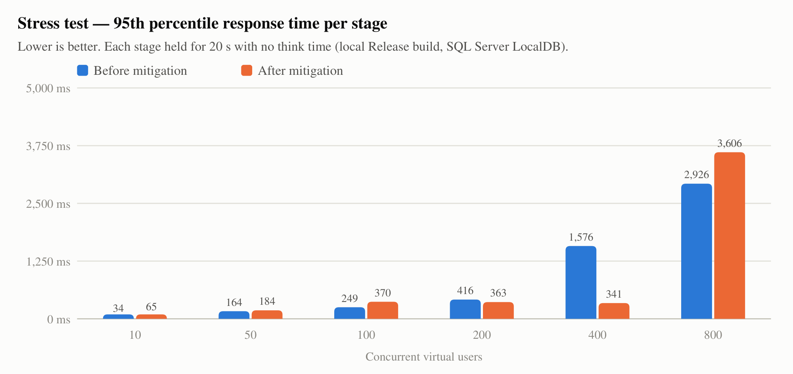
Stress test p95 per stage, before and after mitigation
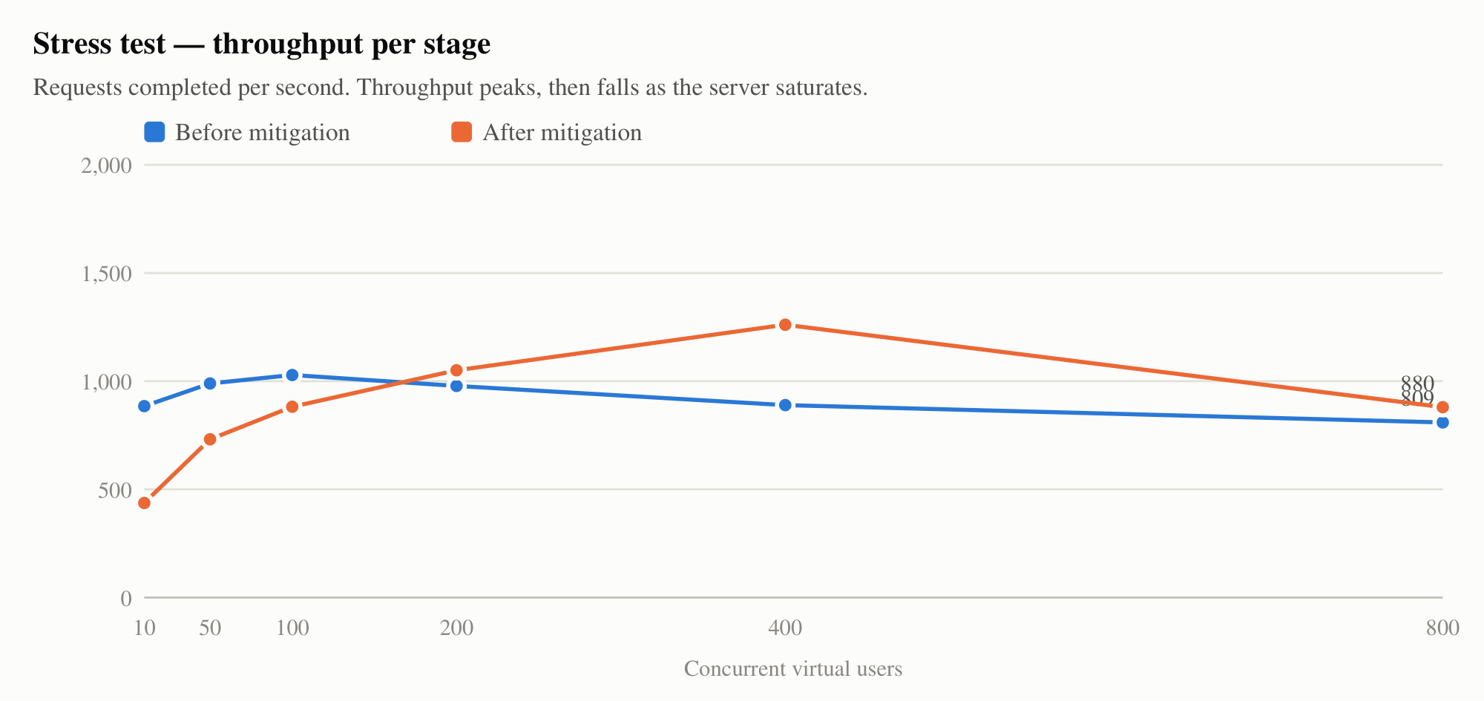
Stress test throughput per stage
Users | Before: req/s | Before: p95 | Before: errors | After: req/s | After: p95 | After: errors
10 | 885 | 34 ms | 0 % | 437 | 65 ms | 0 %
50 | 990 | 164 ms | 0 % | 732 | 184 ms | 0 %
100 | 1,028 (peak) | 249 ms | 0 % | 881 | 370 ms | 0 %
200 | 978 | 416 ms | 0.5 % | 1,051 | 363 ms | 0.6 %
400 | 889 | 1,576 ms | 0 % | 1,261 (peak) | 341 ms | 1.2 %
800 | 809 | 2,926 ms | 0 % | 880 | 3,606 ms | 3.7 %
Before. Throughput peaked at about 1,030 requests/s at 100 users, then fell while latency rose sharply (p95 1.6 s at 400 users, 2.9 s at 800). The first timeouts (102 requests over 10 s) appeared at 200 users. The per-page breakdown pointed to one cause:
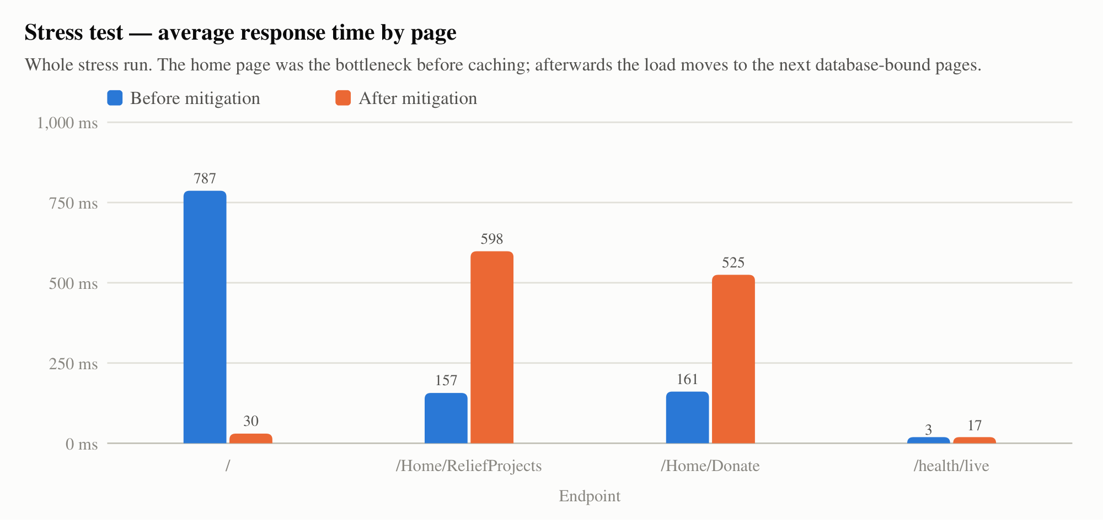
Average response time by page, whole stress run
The home page averaged 787 ms, five times slower than the other pages (≈ 160 ms). Each home-page view runs six database queries: five aggregates for the impact figures (ImpactStatsViewComponent) and one for the featured projects. Under concurrency these queries compete for the database connection pool (100 connections by default), so requests queue for a connection.

5.4 Mitigation and re-test
- Cache the impact figures and featured projects in memory for 30 s (IMemoryCache, configurable through Caching:PublicPageSeconds). The figures are at most 30 s out of date, which is acceptable for public statistics.
- Index ReliefProjects(Status, CreatedDate), which both public project queries filter and sort on (migration Part3PerformanceIndexes).
- The existing retry logic (EnableRetryOnFailure) and rate limiting of form posts (20 per minute per IP, HTTP 429) already protect the database and forms from bursts and abuse. RateLimitingTests proves the limiter works.
After. The home page fell from 787 ms to 30 ms on average. Peak throughput rose by 23 %, from 1,028 to 1,261 req/s, and moved from 100 to 400 users. At 400 users the p95 improved from 1,576 ms to 341 ms.
The bottleneck moved. With the home page cheap, the next database-bound pages (/Home/ReliefProjects 598 ms, /Home/Donate 525 ms on average) took the load, and timeouts at 400–800 users rose to 1.2–3.7 %. The first stage was also slower in the second run (437 vs 885 req/s), most likely because of the cold start after redeploying on the same PC. The timeline shows the spikes are individual requests hitting the 10 s timeout once more than 200 users run with no think time:
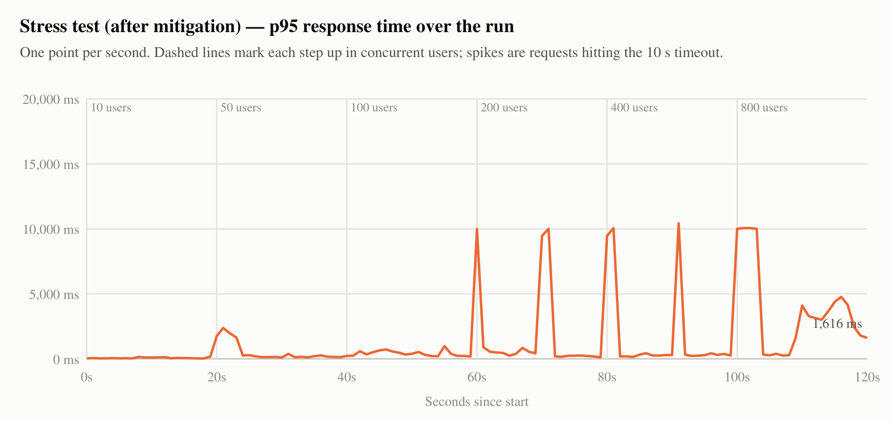
p95 over the stress run, after mitigation
Recovery. Straight after the 800-user stage, /health answered HTTP 200 in 49 ms, and a 20-user load test immediately afterwards ran with 0 errors and p95 6 ms. The application recovers without a restart (stress-after/recovery-health.txt, load-20users-after).

5.5 Conclusions and recommendations
Finding | Recommendation
Capacity with realistic users is far above the Foundation’s expected traffic (100 users: p95 11 ms, 0 errors). | No change needed for normal operation.
Under extreme load the database connection pool is the limit. | Cache the public project list the same way (it changes rarely), and use AsNoTracking projections for list pages.
Load tests ran on a developer PC with LocalDB, not on Azure B1 (1 core, 1.75 GB). | Repeat the 20-user load test against the Azure URL after deployment and add the result to this report. Expect higher latencies because of network distance and the smaller plan.
During a disaster appeal, traffic can spike 10× or more. | Scale out to 2+ instances (S1) during appeals; Azure SQL serverless or S0 for the database.

6. A.4 Selenium UI tests
Where: GiftOfTheGivers.UiTests/UserFlowTests.cs. Visual Studio: Test Explorer → GiftOfTheGivers.UiTests → Run. Set UI_HEADLESS=false to watch the browser.
# | Scenario | Type | Sizes
1 | Home page loads with Donate and Volunteer links (intro animation skipped) | Smoke | Desktop 1366×900 and mobile 390×844
2 | Employee logs in → Employee Dashboard | Happy path | Desktop
3 | Wrong password → Invalid login attempt, still signed out | Negative, Smoke | Desktop
4 | Anonymous visitor opens /Employee/Dashboard → redirected to login | Negative, Smoke | Desktop
5 | Anonymous monthly donation in USD, live rand preview (R 462.50), receipt Awaiting payment | Happy path | Desktop and mobile
6 | Donation with invalid email, no amount, no consent → validation errors, nothing saved | Negative, Smoke | Desktop
7 | Volunteer registration → confirmation page | Happy path | Desktop
8 | Volunteer form with required fields empty → rejected | Negative, Smoke | Desktop
9 | Employee posts a project update → success message | Happy path | Desktop
10 | Donor logs in → dashboard → My Donations → tax certificate with Download link | Happy path | Desktop
Results: 12 test cases (10 scenarios, 2 at two screen sizes), all passing in Chrome 156 and Microsoft Edge 156: 24 of 24 (docs/evidence/part3/ui/ui-chrome.trx, ui-edge.trx, ui-*-console.txt).
Robustness measures: the tests wait for conditions instead of sleeping; they retry stale elements during page changes; they scroll elements into view and fall back to a script click when a floating element covers the target; they load pages eagerly, so slow external fonts cannot time them out; and each test runs in a fresh browser.
Screenshots. Each step saves a labelled PNG. The 20 Chrome screenshots are in docs/deliverables/assets/screenshots/part3/ and are used in the user manual. Three examples:
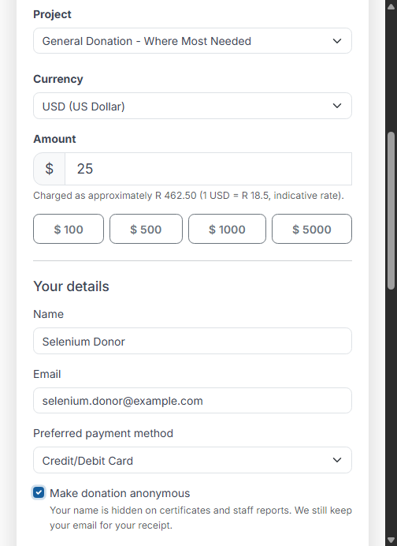
Selenium: anonymous USD monthly donation, mobile size
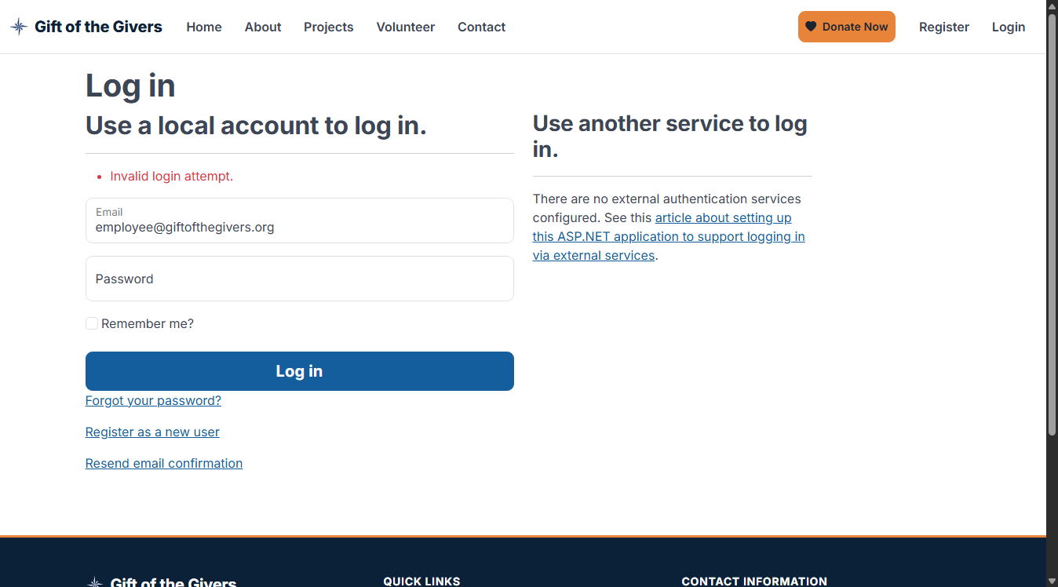
Selenium: wrong password (negative path)
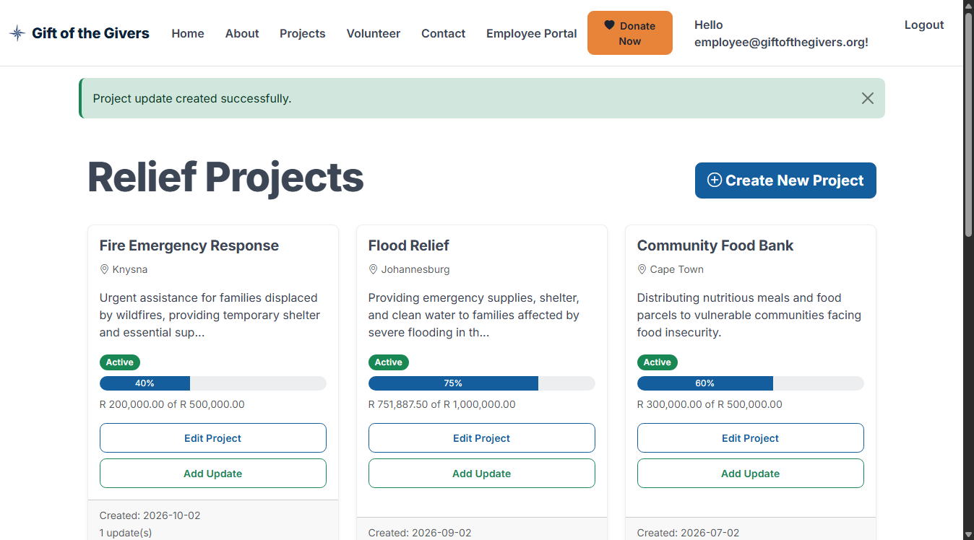
Selenium: employee posted a project update

7. B. Tests in Azure Pipelines
The Build stage of azure-pipelines.yml runs on every commit to main and feature/* and on every pull request into main:
Step | Detail
dotnet-setup.yml template | .NET SDK from global.json, NuGet cache, Azure Artifacts authentication, locked restore
Build | Release, whole solution
Unit tests | --filter Category=Unit, coverage collected, unit.trx
Integration tests | --filter Category=Integration, coverage collected, integration.trx
Selenium UI tests | headless Chrome, desktop + mobile; screenshots published as artifact ui-screenshots
Publish test results ×3 | Three named runs (Unit tests, Integration tests, Selenium UI tests) in the run’s Tests tab; any failure fails the build
Publish code coverage | PublishCodeCoverageResults@2 merges both Cobertura files into the Code Coverage tab and the build summary
Coverage gate | Fails the build if merged line coverage < 70 % (currently 89.9 %)
Quality gates | Vulnerable-package scan, EF model-drift check
Packaging | migrate.sql, rollback.sql, schema-version.txt, webapp.zip, functions.zip
The GitHub workflow ci.yml runs the same tests on GitHub and writes a coverage table into the job summary, so every push is also checked before it is mirrored to Azure DevOps.
Status: the YAML is valid and every command in it was run locally. Screenshots of the first Azure DevOps run must be added after the set-up in deliverable 11 (section 10 lists them).

8. C. Continuous deployment
All deployment stages run only on main, wait for the approval on the giftgivers-production environment, and read secrets from the variable group giftgivers-azure, where they are marked secret and masked in logs. No secret is stored in the repository.

8.1 C.1 Web app (App Service)
Step | Purpose
AzureAppServiceSettings@1 | Writes Database__MigrateOnStartup=false, ForwardedHeaders__Enabled=true and the connection string (from the secret group)
AzureWebApp@1 | Deploys webapp.zip, to the staging slot when useStagingSlot: 'true'
Smoke test (template) | Waits for /health/live, then checks /health, /, projects, donate, volunteer and login for HTTP 200
AzureAppServiceManage@0 Swap | Swaps staging into production with no downtime, then smoke-tests production
on: failure hook | Automatic rollback: swaps back, restoring the previous build that is still in staging
Deployment strategy. Blue/green with slots when the plan is Standard (S1) or higher. On Free/Basic plans, slots are not available: the pipeline deploys straight to production, and rollback means re-running DeployWebApp from the last good run, which redeploys that run’s own artifact. Both paths are documented in deliverable 11, section 9.

8.2 C.2 Function app
Step | Purpose
AzureFunctionApp@2 | Deploys functions.zip (.NET 10 isolated worker)
AzureAppServiceSettings@1 | ConnectionStrings__DefaultConnection from the secret group, organisation settings, FUNCTIONS_WORKER_RUNTIME
Live test, 3 inputs | no key → 401 (function-level authorisation); malformed reference → 400 (validation); valid but unknown reference → 404 (database lookup works). Each call is retried while the function warms up.
The function key is a secret pipeline variable (functionKey), never in the repository. The same three cases, plus the success path, run in-process on every build (TaxCertificateFunctionTests).

8.3 C.3 SQL database
Mechanism | Detail
Migrations | EF Core migrations are the source of truth; 8 versions, the newest is 20261102132424_Part3PerformanceIndexes
Automated script | The build produces an idempotent migrate.sql (each migration is guarded by __EFMigrationsHistory, so it is safe on any database version) and rollback.sql (newest → previous)
Deployment | SqlAzureDacpacDeployment@1 runs migrate.sql on Azure SQL, then lists __EFMigrationsHistory in the log, so the schema version is visible in every run
App start-up | Database:MigrateOnStartup=false in Azure, so only the pipeline changes the schema
Rollback | Run the pipeline with rollbackDatabase ticked: it runs rollback.sql and skips app deployment. For data loss: Azure SQL point-in-time restore (deliverable 11, section 9)
Drift protection | The build fails if the model changed without a migration
Evidence that schema updates and rollback work (SQL Server LocalDB, 2026-11-02, docs/evidence/part3/sql/migration-rollback-evidence.txt): all migrations applied; Part3PerformanceIndexes rolled back to AuditRemediationNov2026; re-applied; __EFMigrationsHistory lists all 8 versions; IX_ReliefProjects_Status_CreatedDate present. The generated forward- and rollback-Part3PerformanceIndexes.sql are stored alongside. The GitHub CI job Apply migrations to SQL Server repeats apply → roll back → re-apply on SQL Server 2022 on every push.
-- rollback-Part3PerformanceIndexes.sql (generated, abridged)
DROP INDEX [IX_ReliefProjects_Status_CreatedDate] ON [ReliefProjects];
ALTER TABLE [ReliefProjects] DROP CONSTRAINT [CK_ReliefProject_Status];
ALTER TABLE [ReliefProjects] ALTER COLUMN [Status] nvarchar(max) NOT NULL;
ALTER TABLE [ReliefProjects] ADD CONSTRAINT [CK_ReliefProject_Status] CHECK ([Status] IN ('Active','Completed','Suspended'));
DELETE FROM [__EFMigrationsHistory] WHERE [MigrationId] = N'20261102132424_Part3PerformanceIndexes';

8.4 GitHub → Azure synchronisation
Every push to GitHub runs .github/workflows/mirror-to-azure-devops.yml, which mirrors all branches and tags to Azure Repos with a PAT held in GitHub secrets. Azure Pipelines triggers on the mirrored commit. Deliverable 11, section 5, gives the full set-up and test procedure.

9. D. Handover package
Item | Location
User manual: login (employee / donor / anonymous), posting updates, donations (once-off, monthly, anonymous, ZAR/USD/EUR), tax certificates, volunteering, accessibility, FAQ. 17 labelled screenshots. | Deliverable 10
Azure deployment and GitHub sync guide, for the member doing the set-up | Deliverable 11
Team contribution report with git evidence | Deliverable 12 (names and roles to be completed by the team)
Earlier deliverables (requirements, design, schema, plan, CI/CD, audits) | Deliverables 01–08
Raw evidence (TRX, coverage, load CSV/JSON, SQL scripts, screenshots) | docs/evidence/part3/

10. Screenshots to capture after the Azure deployment
These cannot be produced until the deployment in deliverable 11 has run. Label each one, for example “Figure C.1-2 — Swap completed”.
For | Screenshot
B.1 | YAML in Azure DevOps; a run summary showing Build and test green
B.1/B.2 | Tests tab with the three runs (unit 48, integration 80, UI 12) all passing
B.2 | Code Coverage tab; the Coverage gate log line
B.2 | Commit on GitHub → mirror Action green → triggered run in Azure DevOps (same SHA)
C.1 | DeployWebApp log (deploy, smoke test, swap); the live site in a browser; App Service Deployment slots page
C.2 | DeployFunctions log with the 401/400/404 results; a browser download of a certificate PDF; Function App → Monitor invocation log
C.3 | DeployDatabase log with the __EFMigrationsHistory listing; portal Query editor showing the same table
A.3 | Optional: 20-user load test against the Azure URL (summary.md)

11. Known limitations
- Not yet deployed to Azure (section 1). This is the main risk to the marks for C.1–C.3.
- Load and stress figures come from a developer PC, not from Azure B1.
- Monthly pledges are recorded but not billed automatically (PayFast subscriptions are not integrated). The user manual says so.
- Some mobile-API work (Controllers/Api, GiftOfTheGivers.Mobile) was still in progress in the working tree when this report was written. It did not compile at that time and is not covered by this report.

12. Declaration of AI assistance
The team must review and complete this declaration so that it is accurate before submission. IIE guidelines allow AI for idea generation, grammar and debugging, but not for writing full code or solutions, or for producing images, diagrams or tables.
- An AI coding assistant (Claude Code) and the GitHub Copilot coding agent (11 commits, visible in the history) were used during this project. In Part 3, AI assistance was used for: [the team lists exactly what, e.g. drafting test cases, the load-test runner, pipeline YAML, this report, the chart script].
- All AI-assisted work was reviewed, run and verified by the team. Every figure in this report comes from test runs whose raw output is in docs/evidence/part3/.
- [Each member states how they personally used AI tools.]

Appendix: run everything locally
# Unit + integration tests with coverage (Visual Studio: Test Explorer → Run All)
dotnet test GiftOfTheGivers.Tests --settings coverage.runsettings --collect "XPlat Code Coverage"
# Selenium (Chrome by default; UI_BROWSER=edge for Edge; UI_HEADLESS=false to watch)
dotnet test GiftOfTheGivers.UiTests
# Selenium against a deployed site, read-only checks only
UI_BASE_URL=https://<site> dotnet test GiftOfTheGivers.UiTests --filter Category=Smoke
# Load / stress (start the app first: dotnet run --project GiftOfTheGivers -c Release --urls http://localhost:5080)
dotnet run --project GiftOfTheGivers.LoadTests -c Release -- load --users 20 --duration 60
dotnet run --project GiftOfTheGivers.LoadTests -c Release -- stress --stages 10,50,100,200 --stage-seconds 20
# Charts from the latest stress results
python docs/tools/load_charts.py
# Rebuild these documents (HTML + PDF)
python docs/tools/build_deliverables.py

Deliverable 10: User Manual
How to sign in, post project updates, make donations, get a tax certificate and register as a volunteer, for staff, donors and volunteers of the Gift of the Givers Foundation.
Version 1.0 · 2026-11-02 · Status: Handover edition

1. About this manual
This manual explains how to use the Gift of the Givers relief website. It is written for Foundation staff with no technical background. Every task is a short list of numbered steps with a picture of the screen.
If you are… | Read
A staff member (employee) | Sections 2, 3 and 4
A donor with an account | Sections 2, 5 and 6
Giving without an account (anonymous) | Sections 5 and 6.3
Someone who wants to volunteer | Section 7
What you need: a phone, tablet or computer with an up-to-date web browser (Chrome, Edge, Safari or Firefox) and an internet connection. Nothing needs to be installed.
Website address: https://gift-relief-managemen-gdbsf9bbena9epgw.southafricanorth-01.azurewebsites.net. Your administrator will confirm the address once the site is live. Bookmark it.
Screens in this manual were captured automatically from the real website during testing on 2 November 2026, using demonstration data and test names. Your screen may show different projects and amounts. On a phone the menu is folded behind the ☰ button at the top right; everything else works the same.
Payments on the demonstration site. Until the Foundation switches on live payments, the site records donations as Awaiting payment and does not charge anyone. The steps are the same once payments are live.

2. Signing in
There are three ways to use the site:
Type of user | Account needed? | What you can do
Anonymous visitor | No | Browse projects, donate (your name can be hidden), apply to volunteer, contact the Foundation
Donor | Yes (free, self-registration) | All of the above, plus see your donation history and download tax certificates
Employee (staff) | Yes, and an administrator must give you staff access | Manage projects, post updates, review volunteers, check donations, issue certificates

2.1 Anonymous visitors
You do not need to sign in. Open the website and use the menu at the top: Projects, Volunteer, Contact or the orange Donate Now button.
The first time you open the home page in a browser session, a short welcome animation plays and then the home page appears (Figure 1).
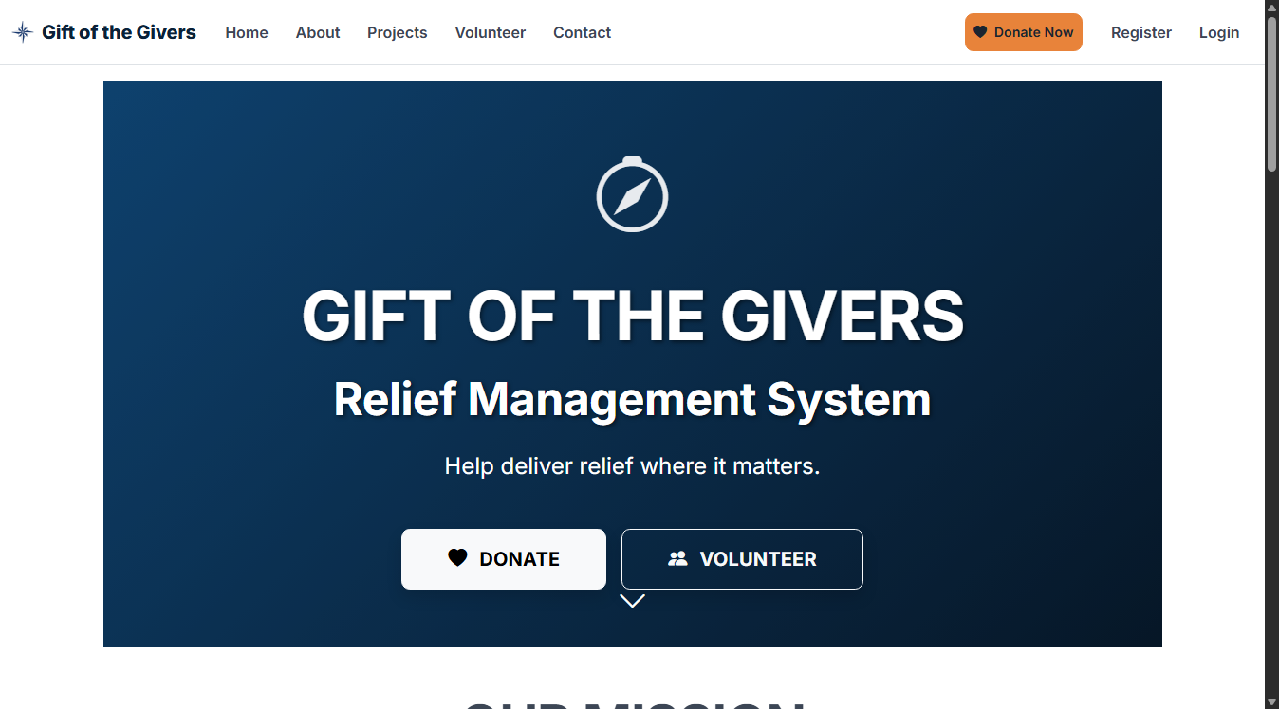
Figure 1 — Home page (desktop). The orange Donate Now button and the main menu are at the top.

2.2 Donors: create an account
- Click Register at the top right.
- Enter your full name, email address and a password of at least 8 characters. Confirm the password.
- Click Register. You are signed in straight away as a donor.
Donations you make while signed in are linked to your account, so you can download their tax certificates later.

2.3 Signing in (donors and employees)
- Click Login at the top right. The sign-in page opens (Figure 2).
- Type your email and password.
- Tick Remember me? only on your own device.
- Click Log in.
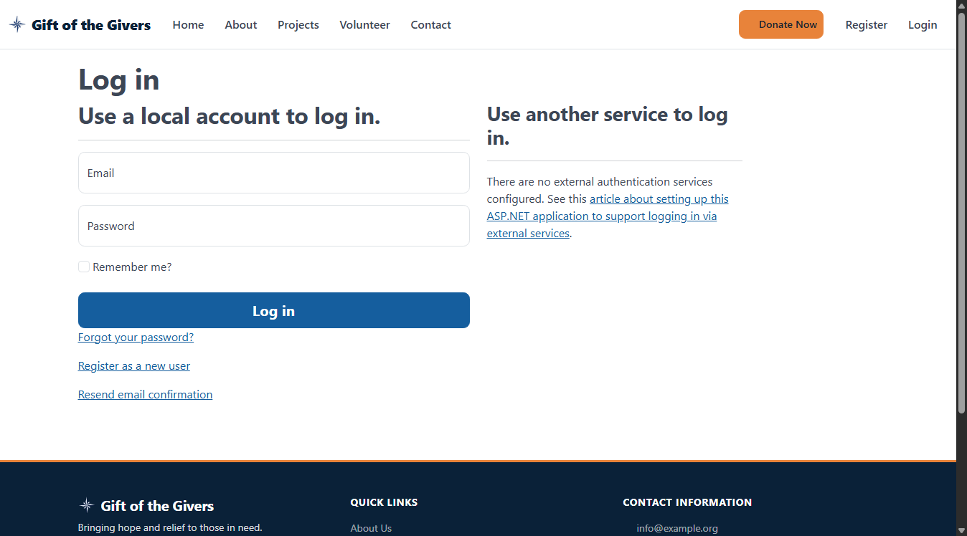
Figure 2 — The sign-in page
After signing in, your email appears at the top right with a Logout button.
- Employees see an extra menu item, Employee Portal. Choose Dashboard to reach the Employee Dashboard (Figure 3).
- Donors see Donor Portal, with Dashboard, My Donations and Make Donation.
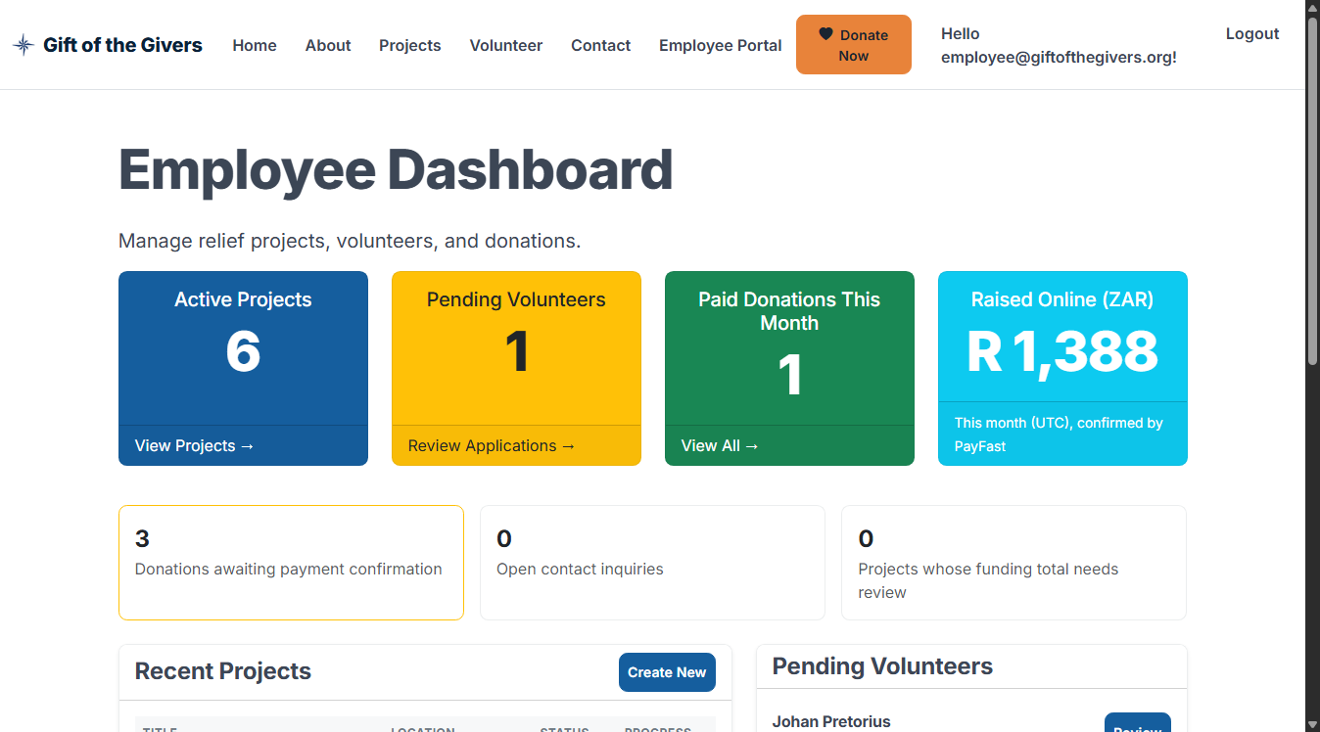
Figure 3 — Employee Dashboard after signing in as a staff member

2.4 If sign-in fails
If the email or password is wrong, the page says Invalid login attempt (Figure 4). Check:
- the email has no spaces;
- Caps Lock is off (passwords are case-sensitive).
After 5 wrong attempts the account is locked for 15 minutes. This protects it from people guessing passwords. Wait, then try again. If you have forgotten your password, ask your administrator to reset it.
Figure 4 — Wrong password: the page shows “Invalid login attempt” and you stay signed out

2.5 Signing out
Click Logout at the top right. Always sign out on shared computers.

3. Getting staff (employee) access
For security, nobody can make themselves an employee.
- The new staff member registers as in 2.2.
- An existing employee opens Employee Portal → Staff Access, types the new person’s email under Grant staff access, and clicks Grant access.
- The new staff member signs out and in again. Employee Portal now appears.
To remove access when someone leaves, open Staff Access and click Remove next to their name, then confirm. Every grant and revoke is recorded in the Audit Log.

4. Employees: posting a project update
Updates tell donors what their money achieved: deliveries, progress, challenges. They appear on the public project pages.
- Sign in as an employee (2.3).
- Open Employee Portal → Manage Projects. The list of relief projects appears (Figure 5).
- Find the project and click Add Update.
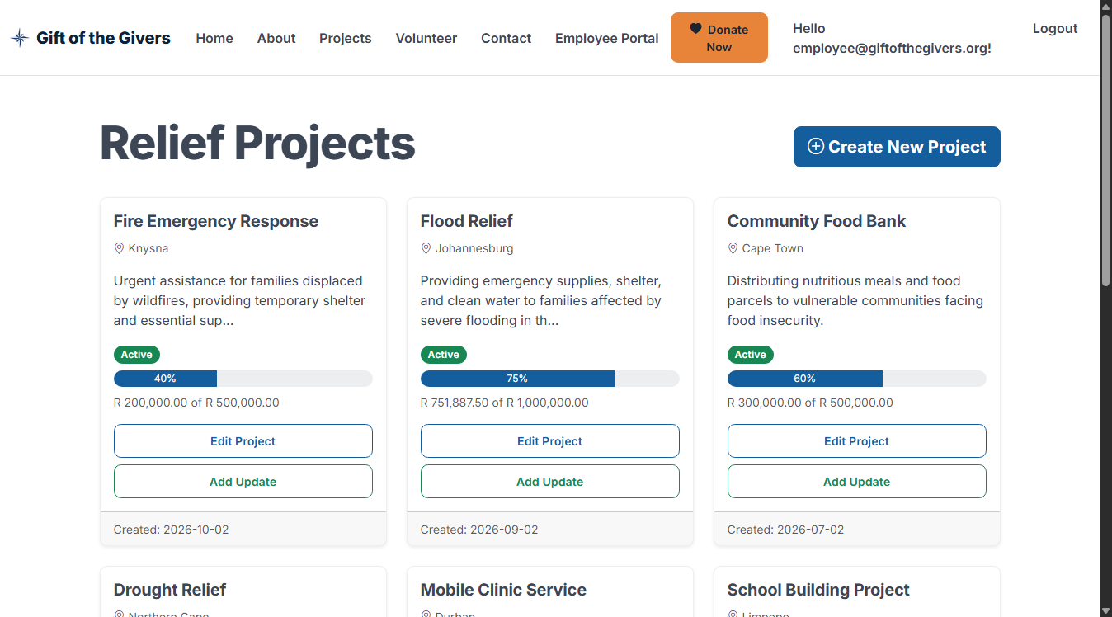
Figure 5 — Relief Projects list for staff. Each project has an Add Update button.
- Fill in the form (Figure 6):
  - Title: a short headline, for example Day 3: 400 food parcels delivered.
  - Content: what happened, in plain words (up to 4,000 characters).
  - Image URL (optional): the web address of a photo already published online. Leave it empty if you have none.
- Click Publish Update.
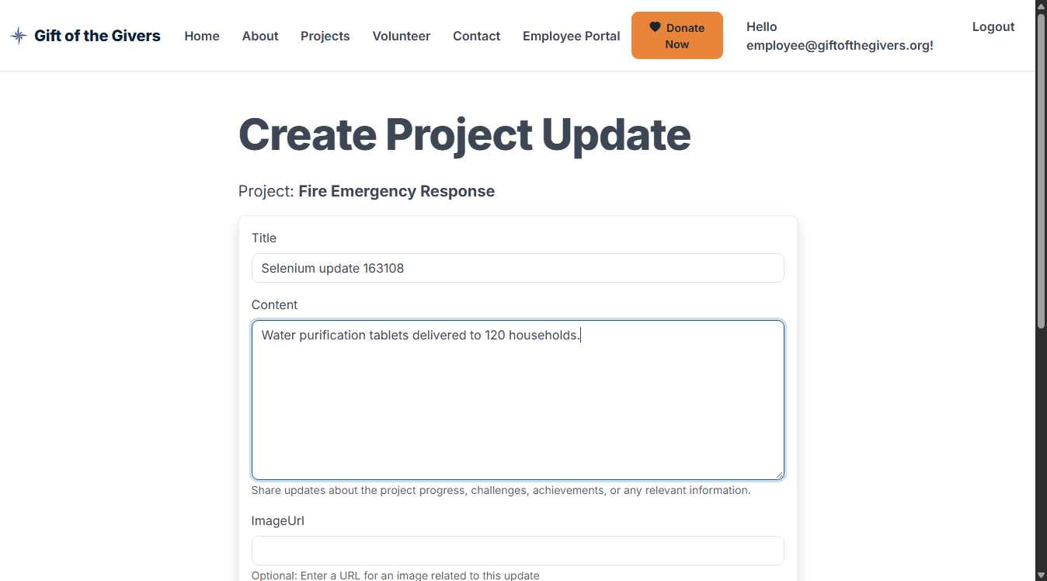
Figure 6 — Writing a project update
- You return to the project list with the green message Project update created successfully (Figure 7). The update is now visible to the public.
Figure 7 — Confirmation that the update was published
To correct an update after publishing, ask the system administrator; editing published updates is not yet available from the menu.
If the form shows red messages: a required field (Title or Content) is empty or too long. Fix it and click Publish Update again. Nothing is saved until the form is accepted.

5. Making a donation
Anyone can donate, with or without an account.

5.1 Step by step
- Click the orange Donate Now button (top of every page), or Donate on a project.
- Choose the donation type (Figure 8):
  - One-time donation: a single gift.
  - Monthly pledge (recurring): records that you intend to give every month. Automatic monthly billing is not yet available, so each month’s payment is made separately with the same form.
- Choose a Project, or leave General Fund so the Foundation can use the money where it is most needed.
- Choose the Currency (see 5.2) and enter the Amount, or click one of the quick-amount buttons.
- Enter your Name and Email. The receipt is sent to this email.
- Choose a Preferred payment method: Credit/Debit Card or EFT.
- To give anonymously, tick Make donation anonymous (see 5.3).
- Optionally add a Message.
- Tick I have read the privacy notice…. This is required.
- Click Continue to payment (on the demonstration site the button reads Record donation) (Figure 9).
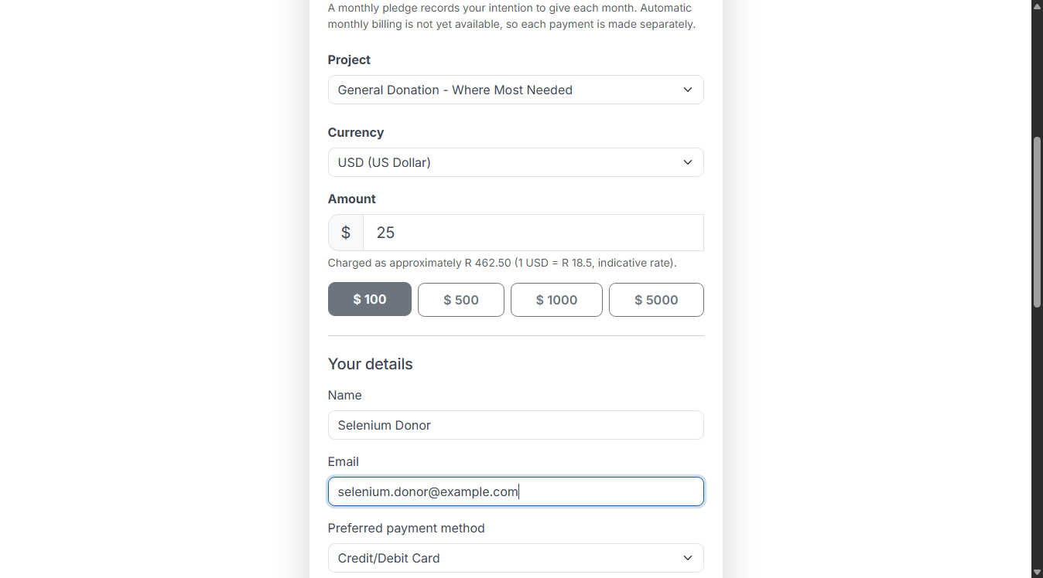
Figure 8 — Top of the donation form: donation type, project, currency and amount
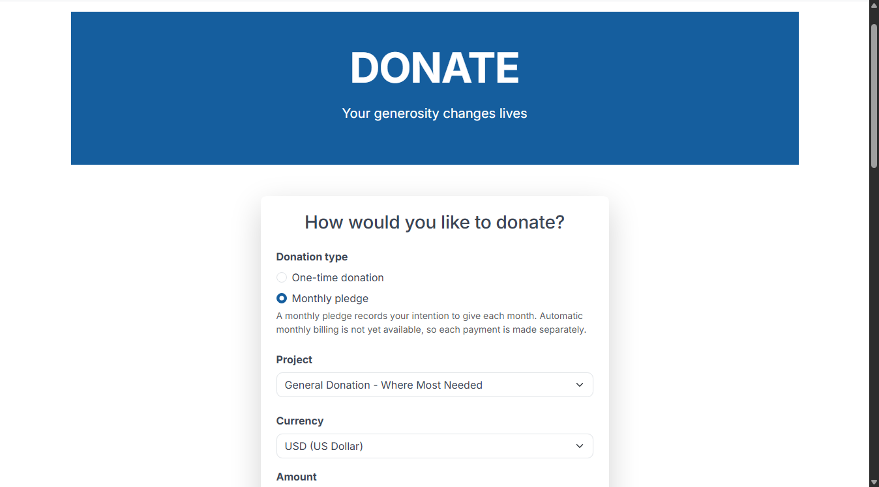
Figure 9 — Bottom of the donation form: anonymous option, privacy consent and the Donate button
- When payments are live, you are taken to PayFast, South Africa’s secure payment page, to pay by card or EFT. The Foundation never sees your card details.
- You return to the Thank You receipt page (Figure 10). It shows the amount, the rand amount charged, the type, the project, the status and your reference number. Keep the reference number.
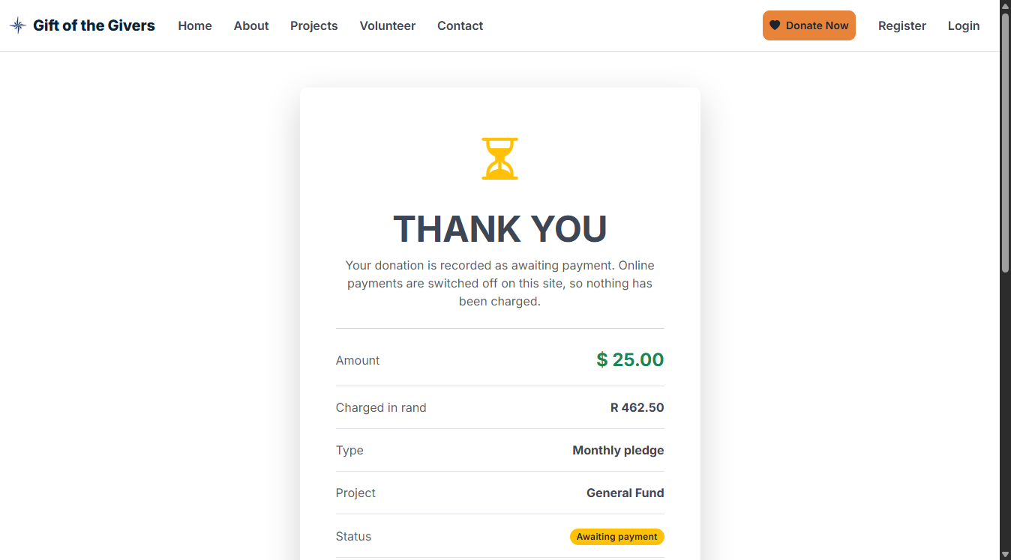
Figure 10 — Receipt page for an anonymous US-dollar monthly pledge. Status “Awaiting payment” changes to “Paid” when PayFast confirms the payment.
Payment status explained
Status | Meaning
Awaiting payment | The donation is recorded; the payment is not yet confirmed.
Paid | PayFast confirmed the payment. It now counts towards the project total and a tax certificate is available.
Failed | The payment was cancelled or declined. Nothing was charged. Click Try again.
Clicking the button twice does not create two donations. The site recognises the same form.

5.2 Giving in another currency
You can give in South African rand (ZAR), US dollars (USD) or euro (EUR).
- When you choose USD or EUR and type an amount, the form shows the rand equivalent, for example Charged as approximately R 462.50 (1 USD = R 18.50).
- PayFast charges in rand, so the rand amount is what your bank charges. Your bank may add a small foreign-transaction fee.
- The receipt shows both your amount (e.g. $ 25.00) and the Charged in rand amount (Figure 10).

5.3 Giving anonymously
Tick Make donation anonymous. Your name is then hidden from staff reports and printed as Anonymous Donor on the tax certificate. The Foundation still keeps your email privately, so it can send your receipt.
You can also give without an account, as an anonymous visitor. In that case keep your reference number, because you will need it to request a tax certificate (6.3).

5.4 If the form shows errors
Red messages appear under any field that needs attention (Figure 11). Common ones:
Message | What to do
Amount must be between 1 and 1,000,000 | Enter an amount of at least 1.
The Your Email field is not a valid e-mail address | Check the email for typos.
You must accept the privacy notice | Tick the privacy box.
This project is not accepting donations | The project has closed. Choose another project or the General Fund.
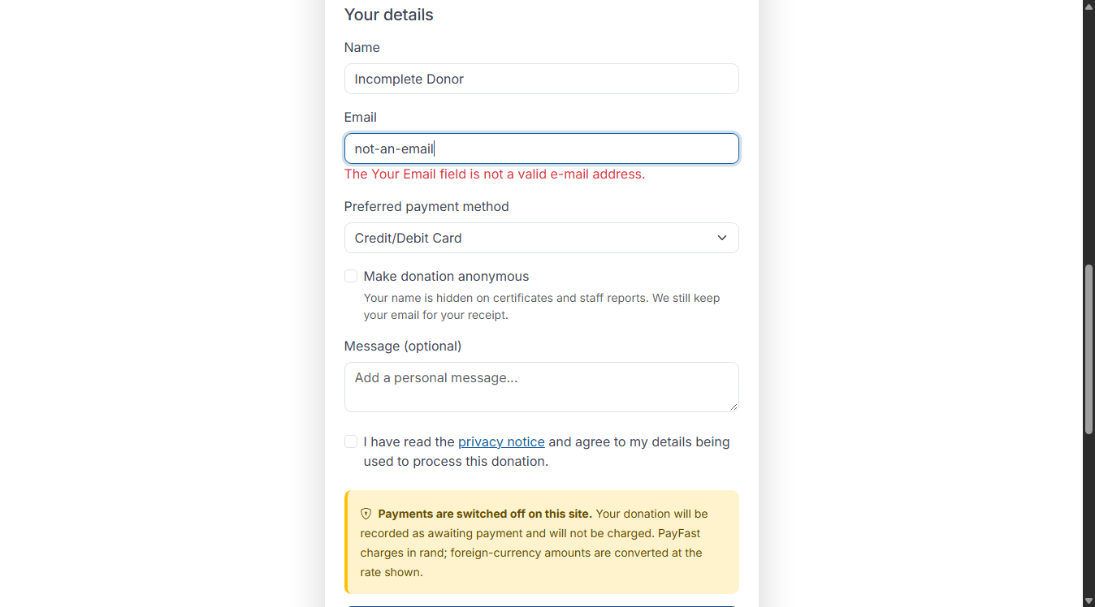
Figure 11 — The form will not submit until the highlighted fields are corrected

6. Getting a tax certificate (Section 18A)
A tax certificate is available for every paid donation. It is a PDF that you can save or print.

6.1 Donors with an account
- Sign in (2.3) and open Donor Portal → Dashboard (Figure 12). It shows your confirmed donations and total given.
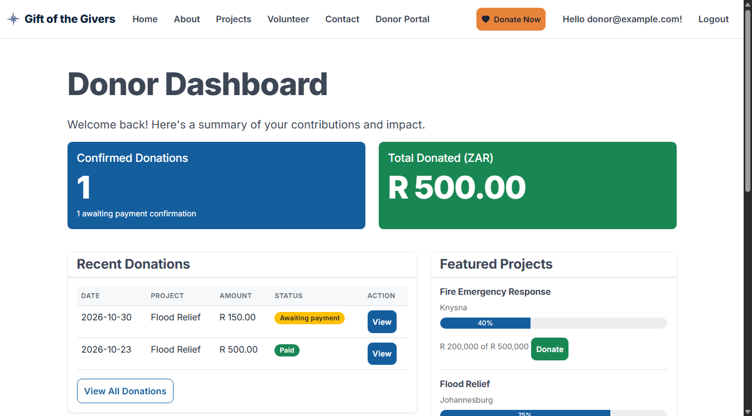
Figure 12 — Donor Dashboard
- Open Donor Portal → My Donations (Figure 13). Each paid donation has a Certificate button.
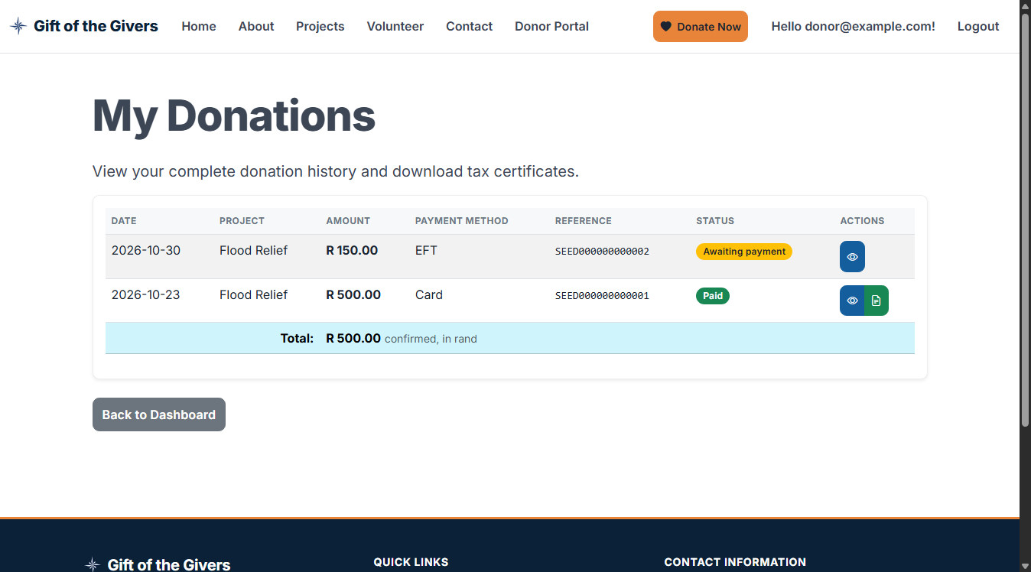
Figure 13 — My Donations: the Certificate button appears for paid donations only
- Click Certificate. The certificate opens on screen (Figure 14).
- Click Download PDF to save it, then print it or attach it to your tax return.
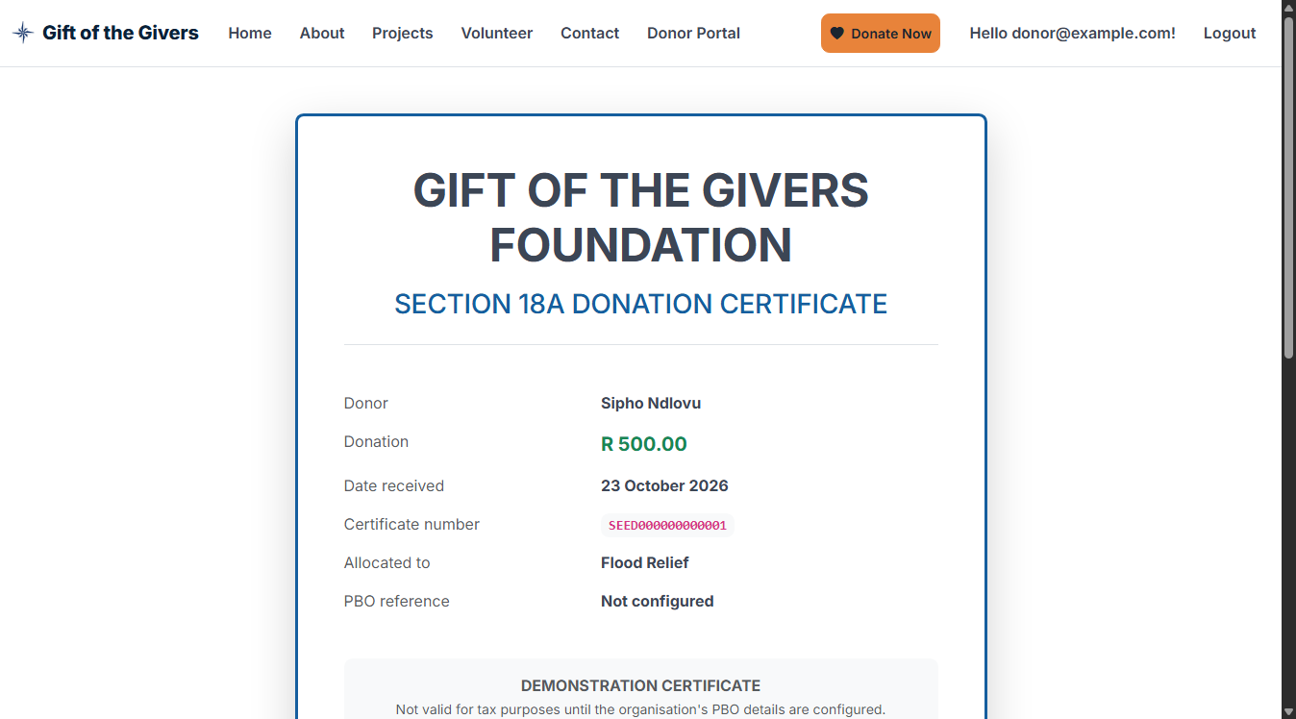
Figure 14 — The tax certificate on screen, with the Download PDF button
No Certificate button? The donation is still Awaiting payment, or it failed. Certificates appear automatically once PayFast confirms the payment, usually within minutes.

6.2 Straight after donating
If you were signed in when you donated, the receipt page shows View Tax Certificate as soon as the payment is confirmed.

6.3 Donors without an account, and staff issuing certificates
If the donor gave without an account, they contact the Foundation with their reference number. A staff member then:
- Signs in and opens Employee Portal → Donations.
- Clicks the Paid filter and finds the donation by the reference number or date.
- Clicks Certificate → Download PDF, and emails the PDF to the donor.
Each time a certificate is viewed or downloaded, this is recorded in the Audit Log.
Demonstration certificates are clearly marked DEMONSTRATION — not a valid Section 18A certificate until the Foundation’s PBO registration number is entered by the administrator.

7. Registering as a volunteer
- Click Volunteer in the top menu.
- Fill in the form (Figure 15):
  - Full name and email: required.
  - Phone number and city: optional, but they help the team contact you.
  - Skills: for example first aid, driving, cooking, logistics. Required.
  - Availability: for example Weekends or Weekdays after 17:00. Required.
  - Date of birth and emergency contact: optional. Volunteers must be at least 16.
- Tick the privacy notice box.
- Click Register interest.
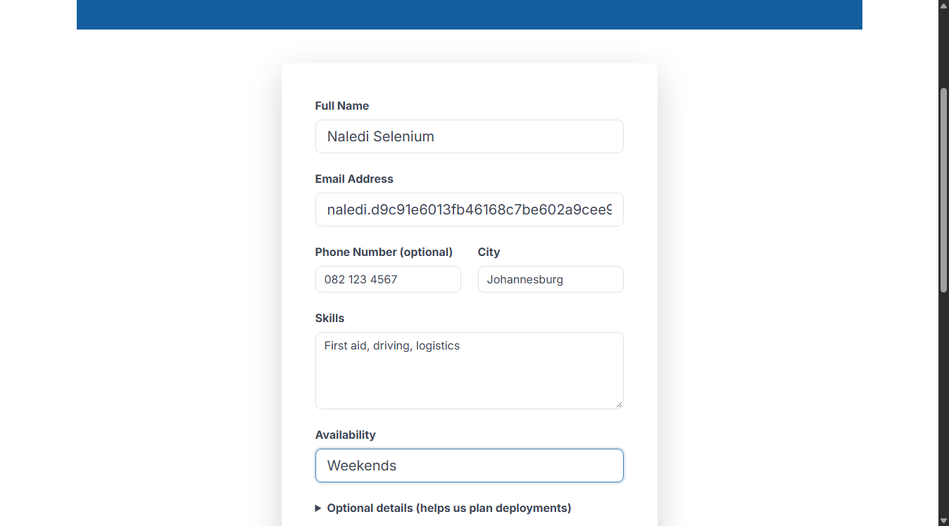
Figure 15 — The volunteer application form
- The Thank you for volunteering page confirms your application (Figure 16). A coordinator reviews it and contacts you by email.
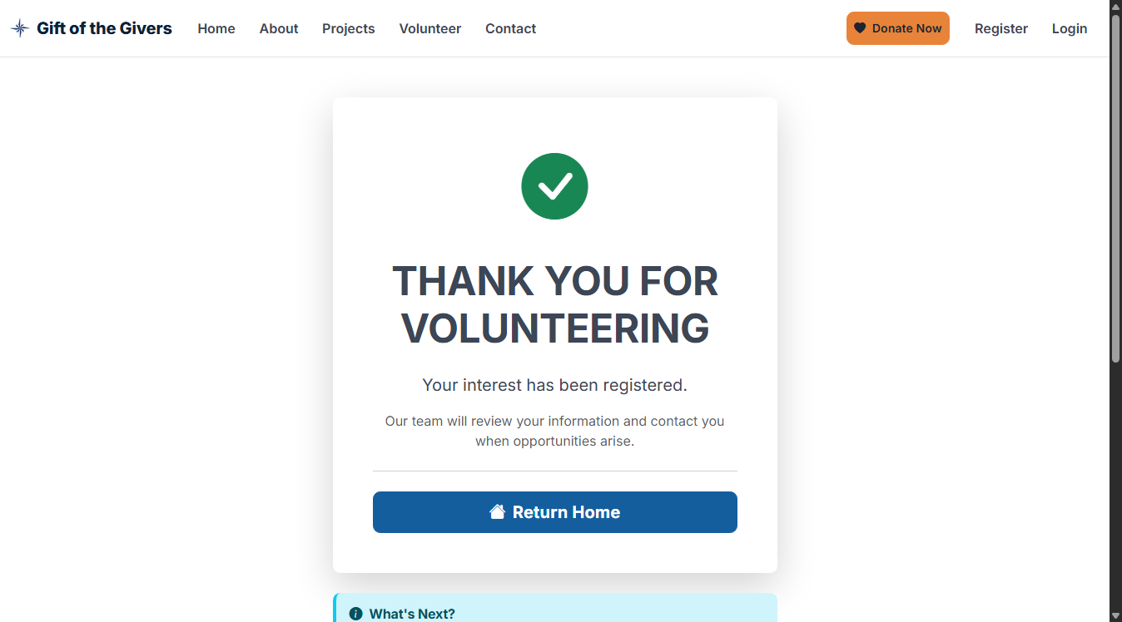
Figure 16 — Confirmation after applying
If required fields are missing, red messages appear under them and nothing is sent. Complete them and submit again.
For staff: new applications appear under Employee Portal → Manage Volunteers (and in Pending Volunteers on the dashboard). Open one, then click Approve or Reject. Approved volunteers can be assigned to active projects from the same page.

8. Accessibility and good practice
- The site works with a keyboard alone: Tab moves between fields and Enter presses a button. Screen readers announce form errors and the currency conversion.
- Text can be enlarged with Ctrl + (Windows) or ⌘ + (Mac) without breaking the layout. The site also adapts to phone screens (Figure 17).
- Colours are never the only signal: every status also has a word (Paid, Awaiting payment, Failed).
- Never share your password. Staff should sign out of shared computers and never email donor lists. Use Export CSV only on Foundation devices.
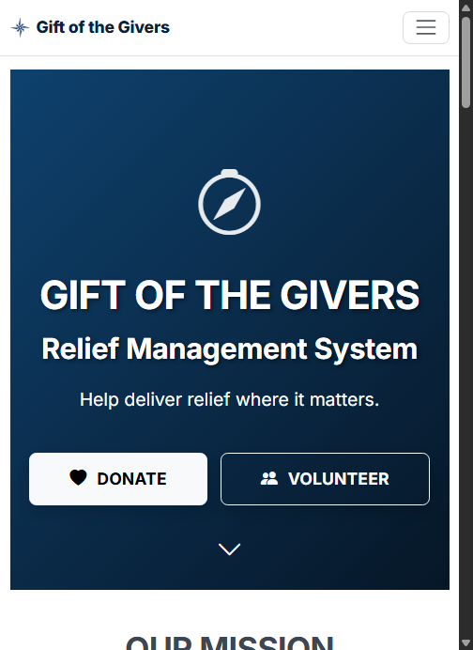
Figure 17 — The same home page on a phone. The menu is behind the ☰ button.

9. Frequently asked questions
Question | Answer
I donated but the status still says Awaiting payment. | PayFast may take a few minutes to confirm. Refresh the receipt page later. If it still says so after a day, contact the Foundation with your reference number.
Can I change or cancel a donation? | Not on the website. Contact the Foundation with your reference number.
Will a monthly pledge charge me automatically? | Not yet. It records your intention; you donate each month with the form.
I gave in dollars. Why does my bank show rand? | PayFast settles in rand. The receipt shows the rand amount charged.
Is my name shown publicly? | No. Donor names are never shown publicly. Anonymous also hides your name from staff reports and certificates.
I am an employee but cannot see Employee Portal. | Ask another employee to grant access (section 3), then sign out and in again.
A form is refused with error 429 (too many requests). | More than 20 forms were sent from your connection in one minute. Wait one minute and try again.

10. Getting help
- Donors and volunteers: use the Contact page. A staff member replies by email.
- Staff: questions arriving through the Contact page are listed under Employee Portal → Inquiries. Mark each as handled once answered.
- Technical problems (site down, errors): contact the system administrator named in the hand-over pack. Include the time, the page address and a screenshot.

Deliverable 11: Azure Deployment and GitHub Sync Guide
Step-by-step instructions for the team member who sets up Azure, connects GitHub to Azure DevOps and turns on continuous deployment.
Version 1.0 · 2026-11-02 · Status: Ready to follow — no step has been carried out in Azure yet

1. What you will end up with
When you finish this guide:
- Every push to the GitHub repository is copied automatically to Azure Repos (Azure DevOps).
- Each copy starts the Azure Pipeline (azure-pipelines.yml). It builds the solution, runs the unit, integration and Selenium tests, publishes test and coverage reports, then on main it:
  - applies database migrations to Azure SQL,
  - deploys the web app to App Service (through a staging slot if your plan has one),
  - deploys the tax-certificate Azure Function, and
  - runs read-only Selenium smoke tests against the live site.
- The live site at https://gift-relief-managemen-gdbsf9bbena9epgw.southafricanorth-01.azurewebsites.net shows the application instead of the Azure “waiting for your content” page.
The path of one change: developer pushes to GitHub → GitHub Action Mirror to Azure DevOps → Azure Repos → Azure Pipeline Build and test → (approval) → DeployDatabase → DeployWebApp and DeployFunctions → LiveSmokeTests.
Time needed: about 2 hours the first time. You need: a browser, Owner or Contributor access to the team’s Azure subscription, Project Administrator access to the Azure DevOps organisation ST10438928, and Admin access to the GitHub repository jBlack-MC/GiftOfTheGivers-HumanitarianAid. Installing nothing locally is fine; the Azure CLI is optional.
Write things down as you go. Section 11 is a checklist of every name, URL and secret you create. Keep it in a password manager, never in the repository, a chat or a document.

2. Before you start: access tokens
Personal access tokens (PATs) are passwords. Rules for this project:
- A PAT that has been pasted into a chat, email or document is compromised. Revoke it (Azure DevOps → your avatar → Personal access tokens → Revoke) and create a new one. A token was shared in this way during Part 3; when tested on 2026-11-02 it was already rejected by Azure DevOps (HTTP 401), but revoke it anyway if it still appears in the list.
- Create each PAT with the smallest scope and an expiry date at the end of the module.
- Store PATs only as GitHub repository secrets or secret pipeline variables.
You will create two PATs in section 5:
PAT | Scope | Stored as
Repository mirror | Code: Read & write | GitHub secret AZURE_DEVOPS_PAT
Helper package publishing (Part 2) | Packaging: Read & write | GitHub secret AZURE_ARTIFACTS_PAT

3. Create the Azure resources
Use the Azure portal (https://portal.azure.com). Use South Africa North for every resource, because the existing web app is already there. The names below are the defaults in pipelines/templates/variables.yml. If a name is taken, choose another and write it down; you will change the file in section 7.

3.1 Resource group
- Search Resource groups → Create.
- Subscription: the team subscription. Name: rg-giftofthegivers. Region: South Africa North.
- Review + create → Create.
The existing web app may already be in a different resource group. Open it (search App Services → gift-relief-management…) and look at Resource group on the Overview page. If it is different, either use that group everywhere below or move the app (Overview → Move → Move to another resource group).

3.2 Azure SQL server and database
- Search SQL databases → Create.
- Resource group rg-giftofthegivers. Database name GiftOfTheGiversDb.
- Server → Create new: name gift-relief-sql, location South Africa North, authentication Use SQL authentication. Admin login, for example gotgadmin, and a strong password. Write both down.
- Want to use SQL elastic pool? No. Workload environment: Development.
- Compute + storage → Configure database: choose Basic (5 DTU, 2 GB), or the free serverless offer if the subscription shows it. Both fit the module’s B1 limits.
- Backup storage redundancy: Locally-redundant (cheapest).
- Networking tab: connectivity Public endpoint. Turn on Allow Azure services and resources to access this server (the web app, function and pipeline need it). Optionally also Add current client IP address so you can query from your PC.
- Review + create → Create. Wait about 5 minutes.
- Open the database → Settings → Connection strings → ADO.NET (SQL authentication). Copy it and replace {your_password} with the real password. This is sqlConnectionString. It looks like:
Server=tcp:gift-relief-sql.database.windows.net,1433;Initial Catalog=GiftOfTheGiversDb;Persist Security Info=False;User ID=gotgadmin;Password=<password>;MultipleActiveResultSets=False;Encrypt=True;TrustServerCertificate=False;Connection Timeout=30;
You do not need to create any tables. The pipeline creates and updates the schema.

3.3 Web app (App Service)
The web app already exists: gift-relief-management… on Windows (it currently shows the Azure placeholder page).
- Open it. On Overview note the Name, the Resource group, the Default domain (the long …azurewebsites.net address) and the App Service plan pricing tier.
- Settings → Configuration → General settings (or Environment variables in the newer portal):
  - Stack: .NET, version .NET 10 (LTS).
  - Platform: 64 Bit. HTTPS Only: On. Always on: On if the tier allows it (B1 and above).
  - Save.
- Health check (under Monitoring): enable it with path /health. App Service then restarts instances that stop answering.
- Deployment slots (only if the plan is Standard S1 or higher): Add slot → name staging, clone settings from production. Copy the slot’s URL; it is webAppStagingUrl. On Free or Basic plans, skip this step and leave useStagingSlot: 'false'.
The pipeline sets all application settings itself (connection string, Database__MigrateOnStartup=false, and so on). You do not need to type them in the portal.

3.4 Function app
- Search Function App → Create → hosting plan Consumption (Windows).
- Resource group rg-giftofthegivers. Name gift-relief-functions (must be unique; write down what you use).
- Runtime stack .NET, Version 10 (LTS), isolated worker model, Region South Africa North, Operating system Windows.
- Storage: let it create a new storage account. Monitoring: Application Insights Yes (gives you logs for the report).
- Review + create → Create.
You will copy the function key after the first deployment (section 8).

3.5 (Optional) Azure CLI equivalent
If you prefer the command line (az login first), this script creates the same resources. Replace the password placeholder, and pick unique names if needed.
RG=rg-giftofthegivers; LOC=southafricanorth
az group create -n $RG -l $LOC
az sql server create -g $RG -n gift-relief-sql -l $LOC -u gotgadmin -p '<strong-password>'
az sql server firewall-rule create -g $RG -s gift-relief-sql -n AllowAzure --start-ip-address 0.0.0.0 --end-ip-address 0.0.0.0
az sql db create -g $RG -s gift-relief-sql -n GiftOfTheGiversDb --service-objective Basic --backup-storage-redundancy Local
az storage account create -g $RG -n giftrelieffuncstore -l $LOC --sku Standard_LRS
az functionapp create -g $RG -n gift-relief-functions --consumption-plan-location $LOC \
--runtime dotnet-isolated --runtime-version 10 --functions-version 4 --os-type Windows \
--storage-account giftrelieffuncstore

4. Prepare Azure DevOps
Open https://dev.azure.com/ST10438928 and the team project (the one that holds the giftgivers-helpers feed from Part 2).

4.1 Azure Repos repository
- Repos → Files. If the project has no repository named GiftOfTheGivers-HumanitarianAid, use the repository drop-down → New repository: Git, that name, no README.
- Click Clone and copy the HTTPS URL, e.g. https://ST10438928@dev.azure.com/ST10438928/<Project>/_git/GiftOfTheGivers-HumanitarianAid. Remove the ST10438928@ part. This is AZURE_DEVOPS_REPO_URL.

4.2 Service connection to Azure
- Project settings → Service connections → New service connection → Azure Resource Manager.
- Identity type: App registration (automatic). Credential: Workload identity federation.
- Scope level: Subscription; pick the subscription and resource group rg-giftofthegivers.
- Service connection name: giftgivers-azure-connection. Tick Grant access permission to all pipelines (or authorise it on the first run).
- Save.
If your student account cannot create app registrations, ask the subscription owner to create the connection, or use Identity type: Managed identity if offered.

4.3 Environment with an approval
- Pipelines → Environments → New environment → name giftgivers-production, resource None → Create.
- ⋮ → Approvals and checks → Approvals → add the deployment lead (and a second member if you want four-eyes). Every production deployment now waits for that approval. This is your release gate.

4.4 Variable group with the secrets
- Pipelines → Library → + Variable group. Name: giftgivers-azure (exact spelling).
- Add these variables. Click the lock icon for every row marked secret:
Variable | Value | Secret
sqlAdminUser | the SQL admin login (e.g. gotgadmin) | yes
sqlAdminPassword | the SQL admin password | yes
sqlConnectionString | the full ADO.NET connection string from 3.2 | yes
functionKey | pending for now; replaced in section 8 | yes
- Pipeline permissions → + → allow the pipeline (after it exists in section 6), or answer Permit on the first run.
- Save.

5. Sync GitHub to Azure DevOps
The repository already contains .github/workflows/mirror-to-azure-devops.yml. On every push to any branch it runs git push --mirror to Azure Repos. GitHub stays the place where the team works, and Azure Repos is an exact copy that Azure Pipelines builds from.

5.1 Create the mirror PAT
- Azure DevOps → avatar (top right) → Personal access tokens → New Token.
- Name github-mirror. Organisation ST10438928. Expiry: end of the module.
- Scopes → Custom defined → Code: Read & write only. Create, then copy the token immediately (it is shown once).

5.2 Add the GitHub secrets
- GitHub → repository → Settings → Secrets and variables → Actions → New repository secret.
- Add:
Secret | Value
AZURE_DEVOPS_REPO_URL | the HTTPS clone URL from 4.1 (without user@)
AZURE_DEVOPS_PAT | the token from 5.1
AZURE_ARTIFACTS_PAT | a token with Packaging: Read & write (only if not already set in Part 2)

5.3 Test the sync
- Make any small commit on GitHub (for example, edit the README on a feature branch) and push it.
- GitHub → Actions → Mirror to Azure DevOps should be green within a minute.
- Azure DevOps → Repos → Commits: the same commit appears with the same SHA.
Never commit directly in Azure Repos. The mirror overwrites it on the next GitHub push and deletes anything that exists only there. All work goes through GitHub pull requests.
Alternative (if the PAT route is blocked): create the pipeline straight from GitHub. In 6.1 choose GitHub instead of Azure Repos Git and install the Azure Pipelines GitHub app. The pipeline then triggers from GitHub directly and the mirror is only a backup copy.

6. Create the pipeline

6.1 First run, build and test only
- Pipelines → New pipeline → Azure Repos Git → GiftOfTheGivers-HumanitarianAid → Existing Azure Pipelines YAML file → branch main, path /azure-pipelines.yml → Continue → Run.
- Rename it GiftOfTheGivers-CI-CD (⋮ → Rename/move).
- If the run asks to authorise the giftgivers-helpers feed or other resources, click Permit.
- With deployEnabled: 'false' (the default) only the Build and test stage runs. Check that:
  - the Tests tab shows three runs: Unit tests, Integration tests, Selenium UI tests, all passing;
  - the Code Coverage tab shows the merged report, and the Coverage gate step prints at least 70%;
  - the Artifacts list has drop, migrations and ui-screenshots.
If restore fails with 401 Unauthorized for giftgivers-helpers: Artifacts → giftgivers-helpers → ⚙ Feed settings → Permissions → Add users/groups → add <Project> Build Service (ST10438928) as Feed and Upstream Reader (Collaborator).

6.2 Turn on deployment
- On GitHub, open pipelines/templates/variables.yml and set:
  - deployEnabled: 'true'
  - webAppName, webAppUrl, resourceGroup, functionAppName, sqlServerName, sqlDatabaseName to the names you wrote down;
  - useStagingSlot: 'true' and webAppStagingUrl only if you created the staging slot in 3.3;
  - webAppType: webApp and functionAppType: functionApp for Windows (the defaults).
- Commit through a pull request into main. When it merges, the mirror copies it and the pipeline starts.
- The run pauses at DeployDatabase waiting for approval (4.3). Open it → Review → Approve.
- Watch the stages: DeployDatabase → DeployWebApp + DeployFunctions → LiveSmokeTests.
The first DeployFunctions run fails at Test the deployed function, because the function key is still pending. That is expected. Do section 8, then re-run that stage.

7. What each deployment stage does
Stage | Steps | Evidence for the report
Build and test | restore (locked) → build → unit → integration → Selenium (Chrome, desktop + mobile) → publish TRX → publish coverage → coverage gate ≥ 70% → vulnerability scan → EF model-drift check → migrate.sql, rollback.sql, schema-version.txt → zip web app and function | Tests tab, Code Coverage tab, artifacts
DeployDatabase | approval → show target schema version → run idempotent migrate.sql on Azure SQL → list __EFMigrationsHistory | the two SQL task logs (applied migrations are listed)
DeployWebApp | apply app settings + connection string → deploy zip (to staging if enabled) → smoke test → swap → smoke test production; on failure: swap back | deployment log, smoke-test HTTP codes
DeployFunctions | deploy zip → apply settings (connection string from the secret group) → call the function three ways: no key (401), bad reference (400), unknown reference (404) | the three HTTP results in the log
LiveSmokeTests | Selenium tests tagged Smoke against the live URL | Tests tab (Live smoke tests), live-screenshots artifact

8. After the first deployment

8.1 Function key
- Portal → Function App gift-relief-functions → Functions → GenerateTaxCertificate → Function Keys → copy default.
- Azure DevOps → Library → giftgivers-azure → set functionKey to that value (keep it secret) → Save.
- Open the last run → DeployFunctions → Rerun failed jobs. It should now pass.
- Manual test in a browser (replace the key): https://gift-relief-functions.azurewebsites.net/api/tax-certificate/SEED000000000001?code=<key> downloads the demo certificate PDF while demo data is on.

8.2 Check the live site
- Open the web app URL. You should see the intro animation and then the home page.
- Visit /health. It should say Healthy (this proves the database connection works).
- Log in with the demo employee employee@giftofthegivers.org / Employee#123 (present because seedDemoData: 'true').

8.3 First real staff account
Before real users arrive:
- Set seedDemoData: 'false' in variables.yml (removes demo seeding on new databases).
- Register the real staff member on the live site.
- App Service → Environment variables → add StaffAccess__BootstrapEmployeeEmails__0 = that email → Apply (the app restarts and grants the Employee role).
- Delete the demo accounts from Staff Access in the app.

9. Rollback and restore
What broke | How to roll back | Time
Web app, with a staging slot | Automatic: if a smoke test fails after the swap, the pipeline swaps back. Manually: portal → App Service → Deployment slots → Swap (staging ↔ production). The previous build is always in staging after a swap. | ~1 min
Web app, no slot | Pipelines → Runs → open the last good run → DeployWebApp → Rerun stage. It redeploys that run’s own webapp.zip. | ~3 min
Function | Re-run DeployFunctions from the last good run. | ~2 min
Database schema (latest migration is bad) | Run pipeline → tick Roll the database back by one migration → Run. The DB stage then runs rollback.sql (the Down() of the newest migration) instead of migrate.sql, and web/function deployment is skipped. Then revert the commit on GitHub. | ~3 min
Database data (rows deleted or corrupted) | Portal → SQL database → Restore → Point-in-time → pick a time before the incident → restore as a new database (e.g. GiftOfTheGiversDb-restored) → check it → update sqlConnectionString in the variable group → re-run DeployWebApp and DeployFunctions. Basic tier keeps 7 days of backups. | 15–30 min
The rollback and re-apply of the newest migration was rehearsed on SQL Server on 2026-11-02 (see the Part 3 report, section 6.3), and the CI workflow repeats it on every push.

10. Troubleshooting
Symptom | Cause and fix
Mirror workflow: AZURE_DEVOPS_PAT is not configured | Add the GitHub secrets (5.2). The names are case-sensitive.
Mirror workflow: Authentication failed / 401 | PAT expired, revoked, wrong organisation or missing Code: Read & write. Create a new one.
Pipeline: variable group giftgivers-azure could not be found | The name is spelled differently, or the pipeline is not authorised: Library → group → Pipeline permissions.
Pipeline: The pipeline is not valid … service connection | Service connection name must equal azureServiceConnection in variables.yml, and it must be authorised for the pipeline.
Restore 401 on giftgivers-helpers | Give the Build Service identity Feed Reader (6.1).
SQL task: Cannot open server … requested by the login or firewall error | Turn on Allow Azure services on the SQL server (3.2, step 7). The task also adds a temporary rule for the agent IP. The service connection needs Contributor on the resource group.
Site shows HTTP Error 500.30 | The app failed to start. App Service → Log stream. Usually a wrong connection string (check the Connection strings tab) or the database not migrated (re-run DeployDatabase).
Site still shows the Azure placeholder page | The DeployWebApp stage did not run (check deployEnabled, branch main, approval) or it deployed to staging without swapping.
/health returns Unhealthy | The database is unreachable: firewall, password, or the Basic database is paused (serverless).
Function smoke test 401 on every call | functionKey is still pending or wrong (section 8.1).
Function returns 500 | Function App → Monitor / Application Insights. Usually ConnectionStrings__DefaultConnection is missing: re-run DeployFunctions.
Live Selenium smoke tests fail but the site works | The site was still warming up. Re-run the stage.

11. Hand-over checklist
Tick each item and keep the values in the team password manager.
✔ | Item | Value / where
☐ | Old shared PAT revoked | Azure DevOps → Personal access tokens
☐ | Resource group | rg-giftofthegivers
☐ | SQL server / database / admin login | gift-relief-sql / GiftOfTheGiversDb / password manager
☐ | Web app name, URL, plan tier | portal Overview
☐ | Staging slot created (S1+ only) | yes / no
☐ | Function app name | gift-relief-functions
☐ | Azure Repos clone URL | GitHub secret AZURE_DEVOPS_REPO_URL
☐ | Mirror PAT (Code R/W), expiry date | GitHub secret AZURE_DEVOPS_PAT
☐ | Service connection | giftgivers-azure-connection
☐ | Environment + approver | giftgivers-production
☐ | Variable group with 4 secrets | giftgivers-azure
☐ | Pipeline created and renamed | GiftOfTheGivers-CI-CD
☐ | deployEnabled: 'true' merged to main | commit SHA
☐ | Function key stored | functionKey
☐ | Screenshots collected for the PoE | see the Part 3 report, section 10

12. Costs and clean-up
- Azure SQL Basic costs about US$5 a month. A Consumption function is free at this volume. The App Service cost depends on the existing plan (Free F1 = free; B1 ≈ US$13 a month; S1, needed for slots, ≈ US$70 a month, so use it only for the demonstration).
- After marking, delete the resource group to stop all charges: portal → rg-giftofthegivers → Delete resource group. Revoke the PATs as well.

Deliverable 12: Team Contribution Report
Roles, responsibilities and evidence of each member’s contribution, Parts 1–3.
Version 0.9 · 2026-11-02 · Status: DRAFT — names, student numbers and roles to be completed and agreed by every member before submission

Members and roles
Each member confirms their own row. The git identities are taken from the repository history (section Evidence).
Member (name, student number) | Git identity | Role(s) | Main responsibilities and deliverables
[Full name, ST number] | jBlack-MC | [e.g. Lead developer] | [e.g. web app features (donation flow, tax-certificate PDF, ERD alignment), most pull requests]
Clarity Masuku, ST10438928 | MPCwGamer, ST10438928@rcconnect.edu.za | [e.g. DevOps / deployment lead] | [e.g. initial Azure Pipelines set-up (commit 2277bdf), Azure DevOps organisation and Artifacts feed]
[Full name, ST number] | Katlego-lab001 | [e.g. Tester / documentation] | [e.g. co-authored 15 commits; testing, user manual]
[Full name, ST number] | [identity] | [role] | [responsibilities]
[Full name, ST number] | [identity] | [role] | [responsibilities]
Delete unused rows. The brief allows at most 5 members.

Evidence (from git log --all, 2026-08-16 → 2026-11-02)
Measure | Value
Commits (all branches) | 102, of which 36 are merge commits
Pull requests | 15 merged into main (#1–#18)
Commits authored by jBlack-MC | 86 (plus 3 from a second account, MPCwGamer)
Commits authored by Clarity Masuku | 1 (2277bdf, Set up CI with Azure Pipelines)
Co-Authored-By trailers | Katlego-lab001 × 15, Clarity Masuku (MPCwGamer) × 13, jBlack-MC × 16
Automated agent commits | copilot-swe-agent[bot] × 11 (PRs #8, #10, #17); see the AI declaration in deliverable 09
Other | 1 commit as Student <student@example.com> (5724267): the author must be identified
Reproduce these numbers with:
git shortlog -sne --all
git log --all --format='%(trailers:key=Co-Authored-By,valueonly)' | sort | uniq -c
gh pr list --state all

Contribution by Part 3 task
Tick who did each task, so the marker can link work to people.
Part 3 task | Member(s)
A.1 Unit tests (DonationServiceTests, existing unit suites) | [ ]
A.2 Integration tests (EmployeeWorkflowTests, DonorPortalTests, TaxCertificateFunctionTests) | [ ]
A.3 Load and stress tests (GiftOfTheGivers.LoadTests, caching mitigation) | [ ]
A.4 Selenium UI tests (GiftOfTheGivers.UiTests) | [ ]
B Pipeline with tests and coverage (azure-pipelines.yml, pipelines/templates) | [ ]
C.1–C.3 Continuous deployment (web app, function, SQL) and Azure set-up | [ ]
D User manual (deliverable 10) | [ ]
Azure deployment guide (deliverable 11) and this report | [ ]

Observations for the next iteration
- Most commit messages are short (good, test, updates). Use descriptive messages such as Add Selenium test for anonymous USD donation so each member’s work can be read from the history.
- Work done in pairs should be committed by the person who typed it, with a Co-Authored-By: line for the partner.
Signed (each member): ____________________ ____________________ ____________________ ____________________ ____________________

