Connor Prikkel

Adam Strotman

CPS 470

Programming Assignment 2

**NOTICE: Both Adam and I tried disabling our firewalls, disabling anti-virus, switching which computer ran the server proxy host, and were both connected on the same network- ‘eduroam’. However, we still could not access the webpages. Most of the information contained in this document was obtained from running the server locally.**

|  |  |  |
| --- | --- | --- |
| **Web Page** | **Response Time without Proxy Server (ms)** | **Response Time with Proxy Server (ms)** |
| http://gaia.cs.umass.edu/wireshark-labs/HTTP-wireshark-file2.html | 0.019705 | 0.015124 |
| http://gaia.cs.umass.edu/wireshark-labs/HTTP-wireshark-file3.html | 0.020499 | 0.014219 |
| http://gaia.cs.umass.edu/wireshark-labs/HTTP-wireshark-file4.html | 0.019725 | 0.012823 |

The proxy server was set up on Connor’s PC(10.64.175.93), whereas the client was set up on Adam’s PC(10.64.165.142)

Client Screenshot:

The client is able to receive GET messages for the three websites.

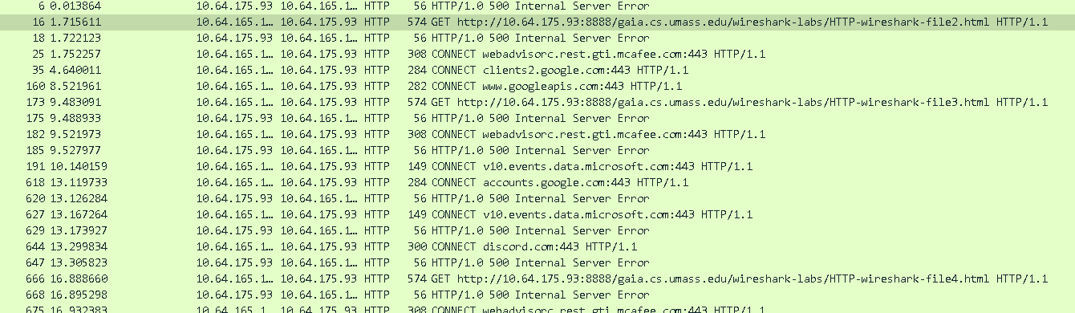

Proxy Server Screenshots(Both Local and External IP):

