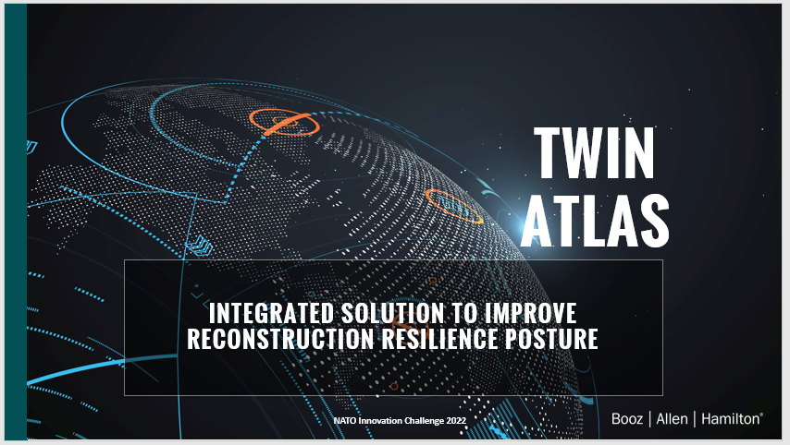

Good Morning, Good Afternoon,

My name is Veronica Davila with Booz Allen Hamilton. And these are my colleagues, John Carrola and Peter Senior.

Our team will present a solution for the need in creating resilience in response, deterrence, and defense efforts.

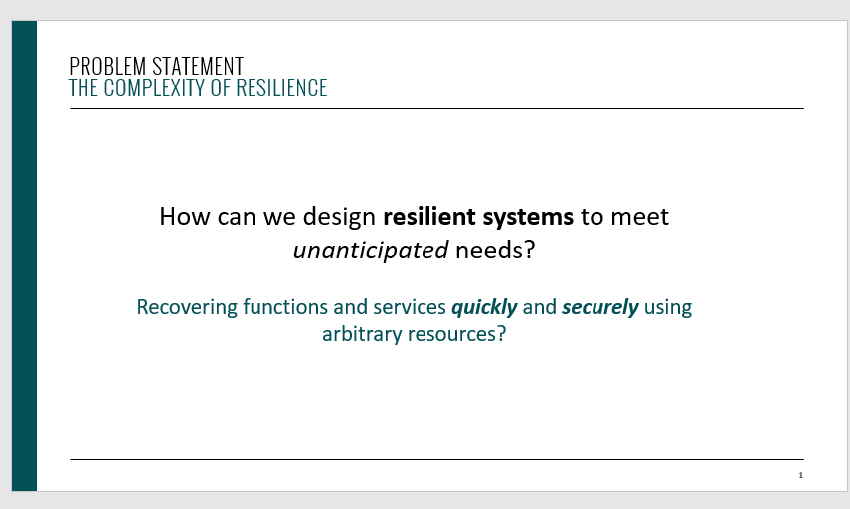

How can we design resilient systems to meet unanticipated needs?

How about recovering functions and services after an attack or disruption quickly and securely using arbitrary resources?

What if we told you we can now QUANITFY RESILIENCE and use these metrics to help build or rebuild critical infrastructure?

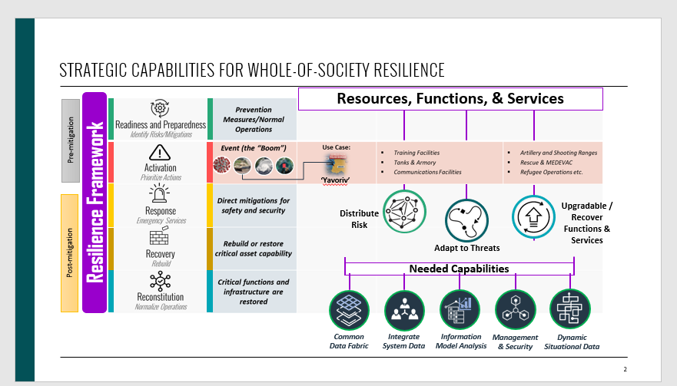

We will show this to you using the example of the real-world event: the Yavoriv International Centre for Peacekeeping and Security, a facility in Western Ukraine that was heavily damaged by Russian forces in March 2022. Due to its role as a strategic hub for the peacekeeping mission in the EU, our solution enhances the Centre’s resilience to withstand further attacks or disruption and maintain readiness.

Our solution utilizes the RESILIENCE FRAMEWORK, to evaluate resources, functions, and services across all phases to the left and right of the “the boom” (or event).

In this case at Yavoriv, Resources such as training facilities and shooting ranges and services like medical evacuation could be rated to determine where there are critical chokepoints or single points of failure, to help drive decisions from leaders in the Rebuilding phase so the installation can be better prepared to adapt to any threat or scenario and recover functions and services quickly. of where risks need to be distributed and decisions need to be adapted.

We will show how our resilient framework covers NATO’s 3 primary capabilities:

* weaving a common data fabric for management and security
* Integration with Operations and Logistics Chain Management systems (NATO)
* Scalable information models for predictive analytics and situational awareness

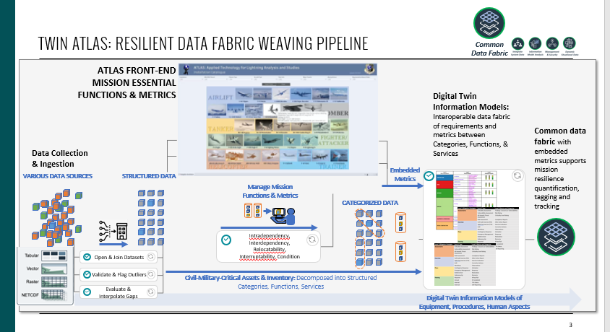

In our general information exchange system, a **structured information model** is defined to standardize **Reconstruction** assets as categories broken down to their systems and functions (systems, components, subcomponents and the functions and services they provide)

These information models cover 3 dimensions:

* procedures,
* equipment and
* human aspects

The models' structure incoming data collected to build and represent the Information Environment as an aspect of Pre-mitigation in the resilient framework for **Reconstruction** efforts:

* Readiness and Preparedness

And can also be used during Normal operations and Response and Recovery.

In a semi-automated process with human analysts in the loop, through the ATLAS interface, they can assign or update inventory sources a weight from a standardized structured model of dependency, condition and criticality (cite what and who is using these)that aligns to the asset categories AND asset's functions and services

{note in FEASIBLITY/USABILITY section note these are working in DoD)

through standardized and structured forms:

* real world assets are digitized into procedures, equipment and human aspect information models ----A digital twin of the real assets and,
* through the ATLAS interface a human-machine collaboration supports embedding the resiliency metrics (MDI and MCI) into the data fabric
  + connecting these 3 information model dimensions

this allows our Twin ATLAS information exchange system to help quantify resilience through single value metrics (MDOI, MCI) and tag and track the assets as well as develop time based models over time in an intuitive manner

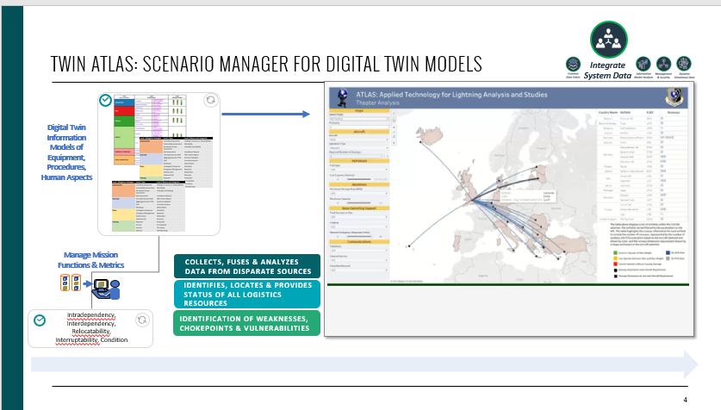

The ATLAS interface is the front-end for the information twin models and can assign, update, or negotiate, optimizing resources and recovering functions and services from AVAILABLE RESOURCES by monitoring changes to the embedded Mission Dependency Index in the mosaic of assets.

Recall how these assets are connected through a measured hierarchy of functions and services.

A team, an analyst or a commander could optimize resources in a crisis event to maintain a threshold MDI or MCI---

* especially during RESPONSE mode in the resiliency framework (This is the VERONICA CONOPS chain)

ATLAS as a scenario manager facilitates showing constraints, chokepoints through the embedded categories of functions and services in the information models

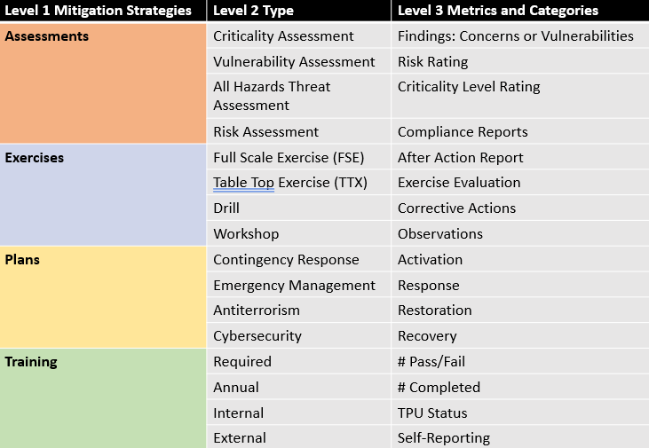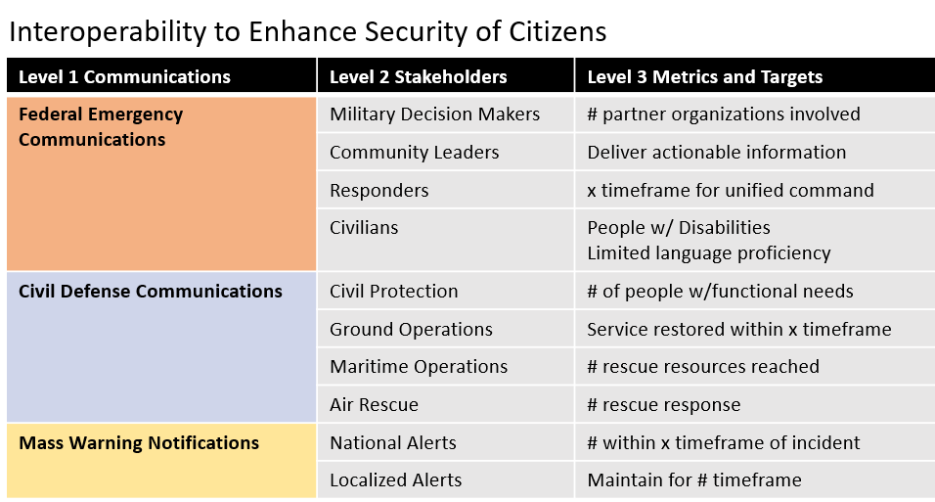

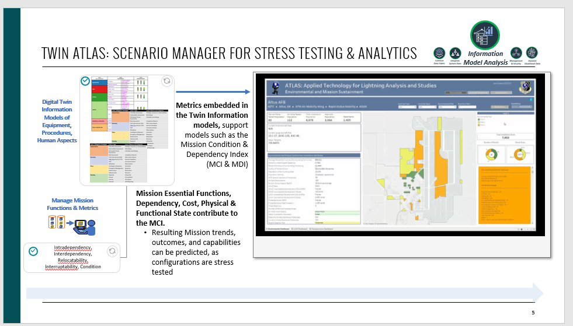

The embedded resiliency metrics (MDI, MCI, etc) support modeling a Mission 'RUL' to quantify reconstruction effectiveness and monitor impact if a disruption is occurring.

developing models based on the MDI such as this involve cost factors ...and [add some more from equation).

The ATLAS scenario manager functions as a stress testing framework to optimize towards maintaining an MDI or other mission effectiveness models by

* adjusting params based on known threats (adversarial tactics), reconstruction, disruptions (supply chain issues from world event), and human impact (water supply tainted in remote town).

A distribution of Optimal response mode configurations can be recorded as an actionable plan.

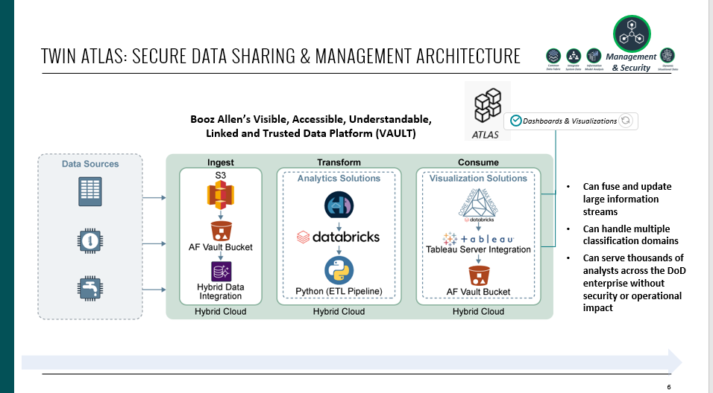

New asset categories of functions and services can be shared securely as ATLAS operates over our VAULT secure architecture

The VAULT Architecture Provides Cybersecure, Cloud-Based Tools to Connect, Find, Share and Learn From Air Force Data

Being technology agnostic, the platform provides the flexibility for COTS, Government Off-The-Shelf (GOTS), and Open-Source software to all be leveraged within a single solution, reducing lock-in of vendors, tools, and environments.

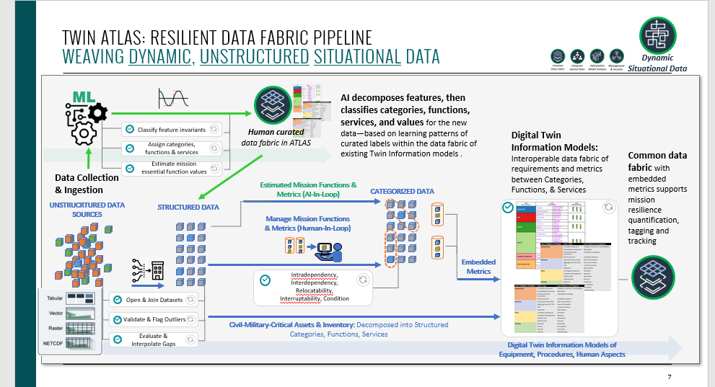

The processes and models described involved structured data from the Pre-mitigation models...after the crisis event, dynamic situational data becomes critical and we want to Twin it.

To integrate this dynamic, unstructured data, it follows our unstructured digitization process: structuring the dynamic data into a relevant information model (i.e., procedures, equipment and human aspects) and embeds the resiliency metrics in order to tag and track the assets.

In this case, a system of probabilistic classifiers (or probabilistic AI) measures features in the incoming dynamic data against the structured labeled data---leveraging the structured human-in-the loop curated data to find patterns in the dynamic data that align with the structured centralized information models' categories, functions and services.

* Based on a threshold, similar and relevant features and configurations are categorized and assigned values to support the resiliency data fabric.

In a sense, during a crisis event producing dynamic unstructured data –

* TWIN ATLAS 'teams' with humans by data mining their expertise by using the pre-mitigation data planning and curation modes with human in the loop curation and twin digitization, as their training data for assigning dynamic unstructured data

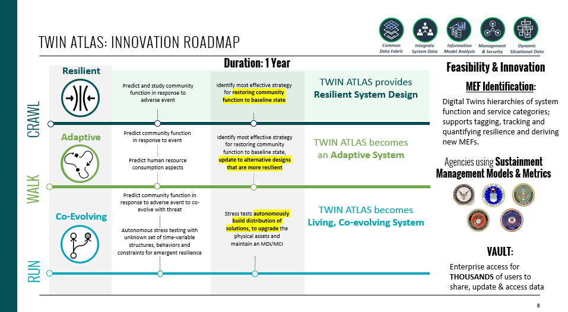

**crawl: TWIN ATLAS provides resilient system design.**

**Predict community function in response to adverse event**

manual updates and assignments, through structured ONTOLOGIES and functions and services static installation data

* structured (easier)
* **identify most effective strategy for restoring community function to baseline state**

**Walk: Adaptative system**

**Predict community function in response to event that permanently destroys structures, changes behaviors (human resource consumption aspects) and radically changing Known constraints**

.... OSINT tools connected during crisis big data and fast

* Unstructured digitizatios

Show the reinforcement graphic...etc....

structured framework examples serve as templates to structure...show threading graphic

* unstructured data to find similar descriptors or models of relevant phenomena in the data....similarity used to map data to ontologies.
* new assets embedded with MDI/MCI(metric for resilience
* can stress test buildings and reconstruction efforts
  + can abstract the functions and services at that points
* **Identify most effective strategy for restoring community function to baseline state and alternative designs that are more resilient**

**RUN: living, co-evolving system**

**Predict community function in response to adverse event to co-evolve with threat---simulate with unknown set of time-variable structures, behaviors and constraints**

* autonomous stress testing framework for emergent resilience
* simulate known threats and tactics
  + targeted building find chokepoints, gaps etc. need to prepare
* stress test and build distribution of solutions (flag system, to upgrade the physical assets to maintain an MDI)

harden and adaptable

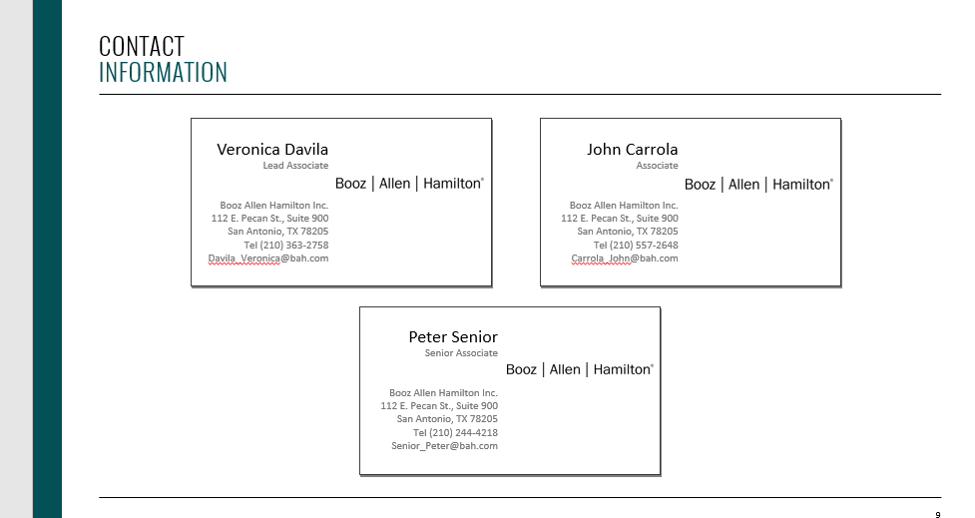

Thank you and we will now take your questions

4