MORVIX UML Deployment Diagram
DSA414 | Software Engineering I | Local course-project deployment
Name(s): ____________________________________ Section: __________ Date: ______________
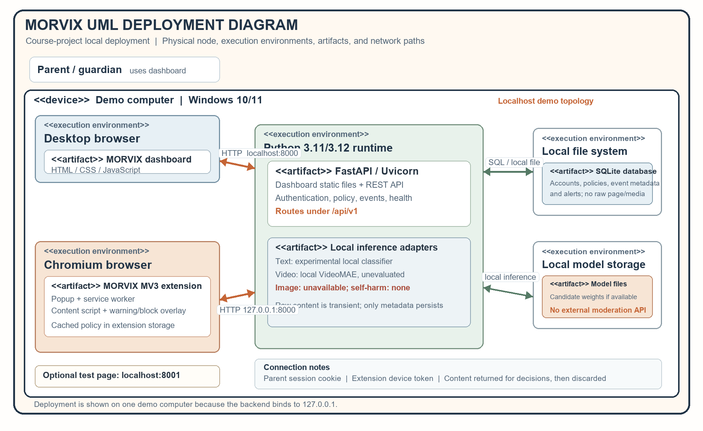
Figure 1. MORVIX deployment nodes, execution environments, software artifacts, and communication paths.

Deployment Explanation
MORVIX is deployed as a local client-server prototype. The parent dashboard and protected Chromium extension communicate with one FastAPI backend on the same Windows demo computer. The backend serves the dashboard, provides the versioned API, evaluates policy, coordinates local inference, and writes account-scoped records to SQLite.

Nodes and deployed artifacts
Parent browser. Runs the dashboard HTML, CSS, and JavaScript served by FastAPI. The parent signs in with a session cookie and uses the dashboard to manage policies, devices, history, and alerts.
Protected Chromium browser. Hosts the Manifest V3 extension: popup, service worker, content script, and warning/block overlay. The extension extracts only accessible page content and keeps the latest policy snapshot in extension-local storage.
Python application runtime. Runs Uvicorn and FastAPI at 127.0.0.1:8000. The application contains authentication and authorization, policy evaluation, API routes, event handling, local text/video adapters, and static dashboard hosting.
Persistent and model storage. SQLite stores account, device, policy, and event/alert metadata. Local model files are loaded by backend adapters when available; inference runs on the demo computer. Neither raw page text nor uploaded media is retained as an event.

Communication paths
Source → destination | Path / credential | Purpose
Parent browser → FastAPI | HTTP localhost:8000; HTTP-only session cookie | Dashboard pages, account authentication, settings, history, and alerts.
Extension → FastAPI | HTTP 127.0.0.1:8000; bearer device token | Pairing, policy sync/status, text/image/video classification requests, and event decisions.
FastAPI → SQLite | Local database access | Persist account-scoped settings and metadata records; no raw page/media.
FastAPI → local model files | In-process local inference | Run a configured classifier without sending content to an external moderation API.

Deployment fit and current limits
The same-machine layout follows the implementation baseline: the backend binds to loopback (127.0.0.1), SQLite is local, and core classification is intended to run locally. A browser on another computer cannot reach a loopback-bound backend; a multi-device demonstration would require a LAN bind and network configuration, which are outside this diagram’s current topology.
Classifier coverage is not complete: text and video pipelines are experimental and unevaluated for MORVIX categories; image classification is unavailable; no self-harm classifier is configured. Audio, cloud hosting, external moderation APIs, and native mobile apps are excluded. The diagram reflects the supplied implementation architecture and the SRS draft, whose final requirements and topology remain subject to team/adviser validation.

