jBulkEmailSender (jBES Discovery)
Phase 0: Enterprise Stabilization & Optimization
Detailed End-to-End Implementation Specification & Developer Guide

Purpose: Establish the secure, scalable, standardized foundation on which the jBulkEmailSender (jBES Discovery) operates. Phase 0 must be completed before introducing third-party SMTP relays, dynamic attachments compression, and advanced telemetry analytics.
------------------------------------------------------------------------------------------

Document Item | Details
Product | jBulkEmailSender - Enterprise-grade, portable bulk email transmission suite
Phase | Phase 0 - Enterprise Stabilization & Optimization
Audience | Product Owner, Technical Architect, Core Developers
Primary Outcome | A working monolithic platform with proactive account rotation, sticky persistent SMTP connections, binary MIME slicing, and high-fidelity logging.
Next Phase Enabled | Phase 1 - Advanced Relay Integrations

1. Executive Summary
Phase 0 focuses on the stabilization, optimization, and architectural monolithic compliance of jBulkEmailSender. The goal is to prepare a secure, highly portable, zero-footprint baseline capable of bypassing standard provider throttling without rework.
- • Consolidate legacy MVC architecture into a stable, single-file monolith (bulk_email_sender.py).
- • Implement TCP socket tuning (1MB buffers) for high-speed transmission.
- • Define a sticky connection strategy with 10-email proactive rotation.
- • Create high-fidelity atomic logs (Build vs. Data latency).
- • Ensure data compliance by migrating write operations to Windows %AppData%.
- • Establish strict First-Time System Authentication, OTP Verification, and Run-Mode checks (Online vs Local).

2. Phase 0 Scope
In Scope | Out of Scope
Monolithic architecture and zero-footprint MSI portability | Web-based dashboards
Environment setup: AppData dynamic migration | Advanced AI/LLM integration
TCP Socket Tuning (SO_SNDBUF) and Sticky Sessions | Third-party bulk email APIs (SendGrid)
System Authentication (First-time OTP, Confirmations, Mode Checks) | Enterprise SSO identity management
Binary MIME slice pre-encoding for attachments | Dynamic real-time attachment compression
Sub-second forensic logging and checkpointing | Enterprise network proxy automatic bypass

3. Phase 0 Implementation Workstreams
Step | Workstream | Objective | Primary Owner | Dependency
0.1 | Architecture Consolidation | Merge MVC to Monolith for portability | Tech Lead | None
0.2 | Data Portability | Migrate Config/Logs to %AppData% | Backend Developer | 0.1
0.3 | Transmission Engine | Implement sticky sessions & socket tuning | Architect | 0.1
0.4 | Payload Processing | Binary MIME pre-encoding for speed | Backend Developer | 0.3
0.5 | Closed-Loop Access Control | Implement OTP Login, Confirmations & Mode checks | Security Arch | 0.1

4. Target Architecture for Phase 0
Phase 0 establishes a clean monolithic structure allowing portable Windows deployment without external dependencies. The architecture integrates a closed-loop feedback mechanism to monitor delivery failures and dynamically update targeting parameters.
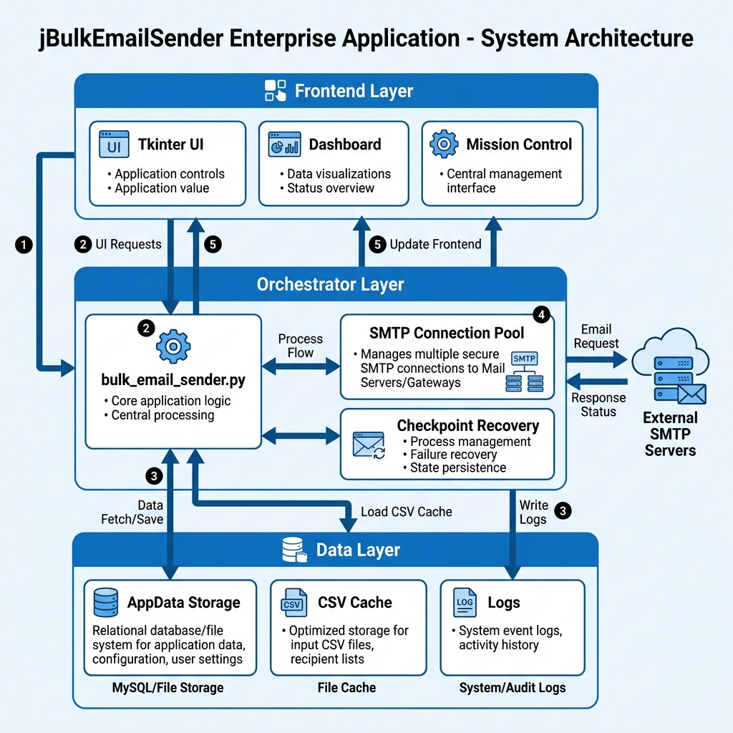
Figure 1: jBulkEmailSender Software Architecture
Layer | Responsibility | Phase 0 Deliverable
Frontend Layer | User interface, mission dashboard, OTP Login Screen | Tkinter with tkinterweb for HTML editing, 3D HUD
Orchestrator Layer | Transmission logic, SMTP connections, thread management | bulk_email_sender.py monolith
Storage Layer | Templates, Config, Mission logs, Checkpoints | Local %AppData% JSON/CSV mapping
Security Layer | OTP verification, App password management | smtplib with integrated retry & auth hooks
Observability Layer | Logging, forensic tracking of Build/Data latency | send_logs.txt with atomic writes, Closed-loop reporting

5. Recommended Technology Baseline
Area | Recommended Choice | Notes
Frontend | Tkinter + ttk + tkinterweb | Native Windows UI, zero footprint requirements
Backend | Python 3.x | Highly optimized for script-to-exe portability
Email Engine | smtplib + email.mime | Standard library, modified for SO_SNDBUF tuning
Deployment | PyInstaller + VBScript | Generates single-click portable MSI/Zip

6. Step 0.1 - Project Structure
Objective: Create a clean portable repository structure for developers to build the MSI.
jBulkEmailSender/
├── PACKAGE_READY_TO_ZIP/
├── app/ (Deprecated MVC)
├── assets/ (UI Icons, Branding)
├── build/
├── config/ (User preferences)
├── core/
│ ├── RichContentManager.py
│ ├── diag.py
│ ├── email_check.py
├── exports/
├── logs/
├── bulk_email_sender.py (Master Orchestrator)
├── main.py (Wrapper)
├── BuildExecutable.bat
└── Deploy_Mission_Control.vbs

7. Step 0.2 - Authentication & System Access
Objective: Establish secure login protocols for system access, terms acceptance, run-mode verification, and backend SMTP transmission.

7.1 System Access Control (OTP & Run Mode)
Before launching the Mission Control dashboard, the user must clear the Security Gateway:
- • First-Time Login & OTP Verification: Upon first execution, the system prompts for a registered email. A one-time verification code (OTP) is dispatched and must be entered to bind the hardware to the user.
- • Terms & Usage Confirmations: The user must explicitly accept a digital EULA/Confirmation dialog allowing the application to execute transmission on their behalf.
- • Run Mode Validation: The orchestrator performs a connectivity check to determine if it should operate in 'Online Run Mode' (telemetry and license ping active) or fallback/restrict to 'Local Run Mode' (offline testing bounds).

7.2 Connection Roles (SMTP Account Types)
Role | Purpose | Typical Access
Primary_Sender | Main communication anchor | Full SMTP rights, highest volume limit
Rotation_Node | Avoids provider tarpitting | Rotates every 10 emails

7.3 Required Core Functions
Function | Purpose
verify_system_access | Triggers OTP dispatch and validates user credentials/terms
check_run_mode | Pings gateway to lock interface to Local or Online operation
smtp_connect | Creates sticky TLS session with 30s timeout and 1MB buffer tuning
smtp_send_with_retry | Auto-reconnects on dropped connections before failure

8. Step 0.3 - Common Transmission Data Model
Objective: Define the shared domain objects that jBES will use for tracking progress.
Core Object | Definition | Why It Matters
Email Target | Destination payload with mapped variables | Base object for mail construction
Checkpoint | Saved state of an interrupted mission | Required for zero-loss recovery
MIME Slice | Pre-encoded binary attachment data | Speeds up build latency to <0.01s
Feedback Event | Closed-loop failure notification (e.g., hard bounce) | Prevents retry loops on dead accounts

9. Step 0.4 - Storage Setup
Objective: Create the base file structure and logic for persisting configuration and progress.
- • Config storage: AppData/jBES_Discovery/config/
- • Zero-Gap CSV: Writes flushed to disk every 50 emails.

10. Step 0.5 - Code Standards & Closed-Loop Design
Objective: Ensure uniform error handling, retry mechanisms, and feedback loops.
- • Standard Exception Handling for smtplib errors.
- • Closed-Loop Feedback: Any hard failures (e.g. SMTPRecipientRefused) instantly update the GUI and are permanently logged in the 'exports/failed/' directory to purge dead leads from future CSV lists, creating a self-cleaning data ecosystem.
- • GUI thread separation from SMTP engine.

11. Step 0.6 - Logging, Monitoring and Audit Foundation
Objective: Capture traceability from day one with micro-second accuracy.
Capability | Requirement
Build Metric | Track precise seconds taken to construct MIME object
Data Metric | Track precise seconds taken by network/AV to upload
Access Audit | Log OTP verification success/failure and runtime mode

12. Frontend Foundation Requirements
- • System Access Gate: Initial Tkinter popup requiring Email entry and OTP validation.
- • EULA Dialog: Confirmation screen explicitly requiring user agreement before unlocking transmission tools.
- • Mode Indicator: HUD element displaying 'ONLINE' or 'LOCAL' run status.
- • GUI Built on Tkinter with L7 Enterprise aesthetics.

13. Backend Foundation Requirements
- • Authentication API integration to dispatch and verify OTP codes.
- • Threading implementation preventing UI freezes during OTP validation or SMTP sends.
- • Monolithic architecture in bulk_email_sender.py.

14. Developer Execution Plan
Day | Focus | Expected Output
Day 1 | Codebase consolidation & Access Gateway | Monolith runs with OTP Login overlay
Day 2 | Run Mode & Confirmations | Local vs Online checks active; EULA confirmation enforced
Day 3 | Sticky Connections & Socket Tuning | Send latency isolated to network restrictions
Day 4 | MIME Slicing & Closed-Loop Feedback | Sub-second builds; failed emails automatically flagged

15. Testing Strategy
- • Verify OTP dispatch triggers accurately upon first launch.
- • Disconnect network adapter to validate graceful fallback to 'Local Mode'.
- • Verify 'Data:' metric correlates to attachment size in isolated networks.
- • Validate 50-email boundary CSV flushes and closed-loop failure logging.

16. Definition of Done for Phase 0
- • User must successfully pass OTP/Terms check to access the main orchestrator.
- • BuildExecutable.bat generates a flawless zero-footprint MSI.
- • Application adapts UI based on Online vs Local checks.

17. Risks and Mitigation
Risk | Impact | Mitigation
Authentication API Downtime | Users cannot bypass OTP gateway | Implement secure offline fallback/cache for previously authenticated machines
Antivirus Deep Scan | Throttles SMTP throughput regardless of code speed | Provide UI instruction to whitelist pythonw.exe
Gmail Tarpitting | Hard-halts rapid email bursts | Implement 10-email rotation strategy

18. Handover Checklist to Start Phase 1
- • Does the OTP and run-mode gateway block unauthorized access effectively?
- • Does rotation bypass initial throttling?
- • Do closed-loop failure mechanisms accurately filter bad recipients?

19. Phase 1 Readiness Output
At the end of Phase 0, the core engine is fully optimized and securely gated. The next phase will leverage this robust foundation to introduce dynamic attachment compression and 3rd-party SMTP relay providers (e.g. SendGrid) to completely bypass environmental limitations.

