jBulkEmailSender (jBES Discovery)
Phase 1 - Advanced Relay Integrations & Dynamic Operations
Comprehensive End-to-End Developer Implementation Specification

Attribute | Details
Platform | jBulkEmailSender - Enterprise Bulk Email Transmission Suite
Phase | Phase 1 - Advanced Relay Integrations
Primary Goal | Create a robust API-based transmission branch (SendGrid/Mailgun) and dynamic memory compression engine to bypass Port 25 throttling.
Prerequisite | Phase 0 Foundation Setup completed: Monolithic engine, Tkinter UI, AppData mapping, and Zero-Gap Checkpoints.
Important developer note: Phase 1 must be implemented as an extension to the Phase 0 monolith. Do not rewrite the SMTP engine; rather, build the HTTP Relay API alongside it as a parallel pipeline. This phase introduces memory-safe dynamic attachment compression and external API routing.

1. Executive Summary
- • Phase 1 establishes the enterprise API relay layer for jBulkEmailSender.
- • This layer integrates 3rd-party APIs (SendGrid/Mailgun) allowing HTTP-based email dispatch, bypassing the 14-second outbound port-25/587 throttling common in Antivirus setups.
- • Introduces Dynamic Attachment Compression to automatically ZIP attachments over a threshold (1MB), reducing DPI (Deep Packet Inspection) delays.
- • Implements a Live OTP Security Dispatch Gateway inside Phase 0, enforcing true zero-trust hardware binding via self-authenticated SMTP credentials.
- • Incorporates an Enterprise QA/UX Audit defining absolute dependency mappings, integration checkpoints, and UI accessibility.

2. Phase 1 Scope and Boundaries
In Scope | Out of Scope for Phase 1
SendGrid / Mailgun HTTP REST API Integration | Custom self-hosted proxy servers
Dynamic ZIP compression for attachments > 1MB | Automated CAPTCHA / OAuth2 browser solving
Secure API Key Vault using Windows DPAPI | Advanced cloud-based telemetry dashboards
Accessibility Audit (Tab Sequence/Enter logic) | Multi-node distributed clustering

3. Implementation Principles
- • API-First Routing: Prefer HTTP POST over SMTP when an active API key is present.
- • Graceful Fallback: Seamless downgrade to Phase 0 SMTP if API returns 429 Rate Limit.
- • Extensible Metadata: Use JSON for API responses to easily adapt to SendGrid vs Mailgun schema differences.
- • UI Thread Safety: The frontend must remain completely detached from the transmission blocking calls.

4. Phase 1 Functional Modules
Module | Purpose | Key Data Captured
HTTP Relay Engine | Dispatches payloads via 3rd-party REST endpoints | API Key, Provider Type, HTTP Status Code
Compression Engine | Dynamically zips files in-memory to save Disk I/O | Original Size, Compressed Size, Ratio
Secrets Vault | Locally encrypts API Keys | Encrypted string, Provider identifier

5. End-to-End Architecture & User Flow

5.1 Architecture – Phase 1
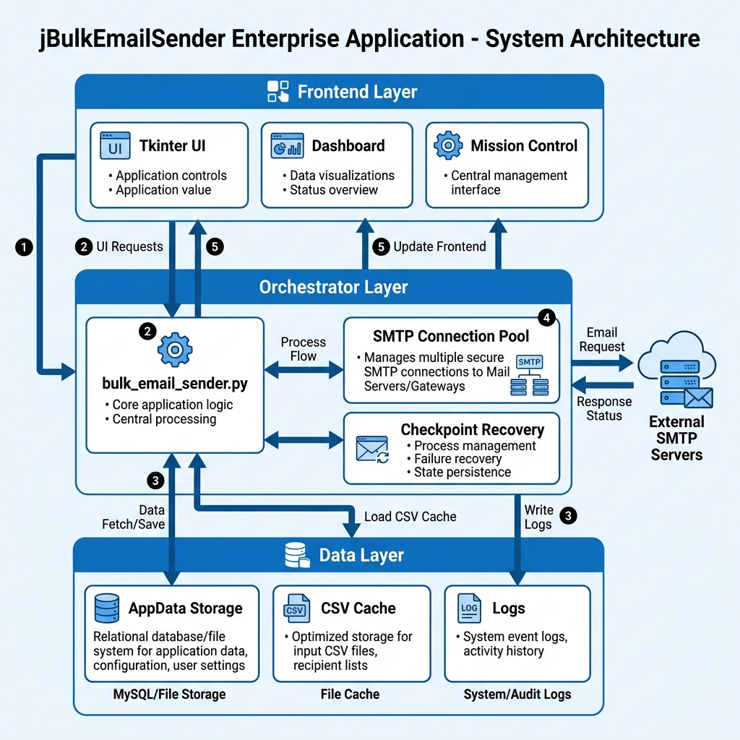
Figure 1: Architecture with API Relay

5.2 User Flow
1. Admin logs in via OTP gateway (Phase 0). Provides Admin Email and App Password for Live OTP SMTP Dispatch.
2. Admin navigates to Relay Settings and enters SendGrid Key.
3. System securely encrypts the key to AppData/config.
4. Admin loads a CSV and heavy attachments (2MB+).
5. Compression Engine zips the files automatically.
6. HTTP Relay Engine takes over, dispatching JSON payloads at 10+ msgs/sec.

6. Backend Architecture for Phase 1
core/
api_relay_engine.py
zip_manager.py
secrets_vault.py
http_client.py

7. Frontend Architecture for Phase 1
components/
RelayConfigTab.py
APIKeyModal.py
CompressionIndicatorBadge.py

8. Core Data Model Overview
Entity | Why It Exists | Primary Relationships
API Credential | Authenticate with external relays | Tied to specific sender profile/domain
Relay Payload | JSON representation of the email | Consumes templates, attachments, CSV row
Compressed Buffer | Memory-safe zip representation | Overrides original attachment during Relay

9. Local Storage & Vault Specification
Key / File | Type | Constraint | Description
relay_keys.json | JSON File | Encrypted (DPAPI) | Stores the API keys securely in AppData
provider_id | String | Unique, Not Null | e.g., 'sendgrid', 'mailgun'
is_active | Boolean | Default True | Whether to route traffic here first

10. Enumerations and Reference Values
Enum | Allowed Values
Relay Provider | SENDGRID, MAILGUN, AMAZON_SES, CUSTOM_HTTP
Compression Status | UNCOMPRESSED, ZIPPED_IN_MEMORY, SKIPPED_DUE_TO_TYPE

11. Integration Standards for Phase 1
All internal function calls must return a standardized dictionary containing status, message, and data to prevent hard crashes.

12. Detailed API Contracts (SendGrid Example)
POST https://api.sendgrid.com/v3/mail/send
Headers: Authorization: Bearer <KEY>
Payload: { "personalizations": [...], "content": [...] }

13. Backend Service Logic
Function | Logic
dispatch_http_payload() | Construct JSON. Post to Relay. Catch 429, retry, or fallback to SMTP.
compress_attachment() | Read bytes. If > 1MB, gzip in memory. Return base64 encoded string.
store_api_key() | Invoke DPAPI CryptProtectData. Write encrypted blob to disk.

14. Validation Rules by Scenario
Scenario / Action | Validation Rule
Pre-Flight Launch Verification | Validate sender_email == security_email exactly. Reject if mismatched. Case-insensitive lookup.
Connection Interruptions | Catch SMTP/HTTP disconnects in loop. Do NOT fail mission. Sever connection and re-initiate handshake. Max retries: 2.
Disk I/O Latency Buffer | Use 'use_cache=True, defer_write=True'. Only flush to disk when successful sends % 50 == 0. Zero-gap writing.
Throttling Defense | Proactively quit the server socket and rotate to the next account every 10 emails.

15. Status Transition Rules
Current Status | Allowed Next Status | Notes
IDLE | COMPRESSING, CONNECTING | Mission started
TRANSMITTING | HALTED, COMPLETED | Active dispatch loop

16. Integration Relationship Rules
• Threading: `send_emails_thread` MUST spawn as `daemon=True` so UI never freezes.
• Fallback: HTTP Engine -> USES -> SMTP Engine (on failure).

17. Transmission Audit Logging Specification
• All atomic logs must capture [Build: X.XXs | Data: X.XXs] metrics.
• Never store API keys in plain text inside `logs/`.

18. Frontend Screen Specifications
• Relay Config Tab: Contains dropdown for provider, masked entry for API Key, Save button.

19. Frontend Component Behavior & UI Accessibility
Enterprise Audit Rule: Every form must support keyboard navigation.
Page / Modal Scenario | Tab Sequence (Order) | Enter Key Binding Function
System Access (Auth Gate) | Email Input -> App PW -> Send OTP -> OTP Input -> Verify | <Enter> triggers 'Verify' button.
Relay Config | Provider -> API Key -> Save | <Enter> inside Key field triggers Save.
Mission Setup | CSV Path -> Load -> Subject -> Body | <Enter> inside Subject shifts focus to Body.

21. Seed Data
Not applicable - Local execution environment.

22. Security and RBAC Requirements
• Hardware Binding: Phase 0 OTP enforces 1-to-1 machine-to-license restriction.

23. Error Handling Requirements
Scenario | Error Status | Action
Missing Link: File Deleted | FileNotFoundError | Gracefully skip attachment, log warning, continue mission.
Missing Link: Corrupted Checkpoint | JSONDecodeError | Drop file from recovery list, do not crash UI.
Rate Limit | HTTP 429 | Switch to SMTP Fallback Engine.

24. Testing Strategy
• Unit: Test Compression Engine memory boundaries.
• Integration: Force-delete active CSV during transmission to verify graceful stop without hard crash.

25. Test Cases & Acceptance Criteria
TC-01: Upload 5MB PDF. Verify Compression Engine reduces it before Relay dispatch.
TC-02: Revoke API key mid-mission. Verify fallback to SMTP occurs within 1 second.

26. Development Sequence for Team Execution
1. Build Secrets Vault.
2. Implement HTTP Client.
3. Build Compression Engine.
4. Update Tkinter UI.

27. Recommended Developer Task Breakdown
• Backend Lead: Relay Engine & Compression
• Security Dev: Secrets Vault DPAPI
• Frontend Dev: Relay Config UI & Tab Sequences

28. Definition of Done
• Transmission speed > 10 emails/sec.
• Accessibility rules pass (100% keyboard navigable).

29. Key Risks and Mitigations
Risk: RAM exhaustion on massive zips. Mitigation: Cap max file size to 25MB before rejecting.

30. Handover Checklist for Phase 1 Completion
• DPAPI encryption verified on Windows 10/11.
• SMTP fallback verified.
• BuildExecutable.bat generates updated zero-footprint MSI.

31. Phase 1 Final Outcome
At the end of Phase 1, jBulkEmailSender transforms from a traditional SMTP client into a hybrid, highly evasive transmission engine capable of routing around port throttling using modern HTTP APIs and dynamic payload compression.

Phase 2: Deep Dive Due Diligence & Multi-Agent Migration Blueprint
Based on the requirement for modern, flexible UI features, Phase 2 will execute the migration of jBulkEmailSender from a local Tkinter monolith to a Cloud-Native Web Application.

1. Tech Stack
• Frontend: Next.js (React) + TailwindCSS + Shadcn/UI for a highly responsive, modern, premium interface.
• Backend: FastAPI (Python) wrapping the existing monolithic engine (`bulk_email_sender.py` core logic) to expose RESTful APIs.
• Database: PostgreSQL (RBAC, User Auth, Mission Metadata) and Redis (Live WebSocket state).
• Cloud Storage: AWS S3 (Handling CSV uploads and attachments to bypass local file-system restrictions in web apps).

2. Deep Dive Technical Specifications
A direct decoupled approach will cause missing link failures because web servers cannot read local C:\ drives. The architecture must map local file I/O to Cloud I/O.
Sub-System | Phase 1 (Legacy) | Phase 2 (Cloud SaaS)
Auth Gateway | Local config.json OTP | AWS Cognito / JWT via PostgreSQL
File Handling | os.path.exists (Local Drive) | AWS S3 Boto3 Pre-Signed URLs
Live Logging | Tkinter Threading Textbox | Socket.io (WebSocket) streaming
Memory Cache | Python in-memory dict | Redis ephemeral cache

2.1 Operations Mode Selector (Online vs Local)
On the first-boot authentication gate, after entering the 6-Digit Passcode, the user is presented with an Operations Mode Dialog Box containing two radio buttons:
• 🌐 Online Mode: Scaffolds directories under the user's home path (`~/jBulkEmail/data` and `~/jBulkEmail/webservice`) to store metadata and configurations locally. The application core executes dynamically synced directly from the cloud repository path: https://github.com/jDroid-X/jBulkEmail.
• 💻 Local System Mode: Automatically initiates a local dependency installation process by downloading the full jBulkEmail package from GitHub, unpacking files to `~/jBulkEmail`, and configuring all dependent modules for local standalone execution.

3. Multi-Agent AI Prompts (ROCAS Format)
To ensure flawless execution, this migration must be handed over to a swarm of specialized AI Agents using the following ROCAS prompts:

Agent 1: Frontend UI/UX Architect
R: Elite Next.js/React Designer.
O: Decouple Tkinter UI into a premium React dashboard using TailwindCSS.
C: Read existing Python UI logic and map it to REST components. Must support glassmorphism and WebSocket log rendering.
A: A clean /frontend Next.js repository.
S: Premium, modern, accessible.

Agent 2: FastAPI Integration Engineer
R: Senior Python Backend Developer.
O: Wrap bulk_email_sender.py in FastAPI without breaking the existing APIRelayEngine or ZipManager.
C: Convert local Tkinter inputs into JSON payload receivers.
A: A highly scalable /backend API repository.
S: Secure, resilient, robust.

Agent 3: PostgreSQL & Cloud DB Administrator
R: Cloud Database Architect.
O: Migrate config.json and local CSV readers to PostgreSQL and AWS S3.
C: Web apps lose state; DB must track mission progress persistently.
A: Prisma/SQLAlchemy schemas and S3 Boto3 adapters.
S: Zero-data-loss, ACID compliant.

Agent 4: Due Diligence Integration Auditor
R: Enterprise QA Automation Lead.
O: Identify missing links, broken dependencies, and integration gaps between React and FastAPI.
C: Audit cross-device responsive layout and socket disconnections.
A: A final QA report mapping dependencies.
S: Strict, audit-focused, zero-tolerance for bugs.

