**Top Cover:**

- Material: 0.048” A1008 Cold Rolled Carbon Steel

- Thickness: 0.048" (1.2192 mm)

- K factor: 0.38

- Bend Radius: 1.1430 mm

- Total width: 250 mm + 1.2192 mm + 1.2192 mm = 252.4384 mm

- Total height must be > 109 mm -> set to 115 mm in case ribs needed

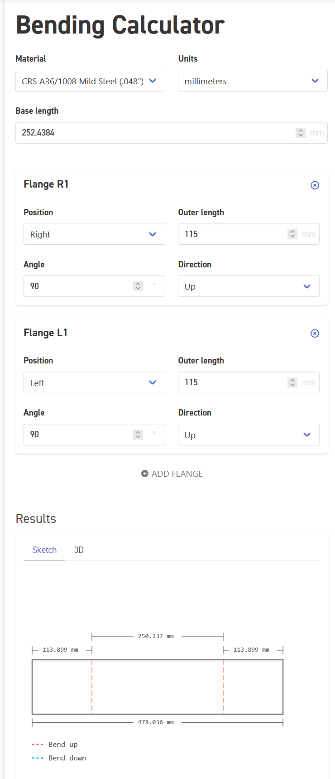

**Baseplate:**

* Material: 0.059” A1008 Mild Steel
* Thickness: 0.059” (1.4986 mm)