**BO4**

**Databases**

| **Name** | **Size** | **Tables** | **Duration** |
| --- | --- | --- | --- |
| **hss_bo4_prod** | **364.29 GB** | **133** | **17:57:23** |
| **hss_bo4_prod_NP** | **75.35 GB** | **130** | **03:19:50** |
| **hss_BO4_prod_TestCompanies** | **709.81 MB** | **130** | **00:1:14** |

**Azure Database Migration Services**

| **Name: we-a-datamigration-hrss** | **SKU: Standard: 1 vCores** |
| --- | --- |
| **Subscription: HR Self Service ACC** | **vNet: net-acc-self-Service/subnet-sqlserver** |

**Azure Database Migration Project**

## We created just one project with one activity that included the 3 databases:

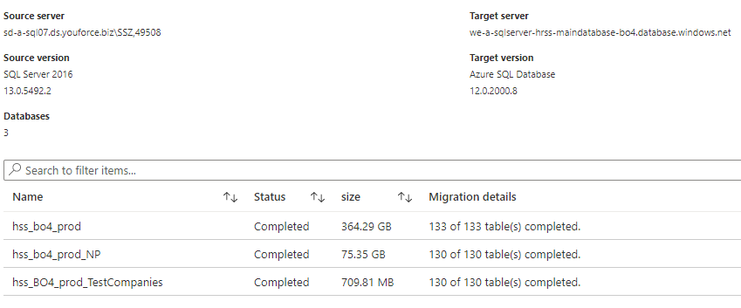

**Process**

During the migration process, we changed the database DTUs capacity everytime we saw that the DTUs consuming had reached the limit, or the DTUs consuming was below the limit.We can see that in the charts “*BO4 Main database DTUs used*” and “*BO4 NP database DTUs used*”.

Almost all the time, the capacity was under the limit, and in the source SQL Server, there were ASYNC_NETWORK_IO waitings, indicating that the bottleneck is maybe in the migration service.

**HRE-HRIS**

**Databases**

| **Name** | **Size** | **Tables** | **Duration** |
| --- | --- | --- | --- |
| **hss_hre_prod** | **121.68 GB** | **129** | **02:26:21** |
| **hss_hre_prod_Jumbo** | **22.61 GB** | **129** | **00:32:52** |
| **hss_hre_prod_KPN** | **28.74 GB** | **129** | **00:41:55** |
| **hss_hris_prod** | **105.25 GB** | **129** | **02:06:59** |

**Azure Database Migration Services**

| **Name: we-a-hrss-migrationservices** | **SKU: Premium: 4 vCores** |
| --- | --- |
| **Subscription: HR Self Service ACC** | **vNet: net-acc-self-Service/subnet-sqlserver** |

**Azure Database Migration Project**

## We created just one project with 4 activities that included 1 database per activity:

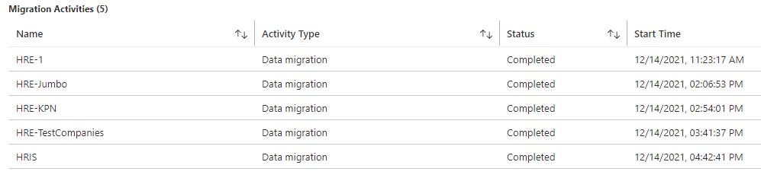

**Process**

During the migration process, we only changed the database DTUs during the main database migration, because in that case we realized that the bottleneck was in the target database. With the new migration service we also saw ASYNC_NETWORK_IO in the source database, but in that case it was caused by the target databases as we can see in the charts.

***BO4 Main database DTUs used***

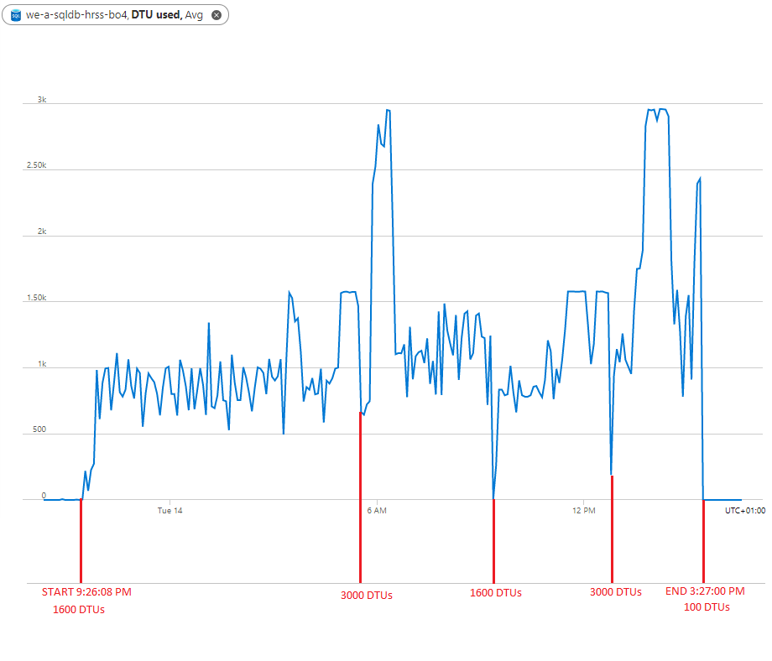

***BO4 NP database DTUs used***

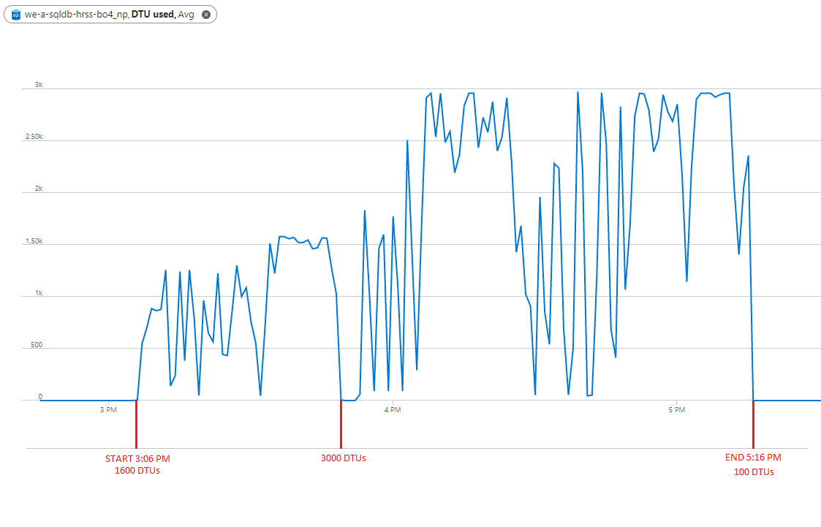

***HRE Main database DTUs used***

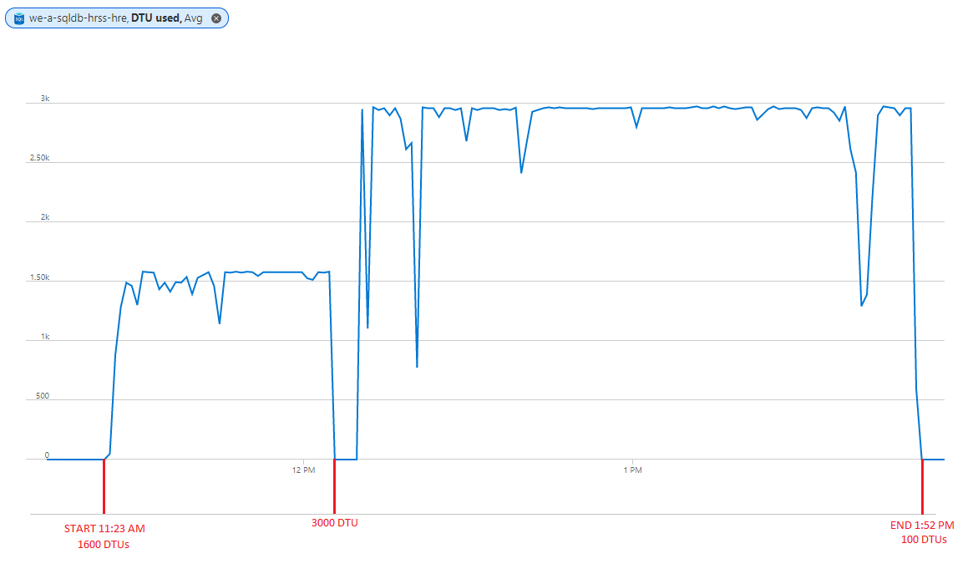

***HRE Jumbo database DTUs used***

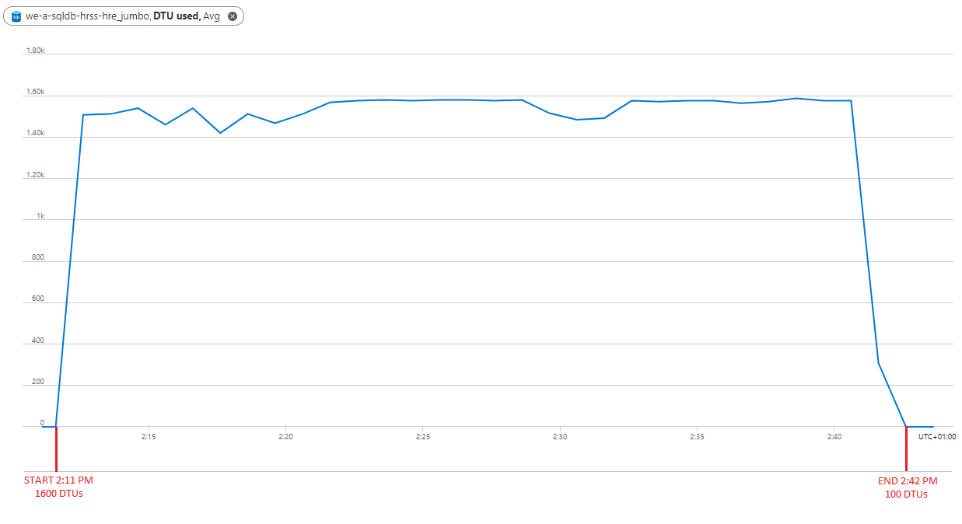

***HRE KPN database DTUs used***

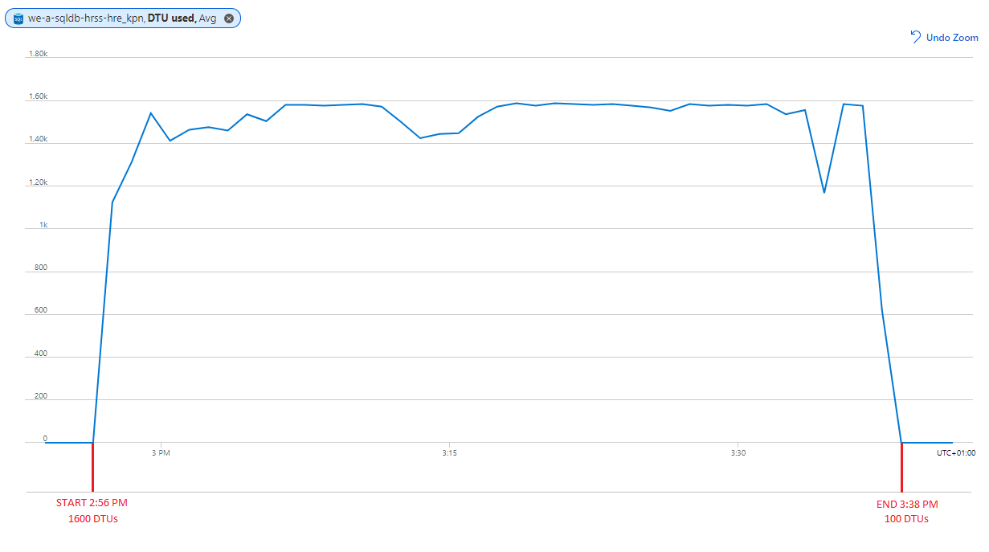

***HRIS Main database DTUs used***

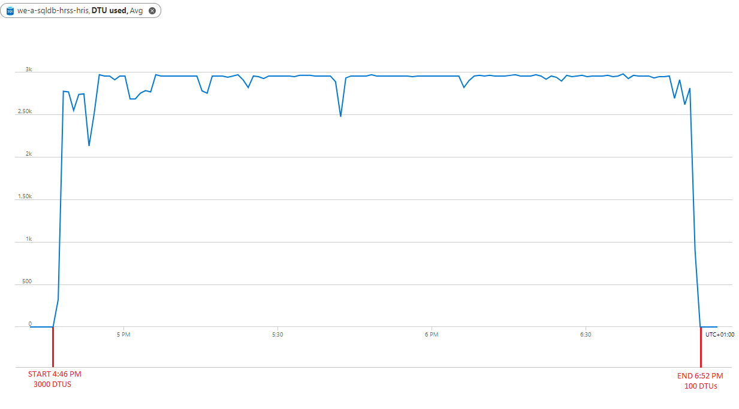

**Impediments founds during the process**

| **Impediment** | **Solution** |
| --- | --- |
| There were some onprem databases with different collation than in Azure | Recreate manually the Azure database with the same collation as the onprem database |
| There were some onprem databases with different size than in Azure | Increase manually the size in those databases in Azure |

**Improvements and recommendations of** [Miguel Molina García](mailto:miguel.molinagarcia@visma.com) **and** [Luis Vilhena Angulo](mailto:luis.vilhena@visma.com)

1. Parameterize the database collation in the pipeline. To do that, we have to add a new column in the HostCredentials table indicating the collation for each database.
2. Parameterize the database size in the pipeline. To do that, we have to add a new column in the HostCredentials table indicating the size for each database.
3. During the creation of the database, add permission for the DBAs. To do that, we have to modify the pipeline, and at the same moment that we add the DevOps user, we need to add the DBAs users and grant them permissions.
4. In DEV and TEST environments, we have to select the locally-redundant backup storage to save costs.

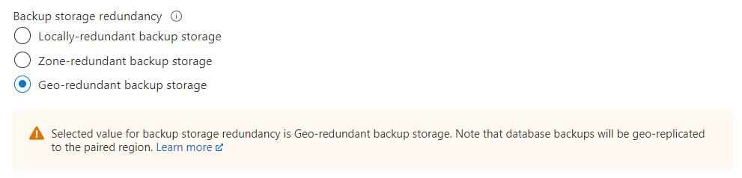

1. In production, we have to activate Microsoft Defender for SQL. It will provide some recommendations to prevent some possible database vulnerabilities.

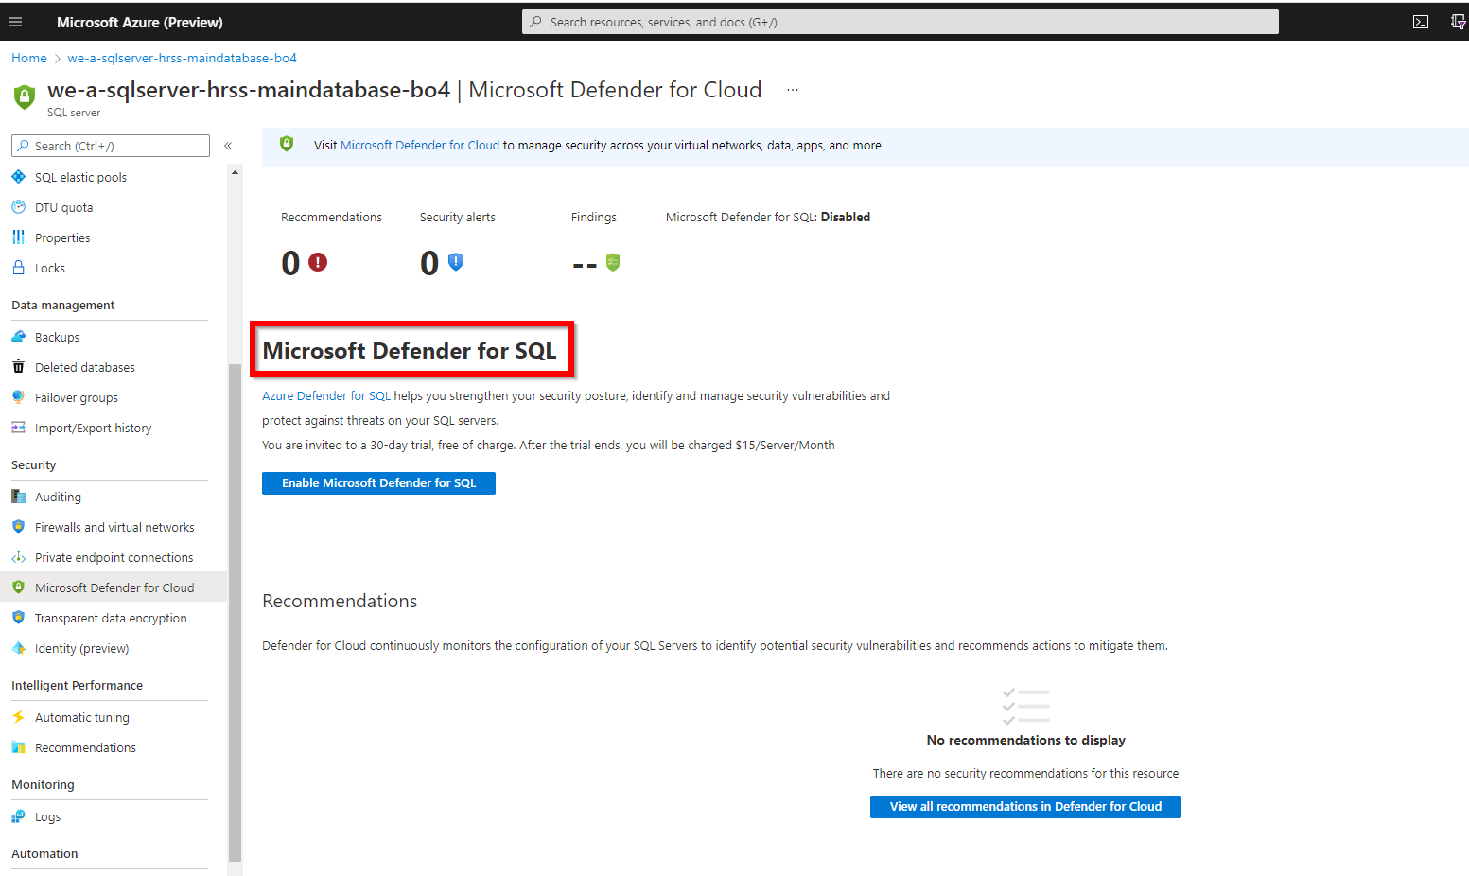

1. We have to enable the option to deny public network access, to prevent any access from the internet and allow only access from the private networks.