**PORTLAND PROJECT**

**PORTLAND CENTER PLAZA**

**THE LINC**

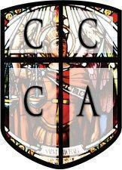

**SUNDAY, APRIL 12th , 2020**

6: 15 AM I arrived on location at PCP, parked my vehicle, and met Officer Aguilar outside the Plaid Pantry.

6:30 AM On duty. Officer Aguilar went over the events of his shift with me and left soon after.

7:00 AM Began first patrol around the PCP parking area and around the nearby storefronts. No issues detected

8:00 AM Conducted a walking patrol of the pool and gym area of the Linc apartments, then proceeded to make sure the garbage area and parking area were safe from illegal activity. There were no issues present.

10:00 AM Began monitoring the parking lot of the PCP parking area. Foot traffic was slightly increased.

11:00 AM Stationed near the Linc parking area to monitor any ongoing activities in the vicinity. No issues presented themselves.

12:00 PM Conducted a vehicle patrol of the surrounding area perimeter. PCP and Linc were both inactive with no issues.

1:00 PM Began to monitor the PCP parking area for issues. No issues at the current time.

2:00 PM conducted a walking patrol of the Linc pool / gym area as well as the West side walking areas.

2:15 PM Received notification that Plaid pantry may have had a thief in progress. I responded and entered the store. The individual ended up standing in line to purchase his items, but was denied alcohol because of no ID. He left but there were no real problems.

3:15 PM At this time a group of transients entered the property from the North side and looked to be headed to the Plaid Pantry. Just as a precaution I walked outside and inside of the Plaid to show presence. There were no issues.

4:30 PM Performed a walking patrol of the Linc parking areas and the surrounding perimeter. No issues detected.

5:30 PM Received a phone call from the Plaid detailing an individual, male, in a dark green jacket that had just left the store with unpurchased food and drink. I responded and followed in the direction he was seen going. The individual was found behind the liquor store with another male, brown hair. The theft gave his name as ‘Rudy Tobar’, though this was unconfirmed. He was verbally trespassed for stealing store merchandise. The two left with no issues.

Trespassed Individual - Name Given: ‘Rudy Tobar’



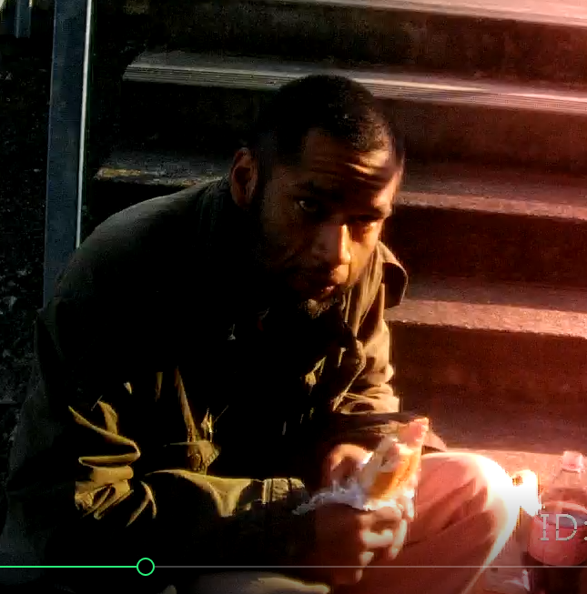

6:00 PM Conducted a vehicle patrol of Linc parking and PCP, nothing out of the ordinary to report. Returned

6:30 PM Off duty, relieved by officer Aguilar.

**\*\*\*\*\*\*\*\*\*\*\*\*\*\*\*\*\*\*\*\*\*\*\*\*\*\*\*\*\*END OF REPORT\*\*\*\*\*\*\*\*\*\*\*\*\*\*\*\*\*\*\*\*\*\*\*\*\*\*\*\*\*\*\***