http://www.irisa.fr/lagadic/visp
需下载开源源代码和图片文件

环境变量
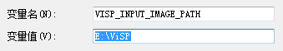

ViSP-BUILD\example\calibration\Debug 标定
- calibrate2dGrid： Camera calibration with any calibration grid.
用PMG格式（必须是灰白的），可用PHOTOSHOP先改为灰度图，再另存为为PGM格式。只计算了内参，没有外参计算。标定图在ViSP-images\calibration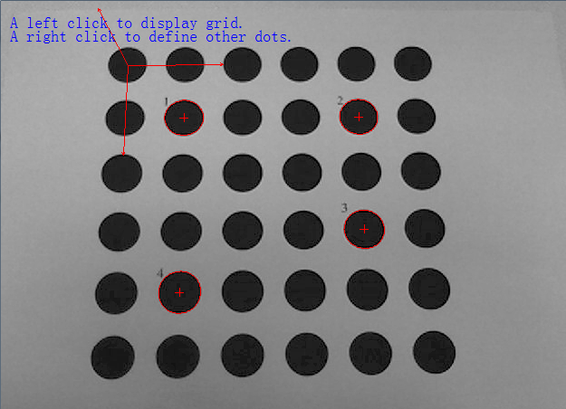
- calibrateTsai: Tsai calibration example to estimate hand to eye transformation.
用于计算手到眼的转换关系。
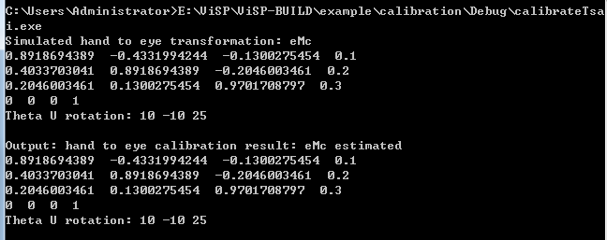

ViSP-BUILD\example\coin-simulator\Debug
其下工程需安装Coin3D和SoQT或SoWin或SoXt

ViSP-BUILD\example\device
Only Unix

ViSP-BUILD\example\direct-visual-servoing\Debug*
PGM图像跟踪（eye in hand）
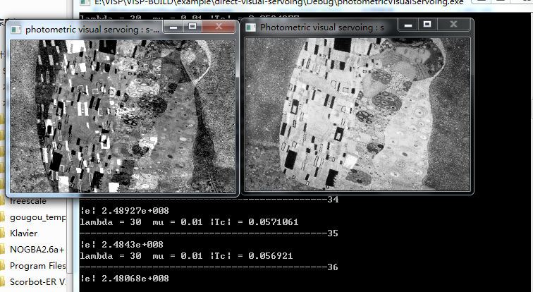

ViSP-BUILD\example\homography\Debug
各种映射估计算法
- homographyHartleyDLT2DObject
- homographyHLM2DObject
- homographyHLM3DObject
- homographyRansac2DObject

ViSP-BUILD\example\image\Debug 未测试成功
imageDiskRW：Reading and writting images on the disk.
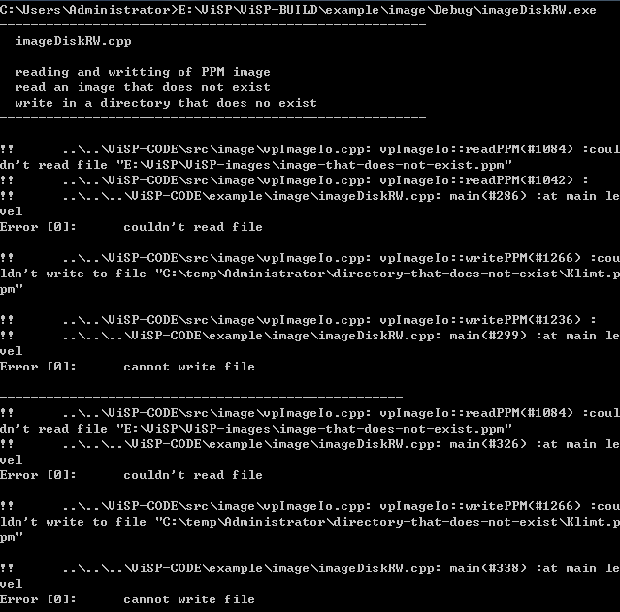

ViSP-BUILD\example\key-point\Debug 特征点
1.fernClassifier:Detection of points of interests and matching using the Ferns classifier.
Can’t load ViSP-images/cube/image.0000.pgm
2.keyPointsurf:Tracking of Surf keypoints.* 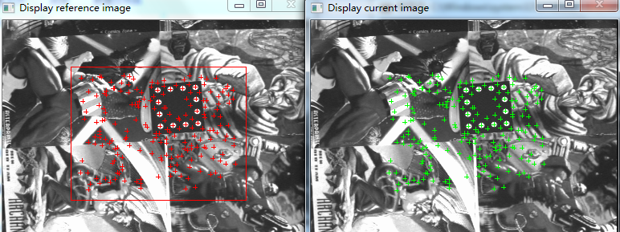
3.planarObjectDetector:Detection of planar surface using Fern classifier.
Can’t load ViSP-images/cube/image.0000.pgm

ViSP-BUILD\example\manual\Debug
- HelloWorld
2.HelloWorldOgre
3.HelloWorldOgreAdvanced
4.manDisplay:error
5.manGeometricFeatures:Geometric features example.
6.manGrab1394-1:Images grabbing example.
7.manGrab1394-2:Images grabbing example.
8.manGrabDirectShow:Images grabbing example.
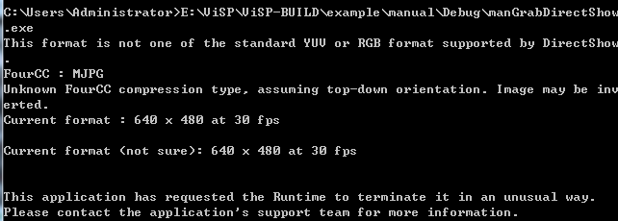
- manGrabV4l2:Images grabbing example.
- manServo4PointsDisplay:Simulation of a visual servoing with display.
Need install GTK
11.manServoMomentsSimple：Example of visual servoing with moments using a polygon as object container
12.manSimu4Dots：Simulation of a visual servoing with visualization and image generation.
其下工程需安装Coin3D和SoQT或SoWin或SoXt
13.manSimu4Points 同上

ViSP-BUILD\example\math\Debug
- BSpline：Exemple of a B-Spline curve.
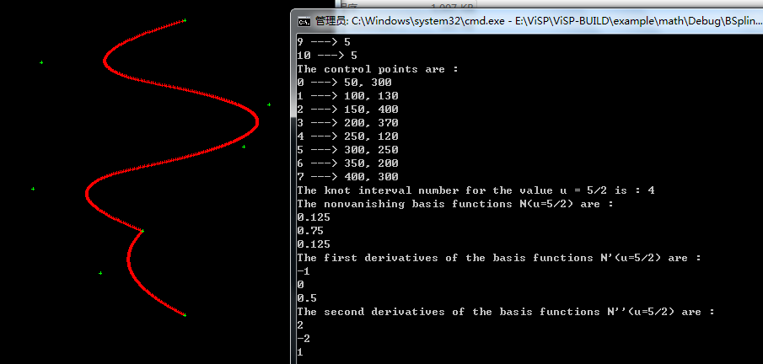
- exponentialMap：Test some vpColVector functionalities.
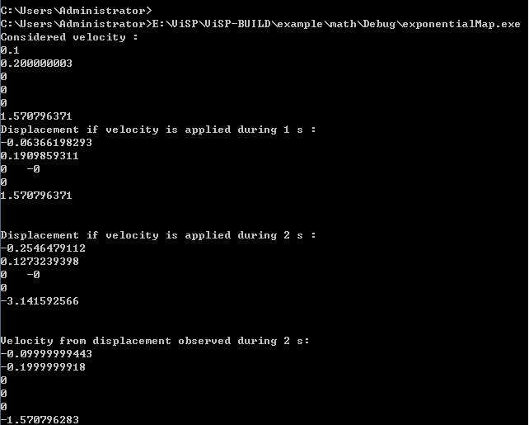
3.Nurbs：Exemple of a Nurbs curve.

ViSP-BUILD\example\moments
其下分为图像、点、多边形三个例子。基于扩展目标的不变矩跟踪算法

ViSP-BUILD\example\ogre-simulator\Debug
Should install ogre3D

ViSP-BUILD\example\parse-argv\Debug
- parse-argv1:Example of command line parsing.
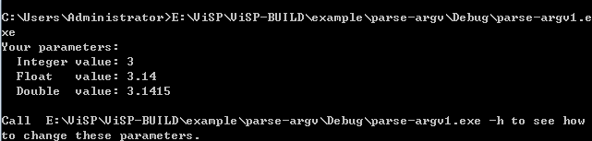
2.parse-argv2:Example of command line parsing.

ViSP-BUILD\example\pose-estimation\Debug
poseVirtualVS:
Pose computation on an object made of dots.
* reading of PGM image
* Display image using either the X11 or GTK or GDI display
* track 4 dots (vpDots) in the image
* compute the pose

example\robot-simulator\afma6\Debug
servoSimuAfma6FourPoints2DCamVelocity:
* Simulation of a 2D visual servoing using 4 points with cartesian
* coordinates as visual feature.

ViSP-BUILD\example\robot-simulator\camera\Debug
1.servoSimu3D_cdMc_CamVelocity:Simulation of a 3D visual servoing.
2.servoSimu3D_cdMc_CamVelocityWithoutVpServo:Simulation of a 3D visual servoing.
3.servoSimu3D_cMcd_CamVelocity:Simulation of a 3D visual servoing.
4.servoSimu3D_cMcd_CamVelocityWithoutVpServo:Simulation of a 3D visual servoing.
5.servoSimuCircle2DCamVelocity
6.servoSimuCircle2DCamVelocityDisplay
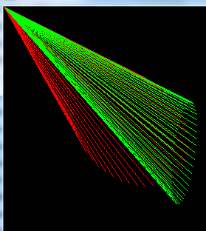
7.servoSimuCylinder2DCamVelocityDisplay
8.servoSimuCylinder2DCamVelocityDisplaySecondaryTask
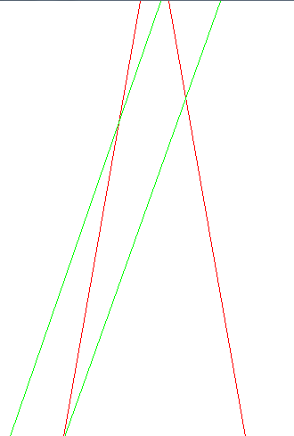
9.servoSimuFourPoints2DCamVelocity
10.servoSimuFourPoints2DCamVelocityDisplay
11.servoSimuFourPoints2DPolarCamVelocityDisplay
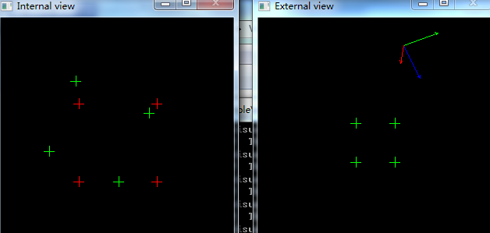
- servoSimuLine2DCamVelocityDisplay
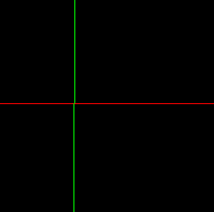
13.servoSimuPoint2DCamVelocity1:Simulation of a 2D visual servoing on a point.
14.servoSimuPoint2DCamVelocity2:Simulation of a 2D visual servoing on a point.
15.servoSimuPoint2DCamVelocity3:Simulation of a 2D visual servoing on a point.
16.servoSimuPoint2DhalfCamVelocity1: Simulation of a 2 1/2 D visual servoing.
17.servoSimuPoint2DhalfCamVelocity2: Simulation of a 2 1/2 D visual servoing.
18.servoSimuPoint2DhalfCamVelocity3: Simulation of a 2 1/2 D visual servoing.
19.servoSimuPoint3DCamVelocity:Simulation of a 3D visual servoing on a 3D point.
20.servoSimuSphere2DCamVelocity:Simulation of a 2D visual servoing on a sphere
21.servoSimuSphere2DCamVelocitySecondaryTask:Simulation of a 2D visual servoing on a sphere
22.servoSimuSquareLine2DCamVelocityDisplay:Simulation of a 2D visual servoing on a line.
23.servoSimuThetaUCamVelocity:
Simulation of a visual servoing using theta U visual features.
* tests the control law
* eye-in-hand control
* velocity computed in the camera frame
* using theta U visual feature

ViSP-BUILD\example\robot-simulator\viper850\Debug
servoSimuViper850FourPoints2DCamVelocity:对于机械臂VIPER 850(六个自由度)的实际仿真模型(eye-in-hand task control)
雅可比矩阵的运算在vpServo.cpp

ViSP-BUILD\example\servo-afma4 无法参考
ViSP-BUILD\example\servo-afma6 无法参考
ViSP-BUILD\example\servo-biclops
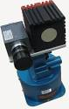未查到具体资料
ViSP-BUILD\example\servo-cycab 无法参考（移动机器人）
ViSP-BUILD\example\servo-pioneer 无法参考（移动机器人）
ViSP-BUILD\example\servo-ptu46 无法参考
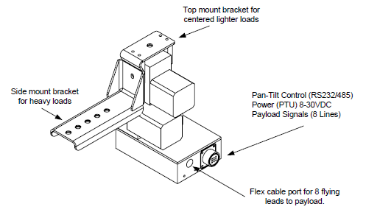
ViSP-BUILD\example\servo-viper850 串行六轴

\ViSP-BUILD\example\tools\Debug
- Histogram:Example of Histogram manipulation.
- Keyboard:Unix only
- ParallelPort:Unix only
- plot2d:二维坐标图像绘制
- plot3d:三维坐标图像绘制

ViSP-BUILD\example\tracking\Debug
1.mbtTracking:Example of model based tracking.
Libxm12 is required to read the configuration of the tracker
2.trackDot:Example of dot tracking.
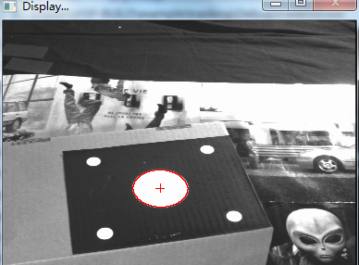
3.trackDot2:Example of dot tracking.
4.trackDot2WithAutoDetection:Test auto detection of dots.
5.trackKltOpencv:Example of dot tracking.
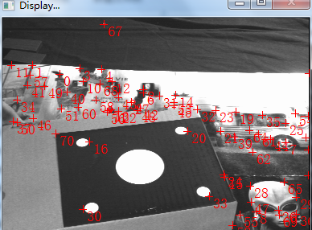
6.trackMeCircle:Tracking of an ellipse.
7.trackMeEllipse:Tracking of an ellipse.
8.trackMeLine:Tracking of a line.
9.trackMeNurbs:Tracking of a nurbs.error

ViSP-BUILD\example\video\Debug
视频存储播放

ViSP-BUILD\example\wireframe-simulator\Debug
wireframeSimulator:Demonstration of the wireframe simulator
ViSP-BUILD\test\camera\Debug
testCameraParametersConversion:Performs various tests on the vpPixelMeterConversion and vpPixelMeterConversion class.
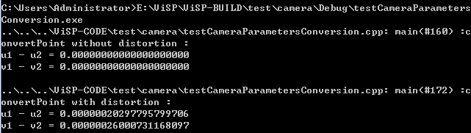

ViSP-BUILD\test\device\display\Debug
- testClick:获得鼠标点击位置像素坐标（区分左右键）
- testDisplays：测试图像显示
- testMouseEvent：测试鼠标点击时间的发生：点击左键记录，点击右键退出
- testVideoDevice：测试显示各类型图片
- testVideoDeviceDual：测试双屏显示

ViSP-BUILD\test\device\framegrabber\Debug 测试帧抓取
需安装libdc 1394-2
1.test1394TwoGrabber
2.test1394TwoResetBus

ViSP-BUILD\test\feature\Debug
testPoint:Performs various tests on the point class.
世界坐标系与相机坐标、二维坐标转换；交互矩阵（ONLY X,ONLY Y,BOTH）；面积

ViSP-BUILD\test\homography\Debug
testDisplacement：Tests transformation within various representations of rotation.
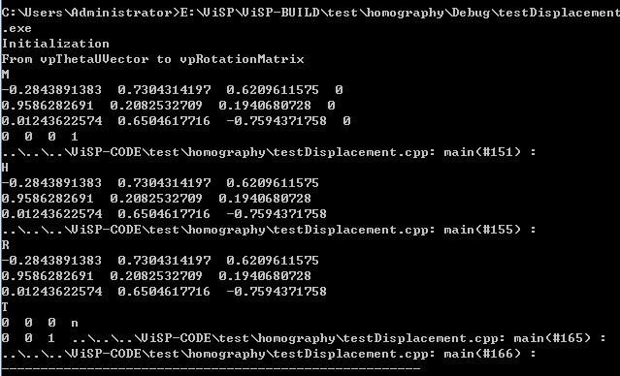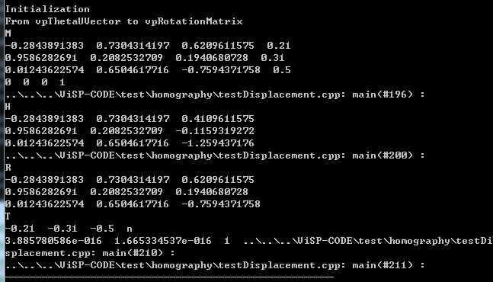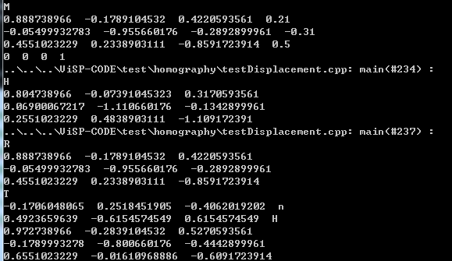
ViSP-BUILD\test\image\Debug
1.testConversion：Test for image conversions.（pgm格式 例：彩=》灰）
2.testCreateSubImage:Test for sub-image extraction.
3.testImagePoint:Test for vpImagePoint class（）
4.testIoPGM:Read and write PGM images on the disk. Error
5.testIoPPM:Read and write PGM images on the disk. Error
6.testReadImage:Read images on the disk.
7.testUndistortImage:Test for image undistortion.

ViSP-BUILD\test\key-point\Debug
testSurfKeyPoint:Test auto detection of dots.
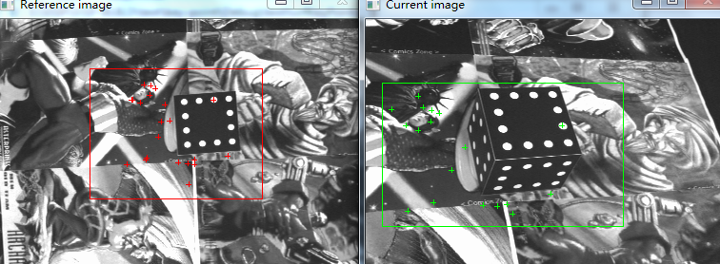

ViSP-BUILD\test\math\Debug
1.testColvector:Test some vpColVector functionalities.
[1;1;1;1]normalize[0.5;0.5;0.5;0.5]
Normalize:x = x/sqrt(x.sumSquare());(1/sqrt(1*1+1*1+1*1+1*1))
2.testKalmanAcceleration:Tests some vpLinearKalmanFilterInstantiation functionalities.
(具体测试内容以后列出)
3.testKalmanVelocity:Tests some vpLinearKalmanFilterInstantiation functionalities.
(具体测试内容以后列出)
4.testMatrix:Test some vpMatrix functionalities.
PRETTY PRINT
vpMatrix M
M.eye(4);

vpTRACE("call std::cout << M;");
std::cout << M << std::endl;

vpTRACE("call M.print (std::cout, 4);");
M.print (std::cout, 4);
输出结果为四阶单位矩阵
vpTRACE("call M.print (std::cout, 4);");
M.print (std::cout, 4);
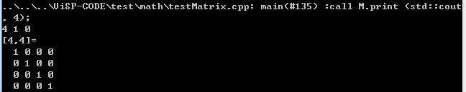
RESIZE
例如M=[1，0，0;
0，1，0;
0，0，1 ]
M.resize(3,2,false);M.resize(5,4,false);
输出[1,0; 输出[1,0,0,0,0;
0,1; 0,1,0,0,0;
0,0 ] 0,0,1,0,0;
0,0,0,0,0]
vpRowVector * vpColVector/vpRowVector * vpMatrix
乘法运算测试
TEST vpGEMM
已知M、N、C
realise the operation D = 2 * M^T * N + 3 C
- testMatrixException:Test matrix exceptions.
ERROR
- testRobust:Test some vpMath functionalities.
double x = -10 ;
while (x<10)
{
if (fabs(x/sig)<=(4.6851))
{
w = vpMath::sqr(1-vpMath::sqr(x/(sig*4.6851)));
}
else
{
w = 0;
}
f << x <<" "<<w <<std::endl ;
x+= 0.01 ;
输出结果X从-4.68至4.68有值0为1
7.testRotation:Tests transformation from various representations of rotation.
Initialization
From vpRotationMatrix to vpQuaternionVector
From vpQuaternionVector to vpRotationMatrix
From vpRotationMatrix to vpRxyzVector
From vpRxyzVector to vpThetaUVector
use From vpRxyzVector to vpRotationMatrix
use From vpRotationMatrix to vpThetaUVector
Initialization vpRzyzVector
From vpRzyxVector to vpRotationMatrix
From vpRotationMatrix to vpRzyxVector
8.testSvd:Test various svd decompositions.
SVD分解
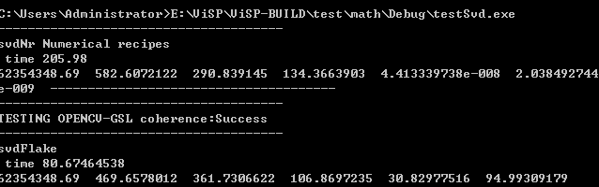
9.testTwistMatrix:Tests some vpMatrix functionalities.
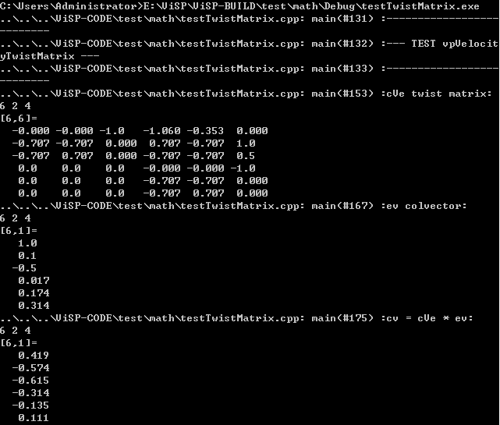
ViSP-BUILD\test\pose\Debug
1.testFindMatch:
Compute the pose of a 3D object using the Dementhon method. Assuming that the correspondance between 2D points and 3D points is not done, we use the RANSAC algorithm to achieve this task
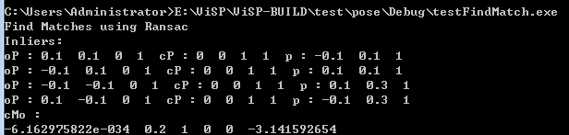
2.testPose:Compute the pose of a 3D object using the Dementhon, Lagrange and Non-Linear approach.
3.testPoseFeatures:Compute the pose from visual features by virtual visual servoing.
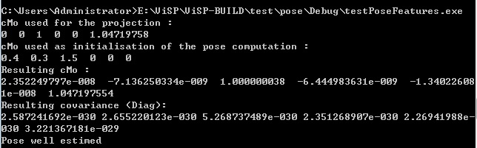
- TestPoseRansac:
Compute the pose of a 3D object using the Dementhon method. Assuming that the correspondance between 2D points and 3D points is not done, we use the RANSAC algorithm to achieve this task
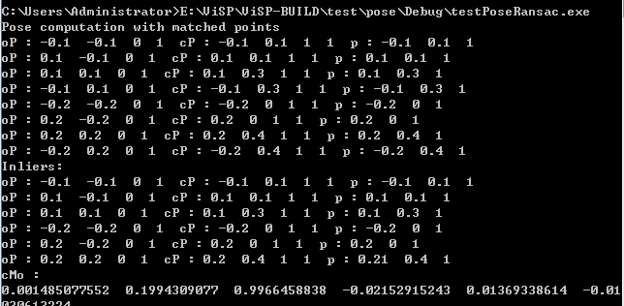

ViSP-BUILD\test\servo-afma4
ViSP-BUILD\test\servo-afma6
ViSP-BUILD\test\servo-viper

ViSP-BUILD\test\tools\geometry\Debug
构造多边形并测其面积、质心

ViSP-BUILD\test\tools\time\Debug 测试时间
testTime
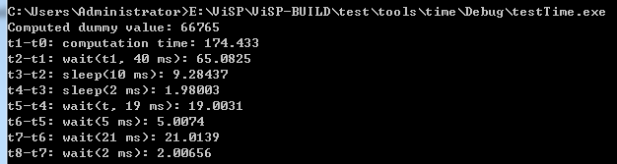

ViSP-BUILD\test\tools\xml\Debug
testXmlParser
Libxm12 is required

ViSP-BUILD\test\tracking\Debug
testTrackDot：Test auto detection of dots.
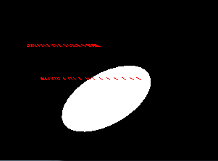

ViSP-BUILD\test\visual-feature\Debug
1.testFeature:Visual feature manipulation.
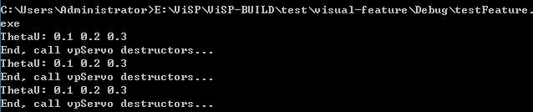
2.testFeatureMoment:Example of visual servoing with moments using a polygon as object container
3.testFeatureSegment:Visual feature manipulation (segment).
