Final Research Report

Course Code: BIOX7011  
Student Name: Yu Sun  
Student Number: 45105764  
Supervisor: [Jan Engelstaedter, Affiliation]  
Date: [Submission Date]

# Abstract

This section provides a concise summary of the entire project (200–300 words). It should clearly outline the research aims, the main methodologies used, the key findings, and the major conclusions derived from the study.

# 1. Introduction

# 尽管结核分枝杆菌已经是利福平耐药性研究最为深入的模型，但利福平毕竟暴露于多种细菌中，无论是临床使用还是环境污染都确定存在。因此，本文进行了对其解跨物种突变模式的预测，这或许能为抗生素耐药性的进化趋同提供一些参考。

# 传统基于文献的整理和分子表征方法在整合分散在不同物种的数千份抗性报告方面，可扩展性有限。机器学习方法，尤其是自然语言处理和无监督特征提取，提供了一个可扩展的框架，可以系统地揭示隐藏的突变模式和跨物种相似性，而这是仅靠人工整理无法实现的。

# 2. Materials and Methods

Provide detailed descriptions of materials, datasets, equipment, and analytical or experimental procedures used. Ensure that another researcher could replicate the work based on this section. Include subsections as appropriate, for example:  
  
2.1 Data Collection  
2.2 Laboratory Experiments / Computational Workflow  
2.3 Software and Statistical Analyses  
2.4 Ethical Considerations (if applicable)

# Results

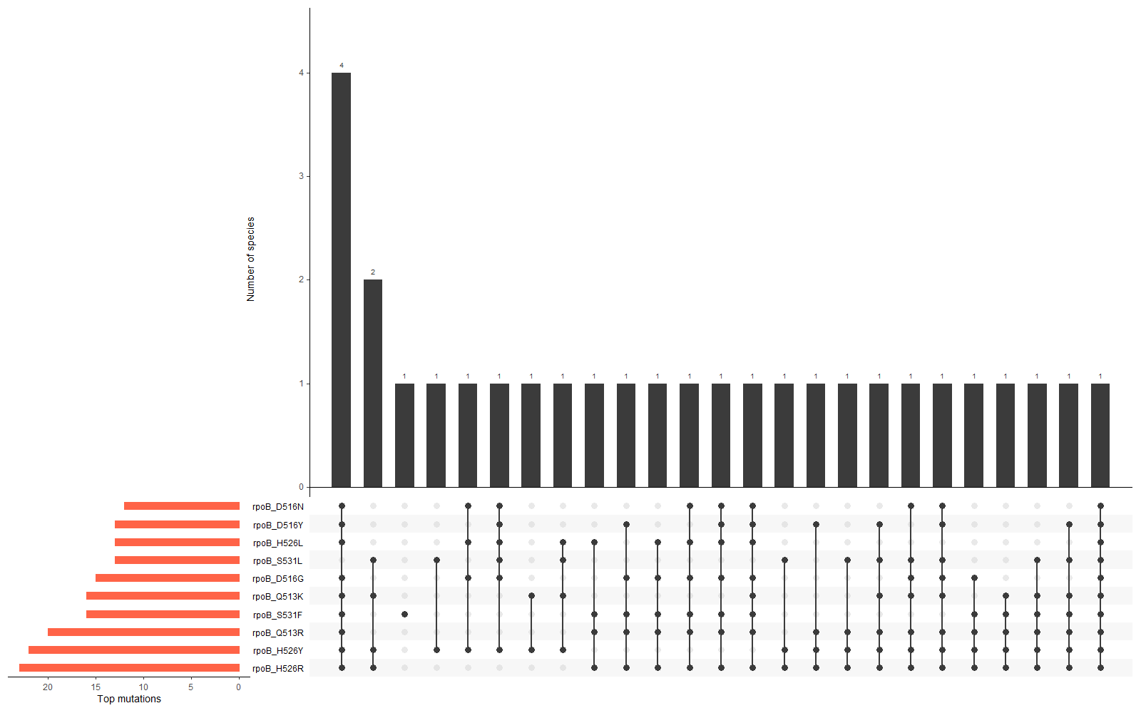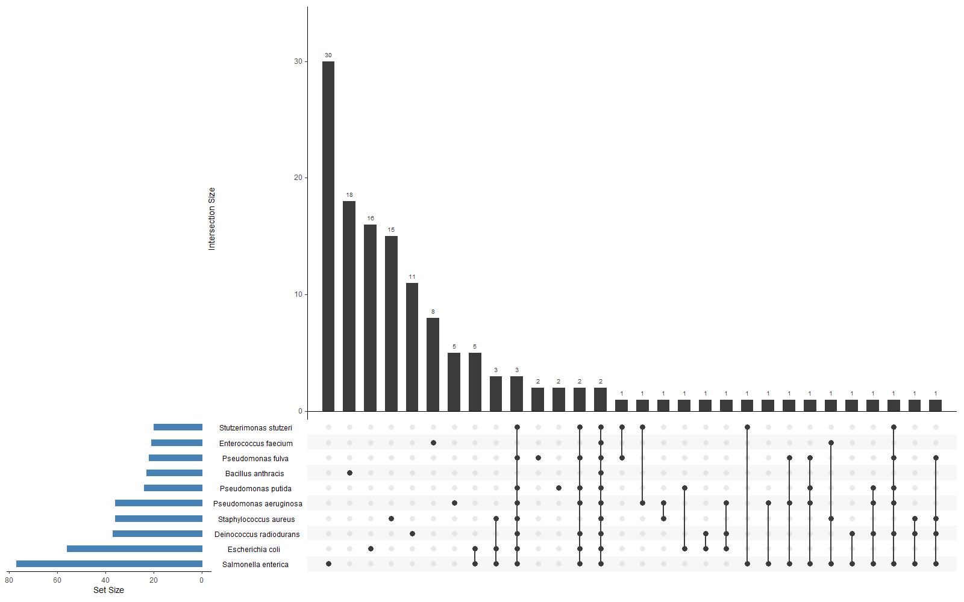

# 4. Discussion

Interpret the results critically in the context of existing literature. Highlight how the findings support or contradict previous studies, and explore possible explanations. Discuss the implications of the results, the limitations of the study, and suggest directions for future research.

# 5. Conclusions

Summarize the most significant findings and their implications. State whether the research aims were achieved and highlight potential applications or follow-up studies.

# 6. References

All cited literature should appear here in a consistent referencing style (APA, Harvard, or a scientific journal format). Example:  
Foster, L., Mouse, M., & Christ, J. (1972). The effect of hypoxia on free divers. J. Irrep. Res., 23, 490–512.

# 7. Figures and Tables

All figures and tables should be labeled and inserted close to where they are first mentioned in the text. Each figure should include a descriptive caption below, while tables should have a title above.

# 8. Appendices

Include any supplementary materials, extended data tables, code snippets, or detailed methodology not essential to the main text.