Name: Jason Pael Section: 2CSA

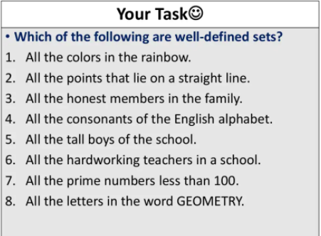

**Ans:**

1. **Well-defined**
2. **Well-defined**
3. **Not well-defined**
4. **well-defined**
5. **well-defined**
6. **not well-defined**
7. **well-defined**
8. **well-defined**

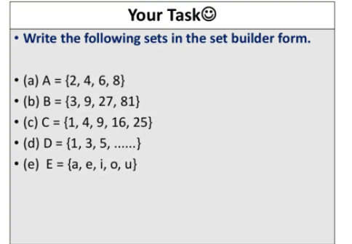

**Ans:**

1. **A = {x : x is an even natural number less than 10}**
2. **B = {x : x = 3^n where n belongs to natural number}**
3. **C = {x : x is a perfect square natural number up to 25}**
4. **D = {x | x is an odd number}**
5. **E = {x : x is a vowel letter in English alphabet}**

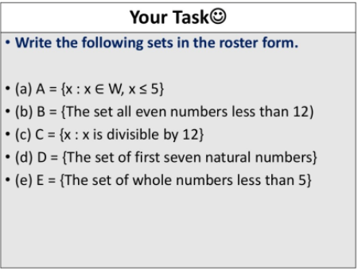

**Ans:**

1. **A = {1, 2, 3, 4, 5}**
2. **B = {0, 2, 4, 6, 8, 10}**
3. **C = {12, 24, 36, 48, 60, …}**
4. **D = {1, 2, 3, 4, 5, 6, 7}**
5. **E = {0, 1, 2, 3, 4}**

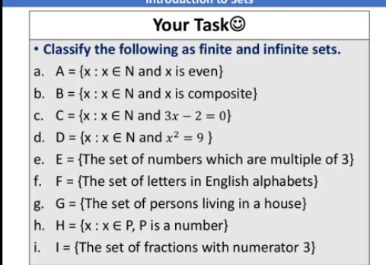

**Ans:**

1. **Infinite**
2. **Infinite**
3. **Finite**
4. **Finite**
5. **Infinite**
6. **Finite**
7. **Finite**
8. **Infinite**
9. **infinite**