

Maggi and Concentri are excited to announce a new partnership!

We are joining forces to bring our customers the best possible experience. Together, we will offer a wider range of products and services, and we will be able to provide our customers with more personalized support.

We are confident that this partnership will be mutually beneficial, and we look forward to working together to create a better future for our customers.

Learn more about our partnership here: https://www.maggi.com

Here are some additional tips for writing an announcement about a partnership or collaboration:



Join us for a day of fun and activities at Cabuyao on August 20, 2023

We'll have games, music, prizes and give aways so there's something for everyone.

Food and drinks will be available for purchase, and there will be a cash prize for the best costume.

Tickets are on sale now! Get yours today and don't miss out on the fun.

<https://www.vox.com>

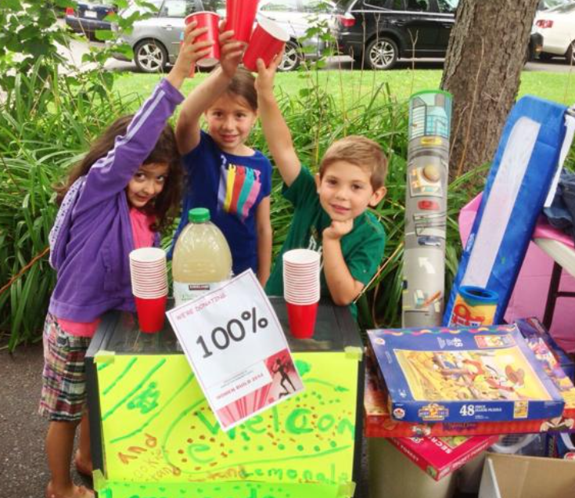

Yard Sale!

Come one, come all! We're having a yard sale to get rid of some of our old stuff.

We've got everything from clothes to furniture to electronics. There's something for everyone!

The sale will be held on August 20,2023] from 9:00 am to 5:00 pm at Gen Store Cabuyao

Everything is priced to sell, so come early and get the best deals!

We hope to see you there!



**Walking Club for Senior Citizens**

Are you a senior citizen who loves to walk? Join our walking club! We meet every Tuesday and Thursday at 10am at the park.

We'll walk for about an hour, and we'll have a lot of fun along the way. We'll also stop for a break to chat and catch up.

This is a great way to get some exercise, meet new people, and make friends.

No experience necessary. Just come as you are!

To join, please contact John Lee at 129-5113-34234

We hope to see you there!



Mural Artists in Action!

Come see our talented mural artists at work! They are creating a beautiful new mural that will brighten up our community.

The mural will be located in the park at J Street and will be completed on August 20, 2023

The artists will be working from 7:00 am to 4:00 pm each day.

Come by and say hello, and watch the mural come to life!

This is a great opportunity to learn about mural art and to see how it is created. It is also a great way to support local artists.

We hope to see you there!