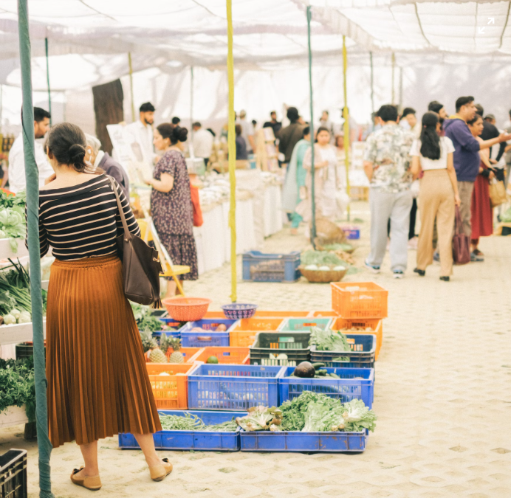

Support Local Farmers and Businesses at the Farmer's Market!

Date: Saturday, August 27, 2023

Time: 9:00 AM to 1:00 PM

Location: Main Street Park, Anytown, CA

Join us for our weekly farmer's market! This is a great opportunity to support local farmers and businesses, and to find fresh, seasonal produce. We will have a variety of vendors selling fruits, vegetables, meats, cheeses, baked goods, and more.

We also have live music, face painting, and other activities for the whole family. So come out and enjoy a day of fun and support your community!

People shopping at a farmer's marketOpens in a new window

www.morefood.org

People shopping at a farmer's market

What to bring:

A reusable bag!

Cash or credit card.

Your appetite!

We hope to see you there!

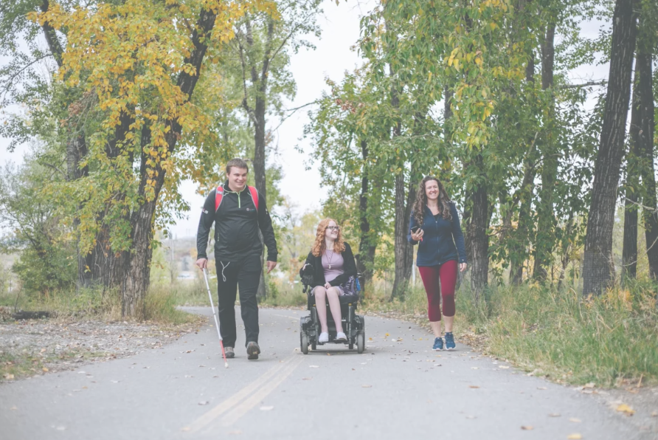

Making the Trans Canada Trail Safe and Accessible for People of All Abilities

Date: Saturday, September 16, 2023

Time: 10:00 AM to 1:00 PM

Location: Anytown, CA

Join us for a community event to discuss ways to make the Trans Canada Trail safe and accessible for people of all abilities. We will hear from experts in accessibility and trail design, and we will have the opportunity to share our own ideas and experiences.

This event is open to everyone who is interested in making the Trans Canada Trail more accessible. No prior experience is necessary.

What to bring:

A willingness to participate and share ideas!

A notebook and pen.

Any materials you would like to use to illustrate your ideas.

We hope to see you there!

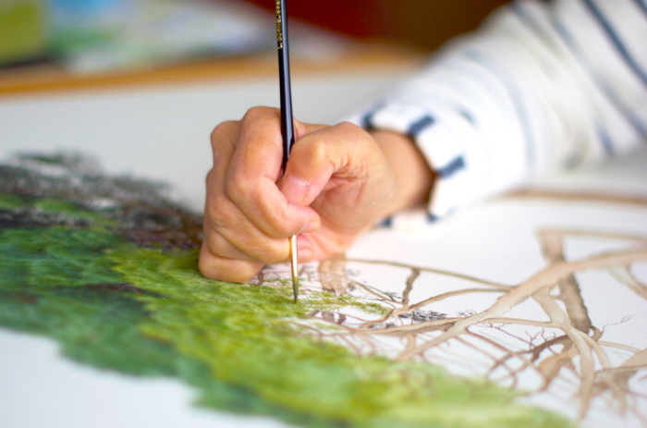

Create Your Own Botanical Art

Date: Saturday, August 27, 2023

Time: 10:00 AM to 1:00 PM

Location: The Greenery, 123 Main Street, Anytown, CA

Join us for a fun and creative workshop on creating botanical art! We will learn about the different techniques used to create botanical art, such as watercolor painting, drawing, and printmaking. We will also have the opportunity to create our own botanical art piece to take home.

This workshop is perfect for beginners and experienced artists alike. No prior experience is necessary.

Cost: $25

To register:

Sign up online at www.thegreenery.com.

Call us at (555) 555-5555.

What to bring:

A willingness to have fun and learn!

A notebook and pen.

Any materials you would like to use for your botanical art piece.

We hope to see you there!

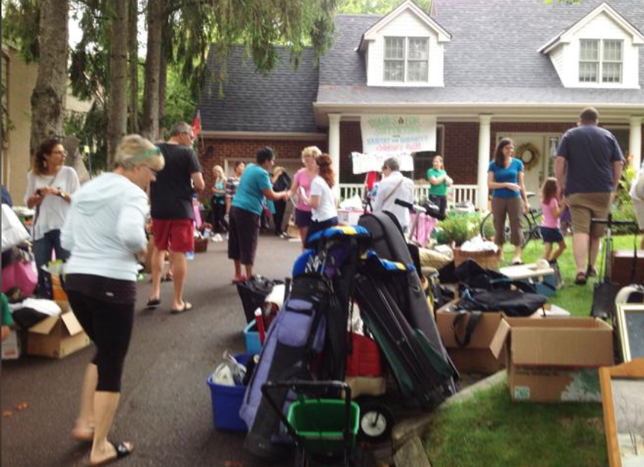

Community Yard Sale

Date: Saturday, August 27, 2023

Time: 9:00 AM to 1:00 PM

Location: 123 Main Street, Anytown, CA

Join us for our annual community yard sale! This is a great opportunity to get rid of your unwanted items and find some great deals. We will have a variety of items for sale, including furniture, clothing, toys, and household goods.

All proceeds from the yard sale will benefit the local food bank. So come out and support a good cause!

To participate:

Sign up by August 20, 2023. Space is limited, so sign up early!

Set up your space on August 26, 2023. Be sure to arrive early to get the best spots.

Bring your own tables and chairs. We will not be providing tables or chairs.

No selling of new items. This is a yard sale for gently used items only.

No pets. Pets are not allowed at the yard sale.

We hope to see you there!

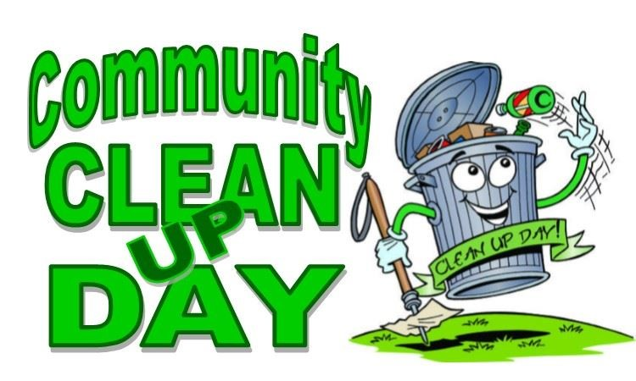

Let's Make Our Community Clean and Beautiful!

Date: Saturday, August 27, 2023

Time: 9:00 AM to 1:00 PM

Location: Main Street Park, Anytown, CA

Join us for a community clean-up day! This is a great opportunity to get together and make our community a cleaner and more beautiful place. We will be cleaning up litter and debris from the park and surrounding areas.

All are welcome to participate, regardless of age or ability. We will provide all the necessary supplies.

What to bring:

Water bottle

Sunscreen

Hat

Closed-toe shoes

We hope to see you there!