# **Richland Engineering kicks off Make A Difference Day food drive**

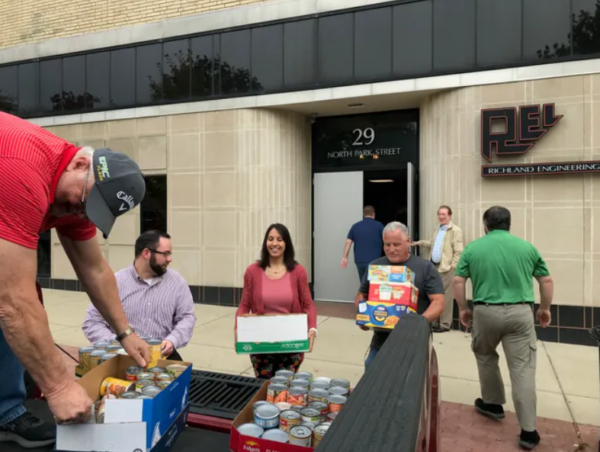

MANSFIELD - Every year for the past 10 years employees at Richland Engineering Limited, 29 N. Park St., make a large donation of canned goods and nonperishable food items for the Make A Difference Day Food Drive, which is coming up this weekend.

Monday, engineers and staff members carried out box after box of goodies to help restock five Richland County food pantries — Harmony House, Salvation Army, Domestic Violence Shelter, Volunteers of America and Catholic Charities HOPE Food Pantry.

Dan Arnett backed a shiny red F-150 up to their downtown doorway and employees brought out Tide, oatmeal, frosting, ravioli, mac and cheese boxes, pasta, Stove Top Stuffing, tuna, bottles of ketchup and more. Plus, employees donated cash, which will be given to food pantries in the form of gift certificates to area grocery stores.

### Chicago Jazz Festival

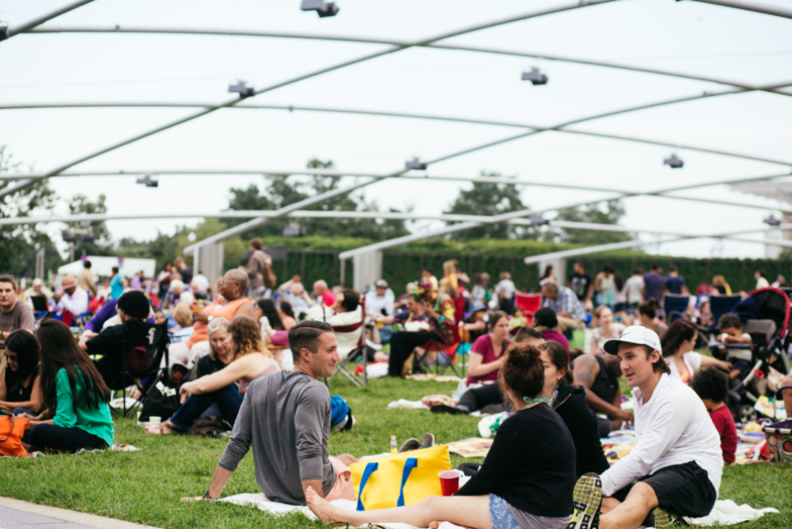

The longest-running of the city’s lakefront music festivals, the **[Chicago Jazz Festival](https://www.choosechicago.com/articles/festivals-special-events/chicago-jazz-festival/)** is also one of the most popular. Known for its artistic creativity, the Labor Day weekend festival promotes awareness and appreciation for all forms of jazz through free live musical performances at two stunning downtown venues: the Chicago Cultural Center and Millennium Park.

### World Music Festival

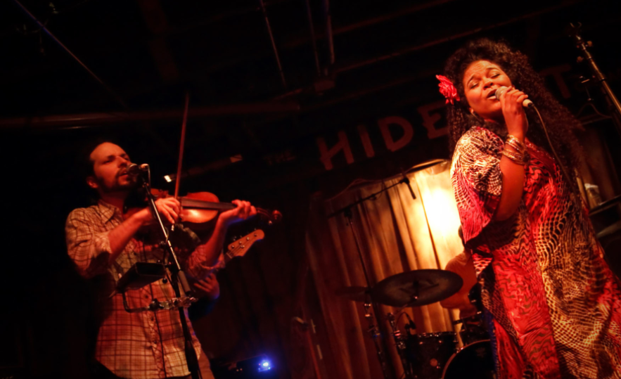

The annual **[World Music Festival Chicago](https://www.choosechicago.com/articles/festivals-special-events/world-music-festival-chicago/)** in late summer/early fall brings music from all over the globe to Chicago for this popular multi-day festival. The city-wide, multi-venue celebration features over 30 artists from 22 countries at venues around Chicago including the Chicago Cultural Center, Millennium Park, and Navy Pier.

Chili’s is home of sizzling fajitas and refreshing margaritas, and you won’t believe these surprising facts about this beloved restaurant.

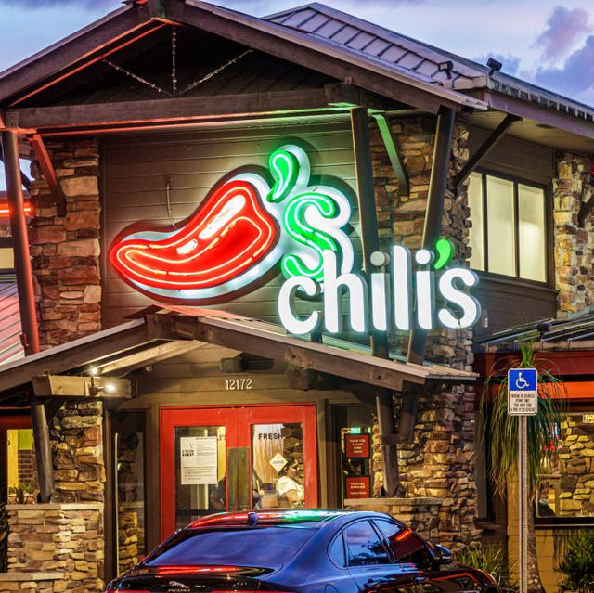

**Local artists begin work to create PNW-inspired mural at PDX**

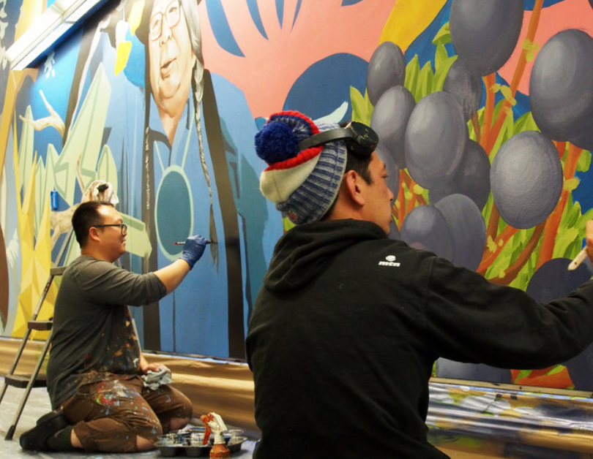

A partnership with the Portland Street Art Alliance is bringing a one-of-a-kind mural to the airport

Street art is coming to the Portland International Airport. Through a partnership with the Port of Portland and [Portland Street Art Alliance](http://www.pdxstreetart.org/), two local artists, Alex Chiu and Jeremy Nichols, are creating a mural in the north pedestrian tunnel at PDX that celebrates the people, history and natural wonders of the Pacific Northwest.

Port of Portland leaders believed it was important to showcase the diversity of the region and take a fresh approach to art in the terminal, especially in a space that many travelers pass through every day to access the parking garage. That’s why the Port of Portland partnered with PSAA to help breathe new life into the space. The goal was to create a magical and fantastic landscape, inspired by the culture and spirit of Portland and the Pacific Northwest.