Jon Rippe  
CSCE A360  
HW #3

Use the database shown in Figure P3.17 to answer Problems 17–20 and 22.

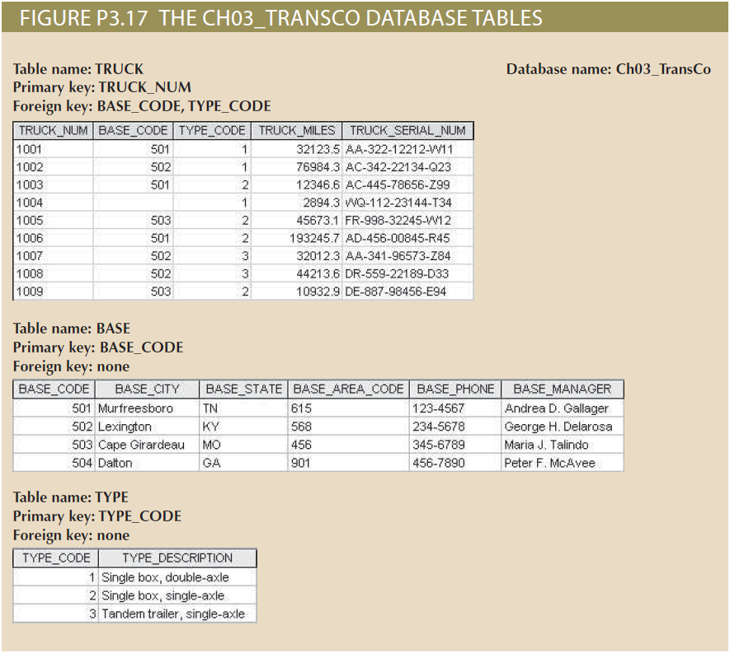

1. For each table, identify the primary key and the foreign key(s). If a table does not have a foreign key, write None.
   * TRUCK:
     + Primary: TRUCK_NUM
     + Foreign: BASE_CODE, TYPE_CODE
   * BASE:
     + Primary: BASE_CODE
     + Foreign: None
   * TYPE:
     + Primary: TYPE_CODE
     + Foreign: None
2. Do the tables exhibit entity integrity? Answer yes or no, and then explain your answer.

Yes. Each table has a primary key with each entity’s key being unique.

1. Do the tables exhibit referential integrity? Answer yes or no, and then explain your answer. Write NA (Not Applicable) if the table does not have a foreign key.

Yes. The TRUCK table is the only table with foreign keys, and those foreign keys point to the unique primary keys of the other tables. Additionally, every foreign key is a reference to a valid, existing entity in the other tables.

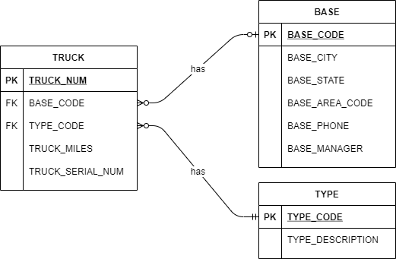

1. Identify the TRUCK table’s candidate key(s).
   * TRUCK_NUM, TRUCK_SERIAL_NUM
2. Create the ERD for this database.
   * Each truck has an optional base.
   * Each base may have many trucks.
   * A base might not have any trucks.
   * Each truck must have a type.
   * Each type may be associated with multiple trucks.
   * Some types might not have any associated trucks (assumed).