Jon Rippe  
CSCE A360  
HW #5

For Questions 9–10, refer to Figure Q5.8.

1. 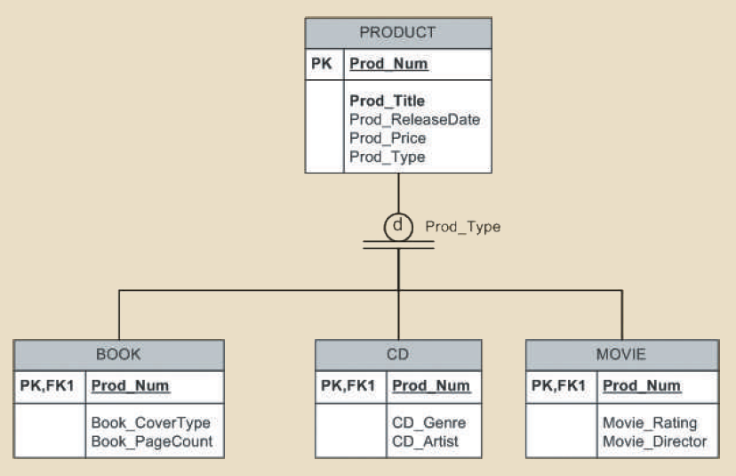According to the data model, is it required that every entity instance in the PRODUCT table be associated with an entity instance in the CD table? Why, or why not?

No. The subtypes are disjoint, so any instance in the PRODUCT table must be associated with one and only one of the three subtypes. A book or movie cannot be associated with a CD.

1. Is it possible for a book to appear in the BOOK table without appearing in the PRODUCT table? Why, or why not?

No. The PK of each subtype is a FK that points to the PK of the PRODUCT table. You can’t create any instance of any of the subtypes without it being associated with an instance in the PRODUCT table.

1. What primary key characteristics are considered desirable? Explain why each characteristic is considered desirable.
   * Unique Values – The PK must only pertain to a single instance. Non-unique values fundamentally don’t work to describe single instances.
   * Nonintelligent – For information security, the PK shouldn’t divulge any possibly usable information about the instance it describes.
   * No change / immutable – The PK can’t be changed, and thus shouldn’t be an attribute with the potential to change.
   * Single-attribute – Reduces the complexity of relationships by keeping the size of foreign key down.
   * Numeric – Allows for easier management and automation by a DBMS
   * Security-compliant – Same reasoning as nonintelligent.
2. Under what circumstances are composite primary keys appropriate?

When creating a composite table that removes a many-many relationship from a database or when there’s a strong relationship between a weak entity and its parent entity.

1. What is a surrogate primary key, and when would you use one?

A surrogate PK is a unique, arbitrary attribute that is added to an entity whose inherent attributes don’t offer a reasonably valid candidate key.