March 4th, 2021

Dear Editors of Applied Physics Letters,

Thank you again for your consideration of the perspective article entitled “Optoelectronic Intelligence” for publication in APL. It seems all three reviewers are supportive of publication. Through your editorial process, I have been given access to valuable feedback and insightful comments from three clearly qualified individuals with expertise in relevant fields. Their observations made this paper significantly stronger, and I am grateful to have had the opportunity to improve my work based on their constructive criticisms. In my opinion, this is exactly how peer review should function.

Thank you again for your consideration and your time,

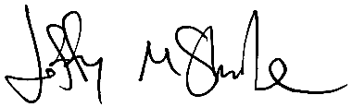

Dr. Jeffrey M. Shainline

Physicist / Staff Scientist

National Institute of Standards and Technology

jeffrey.shainline@nist.gov