100 wafer, 150_nm Thermal oxide. 80 nm/min Nb 1 kW.
Stress _____

1. M0 deposition (150 nm): SNS System Base P = ____ nTorr,
Stress _____
Recipe: M0sfq.rcf: RF Voltage: ____ V, Time: 6:00, Power __ W: ___ nTorr H₂ post
Deposition time 113 s

2. Alignment marks:
Marks Etch: Trion NbSF6 for 25 s __________ W, -_______ V.
Profilometer: AL Left: ______ AL Right: _______

3. M0 etch: Spin: SPR660 2700 rpm, Exp: 270 mJ/cm², dev 60 s
Etch: Trion NbSF6 __________ W, -_______ V. Endpoint + 5s overetch. Profilometer: M0 center: _______
Stress _____

4. I0 deposition (150 nm): ECR SiO2_Volt180W.PRC for wafer before:
Wafer Deposition: Grip ____ Torr, ____ sccm (must be < 1sccm) ___
Stress ____
O2/Ar in situ clean 2 min, ____ W, bias ____ V
Oxide dep. time 125 sec, ________ W. Start bias ____ end bias ____
Measured oxide thickness. Center: ____

5. I0 etch: Spin P20, 2200 rpm resist. Exp: 220 mJ/cm², DP-30-30
Trion SiO2. ______ W, _______ W, - ____V, ____+ 10%
STD Clean Dektak: ______ nm.
Stress ____

6. Tri-layer dep.: Base Pressure: ____nTorr chamber SNS Dep. system: D3L16N.rcf
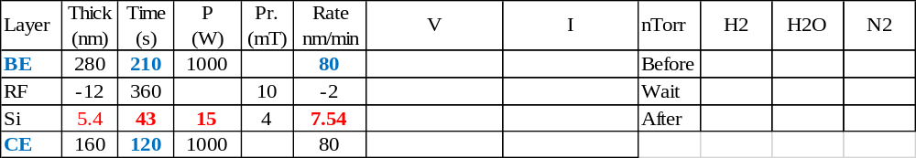

7. Junctions etch
ASE deep etcher. NbMix. HeLUR: _____ mT/min, Endpoint: ______ + 7 s.
or Oxford RIE sfqJJ. Etch _______ W, ____ W, ____ V Endpoint: ____ + 30 s,
Stress: ____
Profilometer.: ____

8. M1 etch: Resist: SPR660 2700 rpm, expose: 270 mJ/cm², dev SP 60 s
Trion NbSF6 (10 sec past BE) He: ___, ____ W, ___ V, ______ s
Stress ____
 | BE | CE+overetch
Ctr
Left
Right

9. ECR I1 dep (350 nm): SiO2_Volt180W.PRC for wafer before:
Wafer Deposition: Grip ____ Torr, ____ sccm (must be < 1sccm) ___
Stress ____
O2/Ar in situ clean 2 min, ____ W, bias ____ V
Oxide dep. time 300 sec, ________ W. Start bias ____ end bias ____
Measured oxide thickness. Center: ____

10. I1 etch:
(Thick Oxide Resist). Spin P20, 2200 rpm resist. DP-30-30
Trion: SiO2 _____, _____ W, ______ V max: ____, min: _____, max: _____, + 60 s.
Stress ____
Dektak: SBE (I1) ____ nm, dJJ ____ nm. On endpt. Squares: I1: ____ nm, HSQ+ZEP: ____

11. M2 dep (450 nm): SNS System Base P = ____ nTorr,
Recipe: wrsfq.rcf: RF Voltage: ____ V, Time: 6:00, Power __ W: ___ nTorr H₂ post
Deposition time ____
Before Etch stress ____

12. M2 etch: STD Resist. 2700 rpm resist. SP-60
Trion. WR: ______ W, _______ W, - ____V, ____+ 15 s (15 sec past WR)
STD Clean Dektak: ______ nm.
Stress ____

13. RS and PADS lift off:
Spin: Spin P20, SPR660 2700 rpm, expose: 270 mJ/cm² develop: SP 60 s
Dep: PVD System; Base P= ___ nTorr_ recipe PdAuResistors
RF | 10 mT | 50 W | ________ V |  | 2:00
Ti | 5 mTorr | 250 W | ________ V | ________ A | 10 s
PdAu | 2.7 mTorr | 250 W | ________ V | ________ A | 5:00
ACE/us 5-10 min (US 1/2 power), ISO spin, Dektak: PADS _____ nm,
Stress _____

14 Deposit Insulator 2
15 Etch windows over pads

