Inverse Tranform Sampling Method

Josh Soboil

21/11/2020

# Inverse Transform Method

Random samples are drawn from uniform distribution, i.e. $x∼U(0,1)$ . For instance

x <- runif(n = 20000)

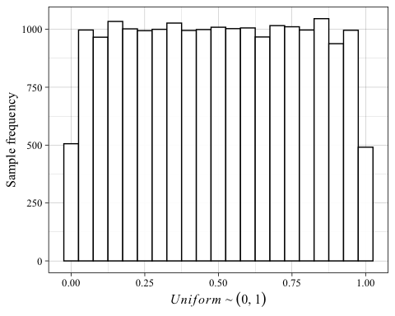 For example, from here, it is then possible to transform these samples into the inverse cdf (quantile function) of the exponential distribution and normal distribution

inv_cdf_exp <- qexp(p = x, rate = 0.4)  
inv_cdf_norm <- qnorm(p = x, mean = 0.65, sd = sqrt(0.7744))

The result of this can be used to inform the probability for a range of parameter values occurring.

## Warning: Removed 48 rows containing non-finite values (stat_density).

## Warning: Removed 48 rows containing non-finite values (stat_ecdf).

## Warning: Removed 227 rows containing non-finite values (stat_density).

## Warning: Removed 227 rows containing non-finite values (stat_ecdf).

