**CMSC 433 Project 1**

**Group Members:**

*Browsers*: Supported in all browsers (designed specifically for FireFox and Chrome)

**Server:** gl.umbc.edu

*PHP version*: 4.3.10

*No JavaScript*

**How it works:** *See Video.* User maneuvers to “Get Started” page, and clicks “Start Advising” to begin degree audit process. Then, user fills out personal information necessary to move to the next step in advising; personal information given is stored in session (no cookies). All personal information is validated before proceeding. The name must only consist of letters and spaces, the campus ID must be in the format that UMBC uses (two letters and then five numbers), and the email must be a umbc.edu email address. All personal info fields are required. After personal information is filled out and submitted, the user moves to the course selection page. On the course selection page, the user will check off all the classes he has passed/expects to pass this semesterand then submit the classes; these classes will also be stored with the other session variables, and then submitted to the database through “POST.” After the user has submitted the classes they have passed, the code will process through his classes in the database and display all courses that they are eligible to take.

**Website Styling:**

Azimuth makes use of an external CSS, consisting of base html tag normalization to ensure consistent display across browsers, with styling handled primarily by custom div classes divided into header, article, and footer sections. The header, article, and footer sections are size-constrained by a single container class and auto-scale based on browser size. Mobile viewports are not supported. All CSS is placed in the external sheet.

To attempt consistency with other UMBC services, website style follows UMBC style guidelines, adopting the official colors, font, and writing conventions ( <http://styleguide.umbc.edu/> ).

**Database Setup:**

Static Courses Table:

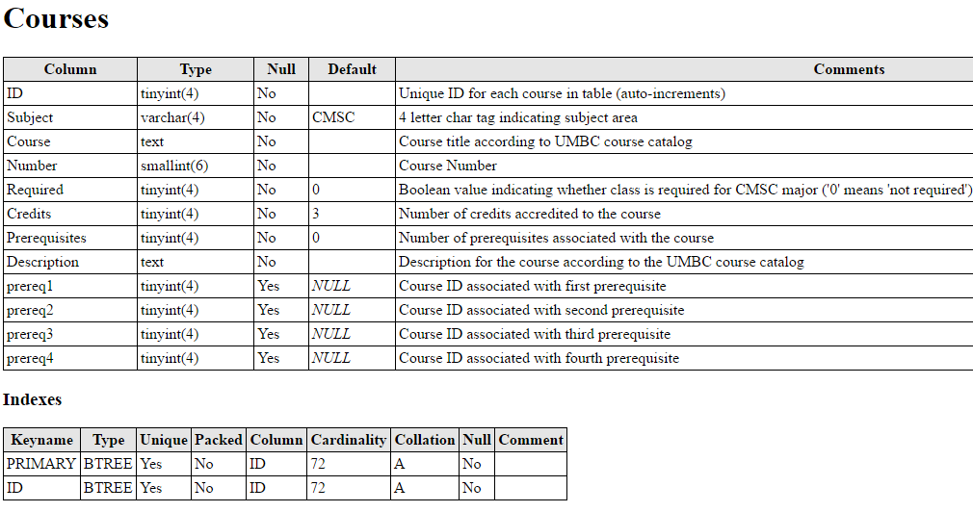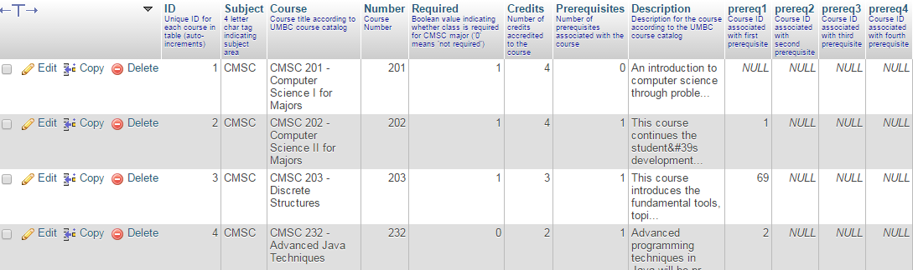

The courses table keeps track of all of the information about the courses. Each course has a unique ID (1-72) that makes it easily identifiable in the PHP code. All other fields are described above in the print view of the Courses table. The Courses table is used in displaying information about all of the courses when prompting the user to select all courses they have passed/expect to pass this semester. It is also used when fetching prerequisites for the courses to determine if the user is eligible to take a course, and then also for displaying the output of all courses the user is eligible to take.

StudentInfo table:

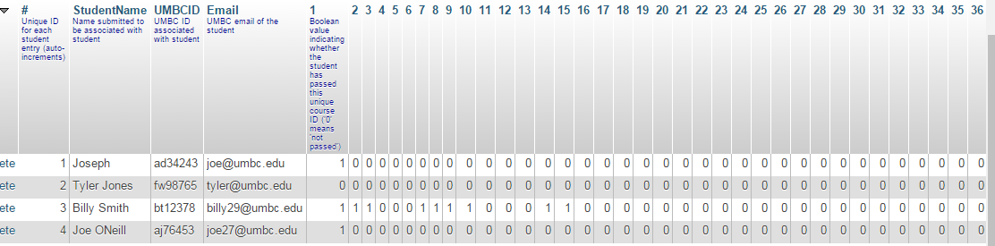

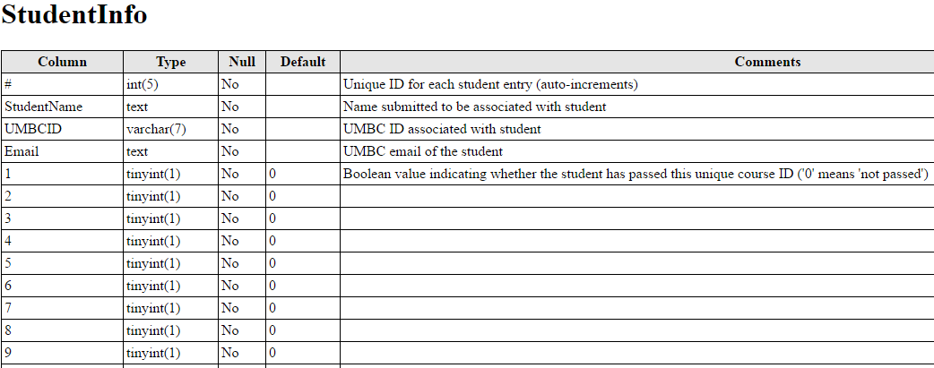

The StudentInfo keeps each student’s submitted info and courses. Each course has a unique row with its ID indicating whether the student **passed** the course (‘1’ for passed, ‘0’ for not passed). This table essentially is the user’s inputted degree audit, and the algorithm that suggests classes uses this table as a benchmark as to what the student has yet to take. The course suggestions also are based on prerequisites and required courses for CMSC majors.